- Navigate to the https://www.arrt.org/ main page
- Click “Verify Credentials”
- Click “Request Verification on ARRT Letterhead”
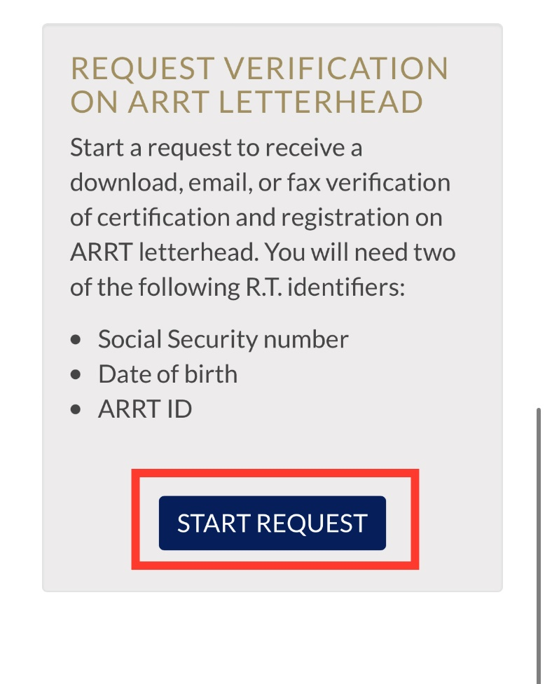
- Enter 2 identifiers for technologist ARRT ID, DOB, SS#)
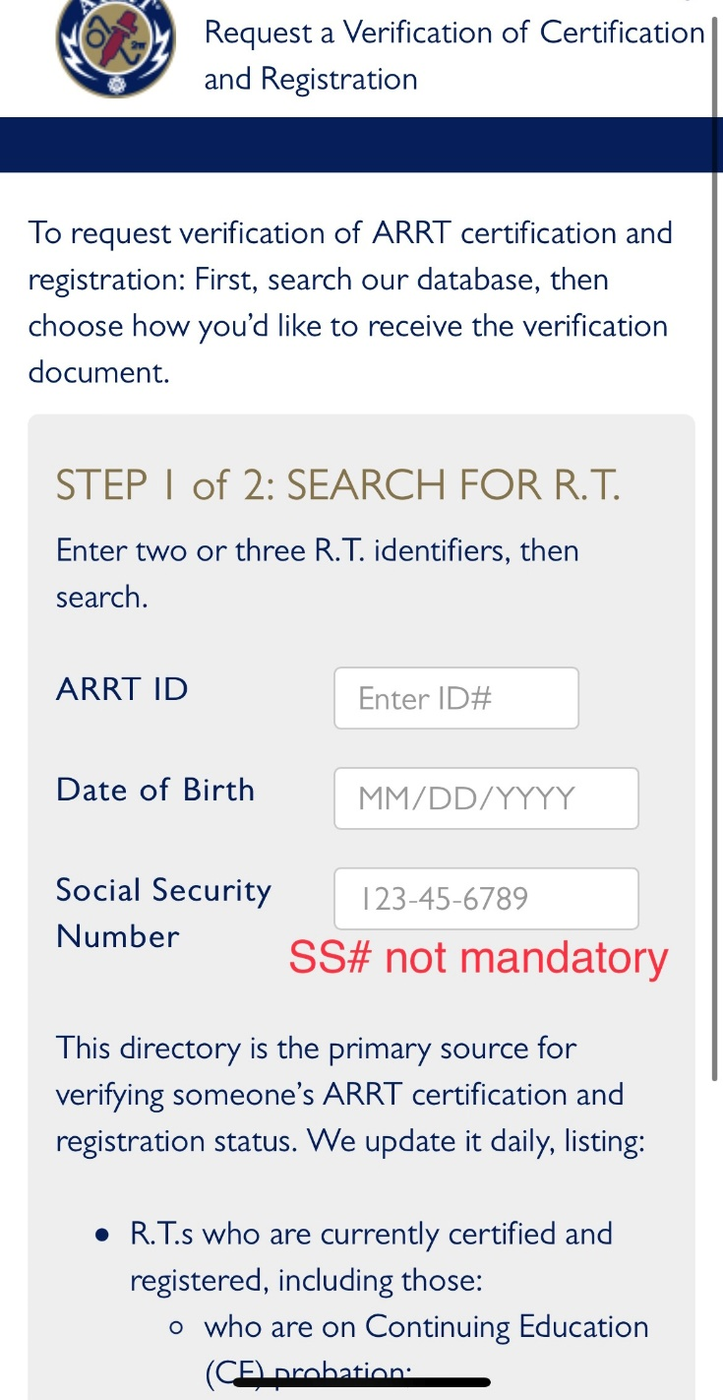

- Choose how you want to receive the verification
- Click Submit
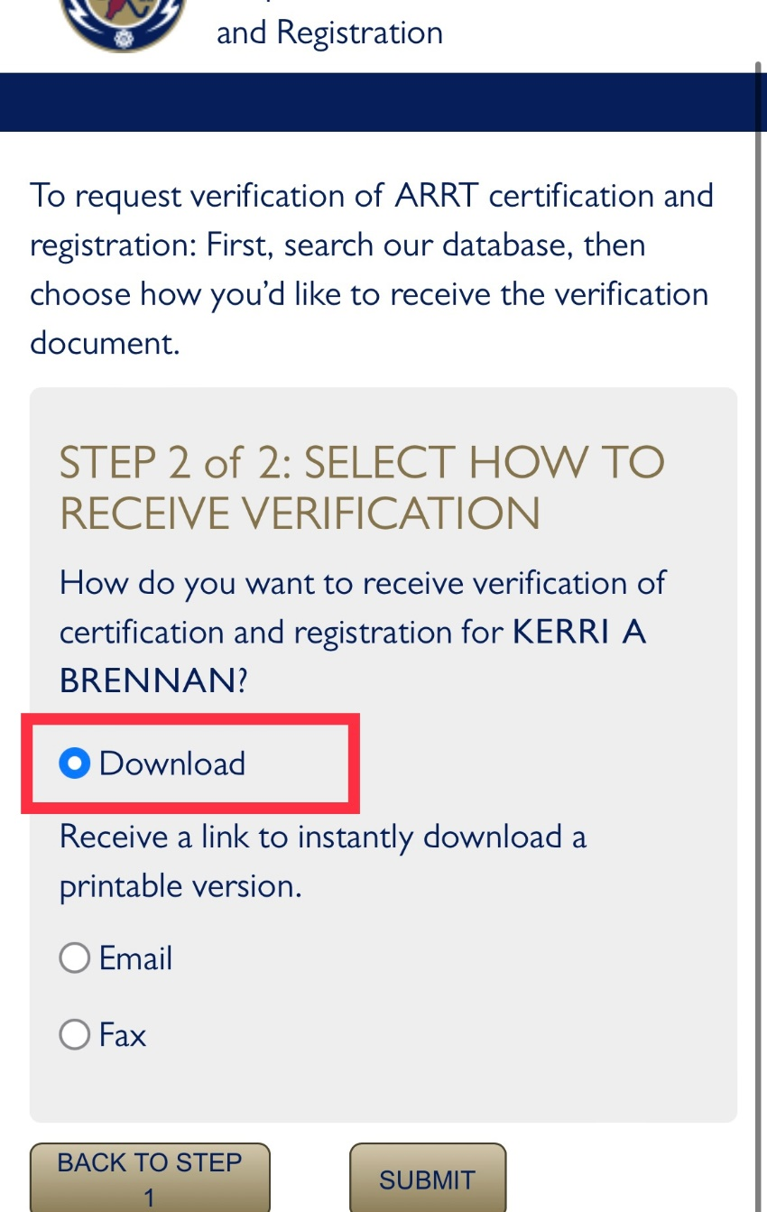
- “Download” allows you to view immediately and/or print
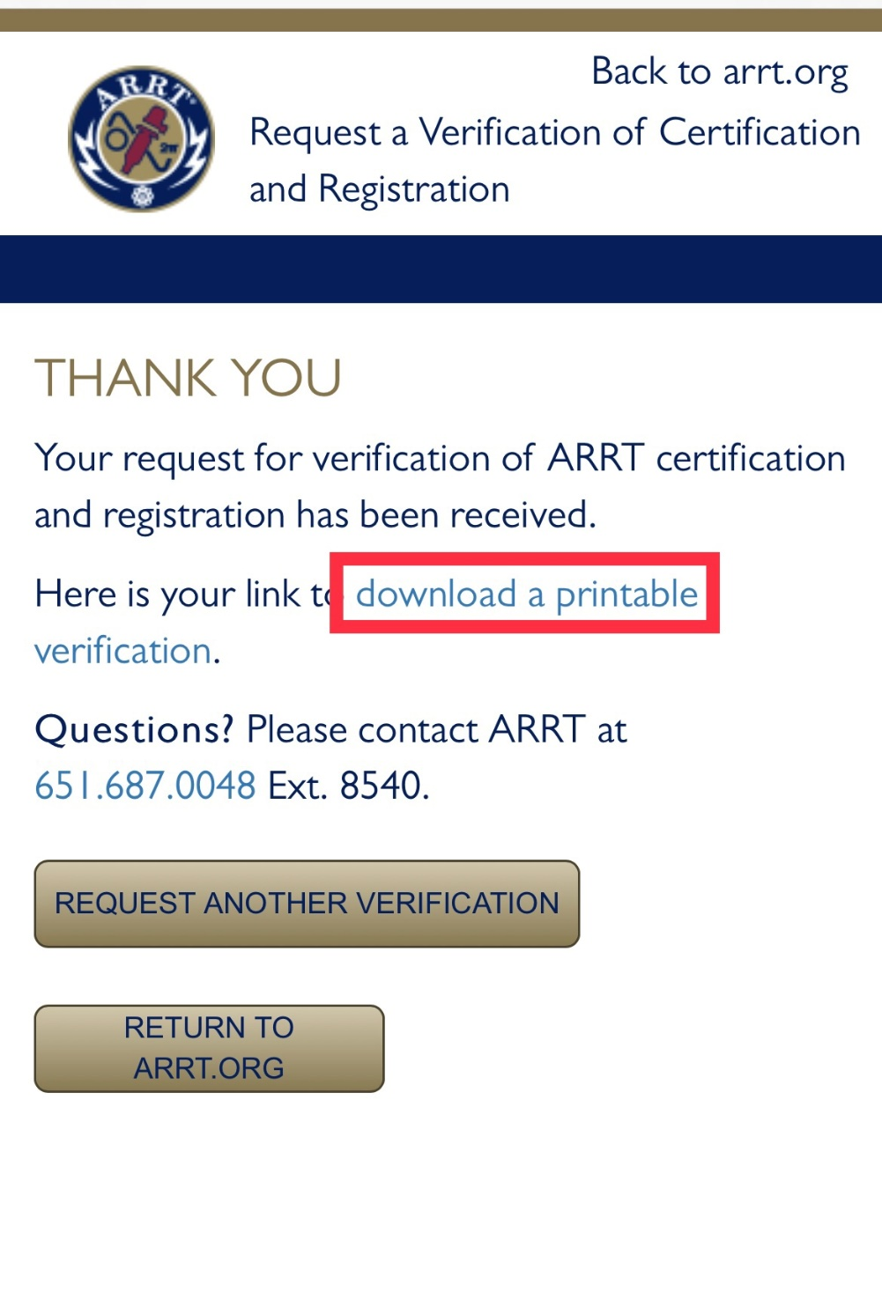

- View & Print
