Electronic Visit Verification (EVV) Implementation in Massachusetts

Monday, December 10, 2018

Colleen Swartz

Slide 1:

21st Century Cures Act mandates EVV use
- Electronic Visit Verification (EVV) refers to the technology a worker uses during a home visit to capture information about the services provided
- Federal law requires EVV for the following Medicaid services:
  - Personal care by 1/1/2020
  - Home health by 1/1/2023
- EVV required for Medicaid services but EOHHS will be requiring it for EOEA Non-Medicaid services as well
- States face a reduction in federal matching funds if they do not implement EVV on time, although states can apply for a 1 year exemption

Slide 2:

EVV Requirements
EVV Systems must verify:
  - Type of service performed;
  - Individual receiving the service;
  - Date of the service;
  - Location of service delivery;
  - Individual providing the service;
  - Time the service begins and ends
- States may choose their own model for EVV Implementation
- States are required to obtain stakeholder input.

Slide 3:

Massachusetts’ goals for EVV implementation

Quality: promote quality outcomes for consumers by ensuring appropriate service delivery
Efficiency: reduce administrative burden of paper timesheets
Program Integrity: reduce billing errors and unauthorized spending

Slide 4:

Hybrid EVV model to be deployed for EOEA programs (Frail Elder Waiver and Home Care)
EVV Options for ASAP-contracted providers
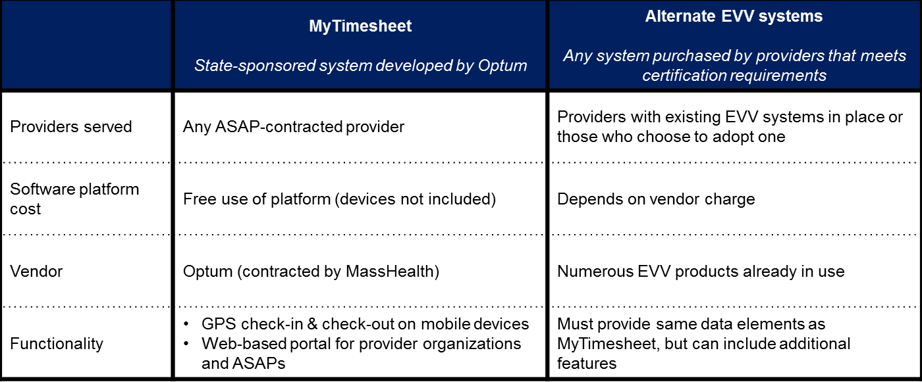
Regular uploads
Automated data flow
State EVV Database

Slide 5:

Alt-EVV: Process & Estimated Timeline
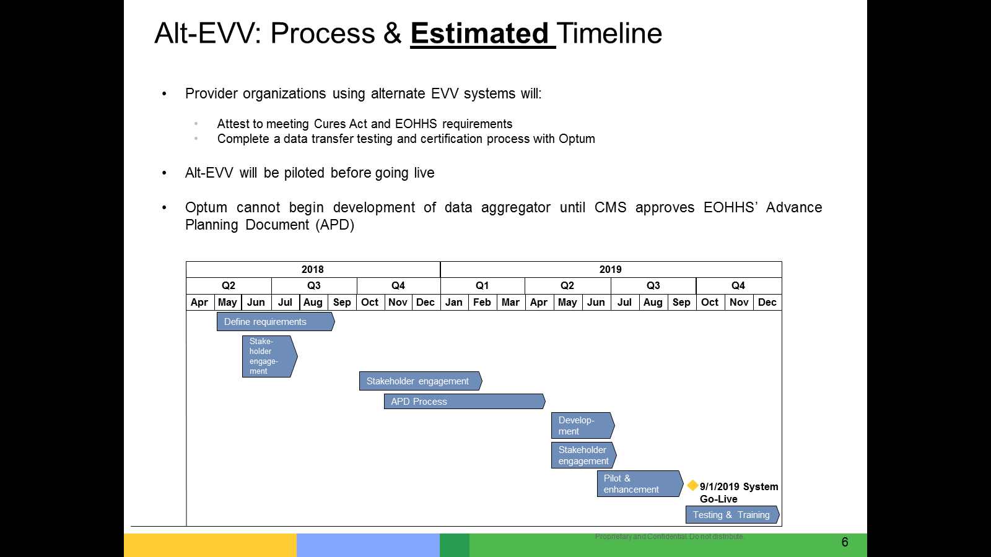

Slide 6:

MyTimesheet: Process & Estimated Timeline
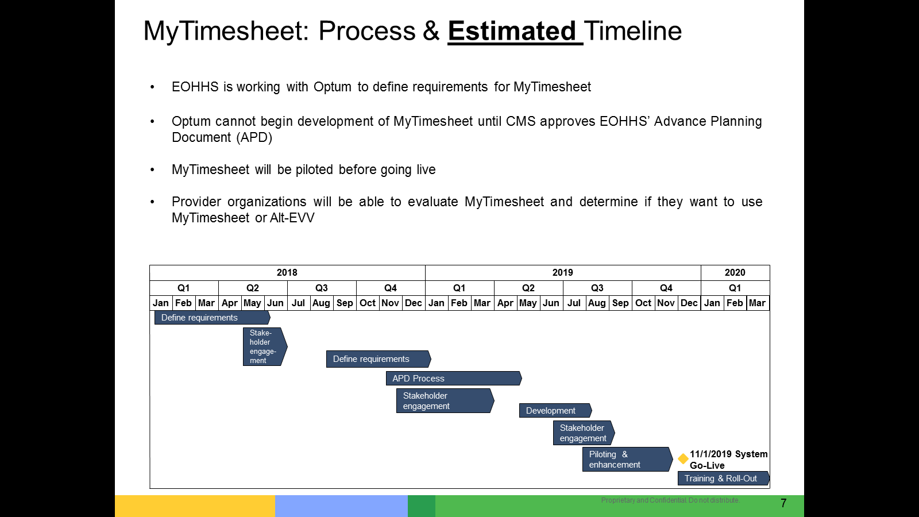

Slide 7:

MyTimesheet mock-ups (worker view)

Worker landing page Worker check-in Worker check-out*
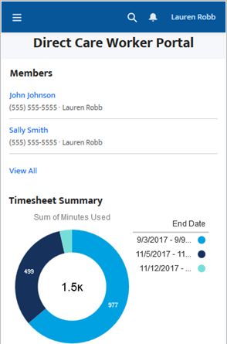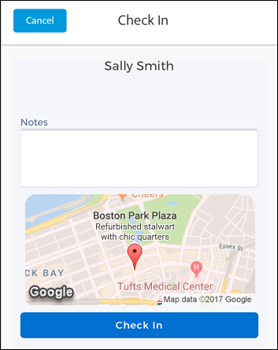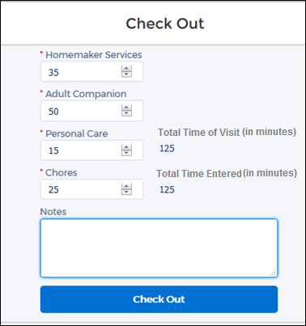
*Services shown are for the Personal Care Attendant program

Slide 8:

MyTimesheet mock-up (provider timesheet view)

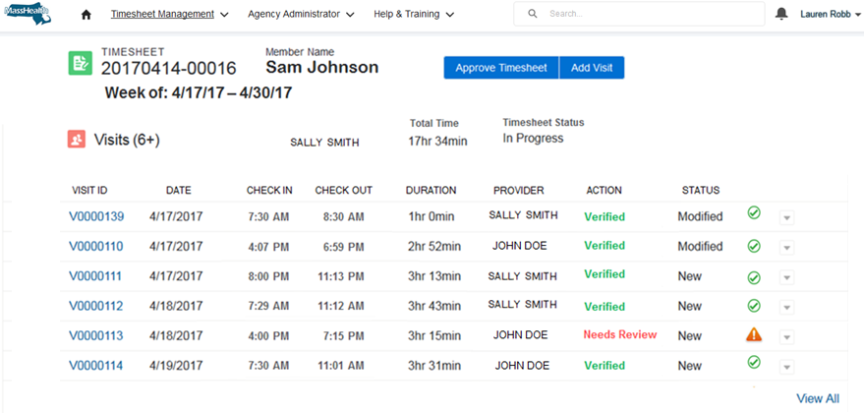

Slide 9:

Stakeholder Engagement
- Federal law requires stakeholder input from:
  - Beneficiaries
  - Family Caregivers
  - Workers
  - Other stakeholders
- Developing Stakeholder Management Plan to ensure a thoughtful and comprehensive plan of engagement
- The Commonwealth expects that stakeholder engagement will both to share information as well as to gather input and feedback.
- Stakeholder engagement to date includes listening sessions, surveying, meetings and presentations.
- Expect a meeting in the near future with Provider Agencies planning on using Alt-EVV systems
- We anticipate seeking stakeholder input at each phase of the Implementation Project to test our assumptions about program operations and integrate insights from individuals who experience these services regularly.

Slide 10:

Thank You!

