Electronic Visit Verification (EVV) Implementation in Massachusetts

Thursday, October 4, 2018

Colleen Swartz

Slide 1:

21st Century Cures Act mandates EVV use
- Federal law requires EVV for the following Medicaid services:
  - Personal care by 1/1/2020
  - Home health by 1/1/2023
- States face a reduction in federal matching funds if they do not implement EVV on time, although states can apply for a 1 year exemption
- EVV must record at least six data points for each visit: date of service, time service begins & ends, location of service, type of service, individual providing service, individual receiving service
- The state has contracted with Optum to develop MyTimesheet EVV software

Slide 2:

Massachusetts’ goals for EVV implementation

Quality: promote quality outcomes for consumers by ensuring appropriate service delivery
Efficiency: reduce administrative burden of paper timesheets
Program Integrity: reduce billing errors and unauthorized spending

Slide 3:

Hybrid EVV model to be deployed for Frail Elder Waiver program
EVV Options for ASAP-contracted providers in the Frail Elder Waiver program
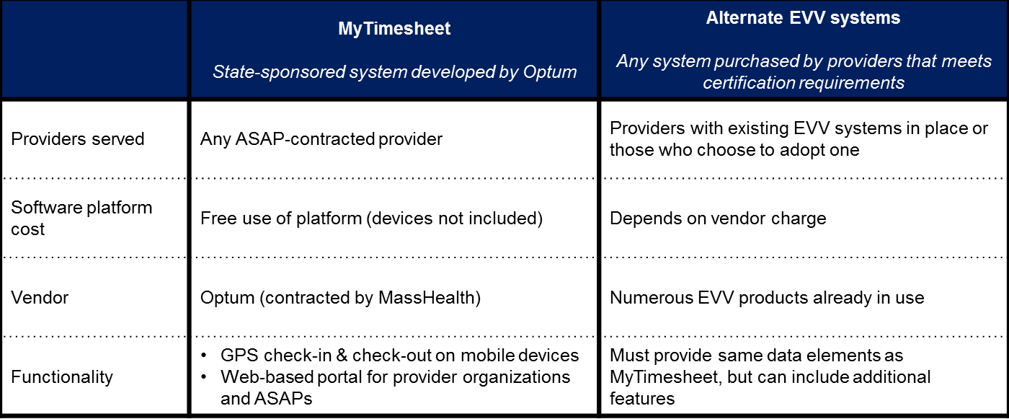
Regular uploads
Automated data flow

State EVV Database

Slide 4:

MyTimesheet mock-ups (worker view)

Worker landing page Worker check-in Worker check-out*
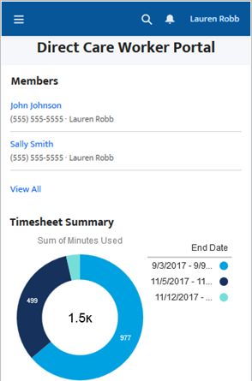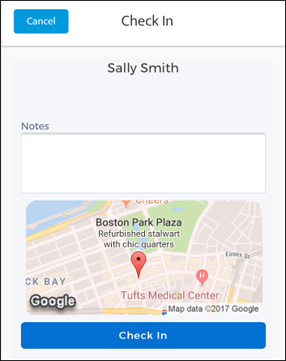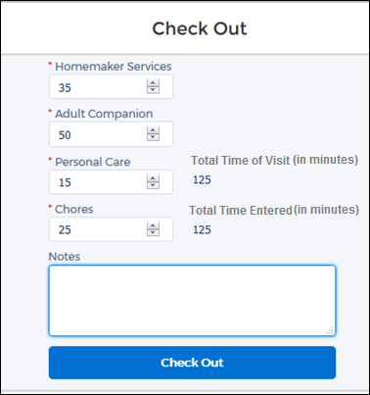
*Services shown are for the Personal Care Attendant program

Slide 5:

MyTimesheet mock-up (provider timesheet view)

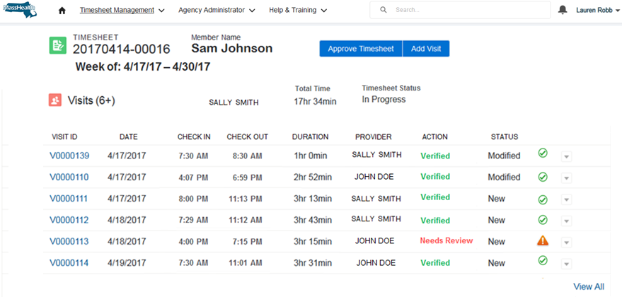

Slide 6:

Estimated Timeline for EVV Implementation
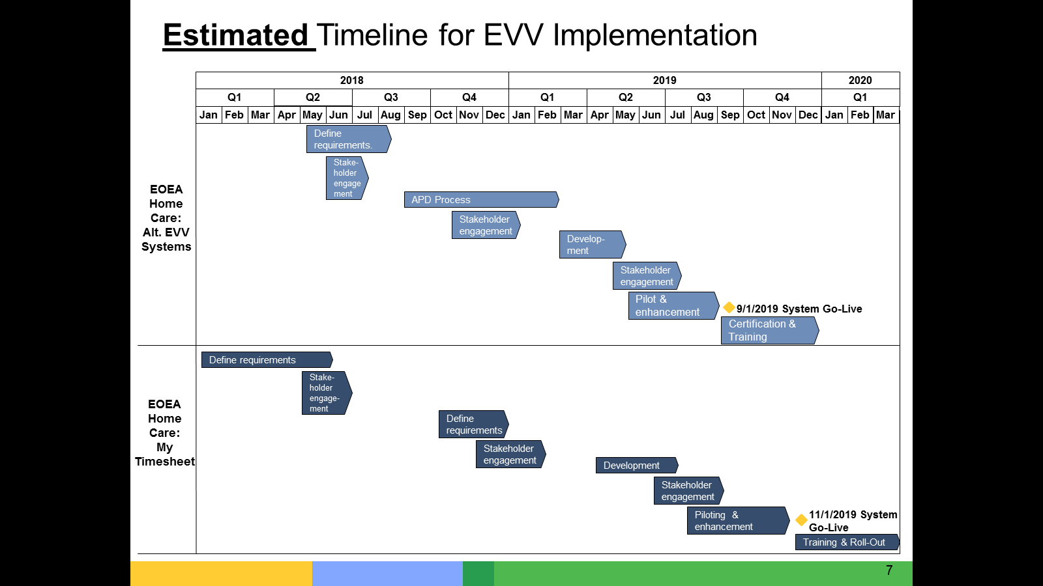

Slide 7:

Stakeholder Engagement
- Federal law requires stakeholder input from:
  - Beneficiaries
  - Family Caregivers
  - Workers
  - Other stakeholders
- Developing Stakeholder Management Plan to ensure a thoughtful and comprehensive plan of engagement
- The Commonwealth expects that stakeholder engagement will both to share information as well as to gather input and feedback.
- Stakeholder engagement to date includes listening sessions, surveying, meetings and presentations.
- Expect a meeting in the near future with Provider Agencies planning on using Alt-EVV systems
- We anticipate seeking stakeholder input at each phase of the Implementation Project to test our assumptions about program operations and integrate insights from individuals who experience these services regularly.

Slide 8:

Thank You!

