Influenza Vaccination of Health Care Personnel in Massachusetts Ambulatory Surgical Centers, Dialysis Centers and Non-Acute Hospitals
2015-2016 Influenza Season
Final Report

2016-2016

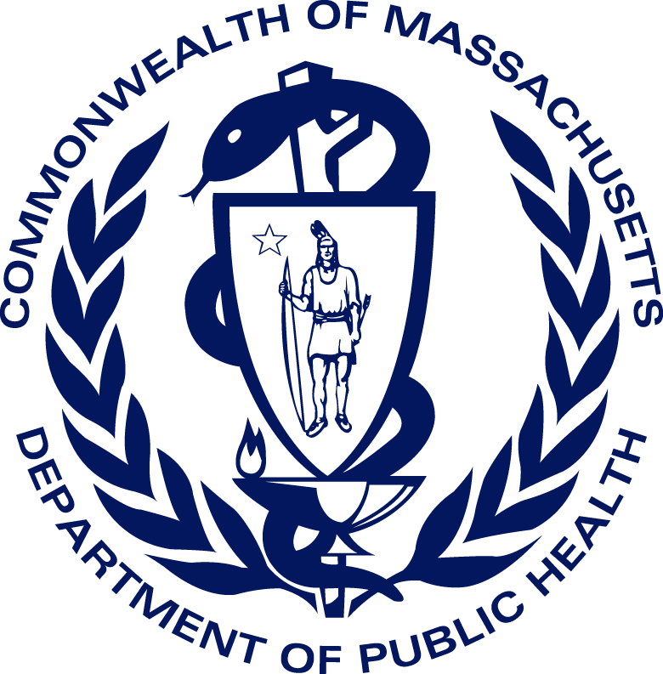
Bureau of Health Care Safety & Quality
Bureau of Infectious Disease and Laboratory Sciences

February 2017

Commonwealth of Massachusetts
Charles D. Baker
Governor

Karyn E. Polito
Lieutenant Governor

Executive Office of Health &
Human Services
MaryLou Sudders
Secretary

Department of Public Health
Monica Bharel, MD, MPH
Commissioner

Table of Contents

BACKGROUND 3

METHODOLOGY 4

RESULTS 4

AMBULATORY SURGICAL CENTER FINDINGS 5

DIALYSIS CENTER FINDINGS 6

NON-ACUTE HOSPITAL FINDINGS 7

ENHANCED PUBLIC HEALTH ACTIONS 8

APPENDIX 9

A. AMBULATORY SURGICAL CENTER RESULTS 9

B. DIALYSIS CENTER RESULTS 11

C. NON-ACUTE HOSPITAL RESULTS 14

Background

The Massachusetts Department of Public Health (DPH) requires licensed health care facilities, including ambulatory surgical centers, dialysis centers and non-acute hospitals to report influenza vaccine coverage among employees. Health care personnel (HCP) are at high risk for influenza exposure and may be a source of influenza virus transmission in health care settings. Annual immunization is the most effective method of preventing influenza and potentially serious complications.

In 2008, DPH mandated that all licensed health care facilities offer personnel free, annual influenza vaccine. Facilities must document and report receipt of vaccine by personnel, whether administered within or outside the facility, and all declination of immunization. This report presents data on influenza vaccine coverage of non-acute health care facility personnel for 2015-16. Health care facilities included in this report are ambulatory surgical centers, dialysis facilities and non-acute hospitals. These facility types are required to report health care personnel influenza data through the National Healthcare Safety Network (NHSN) of the Centers for Disease Control and Prevention (CDC).

Data describing influenza vaccination of health care personnel in acute care hospitals during the 2015-2016 influenza season has been incorporated in the hospital specific healthcare associated infection data summaries available at the following link:

http://www.mass.gov/eohhs/gov/departments/dph/programs/hcq/healthcare-quality/health-care-facilities/flu-vac-hc-personnel/flu-vaccination-reports.html

Data describing influenza vaccination of health care personnel in nursing homes, rest homes, adult day health programs and clinics during the 2015-2016 influenza season is available at the following link:

http://www.mass.gov/eohhs/gov/departments/dph/programs/hcq/healthcare-quality/health-care-facilities/flu-vac-hc-personnel/flu-vaccination-reports.html

While the CDC’s Advisory Committee on Immunization Practices recommends annual influenza vaccination for all health care personnel, Massachusetts is one of only a handful of states that mandates reporting of influenza vaccination rates in order to understand coverage rates. The CDC conducted a national online survey of health care personnel in the spring of 2016 to promote coverage. In a sample of 2,258 respondents, 79.0% of all health care personnel reported receiving the influenza vaccination during the 2015-2016 season. Figure 1 illustrates reported vaccination coverage by care setting.

FIGURE 1. CDC’s SURVEY OF NATIONAL HEALTH CARE PERSONNEL INFLUENZA VACCINATION RATES FOR 2015-16 SEASON

Methodology

NHSN is a secure, web-based system managed by the CDC that enables DPH and health care facilities to track and analyze data on healthcare associated infection and prevention practices to determine their incidence, identify trends and use the data to guide improvement. Participating health care facilities are required to report data according to the NHSN definitions and protocols to ensure data are uniformly reported, consistent over time within a single healthcare facility and comparable across facilities.

Consistent with NHSN protocols, the DPH Healthcare Associated Infection (HAI) Prevention Program required Ambulatory Surgical Centers, Dialysis Centers and Non-Acute Hospitals to offer employees influenza vaccines, and collect data for HCP physically working in the facility for at least one day between October 1 through March 31 of the influenza season, regardless of clinical responsibility or patient contact . Data is reported separately for three categories of healthcare personnel (HCP): employees on payroll, licensed independent practitioners (i.e. physicians, advanced practice nurses, and physician assistants affiliated with the facility but not on payroll), and adult students/trainees and volunteers aged 18 or older. For each HCP group, the total numbers of HCP vaccinated in and outside the facility, HCP who declined vaccine, HCP with a documented medical contraindication to the vaccine, and HCP with unknown vaccine status were compiled and submitted to NHSN.

Results

Figure 2 depicts trends in influenza vaccination rates in ambulatory surgical center, dialysis centers and non-acute hospitals in Massachusetts from the 2011-12 flu seasons through the 2015-16 season. Overall, facilities reported similar or slightly improved mean vaccine coverage rates in 2015-16 when compared to 2014-15. No facility type reached the United State Department of Health and Human Services Healthy People 2020 90% coverage goal; however, dialysis centers were very close and reported 86% coverage. Facilities that achieved this goal or had greater than 90% coverage are listed in the appendix with an asterisk.

Figure 2. mean percent of hcp receiving and declining influenza vaccination: 2011-2016
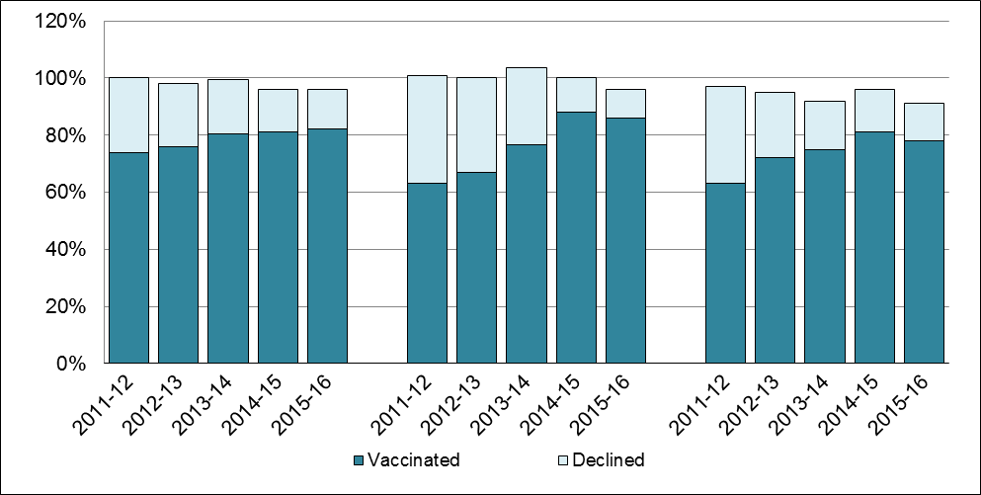
Non Acute Hospital
Dialysis
ASC

Ambulatory Surgical Centers
In 2015-16, on average, 82% of HCP at 53 ambulatory surgical centers were vaccinated against influenza and 14% declined vaccination (Table 1). This was very similar to the 81% influenza vaccine coverage and 15% declination reported in 2014-15(Figure 1). Twenty-two Massachusetts ambulatory surgical centers, representing 42% of reporting facilities, achieved a vaccination rate of 90% or greater in 2015-16. Forty-five percent of employees received their vaccinations at their place of employment and 37% were vaccinated elsewhere.

Table 1. mean percent of hcp at ambulatory surgical centers vaccinated against influenza during 2015-2016 (N=53)

 | Mean % Vaccinated | Range
Total Vaccinated | 82% | (22-100%)
Vaccination Declination Rate | 14% | (0-77%)
HCP With Unknown Status | 2% | (0- 35%)
HCP With Medical Contraindication | 1% | (0-9%)

Location Vaccinated
At Place of Employment | 45% | (0-93%)
Outside Place of Employment | 37% | (0-90%)

In addition to influenza vaccination and declination, medical contraindications and unknown vaccine status were also collected, with specifics for salaried employees, licensed independent practitioners), and students and volunteers. Overall 85% of all HCPs at ASCs received the vaccine and 11% declined (Figure 2). Vaccine coverage among these groups ranged from 80% to 95%, and salaried employees had the highest declination rate at 18%. Medical contraindications were rare, and unknown vaccine status ranged from 1% to 4%, with licensed independent practitioners reported with unknown status most frequently.

FIGURE 3. OVERALL AMBULATORY SURGICAL CENTER VACCINATION OF HCP BY TYPE

Dialysis Centers
Among 57 reporting dialysis centers, the mean influenza vaccine coverage was 86% and declination 10% in 2015-16 (Table 2). In 2015-16, 29 Massachusetts dialysis centers, just over half of reporting facilities, achieved an overall vaccination rate of 90% or greater. On average 59% of employees were vaccinated at their place of employment and 28% were vaccinated elsewhere. Dialysis centers that are located within acute care hospitals are included in the acute care hospital report.

Table 2. Mean Percent of Dialysis Center HCP Vaccinated against Influenza during 2015-2016 (N=57)
 | Mean % Vaccinated | Range
Total Vaccinated | 86% | (20-100%)
Vaccination Declination Rate | 10% | (0-50%)
HCP With Unknown Status | 4% | (0-30%)
HCP With Medical Contraindication | 1% | (0-5%)

Location Vaccinated
At Place of Employment | 59% | (0-90%)
Outside Place of Employment | 28% | (0-100%)

In addition to influenza vaccination and declination, medical contraindications and unknown vaccine status were also collected, with specific data for salaried employees, licensed independent practitioners, and students and volunteers. Eighty-seven percent of all HCPs at dialysis centers received the vaccine and 9% declined (Figure 3). Vaccine coverage among these groups was similar, ranging from 86% to 89%. Students and volunteers had the highest declination rate at 14%. Medical contraindications were rare, and unknown vaccine status ranged from 0% to 10%, with licensed independent practitioners reported with unknown status most frequently.

FIGURE 4. OVERALL DIALYSIS CENTER VACCINATION OF HCP BY TYPE

Non-Acute Care Hospitals
Thirty-six non-acute care hospitals provided information on influenza vaccine coverage. Seventy-eight percent of HCP at non-acute care hospitals, on average, were vaccinated against influenza and 13% declined vaccination in 2015-16 (Table 3). There was a small decrease in mean vaccine coverage in 2015-2016, compared to mean coverage of 81% in 2014-2015. Only 13% of HCP declined vaccination, compared to 15% in 2014-15 (Figure 1). Eleven non-acute care hospitals in Massachusetts reported vaccine coverage greater than 90% during the 2015-16 influenza season. Most personnel received vaccination from the facility that employed them; on average 53% did. Twenty-five percent of HCP at non-acute care hospitals were vaccinated elsewhere.

Table 3. Mean Percent of Non-Acute Care Hospital HCP Vaccinated against Influenza During 2015-2016 (N=36)
 | Mean % Vaccinated | Range
Total Vaccinated | 78% | (49-98%)
Vaccination Declination Rate | 13% | (0-38%)
HCP With Unknown Status | 9% | (0-33%)
HCP With Medical Contraindication | 1% | (0-6%)

Location Vaccinated
At Place of Employment | 53% | (20-77%)
Outside Place of Employment | 25% | (0-50%)

In addition to influenza vaccination and declination, medical contraindications and unknown vaccine status were also collected, with specifics for salaried employees, licensed independent practitioners, and students and volunteers. Seventy-eight percent of all HCPs at non-acute care hospitals received the vaccine and 9% declined (Figure 4). Vaccine coverage among these groups ranged from 72% to 83%. Salaried employees had the highest declination rate at 13%. Medical contraindications were rare, and unknown vaccine status ranged from 8% to 20%, with licensed independent practitioners reported with unknown status most frequently.

Figure 4. Overall Non-acute Care Hospital Vaccination of HCP by Type

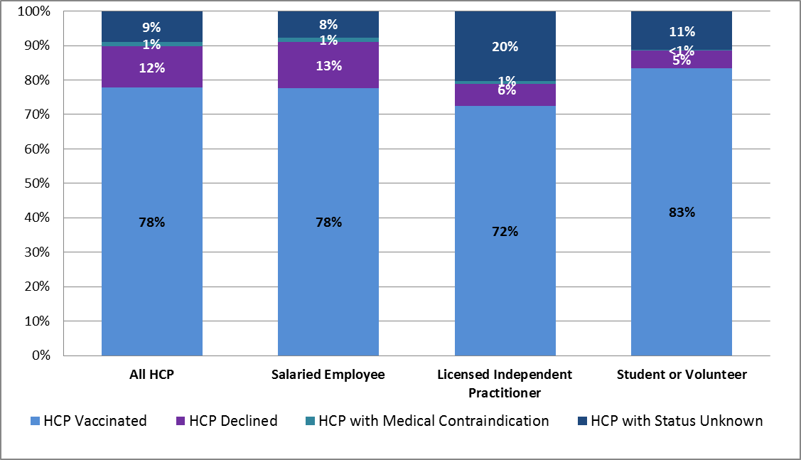

Enhanced Public Health Actions

- DPH will continue to monitor trends and report annual compliance with the HCP influenza vaccination requirements. Compliance will also be assessed by surveys conducted by DPH.

- DPH will promote continuous quality improvement, and recommend licensed facilities share vaccination rates with all staff, including administrators, boards of directors, practice managers, ombudsperson and patient/family councils.

- DPH encourages facilities to review reported data and current HCP influenza policies, and as necessary implement processes to maximize vaccination coverage.

- DPH will continue to promote a continuous, comprehensive influenza prevention program in all licensed health care settings.

- DPH will promote the DPH and Healthy People 2020 target to vaccinate 90% or greater of eligible HCP in all licensed health care settings.

- DPH will collaborate with public health partners to intensify efforts to improve immunization rates among HCP.

Appendix 1. Vaccination Rates by Facility Type and Name

Asterisk* indicates site achieved greater than 90% flu vaccine coverage in 2015-16. “n/a” indicates data not reported by facility to DPH or available through NHSN. DPH distributed guidance to all facilities at the beginning of the influenza season.
Table 4. 2013-2014 TO 2015-2016 HCP Influenza Vaccination and Declination at Massachusetts Ambulatory Surgical Centers
Facility Name | # HCPs | Vaccine Coverage 2015-16 | Vaccine Declined 2015-16 | HCP w/ Medical Contra-indication 2015-16 | HCP w/ Unknown Vaccine Status 2015-16 | Vaccine Coverage 2014-15 | Vaccine Declined 2014-15 | HCP w/ Medical Contra-indication 2014-15 | HCP w/ Unknown Vaccine Status 2014-15 | Vaccine Coverage 2013-14 | Vaccine Declined 2013-14
Adams Cataract and Laser Center Associates P.C. | 22 | 74% | 20% | 6% | 0% | 67% | 27% | 6% | 0% | 65% | 35%
Advanced Eye Surgery Center, LLC | 19 | 78% | 22% | 0% | 0% | 65% | 35% | 0% | 0% | 61% | 39%
ASC of Cape Cod* | 34 | 92% | 8% | 0% | 0% | 94% | 6% | 0% | 0% | 71% | 29%
Berkshire Cosmetic Surgery* | 16 | 94% | 6% | 0% | 0% | 100% | 0% | 0% | 0% | 100% | 0%
Berkshire Endoscopy Center, LLC | 16 | 53% | 47% | 0% | 0% | 22% | 78% | 0% | 0% | n/a | n/a
Boston Center for Ambulatory Surgery, Inc. | 7 | 71% | 29% | 0% | 0% | 89% | 11% | 0% | 0% | 81% | 19%
Boston Endoscopy Center | 38 | 86% | 13% | 1% | 0% | 82% | 18% | 0% | 0% | 65% | 30%
Boston Eye Surgery & Laser Center Boston | 29 | 89% | 5% | 5% | 0% | 72% | 11% | 4% | 13% | 83% | 17%
Boston Eye Surgery & Laser Center West | 25 | 82% | 14% | 4% | 0% | 74% | 14% | 5% | 7% | 65% | 35%
Boston IVF* | 37 | 91% | 9% | 0% | 0% | 85% | 8% | 3% | 4% | 69% | 22%
Boston Outpatient Surgical Suites* | 39 | 90% | 10% | 0% | 0% | 40% | 60% | 0% | 0% | 80% | 20%
Boston Surgery Center, LLC* | 15 | 100% | 0% | 0% | 0% | 94% | 6% | 0% | 0% | 96% | 4%
Boston University Eye Surgery and Laser Center | 14 | 89% | 7% | 4% | 0% | 90% | 7% | 3% | 0% | 96% | 4%
Cape & Islands Endoscopy Center LLC | 33 | 78% | 14% | 8% | 0% | 78% | 18% | 4% | 0% | 74% | 18%
Cape Cod Eye Surgery & Laser Center* | 23 | 92% | 8% | 0% | 0% | 85% | 8% | 2% | 4% | 72% | 28%
Cape Cod Surgery Center Inc.* | 8 | 90% | 10% | 0% | 0% | 92% | 0% | 8% | 0% | 85% | 15%
Cataract & Laser Center Central LLC, The | 28 | 87% | 13% | 0% | 0% | 87% | 13% | 0% | 0% | 82% | 15%
Cataract & Laser Center, West | 29 | 88% | 9% | 0% | 4% | 83% | 17% | 0% | 0% | 82% | 18%
Cataract and Laser Center | 28 | 74% | 22% | 4% | 0% | 93% | 7% | 0% | 0% | 85% | 15%
Cataract and Laser Center, The | 22 | 88% | 12% | 0% | 0% | 77% | 7% | 10% | 7% | 88% | 12%
Cataract Surgery Center of Milford | 10 | 75% | 19% | 6% | 0% | 95% | 5% | 0% | 0% | 100% | 0%
Central MA Ambulatory Endoscopy Center | 19 | 84% | 13% | 3% | 0% | 72% | 23% | 5% | 0% | 82% | 18%
Charles River Endoscopy, LLC.* | 15 | 93% | 7% | 0% | 0% | 89% | 11% | 0% | 0% | n/a | n/a
Commonwealth Endoscopy Center* | 16 | 91% | 9% | 0% | 0% | 95% | 5% | 0% | 0% | n/a | n/a
DHA Endoscopy LLC* | 24 | 94% | 0% | 6% | 0% | 94% | 6% | 0% | 0% | 100% | 0%
East Bay Surgery Center* | 41 | 93% | 6% | 1% | 0% | 90% | 9% | 1% | 0% | 80% | 20%
East Pond Enterprises Inc. | 17 | 48% | 52% | 0% | 0% | 64% | 36% | 0% | 0% | 42% | 58%
Eastern Massachusetts Surgery Center | 23 | 44% | 19% | 2% | 35% | 69% | 8% | 4% | 20% | 76% | 4%
Endoscopy Center of Southeastern Massachusetts | n/a | n/a | n/a | n/a | n/a | n/a | n/a | n/a | n/a | n/a | n/a
Four Women | n/a | n/a | n/a | n/a | n/a | 88% | 12% | 0% | 0% | 94% | 6%
Greater New Bedford Surgicenter | 26 | 61% | 39% | 0% | 0% | 36% | 64% | 0% | 0% | 67% | 33%
Greater Springfield Surgery Center | 20 | 70% | 16% | 0% | 14% | 57% | 17% | 3% | 22% | 64% | 36%
Hyannis Ear Nose and Throat Associates | 14 | 75% | 19% | 6% | 0% | 75% | 19% | 6% | 0% | n/a | n/a
Hyde Park Pain Management, LLC | 18 | 72% | 22% | 6% | 0% | 83% | 17% | 0% | 0% | 67% | 33%
Merrimack Valley Endoscopy Center* | 30 | 93% | 7% | 0% | 0% | 89% | 11% | 0% | 0% | 88% | 12%
Middlesex Endoscopy Center | 9 | 84% | 16% | 0% | 0% | 88% | 8% | 4% | 0% | 91% | 9%
New England Ambulatory SurgiCenter* | 11 | 100% | 0% | 0% | 0% | 57% | 29% | 7% | 7% | 93% | 7%
New England Eye Surgical Center, Inc.* | 23 | 90% | 10% | 0% | 0% | 97% | 3% | 0% | 0% | 78% | 22%
New England Pain Care, Inc. | 32 | 69% | 26% | 0% | 6% | 65% | 35% | 0% | 0% | 100% | 0%
New England SCOPE* | 32 | 100% | 0% | 0% | 0% | 100% | 0% | 0% | 0% | 97% | 3%
New England Surgery Center | 33 | 88% | 12% | 0% | 0% | 70% | 26% | 0% | 4% | 79% | 21%
North Shore Cataract & Laser Center | 26 | 87% | 6% | 6% | 0% | 92% | 4% | 4% | 0% | 97% | 3%
Northeast Ambulatory Center | 8 | 36% | 45% | 9% | 9% | 64% | 29% | 7% | 0% | 0% | 100%
Northeast Endoscopy LLC* | 35 | 96% | 4% | 0% | 0% | 90% | 10% | 0% | 0% | 83% | 17%
Orthopedic Surgical Center of the North Shore* | 56 | 90% | 7% | 0% | 3% | 91% | 7% | 0% | 2% | 70% | 30%
Peabody Surgery Center LLC | n/a n/a n/a | n/a | n/a | n/a | n/a | 100% | 0% | 0% | 0% | n/a | n/a
Pioneer Valley Surgicenter* | 34 | 94% | 6% | 0% | 0% | 95% | 5% | 0% | 0% | 89% | 11%
Plymouth Laser and Surgical Center* | 21 | 97% | 0% | 3% | 0% | 98% | 0% | 2% | 0% | 96% | 4%
Same Day SurgiCare of N.E. | 48 | 78% | 21% | 0% | 1% | 79% | 15% | 0% | 6% | 75% | 38%
SEE New England* | 17 | 100% | 0% | 0% | 0% | 100% | 0% | 0% | 0% | 100% | 0%
South Shore Endoscopy Center | 18 | 85% | 12% | 0% | 3% | 88% | 13% | 0% | 0% | 71% | 29%
Surgery Center of New England | 16 | 87% | 9% | 4% | 0% | 77% | 19% | 3% | 0% | 86% | 14%
Valley Medical Group* | 17 | 95% | 5% | 0% | 0% | 86% | 14% | 0% | 0% | 74% | 26%
West Suburban Eye Surgery Center* | 32 | 94% | 6% | 0% | 0% | 89% | 6% | 4% | 1% | 81% | 19%
Weymouth Endoscopy, LLC | 13 | 87% | 13% | 0% | 0% | 86% | 14% | 0% | 0% | 89% | 11%
Women’s Health Services | n/a | n/a | n/a | n/a | n/a | n/a | n/a | n/a | n/a | n/a | n/a
Worcester Surgical Center | 52 | 73% | 10% | 2% | 16% | 82% | 18% | 0% | 0% | 73% | 27%

* Vaccination rate greater than 90% in 2015-16

Table 5. 2012-2013 TO 2015-2016 HCP Influenza Vaccination and Declination at Massachusetts Dialysis Centers
Facility Name | # HCPs | Vaccine Coverage 2015-16 | Vaccine Declined 2015-16 | HCP w/ Medical Contra-indication 2015-16 | HCP w/ Unknown Vaccine Status 2015-16 | Vaccine Coverage 2014-15 | Vaccine Declined 2014-15 | Vaccine Coverage 2013-14 | Vaccine Declined 2013-14 | Vaccine Coverage 2012-13 | Vaccine Declined 2012-13
ARA - Springfield Dialysis LLC | 31 | 81% | 19% | 0% | 0% | 70% | 30% | 57% | 43% | 53% | 47%
ARA-Ludlow Dialysis, LLC | 32 | 74% | 21% | 3% | 3% | 63% | 38% | 77% | 23% | n/a | n/a
Blackstone Valley Dialysis* | 36 | 93% | 0% | 2% | 5% | 100% | 0% | 90% | 10% | n/a | n/a
BMC South County | 26 | 87% | 13% | 0% | 0% | n/a | n/a | n/a | n/a | n/a | n/a
Boston Dialysis Center (Carney)* | 26 | 100% | 0% | 0% | 0% | 100% | 0% | 74% | 26% | 55% | 45%
Boston Dialysis* | 55 | 100% | 0% | 0% | 0% | 100% | 0% | 91% | 9% | n/a | n/a
Brockton Dialysis Center LLC* | 35 | 92% | 6% | 0% | 3% | 89% | 11% | 74% | 26% | 94% | 6%
Brockton Healthcare Clinic LLC | 34 | 65% | 9% | 0% | 26% | 54% | 46% | 37% | 63% | 24% | 76%
Brookline Dialysis | n/a | n/a | n/a | n/a | n/a | 85% | 15% | 85% | 12% | 92% | 8%
Burlington Dialysis | n/a | n/a | n/a | n/a | n/a | 100% | 0% | 100% | 0% | 17% | 78%
Cape Cod Artificial Kidney Center* | 38 | 93% | 5% | 0% | 3% | 96% | 4% | 55% | 45% | n/a | n/a
Chicopee Dialysis Center* | 20 | 90% | 5% | 5% | 0% | 88% | 12% | 67% | 33% | 57% | 43%
DCI Boston* | 41 | 100% | 0% | 0% | 0% | 98% | 2% | 93% | 7% | 93% | 7%
DCI Brigham/Faulkner | 47 | 75% | 18% | 2% | 5% | 79% | 21% | 54% | 46% | n/a | n/a
DCI Somerville* | 29 | 96% | 2% | 2% | 0% | 97% | 3% | 127% | 7% | 85% | 18%
DCI Walden Pond* | 15 | 100% | 0% | 0% | 0% | 100% | 0% | 92% | 8% | 92% | 8%
Dialysis Center of Attleboro LLC | 19 | 68% | 26% | 5% | 0% | n/a | n/a | n/a | n/a | n/a | n/a
Dialysis Center of Waltham | n/a | n/a | n/a | n/a | n/a | n/a | n/a | n/a | n/a | n/a | n/a
Dialysis Center of Western Massachusetts, LLC | 36 | 61% | 37% | 0% | 3% | n/a | n/a | 39% | 61% | 38% | 62%
East Springfield Dialysis Center* | 24 | 98% | 2% | 0% | 0% | 94% | 6% | 93% | 7% | 82% | 18%
Fall River Kidney Center | 42 | 80% | 18% | 2% | 0% | 66% | 34% | 63% | 38% | 78% | 22%
Framingham Dialysis Center* | 51 | 96% | 4% | 0% | 0% | n/a | n/a | 80% | 20% | n/a | n/a
Freedom Center Worcester | n/a | n/a | n/a | n/a | n/a | n/a | n/a | n/a | n/a | n/a | n/a
Fresenius Medical Care Attleboro* | 21 | 100% | 0% | 0% | 0% | 100% | 0% | n/a | n/a | n/a | n/a
Fresenius Medical Care Chelmsford | 4 | 100% | 0% | 0% | 0% | n/a | n/a | n/a | n/a | n/a | n/a
Fresenius Medical Care Falmouth* | 29 | 91% | 9% | 0% | 0% | 89% | 11% | 50% | 33% | n/a | n/a
Fresenius Medical Care Lowell | 54 | 84% | 12% | 3% | 0% | 86% | 14% | n/a | n/a | n/a | n/a
Fresenius Medical Care Marlborough | 16 | 57% | 13% | 0% | 30% | n/a | n/a | 93% | 7% | n/a | n/a
Fresenius Medical Care Methuen* | 36 | 94% | 2% | 4% | 0% | 86% | 14% | 57% | 43% | n/a | n/a
Fresenius Medical Care Newburyport* | 36 | 98% | 2% | 0% | 0% | 90% | 10% | n/a | n/a | n/a | n/a
Fresenius Medical Care Merrimack Valley | 31 | 86% | 7% | 2% | 5% | n/a | n/a | n/a | n/a | n/a | n/a
Fresenius Medical Care Plymouth-Cordage | 36 | 89% | 8% | 0% | 3% | 95% | 5% | 64% | 32% | n/a | n/a
Fresenius Medical Care Stoneham* | 33 | 93% | 5% | 0% | 3% | n/a | n/a | 63% | 38% | n/a | n/a
Fresenius Medical Care Wareham | 21 | 87% | 13% | 0% | 0% | 50% | 50% | 45% | 55% | n/a | n/a
Hampshire County Dialysis Center* | 23 | 100% | 0% | 0% | 0% | 100% | 0% | 100% | 0% | n/a | n/a
Hawthorn Kidney Center LLC Dartmouth Wareham | 36 | 64% | 33% | 3% | 0% | n/a | n/a | 63% | 38% | 55% | 45%
Hawthorn Kidney Center- Wareham, LLC | 12 | 67% | 33% | 0% | 0% | 50% | 50% | 38% | 63% | n/a | n/a
Heritage Dialysis, LLC | 30 | 73% | 27% | 0% | 0% | 70% | 40% | 63% | 111% | 55% | 45%
Mary Eliza Mahoney Dialysis | 30 | 79% | 11% | 0% | 11% | 85% | 0% | 63% | 38% | n/a | n/a
Medford Dialysis Center | 50 | 62% | 10% | 0% | 29% | 96% | 4% | 67% | 70% | 63% | 38%
New Bedford Dialysis | n/a | n/a | n/a | n/a | n/a | n/a | n/a | n/a | n/a | n/a | n/a
North Andover Renal Center* | 31 | 92% | 8% | 0% | 0% | 87% | 13% | 91% | 9% | 81% | 19%
Northshore Regional Dialysis Center* | 38 | 98% | 2% | 0% | 0% | 100% | 0% | 88% | 13% | n/a | n/a
North Suburban Dialysis Center* | 25 | 94% | 0% | 0% | 6% | 100% | 0% | 79% | 21% | 48% | 52%
Northeast Cambridge Dialysis | n/a | n/a | n/a | n/a | n/a | 89% | 11% | 85% | 15% | 63% | 38%
Nxstage Kidney Care Boston North | 7 | 80% | 13% | 0% | 7% | n/a | n/a | n/a | n/a | n/a | n/a
Nxstage Kidney Care Boston South | 7 | 20% | 50% | 0% | 30% | n/a | n/a | n/a | n/a | n/a | n/a
Palmer Dialysis Center* | 13 | 100% | 0% | 0% | 0% | 90% | 10% | 71% | 29% | 64% | 36%
PDI Worcester | n/a | n/a | n/a | n/a | n/a | 100% | 0% | 96% | 4% | n/a | n/a
Peabody Dialysis Center | 34 | 89% | 11% | 0% | 0% | 94% | 6% | 48% | 52% | 63% | 38%
Physician’s Dialysis Fitchburg | n/a | n/a | n/a | n/a | n/a | 100% | 0% | 96% | 4% | n/a | n/a
Pioneer Valley Dialysis* Center* | 44 | 100% | 0% | 0% | 0% | 97% | 3% | 100% | 0% | 73% | 27%
Pure Life Renal of Stoughton | n/a | n/a | n/a | n/a | n/a | n/a | n/a | n/a | n/a | n/a | n/a
Quality Care Dialysis Weymouth | 38 | 81% | 19% | 0% | 0% | 85% | 15% | 69% | 31% | 63% | 38%
Salem Northeast Dialysis | n/a | n/a | n/a | n/a | n/a | n/a | n/a | n/a | n/a | n/a | n/a
South County Dialysis* | 25 | 98% | 2% | 0% | 0% | 96% | 4% | 57% | 30% | 55% | 45%
South Suburban Dialysis Center* | 36 | 95% | 5% | 0% | 0% | 95% | 5% | 71% | 29% | n/a | n/a
Taunton Healthcare Clinic, LLC | 38 | 87% | 13% | 0% | 0% | 67% | 33% | 86% | 32% | n/a | n/a
The Dialysis Center at Waltham | 23 | 91% | 8.6% | 4.3% | n/a | n/a | n/a | n/a | n/a | n/a | n/a
The Kidney Center* | 27 | 94% | 6% | 0% | 0% | 92% | 8% | 50% | 50% | n/a | n/a
University Dialysis Center | 51 | 77% | 3% | 0% | 20% | 100% | 0% | 60% | 40% | 83% | 17%
USRC Quincy Dialysis Center | 28 | 78% | 19% | 3% | 0% | 93% | 7% | 88% | 12% | 93% | 7%
U S Renal Care Weymouth Dialysis | n/a | n/a | n/a | n/a | n/a | n/a | n/a | n/a | n/a | n/a | n/a
U S Renal Care Foxborough Dialysis | n/a | n/a | n/a | n/a | n/a | n/a | n/a | n/a | n/a | n/a | n/a
Waltham Dialysis, LLC | 22 | 87% | 9% | 4% | 0% | n/a | n/a | 80% | 20% | 70% | 30%
Wellesley Dialysis LLC | 25 | 84% | 16% | 0% | 0% | 84% | 16% | 79% | 21% | 83% | 17%
Western Mass Kidney Center - Springfield* | 36 | 97% | 3% | 0% | 0% | 100% | 0% | 90% | 5% | 71% | 29%
Westwood Dialysis* | 28 | 100% | 0% | 0% | 0% | 95% | 5% | 68% | 32% | n/a | n/a
Weymouth Dialysis | n/a | n/a | n/a | n/a | n/a | n/a | n/a | n/a | n/a | n/a | n/a
Woburn Dialysis* | 20 | 100% | 0% | 0% | 0% | 100% | 0% | 94% | 6% | n/a | n/a
Yankee Family Dialysis Center* | 21 | 100% | 0% | 0% | 0% | 71% | 29% | 153% | 47% | 44% | 56%
* Vaccination rate greater than 90% in 2015-16

Table 6. 2012-2013 TO 2015-2016 HCP Influenza Vaccination and Declination at Massachusetts Non-Acute Care Hospitals
Facility Name | # HCPs | Vaccine Coverage 2015-16 | Vaccine Declined 2015-16 | HCP w/ Medical Contra-indication 2015-16 | HCP w/ Unknown Vaccine Status 2015-16 | Vaccine Coverage 2014-15 | Vaccine Declined 2014-15 | Vaccine Coverage 2013-14 | Vaccine Declined 2013-14 | Vaccine Coverage 2012-13 | Vaccine Declined 2012-13
Adcare Hospital of Worcester, Inc. | 509 | 88% | 2% | 3% | 7% | 112% | 3% | 97% | 3% | 94% | 4%
Amesbury Health Center ** | n/a | n/a | n/a | n/a | n/a | n/a | n/a | n/a | n/a | n/a | n/a
Arbour - HRI Hospital | 184 | 49% | 38% | 5% | 8% | n/a | n/a | 56% | 40% | 56% | 40%
Arbour Fuller Hospital | 379 | 57% | 19% | 1% | 23% | 51% | 23% | 47% | 6% | 54% | 46%
Arbour Hospital | 487 | 52% | 35% | 2% | 11% | n/a | n/a | n/a | n/a | n/a | n/a
Baldpate Hospital* | 102 | 94% | 5% | 1% | 1% | 41% | 17% | 37% | 63% | n/a | n/a
Bay Ridge Hospital | 192 | 79% | 19% | 2% | 0% | n/a | n/a | n/a | n/a | n/a | n/a
Bournewood Hospital | 290 | 61% | 38% | 1% | 0% | 65% | 32% | 65% | 30% | 59% | 38%
Cape Cod & Islands Community Mental Health | 133 | 73% | 13% | 5% | 9% | 78% | 22% | 71% | 23% | n/a | n/a
Dr. John C. Corrigan Mental Health Center | 182 | 65% | 24% | 0% | 10% | 54% | 46% | 68% | 32% | n/a | n/a
Fairlawn Rehabilitation Hospital | 430 | 85% | 8% | 3% | 4% | 82% | 18% | n/a | n/a | n/a | n/a
Franciscan Children’s Hospital | n/a | n/a | n/a | n/a | n/a | 96% | 4% | 96% | 4% | n/a | n/a
HealthSouth Rehabilitation Hospital of Braintree | 434 | 87% | 3% | 1% | 9% | 104% | 4% | 74% | 20% | 76% | 22%
HealthSouth Rehabilitation Hospital of New England* ° | 398 | 91% | 4% | 0% | 4% | 85% | 15% | 88% | 12% | 90% | 17%
HealthSouth Rehabilitation Hospital of Western Massachusetts | 240 | 82% | 16% | 0% | 1% | 83% | 17% | 58% | 12% | n/a | n/a
Hebrew Rehabilitation Center at Dedham | n/a | n/a | n/a | n/a | n/a | 89% | 0% | 75% | 1% | 59% | 7%
Hebrew Rehabilitation Center at Roslindale* | 1188 | 91% | 0% | 0% | 8% | 95% | 1% | 93% | 3% | 55% | 16%
Highpoint Treatment Center | n/a | n/a | n/a | n/a | n/a | n/a | n/a | n/a | n/a | n/a | n/a
Kindred Stoughton | 259 | 69% | 6% | 0% | 25% | 85% | 10% | 61% | 6% | n/a | n/a
Kindred Stoughton | 259 | 69% | 6% | 0% | 25% | 85% | 10% | 61% | 6% | n/a | n/a
Lemuel Shattuck Hospital | 761 | 64% | 12% | 1% | 22% | 74% | 14% | 63% | 14% | 60% | 14%
McLean Hospital ± | 2103 | 68% | 15% | 1% | 15% | 78% | 16% | 63% | 9% | 70% | 15%
New England Sinai* Hospital* | 591 | 94% | 4% | 1% | 2% | 106% | 5% | 93% | 7% | 94% | 6%
Norcap Lodge | n/a | n/a | n/a | n/a | n/a | n/a | n/a | n/a | n/a | n/a | n/a
Pappas Rehabilitation Hospital for Children | 398 | 85% | 13% | n/a | n/a | 85% | 14% | 91% | 9% | 90% | 10%
Providence Behavioral Health* | 388 | 98% | 2% | 0% | 0% | n/a | n/a | n/a | n/a | n/a | n/a
Solomon Carter Fuller Mental Health Center | 187 | 76% | 7% | 3% | 14% | 71% | 9% | 61% | 23% | 73% | 27%
Southcoast Behavioral Health* | 229 | 90% | 3% | 0% | 7% | n/a | n/a | n/a | n/a | n/a | n/a
Spaulding Hospital for Continuing Care Cambridge* | 820 | 93% | 3% | 1% | 3% | 89% | 11% | 88% | 5% | 85% | 9%
Spaulding Rehabilitation Hospital Boston* | 1540 | 90% | 6% | 1% | 4% | 90% | 10% | 89% | 7% | 84% | 14%
Spaulding Rehabilitation Hospital Cape Cod* | 477 | 93% | 4% | 0% | 2% | n/a | n/a | 84% | 12% | n/a | n/a
Taunton State Hospital | 205 | 76% | 18% | 6% | 0% | 69% | 28% | 66% | 9% | 104% | 22%
Tewksbury Hospital | 1078 | 49% | 36% | 1% | 13% | 74% | 16% | 76% | 13% | 67% | 16%
Vibra Hospital of Southeastern Massachusetts | 294 | 89% | 11% | 1% | 0% | 93% | 10% | 89% | 16% | 61% | 39%
Vibra Hospital of Western Massachusetts | 397 | 63% | 4% | 0% | 33% | 88% | 9% | n/a | n/a | n/a | n/a
Vibra Hospital of Western Massachusetts - Central Campus | 112 | 79% | 7% | 1% | 13% | 89% | 6% | 73% | 27% | n/a | n/a
Walden Behavioral Care | 215 | 66% | 34% | 0% | 0% | 57% | 43% | 61% | 19% | n/a | n/a
Western Massachusetts Hospital | 310 | 65% | 18% | 5% | 12% | 76% | 24% | 74% | 26% | 70% | 30%
Westwood Lodge Hospital | 707 | 70% | 24% | 3% | 3% | 75% | 25% | 63% | 37% | n/a | n/a
Whittier Pavilion* | 263 | 95% | 1% | 0% | 3% | 91% | 9% | n/a | n/a | n/a | n/a
Whittier Rehabilitation Hospital | 379 | 87% | 6% | 0% | 7% | 87% | 10% | 95% | 12% | 87% | 13%
Whittier Rehabilitation Hospital Bradford* | 357 | 98% | 1% | 1% | 0% | 98% | 2% | 97% | 3% | 90% | 4%
Worcester Recovery Center and Hospital | 761 | 66% | 17% | 4% | 12% | 81% | 19% | 78% | 22% | 89% | 11%
* Vaccination rate greater than 90% in 2015-16
°° Data included in Anna Jaques acute care hospital report
° 2015-2016 submission includes data for Healthsouth New England at Beverly and Healthsouth New England at Lowell
± Includes data for McLean Southeast

See 105 CMR 140.150 for the influenza vaccination reporting requirements for clinics and dialysis centers; and 105 CMR 130.325 for the reporting requirements for non-acute hospitals. Note that the requirements under 105 CMR 140.150 apply to dialysis centers licensed under 105 CMR 145.000 pursuant to 105 CMR 145.900.
Black CL, Yue X, Ball SW, et al. Influenza Vaccination Coverage Among Health Care Personnel — United States, 2015–16 Influenza Season. MMWR Morb Mortal Wkly Rep 2016;65:1026–1031. DOI: http://dx.doi.org/10.15585/mmwr.mm6538a2

