Joint Advisory

TO: Approved Private Special Education School Residential Programs jointly approved and licensed by the Department of Elementary and Secondary Education and the Department of Early Education and Care

FROM: David E. Johnson, Director, Drug Control Program
Karen Robitaille, Director, School Health Unit

DATE: March 9, 2020

SUBJECT: Medication Administration in Private Approved Special Education School
Residential Programs

Purpose
This advisory details existing law and does not constitute a change in policy. The purpose of this advisory is to provide clarification and guidance applicable to the administration of medications to children residing at Approved Private Special Education School Residential Programs (ASERPs) jointly approved and licensed by the Department of Elementary and Secondary Education (DESE) and the Department of Early Education and Care (DEEC). This guidance does not apply to other types of residential or boarding schools.

Some confusion has been expressed over the administration of medication outside of Regular School Activities to students and non-students who reside at ASERPs. The following definition is for purposes of this guidance, as applicable only to ASERPs. This definition is not applicable to public or private day schools or other types of residential or boarding schools.

Regular School Activities means all instructional/academic activities, as well as all activities organized or sanctioned by the school, including but not limited to, interscholastic sporting events, after school or extracurricular clubs or organizations, and proms or other social events organized as part of the instructional/academic portion of the school, including overnight field trips. Regular School Activities do not include activities associated with residential services and supports provided to youth.

Medication Administration Models
M.G.L. c. 94C sets forth who can lawfully possess and administer medications in Massachusetts. Three distinct models of medication administration in ASERP residential settings are authorized by law and regulation. With appropriate separation of medication administration activities, residential students and non-students may be served by one model or a combination of models, as outlined below.

Licensed Health Care Professional
It is always permissible for a licensed health care professional, including a registered prescriber or nurse, to administer medication within their scope of practice, as outlined in relevant board regulations. Licensed health care professionals may be employed for medication administration to students and non-student residents of an ASERP at any time and in any setting. As authorized by prescriber orders and prescriptions, a licensed health care professional may provide all medication administration at an ASERP or may provide supplemental medication administration for student and non-student residents of an ASERP who cannot be served by one of the other models for any reason. Activities under this model, including drug storage and record keeping, must be separate and distinct from activities conducted under other models and registered sites, even within the same residential site.

School Health
The School Health medication administration model allows a licensed registered nurse to delegate medication administration to unlicensed personnel in an ASERP for students of the ASERP only. Delegation of medication administration to unlicensed personnel in an ASERP is authorized at all times with approval of the Department of Public Health’s (DPH) School Health Unit (SHU) and possession of a School Health Massachusetts Controlled Substance Registration (MCSR), issued by the Drug Control Program (DCP). Once approved and registered, an ASERP may use this model at all times to allow a licensed registered nurse to delegate medication administration for its students to unlicensed school personnel, subject to training requirements outlined in the School Health regulation, provided that the licensed registered nurse is on duty in the school system during times of administration by designated school personnel, and available by telephone should consultation be required.

Medication Administration Program (MAP)
MAP is a medication administration model that is available at an ASERP only for MAP eligible youth residents when they are not engaged in Regular School Activities. To be MAP eligible, youth must be stable recipients of residential services funded by either the Department of Mental Health or the Department of Children and Families (Group Home). This direct authorization model allows unlicensed MAP Certified Staff with requisite training to administer medication according to medication orders of registered prescribers, pursuant to policies outlined in regulation and the MAP Policy Manual, including a requirement for a Nurse Monitor in youth programs. MAP is offered through and regulated by DCP, and requires approved programs to possess a MAP MCSR, issued by DCP.
Massachusetts Controlled Substance Registration (MCSR)
The medication administration models that use unlicensed personnel require the ASERP or Group Home to register with DCP for a facility MCSR. A facility MCSR is issued specifically to a physical location where medications are authorized to be stored and administered. With SHU approval, a School Health MCSR covers the entire campus, including all associated residential sites.

Only one MCSR may be issued to a particular designated medication storage space. Within a residential site, dedicated space may be carved out to allow for a MAP MCSR to be issued, provided that MAP medication administration activities are conducted separately in time and space from School Health medication administration activities, with clear separation of drug storage sites and record keeping, and a well-defined allocation of separate staff activity and responsibility.

Although staff may be trained to administer medication under more than one model, they may not operate under more than one model at the same time. To prevent conflicts that could lead to adverse medication security, dangerous drug errors and potential licensure and certification consequences, if staff members are employed to operate under more than one model, the ASERP shall develop a clear written plan, in accordance with MAP and SHU regulations and policies, for differentiating work hours and tasks under one model from work hours and tasks under another.

This practice of separation is applicable to all medication administration personnel at a site: licensed health care professionals, MAP Certified staff and School Health delegates. For these and other reasons, it has been the long standing policy of DCP to prohibit a licensed health care professional, who is present to conduct medication administration activities under their license, from acting simultaneously as a MAP Nurse Monitor. Likewise, in accordance with an ASERP’s written plan, one person may not simultaneously administer medication as a MAP Certified staff and a School Health delegate or licensed health care professional.

Example 1:
- If an ASERP is approved by the SHU, a single School Health MCSR will authorize the school nurse to conduct medication administration for students, directly or through delegation, at all times, on the whole campus, including the school and all associated residential sites.

Example 2:
- If one or more residential sites (e.g. cottage or dorm) on an ASERP campus houses youth who are MAP eligible and Group Home funded, the residential site’s drug storage area may be registered with a site-specific MAP MCSR to allow MAP Certified staff to support the medication needs of the youth in that residential site when the youth are not engaged in Regular School Activities.
- If the youth, who are MAP eligible and Group Home funded, are also students of the ASERP, their medication needs may be served by any of the three models.

Example 3:
- If youth live in a residential site on an ASERP campus, and are neither ASERP students nor MAP eligible, only a licensed health care professional may administer medication to those youth.

Please note that a licensed health care professional (a registered prescriber or nurse) may administer medication to both students and non-students in a residential site, even if that site also has a School Health MCSR and/or MAP MCSR, with appropriate separation of medication administration activities.

The following illustration demonstrates the medication administration options when all residents do not qualify for the same medication administration model.

Illustration: There are 10 youth in a cottage, 8 of whom are Group Home funded and MAP eligible and are not students of the ASERP.
- MAP Certified Staff may administer medication to the 8 Group Home youth.
- If the 2 remaining youth are ASERP students,
  - they may remain in the cottage, and medication may be administered under a School Health MCSR, provided the drug storage and staff activities are entirely separate, or
  - the school may choose to move the youth to a separate residential site where medication may be administered under the School Health model, or
  - a licensed health care professional, with appropriate separation of activities, may provide medication administration.
- If the 2 remaining youth are not ASERP students, medication must be administered by a licensed health care professional.

Appropriate Model for a Residential Site
Determining which model(s) to use for each residential site will depend on several factors, including the population served by the ASERP and the ability to separate discrete medication storage and administration spaces. See Attachment B. The three models outlined above are distinctly authorized to serve discrete populations. Medication storage and administration must be conducted separately for these discrete populations to ensure medication security, and avoid confusion and potentially serious medication errors.

In ASERPs where these distinct populations reside in the same residential site, DPH, including the Drug Control Program and School Health Unit, is available to work with the ASERP to find reasonably distinct medication storage and administration spaces that may be separately registered within a single residential site to allow for necessary security of medications and safety of children and staff. Separate spaces within a single residential site need not be created if youth can be separated into distinct residential sites depending on the individual needs of the youth, whether they are student or non-students of the ASERP, and whether they are MAP eligible and Group Home funded.

ASERPs are encouraged to reach out to DPH to receive specific advice. DPH staff may visit a site upon request to assist in determining the best solution for the individual circumstances of an ASERP.

Contact Information:
- Questions about MAP and MCSR should be directed to the Drug Control Program:
dcp.dph@state.ma.us
- Questions about School Health approval should be directed to the School Health Unit:
SHSGrant@state.ma.us

Attachment A

NOTE: “Opt-In” notice included for illustration purposes only
Superseded by March 9, 2020 Advisory on Medication Administration in
DESE Approved Special Education Residential Schools (attached)

Medication Administration Program (MAP) Opt-In for Residential Schools
S U P E R S E D E D
Some Residential School providers who are also providing other Caring Together Intensive Group Home (IGH) and Group Home (GH) services at their Residential School sites have requested to be able to opt-in to the Medication Administration Program (MAP) in order to have a single coherent system for medication administration on their campus. MA2P is not a contractual requirement of Residential School programs under Caring Together, while it is required for IGH, GH and Pre-Independent Living programs. Upon review with DPH it has been determined that Residential Schools may choose to opt-in to MAP under the following conditions:
- The provider has a Caring Together contract for Residential School services
- The Residential School contractor agrees to submit to all the requirements of MAP (pursuant to 105 CMR 700.003 (F) and MAP Policy Manual at http://www.mass.gov/eohhs/docs/dph/quality/drugcontrol/map/map-policy-manual.pdf ) and,
- Once approved to operate under MAP, Residential School Contractors may not opt-out from MAP at-will. However, Residential School contractors would have the opportunity to opt out the next scheduled time for contract renewal. The RFR indicates that the scheduled dates for contract renewal options are 7/1/16, and 7/1/19.
S U P E R S E D E D
If a Residential School contractor wishes to operate its medication administration system for its residential school program under the auspices of MAP, the contractor should submit a request to:

John Kelty, Ph.D.
Director of Interagency Residential Operations
Department of Mental Health/Department of Children and Families
25 Staniford Street,
Boston, MA 02114
Voice: 617-626-8076
Fax: 617-626-8077
John.Kelty@state.ma.us
S U P E R S E D E D
Please copy Perry Trilling: Perry.Trilling@state.ma.us

Attachment B

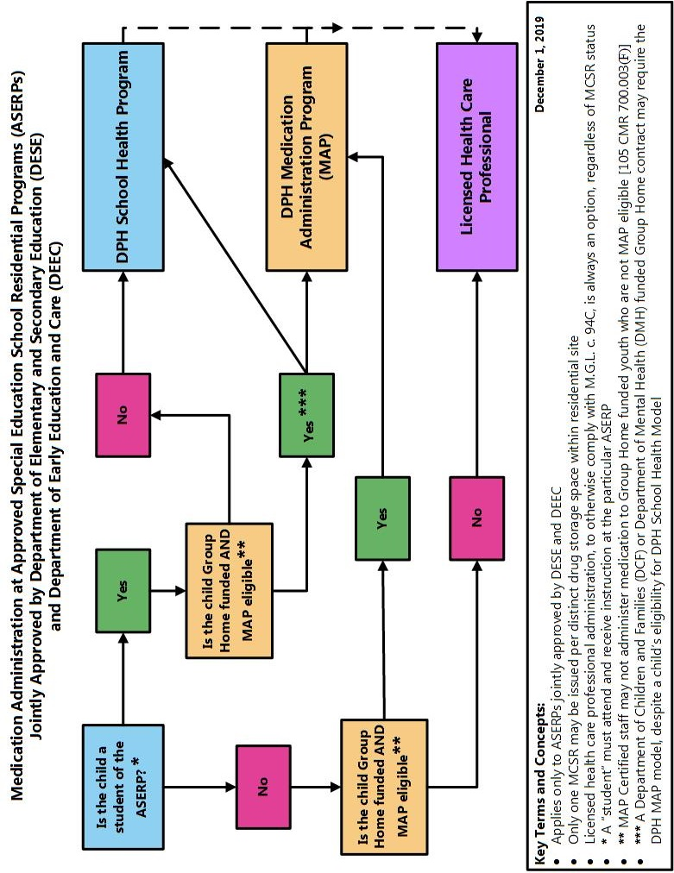

This advisory supersedes the notice issued by John Kelty, Ph.D., entitled “Medication Administration Program (MAP) Opt-In for Residential Schools,” and any interpretations thereof, effective immediately. See Attachment A.
A “student” must attend and receive academic instruction at the particular ASERP. Youth residing at an ASERP, but not attending or receiving instruction at the particular ASERP, are “non-students” for purposes of this advisory.
M.G.L. c. 94C: The Massachusetts Controlled Substances Act; 105 CMR 700: Implementation of M.G.L. c. 94C
Alternatively, a student or non-student residing at an ASERP may be determined to be capable of self-administration.
e.g. 243 CMR: Board of Registration in Medicine; 244 CMR: Board of Registration in Nursing; 263 CMR: Board of Registration of Physician Assistants
244 CMR 3.05(5)(d)
“Unlicensed personnel” means any person other than a licensed health care professional (registered prescriber or nurse), authorized by M.G.L. c. 94C, § 9 to administer medication within their scope of practice.
105 CMR 700.003(E), as outlined in 105 CMR 210.000: The Administration of Prescription Medications in Public and Private Schools.
105 CMR 210.004(B)(3)
“An employee of a community program may administer or assist in the administration of a controlled substance or other prescription medication to a stable non-self-administering person.” 105 CMR 700.003(F)
For purposes of this advisory, a person is stable if their current condition is not prone to change. Instability arises when medical/psychological/social needs are unknown, in crisis, and/or require frequent reassessment.
Registered prescribers include, but are not limited to physicians, dentists, advanced practice registered nurses and physician assistants
https://www.mass.gov/files/documents/2016/07/qv/map-policy-manual.pdf
105 CMR 700.003(F)
“Program and professional staff may not engage in other duties or obligations while performing documentation and medication administration tasks under this section and must comply with applicable Department guidance.” 105 CMR 700.003(F)(1)(i)
MAP Certified Staff are not authorized to administer medication to youth who are not MAP eligible and Group Home funded. 105 CMR 700.003(F).
School Health does not authorize delegation to unlicensed staff for administration of medication to children who are not students of the approved and registered ASERP. 105 CMR 210.004.

