COMMONWEALTH OF MASSACHUSETTS

SUFFOLK COUNTY BOARD OF REGISTRATION IN PHARMACY

)
In the Matter of )
Ashburnham Family )
Pharmacy, Inc. )
License No. DS3314 ) Expires: December 31, 2015 )

Docket No. PHA-2015-0030

CONSENT AGREEMENT FOR REPRIMAND

The Massachusetts Board of Registration in Pharmacy ("Board") and Ashburnham Family Pharmacy, Inc. ("Pharmacy"), a pharmacy licensed by the Board, license number DS3314, do hereby stipulate and agree that the following information shall be entered into and become a permanent part of the Pharmacy's record maintained by the Board:

1. The Pharmacy acknowledges that the Board opened a Complaint against its Massachusetts license related to the conduct set forth in Paragraph 2, identified as Docket Number PHA-2015-0030 ("Complaint").
- The Board and the Pharmacy acknowledge and agree to the following facts: Based on a retail compliance inspection conducted by Office of
Public Protection investigators on or about January 20, 2015, it
was observed that Pharmacy received a transfer of expired Schedule II controlled substance medications from another pharmacy without a DEA 222 form in violation of 21 U.S.C. § 828(a) and M.G.L. c. 94C, §16.

- The Pharmacy acknowledges that the foregoing facts warrant disciplinary action by the Board under M.G.L. c. 112, §§" 42A and 61 and under 247 CMR 10.03(l)(x).

- The Pharmacy agrees that the Board shall impose a REPRIMAND on its license based on the facts admitted in Paragraph 2, effective as of the date on which the Board signs this Agreement ("Effective Date").

- The Board agrees that in return for the Pharmacy's execution and successful compliance with all the requirements of this Agreement, the Board will not prosecute the Complaint.

- The Pharmacy understands that it has a right to formal adjudicatory hearing concerning the Complaint and that during said adjudication the Pharmacy would possess the right to confront and cross-examine witnesses, to call witnesses, to present evidence, to testify on its own behalf, to contest the allegations, to present oral argument, to appeal to the courts, and all other rights as set forth in the Massachusetts Administrative Procedures Act,
M.G.L. c. 30A, and the Standard Adjudicatory Rules of Practice and Procedure, 801 CMR 1.01 et seq. The Pharmacy further understands that by
executing this Agreement the Pharmacy is knowingly and voluntarily waiving its right to a formal adjudication of the Complaint.

- The Pharmacy acknowledges that it has been at all times free to seek and use legal counsel in connection with the Complaint and this Agreement.

- The Pharmacy acknowledges that after the Effective Date, the Agreement constitutes a public record of disciplinary action by the Board subject to the Commonwealth of Massachusetts' Public Records Law, M.G.L. c. 4, § 7. The Board may forward a copy of this Agreement to other licensing boards, law enforcement entities, and other individuals or entities as required or permitted by law.

- The Pharmacy understands and agrees that entering into this Agreement is a voluntary and final act and not subject to reconsideration, appeal or judicial review.

- The individual signing this Agreement certifies that he/she is authorized to enter into this Agreement on behalf of the Pharmacy, and that he/she has read this Agreement.

Ashburnham Family Pharmacy, Inc. 083314
P HA·20 15·0030

Page 2 of 3

9/21/2015
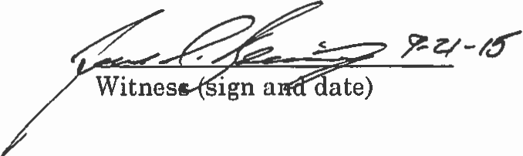

Ashburnham Family Pharmacy, Inc. (sign and date)

(Print name)

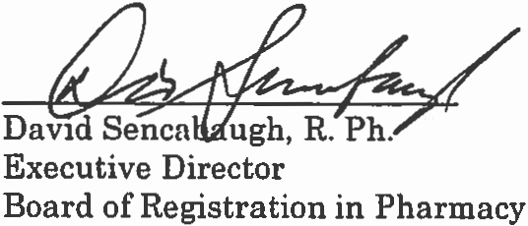

_____________10/8/2015_________
Effective Date of Reprimand Agreement

Fully Signed Agreement Sent to Registrant on 10/8/2015 by

Certified Mail No. 70151520000282548693

Ashburnham Family Pharmacy, Inc. 08331·1
PHA-2015-0030

Page 3 of 3

