INDOOR AIR QUALITY ASSESSMENT

Ashby Elementary School
911 Main Street
Ashby, Massachusetts

Prepared by:
Massachusetts Department of Public Health
Bureau of Environmental Health
Indoor Air Quality Program
January 2023

BACKGROUND
Building: | Ashby Elementary School (AES)
Address: | 911 Main Street, Ashby, MA
Assessment Requested by: | Member of the public
Reason for Request: | Indoor air quality (IAQ) concerns and reports of mold odor
Date of Assessment: | January 13, 2023
Massachusetts Department of Public Health/Bureau of Environmental Health (MDPH/BEH) Staff Conducting Assessment: | Michael Feeney, Director, IAQ Program
Date of Building Construction: | AES was originally constructed in 1952 with classrooms, main offices, a library, cafeteria/kitchen, and gymnasium. A classroom wing as added in 1989. The 1952 original westernmost section [abandoned wing (AW)] of the AES is not in use and the HVAC along with other utilities have been disconnected. Hallway doors separate the AW from occupied areas of the building.
Windows: | Openable

METHODS
Please refer to the IAQ Manual and appendices for methods, sampling procedures, and interpretation of results (MDPH, 2015).

RESULTS and DISCUSSION
The following is a summary of indoor air testing results (Table 1). Note that only specific areas were tested and examined during this visit.
- Carbon dioxide levels were below the MDPH recommended guideline of 800 parts per million (ppm) in most areas.
- Temperature was within the MDPH recommended range of 70°F to 78°F in all areas.
- Relative humidity was close to or below the MDPH recommended range of 40 to 60% in all areas and reflective of outdoor (dry) conditions, which are typical of New England in the winter. Low relative humidity can lead to common symptoms such as: dry skin, lips, and scalp; dry/scratchy throats and noses (nose bleeds); exacerbation of asthma, eczema, or allergies; dry/irritated eyes; and irritation of respiratory tract.
- Carbon monoxide levels were non-detectable (ND) in all areas examined.
- Particulate matter (PM2.5) concentrations measured were below the National Ambient Air Quality (NAAQS) level of 35 μg/m³.

Ventilation
A heating, ventilating, and air conditioning (HVAC) system has several functions. First it provides heating and, if equipped, cooling. Second, it is a source of fresh air. Finally, an HVAC system will dilute and remove normally occurring indoor environmental pollutants by not only introducing fresh air, but by filtering the airstream and ejecting stale air to the outdoors via exhaust ventilation. Even if an HVAC system is operating as designed, point sources of respiratory irritation may exist and cause symptoms in sensitive individuals.
Mechanical ventilation for classrooms is provided the unit ventilators (univents, Pictures 1 and 2). Exhaust ventilation is provided by ducted vents, some of which were located near classroom doors.
Restrooms in the 1952 wing are equipped with mechanical exhaust vents (Picture 3). Restroom doors are equipped with passive door vents (transfer air vents, Picture 4), that allow for air to be drawn from the hallway through the restroom to the exhaust vent. This configuration creates one-way airflow to vent water vapor and odors from restrooms and prevents such odors to enter the hallway. In addition, hallways in the 1952 section do not have fresh air supplies or exhaust vent systems.
It is important to note that univents in each wing were installed when each structure was built, meaning that the univents are 70 years old in the 1952 section and 33 years old in the 1989 section. Also, despite ongoing maintenance and replacement of parts/components by school facilities staff, the univents are at the end of their life cycle. Efficient function of equipment of this age (> 20 years old) is difficult to maintain, since compatible replacement parts are often unavailable. According to the American Society of Heating, Refrigeration, and Air-Conditioning Engineers (ASHRAE), the service life of this type of unit is 15-20 years, assuming routine maintenance of the equipment (ASHRAE, 1991).
To maximize air exchange, the IAQ program recommends that both supply and exhaust ventilation operate continuously during periods of occupancy. In order to have proper ventilation with a mechanical ventilation system, the systems must be balanced after installation to provide an adequate amount of fresh air to the interior of a room while removing stale air from the room. It is recommended that HVAC systems be re-balanced every five years to ensure adequate air systems function (SMACNA, 1994).

Microbial/Moisture Concerns
Of note, were conditions in the AW (Pictures 5 and 6). During the day of assessment, rain created drainage back up (Picture 7) from the AW roof. In addition, there appears to be substantial water accumulation inside the lowest level, which had the odor similar to that of a chronically wet basement/cellar with a wet dirt floor. A similar odor was detected in the main hallway at the administrative office, which was traced to the hallway doors that leads to the AW (Picture 8). Based on these observations, the source of the odor is the wet conditions that exist in the AW. The following are likely pathways AW air enters occupied areas.
- During weather with westerly winds, air infiltrates into the AW through cracks, spaces, or other openings in the windward side of the building, which in turn forces air and odors in an easterly direction towards the occupied sections of the AES. Such weather serves to pressurize the halls and classrooms, which in turn, forces air and odors.
- Such wind pressurization may also force odors through the school crawlspace to enter the occupied areas via spaces between the univent heat pipe and floor (Picture 9). Operating the univent may also draw air from the crawlspace via these openings.
- With operating exhaust ventilation, the depressurization of hallways outside the AW will serve to draw air and odors though the same cracks and spaces that exist into crawls spaces, wall seams, cracks or spaces in walls that separate the AES from the AW.
- In addition, with the AES heated and the AW disconnected from the heating systems, the air temperature differential will have cold air drawn into the occupied spaces as heated air rises.
Based on these observations, the source of odors in the AES is airflow into the occupied
spaces via openings in the shared walls with the AW.

Areas Prone to Moistening
Another contributing factor to this odor is recent New England weather conditions. It is important to note that Massachusetts has experienced extended periods of relative humidity during the summers of 2021 and 2022, with July 2021 being the wettest ever recorded in Massachusetts, and the three-month period from June through August 2021, known as the meteorological summer, was the fourth-wettest on record, according to the National Oceanic and Atmospheric Administration’s Centers for Environmental Information. The three-month period also was the third-warmest ever in the state and was tied for the warmest on record across the United States (HG, 2021, NOAA, 2021).
Based on the type of floor construction (carpet on cement slab), hallway floors may be prone to moistening during extended (> 24 hours) hot, humid weather. Another location prone to condensation, as well as water penetration, is the kitchen storeroom backwall (Picture 10), which is located below grade.
The key to managing condensation in hot, humid weather indoors is understanding that unconditioned hot, humid air in buildings can moisten carpet and other building components. When warm, moist air passes over a porous material, moisture can be absorbed. According to the American Society of Heating, Refrigerating and Air-Conditioning Engineers (ASHRAE), if relative humidity exceeds 70%, mold growth may occur due to wetting of building materials (ASHRAE, 1989). Due to the configuration and condition of exterior hallway doors it is likely relative humidity was near or exceeded 70% in hallways during hot, humid weather over summer months. In this condition, porous materials such as carpeting, cardboard and other materials may become moistened and prone to developing mold.
Water-damaged porous materials cannot be adequately cleaned to remove mold growth. The United States Environmental Protection Agency (US EPA) and the American Conference of Governmental Industrial Hygienists (ACGIH) recommend that porous materials be dried with fans and heating within 24 to 48 hours of becoming wet (US EPA, 2008; ACGIH, 1989). If porous materials are not dried within this time frame, they should be removed and discarded.

Ceiling tiles in classrooms and common hallways are bowed, which is likely the result of moisture exposure from elevated relative humidity conditions. No mold growth was observed on bowed ceiling tiles. Water-damaged ceiling tiles were observed in a few classrooms and hallways. Some water-damaged ceiling tiles were noted (Table 1), which may indicate a leak from the roof or plumbing system. They should be replaced once the source of water is identified and repaired.

Exterior Conditions Impacting the Building
Pine trees exist along the west exterior wall of the new wing, which overhang the roof (Picture 11). These pine trees pose a number of hazards:
- Needles and cones likely accumulate around roof drains, which can create a dam that inhibits rainwater drainage from the roof. This condition can also lead to ice accumulation blocking drains, which can lead to water running off the roof to moisten exterior walls.
- The pine trees prevent sunlight from drying exterior walls.
- The pine trees are a possible danger due to their distance from exterior walls. The recommended safe distance from which a tree should be planted is recommended to be at lease the maximum growth height from the exterior of a building (BI, 2015). Soil subsidence may also be caused by pine tree roots, which can undermine the structure of a building to cause wall and floor cracking as well as other related damage. Within the maximum growth distance, severe weather may result in the tree falling onto the building.
- Also of note is resistance of the pine trees to uprooting during high wind events. In general, a tree root system will spread out in all directions and can extend a considerable distance from their trunks. Any structure disrupting the root structure would then make the tree unstable if subjected to high winds from a certain direction. The west side of the trees likely have root systems disrupting the tarmac. A strong westerly wind would make these trees prone to falling towards the AES.

Other Conditions

Carpeting
Hallways have wall-to-wall carpet of undetermined age (Picture 12) in the 1952 section of the building. If relative humidity indoors is >70 %, it is a sufficient concentration that can cause building materials to become moistened and not dry (ASHRAE, 1989). In addition, if carpeting is moistened and has materials covering it to prevent free airflow to aid in drying, carpet can remain moistened. It is also important to note that the usable life of carpeting in schools is approximately 10-11 years (IICRC, 2002). Aging carpet can produce fibers that can be irritating to the respiratory system.
Carpeting should be vacuumed regularly with a high efficiency particulate arrestance (HEPA) filter equipped vacuum cleaner to avoid particulates from causing further irritation or serving as a reservoir for microbial colonization. Also, carpeting and rugs should be cleaned at least once per year according to Institute of Inspection Cleaning and Restoration Certification recommendations (IICRC, 2012). Area rugs too worn to be effectively cleaned should be replaced. Area rugs should be rolled up and stored in a clean, dry place when rooms are not occupied during the summer months to prevent moistening due to condensation.
Note that the Environmental Protection Agency (EPA) conducted a National School Radon Survey in which it discovered nearly one in five schools had “…at least one frequently occupied ground contact room with short-term radon levels above 4 [picocuries per liter] pCi/L” (US EPA, 1993). The BEH/IAQ Program therefore recommends that every school be tested for radon, and that this testing be conducted during the heating season while school is in session in a manner consistent with USEPA radon testing guidelines. Radon measurement specialists and other information can be found at www.nrsb.org and http://aarst-nrpp.com/wp, with additional information at: http://www.mass.gov/eohhs/gov/departments/dph/programs/environmental-health/exposure-topics/iaq/radon.

CONCLUSIONS and RECOMMENDATIONS
The AES has a number of issues related to moisture as well as HVAC system issues. One issue that is a significant problem is relative humidity and condensation management of the building during extreme hot, humid weather. The following documents can provide guidance that can be used to reduce the impact of hot, humid weather in buildings, even those with HVAC system chilling capacity.
- Mold growth Prevention during Hot, Humid Weather https://www.mass.gov/service-details/preventing-mold-growth-in-massachusetts-schools-during-hot-humid-weather
- Remediation and Prevention of Mold Growth and Water Damage in Public Schools https://www.mass.gov/service-details/remediation-and-prevention-of-mold-growth-and-water-damage-in-public-schools-and
- Methods for Increasing Comfort in Non-air-conditioned Schools https://www.mass.gov/doc/methods-for-increasing-comfort-in-non-air-conditioned-schools/download
To remedy building problems, two sets of recommendations are made: short-term measures that may be implemented as soon as practicable and long-term measures that will require planning and resources to address overall IAQ concerns.
In view of the findings at the time of the visit, the following recommendations are provided:

Short Term Recommendations

Ventilation Recommendations:
- Render the hallway door as airtight as possible. Installing door sweeps and weather-stripping on the doors and door frames can eliminate/reduce odor pathways.
- Seal all spaces in the hallway door/interior window system with an appropriate sealer.
- Consider installing an exhaust vent in the AW near hallways doors to intercept and direct odors to the outdoors. Such a system may also draw air from the AES hallways through any unaccounted or unreachable openings in the shared hallway wall.
- Operate all supply and exhaust ventilation equipment continuously during occupied periods. Continue to ensure both general exhaust vents and restroom exhaust vents are operational.
- In order to prevent air infiltration, the following steps may be used, if feasible, and can be done in a safe manner.
  - Seal all univent exterior wall intakes (Picture 13) permanently with an appropriate waterproof material.
  - Seal all exhaust vent openings in classrooms permanently with an appropriate waterproof material.
  - Seal all rooftop exhaust vents (Picture 14) permanently with an appropriate waterproof material.
  - Weatherproof all exterior doors (Picture 15).
  - Install plywood or other weatherproof materials over all AW windows (Picture 16).

Water Damage Recommendations:
- The Federal Emergency Management Agency (FEMA) provides a number of recommendations in order to prepare for severe thunderstorms. FEMA recommends “Cut down or trim trees that may be in danger of falling on your [building]” (FEMA, 2018). Given the proximity of trees to the AES, removal of pine trees should be strongly considered.

Other Recommendations:
- Clean carpeting (and area rugs) annually or semi-annually in soiled high traffic areas per the recommendations of the Institute of Inspection, Cleaning and Restoration Certification (IICRC, 2012).
- For buildings in New England, periods of low relative humidity during the winter are often unavoidable. Therefore, scrupulous cleaning practices should be adopted to minimize common indoor air contaminants whose irritant effects can be enhanced when the relative humidity is low. To control for dusts, a high efficiency particulate arrestance (HEPA) filter equipped vacuum cleaner in conjunction with wet wiping of all surfaces is recommended. Avoid the use of feather dusters. Drinking water during the day can help ease some symptoms associated with a dry environment (throat and sinus irritation).
- The school should be tested for radon by a certified radon measurement specialist during the heating season when school is in session. Radon measurement specialists and other information can be found at: www.nrsb.org, and http://aarst-nrpp.com/wp.
- To learn more about radon, review the MDPH’s Radon in Schools and Child Care Programs factsheet, with additional information at: http://www.mass.gov/eohhs/gov/departments/dph/programs/environmental-health/exposure-topics/iaq/radon.
- Consider including an IAQ component in the school’s Wellness Advisory Committee program. An IAQ plan should have an IAQ liaison/teacher representative, a member of maintenance/facilities and administration that conduct regular walk-throughs to identify on-going and/or potential environmental issues.
- Consider adopting the US EPA (2000) document, “Tools for Schools,” as an instrument for maintaining a good IAQ environment in the building available at: http://www.epa.gov/iaq/schools/index.html.
- For guidance on maintaining an asthma-friendly healthy school environment, please consult the MDPH Asthma Prevention and Control Program’s Clearing the Air: An Asthma Toolkit for Healthy Schools.
- Refer to resource manual and other related indoor air quality documents located on the MDPH’s website for further building-wide evaluations and advice on maintaining public buildings. These documents are available at http://mass.gov/dph/iaq.
- The school should be tested for radon by a certified radon measurement specialist during the heating season when school is in session. Radon measurement specialists and other information can be found at: www.nrsb.org, and http://aarst-nrpp.com/wp.
- To learn more about radon, review the MDPH’s Radon in Schools and Child Care Programs factsheet, with additional information at: http://www.mass.gov/eohhs/gov/departments/dph/programs/environmental-health/exposure-topics/iaq/radon.

Long Term Recommendations
- Conduct a building-wide ventilation systems assessment. Based on historical issues regarding the HVAC system design, physical deterioration, and availability of parts for ventilation components, such an evaluation is necessary to determine the operability and feasibility of replacing existing HVAC system equipment, such as univents and chilled water pipe insulation.
- Due to its age and moisture exposure, consideration should be given to replacing carpeting with tile or other appropriate materials. It is important to ascertain if hallway carpet was installed over floor tile that contains asbestos. If so, removing carpet would requirement compliance with all relevant federal and state asbestos laws.

REFERENCES
ACGIH. 1989. Guidelines for the Assessment of Bioaerosols in the Indoor Environment. American Conference of Governmental Industrial Hygienists, Cincinnati, OH.
ASHRAE. 1989. Ventilation for Acceptable Indoor Air Quality. American Society of Heating, Refrigeration and Air Conditioning Engineers. ANSI/ASHRAE 62-1989.
ASHRAE. 1991. ASHRAE Applications Handbook, Chapter 33 “Owning and Operating Costs”. American Society of Heating, Refrigeration and Air Conditioning Engineers, Atlanta, GA.
BI. 2015. A List of Trees and the Recommended Safe Distance from Buildings. Bickers Insurance, Littlehampton, West Sussex, UK. https://www.bickersinsurance.co.uk/about-us/latest-news/property-owners-news/a-list-of-trees-and-the-recommended-safe-distance-from-buildings/
FEMA. 2018. How to Stay Safe When a Thunderstorm Threatens. Federal Emergency Management Agency, Washington, DC. FEMA V-1009/May 2018.
HG. 2021. Mold Keeps South Hadley High School Shuttered. Hampshire Gazette. https://www.gazettenet.com/South-Hadley-High-School-still-closed-amid-mold-remediation-42413519
IICRC. 2002. Institute of Inspection, Cleaning and Restoration Certification. A Life-Cycle Cost Analysis for Floor Coverings in School Facilities.
IICRC. 2012. Institute of Inspection, Cleaning and Restoration Certification. Carpet Cleaning: FAQ.
MDPH. 2015. Massachusetts Department of Public Health. Indoor Air Quality Manual: Chapters I-III. Available at: Indoor Air Quality - Facts and Resources | Mass.gov
NOAA. 2021. Summer 2021 neck and neck with Dust Bowl summer for hottest on record. National Oceanic and Atmospheric Administration, 1401 Constitution Avenue NW, Room 5128, Washington, DC 20230 https://www.noaa.gov/news/summer-2021-neck-and-neck-with-dust-bowl-summer-for-hottest-on-record

SMACNA. 1994. HVAC Systems Commissioning Manual. 1st ed. Sheet Metal and Air Conditioning Contractors’ National Association, Inc., Chantilly, VA.
US EPA. 2000. Tools for Schools. Office of Air and Radiation, Office of Radiation and Indoor Air, Indoor Environments Division (6609J). EPA 402-K-95-001, Second Edition. http://www.epa.gov/iaq/schools/index.html
US EPA. 2008. “Mold Remediation in Schools and Commercial Buildings”. Office of Air and Radiation, Indoor Environments Division, Washington, DC. EPA 402-K-01-001. September 2008. Available at: http://www.epa.gov/mold/mold-remediation-schools-and-commercial-buildings-guide.
Williams, A. 2006. The Distance at Which Trees Can Affect a Building is Quite Significant. The Architects’ Journal. https://www.architectsjournal.co.uk/home/the-distance-at-which-trees-can-affect-a-building-is-quite-significant/130858.article
WP. 2018. ‘It’s been relentless’: Smothering summer humidity in the Northeast has crushed records. Washington Post, Washington, DC. https://www.washingtonpost.com/news/capital-weather-gang/wp/2018/08/30/its-been-relentless-smothering-summer-humidity-in-the-northeast-has-crushed-records/
Picture 1
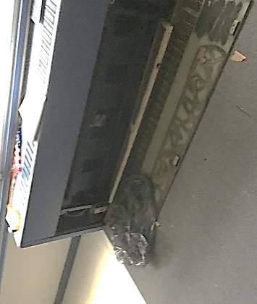
Univent in the 1952 wing

Picture 2
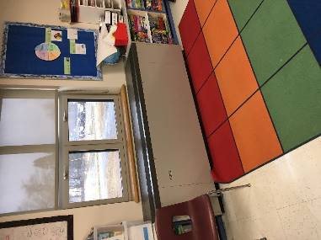

Univent in the 1989 wing
Picture 3
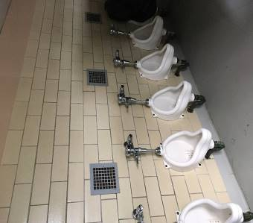
Restroom exhaust vents

Picture 4
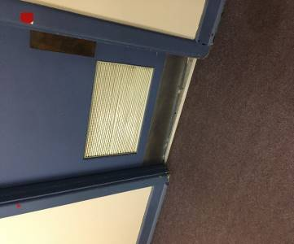

Transfer air vent in restroom door

Picture 5
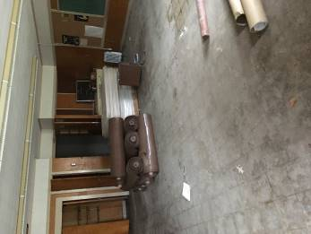
Classroom in lower level in AW, floor slick with moisture

Picture 6
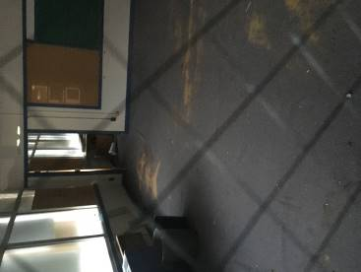
AW upper floor from AES hallway

Picture 7
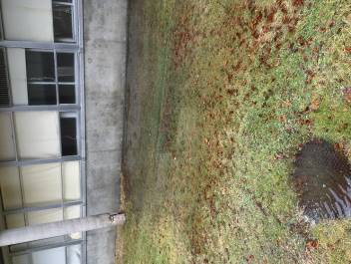
Backed up storm drain connected to AW roof drains overflowing

Picture 8
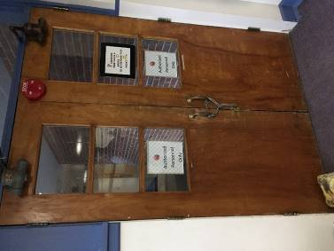
AW hallway doors, note open seams under and between doors
Picture 9
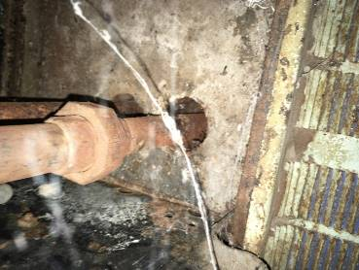
Space between floor and heating pipe in univent

Picture 10
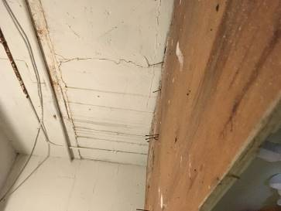
Water damage in kitchen storeroom
Picture 11
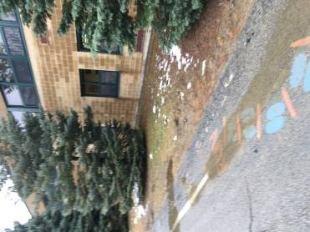
Pine trees near AES exterior wall, note how trees shade walls which slows drying

Picture 12
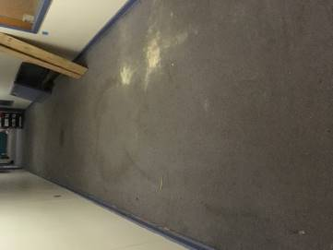
Hallway wall-to-wall carpeting, 1952 wing
Picture 13
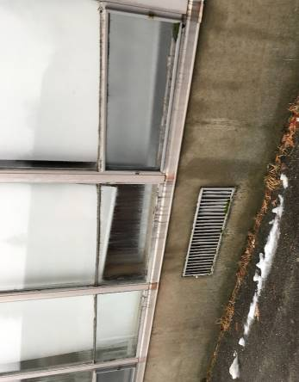
Univent fresh air intake in AW

Picture 14

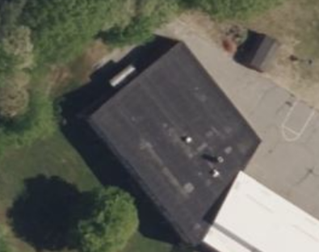
AW rooftop vents/openings to be rendered airtight
Picture 15
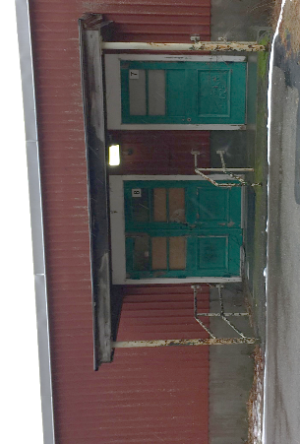
AW exterior door to be rendered airtight

Picture 16
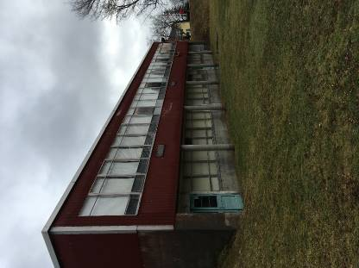
AW windows to be rendered airtight

Location | Carbon  Dioxide  (ppm) | Carbon Monoxide  (ppm) | Temp  (°F) | Relative  Humidity  (%) | PM2.5  (µg/m³) | Bowing Ceiling Tiles | Occupants  in Room | Windows  Openable | Ventilation |  | Remarks
 |  |  |  |  |  |  |  |  | Supply | Exhaust
Outdoor (Background) | 367 | ND | 51 | 84 | ND
Main hallway |  | ND |  |  |  |  |  |  |  |  | Wet basement/cellar odor in main hallway
905 | 552 | ND | 74 | 42 | ND | Y | 22 | Y | Y | Y
902 | 510 | ND | 74 | 38 | ND | Y | 0 | Y | Y | Y
904 | 485 | ND | 75 | 40 | ND | Y | 2 | Y | Y | Y
903 | 527 | ND | 72 | 42 | ND | Y | 0 | Y | Y | Y | Plants
902 | 580 | ND | 72 | 41 | ND | Y | 0 | Y | Y | Y
901 | 862 | ND | 74 | 44 | ND | Y | 18 | Y | Y | Y
900 | 883 | ND | 74 | 43 | ND | Y | 21 | Y | Y | Y
907 | 474 | ND | 74 | 43 | ND | Y | 0 | Y | Y | Y
908 | 632 | ND | 75 | 44 | ND | Y | 20 | Y | Y | Y
Location | Carbon  Dioxide  (ppm) | Carbon Monoxide  (ppm) | Temp  (°F) | Relative  Humidity  (%) | PM2.5  (µg/m³) | Bowing Ceiling Tiles | Occupants  in Room | Windows  Openable | Ventilation | Remarks | Location
909 | 490 | ND | 76 | 40 | ND | Y | 0 | Y | Y | Y
910 | 469 | ND | 76 | 40 | ND | Y | 20 | Y | Y | Y
911 | 579 | ND | 76 | 42 | ND | Y | 17 | Y | Y | Y
913 | 610 | ND | 75 | 42 | ND | Y | 20 | Y | Y | Y
914 | 493 | ND | 75 | 41 | ND | Y | 1 | Y | Y | Y
912 | 440 | ND | 74 | 41 | ND | Y | 0 | Y | Y | Y
505 | 496 | ND | 75 | 39 | ND | Y | 0 | Y | Y | Y
Library | 487 | ND | 77 | 36 | ND | Y | 0 | Y | Y | Y
507 | 434 | ND | 76 | 35 | ND | Y | 0 | Y | Y | Y | Carpet
506 | 440 | ND | 76 | 37 | ND | Y | 0 | Y | Y | Y | 30 + computers
502 | 501 | ND | 77 | 38 | ND | Y | 0 | Y | Y | Y
Gym | 486 | ND | 76 | 40 | ND | N | 0 | N | Y | Y
Location | Carbon  Dioxide  (ppm) | Carbon Monoxide  (ppm) | Temp  (°F) | Relative  Humidity  (%) | PM2.5  (µg/m³) | Bowing Ceiling Tiles | Occupants  in Room | Windows  Openable | Ventilation | Remarks | Location
Cafeteria | 404 | ND | 76 | 42 | ND | Y | 50+ | Y | Y | Y
Kitchen | 493 | ND | 75 | 44 | ND | N | 6 | N | Y | Y
500 | 507 | ND | 76 | 41 | ND | N | 0 | Y | N | N | Window-mounted air conditioner
500 inner room | 559 | ND | 77 | 39 | ND | ND | 0 | Y | N | N

The service life is the median time during which a particular system or component of … [an HVAC]… system remains in its original service application and then is replaced. Replacement may occur for any reason, including, but not limited to, failure, general obsolescence, reduced reliability, excessive maintenance cost, and changed system requirements due to such influences as building characteristics or energy prices (ASHRAE, 1991).

