INDOOR AIR QUALITY ASSESSMENT

Ashby Town Hall
895 Main St.
Ashby, MA 01431

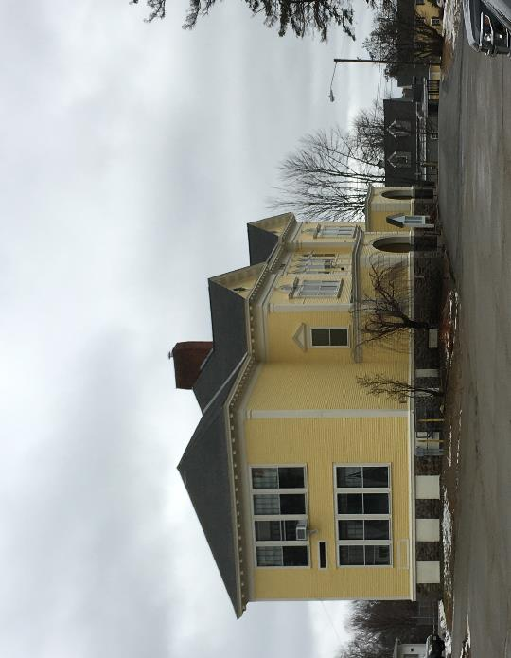

Prepared by:
Massachusetts Department of Public Health
Bureau of Environmental Health
Indoor Air Quality Program
January 2023

BACKGROUND
Building: | Ashby Town Hall (ATH)
Address: | 895 Main St, Ashby, MA
Assessment coordinated via: | Ashby Board of Health
Reason for Request: | Water damage and general indoor air quality (IAQ) concerns
Date of Assessment: | January 6, 2023
Massachusetts Department of Public Heath/Bureau of Environmental Health (MDPH/BEH) Staff Conducting Assessment: | Michael Feeney, Director, IAQ  Program
Building/Site Description: | The ATH is a two-story wood-clad building with basement located near Ashby center. It was originally constructed in the late 1800s, likely as a school. Later renovations included wall-to-wall carpeting over maple tongue-in-groove floors. The basement contains a cable television studio constructed from gypsum wallboard with wall-to-wall carpeting.
Building Population: | The building is staffed with about 5 employees and serves the public daily.
Windows: | Openable

METHODS
Please refer to the IAQ Manual for methods, sampling procedures, and interpretation of results (MDPH, 2015).

RESULTS AND DISCUSSION
The following is a summary of indoor air testing results (Table 1):
- Carbon dioxide was below the MDPH guideline of 800 parts per million (ppm) in all areas visited, indicating adequate fresh air in the space for the occupancy.
- Temperature was below the recommended comfort range of 70°F to 78°F in most areas tested.
- Relative humidity was within or close to the lower end of the recommended range of 40% to 60% in all occupied areas assessed. Relative humidity in the basement was higher than other areas of the building.
- Carbon monoxide levels were below the background (outdoor) reading of 4 ppm in all areas assessed.
- Fine particulate matter (PM2.5) concentrations were below the National Ambient Air Quality Standard (NAAQS) level of 35 μg/m³ in all areas tested.

Ventilation
It is important to note that the ATH was originally constructed as a school and was not intended to be occupied during hot, humid weather that occurs in summer months.
Classrooms are equipped with a unit ventilator (univent, Picture 1). When operating, univents draw air from the outdoors through a fresh air intake located on the exterior of the building (Picture 2) and return air through an air intake located at the base of the unit. Fresh and return air are mixed, filtered, heated, or cooled and provided to rooms through an air diffuser located in the top of the unit (Figure 1).
For univents to provide fresh air as designed, intakes/returns must remain free of obstructions. Importantly, these units must remain on and be allowed to operate while rooms are occupied. However, the mechanical portions of most of the univents in the ATH were non-functional, so the univents only serve as a source of radiant heat. An exhaust vent system, in the form of a wall opening connected to an air shaft, was originally present in each former classroom however these openings were sealed (Picture 3).
The building was originally configured to use cross-ventilation to provide comfort for building occupants. The ATH is equipped with windows on opposing exterior walls and transoms (small windows above doors). This design allows for airflow to enter an open window, pass through a room, through the open transom (Picture 4), into the hallway, pass through the opposing room’s hallway transom, into the opposing room and exit the building on the leeward side (opposite the windward side) as shown in Figure 2. With all windows and hallway doors or transoms open, airflow can be maintained in a building regardless of the direction of the wind. The system fails if the windows or hallway doors are closed (Figure 3). Each room also has a radiator beneath the window which provides heat.

Microbial/Moisture Concerns

Basement conditions
Relative humidity in the basement was measured in a range of 51-62%, which is 14-25% higher than highest measurement on the first floor of 37% (Table 1), These relative humidity measurements indicate that moisture sources exist in the basement. Excess relative humidity can lead to moistening of porous material in the basement, like ceiling tiles, carpeting, or gypsum wallboard. One sign of elevated relative humidity is bowing ceiling tiles in the TV studio (Picture 5). If exposed to significant amounts of moisture, ceiling tiles will sag or bow. While not a sign of mold growth, bowed ceiling tiles indicate chronic exposure to high humidity.
Concerns were raised about mold in the basement areas. Note that at some point, the basement was subdivided to create a television (TV) room using gypsum wallboard installed with plastic coving at the base (Picture 6). This area also is covered with wall-to-wall carpeting (Picture 7). No means of mechanical fresh air or natural ventilation from openable windows exists in the TV studio or other locations in the basement. In addition, the basement can be subject to significant moisture accumulation for the following reasons:
- The basement appears to have contained restrooms which were later removed. Several openings in the floor (Picture 8) and open-ended pipes (Picture 9) were noted during the assessment. It is likely that rainstorms cause water vapor backup into the basement. In addition, rainwater causing the groundwater to rise can also cause water vapor to enter the basement through open/abandoned sewer pipes, seams in walls and/or cracks in floor.
- If a building lacks adequate exhaust ventilation and air chilling capacity to reduce relative humidity from outside air, then hot, moist air can be introduced into a building and linger to increase occupant discomfort. Excess humidity can also moisten materials that may lead to mold growth, particularly in areas that are in direct contact with soil (e.g., basement floor and walls).
- It is important to note that Massachusetts has experienced extended periods of relative humidity during the summer of 2021. July of 2021 was the wettest ever recorded in Massachusetts, and the three-month period from June through August 2021, known as the meteorological summer, was the fourth wettest on record, according to the National Oceanic and Atmospheric Administration’s Centers for Environmental Information. The three-month period also was the third warmest ever in the state and was tied for the warmest on record across the United States. (HG, 2021, NOAA, 2021). Similar hot, humid conditions were seen in the summer of 2018 (WP, 2018).

The key to managing condensation in hot, humid weather indoors is understanding dew point. When air contacts a surface with a temperature below the dew point, condensation will occur and lead to liquid water accumulation which can moisten nearby materials. In addition, when warm, moist air passes over a porous material, moisture can be absorbed. According to American Society of Heating, Refrigeration and Air Conditioning Engineers (ASHRAE), if relative humidity exceeds 70%, mold growth may occur even in the absence of liquid water (ASHRAE, 2019). Due to the configuration and condition of exterior hallway doors it is likely that relative humidity near or exceeded 70% in hallways during hot, humid weather during summer months. In this condition, porous materials such as carpeting, cardboard, and other materials may become prone to developing mold colonization. It is also important to note that camera and related electronic equipment can be adversely affected by >70% relative humidity, which may include corrosion and/or mold growth on accumulated dust/debris inside such equipment (Chandradhas, S. 2022).
It is recommended that porous material be dried with fans and heating within 24 to 48 hours of becoming wet (US EPA, 2008, ACGIH, 1989). If porous materials are not dried within this time frame, mold growth may occur. Water-damaged porous materials cannot be adequately cleaned to remove mold growth.
Buildings constructed in the early 1900’s did not have waterproofing or insulation installed on the exterior side of foundation walls or beneath the basement floor. Basement areas were intended for building utilities, such as furnace, fuel storage (e.g., coal), water service and electrical equipment, and for storage, not for occupancy.

Odors in upper floors
The following concepts explain how mold and associated odors/particulates in the basement can migrate into occupied areas:
- Heated air rises, creating upward air movement (stack effect).
- As the heated air rises, negative pressure is created, which draws cold air to replace the warmed air.
- Airflow created by the stack effect, drafts, or wind can carry airborne odors and particulates.
- The opening of the door to the basement at the base of the Town Selectman’s office can provide a pathway for air carrying odors and particulates to travel from the basement to the upper floors.

To control possible mold growth, water penetration into the basement area must be minimized, and water contact with porous materials limited. Water penetration through the foundation can be limited by tightening up the building envelope and reestablishing proper drainage around the building foundation.
Note that the open fresh air intake vents (Picture 2) connected to the inoperable univents can also be a source of moisture in the building. Since univents are no longer in use, these exterior wall openings can readily allow hot, humidity air to enter the building interior, especially during windy, wet weather.

Other Concerns
Most areas had carpeting that appeared to be several decades old. In many areas, this carpeting was visibly very worn, frayed, wrinkled, and stained. The service life of carpeting in schools is approximately 10-11 years (IICRC, 2002), and will be similar in an environment such as a town hall. Aging carpet can produce fibers that can be irritating to the respiratory system. In addition, torn or lifting carpet can create tripping hazards. Carpeting should be cleaned annually or semi-annually in soiled high traffic areas as per the recommendations of the Institute of Inspection, Cleaning and Restoration Certification (IICRC, 2012).
Below grade space in Massachusetts may also be a source of exposure to radon. Due to the presence of the TV studio in that basement and possible use by students, it is recommended to have the TV studio tested in a manner similar to schools. The Environmental Protection Agency (EPA) conducted a National School Radon Survey in which it discovered nearly one in five schools had “…at least one frequently occupied ground contact room with short-term radon levels above 4 [picocuries per liter] pCi/L” (US EPA, 1993). The BEH/IAQ Program therefore recommends that every school be tested for radon, and that this testing be conducted during the heating season while school is in session in a manner consistent with USEPA radon testing guidelines. Radon measurement specialists and other information can be found at www.nrsb.org and http://aarst-nrpp.com/wp, with additional information at: https://www.mass.gov/radon.

CONCLUSIONS/RECOMMENDATIONS
To address the above-mentioned conditions, the recommendations made to improve indoor air quality in the building are divided into short-term and long-term corrective measures. The short-term recommendations can be implemented as soon as practicable. Long-term measures are more complex and will require planning and resources to adequately address the overall indoor air quality concerns.

Short-Term Recommendations

Ventilation recommendations:
- Use openable windows and hallway doors/transoms for cross ventilation during periods of temperate weather.
- Keep windows closed during heavy rain and hot humid weather to prevent water damage.
- Avoid opening windows in areas where air conditioning is operating.

Water damage recommendations
- Consider removing carpeting in the basement.
- Remove plastic coving from the base of all gypsum wallboard. Examine gypsum wallboard for mold growth and remove any that shows signs of mold growth including dark sports or moldy odors.
- Follow the guidance in “Mold Remediation in Schools and Commercial Buildings” published by the US EPA (2008) when performing mold remediation. Copies of this document can be downloaded from the US EPA website at: https://www.epa.gov/mold/mold-remediation-schools-and-commercial-buildings-guide.
- Consider replacing gypsum wall board with cement board or other materials not prone to mold growth.
- To prevent moisture penetration into the basement, the following actions should be considered:
  - Seal all cracks in cement and asphalt around the front of the building.
  - Remove all mulch from ground near foundation walls.
  - Consider installing a gutter/downspout on roof edges to drain rainfall away from the building.
  - Seal all cracks in the foundation and the foundation/cement/tarmac junctions with an appropriate sealing compound.
  - Remove foliage to at least five feet from the foundation.
  - Improve the grading of the ground away from the foundation at a slope of 6 inches per every 10 feet (Lstiburek, J. & Brennan, T.; 2001).
  - Install a water-impermeable layer on ground surface (clay cap) to prevent water saturation of ground near foundation (Lstiburek, J. & Brennan, T.; 2001).
- Seal pathways between the basement and upper floors. This includes any utility holes. Ensure that the door to the basement remains closed at all times and use weatherstripping to increase airtightness.

Other recommendations
- For buildings in New England, periods of low relative humidity during the winter are often unavoidable. Therefore, scrupulous cleaning practices should be adopted to minimize common indoor air contaminants whose irritant effects can be enhanced when the relative humidity is low. To control for dusts, a high efficiency particulate arrestance (HEPA) filter equipped vacuum cleaner in conjunction with wet wiping of all surfaces is recommended. Avoid the use of feather dusters. Drinking water during the day can help ease some symptoms associated with a dry environment (throat and sinus irritations).
- Clean carpeting in accordance with IICRC recommendations.
- Due to the use of the TV studio, the basement should be tested for radon by a certified radon measurement specialist during the heating season when the building is occupied. Radon measurement specialists and other information can be found at: www.nrsb.org, and http://aarst-nrpp.com/wp.
- Refer to resource manuals and other related indoor air quality documents for further building-wide evaluations and advice on maintaining public buildings. These materials are located on the MDPH’s website at https://www.mass.gov/lists/indoor-air-quality-manual-and-appendices.

Long-Term Recommendations
- If no mechanical ventilation system exists in the TV studio, consideration should be given to either:
  - Re-locating the TV studio an area that is not prone to high relative humidity.
  - Installing a mechanical heating, ventilation, and air conditioning system to control temperature and relative humidity in the basement.
- Consult with an HVAC engineer to determine if unit ventilators can be returned to service, replaced, or should be removed.
- Consult a building engineer on the appropriate method to insulate the basement floor to prevent moisture accumulation.
- Consult with a building engineer on further methods to permanently render the basement as watertight as feasible.
- Consider a plan to replace aging carpeting in the building.

REFERENCES
ACGIH. 1989. Guidelines for the Assessment of Bioaerosols in the Indoor Environment. American Conference of Governmental Industrial Hygienists, Cincinnati, OH.
ASHRAE, 2019. American Society of Heating, Refrigeration and Air Conditioning Engineers (ASHRAE) Ventilation for Acceptable Indoor Air Quality. ANSI/ASHRAE Standard 62.1-2019. Atlanta, GA. (https://ashrae.iwrapper.com/ASHRAE_PREVIEW_ONLY_STANDARDS/STD_62.1_2019)
Chandradhas, S. 2022. How To Prevent Fungus Growth on Lenses. Best Humidity Level For Camera Dry Box - Prevent Lens Fungus (beyondphototips.com).
HG. 2021. Mold keeps South Hadley High School shuttered. Hampshire Gazette. https://www.gazettenet.com/South-Hadley-High-School-still-closed-amid-mold-remediation-42413519.
IICRC. 2002. Institute of Inspection, Cleaning and Restoration Certification. A Life-Cycle Cost Analysis for Floor Coverings in School Facilities.
IICRC. 2012. Institute of Inspection, Cleaning and Restoration Certification. Carpet Cleaning: FAQ.
MDPH. 2015. Massachusetts Department of Public Health. Indoor Air Quality Manual: Chapters I-III. Available at: https://www.mass.gov/lists/indoor-air-quality-manual-and-appendices
NOAA. 2021. Summer 2021 neck and neck with Dust Bowl summer for hottest on record. National Oceanic and Atmospheric Administration, 1401 Constitution Avenue NW, Room 5128, Washington, DC 20230 https://www.noaa.gov/news/summer-2021-neck-and-neck-with-dust-bowl-summer-for-hottest-on-record
US EPA. 1993. Radon Measurement in Schools, Revised Edition. Office of Air and Radiation, Office of Radiation and Indoor Air, Indoor Environments Division (6609J). EPA 402-R-92-014.
US EPA. 2008. “Mold Remediation in Schools and Commercial Buildings”. Office of Air and Radiation, Indoor Environments Division, Washington, DC. EPA 402-K-01-001. September 2008. Available at: http://www.epa.gov/mold/mold-remediation-schools-and-commercial-buildings-guide
WP. 2018. ‘It’s been relentless’: Smothering summer humidity in the Northeast has crushed records. Washington Post, Washington, DC. https://www.washingtonpost.com/news/capital-weather-gang/wp/2018/08/30/its-been-relentless-smothering-summer-humidity-in-the-northeast-has-crushed-records/
Figure 1

Unit Ventilator (Univent)

Mixed Air

Air Diffuser

Outdoors Indoors

Fan

Heating/Cooling Coil

Air Mixing Plenum

Filter

Outdoor Return
Air Air

Air
Flow
Control
Louvers

Air Flow

= Fresh Air/Return Air

= Mixed Air

Figure 2 Cross Ventilation in a Building Using Open Windows and Transoms

Leeward Windward
Side of Side of
Building Building

Wind Direction

Key

Open Window

Open Transom

Interior Path of Cross Ventilation

Drawing Not to Scale

Figure 3 Inhibition of Cross Ventilation in a Building with Several Windows and Transoms Closed

Leeward Windward
Side of Side of
Building Building

Wind Direction
Key

Open Window

Open Transom

Closed Window

Closed Transom

Interior Path of Cross Ventilation

Drawing Not to Scale
Picture 1
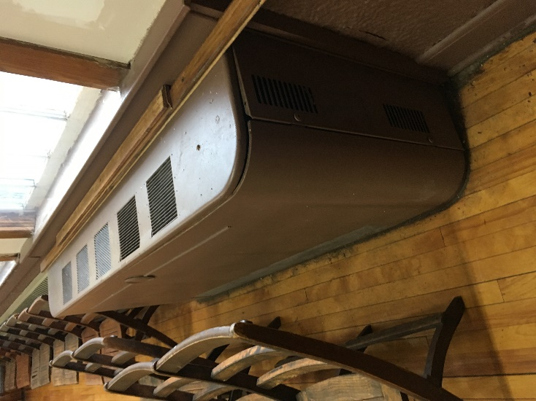
Unit ventilator (univent)
Picture 2
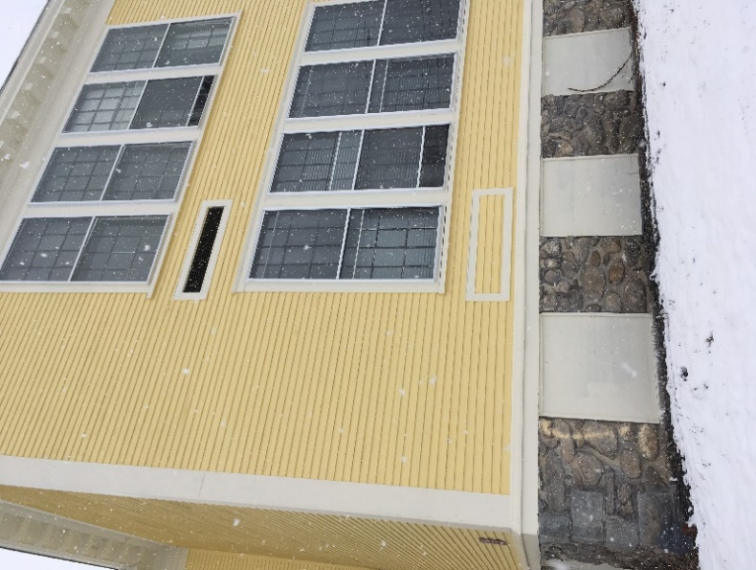
Univent fresh air intake

Picture 3
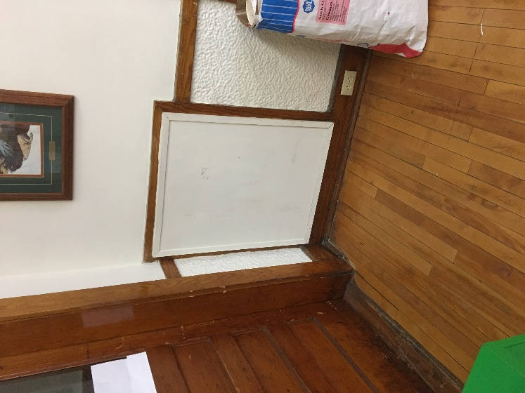
Sealed exhaust vent system (originally connected to an air shaft in each former classroom)
Picture 4
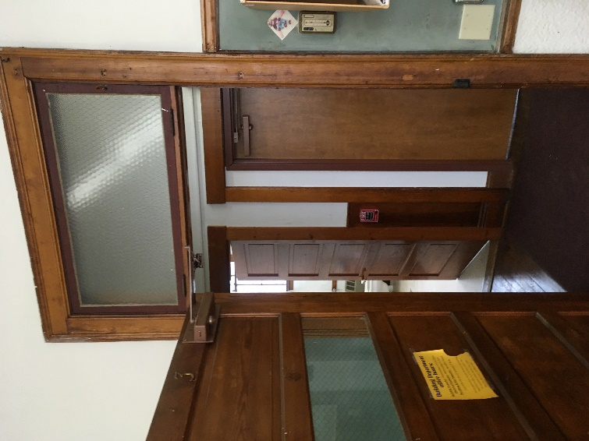
Transom over the door

Picture 5
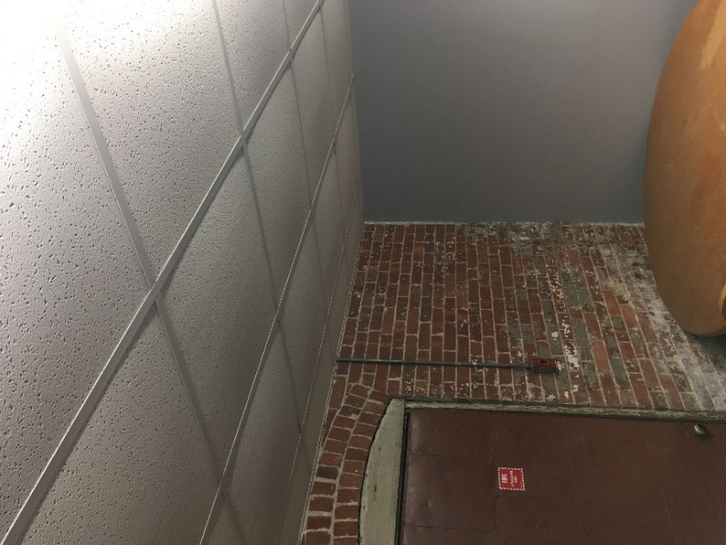
Bowing ceiling tiles in TV studio
Picture 6
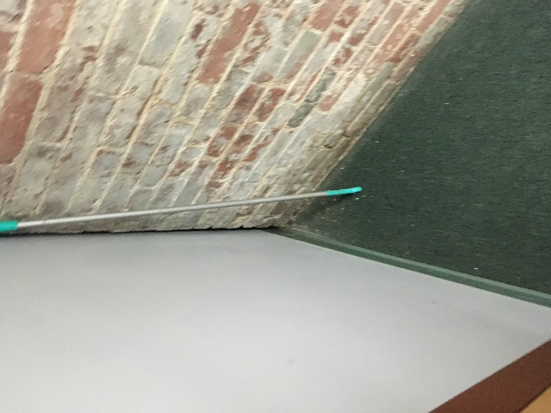
Plastic coving on gypsum wallboard in TV studio

Picture 7
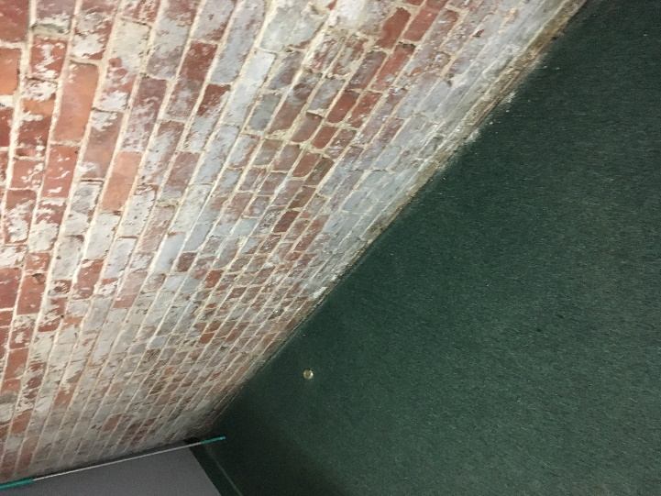
Wall-to-wall carpeting on basement floor
Picture 8
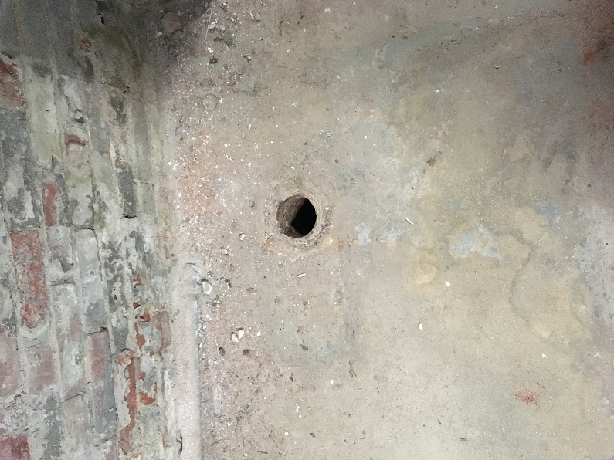
Basement floor opening

Picture 9
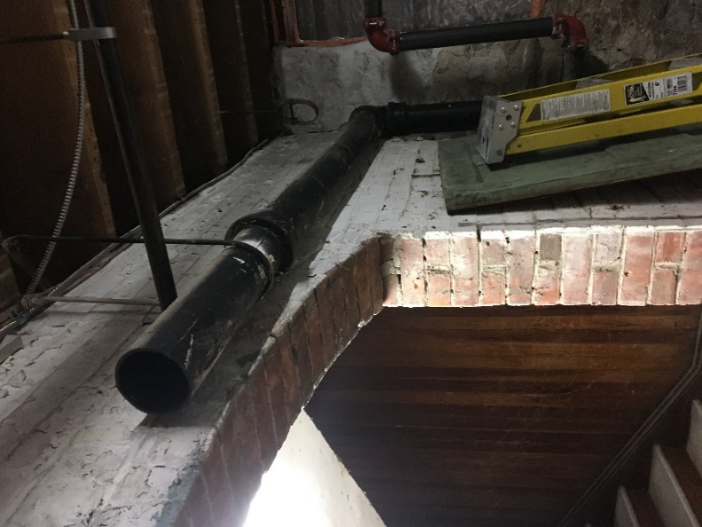
Open pipe in basement

Location | Carbon  Dioxide  (ppm) | Carbon Monoxide  (ppm) | Temp  (°F) | Relative  Humidity  (%) | PM2.5  (µg/m³) | Occupants  in Room | Windows  Openable | Ventilation |  | Remarks
 |  |  |  |  |  |  |  | Supply | Exhaust
Outdoor (Background) | 354 | 4 | 35 | 89 | ND |  |  |  |  | snowing
2 | 501 | 3 | 70 | 33 | ND | 0 | Y | N | N
3 | 487 | 2 | 66 | 37 | ND | 0 | Y | N | N | Water-damaged wall
4 | 389 | 2 | 71 | 31 | ND | 0 | Y | N | N
6 | 491 | 2 | 66 | 36 | ND | 0 | Y | N | N | Open pipe
7 | 383 | 2 | 67 | 33 | ND | 0 | Y | N | N
Board oealth | 386 | 2 | 68 | 34 | ND | 0 | Y | N | N | Water-damaged wall
Council on Aging (COA) | 427 | 2 | 59 | 42 | ND | 0 | Y | N | N | 1 water-damaged ceiling tile
COA kitchen | 399 | 1 | 63 | 38 | ND | 0 | Y | N | N | Ceiling-mounted AC
COA storage | 524 | 1 | 62 | 37 | ND | 0 | Y | N | N | Ceiling-mounted AC
Attic Storage | 404 | 1 | 54 | 42 | ND | 0 | Y | N | N | Ceiling-mounted AC
Attic storage book | 380 | 1 | 48 | 50 | ND | 0 | Y | N | N
Basement-dehumidifier space | 389 | ND | 53 | 56 | ND | 0 | N | N | N | Hole in cement floor
Heater room | 397 | ND | 51 | 62 | ND | 0 | N | N | N | Open pipe
Furnace room | 487 | ND | 58 | 51 | 8 | 0 | N | N | N
Green room | 393 | ND | 58 | 55 | ND | 0 | N | N | N | Carpeting in below grade space  Plastic coving on base of gypsum wallboard

