**Massachusetts Department of Public Health**



# Ask Away

November 21, 2024

**Bureau of Family Health and Nutrition Early Intervention Division**

**Finance Team**

**Deeptha Ramalingam & Scott Geer & Manuela Batista**

**Massachusetts Department of Public Health**



# Assessment Hours / Home Visit Hours

November 21, 2024

2

**Early Intervention**

Massachusetts Early Intervention (EI) is a program for infants and toddlers (birth to 3 years old) who have developmental delays or are at risk of a developmental delay.

**Assessment Hours Definition**

A comprehensive evaluation of the child’s developmental status and family situation, involving the use of a normed developmental assessment tool and measuring fine and gross motor skills, cognitive ability, communication skills, affect and temperament, self-care and feeding skills, socialization, family interactions, and social and economic support systems available to the family.

**Assessment Hours**

* 10 hours maximum per year.
* New assessment hours are available one year from the date of the **first billed assessment service.**
* If the child does not have any assessment hours left after the 10 hours maximum, you must request a waiver.

**Assessment Hours Exceeded**

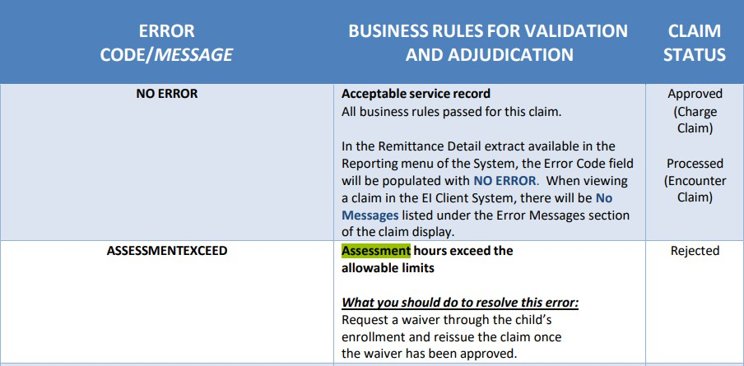

**Assessment Hours Waivers**

* Waiver with a distinct extraordinary circumstance can be approved in some cases or transfer with less than required hours needed to establish eligibility.
* Up to six hours can be approved, following the 2 hour / 3 person suggested model, for the specific date the assessment is scheduled. **Do not put a date range.** Include how previously billed hours have been used, and how many, if any, assessment hours remain.

**Early Intervention Assessments Service Codes**

|  |  |  |  |  |  |
| --- | --- | --- | --- | --- | --- |
| **DPH**  **Allowable Service Codes** | **Service Description** | **Service Definition** | **Billing Unit** | **Per Unit Rate** | |
| **7/1/22 to**  **6/30/24** | **7/1/24 to Present** |
| T1024 | Assessment | A comprehensive evaluation of the child’s developmental status and family situation, involving the use of a normed developmental  assessment tool and measuring fine and gross motor skills, cognitive ability, communication skills, affect and temperament, self-care and feeding skills, socialization, family interactions, and  social and economic support systems available to the family. | 15  Minutes | **$36.21** | **$48.12** |

|  |  |  |  |  |  |
| --- | --- | --- | --- | --- | --- |
| **DPH**  **Allowable Service Codes** | **Service Description** | **Service Definition** | **Billing Unit** | **Per Unit Rate** | |
| **10/1/22**  **to 6/30/24** | **7/1/24**  **to Present** |
|  | Initial | Behavior identification assessment, administered by a physician or other qualified health care professional, each 15 minutes of the physician's or other qualified health care professional's time face-to- face with patient and/or guardian(s) / caregiver(s) administering  assessments and discussing findings and recommendations, and non- face-to-face analyzing past data, scoring/interpreting the assessment, and preparing the report/treatment plan. |  |  |  |
|  | functional |  |  |  |
| 97151 | behavior  assessment | 15  Minutes | **$30.73** | **$30.73** |
|  | and |  |  |  |
|  | reassessment |  |  |  |

**Assessment Hours in EICS**

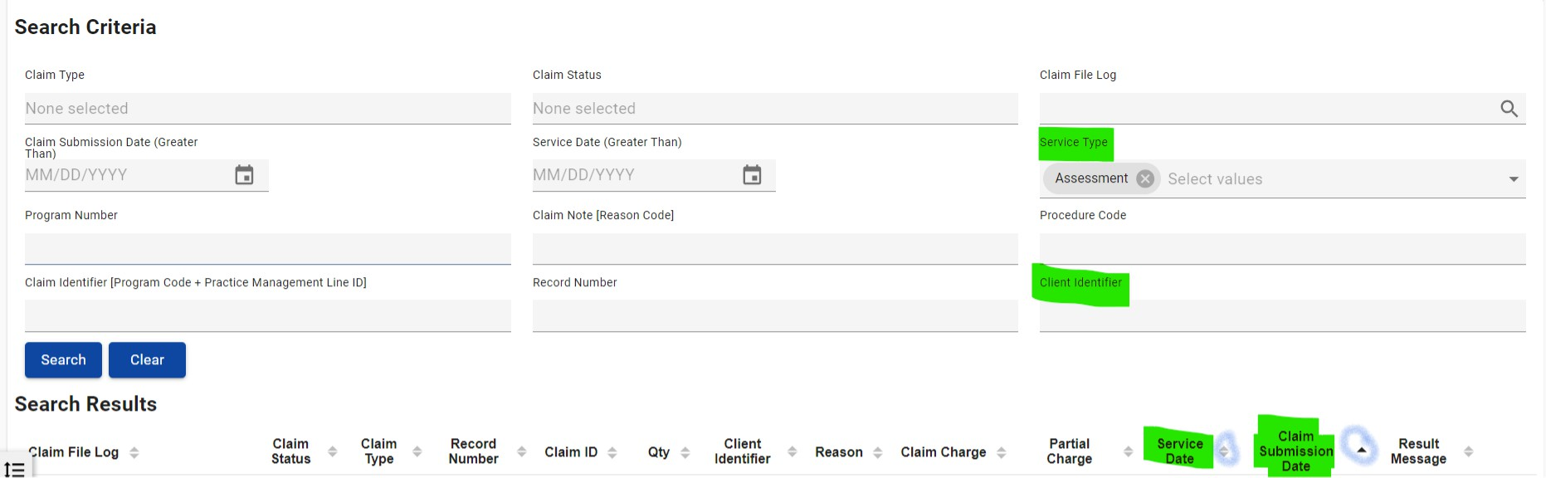

2.

1.

3.

4.

5.

* 1. Client Identifier- Enter the client Identifier
  2. Service Type- Select the service type “Assessment”
  3. Click on the “Search” button
  4. Sort list of claims by the “Service Date” to determine the first submitted assessment date
  5. Sort list of claims by “Claim Submission Date” to account the hours submitted

**Home Visit Hours**

A face-to-face meeting at the client’s home or at an approved setting outside of the center-based site, with the client, the client’s caregiver, or both, and professional staff member(s) for the purpose of furthering the client’s developmental progress.

**Home Visit Hours- Service Level Billing Requirements**

* 2 hours per EI specialist per session per day maximum.
* If a child is deemed ineligible, 2 hours (with 1 or 2 EI Specialists) of service can occur after the completion of the eligibility evaluation for the purpose of reviewing the evaluation/assessment results and transitioning the child and family out of the EI program. Applies only for newly referred children receiving an initial evaluation.
* Billing cannot occur for 2 staff of the same discipline providing the same service.

**Early Intervention Home Visit Service Code**

|  |  |  |  |  |  |
| --- | --- | --- | --- | --- | --- |
| **DPH**  **Allowable Service Codes** | **Service Description** | **Service Definition** | **Billing Unit** | **Per Unit Rate** | |
| **7/1/22 to**  **6/30/24** | **7/1/24 to Present** |
| H2015 | Child visit - Home | A face to face meeting at the client’s home or at an approved setting outside of the center based site, with the client, the  client’s caregiver, or both, and professional staff member(s) for the purpose of furthering the client’s developmental progress. | 15  Minutes | **$27.05** | **$35.95** |
| Child visit –  Day Care |
| Child visit – Hospital |

**Home Visit Hours Exceeded**

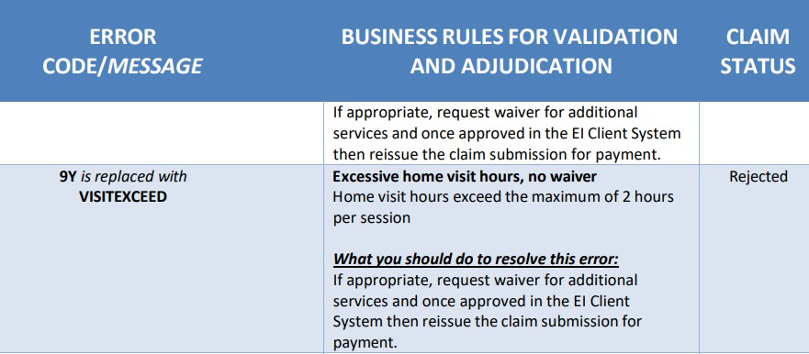

**CONNECT WITH DPH**

