**Massachusetts Department of Public Health**



# Ask Away

## March 20, 2025

**Deeptha Ramalingam, Scott Geer, Manuela Batista**

**Massachusetts Department of Public Health**



# Common Error Codes in EICS (How to resolve them)

## March 20, 2025

2

**Early Intervention**

Massachusetts Early Intervention (EI) is a program for infants and toddlers (birth to 3 years old) who have developmental delays or are at risk of a developmental delay

***Presenter Notes***

*2025-04-23 12:23:42*

--------------------------------------------

We are the Massachusetts Early Intervention Massachusetts Early Intervention is a program for infants and toddlers (birth to 3 years old) who have developmental delays or are at risk of a developmental delay.

**Error Codes**

* Assigning Error Codes

***Presenter Notes***

*2025-04-23 12:23:42*

--------------------------------------------

When service delivery data is uploaded into the EI Client System through the Claim Submission Process, a series of validations and adjudications take place. If the claim passes all validations and adjudications, no errors will appear in the Error Message entity associated with the claim.

If the claim fails any validation or adjudication, an error code will be assigned to the claim.

* When service delivery data has been uploaded into the EI Client System via the Claim Submission Process, a series of validations and adjudications (business rules) occur in the System
* If the claim passes all validations and adjudications, there will be no errors in the Error Message entity associated to the claim
* If the claim does not pass a validation or adjudication, then an error code is assigned to the claim, as shown below

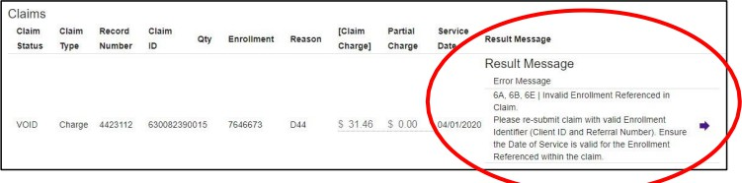

**Claims Status**

When you receive a rejected claim status, it means the claim contains an error. The rejection will include an error code that explains the issue. You must fix the error before the claim can be processed.

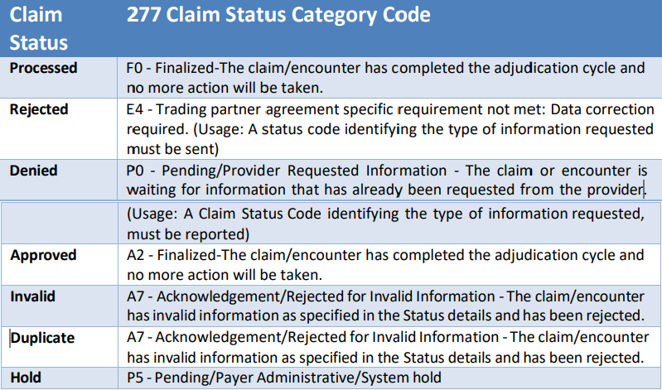

***Presenter Notes***

*2025-04-23 12:23:42*

--------------------------------------------

When you receive a rejected claim status, it means the claim contains an error. The rejection will include an error code that explains the issue. You must fix the error before the claim can be processed.

**Common Errors**

***Presenter Notes***

*2025-04-23 12:23:42*

--------------------------------------------

Error code/message

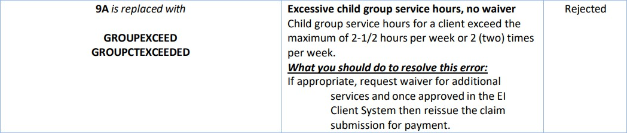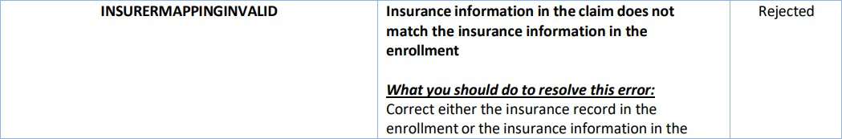

**Common Error reported to Help Desk**

***Presenter Notes***

*2025-04-23 12:23:42*

--------------------------------------------

Assessment exceed error code instructions on what to do next when an error occurs.

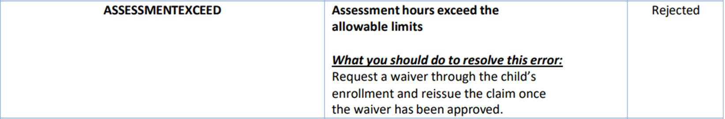

**CONNECT WITH DPH**

