**Massachusetts Department of Public Health**



# Ask Away

## January 16, 2024

**Deeptha Ramalingam, Scott Geer, Manuela Batista**

**Massachusetts Department of Public Health**



# Early Intervention General Policy Overview

## January 16, 2024

2

**Early Intervention**

Massachusetts Early Intervention (EI) is a program for infants and toddlers (birth to 3 years old) who have developmental delays or are at risk of a developmental delay

**Reimbursement Policy Updates**

Reimbursement Policy Manual for Early Intervention and Autism Services **page 2**

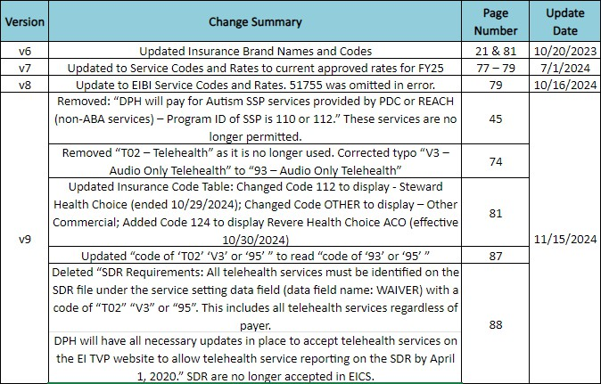

**Fiscal Year Deadline**

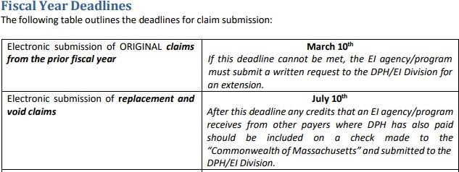

**Fiscal Year 2024: July 1, 2023 - June 30, 2024**

**Fiscal Year Extension Form**

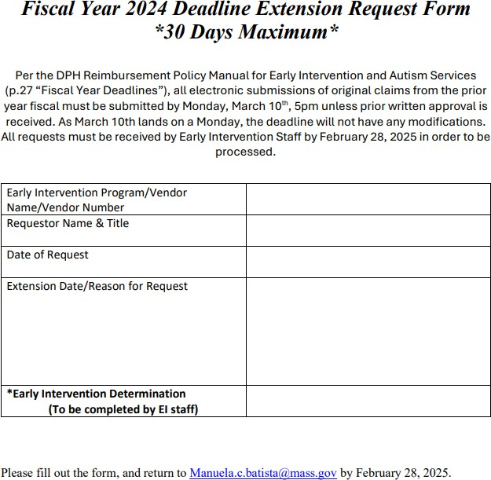

**Negative PV Voucher Requirements**

Negative Vouchers happen when claim adjustments exceed payments resulting in a deficit for any reporting month

It will be necessary to issue and mail out payment to DPH with supporting documentation

**Requirements**

1. Download Remittance file when a negative voucher results for all negative claim adjustments
2. For each negative adjustment you will need to provide:
   * Claim ID
   * Original PV # claim was originally paid on
   * Amount originally paid
   * Reason for adjustment
3. Return this file via the DPH authorize secure portal [Encrypted Email Login](https://ppsecuremail.state.ma.us/securereader/init.jsf?brand=cd301c5c)

**Mail Check:** MA Department of Public Health (DPH) Attention BFHN Early Intervention Finance Manager

250 Washington St, (5th floor), Boston, Massachusetts 02108

**CONNECT WITH DPH**

