**Massachusetts Department of Public Health**



Encounter and Charge Claims

August 15, 2024

1

**Why is this important 1 of 2**

As the Lead Agency (LA) for the Part C program (Early Intervention) for the Commonwealth, we are the "single line of responsibility" and among other things, we are required to:

* Provide general administration and supervision;
* And oversee the Identification and coordination of all available resources (Money).

It is ALL our responsibility to ensure that Part C dollars are used only as the "Payor of Last Resort (POLR):

* MA is a Fee Free state – which means families never pay for EI or EIBI services.
* Order of reimbursement must be: Private/Public source (i.e. Third-Party Insurance or Public Health Insurances), State Funding set aside for EI and finally Federal services when all other options have been exhausted.

Audit requirements:

* Federal: The State must provide the assurance in Section II.B.13 of the annual grant application that it has a statewide system that meets the single line of responsibility for the program.
* State: The department is required to submit routine reports on expenditures. Creates a sustainable Early Intervention system:
* Accurate Encounter and Charge Claims allows for us to ensure our State remains financially viable and is in accordance with both State and Federal regulations and requirements.

**Claim Types**

All service billing activity is to be reported to the Department of Public Health.

This billing activity is categorized into two different types of claims

**Encounter Charge**

**Early Intervention Client System** (**EICS) categorizes these claims into the following categories:**

* Early Intervention Services
  + General
  + Supplemental
  + Uninsured
* Early Intensive Behavior Intervention
  + General
  + Supplemental
  + Uninsured

**Encounter Claim**

* Claim details on Early Intervention Services paid in full by insurance
* EICS PORTAL
* Encounter Claim Submission: Utilizes 837 or XML File Layout

**Charge Claim**

* Claim submission requesting full or partial payment by DPH
* EICS PORTAL
* Charge Claim Submission: Utilizes 837

**Encounter & Charge Validation**

* Documented formatting requirements
* Hours and Date of service is within the enrollment start and discharge data
* Enrollment number and information and insurance information on each claim must match the DPH Early Intervention Client System
* Service type and procedure code
* **Proper adherence to service level requirements (waivers taken into consideration) and rates (only applies to charge)**

**Encounter Claim View**

1

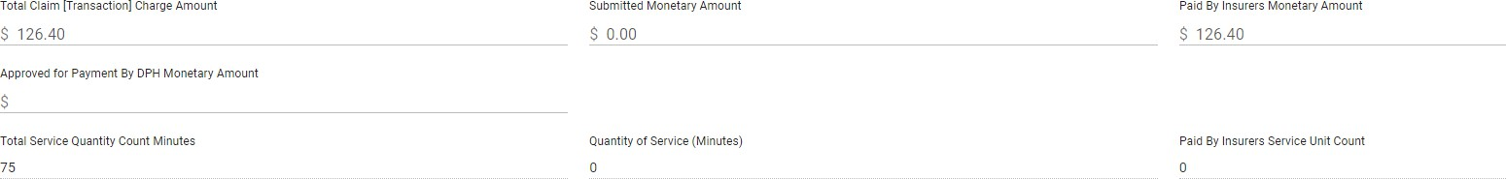

2

3

6

7

4

5

1. Total Claim [ Transaction] Charge Amount
2. Submitted Monetary Amount
3. Paid By Insurers Monetary Amount
4. Approved for Payment By DPH Monetary Amount
5. Total Service Quantity Count Minutes
6. Quantity of Service (Minutes)
7. Paid By Insurers Service Unit Count

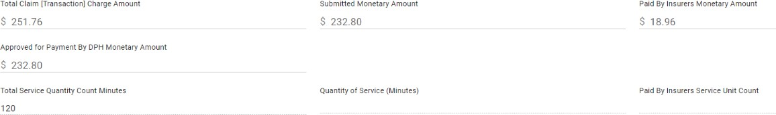

**Charge Claim View w/ Insurance Payment**

|  |  |  |
| --- | --- | --- |
| 1 | 2 | 3 |
| 4 |  |  |
| 5 | 6 | 7 |
|  | 1. Total Claim [ Transaction] Charge Amount 2. Submitted Monetary Amount |  |
|  | 1. Paid By Insurers Monetary Amount 2. Approved for Payment By DPH Monetary |  |
|  | Amount |  |
|  | 1. Total Service Quantity Count Minutes 2. Quantity of Service (Minutes) |  |
|  | 7. Paid By Insurers Service Unit Count |  |

**Charge Claim View w/o Insurance Payment**

1

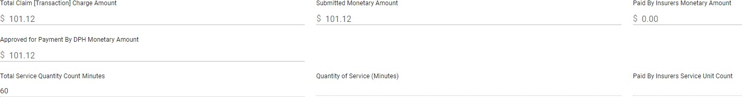

2

3

6

7

4

5

1. Total Claim [ Transaction] Charge Amount
2. Submitted Monetary Amount
3. Paid By Insurers Monetary Amount
4. Approved for Payment By DPH Monetary Amount
5. Total Service Quantity Count Minutes
6. Quantity of Service (Minutes)
7. Paid By Insurers Service Unit Count

**Why is this important 2 of 2**

# Federal Reporting

* Fiscal Indicators

# Legislative reporting requirements

* Quarterly reports are submitted to the State house and senate committees on ways and means on the total number of units of service purchased and the total expenditures for the units of service paid by

the department

# Forecasting budgets (MOE)

* The term maintenance of effort (MOE) cannot be found as such in the Part C regulations, it is the common term used to refer to the "supplement not supplant" requirement for IDEA Part C Funds. (34 CFR §303.225)

**Claim Submission Deadline**

* Monthly PV Cycle10th of the month if not the next business day.

