**Massachusetts Department of Public Health**



# Ask Away

## February 20, 2024

**Deeptha Ramalingam, Scott Geer, Manuela Batista**

**Massachusetts Department of Public Health**



# Parental Consent to Access Insurance Requirement Reminder

## February 20, 2024

2

**Consent to Access Insurance**

* The Early Intervention Division is committed to providing high-quality Part C/early intervention services to enhance the development and learning of infants and toddlers through individualized, developmentally appropriate interventions embedded in everyday activities at no cost to families.
* Part C of the Individuals with Disabilities Education Act (IDEA) requires that parental consent is obtained **before**

public benefits insurance or private insurance is used.

**The Department of Public Health Consent to Access Insurance**

* Under the Individuals with Disabilities Education Act (IDEA), Part C/early intervention services are provided to infants and toddlers with disabilities or developmental delays. Use of public benefits or insurance or private insurance is allowable under 34 CFR 303.520; it is not required.
* Families who choose to use Medicaid, Children’s Health Insurance Program (CHIP), or private insurance, must do so voluntarily. The same applies to private insurance; parents may choose to use it but are not obligated to do so. In either case, written parental consent is required before insurance is accessed. This consent can be changed at any time.
* Families who do not provide consent to use public benefits or insurance or private insurance must not be penalized in any way. These families must not lose access to services or experience a reduction in the quality of services provided. If a parent chooses not to use insurance, it must not result in any extra charges.

**How to capture consent in EICS**

* This is the initial appointment prompt
* You are also required to respond to the 'consent to access' insurance when each IFSP is completed

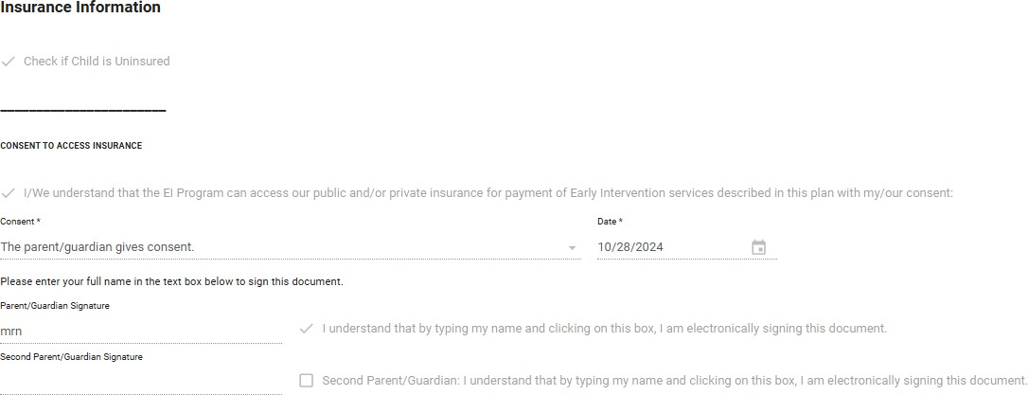

**How to capture consent in EICS**

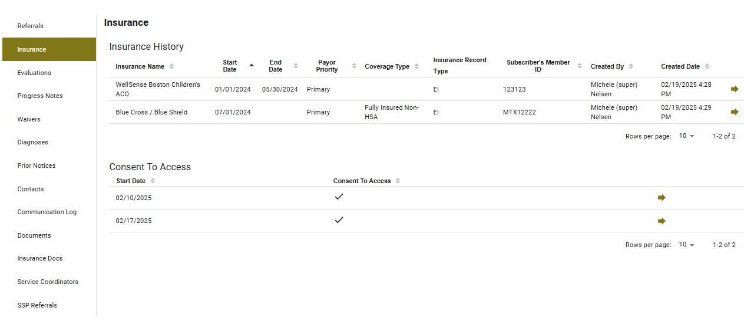

**EICS**

* Ensure to obtain written consent to use public benefits or private insurance initially, each time there is a change in service provision, and when private insurance is a prerequisite for public benefit.
* EMR users – ensure “consent to access” insurance segment with the date and yes/no is sent in.
* 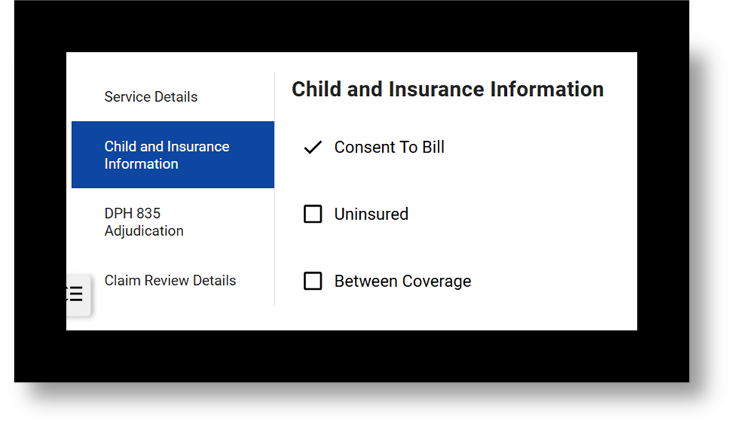This must be attested in EICS prior to each claim submission. Ensure that “Consent to Bill” under Service Details is selected. If not, you will need to go back to the Insurance/PCP Information task or create an Update Insurance Ad Hoc task and complete that section before submitting your claim. Depending on your roles, the Insurance Confirmation task must also be completed.

**Remember: There are many different consents in EICS**

* Ensure to obtain written consent to use public benefits or private insurance initially, each time there is a change in service provision, and when private insurance is a prerequisite for public benefit. This should be maintained at your location and presented upon request.
* Ensure Insurance information in the EICS is current and up to date.
* Ensure consent to access insurance is verified before services are provided and before claims (for both encounter and charge) are submitted to DPH.

**Massachusetts Department of Public Health**



# How to resubmit claims (void claims)

## February 20, 2024

8

**Early Intervention**

Massachusetts Early Intervention (EI) is a program for infants and toddlers (birth to 3 years old) who have developmental delays or are at risk of a developmental delay

**Replacement Claim and Void Claim**

* Replacement Claims and Void Claims are different procedures within the EICS system
* The replacement claim should be submitted with a claim frequency of 7. The Claim Frequency Code should be 7 to indicate that what was previously submitted should be ignored and the submitted claim taken in its place
* Void Claim should be submitted with a claim frequency of 8. The Claim Frequency Code 8 should be used to indicate a complete void of the original claim referenced. The Original Claim ID should be populated with the claim

**Replacement Claim**

If a correction to a previously submitted claim is needed, you can submit a replacement claim to:

* Correct the rate billed, location, procedure, or modifiers
* Add/Correct some patient data such as diagnosis or prior authorization information specific to prior payer information
* Make changes to your original claim such as modify units/minutes or charges for services originally submitted in error
* Ensure a new claim id number is used for the replacement claim and that the Original Claim ID is populated with the Claim Number that needs replacement (need a new replacement claim, you will need a new claim identifier, original claim 123, the replacement claim will be 1234, and you will need to reference the original claim in the replacement claim submission)

***A replacement claim should contain a claim frequency code of [7] in Loop 2300 CLM05-3 segment and reference the original claim identifier

**Void Claim**

Changes have occurred and is needed to void the claim

* Previous list of reasons to submit a replacement claim
* Charge claim has re-adjudicated and an Encounter claim needs to be submitted
* Encounter claim has re-adjudicated and a Charge claim needs to be submitted
* Void existing claim: In order to “void” an already submitted claim, a new claim should be created with a

claim frequency of 8 and it should reference the original claim that is to be voided. The void claim should be sent

to Early Intervention Client System (EICS) when the previously submitted claim should be removed/not considered for payment. A void claim must match the original claim with the exception of the claim frequency type code and the payer assigned claim number. A void claim should not contain “negative” values within the claim. It should contain a claim frequency code of [8] in Loop 2300 CLM05-3 segment. The replacement or void claim is required to be submitted with the “Original Reference Number” (Payer Claim Control Number) in Loop 2300 REF segment. REF01 must be [F8] and REF 02 must be the “Original Reference Number”. If the required information in Loop 2300 REF01 and REF02 is not submitted, the claim will reject back to the submitter

**CONNECT WITH DPH**

