**Massachusetts Department of Public Health**

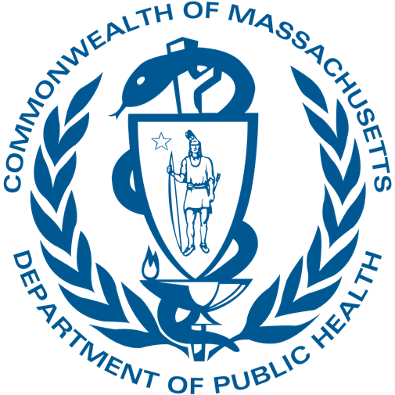

# Ask Away

October 17, 2024

**Bureau of Family Health and Nutrition Early Intervention Division**

**Finance Team**

**Deeptha Ramalingam & Manuela Batista**

**Massachusetts Department of Public Health**



# Payer of Last Resort / Claim Adjustment

October 17, 2024

2

**Who we serve?**

We serve Massachusetts families with children under the age of three who are not reaching age-appropriate milestones, diagnosed with certain conditions, or have medical or social histories which may put them at risk for a developmental delay. EI services are meant to help support families and to enhance the development and learning of infants and toddlers.

When it comes to our early intervention system, our network of providers are a fundamental part of the overall success and functioning of the system. Every day, hundreds of service coordinators, therapists, and program directors come together to invest their time, resources, and skills into improving the lives of infants and toddlers across our Commonwealth.

**Who are we?**

* Massachusetts Early Intervention (EI) is a program for infants and toddlers (birth to 3 years old) who have developmental delays or are at risk of a developmental delay
* MA Part C Program: All parties with roles and responsibilities in the program: Families, Contracted Providers, DPH, and The Early Intervention Program
* Early Intervention Division part of the Bureau of Family Health and Nutrition

**Payment of Last Resort**

Federal Part C dollars can only be used for early intervention services for an eligible infant or toddler when they are not currently entitled to receive or have payment made from any other Federal, State, local or private source (non-substitution of funds) (§303.510(a)).

**Payment for Services**

The providers will bill the insurance provided by the families

* DPH covers the cost of EI services for children who:
  + have charges that are appropriately denied by an insurance
  + have parents/guardians who have not consented to have their insurance billed
  + uninsured

**DPH Regulations**

* DPH, as the payer of last resort, will deny claims determined to be ineligible
* Prior to submission of charge claims to DPH, EI programs must follow insurers procedures and billing rules
* All charges to DPH must be fully justified as charges that another payer is not mandated or obligated to cover

**Claim Process**

* Verify and Bill to Insurance
* **Wait for resolution**
* Bill Encounter or Charge Claim to DPH for reporting and reimbursement purposes

**Claim Adjustments**

If any changes are made to the original claim for example the insurance re-adjudicates the original payment, you **MUST**:

* + Void original encounter claim and submit a charge claim

**or**

* + Update the charge claim according to the insurance bill and resubmit to DPH

**NEGATIVE VOUCHER**

Negative Vouchers happen when claim adjustments exceed payments resulting in a deficit for any reporting month

It will be necessary to issue and mail out payment to DPH with supporting documentation

**Payment Voucher Instructions**

1. Verify amount you are returning
2. Provide original Payment Voucher Reference #
3. **As** well as a negative Payment Voucher Reference # if applicable
4. Reason of adjustment
5. - **All checks should be sent to:**

MA Department of Public Health (DPH) Early Intervention Attention: Early Intervention Financial Manager

250 Washington St, (5th floor), Boston, Massachusetts 02108

**CONNECT WITH DPH**

