**Massachusetts Department of Public Health**



Policy and Reimbursement Manual Review

July 25, 2024

1

**MAEI – Early Intervention Client System (EICS)**

* 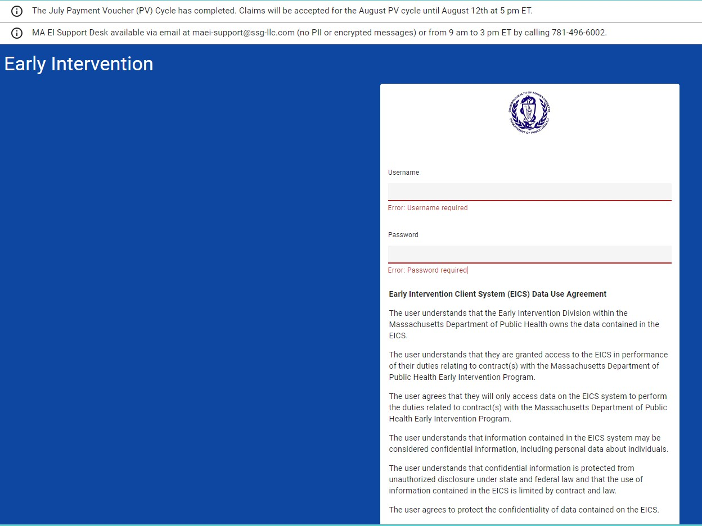Link Early Intervention (casetivity.com)
* Banners contain important reminders and are updated monthly
* Login access required (username/password)
  + Coordinate with your Clinical Oversight Support Specialist to request access

**MAEI – EICS**

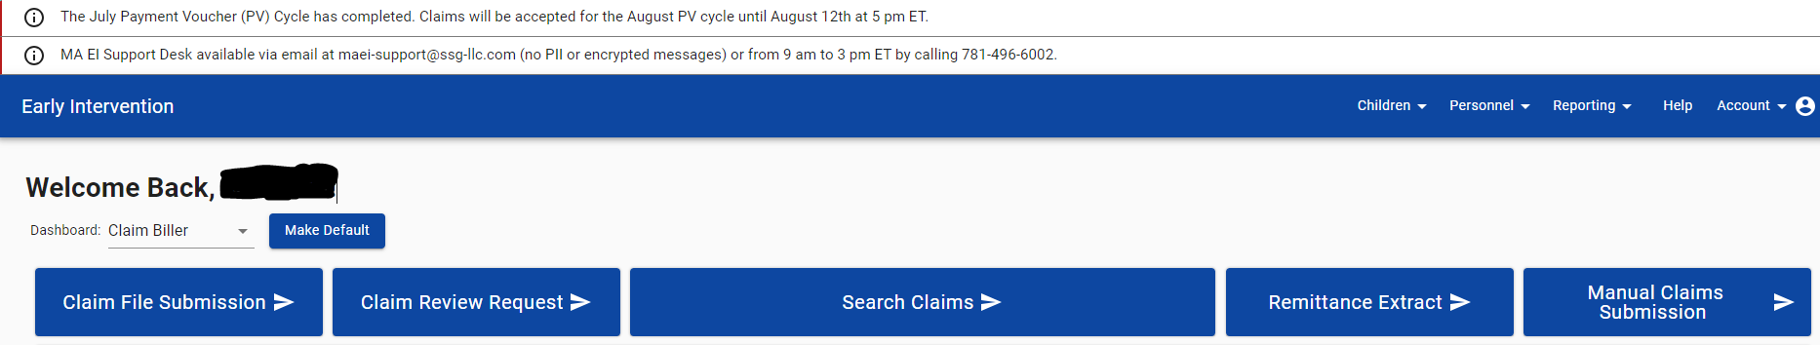

1

2

3

* + 1. Welcome Back Name!
    2. Dashboard: role (Claim Biller)
    3. Right hand corner (HELP)

**Help tab**

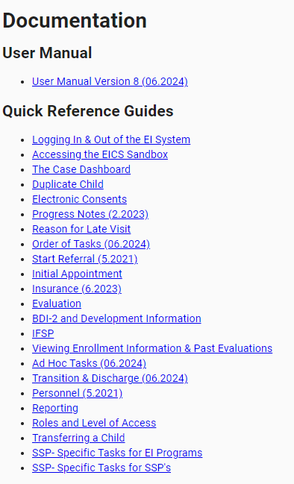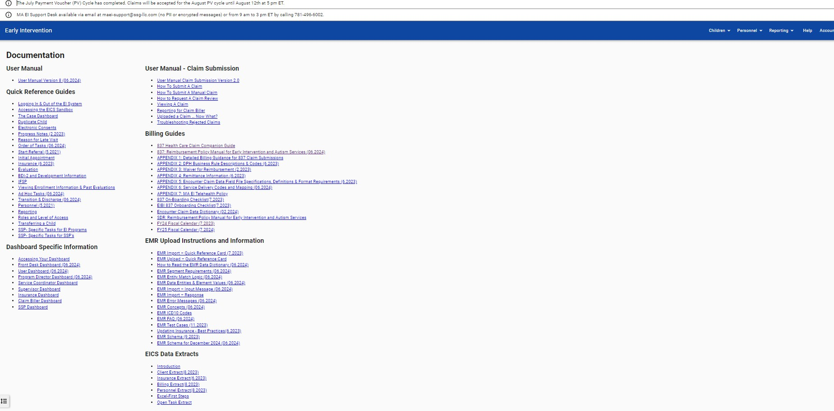

1

**Help tab (continued)**

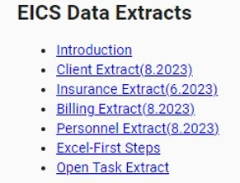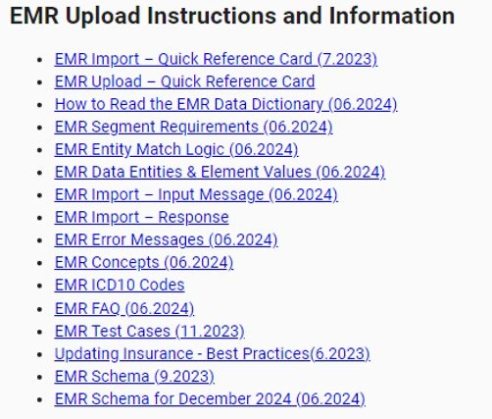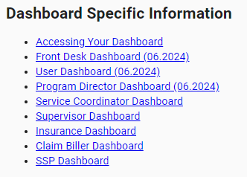2 5 6

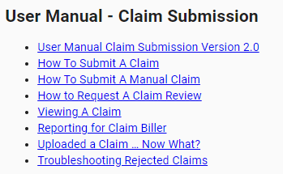3

**Help tab — Billing Guides**

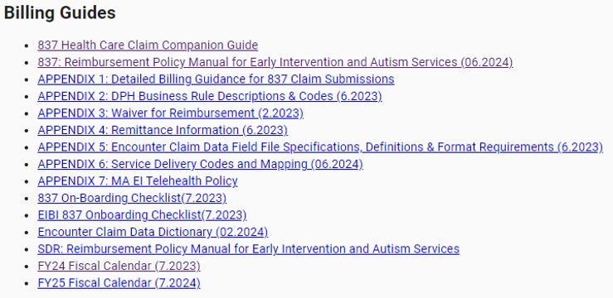4

1. 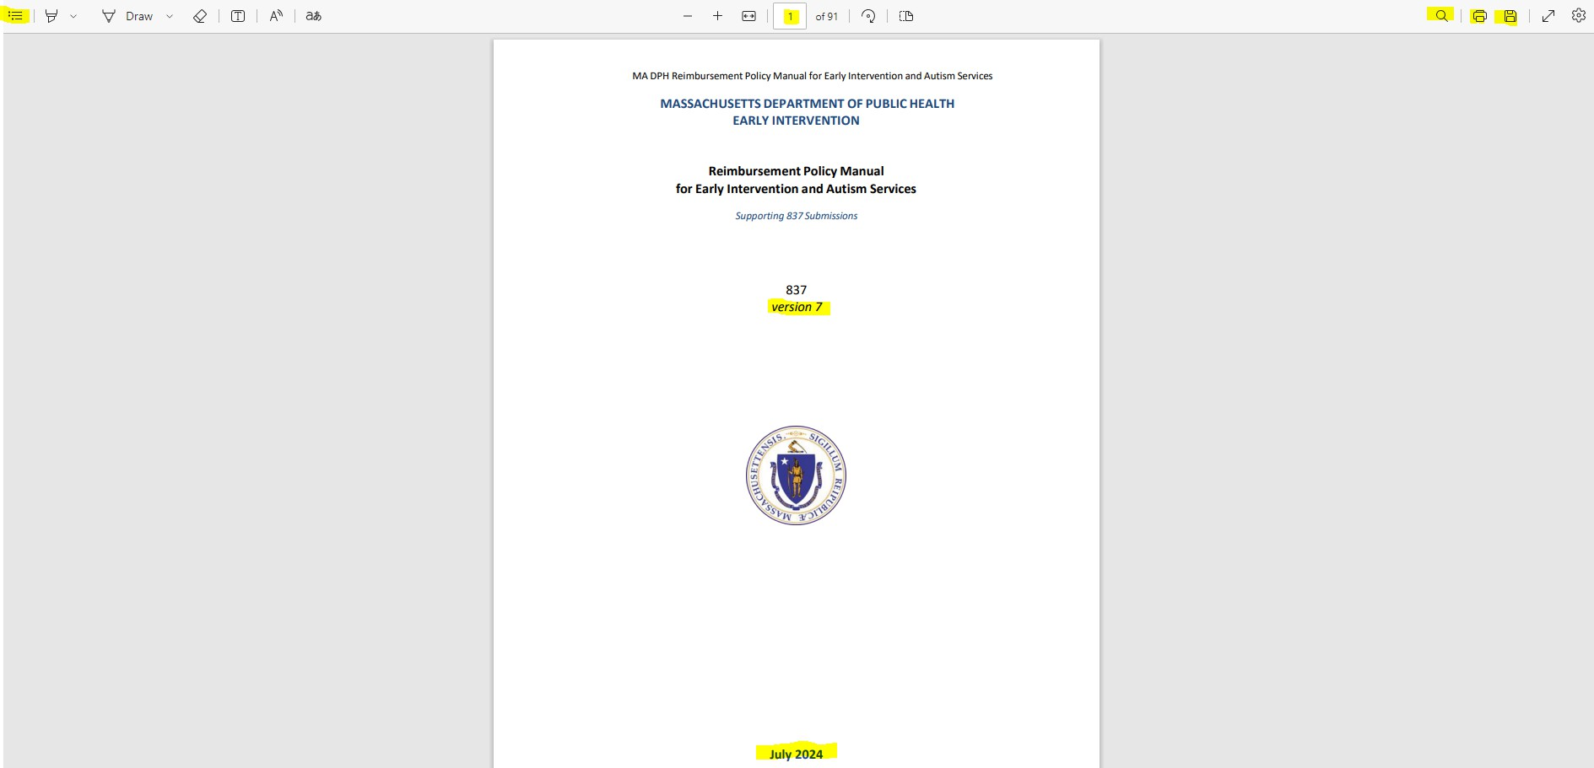**Link:** DPH+EI+Reimbursement+837+Manual+v7.pdf (casetivity.com)

4 5

6 7 8

**Reimbursement Policy Manual**

* 1. Direct link (requires login)
  2. Reflects which version is being viewed

1. 3. Reflects date that manual

was last updated

* + 1. Table of Contents
    2. Reflects current page #, can changed to go to particular page
    3. Search option
    4. Print option
    5. Save/Download option

3

**Reimbursement Recent Updates**

