Health Consultation

Assessment of Cancer Incidence Housatonic River Area, 1982-1994

GE - HOUSATONIC RIVER

PITTSFIELD, BERKSHIRE COUNTY, MASSACHUSETTS EPA FACILITY ID: MAD002084093

APRIL 9, 2002

U.S. DEPARTMENT OF HEALTH AND HUMAN SERVICES Public Health Service
Agency for Toxic Substances and Disease Registry Division of Health Assessment and Consultation Atlanta, Georgia 30333

Health Consultation: A Note of Explanation

An ATSDR health consultation is a verbal or written response from ATSDR to a specific request for information about health risks related to a specific site, a chemical release, or the presence of hazardous material. In order to prevent or mitigate exposures, a consultation may lead to specific actions, such as restricting use of or replacing water supplies; intensifying environmental sampling; restricting site access; or removing the contaminated material.

In addition, consultations may recommend additional public health actions, such as conducting health surveillance activities to evaluate exposure or trends in adverse health outcomes; conducting biological indicators of exposure studies to assess exposure; and providing health education for health care providers and community members. This concludes the health consultation process for this site, unless additional information is obtained by ATSDR which, in the Agency's opinion, indicates a need to revise or append the conclusions previously issued.

You May Contact ATSDR TOLL FREE at 1-888-42ATSDR
or
Visit our Home Page at: http://www.atsdr.cdc.gov

HEALTH CONSULTATION

Assessment of Cancer Incidence Housatonic River Area, 1982-1994

GE - HOUSATONIC RIVER

PITTSFIELD, BERKSHIRE COUNTY, MASSACHUSETTS EPA FACILITY ID: MAD002084093

Prepared by:

Massachusetts Department of Public Health Bureau of Environmental Health Assessment Community Assessment Unit
Under a Cooperative Agreement with the Agency for Toxic Substances and Disease Registry

Assessment of Cancer Incidence
Housatonic River Area, Berkshire County, Massachusetts
1982-1994

TABLE OF CONTENTS

I. INTRODUCTION 1
II. OBJECTIVE 2
III. METHODS FOR ANALYZING CANCER INCIDENCE DATA 3
A. Case Identification/Definition 3
B. Calculation of Standardized Incidence Ratios (SIRs) 5
C. Interpretation of a Standardized Incidence Ratio (SIRs) 6
D. Calculation of 95% Confidence Interval 7
E. Determination of Geographic Distribution 8
F. Evaluation of Risk Factor Information and Population Characteristics 8
IV. RESULTS OF CANCER INCIDENCE ANALYSIS 10
A. Cancer Incidence in Pittsfield (Table 1) 10
B. Cancer Incidence in Pittsfield Census Tracts 11
1. Census Tract 9001 (Table 2) 11
2. Census Tract 9002 (Table 3) 12
3. Census Tract 9003 (Table 4) 13
4. Census Tract 9004 (Table 5) 13
5. Census Tract 9005 (Table 6) 14
6. Census Tract 9006 (Table 7) 15
7. Census Tract 9007 (Table 8) 15
8. Census Tract 9008 (Table 9) 16
9. Census Tract 9009 (Table 10) 16
10. Census Tract 9010 (Table 11) 17
11. Census Tract 9011 (Table 12) 18
C. Cancer Incidence in Great Barrington (Table 13) 18
D. Cancer Incidence in Lee (Table 14) 19
E. Cancer Incidence in Lenox (Table 15) 20
F. Cancer Incidence in Stockbridge (Table 16) 20
V. RESULTS OF ANALYSIS OF RISK FACTOR INFORMATION 21
A. Bladder Cancer 22
1. Age Distribution 22
2. Gender 22
3. Smoking Status 23
4. Occupation 24
B. Breast Cancer 26
1. Age Distribution 27
2. Stage at Diagnosis Pittsfield 28
3. Reproductive Factors 30
4. Socioeconomic Status 32
C. Non-Hodgkin’s Lymphoma 34
1. Age and Gender Distribution 34
2. Occupation 34
VI. REVIEW OF GEOGRAPHIC DISTRIBUTION OF CANCER CASES 36
VII. DISCUSSION 37
VIII. LIMITATIONS 41
IX. CONCLUSIONS 42
X. RECOMMENDATIONS 43
XI. PUBLIC HEALTH ACTION PLAN 43
XII. REFERENCES 45

. '

LIST OF FIGURES

Figure 1. Location of Study Towns, Housatonic River Area, Berkshire County, MA

Figure 2. The Newell Street Area 1 and Newell Street Area 2 Site Locations, Pittsfield, MA

Figure 3. Location of Census Tracts in Pittsfield, MA Figure 4. Census Tract 9251 Great Barrington, MA Figure 5. Census Tract 9141 Lee, MA
Figure 6. Census Tract 9131 Lenox, MA

Figure 7. Census Tract 9241 Stockbridge, MA

Figure 8. Distribution of Known Smoking Status, Male Bladder Cancer, 1982-1994

Figure 9. Distribution of Known Smoking Status, Male Bladder Cancer, 1982-1986

Figure 10. Distribution of Known Smoking Status in Census Tract 9002, Bladder Cancer, 1982- 1986

Figure 11. Distribution of Known Smoking Status in Census Tract 9002, Male Bladder Cancer, 1982-1986

Figure 12. Distribution of Known Smoking Status in Census Tract 9011, Bladder Cancer, 1987- 1994

Figure 13. Distribution of Known Smoking Status in Census Tract 9011, Female Bladder Cancer, 1987-1994

Figure 14. Age Distribution of Female Breast Cancer Cases in Census Tract 9002, 1982-1994

V

Figure 15. Age Distribution of Female Breast Cancer Cases in Pittsfield, MA, 1982-1994

Figure 16. Age-group Specific Breast Cancer Standardized Incidence Ratios in Pittsfield, MA, 1982-1994

Figure 17. Female Breast Cancer Staging, Pittsfield, MA versus the State of Massachusetts, 1982-1994

Figure 18. Annual Trends in Female Breast Cancer Staging, Pittsfield, MA versus the State of Massachusetts, 1982-1994

Figure 19. Female Breast Cancer, by Census Tract, in Pittsfield, MA, 1982-1994

Figure 20. Mean Age at First Birth in Pittsfield, MA, and in the State of Massachusetts, 1975- 1990

Figure 21. Percentage of First Births Among Women Aged 15-29 years and 30-44 years in Pittsfield, MA, and in the State of Massachusetts, 1975-1990

Figure 22A. Percentage Distribution of First, Second, and Third Births in Pittsfield, MA, 1975- 1990

Figure 22B. Percentage Distribution of First, Second, and Third Births, State of Massachusetts, 1975-1990

LIST OF TABLES

Table 1.

Table 2.

Table 3.

Table 4.

Table 5.

Table 6.

Table 7.

Table 8.

Table 9.

Table 10.

Table 11.
Cancer Incidence in Pittsfield, MA, 1982-1994, 1982-186, and 1987-1994

Cancer Incidence in Pittsfield, MA Census Tract 9001, 1982-1994, 1982-1986, and 1987-1994

Cancer Incidence in Pittsfield, MA Census Tract 9002, 1982-1994, 1982-1986, and 1987-1994

Cancer Incidence in Pittsfield, MA Census Tract 9003, 1982-1994, 1982-1986, and 1987-1994

Cancer Incidence in Pittsfield, MA Census Tract 9004, 1982-1994, 1982-1986, and 1987-1994

Cancer Incidence in Pittsfield, MA Census Tract 9005, 1982-1994, 1982-1986, and 1987-1994

Cancer Incidence in Pittsfield, MA Census Tract 9006, 1982-1994, 1982-1986, and 1987-1994

Cancer Incidence in Pittsfield, MA Census Tract 9007, 1982-1994, 1982-1986, and 1987-1994

Cancer Incidence in Pittsfield, MA Census Tract 9008, 1982-1994, 1982-1986, and 1987-1994

Cancer Incidence in Pittsfield, MA Census Tract 9009, 1982-1994, 1982-1986, and 1987-1994

Cancer Incidence in Pittsfield, MA Census Tract 9010, 1982-1994, 1982-1986, and 1987-1994

Table 12.

Table 13.

Table 14.

Table 15.

Table 16.

Table 17.
Cancer Incidence in Pittsfield, MA Census Tract 9011, 1982-1994, 1982-1986, and 1987-1994

Cancer Incidence in Great Barrington, MA, 1982-1994, 1982-1986, and 1987-1994

Cancer Incidence in Lee, MA, 1982-1994, 1982-1986, and 1987-1994

Cancer Incidence in Lenox, MA, 1982-1994, 1982-1986, and 1987-1994

Cancer Incidence in Stockbridge, MA, 1982-1994, 1982-1986, and 1987-1994

Comparison of Breast Cancer Incidence and Socioeconomic Factors in Pittsfield, MA

INTRODUCTION

Following a proposal by the U.S. Environmental Protection Agency (EPA) to include the General Electric Company (GE) site in Pittsfield, Massachusetts (MA) on the Agency's National Priorities List (NPL), EPA initiated several evaluations on, and around, the site. These evaluations were made to examine the possible relationship between polychlorinated biphenyls (PCBs) and other contaminants present in specific regions on and near the site and potential exposures to these contaminants among residents of the Housatonic River Area (EPA 1997). The Pittsfield GE site is comprised of 10 separate areas. Each area is unique and provides an opportunity for distinct exposures on, and around, it. For this reason, each area was evaluated separately. A public health assessment at each of the 10 areas evaluated available environmental sampling data (e.g., surface soil and ambient air) and delineated potential exposure pathways associated with historical contamination with PCBs and other contaminants. In 1998, ATSDR completed a health consultation for 1 of the 10 areas (Allendale School property). During fall 2001, draft reports for 8 public health assessments (MDPH 2001a-h) conducted at the GE site were released for public comment by the Environmental Toxicology Program of the Massachusetts Department of Public Health (MDPH), Bureau of Environmental Health Assessment (BEHA). The assessments were conducted by MDPH through a cooperative agreement with the Agency for Toxic Substances and Disease Registry (ATSDR). The tenth evaluation, on the Housatonic River itself, is expected to be released by late spring 2002.

The Community Assessment Unit (CAU) of BEHA also conducted an evaluation of cancer incidence in each of the city/towns of Pittsfield, Great Barrington, Lee, Lenox, and Stockbridge, MA. This evaluation was produced to complement the public health assessments and to address cancer concerns expressed by area residents, local health officials, and local elected officials. These evaluations also were completed through a cooperative agreement with ATSDR.

In this report, the combined area containing the city/towns of Pittsfield, Great Barrington, Lee, Lenox, and Stockbridge, MA is referred to as the Housatonic River Area (HRA). The location of the HRA and the Housatonic River are shown in Figure 1. Specifically, this evaluation was initiated because of concerns expressed among HRA residents about possible exposures to PCB

contamination associated with the GE sites and the potential association with the incidence of cancer in these communities. Particular emphasis was placed on those census tracts in Pittsfield that immediately surround the GE sites of concern. See Figures 2 and 3. The city/towns of Lenox, Lee, Stockbridge, and Great Barrington were included in this evaluation because of concern about PCB contamination of the Housatonic River and the sediment immediately surrounding the river, and because EPA's proposed listing of the site on the NPL included the Housatonic River between Pittsfield and Rising Pond Dam in Great Barrington.

OBJECTIVE

This report provides a descriptive evaluation of the occurrence of cancer in the city/towns of Pittsfield, Great Barrington, Lenox, Lee and Stockbridge. It compares the incidence of selected cancer types within these communities to the incidence of cancer in the state of Massachusetts. The state of Massachusetts is used as a comparison to provide a stable, standard population to calculate and compare cancer incidence rates. In addition, available information was evaluated about risk factors related to the development of cancer, including environmental factors.

The information described in this report is a descriptive analysis of cancer incidence data and, therefore, cannot be used to establish a causal link between a particular risk factor and the development of cancer. In addition, this analysis cannot determine the cause of any one individual's diagnosis. However, information from such descriptive analyses can be useful in determining whether or not a common etiology (or cause) of cancers is possible, and in identifying specific areas where further public health investigations or actions may be warranted. Such actions may include follow-up environmental investigations or public health intervention activities (e.g., cancer screening, smoking cessation, etc.). Intervention activities may be warranted when an excess of well-established risk factors associated with a disease has been identified in a specific geographic area. The purpose of this evaluation is to report the findings on patterns for cancer in these

communities and discuss them in the context of the available information to determine whether recommendations for follow-up are warranted.

The specific objectives of this investigation were as follows:

To review cancer incidence data for the city/towns of Pittsfield, Great Barrington, Lee, Lenox, and Stockbridge as part of health assessment activities related to the GE site in Pittsfield. This review of cancer-incidence data included evaluations of smaller geographic areas within each city/town for the time period 1982-1994;

To evaluate the geographic distribution and spatial patterns of cancer incidence for all five communities in order to determine whether a geographic pattern of cases exists in certain areas of the five city/towns;

To review available descriptive information as reported to the Massachusetts Cancer Registry (MCR) for individuals in the HRA who were diagnosed with specific cancer types related to risk factors for developing cancer;

To discuss the results of this evaluation, in the context of available scientific and medical literature on cancer, to determine whether future investigation or public health action is warranted.

METHODS FOR ANALYZING CANCER INCIDENCE DATA

A. Case Identification/Definition

The observed number of cancer cases in this evaluation was derived from cases reported to the MCR as primary site cancer cases diagnosed among residents of the five towns during 1982- 1994. Cases were selected for inclusion on the basis of the address reported to the hospital or reporting facility at the time of diagnosis.

The MCR is a population based surveillance system that began collecting information on Massachusetts residents diagnosed with cancer in the state in 1982. All newly diagnosed cancer cases are required by law to be reported to the MCR within six months of the date of diagnosis (M.G.L.c.1 lls.11lb). The 13-year period 1982-1994 constitutes the period for which the most recent and complete cancer incidence data were available at the time of this analysis.

The term "cancer" is used to describe a variety of diseases associated with abnormal cell or tissue growth. Primary site (location in the body where the disease originated) and histology (tissue or cell type) classify the different cancer types. Epidemiological studies have revealed that different types of cancer are individual diseases with separate causes, risk factors, characteristics, and patterns of survival (Bang 1996). Therefore, for this analysis, each cancer type was evaluated separately.

Six cancer types were evaluated in this investigation, cancers of the bladder, breast, liver, and thyroid -- as well as Hodgkin's disease and non-Hodgkin's lymphoma (NHL). These cancer types were selected for evaluation on the basis of concerns expressed by HRA residents or because the scientific literature suggests possible association between PCB exposure and some of these cancer types. Also, an expert panel convened by MDPH supported the selection of these cancer types (MDPH 2000). Only primary site cancers were included in this evaluation. Cancers that occurred as the result of metastases (the spread of a primary site cancer to another location in the body) are not considered as a separate cancer and, therefore, were not included in this evaluation.

In addition, the MCR research file occasionally contains duplicate reports of cancer cases. The data discussed in this report have been controlled for duplicate cases by excluding them from the analysis. However, reports of multiple primary site cancer were included. Duplicate cases are additional reports of the same primary site cancer case. A multiple primary cancer case is defined by the MCR as a new tumor of the same histology (cell type) as an earlier cancer, if diagnosed in the same primary site (original location in the body) more than two months after the initial diagnosis (MCR 1996). The determination that a case was a duplicate and should be excluded from the analysis was made by the MCR, after consultation with the hospital or reporting facilities and obtaining additional information regarding the histology and/or pathology of the case. In this investigation, ten cases were found to be duplicates and, therefore, were not included in the evaluation.

B. Calculation of Standardized Incidence Ratios (SIRs)

To determine whether elevated numbers of cancer cases have occurred in the HRA or any of the appropriate census tracts, cancer incidence data were analyzed by age and gender to compare the observed number of cancer cases in each census tract to the number that would be expected based on the statewide cancer experience. Standardized incidence ratios (SIRs) were calculated for the six cancer types evaluated in each of the five individual communities, and in the case of Pittsfield, for each of its 11 census tracts (CTs). According to the U.S. Census Bureau, the towns Lenox, Lee, Stockbridge and Great Barrington are not geographically subdivided into census tracts. In addition, SIRs were calculated for the time period 1982-1994 and for the two smaller time periods 1982-1986 and 1987-1994, in order to evaluate patterns or trends in cancer incidence over time.

In order to calculate standardized incidence ratios, it is necessary to obtain accurate population information. The population figures used for this analysis were interpolated using 1980 and 1990 U.S. census data for each CT in Pittsfield and for the towns of Great Barrington, Lee, Lenox and Stockbridge (U.S. DOC 1980 and 1990). Midpoint population estimates were calculated for each time period evaluated. To estimate the population between census years, an assumption was made that the change in population occurred at a constant rate throughout the 10-year interval between each census.

Because accurate age-group and gender specific population data are required to calculate SIRs, the CT is the smallest geographic area for which cancer rates can be accurately calculated. Specifically, a CT is a smaller statistical subdivision of a county, as defined by the U.S. Census Bureau. CTs usually contain between 2,500 and 8,000 persons and are designed to be homogenous with respect to population characteristics (U.S. DOC 1990).

According to the 1980 U.S. Census, the city of Pittsfield was comprised of 11 CTs (i.e., 9001 through 9011). During the 1990 U.S. Census, the Census Bureau further divided one Pittsfield CT (9010). This spilt produced a total of 12 census tracts of smaller size in Pittsfield. Each of the remaining towns (i.e., Lenox, Lee, Stockbridge, and Great Barrington) comprises one CT. Upon examination of the 1980 and 1990 U.S. Census maps for the city of Pittsfield, it was determined that CT 9012 was derived from CT 9010. In order to calculate accurate SIRs for the time period 1982-

1994, the two 1990 U.S. census population counts for CTs 9010 and 9012 were combined in an effort to more accurately reflect the 1980 census of Pittsfield that contains 11 CTs. Therefore, for the purpose of this evaluation, SIRs were calculated according to the 1980 census tract designations for Pittsfield (i.e., census tracts 9001, 9002, 9003, 9004, 9005, 9006, 9007, 9008, 9009, 9010, and 9011). The locations of census tracts for Pittsfield and town boundaries of the other four towns are illustrated in Figures 3 through 7.

C. Interpretation of a Standardized Incidence Ratio (SIRs)

An SIR is an estimate of the occurrence of cancer in a population relative to what might be expected if the population had the same cancer experience as some larger comparison population designated as "normal" or average. Usually, the state as a whole is selected to be the comparison population. Using the state of Massachusetts as a comparison population provides a stable population base for the calculation of incidence rates. As a result of the instability of incidence rates based on small numbers of cases, SIRs were not calculated when fewer than five cases were observed.

Specifically, an SIR is the ratio of the observed number of cancer cases to the expected number of cases multiplied by 100. An SIR of 100 indicates that the number of cancer cases observed in the population evaluated is equal to the number of cancer cases expected in the comparison or "normal" population. An SIR greater than 100 indicates that more cancer cases occurred than expected and an SIR less than 100 indicates that fewer cancer cases occurred than expected. Accordingly, an SIR of 150 is interpreted as 50% more cases than the expected number; an SIR of 90 indicates 10% fewer cases than expected.

Caution should be exercised, however, when interpreting an SIR. The interpretation of an SIR depends on both the size and stability of the SIR. Two SIRs can have the same size but not the same stability. For example, an SIR of 150 based on four expected cases and six observed cases indicates a 50% excess in cancer, but the excess is actually two cases. Conversely, an SIR of 150 based on 400 expected cases and 600 observed cases represents the same 50% excess in cancer, but because the SIR is based upon a greater number of cases, the estimate is more stable. It is very unlikely that 200 excess cases of cancer would occur by chance alone.

D. Calculation of 95% Confidence Interval

To help interpret or measure the stability of an SIR, the statistical significance of each SIR was also assessed. The statistical significance of an SIR was assessed by calculating a 95% confidence interval (95% Cl) for each SIR to determine if the observed number of cases is "significantly different" from the expected number or if the difference may be due solely to chance (Rothman and Boice 1982). Specifically, a 95% CI is a range of estimated SIR values that have a 95% probability of including the true SIR for the population. If the 95% CI range does not include the value 100, then the study population is significantly different from the comparison or "normal" population. "Significantly different" means there is less than a 5% chance that the observed difference (either increase or decrease) is the result of random fluctuation in the number of observed cancer cases.

For example, if a confidence interval does not include 100 and the interval is above 100 (e.g., 105-130), then there is a statistically significant excess in the number of cancer cases. Similarly, if the confidence interval does not include 100 and the interval is below 100 (e.g., 45-96), then the number of cancer cases is statistically significantly lower than expected. If the confidence interval range includes 100, then the true SIR may be 100, and it cannot be concluded with sufficient confidence that the observed number of cases is not a result of chance and reflects a real cancer increase or decrease.

In addition to the range of the SIR estimates contained in the confidence interval, the width of the confidence interval also reflects the stability of the SIR estimate. For example, a narrow confidence interval (e.g., 103-115) allows a fair level of certainty that the calculated SIR is close to the true SIR for the population. A wide interval (e.g., 85-450) leaves considerable doubt about the true SIR, which could be much lower than or much higher than the calculated SIR. This would indicate an unstable statistic. Again, due to the instability of incidence rates based on small numbers of cases, statistical significance was not assessed when fewer than five cases were observed. It is important to note that the presence or absence of statistical significance does not necessarily imply public health significance. Determination of statistical significance is just one tool used to interpret SIRs.

E. Determination of Geographic Distribution

The geographic distribution of cancer cases was determined using available information from the MCR indicating the individuals' residential address at the time of diagnosis. This information was mapped for each individual using a computerized geographic information system (GIS) (Maplnfo 1994). This allowed for the assessment of city/town and CT location for each case as well as an evaluation of the spatial distribution of cases at a smaller geographic level (i.e., neighborhoods). The geographic distribution was assessed using a qualitative evaluation of the point pattern of cases within the communities and within each census tract. In instances where address information was incomplete (i.e., did not include specific streets or street numbers), efforts were made to research those cases using telephone books, residential lists, voter lists, death indexes and property deeds. Address information for these individuals was researched from documents issued within two years of an individual's diagnosis. Address locations also were confirmed by site visits to the area. However, some address locations could not be confirmed, even after the above mentioned efforts were employed. As a result, in the towns of Great Barrington, Lee, and Stockbridge, the residential location of six individuals diagnosed with bladder cancer, two with breast cancer, and two with non-Hodgkin's lymphoma could not be mapped or analyzed spatially.

F. Evaluation of Risk Factor Information and Population Characteristics

The MCR routinely collects data related to possible risk factors for individuals diagnosed with cancer (e.g., age, smoking status, and occupation). This information was evaluated for those cancer types that were statistically significantly elevated in any of the five communities evaluated. However, information about other risk factors (e.g., family history, hormonal events, diet) that also may influence the development of some cancers are not collected by the MCR and, therefore, could not be evaluated in this investigation.

This investigation also reviews information from the MCR on the pattern of stage of diagnosis. Staging categorizes the extent of disease and its spread at the time of diagnosis. The analysis of breast cancer in this report defines stages in the following four categories: localized, regional, distant, or unknown. Localized breast cancer represents a diagnosis that the tumor is invasive but the

cancer is confined to the breast. Regional indicates that the tumor has spread beyond the organ of origin (e.g., breast). This may include the spread to adjacent tissues or organs, lymph nodes, or both (MCR 1996). Distant indicates that the cancer has metastasized, or spread, to organs other than those adjacent to the organ of origin, or to distant lymph nodes, or both (MCR 1996). Some of the cases reported to the MCR are reported with an unknown stage. This indicates that the tumor had not been staged at the time it was reported.

It should be noted that this report assesses only breast cancers reported as localized, regional, distant, or unknown. In 1992, the MCR began collecting data regarding breast cancer cases categorized as in-situ breast cancer. Breast cancer in-situ is defined as malignant cells within the breast ductal-lobular system without evidence of invasion of neighboring tissues (Harris et al. 1996). In-situ cases of breast cancer have not been included in this report because these have only been available since 1992.

Such factors as late age at first full-term pregnancy, low parity (few or no children), early age at menarche (menstruation), and late age at menopause have been associated with an increased risk of developing breast cancer. In addition to maintaining the MCR, the Bureau of Health Statistics, Research and Evaluation also collects information for all births that occur in the state of Massachusetts. However, information regarding these factors is not readily available for individuals in Pittsfield who are diagnosed with breast cancer. Furthermore, the information provided by the Bureau of Health Statistics, Research and Evaluation only presents data city/town wide; therefore, an evaluation of census-tract-specific parity could not be reviewed. However, a review of how these factors have changed over time for a community as a whole helps to determine whether these factors suggest a relationship to a pattern associated with increased breast cancer risk. These data were evaluated for the 15-year time period 1975 to 1990.

Indicators of socioeconomic status (SES) (e.g., income and education level) also have been shown to correlate with factors related to an increased risk of breast cancer, including having fewer children (lower parity) and an older age at first childbirth (Henderson et al. 1996a). Additionally, women of higher SES are more likely to have access to screening services and other health care. Data from the U.S. Bureau of the Census for three variables were evaluated for each CT in Pittsfield, for the city of Pittsfield as a whole, and for the state of Massachusetts to determine whether these factors may be related to increased or decreased rates of breast cancer. The three variables evaluated

are 1) age of individuals with a bachelor's degree or higher, 2) median household income, and 3) percentage of individuals below the poverty level (U.S. DOC 1990). It was then possible to make comparisons between each census tract, the city of Pittsfield, and the state of Massachusetts with regards to socioeconomic status. The utility of these types of measures as indicators of reproductive behavior has been shown in other studies (dos Santos Silva and Beral 1997; Heck et al. 1997; Williams 1997).

RESULTS OF CANCER INCIDENCE ANALYSIS

The following sections present cancer incidence rates for Pittsfield as a whole, and for each of the 11 Pittsfield CTs. The primary focus of this evaluation is to address concerns about suspected elevations of cancer in certain areas of Pittsfield, specifically, those areas of CTs 9002 and 9010 surrounding the General Electric site. A review of cancer incidence in each of the 11 Pittsfield CTs is presented in detail in the following sections. Figure 3 depicts the location and boundaries of the 11 CTs evaluated in this report. Tables 1 through 12 summarize cancer-incidence data for the city of Pittsfield for the three different time periods: 1982-1994 and for the two smaller time periods 1982-1986 and 1987-1994.

A. Cancer Incidence in Pittsfield (Table 1)

During the period 1982-1994, the majority of cancer types evaluated in Pittsfield occurred less than or about equal to what was expected. For males and females combined, cancers of the breast and liver, as well as Hodgkin's disease and NHL, occurred less often than expected. Cancer of the bladder and thyroid, however, occurred more often than expected (refer to Table 1). The elevation in bladder cancer nearly achieved statistical significance. Overall, 155 cases were observed, when approximately 133 were expected; SIR=l 17.

Among males, bladder cancer occurred statistically significantly more often than expected; 126 cases were observed when approximately 95 cases would have been expected (SIR=133; 95% CI=111-158) (refer to Table 1). Hodgkin's disease and NHL also occurred more often than expected, among males, but these elevations were not statistically significant. Among females, non­ Hodgkin's lymphoma occurred statistically significantly less often than expected (37 observed cases versus approximately 55 cases expected; SIR=67; 95% CI=47-92). Among females, thyroid cancer

was elevated, 25 cases were observed when approximately 18 cases were expected (SIR=137). This elevation was not statistically significant.

During the earlier time period 1982-1986, cancer incidence in Pittsfield generally occurred lower than the expected rates for most cancer types evaluated. However, the rate of bladder cancer nearly achieved statistical significance (refer to Table 1). Overall, 69 cases of bladder cancer were observed, when approximately 54 cases would have been expected (SIR=127; 95% CI=99-161). Bladder cancer among females, however, occurred less often than expected at a level that was nearly statistically significant (eight cases observed versus approximately 16 cases expected; SIR=51). The incidence of bladder cancer among males occurred statistically significantly more often than expected. Among males, 61 cases of bladder cancer were observed when approximately 39 cases

would have been expected (SIR=158; 95% CI=121-203). Slight elevations also were observed among males diagnosed with NHL and among females diagnosed with cancers of the breast and thyroid. These elevations were based on three or less cases, and none was statistically significant.

Overall, cancer incidence in Pittsfield during the later time period (1987-1994) occurred more often than expected for cancers of the bladder, liver, and thyroid. Although elevations were observed among these cancer types, none of the elevations was statistically significant. Bladder cancer incidence was also elevated among males during 1987-1994; however, the increase was not statistically significant. Non-significant elevations also were observed among males diagnosed with cancer of the liver, as well as Hodgkin's disease and NHL. Among females, eighteen cases of thyroid cancer were observed when approximately 13 were expected. Among females, NHL occurred statistically significantly less often than expected (refer to Table 1).

B. Cancer Incidence in Pittsfield Census Tracts

1. Census Tract 9001 (Table 2)

During the 13-year period 1982-1994, cancer incidence in CT 9001, located in the central portion of the city, generally occurred equal to, or below, expected rates. Among males and females combined, a slight elevation was observed for cancer of the breast. This elevation was not statistically significant and was primarily due to a slight increase in incidence observed among

females (refer to Table 2). Among males, cancer incidence generally occurred at rates equal to, or below, the expected rates.

During the earlier time period 1982-1986, cancer incidence in CT 9001 generally occurred about equal to, or below, the expected rates for the six cancer types evaluated. Overall and among males, a slight elevation was observed in cancer of the bladder, which was based on an increase of approximately one additional case (refer to Table 2). Among females, cancer incidence generally occurred equal to, or below, expected rates. During the later time period 1987-1994, cancer incidence in CT 9001 also generally occurred about equal to, or below, the expected rates. Among females, cancer of the breast and thyroid occurred slightly more often than expected (refer to Table 2). Neither of these elevations was statistically significant. Among males, cancer incidence generally occurred about equal to, or below, the expected rates.

2. Census Tract 9002 (Table 3)

The General Electric site is located adjacent to the eastern portion of this CT. During the 13- year time period 1982-1994, cancer incidence in CT 9002 generally occurred below the expected rates, with the exception of bladder and breast cancers. Cancer of the bladder occurred more often than expected among males and for the city as a whole. The increase observed in bladder cancer incidence was primarily due to a nearly statistically significant elevation in incidence among males (15 observed cases versus approximately 8 cases expected; 95% CI=l00-295). Overall and among females, breast cancer occurred statistically significantly more often than expected (refer to Table 3). Among females, 47 cases of breast cancer were observed, when approximately 31 cases would hav7e been expected (SIR=151; 95% CI=l11-200). No cases of liver cancer were observed in CT 9002 during the entire 13-year time period.

During the earlier time period 1982-1986, cancer incidence generally occurred less than, or about equal to, what was expected, with the exception of bladder cancer. Bladder cancer was statistically significantly elevated overall and among males. Twelve cases of bladder cancer occurred in CT 9002 when approximately five cases were expected (SIR=241; 95% CI=124-420). Among males, 11 cases were observed when approximately four cases were expected (SIR=311; 95% CI=155-557)). One case of bladder cancer occurred among females during 1982-1986. Among females in this census tract, breast cancer occurred slightly more often than expected (refer to Table

3). The elevation was not statistically significant. During the later period, 1987-1994, all cancer types in CT 9002 occurred approximately equal to, or below, expected rates (refer to Table 3).

3. Census Tract 9003 (Table 4)

CT 9003 is located centrally in the city of Pittsfield just north of the General Electric site. During the 13-year time period 1982-1994, cancer incidence in this Pittsfield CT generally occurred equal to, or below, expected rates (refer to Table 4). A slight elevation in breast cancer was observed. However, the increase was based on approximately three additional cases and the elevation was not statistically significant.

During the earlier time period 1982-1986, cancer incidence in CT 9003 also occurred predominantly below expected rates with the exception of breast cancer (refer to Table 4). Breast cancer occurred more often than expected during this time period. Seventeen cases of breast cancer were observed, when approximately 12 cases would have been expected (SIR=143). During the later time period 1987-1994, cancer incidence also generally occurred about equal to, or below, expected rates. One additional case of liver cancer occurred during this time period. One additional case of bladder cancer among males also was observed.

4. Census Tract 9004 (Table 5)
During the 13-year time period 1982-1994, cancer incidence in CT 9004, located in the northern central area of the city along the border with Lanesborough, generally occurred slightly more often than expected. However, female breast cancer occurred statistically significantly less often than expected. During the 13 years evaluated, 34 women were diagnosed with breast cancer in this census tract, when approximately 51 cases were expected (SIR=66). Thyroid cancer occurred slightly more often than expected among females; four cases observed where two cases were expected (refer to Table 5). Cancers of the bladder and liver, as well as Hodgkin's disease and NHL, were slightly elevated among males. None of these elevations were statistically significant, and all were based on an excess of a small number of cases (i.e., less than four cases).

During the earlier time period 1982-1986, cancer incidence in CT 9004 generally occurred about equal to, or below, the expected rates (refer to Table 5). Cancer of the bladder occurred slightly more often than expected overall, and among males. However, the observed increase was based on approximately two additional cases overall. Breast cancer again occurred statistically

significantly less often than expected. Moreover, no cases of liver cancer, Hodgkin's disease, or NHL were observed among females during the earlier time period. During the later time period 1987-1994, cancer of the liver and thyroid, as well as Hodgkin's disease and NHL, occurred slightly more often than expected. None of the observed elevations were statistically significant, and these elevations were based on a small number of cases. The slight elevations observed in cancer of the liver, Hodgkin's disease, and NHL, overall, were primarily attributed to slight elevations in these cancer types among males. However, the elevation observed in thyroid cancer was due to an increase of approximately two cases among females (refer to Table 5).

5. Census Tract 9005 (Table 6)

CT 9005 covers the western portion of Pittsfield along the eastern border of the town of Hancock. During the 13-year time period 1982-1994, bladder cancer overall in CT 9005 was slightly elevated due to an excess of about one additional case each among males and females. NHL also occurred slightly more often than expected overall. This was primarily due to one additional case among females. Among males, cancer of the thyroid was slightly elevated. None of the elevations observed during 1982-1994 were statistically significant (refer to Table 5). No cases of liver cancer were observed in CT 9005 during the entire 13-year time period.

When evaluated for the two smaller time periods (1982-1986 and 1987-1994), cancer incidence in CT 9005 occurred about equal to, or below, expected rates for most of the six cancer types evaluated. During the earlier time period 1982-1986, a slight elevation was observed in breast cancer incidence among females. The observed increase did not achieve statistical significance and was based on approximately three additional cases (13 cases observed versus 10.4 cases expected; SIR=125). Among females, cancer of the bladder occurred slightly more often than expected. Again, this elevation did not achieve statistical significance, and it was based on a small number of excess cases (i.e., less than one case). One case of bladder cancer was observed among males during the earlier time period 1982-1986 (refer to Table 6). No other cancer type occurred among males in CT 9005 during 1982-1986. During the later time period 1987-1994, cancers of the bladder and thyroid as well as NHL were slightly elevated overall and among males. Among females, with the exception of NHL, all cancer types evaluated occurred approximately equal to, or less often than, expected. None of the elevations observed during this time period was statistically significant.

6. Census Tract 9006 (Table 7)

In CT 9006, located in the center portion of Pittsfield, most of the cancer types evaluated occurred below expected rates during the 13-year time period 1982-1994 (refer to Table 7). One additional case above the expected number occurred for cancers of the liver and thyroid. Both cases occurred among males.

During the earlier time period 1982-1986, bladder cancer and NHL incidence in CT 9006 were slightly elevated. All of the other cancer types occurred less often than expected (refer to Table 7). For bladder cancer overall six cases occurred where approximately four cases were expected (SIR=143). For NHL, four cases occurred where approximately three cases were expected. The increase in bladder cancer cases was due to two additional cases that occurred among males in this census tract, whereas for NHL, the increase was due to slightly less than three additional cases above the expected number among females. No cases of NHL occurred among males in CT 9006 during 1982-1986. During the later time period 1987-1994, overall, cancers of the breast, liver and thyroid occurred slightly more often than expected. Thirty-one breast cancer cases were observed among females, when approximately 27 cases would have been expected. Elevations overall in cancer of the liver and thyroid were primarily due to an increase in incidence consisting of one additional case among males. None of these elevations was statistically significant (refer to Table 7).

7. Census Tract 9007 (Table 8)
During the 13-year time period 1982-1994, cancer incidence in CT 9007, located in the southwestern section of Pittsfield, generally occurred below expected rates. Cancer of the bladder and NHL occurred slightly more often than expected overall and among males. None of the observed elevations was statistically significant (refer to Table 8). For bladder cancer, 11 cases occurred versus 8.2 cases expected (SIR=134). For NHL, 9 cases occurred overall versus 6.7 cases expected (SIR=133). No cases of liver cancer were observed in CT 9007 during the entire 13-year time period.

When evaluated for the two smaller time periods (1982-1986 and 1987-1994), cancer incidence in CT 9007 occurred about equal to or less often than expected. Slight, non-significant elevations were primarily observed among males for cancer of the bladder and NHL and overall for cancer of the bladder (refer to Table 8). During the later time period 1987-1994, bladder cancer

occurred more often than expected overall and among males. During this time period, 5 cases of bladder cancer were observed among males when approximately three cases were expected (SIR=149). NHL was slightly elevated overall due to an excess of about two additional cases among females (4 cases observed versus 2.2 cases expected).

8. Census Tract 9008 (Table 9)

During the 13-year time period 1982-1994, cancer incidence in CT 9008, located in the southern portion of Pittsfield along the border of the towns of Lenox, Richmond and Washington, generally occurred about equal to, or less often than, expected. Among males and females combined, cancers of the bladder and thyroid and Hodgkin's disease occurred slightly more often than expected. While bladder cancer and Hodgkin's disease were slightly elevated overall, due to an increase in these cancers among males, thyroid cancer was slightly elevated overall due to an excess of two additional cases among females (refer to Table 9). Among males, 18 cases of bladder cancer occurred during the 13-year period 1982-1994, when approximately 12 cases were expected (SIR=147). Approximately two additional cases of Hodgkin's disease occurred among males during this time period (three cases observed versus about two cases expected).

During the earlier time period 1982-1986, almost all of the six cancer types evaluated occurred at expected rates. Overall, one additional case of both NHL and thyroid cancer occurred. Among males, cancer of the bladder occurred slightly more often than expected (6 cases observed versus 4.5 cases expected; SIR=134). This elevation was not statistically significant, and it was based on a small number of excess cases (i.e., less than two cases) (refer to Table 9). One case of male breast cancer occurred in this census tract during 1982-1986. No cases of liver cancer occurred during the earlier time period. During the later time period 1987-1994, cancer incidence in CT 9008 occurred about equal to, or lower than, the expected rates for most cancer types evaluated. Slight elevations were observed for cancer of the bladder and Hodgkin's disease, but neither elevation was statistically significant. The slight elevations in bladder cancer and Hodgkin's disease, overall, were primarily due to the elevations of these particular cancer types among males.

9. Census Tract 9009 (Table 10)

During the 13-year time period 1982-1994, cancer incidence in CT 9009, located in the central portion of the town, generally occurred less than, or about equal to, the expected level for all

of the six cancer types evaluated. Among males, cancers of the liver and thyroid, Hodgkin's disease, and NHL occurred slightly more often than expected. None of the observed elevations was statistically significant during this time period, and the elevations were based on essentially one additional case beyond the expected number. Among females, fewer cases occurred than would have been expected. Two cases of male breast cancer occurred in this census tract during the 13-year period 1982-1994.

During the earlier time period 1982-1986, cancer incidence in CT 9009 generally occurred below the expected rates. No cases of cancer of the liver or Hodgkin's disease occurred during the earlier time period (refer to Table 10). During the later time period 1987-1994, cancer incidence generally occurred approximately equal to the expected rates.

10. Census Tract 9010 (Table 11)

The General Electric site is located in the western portion of CT 9010. During the entire 1982-1994 time period, cancer incidence in CT 9010, located in the eastern part of town along the Dalton border, generally occurred less than or about equal to expected rates. Cancer of the bladder occurred slightly more often than expected overall and among males. Neither of these elevations was statistically significant. A slight increase overall of approximately two cases was observed in this census tract, 18 cases of bladder cancer occurred, when slightly less than 16 cases were expected (SIR=115). Among males in CT 9010, 17 cases of bladder cancer occurred during 1982-1994, when approximately 11 cases were expected (SIR=150). The additional cases of thyroid cancer occurred in females. Five cases of thyroid cancer occurred among females, when approximately two cases were expected; SIR= 228 (refer to Table 11). No cases of cancer of the liver or Hodgkin's disease occurred in CT 9010 during the entire 13-year period.

During the earlier time period 1982-1986, cancer incidence in CT 9010 generally occurred about equal to, or slightly more often than, expected rates. Cancers of the bladder, thyroid, and NHL were slightly elevated among males and females combined. The elevations were due to one additional case more than the expected number. The elevations in bladder cancer and NHL were primarily due to slight increases of these cancer types among males, whereas the elevation in thyroid cancer was chiefly due to a small number of excess cases among females. Female breast cancer incidence also was elevated in this census tract. During 1982-1986, 29 cases of breast cancer occurred, when approximately 20 cases were expected (SIR=148). This elevation was nearly

statistically significant (95% CI=l00-214). During the later time period 1987-1994, female breast cancer in CT 9010 occurred less often than expected (332 cases observed versus 37.2 cases expected; SIR=86). Also during this time period, a slight elevation was observed overall in bladder cancer incidence (11 cases observed versus 9.5 cases expected; SIR=l 15). The elevation was mainly due to an increased incidence of this cancer type, among males but neither elevation was statistically significant. Hodgkin's disease, liver cancer, and NHL all occurred less often than expected in this census tract during 1987-1994.

11. Census Tract 9011 (Table 12)

CT 9011 is located in the northeast portion of Pittsfield along the southern border of Lanesborough and the western border of Dalton. Cancer incidence in this census tract generally occurred about equal to, or slightly greater than, the expected rates during 1982-1994 (refer to Table 12). Bladder cancer occurred more often than expected overall and among males and females when evaluated separately. Overall, 23 cases of bladder cancer were observed when 16.4 were expected (SIR= 140). NHL also occurred slightly more often than expected overall and among males. Among males, 9 cases were observed, when approximately six cases were expected (SIR=144; 95% CI=66-273). This elevation was not statistically significant. Among females, cancer of the thyroid was slightly elevated. Approximately one additional case of thyroid cancer occurred during the 13- year period 1982-1994.

During the earlier time period 1982-1986 in CT 9011, cancers of the bladder, breast, and NHL occurred more often than expected. Among males, the incidence of NHL was statistically significantly elevated (6 cases observed versus 2.0 expected; SIR=302). The elevations in bladder cancer and breast cancer were not statistically significant, and both were based on approximately 2 additional cases above expected (refer to Table 12). During the later time period 1987-1994, cancer incidence generally occurred below expected rates, with the exception of bladder cancer. Bladder cancer occurred statistically significantly more often than expected among females; eight cases were observed, when less than three cases were expected (SIR=301; 95% CI=l29-592).

C. Cancer Incidence in Great Barrington (Table 13)

Table 13 summarizes cancer incidence data for Great Barrington during the time period 1982-1994, and the two smaller time periods evaluated (1982-1986 and 1987-1994). Unlike

Pittsfield, the town of Great Barrington is not geographically subdivided into smaller census tracts and is comprised of only one census tract, CT 9251.

During the period 1982-1994, the majority of cancer types in Great Barrington generally occurred less than, or about equal to, what was expected. Breast cancer occurred statistically significantly less often than expected, and thyroid cancer occurred slightly more often than expected (refer to Table 13). Among males, elevations were observed for Hodgkin's disease and NHL, but neither elevation was statistically significant. Cancer of the thyroid was slightly elevated overall primarily due to an excess of two additional cases among females. No cases of liver cancer were observed during the entire 13-year time period.

When evaluated for smaller time periods, cancer incidence in Great Barrington also generally occurred about equal to, or lower than, the expected rates for most cancer types during the earlier time period 1982-1986. Slight, non-significant elevations were observed primarily among females for cancer of the bladder, and among males for cancer of the bladder, Hodgkin's disease and NHL (refer to Table 13). During the later time period 1987-1994, cancer of the thyroid occurred more often than expected overall, and among males and females when evaluated separately. Overall, six cases of cancer of the thyroid were observed, when approximately three were expected (SIR=221). NHL, among males, also occurred slightly more often than expected. Seven cases were observed, when approximately six cases were expected (SIR=l 18). None of the elevations was statistically significant.

D. Cancer Incidence in Lee (Table 14)

Table 14 summarizes the cancer incidence data for the town of Lee during the time periods 1982-1994 and the two smaller time periods of 1982-1986 and 1987-1994. Similar to Great Barrington, Lee is not divided into smaller census tracts; it is located within one census tract (9141).

During the period 1982-1994 in the town of Lee, cancers of the breast and thyroid and Hodgkin's disease occurred slightly more often than expected overall (refer to Table 14). None of the elevations observed in Lee was statistically significant. Although elevations in cancers of the breast and thyroid were primarily due to an excess of cases of these cancer types among females, the elevation in the incidence of Hodgkin's disease overall was chiefly due to an excess of slightly less than two additional cases among males. A slight elevation also was observed among females for

cancer of the bladder (7 cases were observed versus 4.1 cases expected; SIR=170). The elevation was based on three additional cases, and it was not statistically significant. No cases of liver cancer were reported in Lee during the entire 13-year period.

During the earlier time period 1982-1986, all cancer types evaluated in the town of Lee occurred approximately equal to, or less than, the expected rates (refer to Table 14). During the later time period 1987-1994, cancers of the bladder, breast and thyroid, and Hodgkin's disease were slightly elevated. Again, these elevations were due primarily to a small number of additional cases among females, and the elevations were not statistically significant (refer to Table 14).

E. Cancer Incidence in Lenox (Table 15)

Table 15 summarizes the cancer incidence data for the town of Lenox during the time periods 1982-1994 and the two smaller time periods 1982-1986 and 1987-1994. The town of Lenox also is not divided into smaller geographic areas and is comprised of one census tract (CT 9131).

During the 13-year period 1982-1994, all of the cancer types evaluated in Lenox generally occurred less than, or about equal to, what was expected. However, a slight elevation was observed in the incidence of NHL among males (9 cases observed versus 6.3 cases expected; SIR=144). This_ elevation was based on a small number of additional cases (less than three), and it was not statistically significant.

When evaluated for the two smaller time periods (1982-1986 and 1987-1994), cancer incidence in Lee generally occurred less often than expected for each of the six cancer types evaluated. A slight elevation in the incidence of NHL among males was observed during the later time period 1987-1994. Again, the elevation was based on approximately three additional cases and was not statistically significant.

F. Cancer Incidence in Stockbridge (Table 16)

Table 16 summarizes cancer incidence data for the town of Stockbridge during the time periods 1982-1991 and the two smaller time periods 1982-1986 and 1987-1994. The town of Stockbridge is located within a single census tract (CT 9241).

During the period 1982-1994, each of the six cancer types occurred less than, or about equal to, what was expected (refer to Table 16). No liver cancer cases were observed during the 13-year period evaluated.

When evaluated for smaller time periods, cancer incidence in Stockbridge generally was either equal to, or lower than, the expected rates of all six types of cancer evaluated (refer to Table 16). No cases of bladder or liver cancers, Hodgkin's disease, or NHL were reported among females during 1982-1986. During this time period, two cases of bladder cancer occurred among males in Stockbridge. No cases of cancers of liver or thyroid or Hodgkin's disease were reported among males. During the later time period 1987-1994, cancer incidence in Stockbridge was equal to, or below, expected rates. Among males, three cases of bladder cancer and one case of thyroid cancer were observed. No cases of cancers of the liver or thyroid, or Hodgkin's disease were reported in Stockbridge among females during the later time period.

RESULTS OF ANALYSIS OF RISK FACTOR INFORMATION

As previously mentioned, cancer is a term that describes a variety of individual diseases. Epidemiological studies have generally shown that different cancer types have separate causes, patterns of incidence, risk factors, characteristics, and trends in survival. Upon completion of the cancer-incidence evaluation for the five city/towns included in this investigation, Pittsfield was the only community in which some cancer types occurred statistically significantly more often than expected. Available information for the city of Pittsfield on risk factors (e.g., age distribution of individuals with these diseases) and other risk factors related to the development of cancer (e.g., age at diagnosis, gender, smoking status) was reviewed for the cancer types that were elevated at statistically significant levels. These included cancers of the bladder, breast and NHL.

Occupational information as reported to the MCR was reviewed for cancer types known to have been associated with exposures in specific occupations. This information was reviewed to determine whether occupational factors might have contributed to the development of some cancers in the HRA. It should be noted, however, that the occupational information reported to the MCR is generally limited to job title and often does not include specific information on job duties, which could further define exposure potential for individual cases. Occupational data were reviewed and evaluated for individuals diagnosed with cancer of the bladder and with NHL in the city of Pittsfield. Due to limited scientific data supporting an association between occupational exposures and

increased risk of breast cancer, MCR occupational data was not reviewed for this cancer type. MDPH had previously released a report, however, suggesting possible associations between bladder cancer and occupation (MDPH 1988).

A. Bladder Cancer

The risk of developing bladder cancer might be influenced by a number of factors; however, epidemiological studies have determined only a few, well-established risk factors for this cancer type. The established risk factors for cancer of the bladder are related to age; race; smoking; and to a lesser extent, occupational exposures (especially those associated with the dye, rubber, leather, textile, paint, or print industries).

1. Age Distribution

The occurrence of bladder cancer rises with increasing age, and approximately two-thirds of all bladder cancer cases occur in persons aged 65 years or more (Silverman et al. 1996). In the city of Pittsfield as a whole, a similar age pattern was observed during the 13-year time period 1982- 1994, when 104 of the 155 cases (67%) were 65 or more years of age. During this period, bladder cancer among males in Pittsfield occurred more often than expected at a statistically significant level. Evaluation of the age distribution for these cases revealed that 83 of the 126 males (66%) diagnosed with bladder cancer were aged 65 or more years.

Bladder cancer also occurred statistically significantly more often among males in CT 9002 during 1982-1986 and among females in CT 9011 during 1987-1994. The age distribution of male bladder cancer cases in CT 9002 revealed that six (approximately 55%) of the 11 cases were diagnosed at the age of 65 or more years. In CT 9011, a review of the age distribution for these individuals was similar, when six of the eight females were 65 or more years of age at the time of diagnosis.

2. Gender

Many cancer types reveal different incidence patterns, especially with respect to race and gender. Some epidemiologic investigations have indicated that inherent, as well as behavioral, differences among males and females might influence increases or decreases in the incidence of a particular cancer type. A review of trends in cancer incidence among gender groups allows for the

determination of patterns, on the basis of differences, for example, in behavioral habits, dietary practices, education, and environmental exposures, which might be indicative of risk factors for increased cancer rates. An evaluation by gender was conducted for individuals diagnosed with bladder cancer and NHL in the city of Pittsfield, as well as certain CTs where cancer incidence was elevated at a statistically significant level.

Bladder cancer accounts for 6% of all cancers among men and 2% among women. Additionally, bladder cancer incidence is about four times higher in men than in women (ACS 2001a). The pattern of bladder cancer in Pittsfield, overall, was consistent with the established pattern for this disease, with 81% (n=126) of the bladder cancer cases occurring among males, and 19% (n=29) among females. fu CT 9002, the incidence of bladder cancer overall, and bladder cancer among males, was elevated at a statistically significant level during the 1982-1986 time period, and the majority (92%) of bladder cancer cases also occurred among males. In CT 9011, however, a significant elevation in bladder cancer among females occurred during 1987-1994. Eight (53%) of 15 observed cases were among females, and seven (47%) cases were diagnosed among males. The pattern of bladder cancer in this census tract differs from the established incidence pattern for this disease.

3. Smoking Status

Cigarette smoking is known to be a causal factor in the development of bladder cancer (Schottenfeld and Fraumeni 1996). Bladder cancer was statistically significantly elevated in the city of Pittsfield as a whole, and in CTs 9002 and 9011. As a result, smoking status was evaluated for individuals with bladder cancer who reported residing in these areas at the time of diagnosis. The distribution of smoking status among these individuals in Pittsfield and the state is presented in Figures 8 through 13.

(i) Pittsfield

During the time periods 1982-1994 and 1982-1986, bladder cancer was statistically significantly elevated among males in the city of Pittsfield as a whole. Throughout 1982-1994, the distribution of current and former smokers among males diagnosed with bladder cancer in Pittsfield was slightly greater than, or comparable to, that observed among males diagnosed with bladder cancer in the state. The available information regarding known smoking status for male bladder cancer cases revealed that 84 individuals (74%) reported a smoking status of current or former

smoker, and 29 individuals (26%) reported having never smoked. In comparison, approximately 70% of males diagnosed with bladder cancer in Massachusetts reported a smoking status of current or former smoker (see Figure 8).

During the earlier period 1982-1986, the percentage of male bladder cancer cases reported as current and former smokers in the city of Pittsfield was approximately 5% higher than the percentage of current and former smokers reported for bladder cancer cases in the state as a whole (refer to Figure 9). Approximately 75% of Pittsfield males diagnosed with bladder cancer during this time period reported a smoking status of either current or former smoker. In comparison, approximately 70% of the male bladder cancer cases in Massachusetts reported a smoking status as current or former smoker. Given that the majority of males diagnosed with bladder cancer in Pittsfield were either current or former smokers, it appears that smoking has played a role in the increase of this cancer among males. A similar trend was observed among males in Pittsfield CT 9002, where approximately 73% of male bladder cancer cases during 1982-1986 were reported as current or former smokers (Figure 11). During the later time period 1987-1994, bladder cancer among females was significantly elevated. The present literature suggests that approximately 32% of bladder cancer cases diagnosed among women may be attributed to tobacco smoking (American Cancer Society 2001a). However, in CT 9011, only one of the eight females diagnosed with bladder cancer reported a smoking status of current or former smoker. Of the remaining seven females diagnosed with bladder cancer during this time period, six individuals were reported to the MCR as having never smoked, and one individual was reported to the MCR as unknown regarding smoking status (Figure 13).

4. Occupation

Studies have revealed a variety of occupations that are suggested to be related to the development of bladder cancer; however, a strong indication of increased risk is apparent for very few occupational groups (Silverman et al. 1996). Working in occupations such as dyestuffs, rubber, and aromatic amine manufacturing is associated with a high risk of developing bladder cancer from exposure to the chemicals 2-naphthylamine, benzidine, or both. Working in other occupations (e.g., tanning, painting, motor vehicle operations) and in the aluminum industry has been associated with the development of bladder cancer, although to a lesser extent (Silverman et al. 1996). So, although the scientific literature mentions a spectrum of occupations that are suggested to be related to the development of bladder cancer; supporting evidence linking occupational exposures (including

workplace exposures involving PCBs) with an increased risk for bladder cancer is not as persuasive as those occupations mentioned above, which involve direct contact with aromatic amines (Silverman et al. 1996).

Review of occupational information for the city of Pittsfield as a whole during the 13-year time period 1982-1994 revealed that occupational data was incomplete or missing for 69 of the 155 (45%) individuals diagnosed with bladder cancer. However, 9% (n=14) of individuals diagnosed with bladder cancer reported occupations or job titles (e.g., mechanic, welder) associated with increased risk of developing this cancer type. Twenty-five percent (n=38) of the individuals diagnosed with bladder cancer in Pittsfield listed an occupation at General Electric (e.g., engineer, assembler, electronics). It is important to note, however, that GE was at one time a major employer in the greater Pittsfield area.

In the late Eighties, using available MCR data, MDPH conducted a preliminary investigation on potential associations between bladder cancer incidence and occupation for male residents of the Pittsfield area (MDPH 1988). The study found an excess of bladder cancer incidence among white males who reported working at GE and residing in the Pittsfield area. Additionally, when GE workers who smoked were compared with other smokers, the excess observed in bladder cancer did not appear to be due to smoking. Therefore, researchers suggested that the observed increase in incidence of bladder cancer possibly resulted from an occupational etiology and not from smoking. Nevertheless, it should be noted that this investigation was not undertaken with the objective of finding conclusive evidence of a causal association, but rather to generate leads for more extensive investigation exploring the relationships of occupational, environmental, and personal factors to bladder cancer incidence among GE workers in the city of Pittsfield.

Review of the occupational data for the 61 males diagnosed with bladder cancer in the city of Pittsfield during the earlier 1982-1986 period, showed that approximately 33% (n=20) of these individuals listed incomplete or missing information. Another 31% (n=19) of the individuals listed their occupation with the General Electric Company (e.g., administrative, crane operator, production coordinator). Eight of the 19 persons who were reported to the MCR to have been employed at General Electric listed jobs that might have placed them at greater risk to PCB exposures. Approximately 13% (n=8) of individuals diagnosed with bladder cancer reported occupations suggested to be associated with an increased risk of developing bladder cancer (e.g., auto mechanic,

engineer). The remaining 23% (n=l4) of the individuals listed occupations that have not been suggested to be associated with bladder cancer.

Occupational information was reviewed for all individuals (n=l2) diagnosed with bladder cancer in CT 9002 during 1982-1986. Occupational information was incomplete for three individuals (i.e., retired). The remaining nine individuals listed occupations that have not been associated with an increased risk of developing bladder cancer.

A review of the occupational data in C_T 9011for females who were diagnosed with bladder cancer during the 1987-1994 time period was evaluated. None of the eight females diagnosed with bladder cancer listed occupations that have been associated with an increased risk of developing bladder cancer.

B. Breast Cancer

Breast cancer is the most frequently diagnosed cancer among women in both the United States and in Massachusetts. In the year 2001, approximately 192,000 women in the U.S. will be diagnosed with breast cancer (ACS 2001a). Worldwide, female breast cancer incidence has increased, mainly among women in the higher age groups, whose proportion of the population continues to increase as well (van Dijck et al. 1997).

A number of factors have been attributed to the risk of developing cancer of the breast; however, epidemiological studies have determined few well-established risk factors for this cancer type. The most well established risk factors for breast cancer are related to family history of breast cancer and specific reproductive events in women (e.g., age at first birth, number of births, age at menopause) (Kessler 1992). Certain factors, such as age and demographic characteristics (e.g., socioeconomic status, race ethnicity) also have been shown to be associated with increased breast cancer rates. Despite the vast number of studies on the causation of breast cancer, known factors are estimated to account for less than half of breast cancers in the general population (Madigan et al. 1995).

Although some studies have suggested an increased risk for breast cancer associated with various occupations, namely professional and managerial positions, most studies have failed to establish an association with breast cancer and occupation (Petralia et al. 1998, Calle et al. 1998).

However, when breast cancer risk among relatively young women employed in industries with extensive use of organic solvents (i.e., the metal product, wood and furniture, printing, chemical, textile and clothing industries) was examined, study results supported the observation that long-term occupational exposure to organic solvents might play a role in breast cancer risk (Hansen 1999). Nevertheless, further studies are required to corroborate the support found in the latter study and to more clearly establish the comprehensive role occupation may or may not play in breast cancer risk. As with occupational exposures, evidence has been conflicting and inconsistent in associating risk for breast cancer and environmental exposures to contaminants (i.e., PCBs and other chemicals with estrogenic properties) (Laden et al. 2001, Lucena et al. 2001, Wolff et al. 1993, Falck et al. 1992). Contrary to earlier findings, several studies to date have not supported the hypothesis that exposure to 2,2-bis(p-chlorophenyl)1,1,I-trichloroethane (DDT), and PCBs increases the risk of breast cancer (Davidson 1998, Dorgan et al. 1999, Laden et al. 2001, Zheng et al. 2000). The MDPH is presently conducting several studies investigating the possible contribution of environment to breast cancer, including an investigation in the HRA.

1. Age Distribution
A woman's risk of developing breast cancer increase with age. In fact, about 77% of women diagnosed with breast cancer in this country are 50 or more years of age (American Cancer Society 1999). Breast cancer incidence increases for women from 35 through 45 years of age, increases at a slower rate from 45 through 50 years of age, and increases at a steeper rate in postmenopausal women from 51 or more years of age (Kessler 1992).

The evaluation of the age distribution among females in Pittsfield CT 9002, in which a statistically significant elevation of breast cancer occurred, revealed a pattern similar to that established for this disease. In this census tract, breast cancer incidence increased as age increased and peaked at the age group 60-64 years. Eighty-nine percent (n=42) of the females diagnosed with breast cancer were at least 50 years of age at the time of diagnosis.

The age distribution among females diagnosed with breast cancer in Pittsfield as a whole also indicated that breast cancer incidence increased with increasing age. During the time period 1982- 1994, approximately 85% (n=428) of the women diagnosed with breast cancer in Pittsfield were 50 or more years of age. The greatest number of cases was observed in the 65-69-year age group

(n=85). The age distribution of breast cancer cases in Pittsfield and CT 9002 is shown in Figures 14 and 15.

2. Stage at Diagnosis

(i) Pittsfield

Breast cancer survival correlates strongly with early stage cancer, especially with cancer limited to the breast (local). Screening improves the odds of breast cancer diagnosis at an early stage. As a result, an evaluation of staging patterns can be used to assess the level of screening in a particular area. Such information might serve to indicate whether individuals residing in the city of Pittsfield are receiving adequate breast cancer screening. Communities in which a large portion of the women are receiving appropriate breast cancer screening (mammography and clinical breast exams) are expected to have a greater number of women diagnosed with earlier stage disease. Likewise, communities with low screening rates would be expected to have more women diagnosed at the later stages of disease. Staging information reported to the MCR at the time of diagnosis for breast cancer cases in Pittsfield and its 11 CTs, as well as the state of Massachusetts, were analyzed and compared.

During the time period, 1982-1994, slightly more than half the breast cancer cases in Pittsfield were diagnosed at a local stage (53%), which is 6% lower than the percentage (59%) observed for the state of Massachusetts. Approximately 43% of the breast cancer cases in Pittsfield were diagnosed at regional/distant stage or late stage. Stage at diagnosis was unknown for 5% of the breast cancer cases in Pittsfield (see Figure 17).

Annually, the distribution of late stage breast cancer cases among females in Pittsfield during the time period 1982-1994 was fairly consistent. Except for earlier years when percentage fluctuated, early stage breast cancer diagnoses, in general, in Pittsfield tended to increase over time Regional and distant breast cancer diagnoses tended to decrease slightly, or remain the same, which was similar to these diagnoses in the state. These data are presented in Figure 18. For the state of Massachusetts, the percentage of local or early stage cases during this time period was more stable, varying from 49% to 61%. The highest percentage of local stage breast cancer cases in Pittsfield occurred in 1989 (62.5%) and 1990 (63.9%).

(ii) Pittsfield Census Tracts

Data for breast cancer stage by census tract in Pittsfield are shown in Figure 19. Throughout each of the 11 CTs during the time period 1982-1994, with the exception of two CTs (CT 9001 and CT 9003), the majority of known women diagnosed with breast cancer were diagnosed at an early or localized stage. In CTs 9001 and 9003, a greater percentage of women with breast cancer were diagnosed at the regional/distant or later stage of the disease, compared to the local stage of the disease (44% in CT 9001 and 53% in CT 9003). The distribution of stage at diagnosis for breast cancer cases within the other nine census tracts was similar that for the city of Pittsfield as a whole and the state of Massachusetts.

Pittsfield CT 9011 had the highest percentage of early stage breast cancers (62%). The largest percentage of women diagnosed with later stage or more advanced (regional and distant combined) breast cancer was observed in CT 9003 (53%). The percentage of later stage breast cancer in this tract was greater than that observed in the city of Pittsfield or the state. These data are summarized in Figure 19. The fact that CT 9003 had the greatest percentage of women in Pittsfield diagnosed with later stage breast cancer indicates that these women might not have adequate access to care where screening methods for the early detection of breast cancer can improve chances for longer survival.

In CT 9002, where a significantly higher incidence of breast cancer was observed, localized or early stage breast cancer was diagnosed more often than late (regional or distant) stage breast cancers (57% versus 40%). The percentage of earlier stage breast cancer in this area was 4% higher than that observed in the city of Pittsfield (53%) and was slightly lower than that observed in the state as a whole (59%). This information is summarized in Figure 17.

In CTs 9001 and 9003, where a greater percentage of women with breast cancer were diagnosed at a regional or distant stage, compared to a localized stage, breast cancer rates during the 13-year period were slightly higher than expected rates (SIR=108 and SIR=111, accordingly). Conversely, in the remaining CTs (excluding CT 9002, where a statistically significant elevation was observed) breast cancer incidence occurred about equal to, or below, expected rates. When compared to the other Pittsfield census tracts, CT 9002 did not have the highest percentage of early stage diagnosis. The percentage (57%) of early stage diagnosis in CT 9002 only varied slightly from

the highest percentage (62%) of early stage diagnosis in CT 9011. These data are summarized in Figure 19. Overall, no clear association was apparent between the SIR for breast cancer and the distribution of stage at diagnosis in Pittsfield census tracts.

3. Reproductive Factors

Epidemiologic studies have shown that a number of reproductive factors increase a woman's risk for developing breast cancer. Such increases are suspected to be related to cumulative exposure of the breast to estrogen and progesterone hormones associated with specific reproductive events in a woman's life, such as early age at menarche, age at first full-term pregnancy, and low parity (i.e., having few or no children) (Henderson et al. 1996a-b, Lipworth 1995). For example, the risk of breast cancer has been shown to increase linearly with age at first live birth. Specifically, women who give birth for the first time before age 18 experience one-third the risk of women who have carried their first full-term pregnancy after age 30 (Boyle et al. 1988). The protective effect of earlier first full-term pregnancy appears to result from the reduced effect of circulating hormones on breast tissue after pregnancy (Kelsey 1993).

As stated earlier, the information provided by the Bureau of Health Statistics, Research and Evaluation, regarding mean age at first birth and parity only presents community-level data. Therefore, a specific evaluation of this data for the women diagnosed with breast cancer in Pittsfield could not be reviewed. Available data regarding mean age at first birth and parity among Pittsfield women, for the city as a whole, was reviewed to determine whether 1) these factors might have changed throughout time and 2) these factors might suggest a relationship to a pattern of increased breast cancer. It should be noted that this information provides an indication of the overall prevalence of these factors in the general female population of Pittsfield that might indicate a pattern that correlates with increased breast cancer incidence. However, this information is not specific to the individual women diagnosed with breast cancer, who are discussed in this report. Therefore, this information does not necessarily indicate an increased risk among these specific individuals.

(i) Age at First Birth

Information regarding mean age at first birth for women of reproductive age (15 through 44 years of age) was evaluated for Pittsfield for the 15-year period, 1975 through 1990. Figure 20 presents mean age at first birth for women in Pittsfield, MA, and in the state of Massachusetts. During this period, the mean age at first birth increased by approximately three years among Pittsfield women. The mean age at first birth was approximately 22 years in 1975 and 25 years in 1990. The mean age at first birth among Pittsfield women was slightly lower than that observed among women in the state as a whole for the entire 15-year time period. In Massachusetts, the mean age at first childbirth was approximately 23 years in 1975 and 26 years in 1990.

Epidemiologic studies have shown that women who give birth for the first time before the age of 18 years experience one-third the risk of women who have carried their first full-term pregnancy after age 30 (Boyle et al. 1988). In Pittsfield, during the 15-year time period 1975 through 1990, the percentage of women over the age of 30 years having a first child increased, and the percentage of women under the age of 30 years having a first child decreased. In 1975, 95% of the women in Pittsfield who gave birth to a first child were under the age of 30 years. However, by 1990 only 80% of first childbirths in the town were among women under the age of30 years (see Figure 21). This represents a decrease in the percentage of first births among women at younger ages. In addition, 20% of the first childbirths in Pittsfield were among women over the age of 30 years, representing a 15% increase in the percentage of first births among this age group, compared to the percentage in 1975. These data are summarized in Figure 21.

Similarly, in the state of Massachusetts, the percentage of women over the age of30 having a first child increased, and the percentage of women under the age of 30 years having a first child decreased steadily. During 1975-1990, the percentage of first births among women under the age of 30 in the state declined from 92% to 71%, and the percentage of women over the age of 30 who had a first child increased from 8% in 1975 to 29% in 1990. This information indicates that women under the age of 30 years in the state continue to have fewer children than women over 30. Although there was a decrease in the percentage of first births in among women under 30 years of age in Pittsfield during 1975-1990, this percentage was still higher in Pittsfield over time than in Massachusetts. These data are summarized in Figure 21.

(ii) Parity

The degree of parity (number of children) also is related to an increased risk of breast cancer. Women who have few or no children have an increased risk for developing this disease. In order to provide an indication of parity among women in Pittsfield, the percentage of women having a first, second, third, or more births was reviewed. Parity was evaluated by reviewing the percentage of total births in Pittsfield that were a first birth, second birth, third, or more birth during the 15-year period 1975 to 1990. The total number of live births in Pittsfield increased during this time period from 641 to 728.

The percentage of first births among women in Pittsfield slightly increased from 41% in 1975 to 44% 1990. The percentage of Pittsfield women having a second birth remained exactly the same, with 34% in 1975 and 34% in 1990. In Pittsfield women, the percentage of third births decreased slightly from 25% in 1975 to 22% in 1990. These data suggest that the reduction in parity observed in Pittsfield may be related to a decline in women having second and third births. Refer to Figure 22A.

In the state of Massachusetts as a whole, the percentage of women having a first birth remained relatively constant, with 42% in 1975 and 44% in 1990. Similarly, as seen in Pittsfield, the percentage of second births among women in Massachusetts remained the same, with 32% in 1975 and 32% in 1990. Among women in the state as a whole, the percentage of third births again remained relatively constant with 25% in 1975 to 24% in 1990. Although data for Pittsfield suggest a decrease in parity over time, the percentage of first, second, and third births for Pittsfield were similar to those for the state as a whole. These data are summarized in Figure 22B.

4. Socioeconomic Status

Higher socioeconomic status, higher educational level, and higher income level have been correlated with factors associated with an increased risk of developing breast cancer (Henderson et al. 1996a). Additionally, women of higher socioeconomic status may be more likely to have access to screening services and other health care, resulting in an increase in the number of breast cancers detected among these women. However, women of higher SES also might have an increased risk

for developing the disease due to different reproductive patterns that are associated with SES (i.e., parity, age at first full-term birth, and age at menarche). Although women of lower SES show lower incidence rates of breast cancer in number, their cancers tend to be diagnosed at a later stage (Segnan 1997). Hence, breast cancer might appear lower due to the lack of screening participation, rather than a decreased risk for the disease. Moreover, it is likely that SES is not in itself responsible for women being diagnosed with breast cancer. Rather, SES probably represents different patterns of reproductive choices, occupational backgrounds, opportunities for environmental exposures, and lifestyle factors (e.g., diet, physical activity, cultural practices) (Henderson et al. 1996a).

An evaluation of socioeconomic factors was conducted to review educational level (age of individuals with a bachelor's degree or higher), the median household income, and the percentage of individuals below the poverty level (U.S. DOC 1990). Indicators of socioeconomic status were evaluated for Pittsfield and it's 11 CTs (Table 17) to determine whether demographic characteristics in the city might indicate a pattern related to increased breast cancer rates.

Review of educational level and income for Pittsfield indicates that Pittsfield has a lower SES than the state of Massachusetts as a whole. According to the 1990 U.S. Census, 27% of Massachusetts residents have a college education or higher. The median household income in the state is $36,952, and approximately 9% of the population live under the poverty level. In Pittsfield, approximately 19% of the population have a college education or higher. The median household income is $31,988, and approximately 10% of the population is below the poverty level.

As discussed, the pattern most often observed with breast cancer in relation to SES is increased breast cancer incidence relative to higher SES. When these factors were reviewed for Pittsfield CTs, the pattern of SES and increased breast cancer was neither clear nor consistent. For example, in CT 9002, breast cancer incidence was significantly elevated, yet review of SES indicated that CT 9002 had the second-lowest socioeconomic status in the city. Census tracts, such as CT 9005 and Census tract (CT) 9008, demonstrated the highest socioeconomic status in the city, yet the breast cancer incidence in these CTs occurred slightly below the expected rate. These data are summarized in Table 17.

C. Non-Hodgkin’s Lymphoma

1. Age and Gender Distribution

As noted previously, although the incidence of NHL occurred lower than the expected rate in Pittsfield overall during 1982-1994, a statistically significant increase in this cancer type was observed among males in CT 9011 during the earlier time period evaluated 1982-1986. The greater male-to-female ratio observed citywide and in CT 9011 was consistent with established literature on this disease (Scherr and Mueller 1996). Non-Hodgkin's lymphoma (NHL) can occur at all ages; however, the median age at diagnosis is in the early 40s, and the incidence of this disease generally increases with age (American Cancer Society 1998). Review of the age distribution for males diagnosed with NHL in Pittsfield CT 9011 indicated that the incidence of the disease increased with increasing age. Therefore, the trend of increasing incidence with increasing age was consistent with the age pattern for this cancer type. Four of the six males (67%) diagnosed with NHL in CT 9011 were over the age of 60 years at the time of diagnosis. Two other cases of NHL occurred among males in the 20-44-year age group. In CT 9011, the average age at diagnosis was 58 years, and the increase in incidence among males in this census tract can be attributed primarily to an increase in diagnoses among individuals in the 65-74-year age group.

2. Occupation

Some occupations have been associated with an increased risk of developing NHL, specifically occupations related to chemicals or agriculture. Farmers, herbicide and pesticide applicators, and grain workers appear to have the highest increased risk (Zahm et al. 1990, 1993; Tatham et al. 1997). Studies conducted among agricultural workers have demonstrated increases in NHL among those individuals who mix or apply herbicides and those who use herbicides more than 20 days per year. A greater incidence of NHL appears to be related specifically to exposure to the herbicide 2,4-dichlorophenoxyacetic acid (2.4-D) and organophosphate insecticides (Ritter et al. 1990, Zahm et al. 1993). Further studies of exposure to these chemicals and NHL incidence have shown that the increased risk is attributed to a specific impurity, 2,3,7,8-tetrachlorodibenzo-p-dioxin (2,3,7,8-TCDD), present in these herbicides. However, reports of accidental industrial exposures to TCDD have not demonstrated an increased risk of NHL (Scherr and Mueller 1996).

PCBs are immunotoxic substances. Given that NHL is associated with conditions that have the potential to impair the immune system, several studies have investigated the possible association

between exposure to PCBs and the development of this cancer type. In two studies, researchers found that adipose tissue, and serum concentrations of some organochlorines (particularly the higher and more persistent polychlorinated biphenyls), were statistically significantly elevated in individuals with NHL, compared to persons without the disease (Hardell et al. 1996, Rothman et al. 1997). However, PCBs are ubiquitous in the environment and consequently most humans have some body burdens of PCBs.

Thus, it is not certain whether a true association exists between PCB levels and increased risk of disease (Hansen 1998). Furthermore, no increased risk of non-Hodgkin's lymphoma was found among capacitor-manufacturing workers, whose serum concentrations of PCBs were at least one order of magnitude higher than those documented in these studies (Sinks et al. 1992). Similarly, when the largest cohort of workers, who were directly exposed to PCBs, was assembled for the specific reason to examine the relationship between PCB exposure and cancer, no significant elevations were observed among the most highly exposed workers (i.e., workers involved in the filling, impregnating, repairing, or moving of PCB-filled capacitors) (Kimbrough et al. 1999). However, despite the assemblage of the largest cohort of PCB workers ever studied, and the achievement of an essentially thorough, long-duration follow-up study, researchers have pointed out a variety of shortcomings attached to the study approach employed in Kimbrough et al. (1999) (Bove et al. 1999, Frumkin and Orris et al. 1999). These inconsistencies in the scientific literature regarding PCB exposure and NHL (and other cancer types) indicate the need for further research on human exposure to PCBs in order to determine whether exposure to PCBs is associated with the development of certain cancers.

Occupational information was reviewed for males diagnosed with NHL in CT 9011 during the 1982-1986 time period. Among the six males diagnosed with NHL during this time period, two of these individuals (33%) might have been occupationally exposed to PCBs. Therefore, for these two individuals, it is possible that workplace exposures might have contributed to the development of their disease and might have played a role in the increase of NHL among males in CT 9011 during the earlier time period 1982-1986. None of the occupations listed for the remaining four individuals has been associated with an increased risk of developing this disease.

REVIEW OF GEOGRAPHIC DISTRIBUTION OF CANCER CASES

Place of residence at the time of diagnosis was mapped for all cancer types to assess any possible geographic pattern of diagnosed cases. In addition to quantitatively determining census­ tract-specific incidence ratios for each cancer type, a qualitative evaluation was conducted to determine whether any specific cancer type appeared to be concentrated in some area(s) within any of the Pittsfield census tracts, or within each of the smaller geographic areas consisting of the towns of Great Barrington, Lee, Lenox, or Stockbridge. Review of these data revealed that no concentration of any specific type of cancer occurred within any census tract, or within any smaller geographic area, which was not likely to be attributable to the presence of a multi-unit complex or high-population density.

The geographic analysis also focused on community concerns regarding General Electric sites within the Lakewood area of CT 9010, which is bounded by East and Newell Streets, Fasce Place, and the Housatonic River. Review of these data indicated that there was no specific pattern of cases observed in the vicinity of either the General Electric sites or the Lakewood area. Because CT 9010 is the geographic area where the highest levels of PCBs were detected in the environment, a particularly close examination was conducted of the distribution of various cancer types in this area. No pattern of any cancer types either associated with PCBs, or suggested as associated with PCBs, was observed. The pattern of cancer incidence in this area was random and did not appear to be different from any other area of Pittsfield. Furthermore, a review of the spatial distribution of cancer cases in relation to the Housatonic River did not reveal any specific pattern and/or concentration of a particular cancer type. The cancer cases appeared to be randomly dispersed throughout the area, with no unusual patterns.

In addition, the geographic distribution of individuals in Pittsfield diagnosed with cancer in close proximity to the Lanesborough border during the 13-year time period 1982-1994 also was reviewed. Designated by the federal government as a National Priorities List site in 1981, the Rose Disposal Pit is situated in a sparsely populated area 2,000 feet north of Pittsfield CTs 9004 and 9005 (ATSDR 1989). Between 1951 and 1959, the pit operated as a GE dumping site for waste oils and solvents, consisting mostly of PCBs and volatile organic compounds (VOCs), including benzene, trichloroethene (TCE), and vinyl chloride. During the 1980s, these chemicals were found to be contaminating groundwater beneath the site and to be migrating eastward into Balance Rock State Park in Lanesborough and south via a small, unnamed stream (ATSDR 1989). Review of the spatial

distribution of individuals diagnosed with cancer in Pittsfield CTs 9004 and 9005 in close proximity to the Lanesborough border and west of Pontosuc Lake demonstrated no specific pattern of cancer incidence or concentrations of any particular cancer type in this area of Pittsfield. During 1982- 1994, no cancer cases of bladder, liver, thyroid or Hodgkin's disease were observed in CTs 9004 and 9005 in the vicinity of the Lanesborough border west of Pontosuc Lake. During the same time period, one individual diagnosed with NHL and one individual diagnosed with breast cancer were observed in this general area of Pittsfield.

Finally, a particular review of the spatial distribution of cancer cases was conducted in CT 9002 and CT 9011 because cancers of the bladder and breast, as well as NHL, were significantly elevated in one or both of these census tracts. However, a review of geographic information pertaining to these cancer types revealed no apparent spatial patterns or concentrations of these cancer types within smaller areas or neighborhoods in either of these census tracts. When evaluated by primary site, the individuals diagnosed with these cancer types were not located in close proximity to each other.

DISCUSSION

The available data suggest that residents of the HRA did not experience excessive rates of cancer incidence for the majority of the six cancer types evaluated during 1982-1994. When evaluated separately, most of the six cancer types occurred at, or below, expected rates all five HRA communities. However, for certain cancer types, the incidence was either higher or lower than expected at statistically significant levels in various Pittsfield CTs and in Great Barrington, during one or more of the three different time periods evaluated for this investigation. While slight elevations in cancers of the breast, thyroid, and Hodgkin's disease were observed during the 13-year time period 1982-1994 in Lee, cancer incidence in Lenox and Stockbridge occurred approximately equal to, or below, the expected rate during each of the three time periods.

The occurrence of bladder cancer among males in the city of Pittsfield as a whole was elevated at a statistically significant level during the entire 13-year period 1982-1994. Further review revealed that bladder cancer among males also was statistically significantly elevated during the earlier time period 1982-1986. Evaluation of bladder cancer incidence throughout the CTs in Pittsfield revealed that this cancer type overall, and among males, occurred statistically significantly more often than expected in CT 9002 during the time period 1982-1986. In addition, bladder cancer

among females in CT 9011 occurred statistically significantly more often than expected during the later time period 1987-1994.
Review according to age and gender of the distribution of bladder cancer cases, as well as risk factor information related to smoking status and occupation, did not reveal any pattern or trend among males that was unexpected or inconsistent with established incidence patterns for this cancer type. For example, cigarette smoking is one of the primary established risk factors for cancer of the bladder. Among males diagnosed with bladder cancer in Pittsfield as a whole during the time period 1982-1994, current or former smokers comprised 67% of all males diagnosed with bladder cancer that were reported to the MCR regarding smoking status, including those reported as unknown. During the earlier time period 1982-1986, of the males diagnosed with bladder cancer in Pittsfield as a whole and Pittsfield CT 9002, 67% and 73%, accordingly, were reported to the MCR as current or former smokers. Therefore, the increased incidence of bladder cancer among males in Pittsfield may be explained in part by this risk factor and is consistent with current patterns of the disease. Conversely, with the exception of age at diagnosis, the occurrence of bladder cancer among females in CT 9011 during 1987-1994 is inconsistent with the established incidence patterns for cancer of the bladder. Among females diagnosed with bladder cancer in this area of Pittsfield, one individual was a current smoker and one individual was reported as unknown regarding smoking status; whereas, the remaining six females were reported to the MCR as nonsmokers.

Within the city of Pittsfield, the incidence of female breast cancer in CT 9002 occurred statistically significantly more often than expected during the 13-year, 1982-1994, time period.
Conversely, in CT 9004, breast cancer among females occurred statistically significantly less often than expected during both, the overall 13-year time period 1982-1994 and the earlier time period 1982-1986. In the town of Great Barrington, breast cancer among females occurred statistically significantly less often than expected during the entire 13-year time period, 1982-1994.
Review of the distribution of individuals diagnosed with breast cancer in the city of Pittsfield according to age did not reveal any pattern or trend among females that was unanticipated or inconsistent with established incidence patterns for this cancer type. For example, the age-specific pattern observed in Pittsfield is consistent with the observed trends in this cancer type nationally and in the state. In Pittsfield, the vast majority of women diagnosed with breast cancer were over the age of 50. Pittsfield CT 9002, where a statistically significant elevation was observed, revealed a similar age trend; 42 females (89%) were age 50 or older.

As discussed, known factors on the causation of breast cancer are estimated to account for less than half or approximately 41% of breast cancer in the general population (Madigan et al. 1995). Researchers are continuing to examine potential risks for developing breast cancer, especially environmental factors. The MDPH is currently working on a number of studies in Massachusetts exploring the relationship of breast cancer and environmental factors, including two studies; one in Cape Cod and in Berkshire County. Additionally, MDPH is also conducting a statewide epidemiologic study to further investigate environmental risk factors for breast cancer and a study of breast cancer and occupation using data from the MCR.
Throughout the entire 1982-1994 time period, and the 1987-1994 time period, NHL among females in Pittsfield occurred statistically significantly less often than expected. However, review of cancer incidence by census tract revealed that in CT 9011 during the 1982-1986 time period, NHL among males occurred statistically significantly more often than expected. Evaluation of the age and gender ratios observed among males in CT 9011 were consistent with the patterns observed in the state of Massachusetts. For instance, the majority of individuals diagnosed with NHL in CT 9011 were males. Among these males, the median age at the time of diagnosis was 65.5.

Due to the close proximity to the GE site, residents in CT 9010 have expressed concern about excessive cancer rates in the area bounded by East and Newell Streets, Fasce Place and the Housatonic River; the area defined as the Lakewood Area. Review of the available data suggests that residents of CT 9010 did not experience excessive rates of cancer incidence during the years 1982-1994. The majority of cancer types evaluated occurred at a rate that was about equal to or below the expected. Slight elevations in different cancer types were observed among males and females in this census tract but none of the increases were statistically significant, and the majority was based on a small number of excess cases.

As a result of polychlorinated biphenyl contamination associated with the General Electric sites, residents also voiced concern over whether a suspected pattern of increased cancer in their area may have been possibly related to PCB contamination. Presently, most scientists concur that the evidence supports that PCBs are definite carcinogens in animals and are possible or probable carcinogens in humans (IARC 1987; IRIS 1999). Overall, the human studies provide some corroboration that PCBs are carcinogenic. However, with respect to associations between environmental exposures to polychlorinated biphenyls and the risk of breast cancer or non-Hodgkin's lymphoma, case control studies of the general population are inconclusive (ATSDR 2000). The

possible relationship between occupational exposures to PCBs and cancer in tissues such as the brain, hematopoietic, and lymphatic systems also remains unclear (ATSDR 2000).

In addition, studies conducted with animals have shown that PCBs are tumor-promoters and, therefore, require a genotoxic agent (i.e., chemicals having the ability to alter DNA) in order to trigger carcinogenesis. That is, individuals exposed to genotoxicants may be particularly vulnerable to the tumor-promoting effects of PCBs. As tumor-promoters, PCBs, have the ability to augment the development of pre-carcinogenic growths, induced by DNA altering substances or genotoxicants, thereby, producing an environment later conducive for malignant growth (Pitot and Dragan 1996). Thus, for most cancers, it is postulated that the greatest effect of PCB exposures is likely their ability to act as tumor promoters rather than initiators. Hence, when exposed to PCBs, persons who engage in occupational or lifestyle activities or behaviors that expose them to genotoxic agents may be at increased risk for various types of cancers (MDPH 2000).

Analysis of the geographic distribution of individuals diagnosed with cancer in each of the five communities investigated did not reveal any atypical spatial patterns or other concentrations of individuals diagnosed with the cancer types evaluated. Additionally, review of the spatial distribution of cancer cases in close proximity to the GE sites (i.e., CT 9010) and in the vicinity of the Lanesborough border (i.e., CTs 9004 and 9005) demonstrated no specific pattern of cancer incidence in these areas. Likewise, the spatial distribution of cancer cases within CT 9002 and CT 9011, where statistically significant elevations in cancers of the bladder and breast as well as NHL were observed, indicated no apparent spatial patterns or concentrations of any particular cancer type within a certain area or neighborhood. The spatial distribution of cancer cases in the four remaining towns (i.e., Lenox, Lee, Stockbridge and Great Barrington) did not appear to be unusually concentrated in relation to the Housatonic River. The cancer cases appeared to be randomly dispersed within each of the four communities evaluated.

In Pittsfield, current trends in cancer incidence for the years 1995-1998 indicated no elevations for any of the six cancer types evaluated in this report. Whereas the incidence of breast cancer closely mirrors the state rate, cancer incidence for bladder cancer and non-Hodgkin's lymphoma, among males and females overall, are below expected rates for the city of Pittsfield for the three-year period 1995-1998. Additionally, although an elevation in bladder cancer among males existed in the earlier time period of 1982-1986 as well as the overall time period 1982-1994 in Pittsfield; this trend has not persisted. Based on data for 1995-1998, the current trend in Pittsfield

shows no elevation in bladder cancer. During the same three-year period, the remaining four towns (Lee, Lenox, Great Barrington, and Stockbridge) illustrate similar trends of lower-than-expected rates for all six cancer types.

LIMITATIONS

This assessment is a descriptive epidemiologic investigation, which analyzes health outcome data for cancer to determine whether the incidence of selected cancers are higher or lower in the Housatonic River Area compared to the state as a whole. Information from such descriptive analyses, which may suggest that a common etiology is possible, cannot determine a causal association between cancer types and any one risk factor (environmental or nonenvironmental). However, these types of analyses can serve to identify areas where further public health actions or investigations may be warranted. Limited information in the available data make it impossible to
determine the precise causal relationships or synergistic roles that may have played a part in the
.
development of cancers evaluated in• these communities. Despite the limitations of descriptive
studies, they can help to identify patterns of risk factors that may exist, such as behaviors or opportunities for environmental exposure in a geographic context.

This investigation is descriptive in nature and can only provide a comparison of the incidence of various cancer types in the Housatonic River Area with the incidence of these cancer types in the state. Descriptive assessments have certain inherent limitations. Only routinely collected data are analyzed, and information about personal risk factors (e.g., occupation, diet, smoking), which may influence cancer incidence, is often limited and is not of an historical nature. Although it is possible to determine an individual's smoking status through the MCR, it is impossible to determine the duration of the habit or the amount smoked per day. This information could better determine the degree of exposure to these risk factors among individuals in the HRA and their impact on cancer incidence rates in this area.

Finally, this investigation is also somewhat limited by the relatively small number of cancer cases, particularly in census tracts, that occurred resulting in some instability of the calculated rates. For many of the specific cancer types in the Housatonic River Valley towns a small number of cases occurred (i.e., less than five). Therefore, evaluation of the incidence of these cancers over time was difficult and SIRs could not be calculated for these cancers in a number of towns. In addition, a change in only one or two cases above or below the expected number could result in a large change

in the calculated incidence rate therefore making evaluations of trends in cancer over time in these areas difficult.

IX. CONCLUSIONS

The available data suggests that for the majority of cancer types evaluated, residents of the Housatonic River Area did not experience excessive rates of cancer incidence during the period 1982-1994. For most primary cancer types evaluated, the incidence occurred at or below expected rates in the five Housatonic River Area communities individually. Also, concentrations of cancer cases in certain areas of the HRA appear to reflect the population density of the area being assessed. Furthermore, when reviewed in relation to known areas of PCB contamination detected in the vicinity of the GE site or the GE sites themselves, the pattern of cancer incidence in the HRA did not suggest a relationship to PCB exposure.

In general, the city of Pittsfield experienced more cancer elevations than the other communities in the Housatonic River Area evaluated in this report. In Great Barrington, Lenox and Stockbridge, cancer rates were generally equal to or lower than expected. Except for slight elevations observed in cancers of the breast, thyroid and Hodgkin's disease during the 13-year time period 1982-1994, cancer rates in the town of Lee occurred approximately equal to or below the expected rates.

In Pittsfield, the pattern of some cancer types showed elevations that were statistically significantly higher than expected in certain areas or during certain time periods throughout the 13-year time period reviewed. In general, no pattern among those census tracts with statistical elevations was observed in the city of Pittsfield.

Although two of the census tracts in Pittsfield adjacent to the GE site (CT 9002 and 9011) experienced statistically significant elevations in cancers of the bladder, breast and NHL, a pattern suggesting that a common environmental exposure pathway played a primary role in these CTs was not observed nor were cases distributed more toward the vicinity of the GE sites.

Review of the available risk factor information related to cancers that were elevated in the city of Pittsfield suggests that cigarette smoking played a role in the increased rates of male bladder cancer.

The occupational information reviewed suggests that workplace exposures may have been a potential factor in the development of some individuals' cancers. However, information on occupation reported to the MCR is generally too limited to evaluate the actual role it may have played in areas where increased cancer rates were observed. Although the information reviewed for this report indicates that smoking and occupation likely played some role in the development of cancers among residents of the HRA, the pattern of cancer in this area does not suggest that environmental factors played a primary role in the increased rates in this area.

X. RECOMMENDATIONS

Due to the relatively low percentage of females diagnosed with early-stage breast cancer in CT 9003, the MDPH recommends that the Pittsfield Board of Health encourage screening for the early detection of breast cancer for women in the area.

XI. PUBLIC HEALTH ACTION PLAN

The Public Health Action Plan for the General Electric site in Pittsfield, Massachusetts contains recommendations for actions to be taken at and in the vicinity of the site subsequent to completion of this cancer incidence assessment and the ten public health assessments. The purpose of the Public Health Action Plan is to ensure that this evaluation of cancer incidence not only identifies public health hazards, but also provides a plan of action designed to mitigate and prevent adverse human health effects resulting from exposure to hazardous substances in the environment. Included is a commitment on the part of the ATSDR/MDPH to follow up on this plan to ensure that it is implemented. The public health actions to be implemented by ATSDR/MDPH are as follows:

- Due to the significantly increased rates of bladder cancers throughout the city of Pittsfield, the Community Assessment Unit of the Massachusetts Department of Public Health will continue to monitor bladder cancer incidence in Pittsfield through the Massachusetts Cancer Registry to determine whether the pattern of bladder cancer changes.

- The information contained in this report relative to cancer and occupation will be provided to MDPH researchers conducting the Occupational Epidemiologic Feasibility Study.

- The information contained in this report will be provided to MDPH researchers conducting

the Berkshire County Environment and Breast Cancer Study.

- As more environmental sampling data becomes available to the BERA, continued efforts will be undertaken to provide a more complete review of the pattern of cancer incidence in relation to known areas of PCB and other contamination in the Housatonic River Area, particularly in those areas near the General Electric site.

The ATSDR/MDPH will reevaluate and expand the Public Health Action Plan when needed. New environmental, toxicological, or health outcome data may determine the need for additional actions at this site.

XII. REFERENCES

Agency for Toxic Substances and Disease Registry (ATSDR). 2000. Toxicological profile for polychlorinated biphenyls (update). Atlanta: U.S. Department of Health and Human Services.

Agency for Toxic Substances and Disease Registry (ATSDR). 1998. Health Consultation for General Electric Company: Lot 18-23-22 Pittsfield, Berkshire County, Massachusetts, CERCLIS Number: MassachusettsD002084093. Atlanta: U.S. Department of Health and Human Services.

Agency for Toxic Substances and Disease Registry (ATSDR). 1989. Health Assessment for Rose Disposal Pit Lanesborough, Berkshire County, Massachusetts, CERCLIS Number: MassachusettsD980524169. Atlanta: U.S. Department of Health and Human Services.

American Cancer Society (ACS). 2001a. Cancer Facts and Figures 2001. Atlanta: ACS.

American Cancer Society (ACS). 1999. Breast Cancer Facts and Figures 1999-2000. Atlanta: ACS. Available at: http://www.cancer.org/statistics/99bcff.

American Cancer Society (ACS). 1998. Non-Hodgkin's Lymphoma. Atlanta: ACS. Available at:
http://www3.cancer.org/cancerinfo/.

Bang, KM. Epidemiology of Occupational Cancer. J Occup Med 1996; 11(3):467-85.

Bove FJ, Slade BA, and Canady RA. Evidence of excess cancer mortality in a cohort of workers exposed to polychlorinated biphenyls. J Occup Environ Med 1999; 41(9): 739-40.

Boyle P and Leake R. Progress in understanding breast cancer: epidemiological and biological interactions. Breast Cancer Res 1988; 11(2) :91-112.

Calle EE, Murphy TK, Rodriguez C, Thun MJ, and Heath CW. Occupation and breast cancer mortality in a prospective cohort of U.S. women. Am J Epidemiol 1998; 148: 191-7.

Davidson NE. Environmental estrogens and breast cancer risk. Curr Opin Oncol 1998; 10(5): 475-

8.

Dorgan JF, Brock JW, Rothman N, Needham LL, Miller R, Stephenson HE Jr, Schussler N, and Taylor PR. Serum organochlorine pesticides and PCBs and breast cancer risk: results from a prospective analysis. Cancer Causes Control 1999; 10(1): 1-11.

Dos Santos Silva I and Beral V. 1997. Socioeconomic differences in reproductive behavior. In Social Inequalities and Cancer. Kogevinas, M. et al. Eds. International agency for Research on Cancer. Lyon, France: International Agency for Research on Cancer (IARC) (Scientific Publication No. 138).

Falck F Jr, Ricci A Jr, Wolff MS, Godbold J, and Deckers P. Pesticides and polychlorinated biphenyl residues in human breast lipids and their relation to breast cancer. Arch Environ Health 1992; 47(2): 143-6.

Frumkin H and Orris P. Evidence of excess cancer mortality in a cohort of workers exposed to polychlorinated biphenyls. J Occup Environ Med 1999; 41(9): 739-45.

General Electric Company. 1998. GE finishes first phase of cleanup; much more ahead. General Electric Corporate Environmental Programs. Pittsfield, MA: General Electric Company. Pg. 1.

Hansen J. Breast cancer risk among relatively young women employed in solvent-using industries.
Am J Ind Med 1999; 36(1): 43-7.

Hansen LG. Stepping backward to improve assessment of PCB congener toxicities. Environ Health Perspect 1998; 106(Suppl 1): 171-89.

Hardell L, van Bavel B, Lindstrom G, Frederikson H, Hagberg H, Liljegren G, Nordstrom M, and Johansson B. Higher concentrations of specific polychlorinated biphenyl congeners in adipose tissue from non-Hodgkin's lymphoma patients compared with controls without a malignant disease. Int J Oncology 1996; 9: 603-8.

Harris JR, Lippman ME, Veronesi U, and Willett W. Breast Cancer (3). N Engl J Med 1992; 327(5): 319-28.

Harris, JR, Lippman, ME, et al., eds. 1996. Diseases of the Breast. Lippincott-Raven Publishers, Philadelphia.

Heck HE, Schoendorf KC, Ventura SJ, and Kiley JL. Delayed childbearing by education level in the United States, 1969-1994. Matern Child Health J 1997; 1(2): 81-8.

Henderson BE, and Bernstein L. 1996a. Endogenous and exogenous hormonal factors. Chapter 7.3 in Diseases of the Breast. Harris, JR and Lippman, ME et al. Eds. Lippincott-Raven Publishers, Philadelphia.

Henderson BE, Pike MC, Bernstein L, and Ross RK. 1996b. Breast Cancer. In: Schottenfeld D and Fraumeni JF. Editors. Cancer Epidemiology and Prevention., Second Edition. New York: Oxford University Press. Pp. 1022-39.

IARC. 1987. IARC monographs on the evaluation of the carcinogenic risk of chemicals to humans. Supplement 7: Overall evaluations of carcinogenicity: An updating of IARC monographs volumes 1 to 42. International Agency for Research on Cancer, World Health Organization, Lyon, France.

IRIS. 1999. Polychlorinated biphenyls (PCBs). Integrated Risk Information System. Washington:
U.S. Environmental Protection Agency. http://www.epa.gov/ngispgm3/iris/subst/0294.htm.

Kelsey JL. Breast cancer epidemiology. Epidemiol Revs 1993; 15: 7-16.

Kessler, FG. The relationship between age and incidence of breast cancer. Cancer Suppl 1992; 69(7):1896-903.

Kimbrough RD, Doemland ML, and LeVois ME. Mortality in male and female capacitor workers exposed to polychlorinated biphenyls. J Occup Environ Med 1999; 41(3): 161-71.

Laden F, Hankinson SE, Wolff MS, Colditz GA, Willett WC, Speizer FE, and Hunter DJ. Plasma organochlorine levels and the risk of breast cancer: an extended follow-up in the Nurses' Health Study. Int J Cancer 2001; 91(4):568-74.

Lipworth L. Epidemiology of breast cancer. Eur J Cancer 1995; 4: 7-30.

Lucena RA, Allam MF, Costabeber IH, Villarejo ML, and Navajas RF. Breast cancer risk factors: PCB cogeners. Eur J Cancer Prev 2001; 10(1): 117-9.

Madigan MP, Ziegler RG, Benichou J, Byrne C, Hoover RN. Proportion of breast cancer cases in the United States explained by well-established risk factors. J Natl Cancer Inst 1995; 87: 1681-5.

Maplnfo, version 3.0. 1994. Copyright Maplnfo Corporation 1985-1994. Troy (NY).
Massachusetts Cancer Registry (MCR). 2001. Cancer Incidence and Mortality in Massachusetts 1994-1998: Statewide Report. Boston: Massachusetts Department of Public Health, Bureau of Health Statistics, Research and Evaluation, MCR.

Massachusetts Cancer Registry (MCR). 1996. Massachusetts Cancer Registry Abstracting and Coding Manual for Hospitals. 2nd Edition. Boston: Massachusetts Department of Public Health, Bureau of Health Statistics, Research and Evaluation, MCR.

Massachusetts Department of Public Health (MDPH). 2001a. Public Health Assessment for General Electric Site-East Street Area 1 (a/k/a GE-Housatonic River) Pittsfield, Berkshire County, Massachusetts. Boston: MDPH, Bureau of Environmental Health Assessment. Fall 2001.

Massachusetts Department of Public Health (MDPH). 2001b. Public Health Assessment for General Electric Site-East Street Area 2 (a/k/a GE-Housatonic River) Pittsfield, Berkshire County, Massachusetts. Boston: MDPH, Bureau of Environmental Health Assessment. Fall 2001.

Massachusetts Department of Public Health (MDPH). 2001c. Public Health Assessment for General Electric Site-Former Oxbows (a/k/a GE-Housatonic River) Pittsfield, Berkshire County, Massachusetts. Boston, MA: MDPH, Bureau of Environmental Health Assessment. Fall 2001.

Massachusetts Department of Public Health (MDPH). 2001d. Public Health Assessment for General Electric Site-Hill 78 Area (a/k/a GE-Housatonic River) Pittsfield, Berkshire County, Massachusetts. Boston: MDPH, Bureau of Environmental Health Assessment. Fall 2001.

Massachusetts Department of Public Health (MDPH). 2001e. Public Health Assessment for General Electric Site-Lyman Street (a/k/a GE-Housatonic River) Pittsfield, Berkshire County, Massachusetts. Boston: MDPH, Bureau of Environmental Health Assessment. Fall 2001.

Massachusetts Department of Public Health (MDPH). 2001£ Public Health Assessment for General Electric Site-Newell Street Area I (a/k/a GE-Housatonic River) Pittsfield, Berkshire County, Massachusetts. Boston: MDPH, Bureau of Environmental Health Assessment. Fall 2001.

Massachusetts Department of Public Health (MDPH). 2001g. Public Health Assessment for General Electric Site-Newell Street Area II (a/k/a GE-Housatonic River) Pittsfield, Berkshire County, Massachusetts. Boston: MDPH, Bureau of Environmental Health Assessment. Fall 2001.

Massachusetts Department of Public Health (MDPH). 2001h. Public Health Assessment for General Electric Site-Unkamet Brook (a/k/a GE-Housatonic River) Pittsfield, Berkshire County, Massachusetts. Boston: MDPH, Bureau of Environmental Health Assessment. Fall 2001.

Massachusetts Department of Public Health (MDPH). 2000. Information Booklet for the Meeting Summary of the Expert Panel on the Health Effects of Polychlorinated Biphenyls (PCBs). Boston: MDPH, Bureau of Environmental Health Assessment. October 2000.

Massachusetts Department of Public Health (MDPH). 1988. Bladder cancer and employment in the Pittsfield, Massachusetts area: a preliminary investigation. Boston: MDPH, Division of Health Statistics and Research. February 1988.

Massachusetts General Laws, Chapter 111, Section 111b.

NCI. 1996. Cancer Rates and Risks. 4th ed. Bethesda (MD): National Cancer Institute, National Institutes of Health, Publication No. 96-691.

Petralia SA, Vena JE, Freudenheim JL, Marshall JR, Michalek A, Brasure J, Swanson M, and Graham S. Breast cancer risk and lifetime occupational history: employment in professional and managerial occupations. J Occup Environ Med 1998; 55: 43-8.

Pitot HC and Dragan YP. 1996. Chemical Carcinogenesis. In: Klaassen CD. Editor. Casarett and Doull's Toxicology: The basic science of poisons. Fifth edition. New York: McGraw-Hill, Health Professions Division. Pp. 201-67.

Ritter L, Wigle DT, Semenciw RM, Wilkins K, Riedal D, and Mao Y. Mortality study of Canadian male farm operators: cancer mortality and agricultural practices in Saskatchewan. Med Lav 1990; 81(6): 499-505.

Rothman KJ, and Boice JD. 1982. Epidemiologic analysis with a programmable calculator. Boston: Epidemiology Resources, Inc.

Rothman N, Cantor KP, Blair A, Bush D, Brock JW, Helzlsouer K, Zahm SH, Needham LL, Pearson GR, Hoover RN, Comstock GW, and Strickland PT. A nested case-control study of non-Hodgkin's lymphoma and serum organochlorine residues. Lancet 1997; 350: 240-4.

Scher PA and Mueller NE. 1996. Non-Hodgkin's Lymphomas. In: Schottenfeld D and Fraumeni JF. Editors. Cancer Epidemiology and Prevention, Second Edition. NewYork: Oxford University Press. pp. 920-45.

Segnan N. Socioeconomic status and cancer screening. IARC: International Agency for Research on Cancer 1997; 138: 369-76.

Silverman D, Morrison A, and Devesa S. 1996. Bladder Cancer. In: Schottenfeld D and Fraumeni JF. Editors. Cancer Epidemiology and Prevention, Second Edition. New York: Oxford University Press. pp. 1156-79.

Sinks T, Steele G, Smith AB, Watkins K, and Shults RA. Mortality among workers exposed to polychlorinated biphenyls. Am J Epidemiol 1992; 136: 389-98.

Tatham L, Tolbert P, and Kjeldsberg C. Occupational risk factors for subgroups of non-Hodgkin's lymphoma. Epidemiol 1997; 8(5): 551-8.

U.S. Department of Commerce. 1990. Census of Population: General Population Characteristics, Massachusetts. Washington: U.S. Government Printing Office.

U.S. Department of Commerce. 1980. Census of Population: General Population Characteristics, Massachusetts. Washington: U.S. Government Printing Office.

U.S. Environmental Protection Agency (EPA). 1997. 40CFR 300. National Priorities List for Uncontrolled Hazardous Waste Sites, Proposed Rule No. 23. Washington: EPA. September 25, 1997 (Vol. 62, No. 186).

Van Dijck JA, Broeders MJ, and Verbeek, AL. Mammographic screening in older women. Is it worthwhile? Drugs Aging_1997; 10(2): 69-79.

Williams, DR. Community on monitoring socioeconomic status. Public Health Reports 1997; 112:492-94.

Wolff MS, Toniolo PG, Lee EW, Rivera M, and Dubin N. Blood levels of organochlorine residues and risk of breast cancer. J Natl Cancer Inst 1993; 85(8): 648-52.

Zahm SH, Weisenburger DD, Babbitt PA, Saal RC, Vaught ID, Cantor KP, Blair A. A case-control study of non-Hodgkin's lymphoma and the herbicide 2, 4-dichlorophenoxyacetic acid (2,4-D) in eastern Nebraska Epidemiol 1990; 1(5): 349-56.

Zahm SH, Weisenburger DD, Saal RC, Vaught ID, Babbitt PA, and Blair A. The role of agricultural pesticide use in the development of non-Hodgkin's lymphoma in women. Arch Environ Health 1993; 48(5): 353-8.

Zheng T, Holford TR, Taylor Mayne S, Tessari J, Ward B, Carter D, Hansen Owens P, Boyle P, Dubrow R, Archibeque-Engle S, Dawood 0, and Zahm SH. Risk of female breast cancer associated with serum polychlorinated biphenyls and 1, l-dichloro-2,2'-bis(p-chlorophenyl)ethylene. Cancer Epidemiol Biomarkers Preven 2000; 9: 167-74.

CERTIFICATION

The Health Consultation on the Assessment of Cancer Incidence in the Housatonic River Area, Berkshire County, Massachusetts was prepared by the Massachusetts Department of Public Health under a cooperative agreement with the Agency for Toxic Substances and Disease Registry (ATSDR). It is in accordance with approved methodology and procedures existing at the time the Health Consultation was begun.

Roberta Erlwein, MPH Technical Project Officer
Superfund Site Assessment Branch (SSAB) Division of Health Assessment and Consultation (DHAC)
ATSDR

The Division of Health Assessment and Consultation, ATSDR, has reviewed this Health Consultation and concurs with its findings.

Richard E. Gillig, MCP
Chief, SSAB, DHAC, ATSDR

FIGURES
Figure 1
Location of Study Towns
Housatonic River Area
Berkshire County, MA

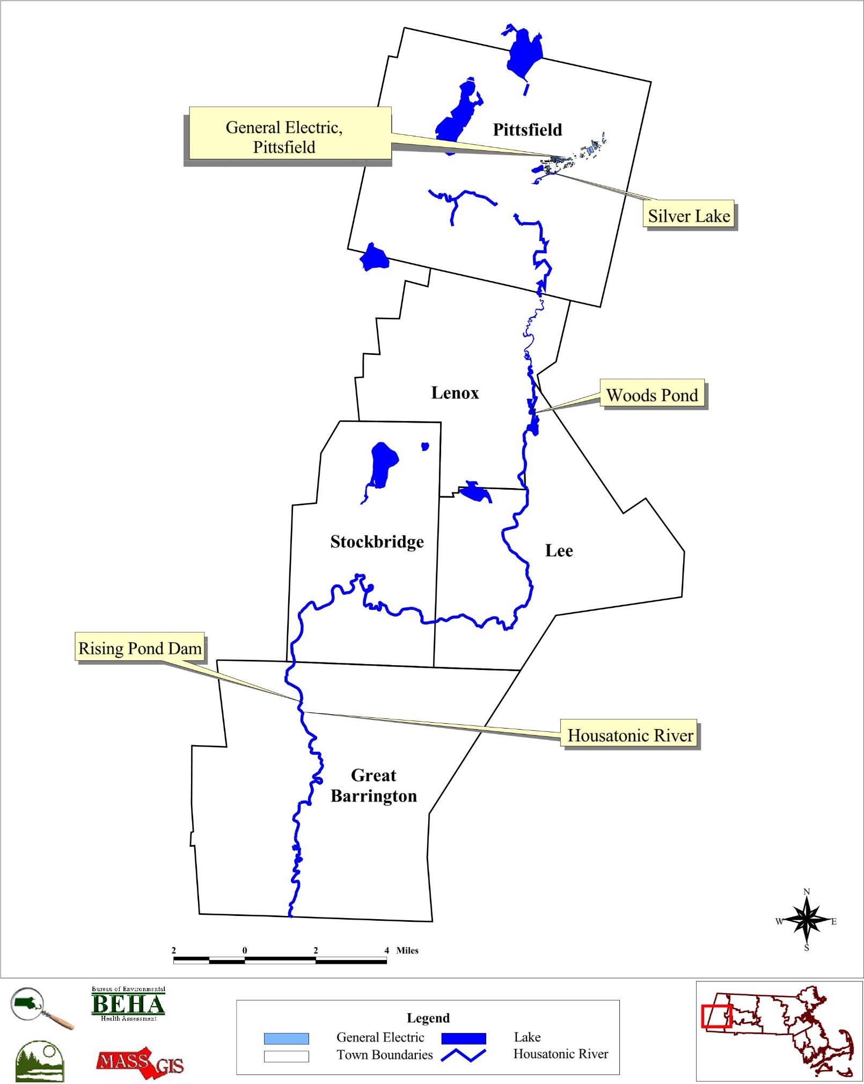
Figure 2
General Electric Company Site Location
Pittsfield
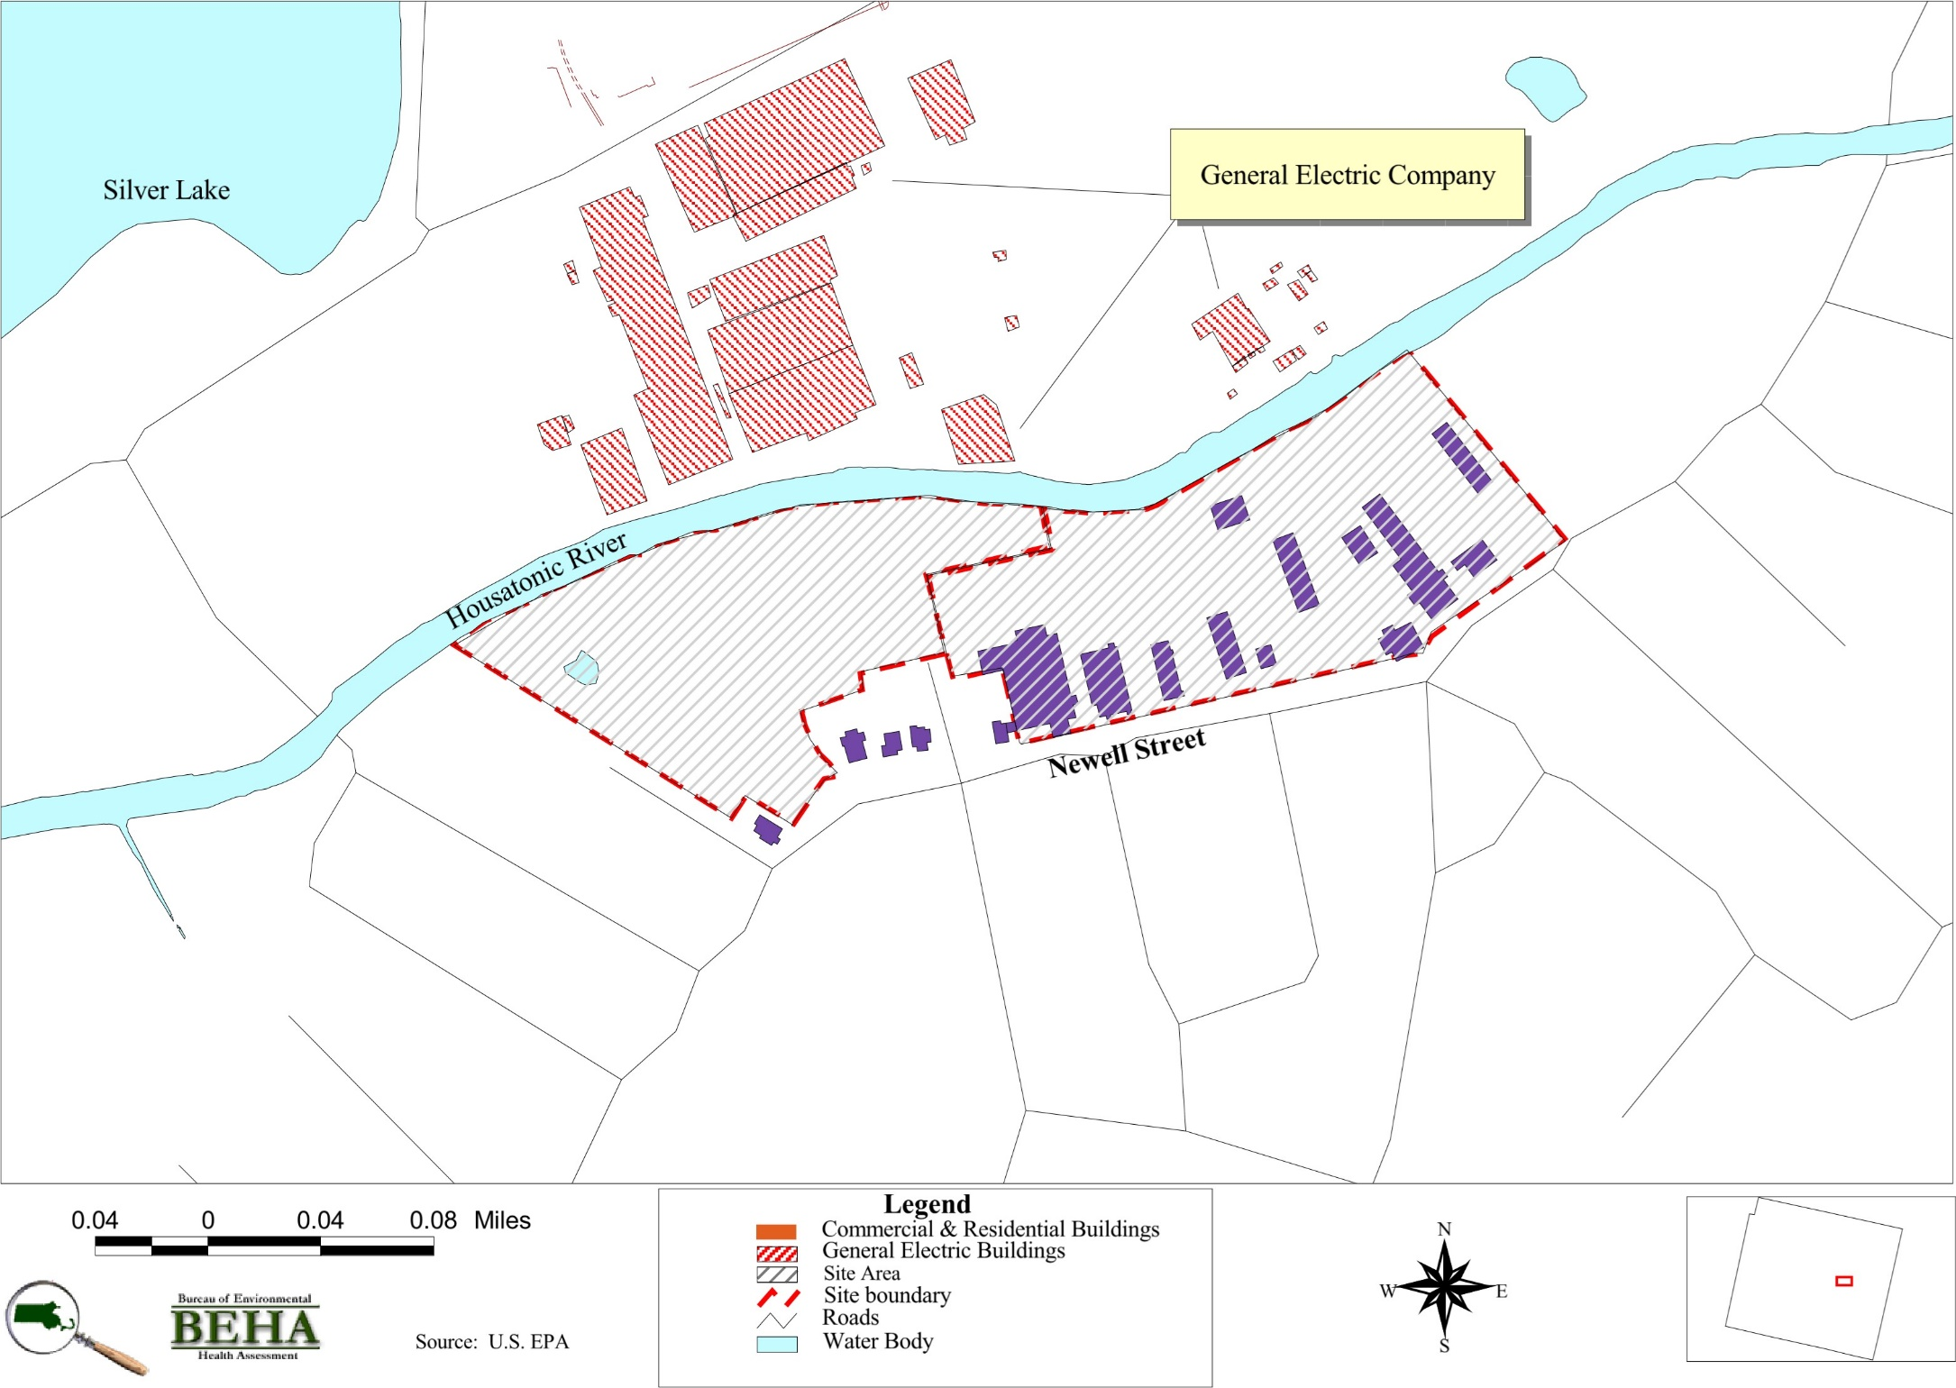

Figure 3
Location of Census Tracts in
Pittsfield, MA
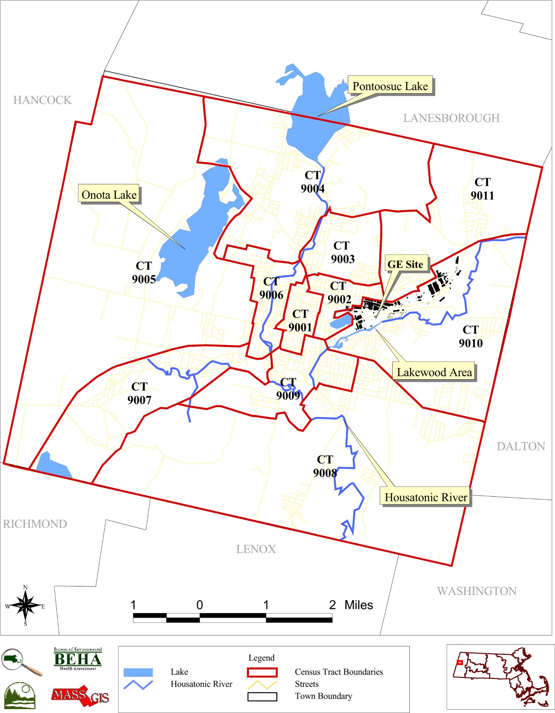

Figure 4
Census Tract 9251
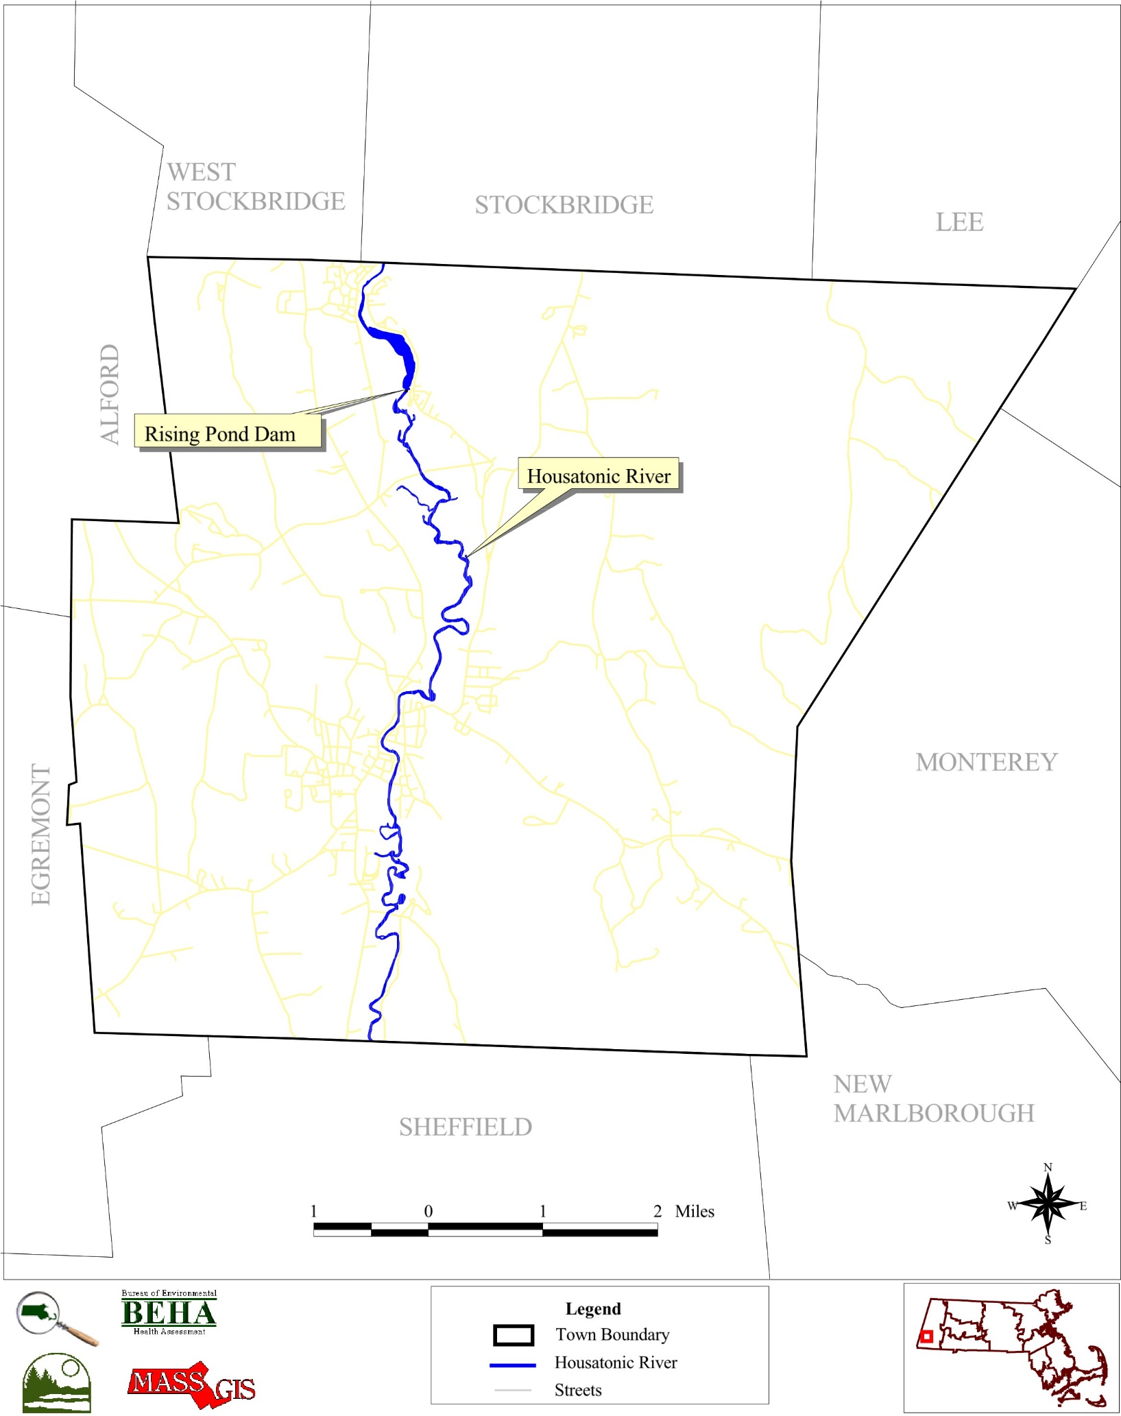
Great Barrington, MA
Figure 5
Census Tract 9141
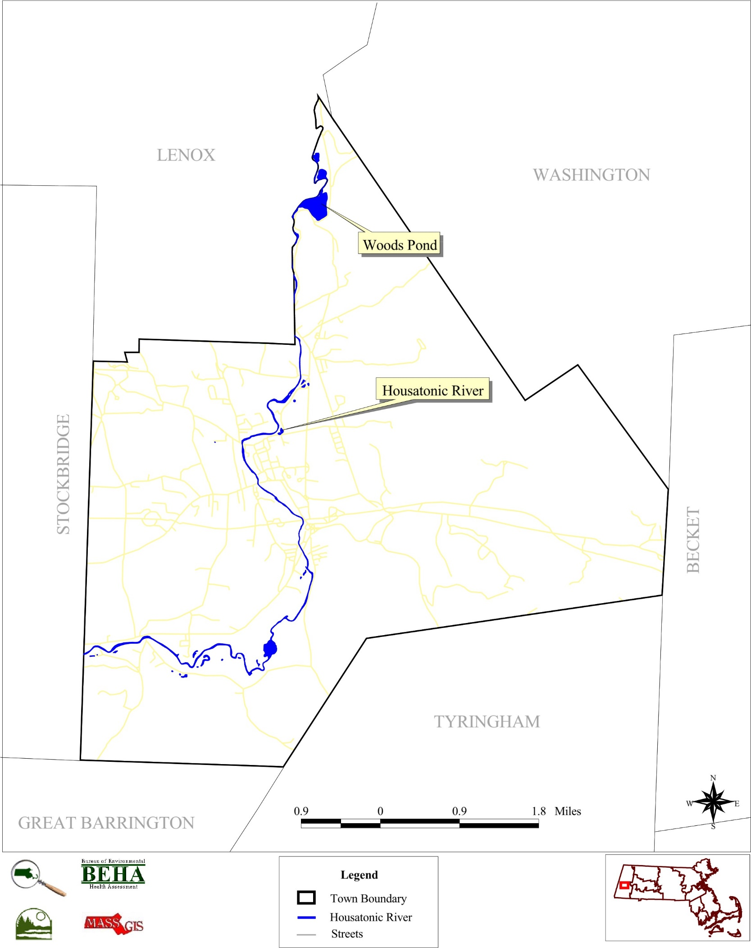
Lee, MA
Figure 6
Census Tract 9131
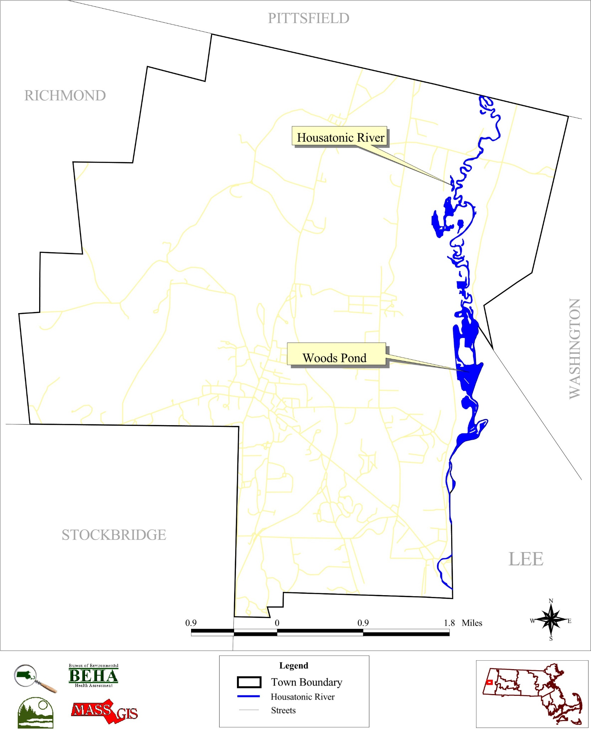
Lenox, MA

Figure 7
Census Tract 9241
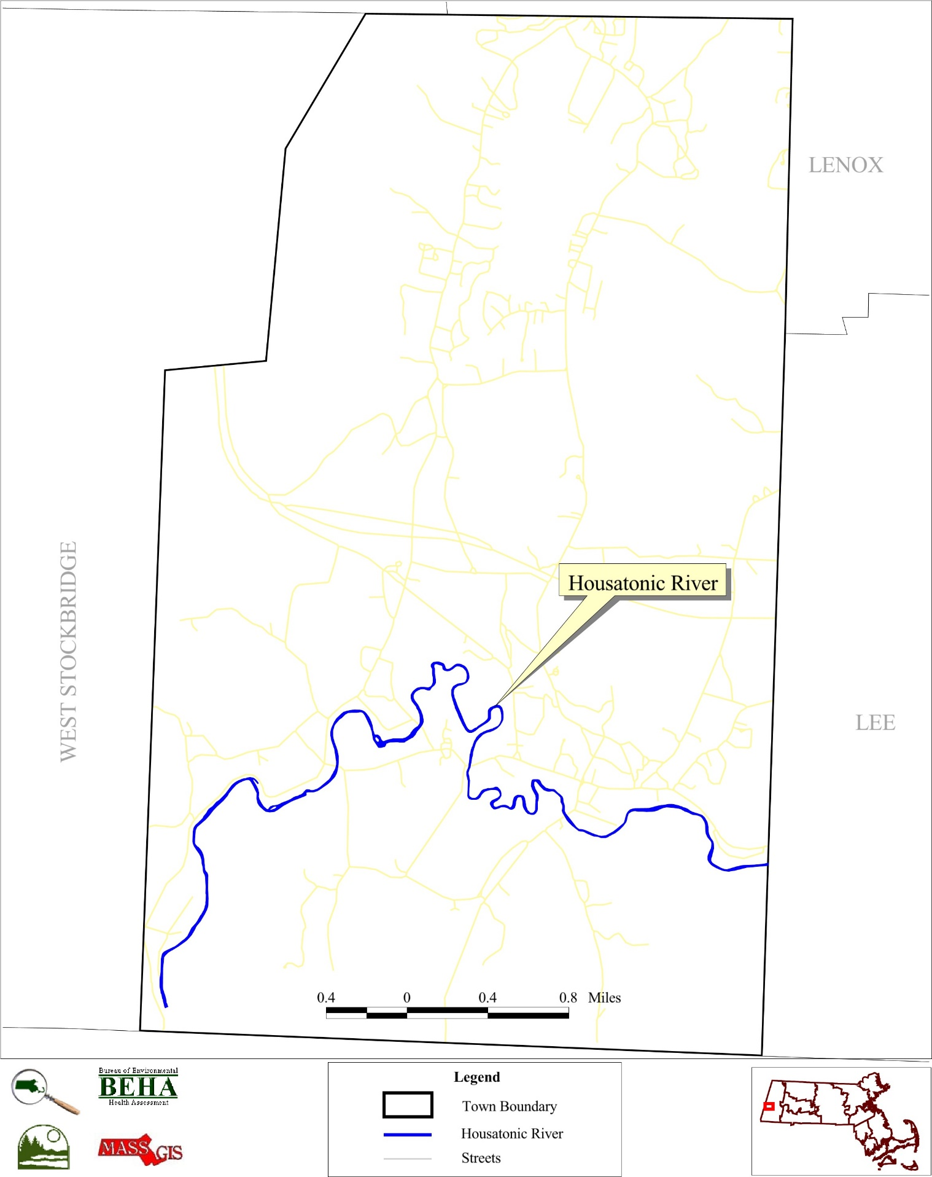
Stockbridge, MA

Figures 8 and 9
Distribution of Known Smoking Status
Pittsfield

Data Source: Massachusetts Cancer Registry; Massachusetts Department of Public Health
Data Preparation: Community Assessment Unit, Bureau of Environmental Health Assessment, MDPH
Figures 10 and 11
Distribution of Known Smoking Status
Census Tract 9002

Data Source: Massachusetts Cancer Registry; Massachusetts Department of Public Health
Data Preparation: Community Assessment Unit, Bureau of Environmental Health Assessment, MDPH

Figures 12 and 13
Distribution of Known Smoking Status
Census Tract 9011

Data Source: Massachusetts Cancer Registry; Massachusetts Department of Public Health
Data Preparation: Community Assessment Unit, Bureau of Environmental Health Assessment, MDPH

Figure 14
Age Distribution of Female Breast Cancer Cases, 1982-1994
Census Tract 9002

Figure 15
Age Distribution of Female Breast Cancer Cases, 1982-1994
Pittsfield, MA
(n=503)

Figure 16
Age-group Specific Breast Cancer SIRs, 1982-1994
in Pittsfield, MA

Figure 17
Female Breast Cancer Staging 1982-1994
Pittsfield vs. Massachusetts

Data Source: Massachusetts Cancer Registry; Bureau of Health Statistics, Research, and Evaluation; Massachusetts Department of Public Health

Figure 18
Annual Trends in Female Breast Cancer Staging 1982-1994
Pittsfield vs. Massachusetts

Data Source: Massachusetts Cancer Registry; Bureau of Health Statistics, Research, and Evaluation; Massachusetts Department of Public Health

Figure 19
Female Breast Cancer by Census Tract
in Pittsfield, MA
(n=503)

Data Source: Massachusetts Cancer Registry; Bureau of Health Statistics, Research, and Evaluation; Massachusetts Department of Public Health

Figure 20
Mean Age at First Birth in Pittsfield and Massachusetts
1975-1990
Pittsfield
Massachusetts

Data Source: Massachusetts Cancer Registry; Bureau of Health Statistics, Research, and Evaluation; Massachusetts Department of Public Health

Figure 21
Percentage of First Births Among Women Ages 15-29 and 30-44
in Pittsfield and Massachusetts
Massachusetts
Pittsfield
Pittsfield
Massachusetts
Data Source: Massachusetts Cancer Registry; Bureau of Health Statistics, Research, and Evaluation; Massachusetts Department of Public Health
Figure 22A and 22B
Percent Distribution of First, Second, and Third Births 1975-1990
Pittsfield vs. Massachusetts

Data Source: Massachusetts Cancer Registry; Bureau of Health Statistics, Research, and Evaluation; Massachusetts Department of Public Health

TABLES

Table 1
Cancer Incidence in Pittsfield, MA
1982-1994, 1982-1986 and 1987-1994
Notes:
Expected number of cases presented are rounded to the nearest tenth.
SIRs are calculated based on the exact number of expected cases.
SIRs and 95% Confidence Interval are not calculated when fewer than 5 cases are observed.
Obs = Observed number of cases
Exp = Expected number of cases
SIR = Standardized Incidence Ratio
NC = Not calculated when OBS<5
95% CI = 95% Confidence Interval
* Indicates statistical significance (P<.05)

Data source: Massachusetts Cancer Registry, Bureau of Health Statistics, Research, and Evaluation, Massachusetts Department of Public Health
Data analysis: Community Assessment Unit, Bureau of Environmental Health Assessment, Massachusetts Department of Public Health
Table 2
Cancer Incidence in Pittsfield, MA
Census Tract 9001
1982-1994, 1982-1986 and 1987-1994
Notes:
Expected number of cases presented are rounded to the nearest tenth.
SIRs are calculated based on the exact number of expected cases.
SIRs and 95% Confidence Interval are not calculated when fewer than 5 cases are observed.
Obs = Observed number of cases
Exp = Expected number of cases
SIR = Standardized Incidence Ratio
NC = Not calculated when OBS<5
95% CI = 95% Confidence Interval
* Indicates statistical significance (P<.05)

Data source: Massachusetts Cancer Registry, Bureau of Health Statistics, Research, and Evaluation, Massachusetts Department of Public Health
Data analysis: Community Assessment Unit, Bureau of Environmental Health Assessment, Massachusetts Department of Public Health
Table 3
Cancer Incidence in Pittsfield, MA
Census Tract 9002
1982-1994, 1982-1986 and 1987-1994
Notes:
Expected number of cases presented are rounded to the nearest tenth.
SIRs are calculated based on the exact number of expected cases.
SIRs and 95% Confidence Interval are not calculated when fewer than 5 cases are observed.
Obs = Observed number of cases
Exp = Expected number of cases
SIR = Standardized Incidence Ratio
NC = Not calculated when OBS<5
95% CI = 95% Confidence Interval
* Indicates statistical significance (P<.05)

Data source: Massachusetts Cancer Registry, Bureau of Health Statistics, Research, and Evaluation, Massachusetts Department of Public Health
Data analysis: Community Assessment Unit, Bureau of Environmental Health Assessment, Massachusetts Department of Public Health
Table 4
Cancer Incidence in Pittsfield, MA
Census Tract 9003
1982-1994, 1982-1986 and 1987-1994
Notes:
Expected number of cases presented are rounded to the nearest tenth.
SIRs are calculated based on the exact number of expected cases.
SIRs and 95% Confidence Interval are not calculated when fewer than 5 cases are observed.
Obs = Observed number of cases
Exp = Expected number of cases
SIR = Standardized Incidence Ratio
NC = Not calculated when OBS<5
95% CI = 95% Confidence Interval
* Indicates statistical significance (P<.05)

Data source: Massachusetts Cancer Registry, Bureau of Health Statistics, Research, and Evaluation, Massachusetts Department of Public Health
Data analysis: Community Assessment Unit, Bureau of Environmental Health Assessment, Massachusetts Department of Public Health
Table 5
Cancer Incidence in Pittsfield, MA
Census Tract 9004
1982-1994, 1982-1986 and 1987-1994
Notes:
Expected number of cases presented are rounded to the nearest tenth.
SIRs are calculated based on the exact number of expected cases.
SIRs and 95% Confidence Interval are not calculated when fewer than 5 cases are observed.
Obs = Observed number of cases
Exp = Expected number of cases
SIR = Standardized Incidence Ratio
NC = Not calculated when OBS<5
95% CI = 95% Confidence Interval
* Indicates statistical significance (P<.05)

Data source: Massachusetts Cancer Registry, Bureau of Health Statistics, Research, and Evaluation, Massachusetts Department of Public Health
Data analysis: Community Assessment Unit, Bureau of Environmental Health Assessment, Massachusetts Department of Public Health
Table 6
Cancer Incidence in Pittsfield, MA
Census Tract 9005
1982-1994, 1982-1986 and 1987-1994
Notes:
Expected number of cases presented are rounded to the nearest tenth.
SIRs are calculated based on the exact number of expected cases.
SIRs and 95% Confidence Interval are not calculated when fewer than 5 cases are observed.
Obs = Observed number of cases
Exp = Expected number of cases
SIR = Standardized Incidence Ratio
NC = Not calculated when OBS<5
95% CI = 95% Confidence Interval
* Indicates statistical significance (P<.05)

Data source: Massachusetts Cancer Registry, Bureau of Health Statistics, Research, and Evaluation, Massachusetts Department of Public Health
Data analysis: Community Assessment Unit, Bureau of Environmental Health Assessment, Massachusetts Department of Public Health
Table 7
Cancer Incidence in Pittsfield, MA
Census Tract 9006
1982-1994, 1982-1986 and 1987-1994
Notes:
Expected number of cases presented are rounded to the nearest tenth.
SIRs are calculated based on the exact number of expected cases.
SIRs and 95% Confidence Interval are not calculated when fewer than 5 cases are observed.
Obs = Observed number of cases
Exp = Expected number of cases
SIR = Standardized Incidence Ratio
NC = Not calculated when OBS<5
95% CI = 95% Confidence Interval
* Indicates statistical significance (P<.05)

Data source: Massachusetts Cancer Registry, Bureau of Health Statistics, Research, and Evaluation, Massachusetts Department of Public Health
Data analysis: Community Assessment Unit, Bureau of Environmental Health Assessment, Massachusetts Department of Public Health
Table 8
Cancer Incidence in Pittsfield, MA
Census Tract 9007
1982-1994, 1982-1986 and 1987-1994
Notes:
Expected number of cases presented are rounded to the nearest tenth.
SIRs are calculated based on the exact number of expected cases.
SIRs and 95% Confidence Interval are not calculated when fewer than 5 cases are observed.
Obs = Observed number of cases
Exp = Expected number of cases
SIR = Standardized Incidence Ratio
NC = Not calculated when OBS<5
95% CI = 95% Confidence Interval
* Indicates statistical significance (P<.05)

Data source: Massachusetts Cancer Registry, Bureau of Health Statistics, Research, and Evaluation, Massachusetts Department of Public Health
Data analysis: Community Assessment Unit, Bureau of Environmental Health Assessment, Massachusetts Department of Public Health
Table 9
Cancer Incidence in Pittsfield, MA
Census Tract 9008
1982-1994, 1982-1986 and 1987-1994
Notes:
Expected number of cases presented are rounded to the nearest tenth.
SIRs are calculated based on the exact number of expected cases.
SIRs and 95% Confidence Interval are not calculated when fewer than 5 cases are observed.
Obs = Observed number of cases
Exp = Expected number of cases
SIR = Standardized Incidence Ratio
NC = Not calculated when OBS<5
95% CI = 95% Confidence Interval
* Indicates statistical significance (P<.05)

Data source: Massachusetts Cancer Registry, Bureau of Health Statistics, Research, and Evaluation, Massachusetts Department of Public Health
Data analysis: Community Assessment Unit, Bureau of Environmental Health Assessment, Massachusetts Department of Public Health
Table 10
Cancer Incidence in Pittsfield, MA
Census Tract 9009
1982-1994, 1982-1986 and 1987-1994
Notes:
Expected number of cases presented are rounded to the nearest tenth.
SIRs are calculated based on the exact number of expected cases.
SIRs and 95% Confidence Interval are not calculated when fewer than 5 cases are observed.
Obs = Observed number of cases
Exp = Expected number of cases
SIR = Standardized Incidence Ratio
NC = Not calculated when OBS<5
95% CI = 95% Confidence Interval
* Indicates statistical significance (P<.05)

Data source: Massachusetts Cancer Registry, Bureau of Health Statistics, Research, and Evaluation, Massachusetts Department of Public Health
Data analysis: Community Assessment Unit, Bureau of Environmental Health Assessment, Massachusetts Department of Public Health
Table 11
Cancer Incidence in Pittsfield, MA
Census Tract 9010
1982-1994, 1982-1986 and 1987-1994
Notes:
Expected number of cases presented are rounded to the nearest tenth.
SIRs are calculated based on the exact number of expected cases.
SIRs and 95% Confidence Interval are not calculated when fewer than 5 cases are observed.
Obs = Observed number of cases
Exp = Expected number of cases
SIR = Standardized Incidence Ratio
NC = Not calculated when OBS<5
95% CI = 95% Confidence Interval
* Indicates statistical significance (P<.05)

Data source: Massachusetts Cancer Registry, Bureau of Health Statistics, Research, and Evaluation, Massachusetts Department of Public Health
Data analysis: Community Assessment Unit, Bureau of Environmental Health Assessment, Massachusetts Department of Public Health
Table 12
Cancer Incidence in Pittsfield, MA
Census Tract 9011
1982-1994, 1982-1986 and 1987-1994
Notes:
Expected number of cases presented are rounded to the nearest tenth.
SIRs are calculated based on the exact number of expected cases.
SIRs and 95% Confidence Interval are not calculated when fewer than 5 cases are observed.
Obs = Observed number of cases
Exp = Expected number of cases
SIR = Standardized Incidence Ratio
NC = Not calculated when OBS<5
95% CI = 95% Confidence Interval
* Indicates statistical significance (P<.05)

Data source: Massachusetts Cancer Registry, Bureau of Health Statistics, Research, and Evaluation, Massachusetts Department of Public Health
Data analysis: Community Assessment Unit, Bureau of Environmental Health Assessment, Massachusetts Department of Public Health
Table 13
Cancer Incidence in Great Barrington, MA
1982-1994, 1982-1986 & 1987-1994
Notes:
Expected number of cases presented are rounded to the nearest tenth.
SIRs are calculated based on the exact number of expected cases.
SIRs and 95% Confidence Interval are not calculated when fewer than 5 cases are observed.
Obs = Observed number of cases
Exp = Expected number of cases
SIR = Standardized Incidence Ratio
NC = Not calculated when OBS<5
95% CI = 95% Confidence Interval
* Indicates statistical significance (P<.05)

Data source: Massachusetts Cancer Registry, Bureau of Health Statistics, Research, and Evaluation, Massachusetts Department of Public Health
Data analysis: Community Assessment Unit, Bureau of Environmental Health Assessment, Massachusetts Department of Public Health
Table 14
Cancer Incidence in Lee, MA
1982-1994, 1982-1986 & 1987-1994
Notes:
Expected number of cases presented are rounded to the nearest tenth.
SIRs are calculated based on the exact number of expected cases.
SIRs and 95% Confidence Interval are not calculated when fewer than 5 cases are observed.
Obs = Observed number of cases
Exp = Expected number of cases
SIR = Standardized Incidence Ratio
NC = Not calculated when OBS<5
95% CI = 95% Confidence Interval
* Indicates statistical significance (P<.05)

Data source: Massachusetts Cancer Registry, Bureau of Health Statistics, Research, and Evaluation, Massachusetts Department of Public Health
Data analysis: Community Assessment Unit, Bureau of Environmental Health Assessment, Massachusetts Department of Public Health
Table 15
Cancer Incidence in Lenox, MA
1982-1994, 1982-1986 & 1987-1994
Notes:
Expected number of cases presented are rounded to the nearest tenth.
SIRs are calculated based on the exact number of expected cases.
SIRs and 95% Confidence Interval are not calculated when fewer than 5 cases are observed.
Obs = Observed number of cases
Exp = Expected number of cases
SIR = Standardized Incidence Ratio
NC = Not calculated when OBS<5
95% CI = 95% Confidence Interval
* Indicates statistical significance (P<.05)

Data source: Massachusetts Cancer Registry, Bureau of Health Statistics, Research, and Evaluation, Massachusetts Department of Public Health
Data analysis: Community Assessment Unit, Bureau of Environmental Health Assessment, Massachusetts Department of Public Health

Table 16
Cancer Incidence in Stockbridge, MA
1982-1994, 1982-1986 & 1987-1994
Notes:
Expected number of cases presented are rounded to the nearest tenth.
SIRs are calculated based on the exact number of expected cases.
SIRs and 95% Confidence Interval are not calculated when fewer than 5 cases are observed.
Obs = Observed number of cases
Exp = Expected number of cases
SIR = Standardized Incidence Ratio
NC = Not calculated when OBS<5
95% CI = 95% Confidence Interval
* Indicates statistical significance (P<.05)

Data source: Massachusetts Cancer Registry, Bureau of Health Statistics, Research, and Evaluation, Massachusetts Department of Public Health
Data analysis: Community Assessment Unit, Bureau of Environmental Health Assessment, Massachusetts Department of Public Health

