Manage Enrollment Locations (MEL) Overview
The Manage Enrollment Locations (MEL) functionality allows providers the ability to enter monthly SDR data more efficiently. Providers identify sites or locations within their organization where services are delivered to clients. These locations are set up in EIM so that client can be enrolled into the contracts.
The Manage Enrollment Location (MEL) functionality is two-fold:
- Add/Edit Participating Organization: Each fiscal year all providers must update the Participating Organization section of their contracts so that they can enroll and bill clients in EIM. If the ‘Billing’ and ‘Enrolling’ checkboxes are not checked for each location associated to the contract, providers cannot enroll clients and thus cannot bill for services. This is a beginning of the fiscal year task that all providers are responsible for.
- Assign Enrollment Locations: All interfaced client enrollment records (new or modified; providers who have contracts with DDS and DMH) from an agency enrollment systems (e.g., Meditech) appear in EIM at the parent level of the organization. If a provider organization wants a client enrollment record to specify the location that a client is receiving services at, they must assign the location to the client enrollment record in EIM. Providers who have EIM contracts with DPH, MRC, and/or DTA manually enroll their clients into ESM and assign the client to the location at the time of enrollment.
  - Provider Organizations who bill in a Centralized method this step is optional. Centralized billing is managed and processed at the parent level of the organization. Billing staff will see all client enrollments on the monthly SDR if they bill in this manner. Organizations who utilize Centralized billing have the ability to assign client enrollment records to specific locations, if desired.
  - Provider Organizations who bill in a Decentralized method, this step is very important. If the client enrollment is not assigned to a location, billing staff at the specified locations will not see the client on their monthly SDR due to how their security roles have been setup. Provider Organizations who bill in a decentralized method are not allowed to see the client enrollments for any location other than their own. So when client enrollment records come into EIM at the parent level of the organization only billing staff at the parent level can see those records unless the record is assigned to a specific location.
Clients > View Enrollments
- Select the Clients module.

- Click the [View Enrollments] link on the left Navigation bar.
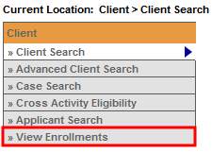
Clients > View Enrollments > Assign Enrollment Locations
The Assign Enrollment Locations page appears.
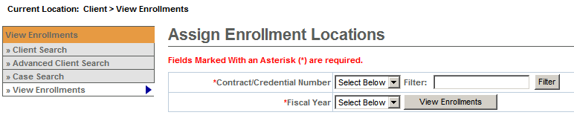
- Select [*Contract/Credential Number] from drop down box.
- The [*Fiscal Year] field will default to current year once Contract/Credential Number is selected.
- Click the [View Enrollments] button.
Note: The Filter field allows you to search for your contract using the wildcard (%) symbol.
The Assign Enrollment Locations page displays all client enrollments that are associated with a contract in EIM. When client enrollment records are interfaced to EIM/ESM, the client record displays in EIM/ESM at the parent level of the organization not the provider location. Agency Enrollment Systems (e.g. Meditech) indicate which location each client is receiving services from and is the system of record concerning client enrollments. The Assign Enrollment Locations page allows you to assign client enrollment records to the provider location in EIM/ESM.
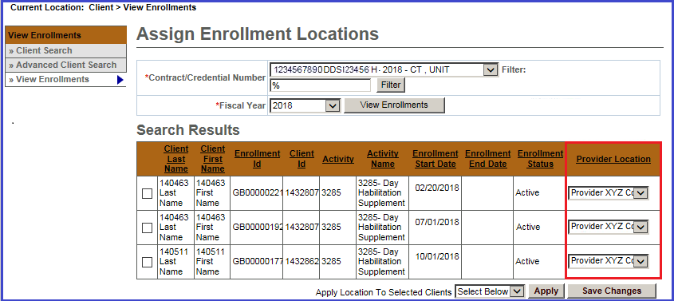
Note:
The Provider Location defaults to the parent level when interfacing into EIM/ESM.
The Assign Enrollment Locations page can be updated in one of two ways:
- Using the Provider Location to Update Assign Enrollment Location page for Individual Clients

- Using the Apply Location to Selected Clients button to Update Assign Enrollment Location page for Multiple Clients Served at the Same Location

Using the Provider Location to Update Assign Enrollment Location for Individual Clients

- Select the [Provider Location] from the drop down box.
- Click the [Save Changes] button.
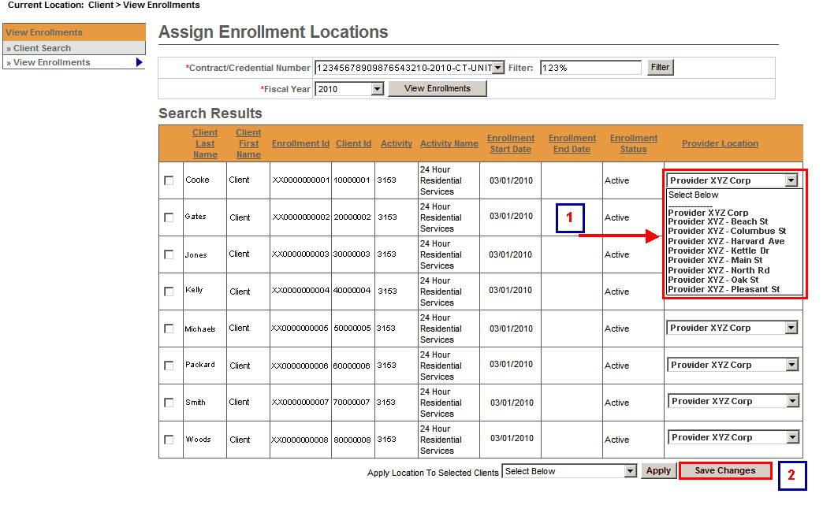
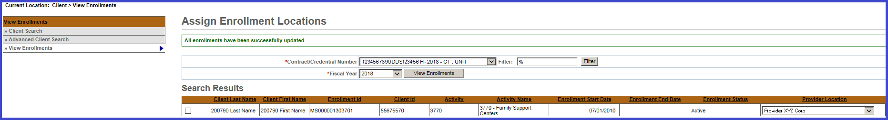
The message “All enrollments have been successfully updated” will appear at the top of the Assign Enrollments Locations page.
Using the Apply Location to Selected Clients button to Update Assign Enrollment Location for Multiple Clients Served at the Same Location

- Check the checkbox for all clients (s) that need to be assigned to the same provider location.
- Select [Apply Location to Selected Clients] drop down box to select provider location from list.
- Click the [Apply] button.
- Click the [Save Changes] button.

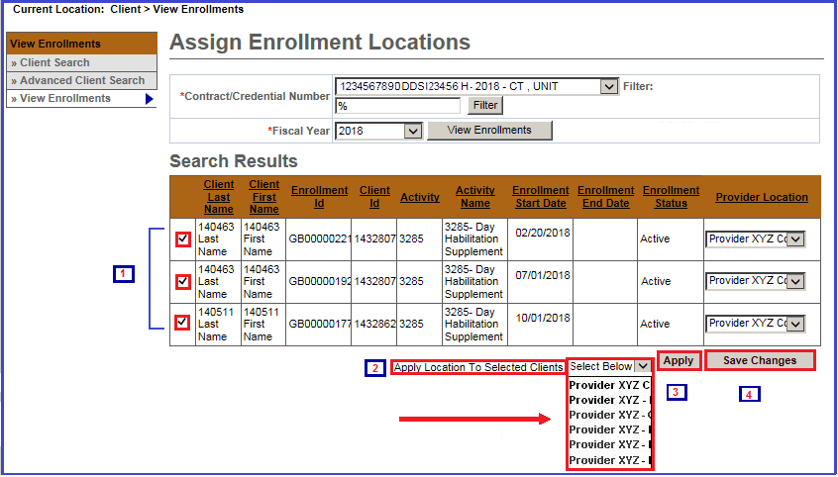
The message “All enrollments have been successfully updated” will appear at the top of the Assign Enrollments Locations page.
Additional Learning Opportunities
- 159 Manage Enrollment Locations CBT – To take online course, log into PACE.
- See Add/Edit Participating Organization Job Aid for instructions on assigning participating organizations to contracts. EIM/ESM Provider Job Aids are found under EIM/ESM Provider User Manuals and Instructional Materials
Questions or need assistance? Call Virtual Gateway Customer Service
1-800-421-0938 (617-948-6578 - TTY for the deaf and hard of hearing)
8:30 am to 5:00 pm Monday through Friday

