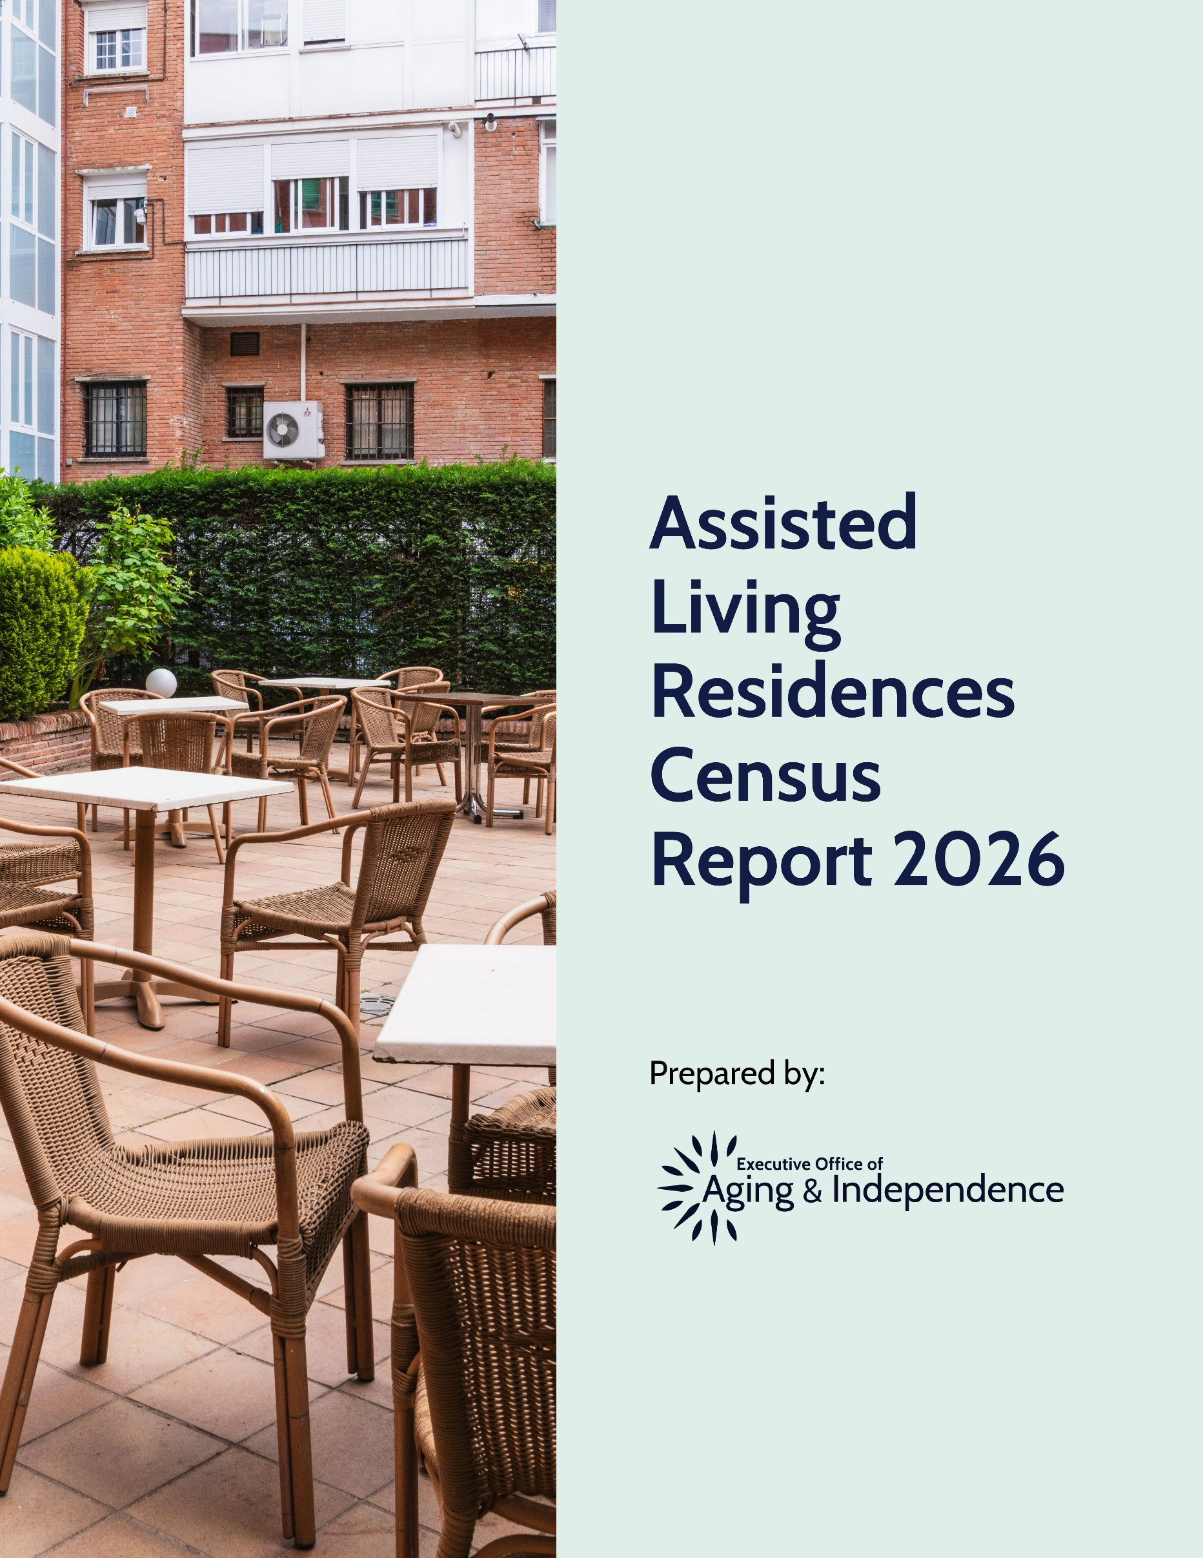

Table of Contents
Introduction 3
Organization and Leadership 4
Units 8
Staffing 11
Residents 12
Services 24
Departures 27
Safety 30
Fees 31
Appendix: Data Collection and Analysis 33

Introduction
Assisted living residences (ALRs) provide housing, meals, and personalized assistance for older adults and other adults with disabilities. ALRs seek to offer residents the maximum amount of independence while providing assistance with activities of daily living (such as eating and bathing). For more information on ALRs in Massachusetts, see: Assisted Living in Massachusetts: A Consumer Guide.

In Massachusetts, ALRs must be certified by the Executive Office of Aging & Independence (AGE). As of January 2026, 272 certified ALRs were operating in Massachusetts.

About this Report
This report summarizes Massachusetts ALRs, residents and ALR assistance provided in 2025. Unless otherwise noted, the data presented reflects ALRs as of December 31, 2025.

In February 2026, AGE requested data for calendar year 2025 from each certified ALR. Approximately 99% (268/272) of Massachusetts ALRs provided at least some data. (See the appendix for more information on data collection and analysis.) AGE uses this information for certification and summarizes the data annually in this public report.

Throughout the report, AGE uses “N =” to indicate the number of ALRs that provided valid data for each topic. Although 268 ALRs completed the surveys, some ALRs did not answer specific questions or provided invalid data for some questions (see appendix for more information on how sample sizes were calculated for each statistic).

Some ALRs reported inconsistent information in their responses (for example, when describing resident gender, a hypothetical ALR could report 32 total residents while reporting 35 total residents when describing resident race). This report describes identified inconsistencies in footnotes. The appendix also details some minor corrections AGE made when the data submitted by ALRs was clearly incorrect.

When providing statistics about ALRs, this report will often refer to a median ALR (for example, the median ALR having 60 traditional units). For each statistic, the median is the number such that half of ALRs are above and half of the ALRs are below (to continue the example, half of ALRs have more than approximately 60 traditional units). The median can be more informative than the average because some ALRs have extreme values on certain characteristics and these outliers can greatly affect the average, but not the median.

Organization and Leadership
Massachusetts laws and regulations allow ALRs to be registered as for-profit or non-profit organizations, and historically most organizations in the state have been for-profit. ALRs can operate independently or be part of a Continuing Care Retirement Community (CCRC), which offers multiple levels of care (such as independent living, assisted living, and skilled nursing) on one campus. All ALRs must have a manager, typically known as an executive director, who has general supervision of the ALR. ALRs must also have a service coordinator, typically known as a resident care director, whose responsibilities include developing, maintaining, and implementing or coordinating implementation of individualized resident service plans.

Organizational Status
Roughly 78% of Massachusetts ALRs (210/268) were operated as for-profit organizations (Figure 1).

Figure 1. ALR Tax Status (N=268 ALRs)
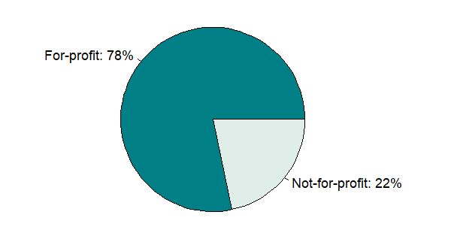

CCRC
The vast majority, 89% (238/268) of Massachusetts ALRs are not part of a continuing care retirement community. Of the 30 ALRs that were in a CCRC, most (18/30) have a skilled nursing facility on campus.
Figure 2. CCRC Status (N=268 ALRs)
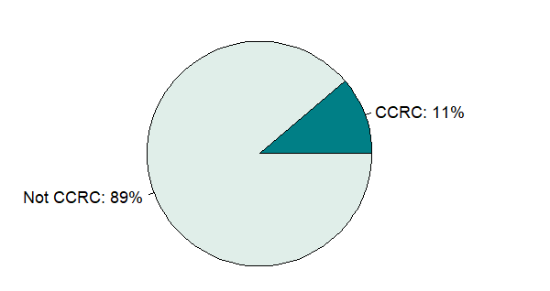

Leadership Transitions
Approximately 75% of ALRs reported having one executive director during 2025, 16% of ALRs reported having two executive directors during 2025, and the remaining 8% of ALRs reported three or more executive directors during 2025 (Figure 3).

Figure 3. Number of Executive Directors During 2025 (N=268 ALRs)
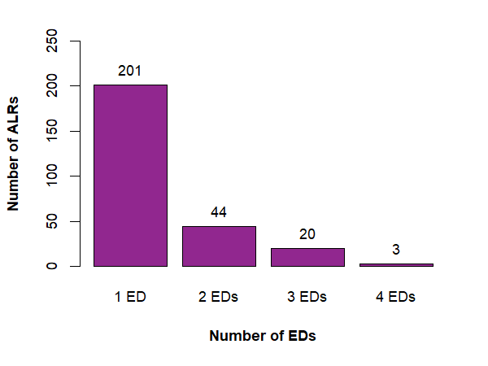
Notes. Includes interim executive directors.
Roughly 69% of ALRs reported one resident care director during 2025 and 23% reported two directors (Figure 4).

Figure 4. Number of Resident Care Directors During 2025 (N=268 ALRs)
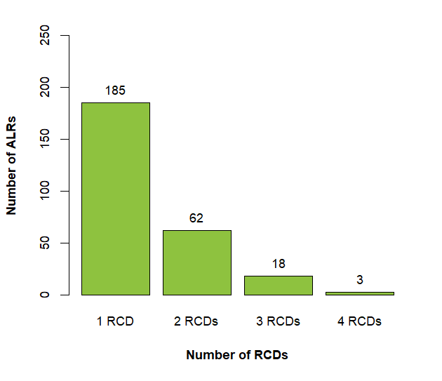
Notes. Includes interim resident care directors.

Units
An ALR residence is composed of multiple units where one or more residents live, and each unit must have a half-bathroom (newly constructed units must have a full bathroom) and a kitchenette. ALRs can have a traditional residence, special care residences (SCRs), or both. SCRs provide care and services for residents who require assistance with specialized needs, such as Alzheimer’s disease and related dementias (ADRD) or mental health needs.

Units, by Type
Approximately 87% (233/268) of ALRs reported having traditional units. For these ALRs, the number of traditional units varied, ranging between 8 and 150 units, and the median ALR had 61 traditional units (see Figure 5). In total, the responding Massachusetts ALRs reported having 14,004 certified traditional units for residents.

Figure 5. Number of Traditional Units (N=233 ALRs)
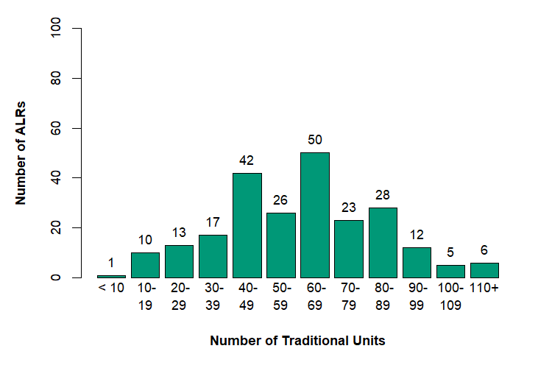
Approximately 75% (201/268) of ALRs reported having special care units. These units are grouped in SCRs—173 ALRs operated one SCR, 17 ALRs operated two SCRs, 5 ALRs operated three SCRs, and 5 ALRs operated four SCRs. Of the reported SCRs, roughly 99% (237/239 residences) were designated for residents with a diagnosis of ADRD and about 1% (2/239 residences) were designated for residents with mental health needs. The number of SCR units varied across ALRs, ranging between 7 and 72, with the median ALR having 24 SCR units (see Figure 6). In total, the responding ALRs reported having 5,488 SCR units.

Figure 6. Number of SCR Units (N=201 ALRs)
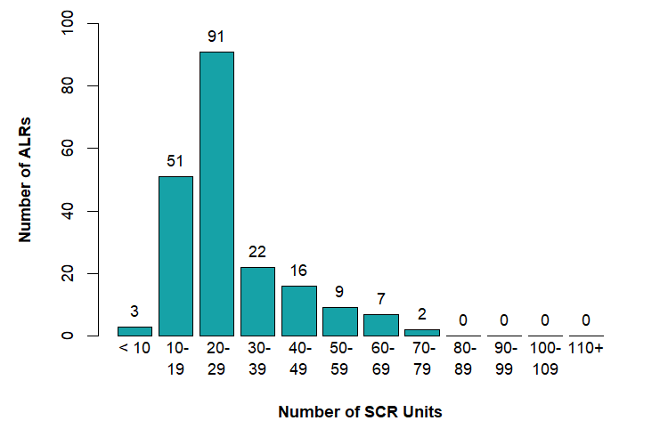

Units Occupied
Roughly 78% (196/251) of ALRs had more than 80% of units occupied in December 2025, with a median percentage occupied of 91% (Figure 7). Throughout the year, the median percentage occupied was between 88-91%.

Figure 7. Percentage of Units Occupied in December 2025 (N=251 ALRs)
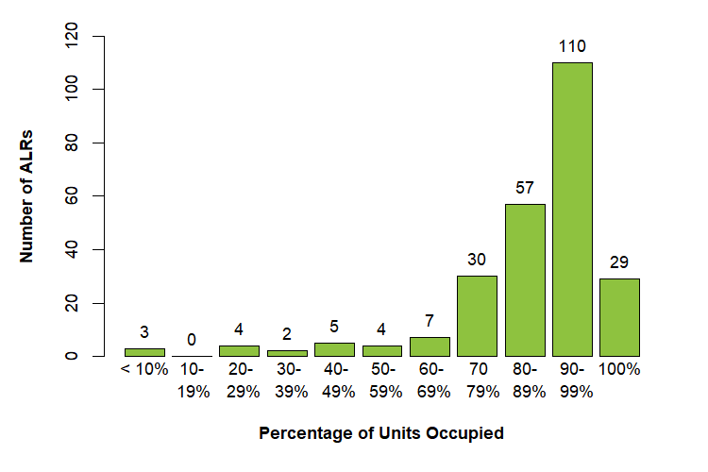
Each ALR unit can be occupied by one or two residents. Approximately 75% of ALRs with traditional units (173/230) had no units occupied by multiple unrelated residents, while roughly 44% of ALRs with SCR units (88/200) had no units occupied by two or more unrelated residents.

Staffing
By regulation, ALRs must always have sufficient staff to handle emergencies and meet resident needs as required by resident service plans. ALRs can meet staffing requirements by hiring and employing individuals or by using trained providers from outside contractors (often referred to as agency staff). Approximately 39% (103/267) of ALRs reported using contracted providers in 2025.

Contracted Providers

Not all ALRs that reported using contractors during 2025 used them every month; between 60% - 73% used contractors during each month. The median ALR employing contractors used them for between 82 – 120 hours a month, depending on the month. ALRs were most likely to use personal care attendants as contracted providers, followed by licensed practical nurses, and registered nurses.

Table 1. Contracted Provider Hours and Type, by Month (N=103 ALRs)
Month | % ALRs  Using Contractors | Median Contractor Hours/Month | % ALRs Using LPNs | % ALRs Using  RNs | % ALRs Using PCAs
January | 61% | 114 | 43% | 25% | 71%
February | 60% | 116.5 | 47% | 24% | 65%
March | 63% | 112 | 48% | 25% | 63%
April | 60% | 147 | 48% | 24% | 68%
May | 60% | 112 | 48% | 27% | 68%
June | 61% | 102 | 46% | 30% | 63%
July | 63% | 87 | 45% | 28% | 62%
August | 64% | 105.5 | 52% | 30% | 64%
September | 66% | 82 | 51% | 26% | 66%
October | 73% | 101 | 48% | 31% | 61%
November | 68% | 116.5 | 47% | 24% | 63%
December | 67% | 120 | 46% | 23% | 70%
LPN = Licensed Practical Nurses
RN = Registered Nurses
PCA = Personal Care Attendants
Notes. The second column indicates the percentage of ALRs reporting more than zero contractor hours per month. The numbers in the remaining columns are only for ALRs that reported using contractors for more than zero hours in the month.

Residents
To describe ALR residents, this report presents two different types of information:
- Statistics about residents. For example, in 2025, 23% of Massachusetts traditional ALR residents were diagnosed with ADRD. The units analyzed are ALR residents, and the analysis describes the Massachusetts ALR population. These statistics do not reveal potentially large differences between residents in different ALRs.
- Statistics about ALRs. For example, in 2025, in 54 ALRs with traditional residents, fewer than 10% of residents were diagnosed with ADRD while 17 ALRs with traditional residents, more than 50% of traditional residents were diagnosed. This analysis examines residents as part of an ALR.

For clarity, this report presents statistics about residents in tables, and reports statistics about ALRs in figures.

The responding ALRs reported a total of 18,463 residents, with 12,912 traditional unit residents and 5,551 SCR residents as of December 31, 2025.

The total number of ALR residents (traditional plus SCR) increased incrementally during most months of 2025 (Table 2).

Table 2. Number of ALR Residents in 2025, by Month
Month | Number of Residents | % Change from Previous
January | 17,758 | -
February | 17,703 | 0%
March | 17,723 | 0%
April | 17,777 | 0%
May | 17,775 | 0%
June | 17,872 | 1%
July | 17,958 | 0%
August | 18,034 | 0%
September | 18,016 | 0%
October | 18,131 | 1%
November | 18,201 | 0%
December | 18,245 | 0%
Notes. This table is based on data provided by 268 ALRs.

Of those 233 ALRs with traditional units and complete data, the median ALR had 55 traditional unit residents (for variation, see Figure 8). Of those 201 ALRs with SCR units, the median ALR had 24 SCR residents.

Figure 8. Number of ALRs, by Traditional and SCR Residents (N=268 ALRs)
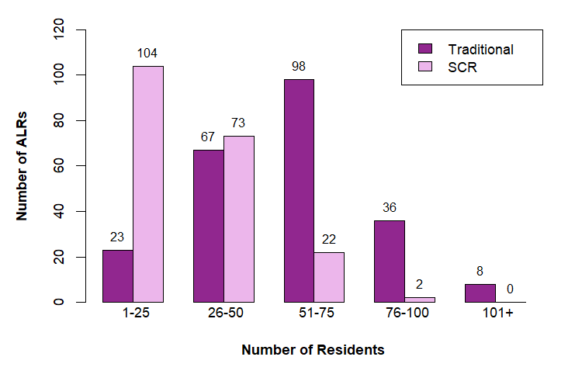
Notes. N=233 ALRs (traditional) and 201 ALRs (SCR)

Age and Gender
Among traditional unit residents, the most common age range for all genders was 80-89 (see Table 3). The proportion of women in Massachusetts traditional residences was approximately 70%.

Table 3. Number of Traditional Unit Residents, by Gender and Age Group
Age Group | Men | Women | Other
<50 years old | 4 | 8 | 0
50-59 years old | 37 | 44 | 0
60-69 years old | 243 | 298 | 1
70-79 years old | 835 | 1,501 | 4
80-89 years old | 1,688 | 3,924 | 19
90-99 years old | 1,135 | 2,873 | 11
100+ years old | 74 | 213 | 0
Total | 4,016 | 8,861 | 35
Notes. Based on data provided by 233 ALRs.

For traditional units, the median ALR percentage of men, women, and other residents was 31%, 69%, and 0% respectively (see Figure 9 for variation across ALRs).

Figure 9. Number of ALRs, by Percentage of Women Traditional Residents (N=233 ALRs)
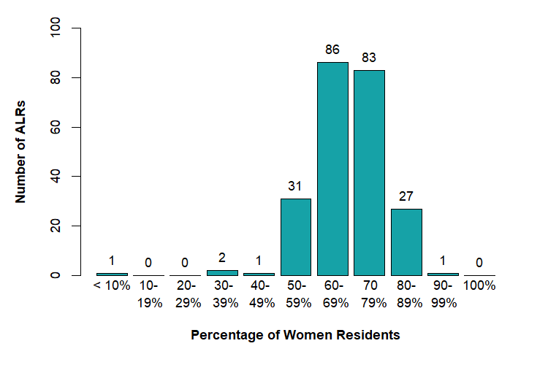
For SCR unit residents, the most common age range for all genders was 80-89 (see Table 4). The proportion of women in Massachusetts SCR residences was 74%.

Table 4. Number of SCR Unit Residents, by Gender and Age Group
Age Group | Men | Women | Other
< 50 years old | 0 | 0 | 0
50-59 years old | 5 | 9 | 0
60-69 years old | 69 | 95 | 1
70-79 years old | 350 | 771 | 2
80-89 years old | 698 | 2,002 | 6
90-99 years old | 327 | 1,115 | 3
100+ years old | 16 | 82 | 0
Total | 1,465 | 4,074 | 12
Notes. This table is based on data provided by 201 ALRs.

For SCR units, the median ALR percentage of men, women, and other residents was 25%, 75%, and 0% respectively (see Figure 10 for variation across ALRs).

Figure 10. Number of ALRs, by Percentage of Women SCR Residents (N=201 ALRs)
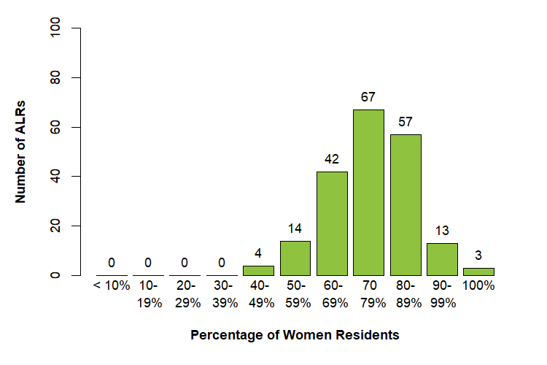

Race and Ethnicity
Based on the 193 ALRs that collected data on resident race and ethnicity, Massachusetts ALR residents were approximately 92% White (12,205/13,223), 1% Black/African American (172/13,223), 1% Asian (120/13,223), 1% Hispanic/Latino (115/13,223), 1% Middle East/North African (111/13,223), less than 1% American Indian or Native Alaskan (13/13,223), less than 1% Hawaiian/Pacific Islander (7/13,223), and 1% Other (34/13,223); ALRs did not know the race of 3% of residents (446/13,223).

The median ALR percentage of White residents was 98%, and the median percentage of each other race, including other race and unknown race, was 0%. Classifying all non-White residents as residents of color, the median percentage of all residents of color was 2%, although several ALRs had more residents of color (Figure 11).

Figure 11. Number of ALRs, by Percentage of Residents of Color (N=193 ALRs)
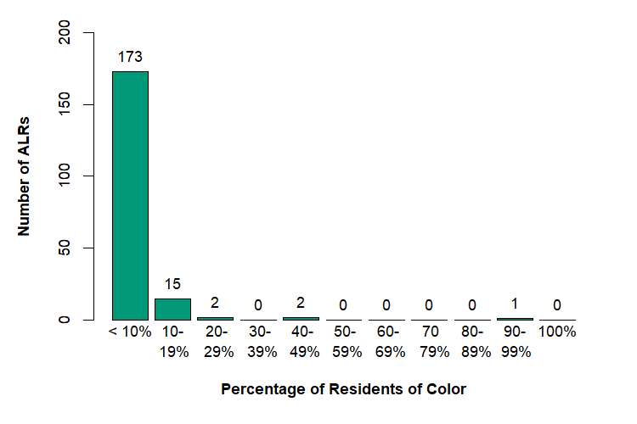
Notes. Residents of Color include those residents reported as Black/African American, Hispanic/Latino, Middle East/North African, Asian, American Indian/Alaska Natives, or Native Hawaiian/Other Pacific Islander.

Veteran Status
Based on the 212 ALRs that collected data on resident veteran status, approximately 13% of Massachusetts ALR residents were veterans (1,770/13,586) and 78% were non-veterans (10,609/13,586); ALRs did not know the veteran status of 9% of residents (1,207/13,586).

The median ALR percentage of veteran residents was 13%, the median percentage of non-veterans was 86%, and the median percentage of unknown status was 0%.

Functioning
Approximately 23% of ALR traditional unit residents (2,975/12,912) were diagnosed with ADRD, as were 93% of ALR SCR residents (5,178/5,551).

Of those ALRs with traditional residents, the median ALR had 20% of traditional unit residents diagnosed with ADRD (for variation, see Figure 12). Of those ALRs with SCR residents, the median ALR had 100% SCR residents diagnosed with ADRD.

Figure 12. Number of ALRs, by Percentage of Residents with ADRD (N=266 ALRs)
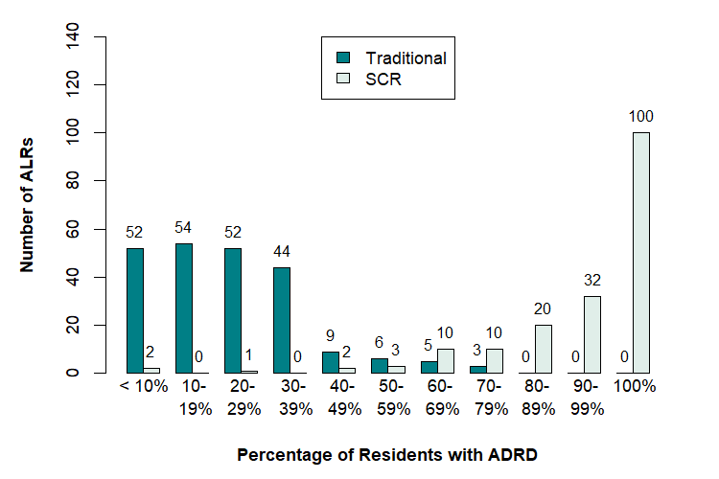
Notes. N=228 ALRs (traditional) and 200 ALRs (SCR)

Health Care Proxies and Medical Orders
Approximately 72% of ALR traditional unit residents (9,262 /12,912) had a Health Care Proxy on file with their ALR, as did 92% of ALR SCR residents (5,150/5,551).

Of those ALRs with traditional residents, the median ALR had 82% traditional-unit residents with a Health Care Proxy on file (for variation, see Figure 13). Of those ALRs with SCR residents, the median ALR had 100% SCR residents with a Health Care Proxy on file.

Figure 13. Number of ALRs, by Percentage of Residents with Health Care Proxy (N=259 ALRs)
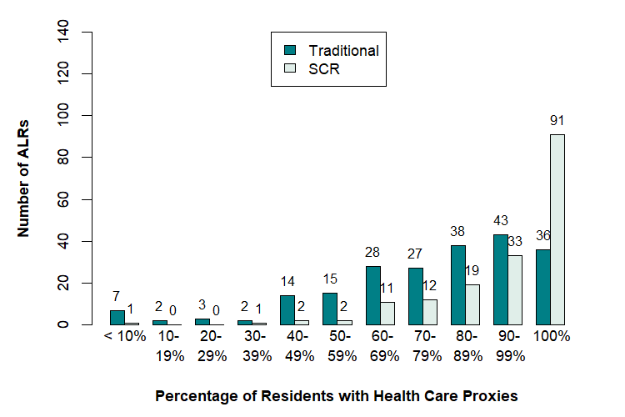
Notes. N=221 ALRs (traditional) and 196 ALRs (SCR)

A medical order for life sustaining treatment (MOLST) is a medical order form that communicates instructions between health professionals about a patient's care (for example, whether the patient should receive dialysis). Approximately 43% of ALR traditional unit residents (5,512/12,912) had a MOLST on file with their ALR, as did 63% of ALR SCR residents (3,519/5,551).

Of those ALRs with traditional residents, the median ALR had 47% traditional unit residents with a MOLST (for variation, see Figure 14). Of those ALRs with SCR residents, the median ALR had 71% SCR residents with a MOLST on file.

Figure 14. Number of ALRs, by Percentage of Residents with MOLST (N=255 ALRs)
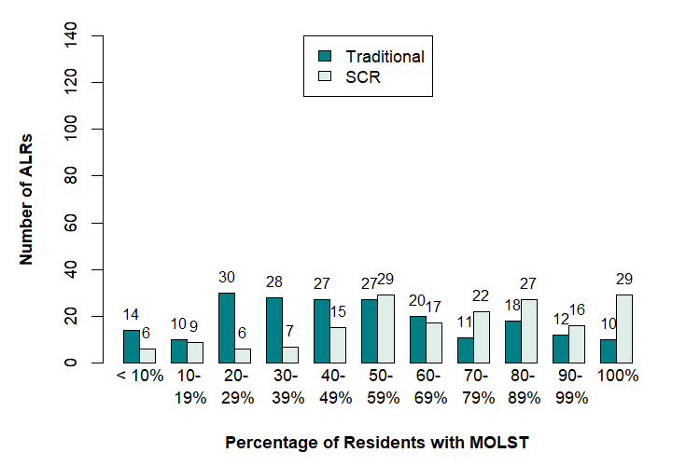
Notes. N=190 ALRs (traditional) and 184 ALRs (SCR)

Program and Plan Participation
Some ALR residents participate in government programs that help cover the cost of living in an ALR—1% of residents participated in Group Adult Foster Care (GAFC), 1% received Section 8 Rental Assistance, and less than 1% received MA Rental Voucher Program (MRVP) Rental Assistance (see Table 5 for residents participating in each program).

Table 5. Number of Residents Participating in Government Programs, by ALR Residence Type
Program | Traditional | SCR | Total
GAFC | 155 | 10 | 165
Section 8 | 183 | 4 | 187
MRVP | 31 | 0 | 31
Notes. For traditional residents, this table is based on data provided by 231 ALRs. For SCR residents, this table is based on data provided by 197 ALRs. For total residents, the data was provided by 266 ALRs.

Most ALRs did not report any residents receiving GAFC, Section 8, or MRVP. For example, 195 ALRs reported no traditional GAFC residents and 188 ALRs reported no SCR GAFC residents. At the ALRs with at least one GAFC resident, these residents were typically less than a quarter of the residents (there was one ALR where most traditional residents received GAFC). Similarly, 224 ALRs had no traditional residents receiving Section 8 and 196 ALRs had no SCR residents receiving Section 8. Some ALRs with traditional residents receiving Section 8 often had a high proportion of residents receiving Section 8; two had more than 50% of residents receiving Section 8. One ALR had traditional residents receiving MRVP (91% received at that ALR) and no ALRs had SCR residents receiving MRVP.

ALRs also reported on whether residents were participating in dual-eligible health plans. Approximately 1% were enrolled in Senior Care Options (SCO), 7% were enrolled in Program of All-Inclusive Care of the Elderly (PACE), and less than 0.1% were enrolled in One Care (see Table 6 for residents participating in each insurance plan).

Table 6. Number of Residents with Dual-Eligible Health Plans, by ALR Residence Type
Plan | Traditional | SCR | Total
SCO | 155 | 4 | 159
PACE | 999 | 224 | 1,223
One Care | 7 | 0 | 7
Notes. This table is based on data provided by 225 ALRs (traditional residents) and 195 ALRs (SCR residents). For total residents, the data came from 263 ALRs.

Most ALRs did not have any residents participating in a dual-eligible insurance plan. For example, 209 ALRs reported no traditional residents participating in an SCO and 191 ALRs reported no SCR residents participating in an SCO health plan. Similarly, 162 ALRs reported no traditional residents covered by PACE and 162 ALRs reported no SCR residents covered by a PACE plan. Three ALRs reported traditional residents covered by One Care.

Services
By law, Massachusetts ALRs must offer certain services to residents. Specifically, ALRs must provide “assistance with activities of daily living,” (ADLs) which can include help getting dressed, eating, and so on. ALRs are also required to provide self-administered medication management (SAMM) to residents whose service plans indicate that such management is required. ALRs can choose whether to offer other resident services, such as transportation, limited medication administration (LMA), and have outside vendors provide skilled nursing care.

Medication Assistance
Approximately 66% (176/268) of ALRs reported offering LMA to residents. Of the ALRs with traditional residents, 62% (145/233) offered LMA while 81% (163/201) of the ALRs with SCR residents offered LMA.

In traditional units, the most common form of medication assistance was SAMM-only, while in SCR units, LMA-only was most common, slightly more common than SAMM-only (Table 7).

Table 7. Number of Residents Receiving Medication Assistance, by Type
Assistance | Traditional | SCR | All
SAMM-only | 6,427 | 2,013 | 8,440
LMA-only | 727 | 2,799 | 3,526
Both | 477 | 456 | 933
Neither | 4,799 | 154 | 4,953
Total | 12,430 | 5,422 | 17,852
Notes. This table is based on data provided by 233 ALRs (traditional residents) and 196 ALRs (SCR residents).

Among ALRs offering LMA and with traditional residents (145 ALRs), the median ALR had 47% of traditional residents receiving SAMM-only, 3% receiving LMA-only, 1% receiving both, and 37% receiving neither. For SCR residents (N=159 ALRs), the respective median percentages were: 0% (SAMM only), 92% (LMA only), 0% (both), and 0% (neither).

Among ALRs not offering LMA and with traditional residents (N=89), the median ALR had 71% traditional residents receiving SAMM, with 29% not receiving SAMM. For SCR residents (N=37 ALRs), the respective median percentages were: 100% (SAMM) and 0% (not receiving SAMM).

Skilled Nursing Care
Approximately 51% (137/268) of ALRs reported that outside providers delivered skilled nursing care to residents. Of the ALRs with traditional residents, 51% (118/233) provided skilled care while 36% (112/201) of the ALRs with SCR residents provided skilled care.

Assistance with Activities of Daily Living
Most ALR residents (76%) received help with at least one activity of daily living (Table 9).

Table 9. Residents Receiving Assistance with ADLs
Number of ADLs | Residents | Percentage
0 | 4,519 | 24%
1 | 2,463 | 13%
2 | 2,630 | 14%
3 | 2,683 | 14%
4 | 2,483 | 13%
5 | 2,261 | 12%
6 | 1,528 | 8%
Total | 18,567 | -
Notes. This table is based on data provided by 267 ALRs. Percentages do not sum to 100% due to rounding.

At the ALR level, 20 ALRs had 50% or more of residents receiving no assistance with ADLs, 57 ALRs had 50% or more of residents receiving assistance with one or fewer ADLs, 129 ALRs had 50% or more of residents receiving assistance with two or fewer ADLs, and 206 ALRs had 50% or more of residents receiving assistance with three or fewer ADLs (N=265).

Respondents also reported the number of residents receiving assistance with specific ADLs, and the most common were bathing, dressing/undressing, and grooming/hygiene (Table 10).

Table 10. Residents Receiving Assistance with Specific ADLs
ADL | Residents | Percentage
Bathing | 11,488 | 62%
Dressing/Undressing | 10,218 | 55%
Grooming/Hygiene | 8,449 | 45%
Ambulation | 5,082 | 27%
Eating | 1,297 | 7%
Toileting | 6,848 | 37%
Notes. This table is based on data provided by 267 ALRs.

Other Services
Roughly 67% (180/268) of ALRs offered residents free transportation for routine medical appointments, 82% (221/268) of ALRs offered free transportation for shopping, and 88% (237/268) of ALRs offered free transportation for social events.

Approximately 57% (154/268) of ALRs offered 2-person assist, a resident movement or transfer approach used when a patient cannot support their own weight, is unsteady, or cannot cooperate. Roughly 37% (100/268) of ALRs offered Hoyer lift assist, which uses a mechanical device to transfer residents, and 33% (88/268) of ALRs offered Sit To Stand lift that involves a device designed to help partially weight-bearing residents rise from a seated position to a standing one.

ALRs can also offer meal options to serve resident needs or religious diets. ALRs reported offering the following options: 10% (27/268) offered kosher meals, 60% (160/268) offered mechanical soft meals, 58% (156/268) offered pureed meals, 46% (122/268) offered gluten-free meals, and 54% (144/268) offered thickened liquids.

Roughly 2% (10/268) offered daycare for non-residents.

Departures
ALR residents effectively rent an apartment and can choose to move out when the residency agreement ends. ALRs cannot legally prohibit residents from living in their unit without formally terminating the tenancy and obtaining an eviction order.

Move Outs
ALRs reported that 8,027 residents moved out during 2025 (N=266 ALRs)., The median ALR had 33 residents move out during 2025.

Length of Stay
Most ALR residents who moved out had resided in their ALR for fewer than two years (Table 11).

Table 11. Number of Residents, by Length of Stay Before Moving Out
Length of Residency | Residents
Less than 3 months | 1,362
3-5 months | 779
6-8 months | 591
9-11 months | 554
1 year – 1 year 11 months | 1,615
2 years – 2 years 11 months | 1,221
3 years – 3 years 11 months | 751
4 years – 4 years 11 months | 414
5 years – 5 years 11 months | 271
6 years – 6 years 11 months | 144
7 years – 7 years 11 months | 119
8 years – 8 years 11 months | 64
9 years – 9 years 11 months | 39
10 years – 14 years 11 months | 79
15+ years | 24
Total | 8,027
Notes. This table is based on data provided by 266 ALRs. One ALR reported that none of their residents moved out during 2025.

Reasons for Moving Out
The most common reason for moving out of the ALR was death, followed by moving to a skilled nursing facility (Table 12).

Table 12. Number of Residents, by Reason for Moving Out (All Residents)
Reason | Residents
Death | 3,682
Moved to Skilled Nursing Facility/Higher Care | 2,310
Respite Stay Concluded | 520
Moved to Another ALR in Massachusetts | 440
Returned Home or to Other Independent Living | 467
Financial/Non-Payment | 605
Moved Out of State | 225
Behavior/Aggressive | 83
Other (respondent listed) | 40
Total | 8,372
Notes. This table is based on data provided by 268 ALRs.

Examining only people who were ALR residents for less than three months, the most common reason for moving out of the ALR was conclusion of respite stay followed by death (Table 13).

Table 13. Number of Residents, by Reason for Moving Out (In ALR Less Than 3 Months)
Reason | Residents
Respite Stay Concluded | 464
Death | 383
Moved to Skilled Nursing Facility/Higher Care | 230
Returned Home or to Other Independent Living | 169
Moved to Another ALR in Massachusetts | 66
Moved Out of State | 23
Financial/Non-Payment | 45
Behavior/Aggressive | 20
Other (respondent listed or left blank) | 15
Total | 1,436
Notes. This table is based on data provided by 233 ALRs.

Safety
ALRs can choose to install video surveillance in public areas or maintain a backup generator to provide electricity during power outages.

Video Surveillance in Public Areas
Approximately 79% (211/268) of ALRs reported having video surveillance. Of these ALRs, 98% (206/211) reported that the surveillance covered main entrances, 91% (191/209) reported the surveillance covered other entrances, 60% (126/208) reported surveilling common areas, and 57% (118/206) reported the surveillance covered hallways.

Backup Generator
Roughly 93% (249/268) of ALRs reported having a backup generator in case of power outage.

Emergency Devices
Approximately 37% (99/268) of ALRs reported having an automated external defibrillator (AED), roughly 6% (16/268) reported having an Epinephrine auto-injector (such as an EpiPen), and 5% (14/268) reported having Narcan (Naloxone).

Fees
Aside from the roughly 22% of ALRs (58/268) that reported housing affordability restrictions due to government financing requirements (such as 40B, Low Income Housing Tax Credits, Project Based Vouchers), there are no legal restrictions on ALR service fees. Fees vary within an ALR depending on the unit size, amenities, resident services required, residence type, and other factors.

Lowest and Highest Fees
The lowest and highest fees varied widely across ALRs—the lowest fee for any traditional resident in Massachusetts was $39 and the lowest for an SCR resident was $80, while the highest fees for a traditional and SCR resident were $22,630 and $22,610 respectively (see Figures 15 and 16 for variation across ALRs). For ALRs with traditional residents, the median lowest monthly fee was $4,450, and the median highest monthly fee was $9,780. For SCR units, the median lowest monthly fee was $7,218 and the median highest fee was $11,985.

Figure 15. Number of ALRs, by Lowest/Highest Fees for Traditional Units (N=233 ALRs)
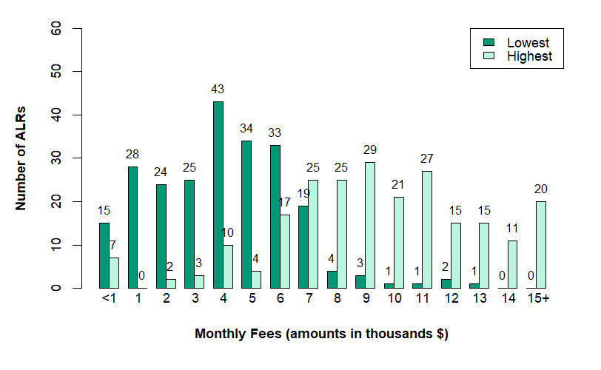

Figure 16. Number of ALRs, by Lowest/Highest Fees for SCR Units (N=200 ALRs)
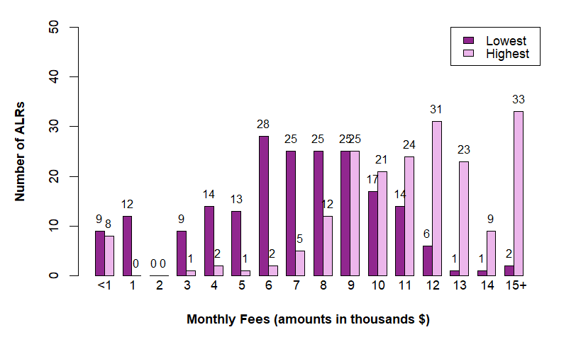

Appendix: Data Collection and Analysis
On February 3, 2026, AGE’s Director of Assisted Living Certification & Compliance emailed all ALR executive directors with a request to provide ALR 2025 data via an online survey. The email included a link to the survey and informed ALRs that, “in accordance with [regulations] 651 CMR 12.04(13)(a)(2) all Massachusetts certified Assisted Living Residences (ALRs) must submit an accurate report of 2025 information to the Executive Office of Aging & Independence (AGE) on or before March 3rd.” Attached to the email were survey instructions and a PDF of the survey. LeadingAge Massachusetts and the Massachusetts Assisted Living Association sent reminders to ALRs that did not submit.

Of the 272 ALRs contacted, four did not submit any data:
- Allerton House at Harbor Park
- Atria Woodbriar Park
- Clifton Assisted Living Community
- The Current South Shore

The complete online survey contained 54 items, and many items had multiple sub-items. The survey used skip logic where appropriate (for example, ALRs without SCR were not presented with questions about SCRs) such that some ALRs were presented with fewer questions.

Only a few items (such as identifying the ALR and site address) required responses to continue. For the remaining items, after skipping items, respondents would be notified which items had been skipped when they tried to move to the next page.

Respondents
Executive directors typically completed the survey (Table A1).

Table A1. Primary Respondent Title
Title | Frequency Listed
Executive Director | 224
Resident Care Director | 8
Business Manager or General Manager | 8
Clinical and Regulatory Director | 7
Owner | 7
Chief Operating Officer or Chief Financial Officer | 1
Other | 13
Total | 268

Data Inconsistencies and Anomalies
To minimize frustration, AGE did not include automatic logic checks that required respondents to provide consistent information across sections.

The online survey did present information that respondents could use to check the consistency of answers. For example, after the respondent entered the total number of residents in the age-by-gender section, that information would be presented when the respondent entered in the number of residents by race so that respondents could compare the totals (this information was also provided when respondents were reporting veteran status and ADLs). Similarly, after respondents completed the survey but before submission, the online survey conducted three consistency checks and reported inconsistencies to respondents. Respondents could then choose whether to update their responses. After being informed of these inconsistencies, some respondents did not update their responses.

When respondents submitted inconsistent information, AGE cannot easily determine which information is most accurate. For example, if the ALR reported 101 total residents when describing resident gender and reported 98 total residents when describing resident race, which is correct? As most of the inconsistencies involved a few residents, AGE typically made no changes to the data and notes the inconsistencies in footnotes.

When the inconsistencies led to calculated percentages greater than 100%, AGE changed the data to missing. For example, when reporting the number of units that existed on December 31, 2025 and that were occupied on December 31, 2025, some ALRs listed more units occupied than units that existed. When calculating the occupancy rate, AGE set the occupancy rate for these ALRs to missing.

AGE Changes and Corrections
The submitted forms also contained clear errors or highly implausible data. In these situations, AGE changed the data to missing or corrected the data. Specifically, AGE made the following changes before analyzing the data:
- Three ALRs reported one traditional unit, one SCR unit, or both. According to AGE records, all ALRs have eight or more certified units, and so AGE reclassified the ALR unit numbers according to the number of certified units in AGE records.
- Three ALRs with traditional residents and four with SCR residents summed the number of male and female residents when reporting the number of residents with “other” gender (that is, these ALRs appeared to mistake the other column for a total column). For these ALRs, AGE reset the number of residents with other gender to 0.
- The online survey tool incorrectly summed the total number of traditional residents (age and gender) for three ALR and incorrectly summed the total number of SCR residents (age and gender) for four ALRs. AGE corrected these values to the actual sums.
- The online survey tool incorrectly summed the total number of residents (veteran status) for one ALR. AGE corrected this to the actual sum.
- The online survey tool incorrectly summed the total number of ADLs for two ALRs. AGE corrected the total to the actual sum.
- Three ALRs reported that their ALR did not provide LMA services but reported in another section that a number of residents were receiving LMA services. The number of residents receiving LMA appeared to be an error for one ALR, so AGE set the number of residents to 0. For the other two ALRs, AGE reset their response to indicate providing LMA services.
- The online survey tool incorrectly summed the total number of residents receiving specific numbers of ADLs. AGE corrected this to the actual sum.
- Three ALRs appear to have reported all resident departures when asked only for departures for residents who resided for less than three months. AGE reset the categories to missing.
- One ALR, with only SCR units, appeared to report values for traditional units. AGE switched these values to SCR units and set traditional unit values to missing.

Finally, AGE replaced non-responses in some categories with zeros. For example, when respondents reported 10 women between 80-89 but did not complete the field for the number of men between 90-99, AGE imputed zero men aged 90-99. Because respondents completed some categories (10 women between 80-89), AGE assumed that the respondent meant to indicate zero residents when leaving the category field blank rather than indicating that the respondent did not know the number. If the respondent left all categories blank, AGE assumed the respondent did not report the relevant information for that characteristic and did not impute zero. AGE performed this imputation for demographic characteristics, medication assistance, number and type of ADLs, skilled nursing services, and moveout duration and reason.

Calculating the Number of ALRs Providing Valid Information
AGE determined whether an ALR reported valid data for an item (i.e., should be included in the N) as follows:
- ALR Tax Status (Figure 1). AGE considers all submissions as valid data because the online survey requires ALRs to answer this item and select a valid option.
- CCRC Status (Figure 2). AGE considers all submissions as valid data because the online survey requires ALRs to answer this item and select a valid option.
- Executive Directors (Figure 3). AGE considers a response as valid data if the ALR reported between one and 10 directors. (AGE assumes that numbers outside this range are likely errors.)
- Resident Care Directors (Figure 4). AGE considers a response as valid data if the ALR reported between one and 10 directors. (AGE assumes that numbers outside this range are likely errors.)
- Traditional Certified Units (Figure 5). AGE considers a response as valid data if the ALR reported more than zero units. Note that when an ALR indicates one or two units, AGE resets the number to the registered number of units.
- SCR Certified Units (Figure 6). AGE considers a response as valid data if the ALR reported more than zero units. Note that when an ALR indicates one or two units, AGE resets the number to the registered number of units.
- Units Occupied (Figure 7). AGE considers a response as valid data if the ALR reported one or more units occupied in December.
- Contracted Providers (Table 1). AGE considers an ALR as providing valid data if the ALR indicated using contracted providers during the year.
- Total Residents (Figure 8). AGE considers a response as valid data if the ALR reported one or more traditional residents when reporting age/gender and one or more SCR residents when reporting age/gender.
- Number of Residents by Month (Table 2). AGE considers a response as valid if the ALR reported one or more resident in any month.
- Traditional Resident Gender (Table 3 and Figure 9). AGE considers the response as valid data if the ALR reported one or more male, female, or non-binary resident. Note this item only appears if the ALR reported traditional units.
- SCR Resident Gender (Table 4 and Figure 10). AGE considers the male/female count as valid data if the ALR reported one or more male, female, or non-binary resident. Note this item only appears if the ALR reported SCR units.
- Resident Race (Figure 11). AGE considers a response as valid data if the ALR reported a number greater than 0 for any race (reporting all residents as race unknown is not considered valid data).
- Resident Veteran Status. AGE considers a response as valid data if the ALR reported a number greater than zero for either veteran status (reporting all residents as veteran status unknown is not considered valid data).
- Residents with ADRD (Figure 12). AGE considers a response as valid data for traditional/SCR residents if the ALR reported having traditional/SCR units and reported a number, including zero, for traditional/SCR residents with ADRD.
- Residents with Health Care Proxy (Figure 13). AGE considers a response as valid data for traditional/SCR residents if the ALR reported having traditional/SCR units and reported a number, including zero, for traditional/SCR residents with a proxy.
- Residents with MOLST (Figure 14). AGE considers a response as valid data for traditional/SCR residents if the ALR reported having traditional/SCR units and reported a number, including zero, for traditional/SCR residents with a MOLST.
- Residents in Programs (Table 5). AGE considers a response as valid data for traditional/SCR residents if the ALR reported having traditional/SCR units and reported a number, including zero, for traditional/SCR residents for any program or plan.
- Residents in Plans (Table 6). AGE considers a response as valid data for traditional/SCR residents if the ALR reported having traditional/SCR units and reported a number, including zero, for traditional/SCR residents in a plan.
- Limited Medication Administration. AGE considers a response as valid data if the ALR selected a response option.
- Number of Residents with Self-Administered Medication Management & Limited Medication Administration (Table 7). AGE considers a response as valid data for traditional/SCR residents if the ALR reported having traditional/SCR units and reported a number, including zero, for traditional/SCR residents receiving assistance.
- Skilled Nursing Care. AGE considers a response as valid data if the ALR selected a response option.
- Residents Requiring Assistance with Number of Activities of Daily Living (Table 9). AGE considers a response as valid data if the ALR reported a number, including zero, for any number of ADLs.
- Residents Requiring Assistance with Specific Activities of Daily Living (Table 10). AGE considers a response as valid data if the ALR reported a number, including zero, for any specific ADL.
- Daycare Programs. AGE considers a response as valid data if the ALR selected a response option.
- Transportation. All submissions count as valid data because ALRs that do not check any boxes might not offer any transportation (i.e., blank responses are a valid response).
- Mobility Assistance. All submissions count as valid data because ALRs that do not check any boxes might not offer any mobility assistance (i.e., blank responses are a valid response).
- Meal Options. All submissions count as valid data because ALRs that do not check any boxes might not offer any meal options (i.e., blank responses are a valid response).
- Unique Residents. AGE considers a response a valid data if the ALR reported one or more unique residents.
- Length of Residency (Table 11). AGE considers a response as valid data if the ALR reported a number for any duration.
- Move Out Reasons (Table 12). AGE considers a response as valid data if the ALR reported a number for any reason.
- Move Out Reasons-3 Months or Less (Table 13). AGE considers a response as valid data if the ALR reported a number for any reason.
- Video Surveillance. AGE considers a response as valid data if the ALR selected a response option.
- Video Surveillance Coverage. AGE considers a response as valid if the ALR selected at least one response option. Note this item only appears if the ALR reported surveillance.
- Backup Generator. AGE considers a response as valid data if the ALR selected a response option.
- Emergency Devices. All submissions count as valid data because ALRs that do not check any boxes might not have any emergency devices (i.e., blank responses are a valid response).
- Highest and Lowest Monthly Fees (Figures 15 and 16). AGE considers a response as valid data for traditional/SCR residents if the ALR reported having traditional/SCR units and reported a dollar amount greater than zero for that category of residents.
- Respondent Title (Table A1). All submissions count as valid data because the online survey requires ALRs to answer this item and select a valid option.

M.G.L. ch.19D § 3-4.
M.G.L. ch.19D, § 15.
651 CMR 12.04(2).
Throughout the report, N indicates the number of ALRs that provided valid data.
651 CMR 12.04.
The term ‘residence’ can be used in reference to the entire complex or any distinct section(s) within the complex.
One ALR reported SCR units but did not report the number or type of SCR residences.
Two ALRs with one SCR residence did not describe the resident type.
Fifteen ALRs reported that the ALR had more units occupied on December 31 than reported units available on December 31. The differences ranged from one additional unit occupied to 19 additional units. For these ALRs, AGE set the percentage occupied to blank.
For each month and ALR, the denominator for this calculation is the number of units reported for December 2025. As some ALRs opened during the year, the number of ALRs with units varies by month.
When reporting the number of units occupied by two or more residents, one ALR listed more traditional units occupied by two or more residents than reported traditional units that existed. In addition, one ALR listed more SCR units occupied by two or more residents than reported SCR units that existed. For these ALRs, AGE set the percentage occupied by multiple residents to blank.
651 CMR 12.06.
Information about all residents can help policymakers, researchers, nonprofit organizations, and businesses better understand the ALR resident population. However, different types of people choose to live in different ALRs and only reporting aggregate statistics across all ALRs might obscure important differences between residents of different ALRs.
These statistics are based on ALR reporting of residents by age and gender. When ALRs reported the total number of residents (traditional + SCR) monthly, they reported 18,245 residents at the end of December (Table 2).
For 77 ALRs, the total number of residents listed in the age-by-gender section differed from the total number of residents listed in the December monthly reporting of residents (190 ALRs reported consistent numbers or did not report data on age-by-gender section). For most of the inconsistent ALRs, the discrepancies were minor—less than five residents.
AGE requested data on resident race and ethnicity using the standard federal racial and ethnicity categories.
For six ALRs, the total number of residents listed in the age-by-gender section differed from the total number of residents listed in the race section (258 ALRs provided consistent numbers or did not report data on gender or race).
For 32 ALRs, the total number of residents listed in the age-by-gender section differed from the total number of residents listed in the veteran status section (231 ALRs provided consistent numbers or did not report data on gender or veteran status).
For three ALRs, the total number of traditional residents listed in the age-by-gender section was less than the total number of traditional residents with Alzheimer’s disease or related dementia (that is, this ALR reported more traditional residents with dementia than traditional residents). For 20 ALRs, the total number of SCR residents listed in the age-by-gender section was less than the total number of SCR residents with Alzheimer’s disease or related dementia (that is, these ALRs reported more SCR residents with dementia than SCR residents).
For the ALRs that reported more residents with dementia than total residents, AGE set the percentage with dementia to blank. These percentages are calculated using the total number of residents listed in the relevant age-by-gender section.
For 6 ALRs, the total number of traditional residents listed in the age-by-gender section was less than the total number of traditional residents with a health care proxy (that is, these ALRs reported more traditional residents with a health care proxy than traditional residents overall). For 24 ALRs, the total number of SCR residents listed in the age-by-gender section was less than the total number of SCR residents with a health care proxy (that is, these ALRs reported more SCR residents with a health care proxy than SCR residents overall).
For the ALRs that reported more residents with proxies than total residents, AGE set the percentage of residents with a health care proxy to blank. These percentages are calculated using the total number of residents listed in the age-by-gender section for the relevant ALRs as the denominator.
In late 2024, some Massachusetts providers began transitioning from the MOLST to the POLST. Fewer than 20 ALRs with traditional residents, and a similar number with SCR residents, reported having residents with a POLST in 2025.
For two ALRs, the total number of traditional residents listed in the age-by-gender section was less than the total number of traditional residents with a MOLST (that is, these ALRs reported more traditional residents with a MOLST than traditional residents overall). For four ALRs, the total number of SCR residents listed in the age-by-gender section was less than the total number of SCR residents with a MOLST (that is, these ALRs reported more SCR residents with a MOLST than SCR residents overall).
For the ALRs that reported more residents with MOLST than total residents, AGE set the percentage of residents with a MOLST to blank. These percentages are calculated using the total number of residents listed in the age-by-gender section for the relevant ALRs as the denominator.
MassHealth’s GAFC helps older adults with low incomes by paying for personal care services and medication management and administration. GAFC does not pay for room and board, but the Supplemental Security Income (SSI-G) Assisted Living Benefit can cover these costs. To qualify for GAFC in an ALR, an older adult must have SSI-G.
These percentages are calculated using the total number of residents listed in the age-by-gender section as the denominator.
These are integrated health plans whose beneficiaries are eligible for both Medicaid (MassHealth) and Medicare.
M.G.L. ch. 19D, § 1.
M.G.L. ch. 19D, § 10. For SAMM, ALR staff can remind and assist residents with taking medication. For example, staff can remind a resident when to take medication and open bottles or other containers. They cannot directly administer any medication to a resident.
For LMA, a nurse, an individual designated by the resident, or the resident's representative can administer eye drops, apply medicated cream, and crush medications and place them in a resident’s mouth.
For 111 ALRs with traditional residents, the total number of traditional residents listed in the age-by-gender section differed from the total number of residents listed in the medication assistance (LMA/SAMM) section (for 122 ALRs the numbers were identical or the ALRs did not report medication assistance information or age-by-gender information). For 80 ALRs with SCR residents, the ALRs reported a different number of residents in the age-by-gender section than in the medication assistance section (for 116 ALRs the numbers were identical or the ALRs did not report medication assistance information or age-by-gender information).
Chapter 197 of the Acts of 2024. The Act allows ALRs to offer basic health services defined as “certain services provided at an assisted living residence by employees of the residence that are qualified to administer such services or a qualified third party in accordance with a care order issued by an authorized medical professional; provided, however, that such services shall include all of the following: (i) injections; (ii) the application or replacement of simple non-sterile dressings; (iii) the management of oxygen on a regular and continuing basis; (iv) specimen collection and the completion of a home diagnostic test, including, but not limited to, warfarin, prothrombin or international normalized ratio testing and glucose testing; provided, that such home diagnostic test or monitoring is approved by the United States Food and Drug Administration for home use; and (v) application of ointments or drops.”
For seven ALRs, the total number of residents listed in the age-by-gender section differed from the total number of residents listed in the ADL section (the numbers were identical for 258 ALRs and the remaining ALRs did not report ADL information).
M.G.L. ch. 19D § 9.
For each resident who left, ALRs provided both the reasons for moving out and the length of stay before moving out. For 111 ALRs, the total numbers of residents moving out in the reasons section differed from the total number of residents moving out in the length of stay section (157 ALRs reported identical numbers of residents). This report uses the length of stay sum (Table 11).
ALRs also reported the number of unique residents—22,525 residents (N= 258 ALRs). As some ALRs did not report the number of unique residents, AGE cannot calculate the percentage of residents who moved out.
For 39 ALRs, the total number of residents listed in the reason-for-leaving-only-residents-staying-less than-three-months differed from the total number of residents listed as staying less than three months (for 229 ALRs, the numbers were identical, or the ALRs had no residents leave within three months, or the ALR did not provide valid data).
When the submitted data was merely improbable—such as a small ALR composed entirely of men, women, or non-binary adults—AGE did not change the data.

