December 16, 2019

Re: BORND: 273 CMR - Comments Regarding Administrative Rules for Naturopathic Doctors Dear Board Counsel,
The Association of Accredited Naturopathic Medical Colleges respectfully submits the following feedback regarding implementation of the law to license naturopathic doctors. We commend you on your work to ensure the citizens of the Commonwealth of Massachusetts have access to trained and regulated graduates of accredited naturopathic programs. There are several areas where language in the law was not included in the regulations, and we request that it be added back in to regulations.

- Under Section (3.03: Licensure Eligibility), we request that “OR ITS EQUIVALANT” is included in reference to both the licensing examination and baccalaureate degree requirement.

  - All applicants must be at least 18 years of age, of good moral character and possess a baccalaureate degree or its equivalent, or higher, from an accredited educational institution, as determined by the Board.

  - Eligibility by examination. Applicants for licensure by examination must:
- Graduate from, and hold a doctor of naturopathic medicine or doctor of naturopathy degree from, a naturopathic education program that is either:
  - A Board-approved naturopathic medical college, provided that the applicant completed a minimum of 1200 hours of Board-approved clinical training before graduation, or
  - A four-year naturopathic doctoral program located outside the United States, provided that such program is substantially equivalent to programs that meet the requirements in 273 CMR 3.03(2)(a)1.; and
- Successfully pass a competency-based national naturopathic licensing examination (OR ITS EQUIVALANT) approved by the Board.

- Changes in section (3.04: License Application)

  - Eligibility by examination. An applicant for an initial license as a naturopathic doctor by examination shall submit a complete and signed application on forms provided by the Board for that purpose, accompanied by the following documentation:
    - An authorization signed by the applicant, which authorizes the NABNE (OR ITS EQUIVALANT) to release such information as the Board may deem necessary to verify that the applicant has passed the NPLEX (OR ITS EQUIVALANT) approved by the Board;

Thank you for your consideration. We are happy to respond to any additional comments or questions the Board may have in promulgating the rules set forth in legislation.
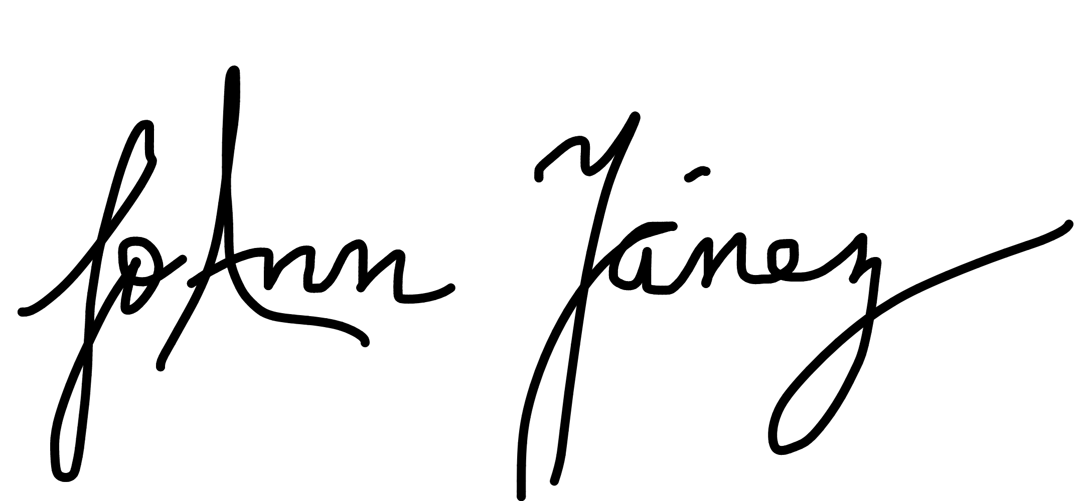
Respectfully,

Dr. JoAnn Yanez Executive Director

1717 K Street NW, Suite 900, Washington, DC 20006 800-345-7454 AANMC.org

