Ahmiyada Dugsiyada Saaxiibtinimada u leh Xiiqda

# Arrinta

Ugu dhawaan

**1 ka mid**

**ah 11**

**12%** Celceliska

waxaa dhici karta inay

carruurta ka yar 18 ee hadda qaba xiiqda gudaha Massachusetts1

ee bulshooyinka MA waxay lahaayeen heer wayn oo aad u sareeya ee carruurta 5-14 ee qabta xiiqda oo ka badan celceliska gobolka gudaha sanad dugsiyeedkii 2023-20242

carruurt qabaan xiiqda fasalkiiba3

Badanka dugsiyada leh deegaan ahaan xiiqda waxyaabaha kiciya sida:

Dilaacyada iyo caaryada

cayayaanka boodhka qiiqa ka soo baxaya alaabta

nadiifinta

Carruurta qabta xiiqda waxay si wanaagsan u awoodaan inay xakameeyaan astaamahooda xiiqda marka la qaado tallaabooyinka si loo aqoonsado oo loo yareeyo xiiqda waxyaabaha kiciya gudaha dugsiyada.

# Dheefaha

**Ka wanaagsan: Ka yar:**

**soo xaadirka**

**barashada**

**xooga saar**

**astaamaha**

**xayiraadaha ka qayb gelida hawlaha jidhka**

**gurmadka caafimaadka**

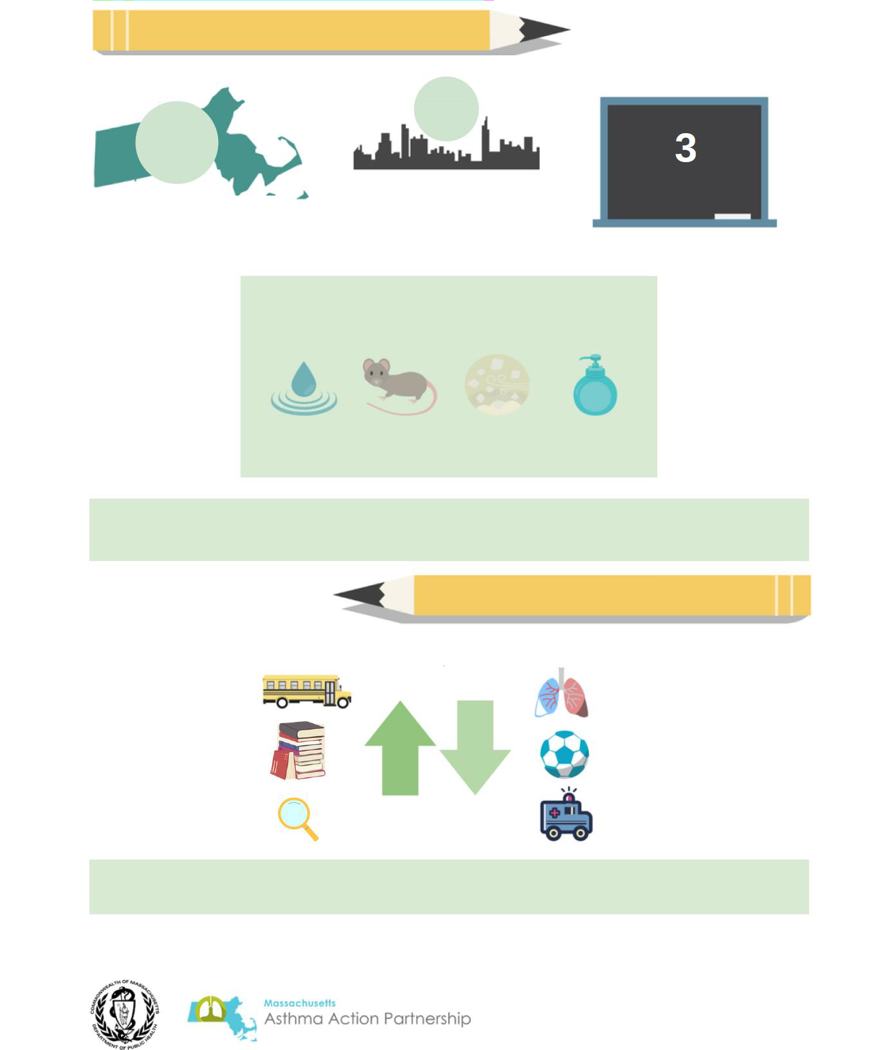

Dugsiyada caafimaadka leh ee leh hawo nadiif ah oo gudaha ah = ardayda si wada wanaagsan wax u barta ee caafimaadka qaba

**Haddii aad ka walaacsan tahay waxyaabaha kiciya xiiqda ee deegaanka gurigaaga waxaad wax badan ka heli kartaa EPA halkan:** [**Ingiriisi**](https://www.epa.gov/sites/default/files/2021-05/documents/asthma_triggers_infographic.pdf) **ama** [**Isbaanish**](https://espanol.epa.gov/sites/default/files/2021-05/documents/spanish_asthma_triggers_infographic.pdf)

Ilaha:

1. Nidaamka Dabagalka Sababta Khatarta Dhaqanka ah (2022)
2. Raacida Caafimaadka Dad waynaha ee Deegaanka Massachusetts (2023-2024 Sanad Dugsiyeedka)
3. Xarumaha Xakamaynta Cudurka iyo Ka hortagga (2022)