

Nearly

**1 in 11**

**12%**

children under 18 currently have asthma in Massachusetts 1

of communities in MA had a significantly higher percentage of children ages 5-14 with asthma than the state average in the 2023-2024 school year 2

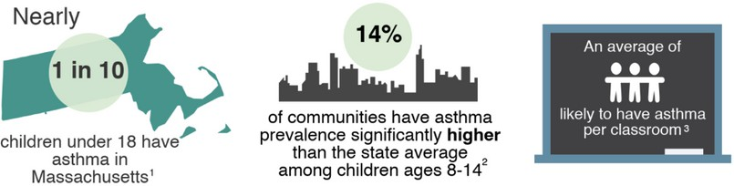

An average of

**3**

children are likely to have asthma per classroom 3

**The Importance of Asthma-Friendly Schools**

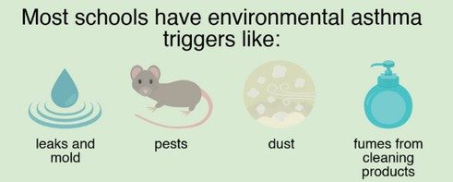

Most schools have environmental asthma triggers like:

Children with asthma are better able to control their asthma symptoms when steps are taken to identify and reduce asthma triggers in their schools.



**Benefits**

Better: Fewer:

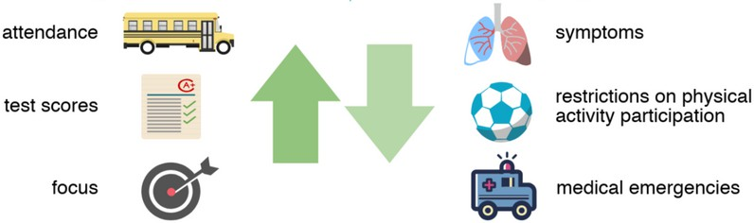

**attendance**

**learning**

**restrictions participating in physical activities**

**focus**

**medical emergencies**

**symptoms**

Healthy schools with clean indoor air = healthy, high performing students

**If you are concerned about environmental asthma triggers in your home you can find more information from the EPA here:** [**English**](https://www.epa.gov/sites/default/files/2021-05/documents/asthma_triggers_infographic.pdf) **or** [**Spanish**](https://espanol.epa.gov/sites/default/files/2021-05/documents/spanish_asthma_triggers_infographic.pdf)

Sources

1. Behavioral Risk Factor Surveillance System (2022)
2. Massachusetts Environmental Public Heath Tracking (2023-2024 School Year)
3. Centers for Disease Control and Prevention (2022)