

Massachusetts Department of Public Health
Bureau of Climate and Environmental Health|Bureau of community health and prevention
Asthma in Schools
Data to Action Project
The Asthma in Schools: Data to Action Project is a collaboration between Massachusetts Department of Public Health (DPH) programs, local health departments, and local school health and administration officials to support asthma prevention and intervention efforts in school settings.
How are Schools Selected?
Each year, school nurses across the Commonwealth provide data to the DPH about the number of students in grades K-8 with asthma. This joint effort uses the pediatric asthma data to identify schools and communities that could most benefit from indoor air quality (IAQ) assessments. Coordinated asthma interventions will focus on public schools that have a high burden of pediatric asthma and are located in or near designated environmental justice neighborhoods, which are areas that have historically experienced inequitable exposure to environmental hazards.
Partnering agencies include DPH’s Bureau of Climate and Environmental Health’s Indoor Air Quality Unit (IAQ) and Division of Environmental Epidemiology (DEE) and the Bureau of Community Health and Prevention’s Asthma Prevention and Control Program (APCP) and School Health Unit (SHU).
How Does the Project Work?
Five schools will be invited to participate each school year to receive a free indoor air quality assessment between January - March. Each assessment will include the following:
On-Site IAQ School Assessment:
- Evaluation of mechanical ventilation systems
- Visual inspection for water-damaged materials/microbial growth
- Exterior building envelope evaluation
- Identification of point sources of irritation (e.g., asthma triggers and allergens)
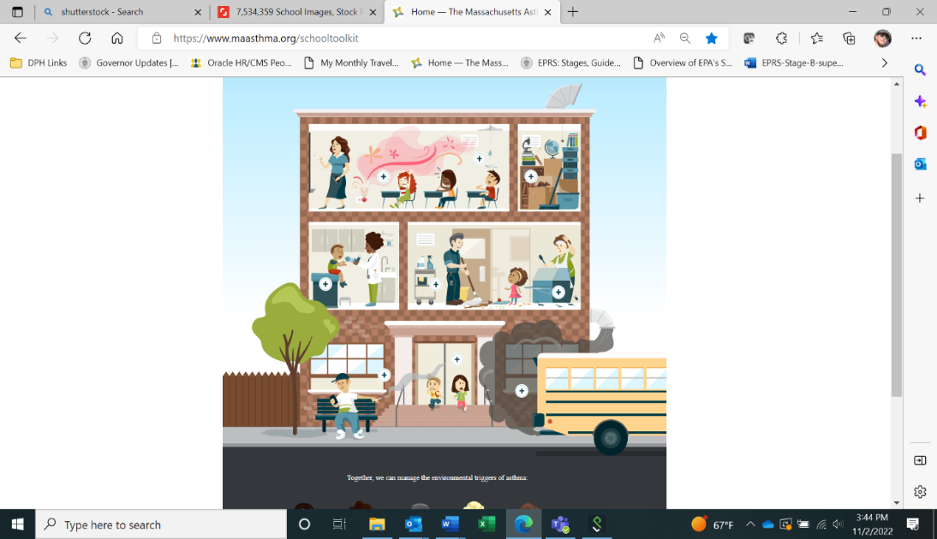
School-specific reports and recommendations from IAQ, as well as implementation support

Educational materials and training offered by APCP and SHU

Learn more about healthy schools with the DPH Clearing the Air Toolkit.
DPH programs hope to support schools in providing a healthy environment for children with asthma and reduce the incidence of asthma events.

