**Low-Risk Deleading Work by Homeowners and Their Agents**

**A Step-by-Step Guide**

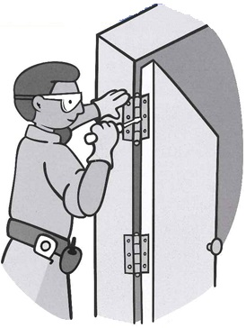**Table of Contents**

**Childhood Lead Poisoning Prevention Program  
(CLPPP)**

**Call for free 1-800-532-9571**

|  |  |
| --- | --- |
| **Understanding Low-Risk Deleading** |  |
| * How to Use This Book | **2** |
| * What Is Low-Risk Deleading | **3** |
| * Who Can do Low-Risk Work | **3** |
| * The Lead Law | **3** |
| * Reading Your Inspection Report | **4** |
| * + Types of Hazards | **4** |
| * Low-Risk Deleading Methods | **5** |
| **Getting Ready to do Low-Risk Work** |  |
| * Before You Start the Work | **6** |
| * Inside Work Area Preparation | **6** |
| * Outside Work Area Preparation | **8** |
| * Occupancy | **9** |
| * Notification | **10** |
| * Scheduling the Work | **15** |
| **Doing Low-Risk Work** |  |
| * How to Remove or Replace Components | **16** |
| * How to Cover Surfaces | **18** |
| * Clean Up | **22** |
| * Disposal of Debris and Components | **24** |
| * Final Inspection | **25** |
| * Additional Resource |  |
| **Quiz** | **11-14** |
|  |  |

**How to Use this Book**

This book explains low-risk deleading work that you (or your agent) can do yourself. You must read this book and take the quiz. After you send the quiz to the Childhood Lead Poisoning Prevention Program (CLPPP), you will get an authorization number in the mail.

**You cannot begin any work until you get an authorization number from CLPPP.**

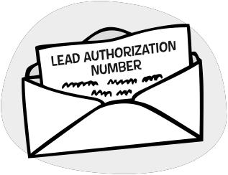

Only low-risk tasks are listed in this book. There is a separate booklet for encapsulation. You must have an encapsulation authorization number to apply encapsulants. In order to replace windows, scrape small amounts of paint, and do other moderate-risk work, home owners must take a one-day training class on moderate-risk deleading. Scraping large amounts of paint, using chemical paint strippers, or demolition can only be done by a licensed deleader.

**Before you begin, be sure to read the *All About Deleading* guide that came with this book. The guide contains important information about financial assistance, how to get a Letter of Full Deleading Compliance or Interim Control, and the different types of deleading.**

**What Is Low-Risk Deleading?**

2

**Low-risk deleading is:**

* Removing doors, cabinet doors, or shutters from hinges
* Covering surfaces
* Encapsulating surfaces (requires a separate training and authorization number)

**Who Can do Low-Risk Work?**

Homeowners and agents can do low-risk deleading. An **agent** is a person who does work for the owner. An agent can be an employee, contractor, family member, or friend. An agent must be 18 years of age or older.

**Before you do any work, you must have a lead inspection!**

**The Lead Law**

The Lead Law protects a child’s right to a lead-safe home. The Law requires that homes be deleaded or brought under interim control when:

1. the home was built before 1978 and contains lead hazards; and
2. child under the age of 6 lives there.

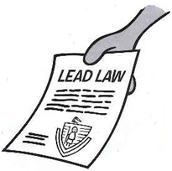**Reading Your Inspection Report**

3

On the cover of the report there is a drawing of the floor plan of your home. Each side of the home is given a letter. Side A is the street side – this is the side where the home gets its address. Each room is given a number or a label. Walk through the home to make sure you understand the drawing.

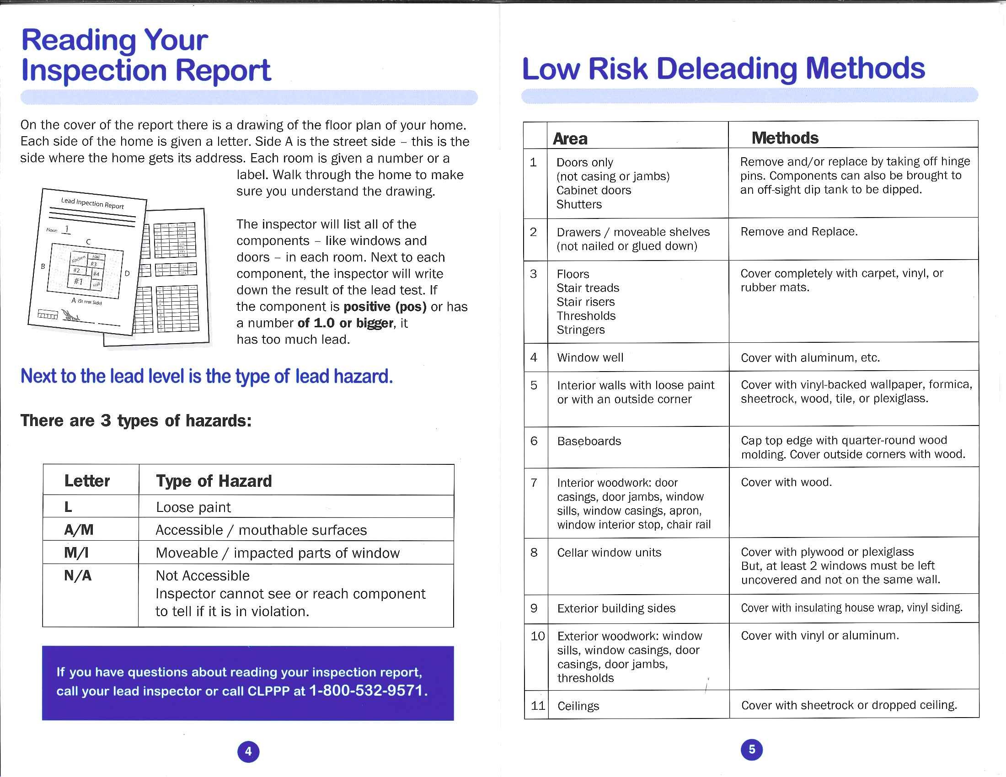The inspector will list all of the components - like windows and doors - in each room. Next to each component, the inspector will write down the result of the lead test. If the component is **positive (pos)** or has a number of **1.0 or bigger**, it has too much lead.

**Next to the lead level is the type of lead hazard.**

|  |  |
| --- | --- |
| **Letter** | **Type of Hazard** |
| **L** | Loose Paint |
| **A/M** | Accessible / mouthable surfaces |
| **M/I** | Moveable / impacted parts of window |
| **F** | Friction Surfaces |
| **N/A** | Not Accessible  Inspector cannot see or reach component to tell if it is a hazard. |

**If you have questions about reading your inspection report, call your lead inspector or call CLPPP at 1-800-532-9571.**

**Low Risk Deleading Methods**

4

|  |  |  |
| --- | --- | --- |
|  | **Area** | **Methods** |
| 1 | Doors only (not casing or jambs) Cabinet doors Shutters | Remove and/or replace by taking off hinge pins. Components can also be brought to an off-sight dip tank to be dipped. |
| 2 | Drawers / moveable shelves with loose paint  (not nailed or glued down) | Remove and Replace. |
| 3 | Floors  Stair treads  Stair risers  Thresholds  Stringers | Cover completely with carpet, vinyl, or rubber mats. |
| 4 | Window well | Cover with aluminum, etc. |
| 5 | Interior walls with loose paint | Cover with vinyl-backed wallpaper, formica, sheetrock, wood, tile, or plexiglass. |
| 6 | Interior woodwork with loose paint: door casings, door jambs, window sills, window casings, apron, window interior stop, chair rail | Cover with wood. |
| 7 | Cellar window units | Cover with plywood or plexiglass  But, at least 2 windows must be left uncovered and not on the same wall. |
| 8 | Exterior building sides | Cover with insulating house wrap, vinyl siding. |
| 9 | Exterior woodwork: window sills, window casings, door casings, door jambs, thresholds | Cover with vinyl or aluminum. |
| 10 | Ceilings | Cover with sheetrock or dropped ceiling. |

**Before You Start the Work**

5

**Be sure all people and animals are removed from the work area! They may return after the work is done and the work area is cleaned.**

**Inside Work Area Preparation**

The **work area** is the room where the work is being done.

* If the work will be done on a door that leads out of the room, then the work area extends 10 feet from the door system.
* If the work is in a long hallway, then the work area is 10 feet in every direction from the activity.

Occupants can use the work area once it is cleaned and all the equipment is stored.

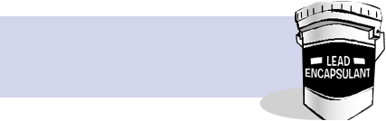

**Some surfaces may be able to be encapsulated.   
See the Encapsulation booklet.**

**Set-Up:**

1. Shut-down and cover all heating and cooling vents in the area with plastic. Seal with tape.
2. Move plants, lamps, pictures and other objects out of the work area.

6

1. Push large objects, such as tables and chairs, into the center of the room. Cover them with plastic and tape the plastic to the floor.

* Occupants of rental property should be informed that objects will be removed or covered.
* Occupants must clean out closet and cabinet areas that need to be deleaded.

1. Objects that cannot be moved, like refrigerators and stoves, must be covered in plastic. Seal the plastic to the floor and walls with tape.
2. Cover the floor with plastic.
   * The plastic should extend far enough to collect any falling debris.
   * If you are deleading the floor, you do not need to cover the floor.
   * You can use a tarp instead of plastic sheeting around ladders and scaffolding so that you do not slip.
3. Keep the work area separate from other areas.

* Shut windows and doors to prevent lead dust from spreading.
* If you are deleading a window or door, it can be opened while you do the work.

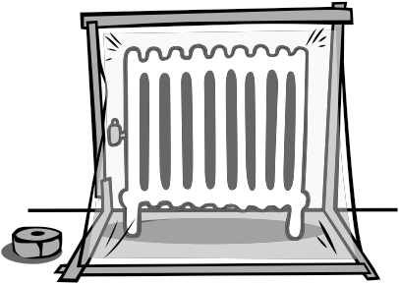

**Outside Work Area Preparation**

7

1. Close doors and windows on the same side of the house that you are working on. Close doors and windows on the same floor that you are working on.
2. Cover the ground – including plants – with tarps. Use rocks or other heavy objects to hold the tarps down. The tarps should extend out far enough to catch any falling debris.
3. Move sandboxes or play equipment out of the work area.  
   If you cannot move them, cover them with plastic.
4. Do not work on windy days.
5. Paint chips and debris cannot fall more than 40 feet, unless you are using a dust-tight chute.

Drawing of a man putting plastic over his windows to help pevent lead dust from spreading when he starts to delead his house. Be a Good  Neighbor;
Make sure dust  and debris are not traveling to your neighbors’ yards. If you are not working safely, your local Board  of Health  can  stop your work.


**Be a Good Neighbor**

**Make sure dust and debris are not traveling to your neighbors’ yards. If you are not working safely, your local Board of Health can stop your work.**

**Occupancy**

8

Occupants must be **out of the work area** if you are:

* + Covering surfaces
  + Removing doors, cabinets, or shutters

The **work area** is the room where the work is being done. If you are deleading a door, then the work area extends 10 feet out from the door system. If you are doing work in a hallway, the work area is 10 feet in every direction.

Occupants can use the work area once the work is done for the day and the area has been cleaned. The work area does not have to be inspected by a lead inspector before the area can be used.

If you are working on the **exterior** of the house, occupants must stay out of the work area. The work area is the side of the building the work is being done on.

**Occupants must be out of the unit for the day if they have to walk through the work area to exit the building. A fire escape is not an acceptable means of exit.**

**Occupants can return home after the work is done for the day and the work area has been cleaned. You do not need an inspection at the end of the day.**

**If occupants must be out of the unit for the day, you should:**

* **Agree on a time when the work will be done and cleaned up.**
* **Have a contact number to call to notify occupants when it is safe to return.**

**Notification**

9

You will receive a Deleading Notification Form in the mail with the Authorization Number. This form will include a list of who must be notified before you begin work.

The Notification Form must be completely and clearly filled out. Incomplete forms will be returned.

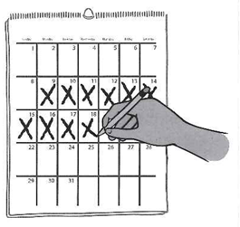**QUIZ**

**10 Day Waiting Period**

If low-risk deleading work is being done on the interior of a non-owner occupied unit or in the common areas of an occupied building, you must notify occupants and the agencies included in your letter 10 calendar days before any deleading work can be done. *If the unit is owner-occupied or vacant, you do not need to wait 10 days. You must still send proper notification.*

10

Please check all boxes that apply:

I have read this book

I am the homeowner.

I am the agent (18 years or older) working for the homeowner.

Name:

Mailing Address with zip code:

Email Address:

Signature:

Today’s Date: Date of Birth:

Home Telephone Number: ( )

Work Telephone Number: ( )

Address of the property being deleaded:

**QUIZ** cont.

**True or False?**

1. Low-risk deleading work can be done by a person who is under 18 years old.

True  False

1. If the paint on the outside of the home is flaking, a homeowner or agent must cover the sides with insulating house wrap before installing vinyl siding.

True  False

1. Debris from low-risk deleading should be double-bagged before disposal.

True  False

1. You do not need to shut windows and doors before you start low-risk deleading.

True  False

1. The information in the booklet teaches me how to encapsulate surfaces.

True  False

1. Using chemical strippers to strip paint is considered low-risk work as long as it does not make dust.

True  False

**QUIZ** cont.

**Circle the Best Answer**

1. What type of work are low-risk authorized homeowners and agents NOT allowed to do?
   * 1. covering stair treads, risers, and window wells
     2. scraping, sanding, patching surfaces and replacing windows
     3. covering interior walls
     4. covering exterior building sides
2. Which of the following workmanship rules will the inspector look for?
   * + - 1. exterior coverings are caulked and sealed to prevent water damage
         2. no bent or protruding nails or sharp edges
         3. covering fits completely and securely
         4. all of the above
3. At the re-inspection, the low-risk work must pass this test in order to get a Letter of Full Deleading Compliance.
   1. dust wipe test
   2. TSP test
   3. clean-up test
   4. vacuum test
4. What safety precautions must you take when you are doing low-risk deleading work outside?
   1. move play equipment and sandboxes
   2. cover soil and plants next to the work area with thick plastic
   3. close windows to keep debris from getting inside the home
   4. all of the above

**QUIZ** cont.

1. Where can occupants be when you are removing doors in a room?
   * 1. out of the work area
     2. at least 5 feet away from the person doing the work
     3. out of the unit for the day
     4. in a hotel or motel overnight
2. What is the best way to clean up a work area?
3. sweeping the area with a broom
4. vacuuming the room with a regular vacuum
5. washing the area with paper towels and all-purpose cleaner
6. all of the above

**YOU MUST SEND THIS QUIZ TO CLPPP**

Email: [CLPPPOwnerAndAgentAuthorization@mass.gov](mailto:CLPPPOwnerAndAgentAuthorization@mass.gov)

OR mail:

Childhood Lead Poisoning Prevention Program  
5 Randolph Street  
Donovan Building  
Canton, MA 02021

**Scheduling the Work**

**You cannot begin any low-risk Deleading work until you have an authorization number and have given proper notification. If you have any questions, please call 1-800-532-9571.**

Different levels of authorized people (such as low-risk or moderate-risk) cannot be in the same work site at the same time. Each level of authorized person must do his/her work and clean up before the other level of authorized person can begin work on the site.

For scheduling purposes, the interior of the unit is considered one work site and the exterior of the home is one work site. This means that if you are covering surfaces upstairs (low-risk deleading), a licensed deleader cannot be working in a different room or downstairs at the same time.

Try to plan deleading projects that move from low to high risk.

Quiz Answer Key:

**9571.**

**How to Remove or   
Replace Components**

15

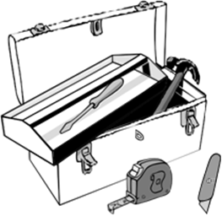**Removable components include:**

Doors (on hinges)

Cabinet doors (on hinges)

Shutters (on hinges)

Drawers

Shelves that are not affixed

**You will need:**

* Screwdriver
* Utility knife
* Tape measure
* Hammer
* Spray bottle filled with water

**Steps:**

1. If you are replacing the component, take measurements and purchase new materials. If you are dipping the component, make arrangements at an off-site dip tank.
2. Unscrew the hinges (not for drawers or shelves).
3. If the hinge hardware has been painted, use a utility knife to break the paint seal between the hardware and the component and wet-mist the hinge.
4. Gently lift and remove the component.
5. Bag or wrap the component and seal with tape for disposal.
6. If there is any other hardware that needs to be removed, remove it following steps 2 and 3.
7. Install the new component.

* Bathroom doors must be replaced immediately.
* Dipped doors must be free from paint or residue on all edges.

16

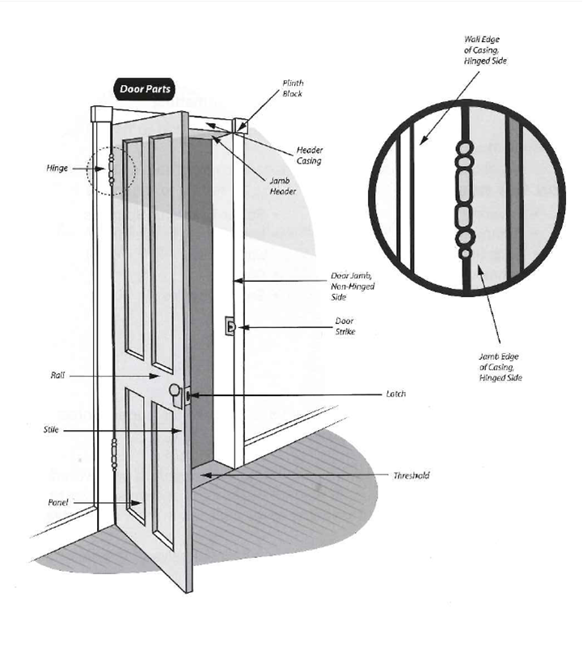**How to Cover Surfaces**

17

Only approved coverings can be used. These include:

|  |  |
| --- | --- |
| * Paneling * Sheet rock * Vinyl-backed wallpaper * Wood * Tile * Vinyl | * Aluminum * Plexi-glass * Formica * Acrylic sheets * Durable carpeting * Rubber matting |

Covering must be used appropriately.

**You will need:**

|  |  |
| --- | --- |
| * Covering material * Hammer * Nails (if appropriate) * Adhesive (if appropriate) * Utility knife * Caulking | * Paper Towels or Sponges * Large spray bottle filled with water * Gloves * Safety goggles |

**Steps:**

* + - 1. If there is loose paint, do not flake or make the surface intact  
         (this is moderate-risk deleading).
      2. Cut or shape the coverings to fit the component to be covered. Most coverings must fit flush to the surface and must cover to a height of 5 feet. They must cover 4 inches in from each edge.
      3. If you are gluing on the covering, apply adhesive to the backside of the covering.

**4**. Place covering on component and securely affix.

18

* Wipe away extra adhesive.
* If you are nailing or tacking on covering, make sure the nails are close enough together to make a tight fit (about 16 inches apart).

1. Cut off or bend sharp edges.
2. Caulk all junctures and seams. You do not need to caulk wallpaper or carpet.
3. Collect debris using a wet paper towel and put it in a plastic bag.

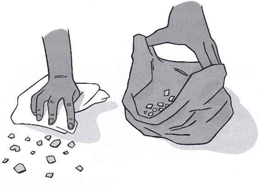

**Exterior building sides do not need to be intact before you apply vinyl siding. If the siding has loose paint, it must be covered with insulating house wrap before you begin the work.**

19

20

**Clean Up**

2**You will need:**

* Garbage bags
* Duct tape
* All purpose cleaner
* Sponges or paper towels
* Buckets of Warm Water

1. Double-bag or wrap and tape any debris. Seal plastic bags with duct tape.
2. Wash down tools and equipment. Once they are clean, remove them from the work area.
3. Carefully remove plastic covering from furniture.
4. Carefully remove the tape that is sealing the plastic to the floor. Be sure you do not remove paint along with the tape!

* Once you have removed all of the tape, slowly fold the edges of the plastic into the center of the room. This should trap the dust and debris in the plastic.
* Double bag or wrap and tape the dirty plastic and bring it out of the work area.

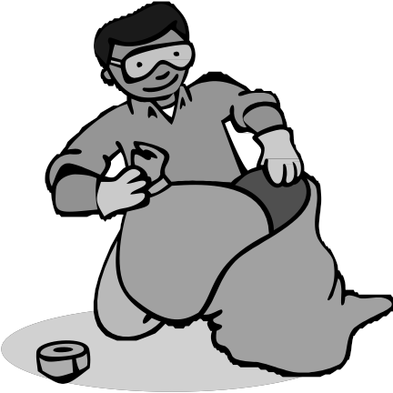

22

22

1. Wash the deleaded areas. Do not wash any drying encapsulants.

* Start at the top of the room and at the top of each component (door, window, etc.) Wash the area from the top to the bottom.
* Use all-purpose cleaner, disposable sponges or paper towels, and warm water.
* Change the water and sponges often.
* Next, rinse off the all-purpose cleaner. Use warm water. Start at the top and work your way down.
* Flush dirty water down the toilet.

1. Do not use a broom or vacuum to clean up debris. This can spread dangerous lead dust.

**The lead inspector must wait one hour from the end of the clean-up before taking dust wipes. This will allow the surfaces to dry.**

**Disposal of Debris and Components**

23

You can dispose of debris from low-risk deleading in the household trash or at the municipal dump. A Letter of Full Deleading Compliance cannot be issued until the debris has been properly disposed of.

**Household Trash:**

* Trash must not be put out until the night before or the day of collection.
* Trash and components must be completely covered and sealed with tape.
* Check with your local trash company about size limitations.

**Municipal Dump:**

* Trash and components must be completely covered and sealed with tape.
* If there is a choice of facilities, send debris to a lined solid waste landfill rather than a waste-to-energy landfill.

**Final Inspection**

24

After all of the low-risk deleading is complete, a licensed lead inspector will inspect the home for final compliance. The inspector will check to see that the work has been done properly. He/she will do a dust wipe test to make sure the work was done correctly and the area has been cleaned up.

At the time of final inspection there should be:

* No visible dust
* No debris
* No tools in the work areas

**If the home passes the dust wipe test and all of the lead hazards have been fixed, you will receive a Letter of Full Deleading Compliance.**

**Resources**

25

A **Letter of Full Deleading Compliance** and your **Re-Inspection Report** (which shows how each surface was fixed) are very important legal documents. Keep them in a safe place so you do not lose them.

**Childhood Lead Poisoning Prevention Program (CLPPP)**

MA Department of Public Health

250 Washington Street, Seventh Floor

Boston, MA 02108

1-800-532-9571 (toll free)

To find a licensed lead inspector or deleader visit the CLPPP website at: [www.mass.gov/dph/clppp](http://www.mass.gov/dph/clppp)

**Department of Labor Standards**

Lead Program

Department of Labor and Workforce Development

19 Staniford St., 2nd floor

Boston, MA 02114

1-617-626-6960

[www.mass.gov/LWD/labor-standards/lead-](http://www.mass.gov/LWD/labor-standards/lead-)program

**To find your local Board of Health:**

Massachusetts Association of Health Boards

1-508-643-0234

[www.mahb.org](http://www.mahb.org/)

**For financial help:**

Get the Lead Out Program

1-617-854-1000

[www.masshousing.com/portal/server.pt](http://www.masshousing.com/portal/server.pt)

**FOR MORE INFORMATION, CONTACT:**

**Childhood Lead Poisoning Prevention Program (CLPPP)**

Massachusetts Department of Public Health

250 Washington Street, Seventh Floor

Boston, MA 02108



Call for free: 1-800-532-9571

On the web: [www.mass.gov/dph/clppp](http://www.mass.gov/dph/clppp)

Massachusetts Department of Public

Bureau of Environmental Health

2021