INDOOR AIR QUALITY/WATER DAMAGE INVESTIGATION

Atherton Hough Elementary School
1084 Sea Street
Quincy, Massachusetts

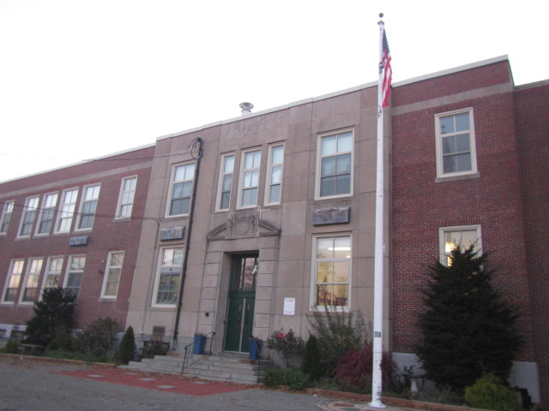

Prepared by:
Massachusetts Department of Public Health
Bureau of Environmental Health
Indoor Air Quality Program
November 2021

BACKGROUND
Building: | Atherton Hough Elementary School (AHES)
Address: | 1084 Sea Street, Quincy, MA
Assessment Requested by: | Quincy Public Schools
Reason for Request: | Water damage/mold concerns in a basement room and general indoor air quality (IAQ) conditions
Date of Assessment: | November 15, 2021
Massachusetts Department of Public Health/Bureau of Environmental Health (MDPH/BEH) Staff Conducting Assessment: | Cory Holmes, Assistant Director, IAQ  Program
Date of Building Construction: | The original school building was constructed in 1911. Additions were built in 1929 and in 1949.
Building/Site Description: | The school is a two-story brick structure with an occupied basement. Most rooms have tile floors and plaster walls and ceilings. Some areas have been built out with gypsum wallboard (GW) and suspended ceiling tile systems.
Windows: | Openable

INTRODUCTION

The IAQ Program previously assessed the AHES in 2002; the report for that visit is included as Appendix A. Since 2002, the AHES was renovated to install mechanical heating and ventilation components.

METHODS
DPH staff conducted a series of visual assessments, temperature, and relative humidity measurements focused in basement areas, to identify likely areas that could be prone to condensation in hot, humid weather. Please refer to the IAQ Manual for methods, sampling procedures, and interpretation of results (MDPH, 2015).

RESULTS AND DISCUSSION
The following is a summary of indoor air testing results (Tables 1 & 2):
- Temperature was below or close to the MDPH recommended range of 70°F to 78°F in areas tested.
- Relative Humidity was below the MDPH recommended range of 40 to 60% in areas tested, which were reflective of outside conditions.
- Moisture Measurements of porous materials in the basement were normal (i.e., dry) at the time of the assessment.
- Carbon Monoxide was not detected (ND) in any area tested.
- Particulate matter (PM2.5) concentrations measured were below the National Ambient Air Quality (NAAQS) level of 35 μg/m³ in all areas tested.

Ventilation
A heating, ventilating and air conditioning (HVAC) system has several functions. First it provides heating and, if equipped, cooling. Second, it is a source of fresh air. Finally, an HVAC system will dilute and remove normally occurring indoor environmental pollutants by not only introducing fresh air, but by filtering the airstream and ejecting stale air to the outdoors via exhaust ventilation. Even if an HVAC system is operating as designed, point sources of respiratory irritation may exist and cause symptoms in sensitive individuals.

Original 1911 Building
Fresh air is provided by an air handling unit (AHU) located in a large room on the ground floor that is connected to ductwork leading to wall-mounted air diffusers (Picture 1). Classroom fresh air supply grilles are connected to the fan unit by ductwork. Each classroom contains an exhaust vent located at floor level (Picture 2). A number of these vents were obstructed by cabinets, bookcases, and other items (Picture 3).

1929 & 1949 Wings
Fresh air in these classrooms is supplied by unit ventilator (univent) systems (Picture 4). Univents are designed to draw air from outdoors through a fresh air intake located on the exterior wall of the building (Picture 5) and return air through an air intake located at the base of each unit (Figure 1). Fresh and return air are mixed, filtered, heated, and provided to classrooms through a fresh air diffuser located on the top of the unit. Obstructions to airflow, such as paper and boxes stored on univent air diffusers (Picture 4) and furniture and other items in front of univent return vents, were also noted in classrooms. In order for univents to provide fresh air as designed, univent air diffusers and return vents must remain free of obstructions.
Exhaust ventilation in these areas is provided by wall vents or exhaust cubbies. As with the univents, several of these vents were obstructed by various classroom items (Pictures 6 and 7), which can limit airflow.
To maximize air exchange, the IAQ program recommends that both supply and exhaust ventilation operate continuously during periods of occupancy. In order to have proper ventilation with a mechanical ventilation system, the systems must be balanced after installation to provide an adequate amount of fresh air to the interior of a room while removing stale air from the room. It is recommended that HVAC systems be re-balanced every five years to ensure adequate air systems function (SMACNA, 1994).

Microbial/Moisture Concerns
The assessment was prompted by reports of mold growth on GW in the basement OT room. At the time of the assessment the GW had been removed, replaced, and refinished (Picture 8), along with insulation materials within the wall cavity of this area. No evidence of water damage or visible mold growth was observed. In addition, moisture testing of all walls in this area was conducted and found to be normal (i.e., dry).
It is also important to note that both portable dehumidifiers and air purifiers were in use in basement areas. These devices contain filters that should be cleaned/changed per manufacturers’ instructions. In addition, dehumidifiers hold standing water and should be emptied/cleaned regularly to prevent scale, odors, and mold growth.

Other Sources of Water Damage/Moisture
Water-damaged wall and ceiling plaster was observed in the form of peeling paint, stains, and efflorescence (i.e., mineral deposits) in several areas in the building (Table 1, Pictures 9 and 10). No current/active leaks were observed or reported, which indicates the damage is likely from historic water penetration issues. Efflorescence is a characteristic sign of water intrusion. As moisture penetrates and works its way through mortar around brick it leaves behind these characteristic mineral deposits.
Some areas had water-damaged ceilings tiles (Table 1). Water-damaged ceiling tiles can provide a source of mold and should be replaced after a water leak is discovered and repaired.

Building Materials Prone to Condensation
It is important to note that Massachusetts has experienced extended periods of relative humidity during the summer of 2021. This July was the wettest ever recorded in Massachusetts, and the three-month period from June through August, known as the meteorological summer, was the fourth wettest on record, according to the National Oceanic and Atmospheric Administration’s Centers for Environmental Information. The three-month period also was the third warmest ever in the state and was tied for the warmest on record across the United States. (HG, 2021, NOAA, 2021).
According to American Society of Heating, Refrigerating and Air-Conditioning Engineers (ASHRAE), if relative humidity exceeds 70%, mold growth may occur due to wetting of building materials (ASHRAE, 1989). It is recommended that porous material be dried with fans and heating within 24 to 48 hours of becoming wet (US EPA, 2008, ACGIH, 1989). If porous materials are not dried within this time frame, mold growth may occur. Water-damaged porous materials cannot be adequately cleaned to remove mold growth.
Due to the weather conditions of this past summer, IAQ staff conducted temperature testing to assess whether building components may become mold-contaminated during extended periods of hot, humid weather. The key to managing condensation indoors during hot, humid weather is understanding dew point. When warm, moist air passes over a cooler surface, condensation can form. Condensation is the collection of moisture on a surface at or below the dew point. The dew point is the temperature that air must reach for saturation to occur. If a building material/component has a temperature below the dew point, condensation will accumulate on that material. Over time, condensation can collect and form water droplets.
A method to locate areas in a building prone to condensation would be to measure air and building material temperatures using a laser thermometer (Table 1). If a wide temperature range exists between measurements, the building materials at the colder end of the range may be prone to becoming moistened with condensation if exposed to hot, humid weather (outdoor relative humidity >70%) for extended periods of time (at least 48 hours). According to the test results in Table 1, a number of areas may be prone to condensation if exposed to hot, humid weather during summer months.

Other Issues
Some areas were carpeted. Carpets should be cleaned annually (or semi-annually in soiled/high traffic areas) in accordance with Institute of Inspection, Cleaning and Restoration Certification (IICRC) recommendations, (IICRC, 2012). The service life of carpeting is approximately 10-11 years (IICRC, 2002). Regular cleaning with a high efficiency particulate air (HEPA) filtered vacuum in combination with an annual cleaning will help to reduce accumulation and potential aerosolization of materials from carpeting. In addition, carpeting is generally not recommended in basement areas due to elevated humidity and condensation issues. Several rooms had area rugs, which should also be vacuumed/cleaned on a regular basis. Area rugs should be rolled up and stored in a clean, dry place when rooms are not occupied during the summer months to prevent moistening due to condensation.
Exposure to low levels of total VOCs (TVOCs) may produce eye, nose, throat, and/or respiratory irritation in some sensitive individuals. To determine if VOCs were present, BEH/IAQ staff examined rooms for products containing VOCs. BEH/IAQ staff observed dry erase materials, hand sanitizers, spray cleaners and air fresheners in use within the building. These products have the potential to be irritants to the eyes, nose, throat, and respiratory system of sensitive individuals.
In a few areas, tennis balls had been sliced open and placed on table/chair footings to reduce noise (Picture 11, Table 1). Tennis balls are made of a number of materials that are a source of respiratory irritants. Constant wearing of tennis balls can produce fibers and lead to off-gassing of VOCs. Tennis balls are made with a natural rubber latex bladder, which becomes abraded when used as a chair leg pad. Use of tennis balls in this manner may introduce latex dust into the school environment. Some individuals are highly allergic to latex (e.g., spina bifida patients) (SBAA, 2001). It is recommended that the use of materials containing latex be limited in buildings to reduce the likelihood of symptoms in sensitive individuals (NIOSH, 1997; NIOSH, 1998).
Exposed fiberglass insulation around pipes was seen in several areas (Table 1, Picture 12). Fiberglass insulation fragments are a source of eye, skin, and respiratory irritation.
The Environmental Protection Agency (EPA) conducted a National School Radon Survey in which it discovered nearly one in five schools had “…at least one frequently occupied ground contact room with short-term radon levels above 4 [picocuries per liter] pCi/L” (US EPA, 1993). The BEH/IAQ Program therefore recommends that every school be tested for radon, and that this testing be conducted during the heating season while school is in session in a manner consistent with USEPA radon testing guidelines. Radon measurement specialists and other information can be found at www.nrsb.org and http://aarst-nrpp.com/wp, with additional information at: http://www.mass.gov/eohhs/gov/departments/dph/programs/environmental-health/exposure-topics/iaq/radon.

CONCLUSIONS AND RECOMMENDATIONS
In view of the findings at the time of the visit, the following recommendations are made:

Ventilation recommendations
- Remove all items from the top and front of classroom univents, supply vents, and exhaust vents/cubbies.
- Operate all supply and exhaust ventilation systems throughout the building continuously during periods of occupancy to maximize air exchange and filtration.
- Consider adopting a balancing schedule of every 5 years for all mechanical ventilation systems, as recommended by ventilation industrial standards (SMACNA, 1994).
- Change filters for HVAC equipment 2-4 times a year using the best quality/highest Minimum Efficiency Reporting Value (MERV) rated filters that can be used with current equipment.
- Use openable windows to supplement fresh air during temperate weather. Ensure all windows are tightly closed at the end of the day and during periods of elevated relative humidity to avoid condensation/mold growth conditions.
- The U.S. Department of Education has released new guidance encouraging the use of American Rescue Plan (ARP) funds to improve ventilation systems and make other indoor air quality improvements in schools. More information can be found at this link https://www.ed.gov/coronavirus/improving-ventilation.

Water Damage Recommendations
- Ensure roof and plumbing leaks are repaired and replace water-damaged ceiling tiles.
- Continue with plans to seal the exterior of the building outside OT room as needed and monitor closely for any further signs of water damage/mold growth for prompt remediation.
- Continue to utilize dehumidifiers in basement (and other areas) as needed. Ensure windows are shut during periods of elevated relative humidity (e.g., over 70%).
- Closely monitor parameters such as temperature, relative humidity, and dew point over summer months to prevent condensation on floors/surfaces. Refrain from storing porous items, such as cardboard and paper on floor in these areas. If carpeting is present, consider removing from areas that are prone to condensation, particularly in basement areas.
- Do not place area rugs on carpeting. Area rugs should be rolled up and stored in a clean, dry place when rooms are not occupied during the summer months to prevent moistening due to condensation.
- Move furniture away from walls several inches to allow airflow and prevent “moisture trapping” which can lead to mold growth on walls.
- Clean/scrape down peeling paint and efflorescence off walls and ceilings and monitor for further water penetration.
- Consider using the methods described in the document “Preventing Mold Growth in Massachusetts Schools During Hot, Humid Weather” to help reduce impact of conditions during hot, humid weather. This guideline can be found online at: https://www.mass.gov/service-details/preventing-mold-growth-in-massachusetts-schools-during-hot-humid-weather

Other Recommendations
- Change filters and maintain portable air purifying units per manufacturers’ recommendations.
- Regularly clean/vacuum supply/exhaust/return vents and personal fans to avoid aerosolizing accumulated particulate matter.
- Reduce use of products and equipment that create irritating volatile organic compounds (VOCs) and only use in well-ventilated areas. Minimize the use of air fresheners (e.g., plug-ins), deodorizers and scented products.
- Keep spray bottles/cleaning products out of the reach of children. Ensure that products are compatible with one another. It is suggested that only school-supplied products be used to avoid product interactions.
- Clean carpeting annually (or semi-annually in soiled high traffic areas) as per the recommendations of the Institute of Inspection, Cleaning and Restoration Certification (IICRC, 2012).
- Consider replacing any carpeting that is beyond its service life (i.e., > 11yrs.).
- For buildings in New England, periods of low relative humidity during the winter are often unavoidable. Therefore, scrupulous cleaning practices should be adopted to minimize common indoor air contaminants whose irritant effects can be enhanced when the relative humidity is low. To control dust, a high efficiency particulate arrestance (HEPA) filter equipped vacuum cleaner in conjunction with wet wiping of all surfaces is recommended. Avoid the use of feather dusters. Drinking water during the day can help ease some symptoms associated with a dry environment (throat and sinus irritations).
- Contain or seal exposed fiberglass around pipes in occupied areas with a proper fire-rated material.
- Replace tennis balls on chair/table footings with latex-free glides.
- The school should be tested for radon by a certified radon measurement specialist during the heating season when school is in session. Radon measurement specialists and other information can be found at: www.nrsb.org, and http://aarst-nrpp.com/wp.
- To learn more about radon, review the MDPH’s Radon in Schools and Child Care Programs factsheet, with additional information at: http://www.mass.gov/eohhs/gov/departments/dph/programs/environmental-health/exposure-topics/iaq/radon.
- Consider forming an IAQ committee in each school building district-wide. Committees should have an IAQ liaison/teacher representative, a member of maintenance/facilities and administration that conduct regular walk-throughs to identify on-going and/or potential environmental issues.
- Consider adopting the US EPA (2000) document, “Tools for Schools”, as an instrument for maintaining a good IAQ environment in the building available at: https://www.epa.gov/iaq-schools/indoor-air-quality-tools-schools-action-kit
- Refer to resource manual and other related IAQ documents located on the MDPH’s website for further building-wide evaluations and advice on maintaining public buildings. These documents are available at: http://mass.gov/dph/iaq.

REFERENCES
ACGIH. 1989. Guidelines for the Assessment of Bioaerosols in the Indoor Environment. American Conference of Governmental Industrial Hygienists, Cincinnati, OH.
ASHRAE. 1989. Ventilation for Acceptable Indoor Air Quality. American Society of Heating, Refrigeration and Air Conditioning Engineers. ANSI/ASHRAE 62-1989.
HG. 2021. Mold keeps South Hadley High School shuttered. Hampshire Gazette. https://www.gazettenet.com/South-Hadley-High-School-still-closed-amid-mold-remediation-42413519.
IICRC. 2002. Institute of Inspection, Cleaning and Restoration Certification. A Life-Cycle Cost Analysis for Floor Coverings in School Facilities.
IICRC. 2012. Institute of Inspection, Cleaning and Restoration Certification. Carpet Cleaning: FAQ.
MDPH. 2015. Massachusetts Department of Public Health. “Indoor Air Quality Manual: Chapters I-III”. Available at: https://www.mass.gov/lists/indoor-air-quality-manual-and-appendices
NIOSH. 1998. Latex Allergy A Prevention. National Institute for Occupational Safety and Health, Atlanta, GA.
NIOSH. 1997. NIOSH Alert Preventing Allergic Reactions to Natural Rubber latex in the Workplace. National Institute for Occupational Safety and Health, Atlanta, GA.
NOAA. 2021. Summer 2021 neck and neck with Dust Bowl summer for hottest on record. National Oceanic and Atmospheric Administration, 1401 Constitution Avenue NW, Room 5128, Washington, DC 20230 https://www.noaa.gov/news/summer-2021-neck-and-neck-with-dust-bowl-summer-for-hottest-on-record
SBAA. 2001. Latex in the Home and Community Updated Spring 2001. Spina Bifida Association of America, Washington, DC.
SMACNA. 1994. HVAC Systems Commissioning Manual. 1st ed. Sheet Metal and Air Conditioning Contractors’ National Association, Inc., Chantilly, VA.
US EPA. 1993. Radon Measurement in Schools, Revised Edition. Office of Air and Radiation, Office of Radiation and Indoor Air, Indoor Environments Division (6609J). EPA 402-R-92-014.
US EPA. 2000. Tools for Schools. Office of Air and Radiation, Office of Radiation and Indoor Air, Indoor Environments Division (6609J). EPA 402-K-95-001, Second Edition. https://www.epa.gov/iaq-schools/indoor-air-quality-tools-schools-action-kit
US EPA. 2008. “Mold Remediation in Schools and Commercial Buildings”. Office of Air and Radiation, Indoor Environments Division, Washington, DC. EPA 402-K-01-001. September 2008. Available at: http://www.epa.gov/mold/mold-remediation-schools-and-commercial-buildings-guide.
Figure 1

Unit Ventilator (Univent)

Mixed Air

Air Diffuser

Outdoors Indoors

Fan

Heating/Cooling Coil

Air Mixing Plenum

Filter

Outdoor Return
Air Air

Air
Flow
Control
Louvers

Air Flow

= Fresh Air/Return Air

= Mixed Air

Picture 1

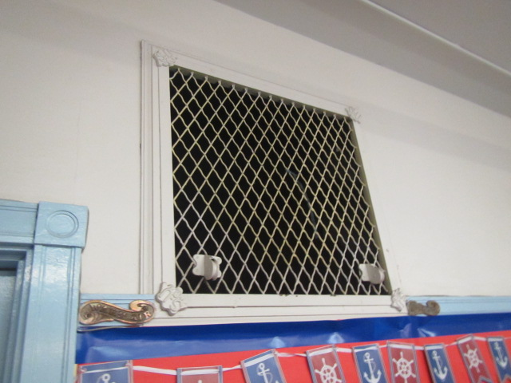

Supply vent for 1911 building

Picture 2

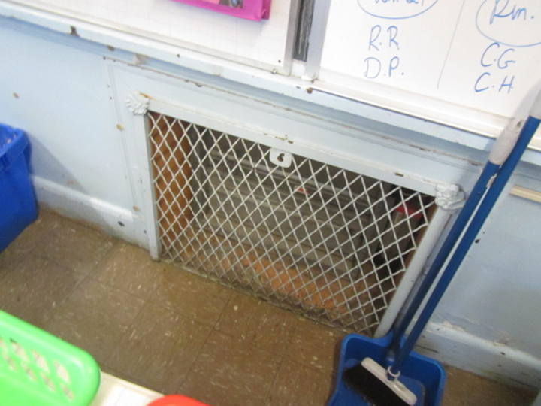

Classroom exhaust vent in 1911 building
Picture 3

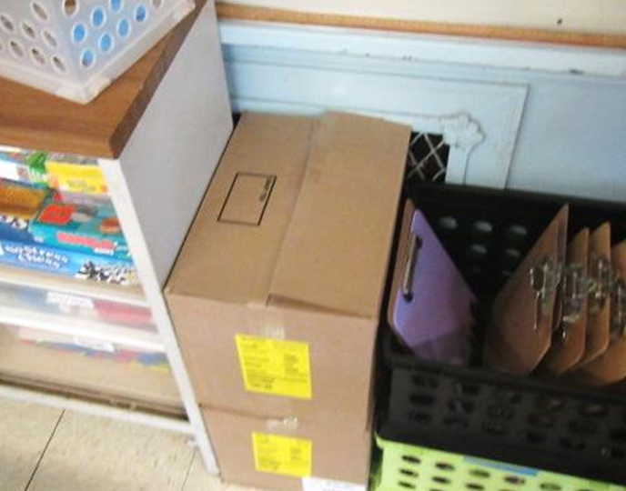

Exhaust vent obstructed by classroom items

Picture 4

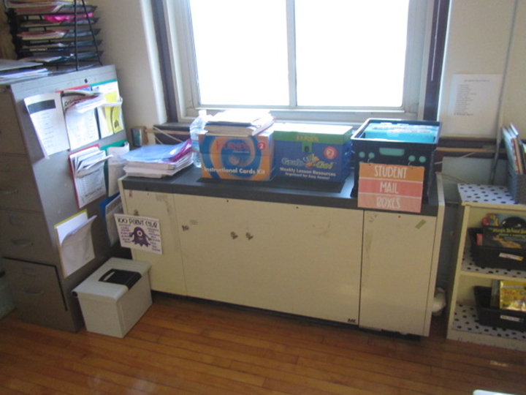

Classroom univent, note items on top obstructing airflow
Picture 5

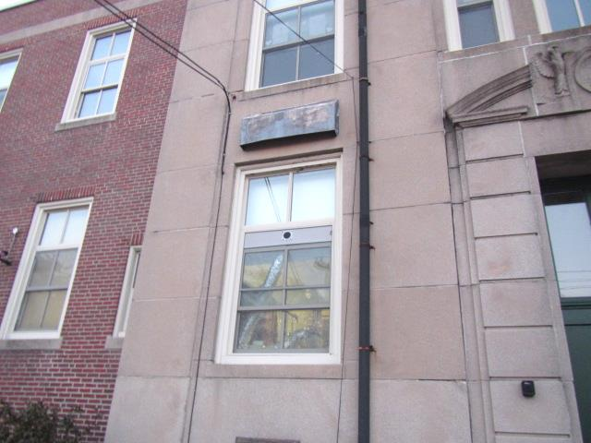

Univent fresh air intake (arrow)

Picture 6

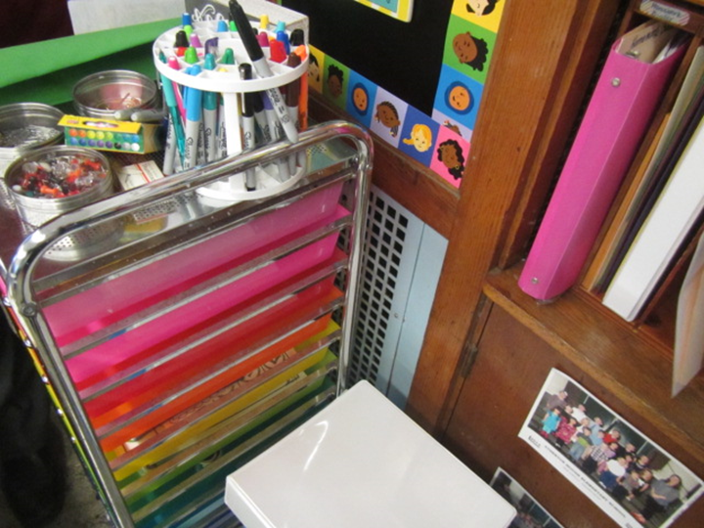

Exhaust vent obstructed by classroom items
Picture 7

Classroom items stored in exhaust cubby

Picture 8

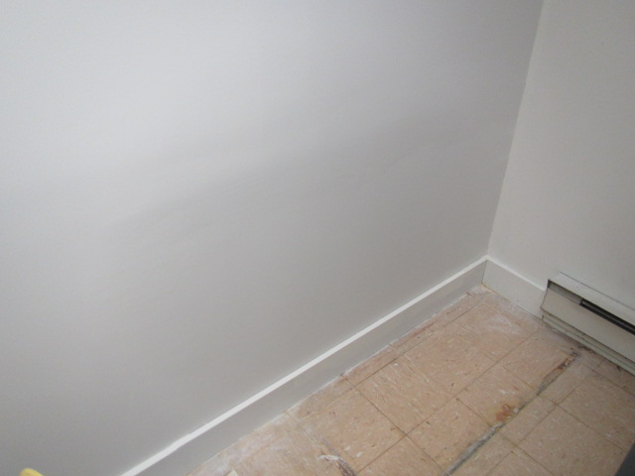

Replacement building materials in basement OT area where mold growth was reported
Picture 9

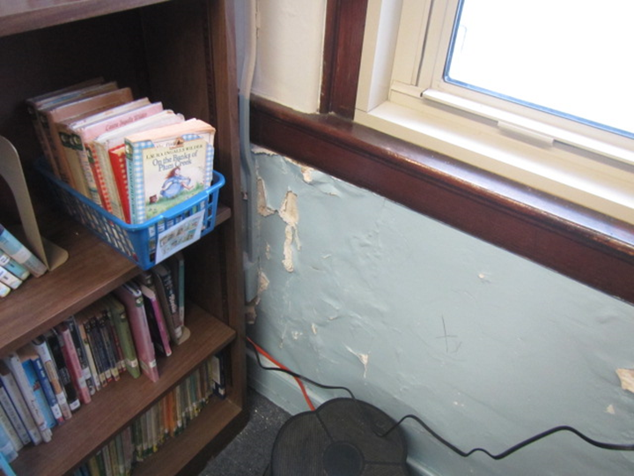

Efflorescence (i.e., mineral deposits) and peeling paint on plaster wall

Picture 10

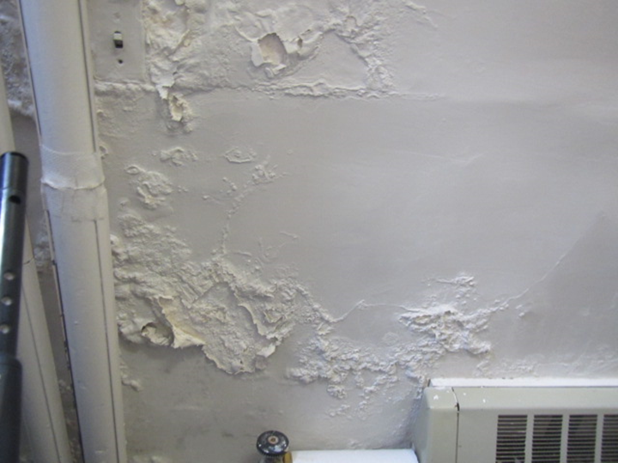

Efflorescence (i.e., mineral deposits) and peeling paint on plaster wall
Picture 11

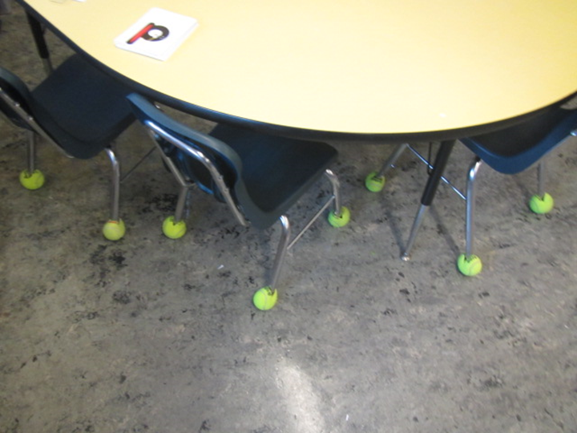

Tennis balls on chair legs in classroom

Picture 12

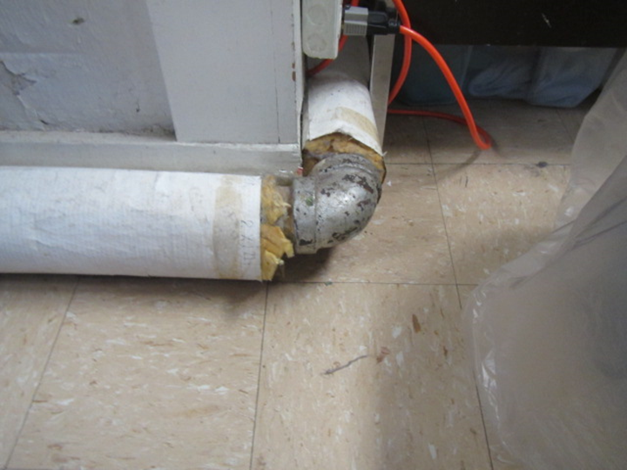

Exposed fiberglass around pipes in classroom
Location | Carbon Monoxide  (ppm) | Temp  (°F) | Relative  Humidity  (%) | PM2.5  (µg/m³) | Windows  Openable | Ventilation |  | Remarks
 |  |  |  |  |  | Supply | Exhaust
Background | ND | 52 | 35 | 21 |  |  |  | Windy, cloudy/cool, heavy traffic conditions (afternoon release)
Basement
OT | ND | 63 | 30 | 3 | Y  open | N | N | Window open with dehumidifier operating, AP, TB, moisture measurements of GW walls-normal (i.e., dry)
OG | ND | 64 | 30 | 2 | Y | N | N | PF, AP, plants, exposed fiberglass around pipes, moisture measurements of GW walls-normal (i.e., dry)
Teacher’s Lounge/Offices | ND | 64 | 30 | 4 | Y | N | N | Carpet squares in offices, moisture measurements of carpet-normal (i.e., dry)
1st Floor
1 | ND | 63 | 32 | 3 | Y | Y | Y | Area rug
Speech | ND | 62 | 31 | 5 | Y | N | N
2 | ND | 63 | 33 | 3 | Y | Y | Y | Area rug, PF
3 | ND | 65 | 35 | 3 | Y | Y | Y | PF, area rug
4 | ND | 64 | 34 | 3 | Y | Y | Y | Efflorescence (wall)
5 | ND | 64 | 34 | 3 | Y | Y | Y
6 | ND | 65 | 32 | 2 | Y | Y | Y | Exhaust vent obstructed, area rugs
7 | ND | 64 | 35 | 2 | Y | Y | Y | Area rug
8 A & B | ND | 66 | 34 | 4 | Y | Y | Y
Nurse | ND | 65 | 35 | 4 | Y | Y | Y | Wall to wall carpet
Principal’s Office | ND | 66 | 34 | 8 | Y | N | N
School Secretary’s Office | ND | 66 | 35 | 3 | Y | Y | Y
9 | ND | 65 | 32 | 3 | Y | Y | Y | TB, area rug
10 | ND | 62 | 31 | 3 | Y | Y | Y
2nd Floor
EL | ND | 64 | 30 | 18 | Y | N | N | Exposed fiberglass around pipes, plants
11 | ND | 61 | 33 | 3 | Y | Y | Y
12 | ND | 62 | 33 | 3 | Y | Y | Y | WD CP, area rugs, PF
13 Library | ND | 62 | 33 | 4 | Y | Y | Y | Wall to wall carpet (worn)
14 | ND | 65 | 33 | 3 | Y | Y | Y | PF
15 | ND | 65 | 34 | 4 | Y | Y | Y | TB, area rug
16 | ND | 65 | 34 | 4 | Y | Y | Y | TB, area rug
17 | ND | 64 | 35 | 3 | Y | Y | Y | WD CT, PF, area rug
18 | ND | 65 | 29 | 3 | Y | Y | Y | PF
19 | ND | 64 | 31 | 4 | Y | Y | Y
20 | ND | 62 | 33 | 3 | Y | Y | Y | Efflorescence, WD CP, exposed fiberglass, area rugs, AF
21 | ND | 62 | 33 | 4 | Y | Y | Y
2nd Floor Workroom | ND | 61 | 33 | 3 | Y | N | N | Photocopier
2nd Floor OG | ND | 63 | 33 | 13 | N | N | Y

Location | Air Temp  (ºF) | Relative Humidity  (%) | Dew Point  (%) | Floor Temp  (ºF) | Temp at Floor/ Exterior Wall Junction  (ºF) | Water-Damaged Ceiling Tiles-stained  (#) | Ventilation |  |  | Floor to Air Temp  Difference  (ºF) | Comments
 |  |  |  |  |  |  | Windows openable | Supply | Exhaust
Background (outdoors) | 52 | 35 | 25 |  |  |  |  |  |  |  | Windy, cloudy/cool, heavy traffic conditions (afternoon release)
Basement
OT | 63 | 30 | 31 | 58 | 62 | 0 | Y | N | N | 5 | Window open with dehumidifier operating, moisture measurements of GW walls-normal (i.e., dry)
OG | 64 | 30 | 32 | 61 | 61 | 0 | Y | N | N | 3 | Moisture measurements of GW walls-normal (i.e., dry)
Teacher’s Lounge/Offices | 64 | 30 | 34 | 72 | 71 | 0 | Y | N | N | 8 | Carpet squares in offices, moisture measurements of carpet-normal (i.e., dry)
1st Floor
Secretary’s Office | 66 | 31 | 35 | 62 | 60 | 0 | Y | N | N | 4
1 | 63 | 30 | 32 | 56 | 55 | 0 | Y | Y | Y | 7
5 | 64 | 34 | 34 | 55 | 56 | 0 | Y | Y | Y | 9
6 | 65 | 33 | 32 | 54 | 53 | 0 | Y | Y | Y | 11
7 | 64 | 33 | 35 | 56 | 56 | 0 | Y | Y | Y | 8
2nd Floor
19 | 64 | 31 | 34 | 57 | 58 | 0 | Y | Y | Y | 7
2nd Floor Workroom | 61 | 33 | 32 | 51 | 53 | 0 | Y | N | N | 10

INDOOR AIR QUALITY ASSESSMENT

Atherton Hough Elementary School
1984 Sea Street
Quincy, Massachusetts

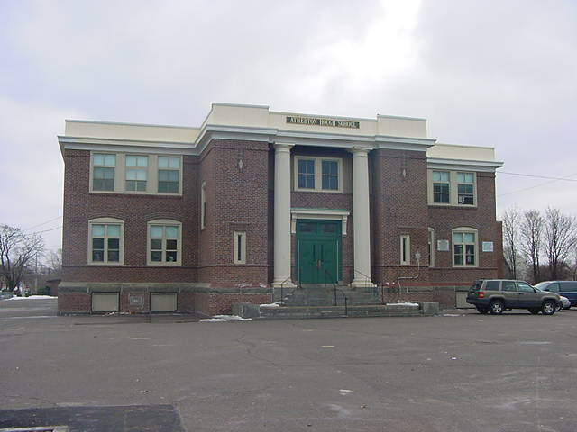

Prepared by:
Massachusetts Department of Public Health
Bureau of Environmental Health Assessment
Emergency Response/Indoor Air Quality Program
March 2003

Background/Introduction
At the request of a parent, the Massachusetts Department of Public Health (MDPH), Bureau of Environmental Health Assessment (BEHA) provided assistance and consultation regarding indoor air quality at the Atherton Hough Elementary School, 1984 Sea Street, Quincy, Massachusetts. Concerns about poor indoor air quality prompted the request.
On December 11, 2002, a visit was made to this school by Cory Holmes, an Environmental Analyst in the Emergency Response/Indoor Air Quality (ER/IAQ), BEHA, to conduct an indoor air quality assessment. Mr. Holmes was accompanied by Cindy DeCristofaro of the Quincy Health Department and Kenny Olson, Senior Custodian. Andrew Scheele, Health Commissioner, Quincy Health Department and Dorothy Greene, School Principal were present for portions of the assessment.
The school is a two-story brick structure with occupied basement. The original school building was constructed in 1911. Additions were built in 1929 and in 1949. The school is made up of general classrooms, a cafeteria/auditorium, an art room, a daycare facility and a neighborhood dental clinic, which is located in the basement. Windows are openable throughout the building.

Methods
Air tests for carbon dioxide, temperature and relative humidity were taken with the TSI, Q-Trak, IAQ Monitor Model 8551.
Results
The school has a kindergarten through fifth grade student population of 264 and a staff of approximately 35. The tests were taken during normal operations at the school. Test results appear in Tables 1-4.

Discussion
Ventilation
It can be seen from the tables that carbon dioxide levels were above 800 parts per million of air (ppm) in seven out of thirty-two areas surveyed, indicating a ventilation problem in some areas of the building. Some portions of the ventilation system were not operating during the evaluation, which can limit airflow leading to increased carbon dioxide levels.
As discussed previously the school is comprised of three sections, each outfitted with different types of ventilation systems. Due to the complexity of the building’s ventilation systems, this section is divided into three sub-sections.

Original 1911 Building
Fresh air is provided by an air handling unit (AHU) located in a large room on the ground floor that is connected to ductwork leading to air diffusers (see Picture 1). Fresh air is drawn into the building through a louvered vent in the basement (see Picture 2). Air is drawn through heating elements into a fan unit that distributes the air via wall mounted fresh air grilles in classrooms (see Picture 3). Classroom fresh air supply grilles are connected to the fan unit by ductwork located in the basement.
Pressurization created by the fresh air supply system provides classroom exhaust ventilation. Each classroom contains an exhaust vent located at floor level that is connected by ventilation shafts to the basement heating elements. A number of these vents were obstructed by cabinets, bookcases and other items; some were intentionally sealed to prevent backdrafting (see Tables/Picture 4). As the heating elements draw air into the ducts, return air is drawn from the basement exhaust ventilation shafts. Negative pressure is created in these shafts, which in turn draw air into the exhaust vents of each classroom. The draw of air into these vents is controlled by a draw chain pulley system in classrooms and pneumatically controlled louvers at the exit of rooftop exhaust shafts (see Picture 5). This system was either deactivated or inoperable in certain areas. The exhaust/chimney cap pneumatic louver system in Picture 6 had been removed, leaving the chimney cap open to the elements (see Other Concerns section of this report).
In addition, many of the control mechanisms for the natural ventilation system are either not operable or are missing (i.e., pull chains and louvers). Since the system is still in operation, the control mechanisms should be restored. Without a fully functional ventilation system, environmental pollutants can build up in the indoor environment and lead to poor air quality/comfort complaints.
1929 Wing
Fresh air in classrooms is supplied by a unit ventilator (univent) system (see Picture 7). Univents are designed to draw air from outdoors through a fresh air intake located on the exterior wall of the building (see Picture 8) and return air through an air intake located at the base of each unit (see Figure 1). Fresh and return air are mixed, filtered, heated and provided to classrooms through a fresh air diffuser located on the front of the unit. Univents were found deactivated in a few areas, which prevents a continuous source of outside air to provide ventilation. Obstructions to airflow, such as paper and boxes stored on univent air diffusers and desks in front of univent return vents, were also noted in classrooms (see Picture 9). In order for univents to provide fresh air as designed, univent air diffusers and return vents must remain free of obstructions. Importantly, these units must remain activated while classrooms are occupied.
Exhaust ventilation is provided by a mechanical system, which draws air into an ungrated hole, located at floor level in classrooms. Airflow is controlled by a flue located inside the duct. This system appeared to be off in some classrooms surveyed. In addition, these ungrated holes were being used to store recycling bins, crates, books, boxes and files in a number of areas (see Picture 10). As with the univents, in order for exhaust ventilation to function as designed, exhaust fans must be activated and remain free of obstructions.
1949 Addition
Fresh air for classrooms in the 1949 addition is also supplied by a univent system. Univents were found deactivated and or obstructed in several areas. The mechanical exhaust ventilation system in classrooms in this wing consists of grated, wall-mounted exhaust vents powered by rooftop motors. A number of exhaust vents were also obstructed by tables, chairs, boxes and other items.
To maximize air exchange, the BEHA recommends that both supply and exhaust ventilation operate continuously during periods of school occupancy. In order to have proper ventilation with a mechanical supply and exhaust system, the systems must be balanced to provide an adequate amount of fresh air to the interior of a room while removing stale air from the room. The date of the last servicing and balancing was not available at the time of the assessment. It is recommended that existing ventilation systems be re-balanced every five years to ensure adequate air systems function (SMACNA, 1994). Please note that some of the ventilation systems, in their condition at the time of the assessment, cannot be balanced.
The Massachusetts Building Code requires a minimum ventilation rate of 15 cubic feet per minute (cfm) per occupant of fresh outside air or have openable windows in each room (SBBRS, 1997; BOCA, 1993). The ventilation must be on at all times that the room is occupied. Providing adequate fresh air ventilation with open windows and maintaining the temperature in the comfort range during the cold weather season is impractical. Mechanical ventilation is usually required to provide adequate fresh air ventilation.
Carbon dioxide is not a problem in and of itself. It is used as an indicator of the adequacy of the fresh air ventilation. As carbon dioxide levels rise, it indicates that the ventilating system is malfunctioning, or the design occupancy of the room is being exceeded. When this happens a buildup of common indoor air pollutants can occur, leading to discomfort or health complaints. The Occupational Safety and Health Administration (OSHA) standard for carbon dioxide is 5,000 parts per million parts of air (ppm). Workers may be exposed to this level for 40 hours/week, based on a time-weighted average (OSHA, 1997).
The Department of Public Health uses a guideline of 800 ppm for publicly occupied buildings. A guideline of 600 ppm or less is preferred in schools due to the fact that the majority of occupants are young and considered to be a more sensitive population in the evaluation of environmental health status. Inadequate ventilation and/or elevated temperatures are major causes of complaints such as respiratory, eye, nose and throat irritation, lethargy and headaches. For more information concerning carbon dioxide, please see Appendix I.
Temperature readings ranged from 69º F to 82 º F, which were above and slightly below the BEHA recommended comfort guidelines in several areas during the assessment. The BEHA recommends that indoor air temperatures be maintained in a range of 70 º F to 78 º F in order to provide for the comfort of building occupants. A number of temperature control/comfort complaints were expressed throughout the building; drafts were reported around the univent in classroom 15. In many cases concerning indoor air quality, fluctuations of temperature in occupied spaces are typically experienced, even in a building with an adequate fresh air supply. Temperature control is difficult in an old building without fully functioning ventilation systems.
The relative humidity ranged from 19 to 40 percent, which was below the BEHA recommended comfort range in most of the areas surveyed. The BEHA recommends a comfort range of 40 to 60 percent for indoor air relative humidity. Relative humidity in the building would be expected to drop during the winter months due to heating. The sensation of dryness and irritation is common in a low relative humidity environment. Low relative humidity is a common problem during the heating season in the northeast part of the United States.

Microbial/Moisture Concerns
Water damaged wall plaster and efflorescence (i.e., mineral deposits) were observed in a few areas (see Picture 11), which indicates a current or historic water penetration problem. Efflorescence is a characteristic sign of water intrusion. As moisture penetrates and works its way through mortar around brick it leaves behind these characteristic mineral deposits. This condition indicates that water from the exterior is penetrating into the building.
Plants were noted in several classrooms. Plants can be a source of pollen and mold, which can be respiratory irritants for some individuals. Plants should be properly maintained and equipped with drip pans. Plants should also be located away from univents to prevent the aerosolization of dirt, pollen or mold.
Spaces between the sink countertop and backsplash were noted in classroom 16. Improper drainage or sink overflow could lead to water penetration of countertop wood, the cabinet interior and behind cabinets. Like other porous materials, if these materials become wet repeatedly, they can provide a medium for mold growth.

Other Concerns
Several other conditions were noted during the assessment, which can affect indoor air quality. Unless functioning properly, the ventilation system can serve as a pathway for particulates and odors to migrate between areas of the building. The open shaft on the roof is a potential pathway for moisture, particulates and pests to enter the building.
A number of classrooms contained dry erase boards and dry erase board markers. Materials such as dry erase markers and dry erase board cleaners may contain volatile organic compounds (VOCs) (e.g. methyl isobutyl ketone, n-butyl acetate and butyl-cellusolve) (Sanford, 1999). Dry erase board markers and cleaners contain chemicals that can be irritating to the eyes, nose and throat of sensitive individuals.
In an effort to reduce noise from sliding chairs, tennis balls are sliced open and placed on chair legs. Tennis balls are made of a number of materials that are a source of respiratory irritants. Constant wearing of tennis balls can produce fibers and to off-gas VOCs. Tennis balls are made with a natural rubber latex bladder, which becomes abraded when used as a chair leg pad. Use of tennis balls in this manner may introduce latex dust into the school environment. Some individuals are highly allergic to latex (e.g., spina bifida patients) (SBAA, 2001). It is recommended that the use of materials containing latex be limited in buildings to reduce the likelihood of symptoms in sensitive individuals (NIOSH, 1997). A question and answer sheet concerning latex allergy is attached as Appendix II (NIOSH, 1998).
The teacher’s workroom contained a lamination machine, two photocopiers, three mimeograph machines and several containers of duplicating fluid. Lamination machines can produce irritating odors during use. VOCs and ozone can be produced by photocopiers, particularly if the equipment is older and in frequent use. Ozone is a respiratory irritant (Schmidt Etkin, D., 1992). It was reported by Mr. Olson that a work order had been submitted to provide local exhaust ventilation for this area.
Although no complaints of vehicle exhaust odors have been reported to MDPH in relation to the building, the potential for entrainment exists. Picture 12 illustrates the close proximity of the employee parking lot to the building and the potential for vehicle exhaust to be pulled into the univent fresh air intakes (called entrainment). Idling vehicles can result in the entrainment of vehicle exhaust into the building, which may, in turn, provide opportunities for exposure to compounds such as carbon monoxide. M.G.L. chapter 90 section 16A prohibits the unnecessary operation of the engine of a motor vehicle for a foreseeable time in excess of five minutes (MGL, 1996).

Conclusions/Recommendations
As discussed, with a number of the components of the school’s ventilation system not fully functional, normally occurring environmental pollutants can build-up and lead to indoor air quality/comfort complaints. In view of the findings at the time of this visit, the following recommendations are made:
- Based on the age, condition and availability of parts for ventilation components, the BEHA strongly recommends that an HVAC engineering firm fully evaluate the ventilation systems throughout the building.
- Repair/replace the chimney cap on the roof to prevent entry of pests, moisture, particulates and drafts. Cover the open cap in the meantime with wire mesh (chicken wire) to prevent entry.
- Repair/replace thermostats and control mechanisms (e.g. pull chains, louvers) for ventilation system where needed.
- Remove all blockages from univents and exhaust vents to ensure adequate airflow.
- To maximize air exchange, the BEHA recommends that all ventilation systems that are operable throughout the building (e.g., gym, cafeteria, classrooms) operate continuously during periods of school occupancy independent of thermostat control.
- Ensure plants have drip pans. Examine drip pans periodically for mold growth and disinfect with an appropriate antimicrobial where necessary. Keep plants away from the air stream of univents.
- Seal areas around sinks to prevent water-damage to the interior of cabinets and adjacent wallboard. Inspect wallboard for water-damage and mold/mildew growth, repair/replace as necessary. Disinfect areas of microbial growth with an appropriate antimicrobial as needed. Consider replacing with one-piece, molded countertop.
- For buildings in New England, periods of low relative humidity during the winter are often unavoidable. Therefore, scrupulous cleaning practices should be adopted to minimize common indoor air contaminants whose irritant effects can be enhanced when the relative humidity is low. To control for dusts, a high efficiency particulate arrestance (HEPA) filter equipped vacuum cleaner in conjunction with wet wiping of all surfaces is recommended. Avoid the use of feather dusters. Drinking water during the day can help ease some symptoms associated with a dry environment (throat and sinus irritations).
- Consider discontinuing the use of tennis balls on chairs to prevent latex dust generation.
- Continue with plans to install local exhaust ventilation in photocopier room.
- Seal around univent in classroom 15 to prevent drafts.
- Consider relocating employee parking from areas in close proximity to air intake vents. If not feasible, post signs in parking area instructing employees not to back in to avoid entrainment of vehicle exhaust to remind them of Massachusetts anti-idling laws (MGL, 1996).
- In order to maintain a good indoor air quality environment on the building, consideration should be give to adopting the US EPA document, “Tools for Schools”, which can be downloaded from the Internet at http://www.epa.gov/iaq/schools/index.html.
- For further building-wide evaluations and advice on maintaining public buildings, see the resource manual and other related indoor air quality documents located on the MDPH’s website at http://www.state.ma.us/dph/beha/iaq/iaqhome.htm.

References

BOCA. 1993. The BOCA National Mechanical Code-1993. 8th ed. Building Officials & Code Administrators International, Inc., Country Club Hills, IL. M-308.1

MGL. 1996. Stopped motor vehicles; Operation of Engine; Time Limit; Penalty. Massachusetts General Laws. M.G.L. c. 90:16A.

NIOSH. 1998. Latex Allergy A Prevention. National Institute for Occupational Safety and Health, Atlanta, GA.

NIOSH. 1997. NIOSH Alert Preventing Allergic Reactions to Natural Rubber latex in the Workplace. National Institute for Occupational Safety and Health, Atlanta, GA.

OSHA. 1997. Limits for Air Contaminants. Occupational Safety and Health Administration. Code of Federal Regulations. 29 C.F.R 1910.1000 Table Z-1-A.

Sanford. 1999. Material Safety Data Sheet (MSDS No: 198-17). Expo® Dry Erase Markers Bullet, Chisel, and Ultra Fine Tip. Sanford Corporation. Bellwood, IL.

SBAA. 2001. Latex In the Home And Community Updated Spring 2001. Spina Bifida Association of America, Washington, DC. Http://www.sbaa.org/html/sbaa_mlatex.html

SBBRS. 1997. Mechanical Ventilation. State Board of Building Regulations and Standards. Code of Massachusetts Regulations. 780 CMR 1209.0

Schmidt Etkin, D. 1992. Office Furnishings/Equipment & IAQ Health Impacts, Prevention & Mitigation. Cutter Information Corporation, Indoor Air Quality Update, Arlington, MA.

SMACNA. 1994. HVAC Systems Commissioning Manual. 1st ed. Sheet Metal and Air Conditioning Contractors’ National Association, Inc., Chantilly, VA.
Sanford. 1999. Material Safety Data Sheet (MSDS No: 198-17). Expo® Dry Erase Markers Bullet, Chisel, and Ultra Fine Tip. Sanford Corporation. Bellwood, IL.

Figure 1

Unit Ventilator (Univent)

Mixed Air

Air Diffuser

Outdoors Indoors

Fan

Heating/Cooling Coil

Air Mixing Plenum

Filter

Outdoor Return
Air Air

Air
Flow
Control
Louvers

Air Flow

= Fresh Air/Return Air

= Mixed Air

Picture 1

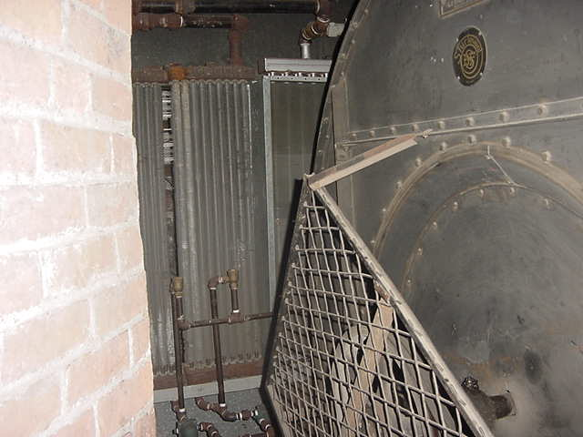

Large Fan Supplying Mechanical Ventilation System in 1911 Wing

Picture 2

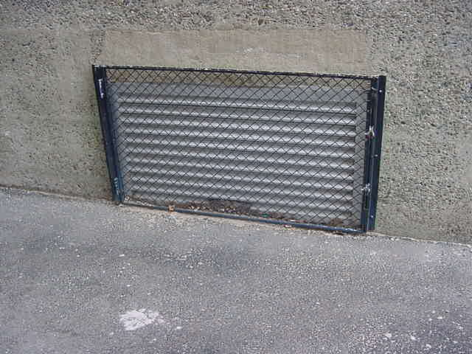

Fresh Air Intake

Picture 3

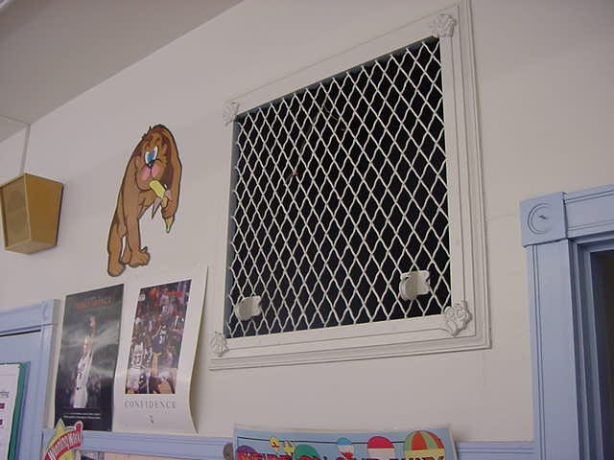

Supply Air Vent in Classroom

Picture 4
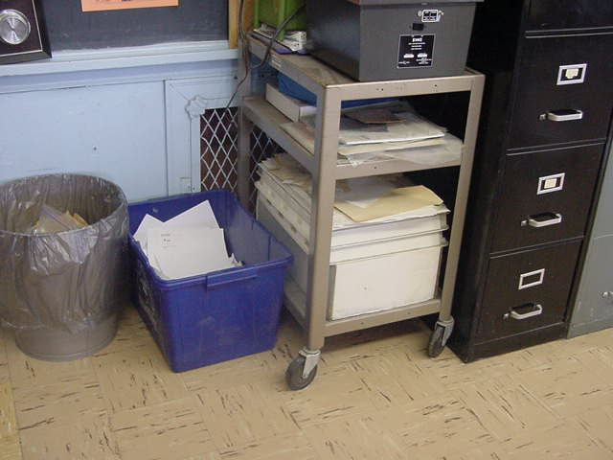

Obstructed Exhaust Vent in Classroom

Picture 5

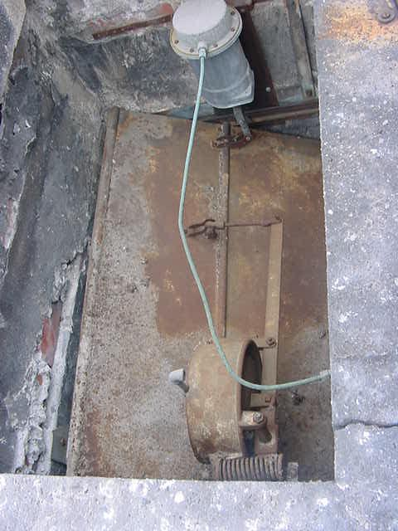

Pneumatically Controlled Exhaust Louvers on Rooftop Ventilation Shaft

Picture 6
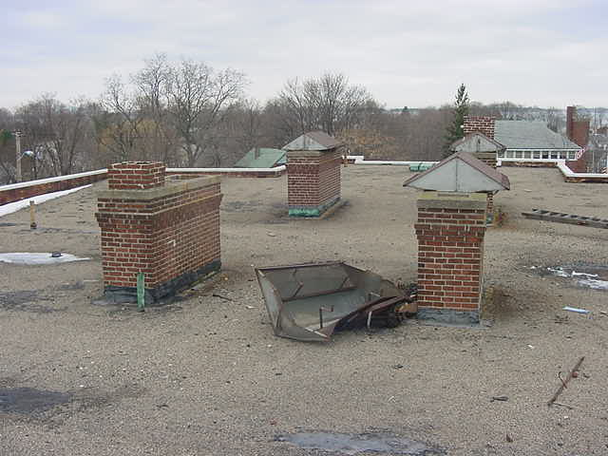

Chimney Capped Removed from Ventilation Shaft

Picture 7

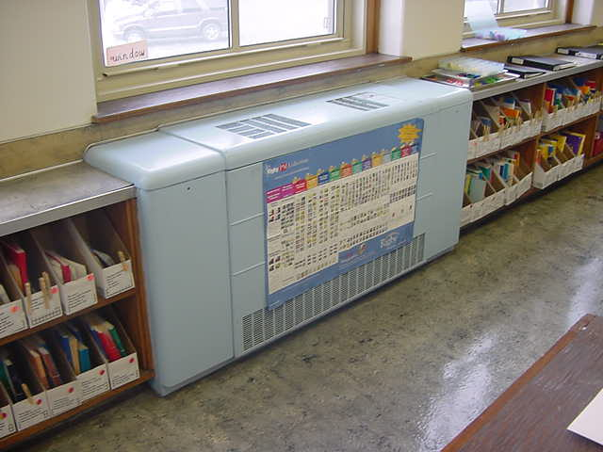

Classroom Univent

Picture 8

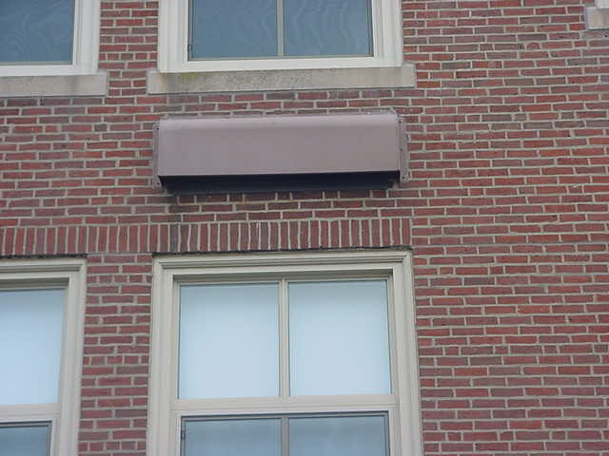

Covered Air Intake for Classroom Univent

Picture 9

Various Items Obstructing Airflow of Classroom Univent

Picture 10

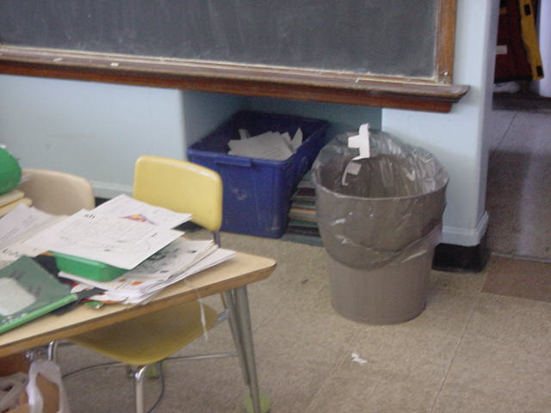

Exhaust Cubby in Classroom, Note Materials Stored Within

Picture 11

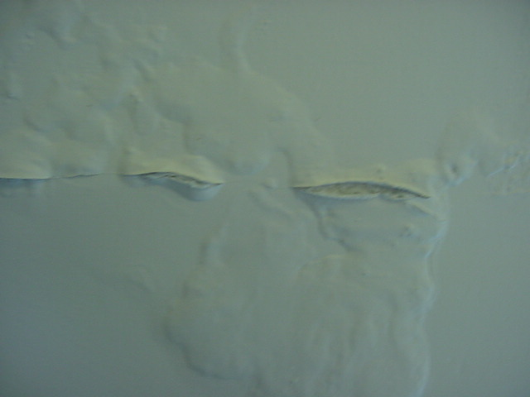

Efflorescence Peeling Paint in Classroom

Picture 12

Vehicles Parked near Fresh Air Intake

Location | Carbon Dioxide *ppm | Temp.  ºF | Relative Humidity  % | Occupants in Room | Windows Openable | Ventilation |  | Remarks
 |  |  |  |  |  | Intake | Exhaust
(Outside) Background | 420 | 36 | 38 |  |  |  |  | Weather cold, westerly winds 5-10 MPH, overcast and cold
Gym (right side heating unit) |  |  |  |  |  |  |  | No fresh air – work order in for repair Thermostat not working
Gym (left side heating unit) |  |  |  |  |  |  |  | Thermostat not working
Basement Day Care Music Room | 734 | 77 | 22 | 1 | Y | N | N | Door open
W-Daycare | 880 | 82 | 19 | 2 | Y | N | N
Gym/Auditorium/Cafeteria | 690 | 74 | 19 | ≥55 | Y | Y | Y | Poor temperature control  Supply not operable
Kitchen (off Gym) | 1960 | 74 | 23 | 0 | N | N | N | No working ventilation  Door open
Speech/Hearing | 3400 | 77 | 28 | 4 | Y | N | N
Room 1 | 1081 | 78 |  |  | Y | Y | Y | Exhaust blocked not working, plants  Computer monitors, window frame – water damage
Room 2 | 900 | 79 | 24 | 24 | Y | Y | Y | Exhaust sealed
Room 10 | 668 | 80 | 22 | 0 | Y | Y | Y | Exhaust sealed, perimeter heat 8 computer terminals
Room 12 Vacant | 510 | 72 | 28 | ≥ 16 | Y | Y | Y | Exhaust closed due to heat Occupants gone 20 min
Rooftop |  |  |  |  |  |  |  | Chimney chase cap off Chicken wire – loose 1 open
Room 12 Occupied | 789 | 69 | 39 | 16 | Y | Y | Y | Exhaust closed
Room 20 | 969 | 70 | 40 | 23 | Y | Y | Y | Window open Exhaust blocked/closed
Room 11 | 760 | 72 | 34 | 16 | Y | Y | Y | 4 computer monitors Exhaust shut and blocked
Room 21 | 740 | 73 | 32 | 14 | Y | Y | Y | Exhaust blocked  Plants
School Psychology | 632 | 75 | 32 | 0 | Y | N | N | Radiator
Principal’s Inner Office | 470 | 78 | 23 | 0 | Y | N | N
Principal’s Outer Office | 570 | 78 | 24 | 1 | N | N | N | Door open  2 computers
Room 16 | 465 | 72 | 22 | 0 | Y | Y | Y | Exhaust – pull chain, sink caulking, Supply off
Room 16 | 643 | 72 | 25 | 9 | Y | Y | Y | Supply on, 5 computer monitors, Exhaust closed, door open, pull chain
Room 17 | 750 | 74 | 26 | 18 | Y | Y | Y | Supply on  Exhaust partially blocked
Room 15 | 585 | 72 | 24 | 0 | Y | Y | Y | Supply off and blocked  Exhaust blocked, plants, drafty UV
Room 18  Computer Lab | 480 | 71 | 25 | 0 | Y | Y | Y | Supply on, chair in front of cubby  2 computer monitors
Room 19  Art Room | 550 | 73 | 25 | 0 | Y | Y | Y | Supply on  Exhaust blocked, fan on, plants
Boys Room |  |  |  | 0 | Y |  |  | Supply on  Exhaust blocked, carpeting
O T | 600 | 70 | 28 | 0 | Y | N | N
Girls Room |  |  |  |  | Y | N | Y
Room 9 | 655 | 80 | 22 | 0 | Y | Y | Y | Exhaust not working – blocked w/easel, blackboard  7 computer monitors
1st Floor Girls Room |  |  |  | 0 | Y | N | Y | Sealed floor drain  6 stalls/2 adult
Guidance Office | 996 | 79 | 24 | 1 | Y | N | N
Media Office | 760 | 79 | 22 | 1 | N | N | N | Laminator, Xerox, laser print  Work order in for ventilator
Nursing Office | 799 | 78 | 22 | 1 | N | N | N | Hepa filter
Boys Room |  |  |  | 0 | Y | N | N | Cleaning supplies
Room 8 | 571 | 76 | 21 | 0 | Y | Y | Y | Not working properly (deactivated w/switch) reheat
Room 3 | 625 | 77 | 23 | 5 | Y | Y | Y
Room 4 | 586 | 76 | 22 | 5 | Y | Y | Y | Supply on  Exhaust blocked w/supplies
Room 7 | 716 | 77 | 24 | 17 | Y | Y | Y | Supply on and blocked, tennis balls-chairs, exhaust blocked w/items
Room 5 | 436 | 74 | 23 | 1 | Y | Y | Y | Window open, 15 pp usually, plants  Supply off, blocked, exhaust partially blocked

Appendix I

Carbon Dioxide and its Use in Evaluating Adequacy
of Ventilation in Buildings

The Bureau of Environmental Health’s (BEH) Indoor Air Quality (IAQ) Program examines indoor air quality conditions that may have an effect on building occupants. The status of the ventilation system, potential moisture problems/microbial growth and identification of respiratory irritants are examined in detail, which are described in the attached report. In order to examine the function of the ventilation system, measurements for carbon dioxide, temperature and relative humidity are taken. Carbon dioxide measurements are commonly used to assess the adequacy of ventilation within an indoor environment.
Carbon dioxide is an odorless, colorless gas. It is found naturally in the environment and is produced in the respiration process of living beings. Another source of carbon dioxide is the burning of fossil fuels. Carbon dioxide concentration in the atmosphere is approximately 250-600 ppm (Beard, 1982; NIOSH, 1987).
Carbon dioxide measurements within an occupied building are a standard method used to gauge the adequacy of ventilation systems. Carbon dioxide is used in this process for a number of reasons. Any occupied building will have normally occurring environmental pollutants in its interior. Human beings produce waste heat, moisture and carbon dioxide as by-products of the respiration process. Equipment, plants, cleaning products or supplies normally found in any building can produce gases, vapors, fumes or dusts when in use. If a building has an adequately operating mechanical ventilation system, these normally occurring environmental pollutants will be diluted and removed

from the interior of the building. The introduction of fresh air both increases the comfort of the occupants and serves to dilute normally occurring environmental pollutants.
An operating exhaust ventilation system physically removes air from a room and thereby removes environmental pollutants. The operation of supply in conjunction with the exhaust ventilation system creates airflow through a room, which increases the comfort of the occupants. If all or part of the ventilation system becomes non-functional, a build up of normally occurring environmental pollutants may occur, resulting in an increase in the discomfort of occupants.
The MDPH approach to resolving indoor air quality problems in schools and public buildings is generally two-fold: 1) improving ventilation to dilute and remove environmental pollutants and 2) reducing or eliminating exposure opportunities from materials that may be adversely affecting indoor air quality. In the case of an odor complaint of unknown origin, it is common for BEH staff to receive several descriptions from building occupants. A description of odor is subjective, based on the individual’s life experiences and perception. Rather than test for a potential series of thousands of chemicals to identify the unknown material, carbon dioxide is used to judge the adequacy of airflow as it both dilutes and removes indoor air environmental pollutants.
As previously mentioned, carbon dioxide is used as a diagnostic tool to evaluate air exchange by building ventilation systems. The presence of increased levels of carbon dioxide in indoor air of buildings is attributed to occupancy. As individuals breathe, carbon dioxide is exhaled. The greater the number of occupants, the greater the amount of carbon dioxide produced. Carbon dioxide concentration build up in indoor environments is attributed to inefficient or non-functioning ventilation systems. The Occupational Safety and Health Administration (OSHA) standard for carbon dioxide is 5,000 parts per million parts of air (ppm). Workers may be exposed to this level for 40 hours/week, based on a time-weighted average (OSHA, 1997).
Carbon dioxide can be a hazard within enclosed areas with no air supply. These types of enclosed areas are known as confined spaces. Manholes, mines and sewer systems are examples of confined spaces. An ordinary building is not considered a confined space. Carbon dioxide air exposure limits for employees and the general public have been established by a number of governmental health and industrial safety groups. Each of these standards of air concentrations is expressed in parts per million (ppm). Table 1 is a listing of carbon dioxide air concentrations and related health effects and standards.
The MDPH uses a guideline of 800 ppm for publicly occupied buildings (Burge et al., 1990; Gold, 1992; Norback, 1990; OSHA, 1994; Redlich, 1997; Rosenstock, 1996; SMACNA, 1998). A guideline of 600 ppm or less is preferred in schools due to the fact that the majority of occupants are young and considered to be a more sensitive population in the evaluation of environmental health status. Several sources indicate that indoor air problems are significantly reduced at 600 ppm or less of carbon dioxide (ACGIH, 1998; Bright et al., 1992; Hill, 1992; NIOSH, 1987). Inadequate ventilation and/or elevated temperatures are major causes of complaints such as respiratory, eye, nose and throat irritation, lethargy and headaches.
Air levels for carbon dioxide that indicate that indoor air quality may be a problem have been established by the American Society of Heating, Refrigerating and Air-conditioning Engineers (ASHRAE). Above 1,000 ppm of carbon dioxide, ASHRAE recommends adjustment of the building’s ventilation system (ASHRAE, 1989). In 2001, ASHRAE modified their standard to indicate that no more than 700 ppm above the outdoor air concentration; however 800 ppm is the level where further investigation will occur.
Carbon dioxide itself has no acute (short-term) health effects associated with low level exposure (below 5,000 ppm). The main effect of carbon dioxide involves its ability to displace oxygen for the air in a confined space. As oxygen is inhaled, carbon dioxide levels build up in the confined space, with a decrease in oxygen content in the available air. This displacement of oxygen makes carbon dioxide a simple asphyxiant. At carbon dioxide levels of 30,000 ppm, severe headaches, diffuse sweating, and labored breathing have been reported. No chronic health effects are reported at air levels below 5,000 ppm.
Air testing is one method used to determine whether carbon dioxide levels exceed the comfort levels recommended. If carbon dioxide levels are over 800-1,000 ppm, the MDPH recommends adjustment of the building's ventilation system. The MDPH recommends that corrective measures be taken at levels above 800 ppm of carbon dioxide in office buildings or schools. (Please note that carbon dioxide levels measured below 800 ppm may not decrease indoor air quality complaints). Sources of environmental pollutants indoors can often induce symptoms in exposed individuals regardless of the adequacy of the ventilation system. As an example, an idling bus outside a building may have minimal effect on carbon dioxide levels, but can be a source of carbon monoxide, particulates and odors via the ventilation system.
Therefore, the MDPH strategy of adequate ventilation coupled with pollutant source reduction/removal serves to improve indoor air quality in a building. Please note that each table included in the IAQ assessment lists BEH comfort levels for carbon dioxide levels at the bottom (i.e. carbon dioxide levels between 600 ppm to 800 ppm are acceptable and <600 ppm is preferable). While carbon dioxide levels are important, focusing on these air measurements in isolation to all other recommendations is a misinterpretation of the recommendations made in these assessments.
Table 1: Carbon Dioxide Air Level Standards
Carbon Dioxide  Level | Health Effects | Standards or Use of Concentration | Reference
250-600 ppm | None | Concentrations in ambient air | Beard, R.R., 1982  NIOSH, 1987
600 ppm | None | Few indoor air complaints, used as reference for air exchange for protection of children | ACGIH, 1998; Bright et al., 1992; Hill, 1992; NIOSH 1987
800 ppm | None | Used as an indicator of ventilation adequacy in schools and public buildings, used as reference for air exchange for protection of children | Mendler, 2003  Bell, A. A., 2000; NCOSP, 1998;  SMACNA, 1998; EA, 1997;  Redlich, 1997; Rosenstock, 1996; OSHA, 1994; Gold, 1992;  Burge et al., 1990; Norback, 1990 ;  IDPH, Unknown
1000 ppm | None | Used as an indicator of ventilation inadequacy concerning removal of odors from the interior of building. | ASHRAE, 1989
950-1300 ppm* | None | Used as an indicator of ventilation inadequacy concerning removal of odors from the interior of building. | ASHRAE, 1999
700 ppm (over background) | None | Used as an indicator of ventilation inadequacy concerning removal of odors from the interior of building. | ASHRAE, 2001
5000 ppm | No acute (short term) or chronic (long-term) health effects | Permissible Exposure Limit/Threshold Limit Value | ACGIH, 1999  OSHA, 1997
30,000 ppm | Severe headaches, diffuse sweating, and labored breathing | Short-term Exposure Limit | ACGIH, 1999  ACGIH. 1986
* outdoor carbon dioxide measurement +700 ppm

References
ACGIH. 1986. Documentation of the Threshold Limit Values. American Conference of Governmental Industrial Hygienists. Cincinnati, OH.
ACGIH. 1998. Industrial Ventilation A Manual of Recommended Practice. 23rd Edition. American Conference of Governmental Industrial Hygienists. Cincinnati, OH.
ACGIH. 1999. Guide to Occupational Exposures-1999. American Conference of Governmental Industrial Hygienists, Cincinnati, OH.
ASHRAE. 1989. Ventilation for Acceptable Indoor Air Quality. American Society of Heating, Refrigeration and Air Conditioning Engineers. ANSI/ASHRAE 62-1989.
ASHRAE. 1999. Ventilation for Acceptable Indoor Air Quality. American Society of Heating, Refrigeration and Air Conditioning Engineers. ANSI/ASHRAE 62-1999.
ASHRAE. 2001. Ventilation for Acceptable Indoor Air Quality. American Society of Heating, Refrigeration and Air Conditioning Engineers. ANSI/ASHRAE 62-2001.
Beard, R.R. 1982. Chapter Fifty-two, Inorganic Compounds of Oxygen, Nitrogen, and Carbon. Patty’s Industrial Hygiene and Toxicology, Vol. IIc. 3rd ed. Clayton, G. D. & Clayton, F. E., eds. John Wiley & Sons, New York, NY.
Bright, P.; Mader, M.; Carpenter, D.; and Hermon-Cruz, I.Z. 1992. Guideline for Indoor Air Surveys. Brooks Air Force Base, TX. Armstrong Laboratory, Occupational and Environmental Health Directorate. NTIS AL-TR-1992-0016.
Burge, H. and Hoyer, M. 1990. Focus On … Indoor Air Quality. Appl. Occup. Environ. Hyg. 5(2):88.
EA. 1997. Indoor Air Quality. Environment Australia, Department of the Environment, Sport and Territories, Canberra, Australia. www.environment.gov.au/soe/1996/publications/technical/pubs/12indora.pdf
Gold, D. 1992. Indoor Air Pollution. Clinics in Chest Medicine. 13(2):224-225.
Hill, B.; Craft, B.; and Burkart, J. 1992. Carbon Dioxide, Particulates and Subjective Human Responses in Office Buildings without Histories of Indoor Air Quality Problems. Appl. Occup. Environ. Hyg. 7(2): 101-111.
IDPH. Unknown. Illinois Department of Public Health Guidelines for Indoor Air Quality. Illinois Department of Public Health, Springfield, Il. http://www.idph.state.il.us/envhealth/factsheets/indoorairqualityguide_fs.htm
Mendler, S. and Odell, W. 2003. Indoor Air Quality for the EPA. ArchitectureWeek. April 16, 2003. http://www.architectureweek.com/2003/0416/environment_1-2.html
NCOSP. 1998. Workplace Requirements for Safety & Health, Indoor Air Quality 3.3.3. NC Office of State Personnel, Raleigh, NC. www.osp.state.nc.us/emprsk/safety/handbook/5-9.pdf
NIOSH. 1987. Guidance for Indoor Air Quality Investigations. Cincinnati, OH. National Institute for Occupational Safety and Health, Hazards Evaluations and Technical Assistance Branch, Division of Surveillance, Hazard Evaluation and Field Studies.
Norback, D.; Torgen, M.; and Edling, C. 1990. Volatile Organic Compounds, Respirable Dust, and Personal Factors Related to Prevalence and Incidence of Sick Building Syndrome in Primary Schools. British Journal of Industrial Medicine. 47:740.
OSHA. 1994. Occupational Safety and Health Administration. Indoor Air Quality (Proposed Regulation), Federal Register 59:15968-16039, (1994) Appendix A.
OSHA. 1997. Limits for Air Contaminants. Occupational Safety and Health Administration. Code of Federal Regulations. 29 C.F.R 1910.1000 Table Z-1-A.
Redlich, C.; Sparer, J.; and Cullen, M. 1997. Sick-building Syndrome. Lancet. 349:1016.
Rosenstock, L. 1996. NIOSH Testimony to the U.S. Department of Labor on Air Quality, Appl. Occup. Environ. Hyg. 11(12):1368.
SMACNA. 1998. Indoor Air Quality: A Systems Approach. 3rd ed. Sheet Metal and Air Conditioning Contractors’ National Association, Inc, Chantilly, VA. National Association, Inc.

Appendix II

National Institute for Occupational Safety and Health

LATEX ALLERGY
June 1997

What Is Latex Allergy?

Latex allergy can result from repeated exposures to proteins in natural rubber latex through skin contact or inhalation. Reactions usually begin within minutes of exposure to latex, but they can occur hours later and can produce various symptoms. These include skin rash and inflammation, respiratory irritation, asthma, and in rare cases shock. In some instances, sensitized employees have experienced reactions so severe that they impeded the worker’s ability to continue working in their current job.
The amount of exposure needed to sensitize individuals to natural rubber latex is not known, but reductions in exposure to latex proteins have been reported to be associated with decreased sensitization and symptoms. People at increased risk for developing latex allergy include workers with ongoing latex exposure, persons with a tendency to have multiple allergic conditions, and persons with spina bifida. Latex allergy is also associated with allergies to certain foods such as avocados, potatoes, bananas, tomatoes, chestnuts, kiwi fruit, and papaya.

How Large a Problem is Latex Allergy?

Reports of work-related allergic reactions to latex have increased in recent years, especially among employees in the growing health-care industry, where latex gloves are widely used to prevent exposure to infectious agents. At least 7.7 million people are employed in the health-care industry in the U.S. Once sensitized, workers may go on to experience the effects of latex allergy. Studies indicate that 8-12% of health-care workers regularly exposed to latex are sensitized, compared with 1-6% of the general population, although total numbers of exposed workers are not known. In the health-care industry, workers at risk of latex allergy from ongoing latex exposure include physicians, nurses, aides, dentists, dental hygienists, operating room employees, laboratory technicians, and housekeeping personnel.
Workers who use gloves less frequently, such as law enforcement personnel, ambulance attendants, fire fighters, food service employees, painters, gardeners, housekeeping personnel outside the health-care industry, and funeral home employees, also may develop latex allergy. Workers in factories where natural rubber latex products are manufactured or used also may be affected.

Prevention

The National Institute for Occupational Safety and Health (NIOSH) recommends wherever feasible the selection of products and implementation of work practices that reduce the risk of allergic reactions. These recommendations include:
- Use nonlatex gloves for activities that are not likely to involve contact with infectious materials (food preparation, routine housekeeping, maintenance, etc.).
- Appropriate barrier protection is necessary when handling infectious materials. If you choose latex gloves, use powder-free gloves with reduced protein content.
- When wearing latex gloves, do not use oil-based hand creams or lotions unless they have been shown to reduce latex-related problems.
- Frequently clean work areas contaminated with latex dust (upholstery, carpets, ventilation ducts, and plenums).
- Frequently change the ventilation filters and vacuum bags used in latex-contaminated areas.
- Learn to recognize the symptoms of latex allergy: skin rashes; hives; flushing; itching; nasal, eye, or sinus symptoms; asthma; and shock.
- If you develop symptoms of latex allergy, avoid direct contact with latex gloves and products until you can see a physician experienced in treating latex allergy.
- If you have latex allergy, consult your physician regarding the following precautions:
- Avoid contact with latex gloves and products.
- Avoid areas where you might inhale the powder from latex gloves worn by others.
- Tell your employers, physicians, nurses, and dentists that you have latex allergy.
- Wear a medical alert bracelet.
- Take advantage of latex allergy education and training provided by your employer.

Additional Information
NIOSH has issued an Alert, Preventing Allergic Reactions to Natural Rubber Latex in the Workplace (DHHS [NIOSH] Publication No. 97-135), that summarizes the existing data on latex allergy. Copies are available free-of-charge from the NIOSH Publications Office while supplies last:
fax 513-533-8573
telephone 1-800-35-NIOSH (1-800-356-4674)
fax 513-533-8573
For a complete listing of documents available on the CDC Fax Information Service call
1-888-CDC-FAXX (1-888-232-3299) and request document #000006. This information is also
available on the Internet at CDC's web site.

Document #705006

THIS PAGE WAS LAST UPDATED ON August 12, 1997

Document re-formated by BEH staff: 4/29/2002

