- Create the Draft SDR at the primary activity (3055). All sub-activities associated to the contract are then available in the SDR.
Once the draft is created the steps below can be used to apply a Service Delivery Pattern by Sub-Activity.
For additional information on creating an SDR please refer to Unit Rate Job Aids at link below
https://www.mass.gov/lists/provider-user-manuals-and-instructional-materials#unit-rate-(sdr)-contracts-

Go to Service Delivery Pattern screen:
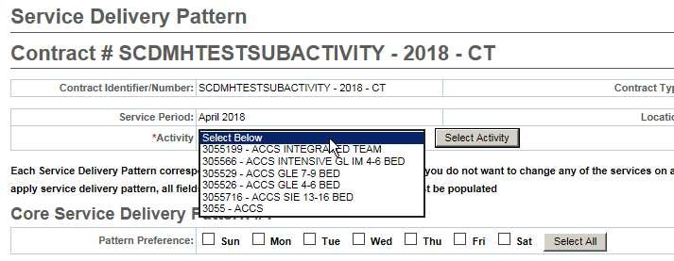
Select subactivity from drop-down and click Select Activity button. Only the relevant clients enrolled to the subactivity will appear to apply a pattern to:
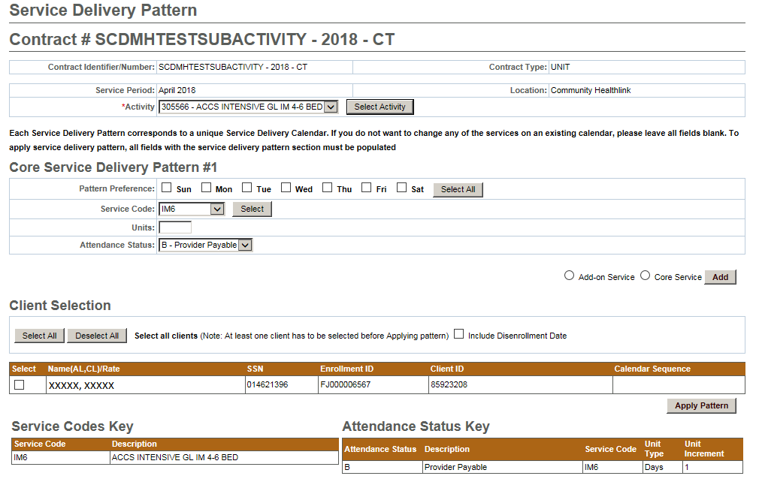
Apply services in a pattern (by selecting a service code, number of units, Attendance Status and applying for to one-some-all clients. If there are exceptions to the pattern, the user can then go into the specific client record to change the services reported on that day.

