OFFICE OF THE GOVERNOR
COMMONWEALTH OF MASSACHUSETTS
STATE HousE • BosrnN, MA 02133 (617) 725-4000

MAURA T. HEALEY GOVERNOR

ATTACHMENT B
KIMBERLEY DRISCOLL LIEUTENANT GOVERNOR

July 4, 2025

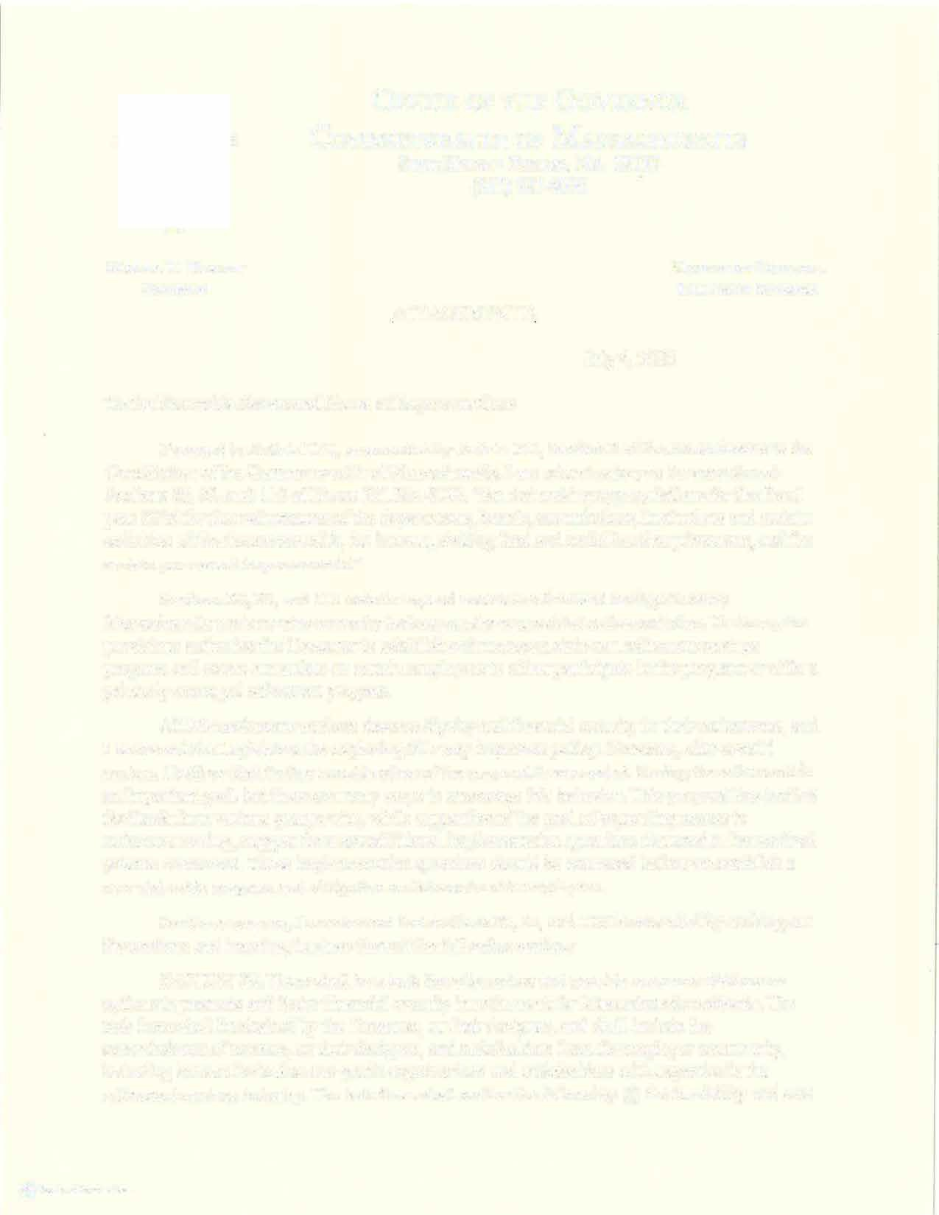

To the Honorable Senate and House of Representatives:

Pursuant to Article LVI, as amended by Article XC, Section 3 of the Amendments to the Constitution ofthe Commonwealth of Massachusetts, I am returning to you for amendment Sections 20, 23, and 110 of House Bill No. 4240, "An Act making appropriations for the fiscal year 2026 for the maintenance of the departments, boards, commissions, institutions and ce11ain activities of the Commonwealth, for interest, sinking fund and serial bond requirements, and for certain permanent improvements."
Sections 20, 23, and 110 seek to expand access to retirement savings to many Massachusetts workers who currently lack an employer-provided retirement plan. To do so, the provisions authorize the Treasurer to establish and manage a state-run retirement savings program and create a mandate on ce11ain employers to either participate in the program or offer a privately-managed retirement program.
All Massachusetts workers deserve dignity and financial security in their retirements, and I commend the Legislature for exploring this very important policy. However, after careful review, I believe that further consideration of the proposal is warranted. Saving for retirement is an impo11ant goal, but there are many ways to encourage this behavior. This proposal has invited feedback from various groups who, while supportive of the goal of expanding access to retirement saving, suggest there are additional implementation questions that need to be resolved prior to enactment. These implementation questions should be answered before we establish a new statewide program and obligation on Massachusetts employers.
For these reasons, I recommend that sections 20, 23, and 110 be amended by striking out the sections and inserting in place thereof the following section:-
SECTION 20. There shall be a task force to review and provide recommendations on options to promote and foster financial security in retirement for Massachusetts residents. The task force shall be chaired by the Treasurer, or their designee, and shall include the commissioner ofrevenue, or their designee, and stakeholders from the employer conununity, including but not limited to non-profit organizations and stakeholders with expertise in the retirement savings industiy. The task force shall review the following: (i) the feasibility and cost

@ Pt: ^{L}'\Tt::U0.\ IW.)tlLL• PMOI

of establishing a state-run retirement savings program; (ii) benefits to employers on offering retirement programs, either privately or publicly run; (iii) ways to reduce the administrative and cost impacts of offering retirement programs on employers; (iv) ways to enforce a state law requirement to provide access to retirement savings programs; and (v) any other topics the Treasurer would recommend.
The Treasurer shall publicly post a report on their website no later than July 1, 2026.

Respectfully submitted,

�-::Y� Governor

