The Massachusetts Department of Housing
and Community Development

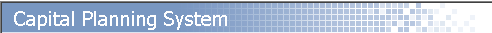

CIP, CMS and CIMS Overview Training

Schedule and Enrollment Form

CIP, CPS and CIMS Overview Training Schedule 2
Locations & Addresses 2
Training Recommendation - Order of Classes 3
Course Outlines 4
The CIP Process - CPS, CIMS & District Hours (Mini-session - Remote) 4
Introduction to CPS (In-person) 5
Creating Projects (Mini-session - Remote) 5
Updating Inventory & Closing/Archiving Projects (Mini-session - Remote) 5
Enrollment Instructions 6
Registration Contact Information 6
Enrollment Form 7
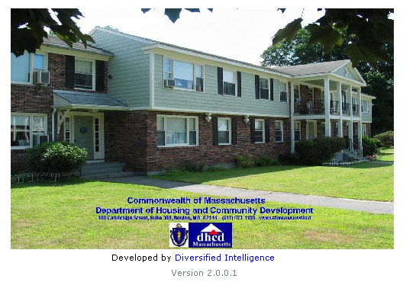





CIP, CPS and CIMS Overview Training Schedule

March 2016 - June 2016
DHCD is sponsoring CPS training classes to help LHA’s feel more comfortable when updating their CPS data. Ideally, your inventory and projects should be updated on an ongoing basis. These classes are perfect for new and existing Executive Directors, Modernization staff, and anyone who is responsible for the capital planning process. The classes can also be used as a Refresher. There is no charge to your Authority to attend.
Some "remote" sessions are geared towards more experienced CPS users who have attended an in-person session during the past 3 years. Other "remote" sessions are an overview of the whole process. Brand New Users should attend the "remote" CIP Process Overview session and then attend "in-person" to the Introduction to CPS class.

Date | Location | Class Name | Type | Class Hours
March 25 | Remote | CIP Process Overview - CPS, CIMS, District Hours | Mini-session Via Web | 9:30 - 11:30
March 25 | Remote | Creating Projects | Mini-session Via Web | 12:30 - 2:30
April 5 | Milford | Introduction to CPS | In-person | 9:30 - 4:00
April 11 | Remote | CIP Process Overview - CPS, CIMS, District Hours | Mini-session Via Web | 9:30 - 11:30
April 11 | Remote | Creating Projects | Mini-session Via Web | 12:30 - 2:30
April 20 | Remote | Updating Inventory, Closing etc | Mini-session Via Web | 9:30 - 11:30
April 20 | Remote | CIP Process Overview - CPS, CIMS, District Hours | Mini-session Via Web | 12:30 - 2:30
May 9 | Woburn | Introduction to CPS | In-person | 9:30 - 4:00
May 12 | Remote | Updating Inventory, Closing etc | Mini-session Via Web | 9:30 - 11:30
May 12 | Remote | CIP Process Overview - CPS, CIMS, District Hours | Mini-session Via Web | 12:30 - 2:30
May 17 | Remote | Creating Projects | Mini-session Via Web | 9:30 - 11:30
May 17 | Remote | Updating Inventory, Closing etc | Mini-session Via Web | 12:30 - 2:30
May 31 | Brockton | Introduction to CPS | In-person | 9:30 - 4:00
June 1 | Remote | CIP Process Overview - CPS, CIMS, District Hours | Mini-session Via Web | 9:30 - 11:30
June 1 | Remote | Updating Inventory, Closing etc | Mini-session Via Web | 12:30 - 2:30
June 13 | Remote | Creating Projects | Mini-session Via Web | 9:30 - 11:30
June 13 | Remote | CIP Process Overview - CPS, CIMS, District Hours | Mini-session Via Web | 12:30 - 2:30
June 20 | Remote | CIP Process Overview - CPS, CIMS, District Hours | Mini-session Via Web | 9:30 - 11:30
June 20 | Remote | Updating Inventory, Closing etc | Mini-session Via Web | 12:30 - 2:30
June 29 | Holyoke | Introduction to CPS | In-person | 9:30 - 4:00

Locations & Addresses

These sessions are being held at various classrooms across the State. Each participant will have a laptop to work with and have Internet connectivity. We recommend www.mapquest.com if you need driving directions.

City/Town | Location | Address
Brockton | Brockton Housing Authority | James Michael Dwyer Inventory and Training Center  75 Plain Street, Brockton, MA 02301
Holyoke | Holyoke Housing Authority | 475 Maple Street, Holyoke, MA 01040
Milford | Milford Housing Authority | Community Room  (on right as you enter the complex)  45 Birmingham Court, Milford, MA 01757
Woburn | Woburn Housing Authority | “little white schoolhouse near tot lot playground”  143 – 145 Spring Court Extension, Woburn, MA 01801

Training Recommendation - Order of Classes

Below is a chart for the recommended order to take these classes.

- The CIP Process Overview class should be done before any other class is taken. This class explains the whole capital planning process, what FISH is, what CIMS and CPS are, what is a checklist appointment, and what are District Hours.

- Introduction to CPS is a full day hands-on class which fully covers CPS. This class is for those who are either new directors, new to CPS or capital planning, less than confident in their CPS skills, or recently assigned to keep CPS up-to-date.

- The Creating Projects and Updating Inventory webinars are designed for people who have already been using CPS for a while and need a refresher; or for those who use it regularly but now understand it enough to ask specific questions based on their own experience.

There is no limit to the number of times a class can be taken and DHCD takes care of the cost of this training. If you do not feel proficient in creating projects, you should re-take the Intro to CPS in person class.

Order in which to take this class | Name of Class | Format of class - web or in-person | Class Length
1 | CIP Process Overview - CPS, CIMS, District Hours | Mini-session Via Web | 2 hours
2 | Introduction to CPS | In-person | 5.5 hours
3 | Creating Projects | Mini-session Via Web | 2 hours
4 | Updating Inventory, Closing etc | Mini-session Via Web | 2 hours

Course Outlines

The CIP Process - CPS, CIMS & District Hours (Mini-session - Remote)

The CIP process is an annual occurrence where the capital needs of your LHA are reviewed and planned. During a 3-hour appointment we call “District Hours”; we work with you to create your CIP. Each CIP is a rolling 5-year plan, to address immediate needs and to plan for future expected needs. It is created in a program called CIMS, which connects to other programs (CPS, FISH, and HAFIS) in one central location.
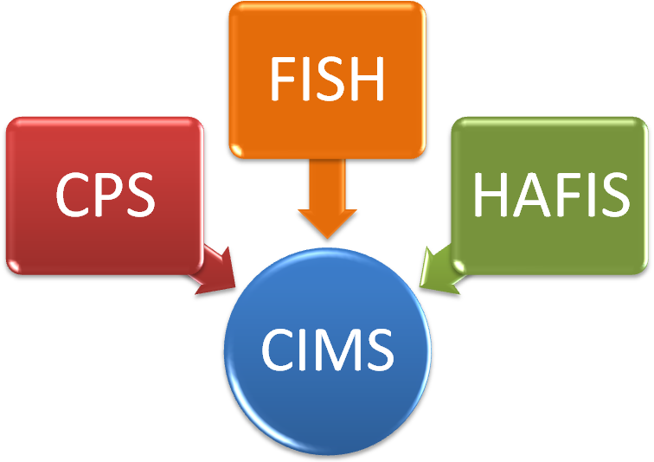

CPS - Projects are created in CPS. We offer recurring classes in CPS to help teach you how to create and archive projects.
FISH - Projects, once they start, are controlled by your Project Manager using FISH. Line items for all soft costs, hard costs, offsetting income, and contingency are all controlled here.
HAFIS - And monthly or quarterly reports are captures in HAFIS. These reports need to be up-to-date prior to submitting the CIP.

This webinar will illustrate The Big Picture to help you prepare throughout the year for your annual District Hours appointment to create your CIP.

Introduction to CPS (In-person)

Introduction to CPS is a full day class for those who have either never used CPS before, or those who only use it a few times per year and do not feel confident.

Objectives:

Logging In
Change a password

What is CPS?
CPS Hierarchy

Program Overview

Projects
Viewing a Project
Creating a Project
Phasing a Project
Closing a Project

Reports
Commonly Used Reports

Inventory
Conducting a Facility Condition Assessment
Splitting-the-Record for Inventory Components

Utilities
Users & Preferences
Change Password

Facilities

Appendix
Developing Cost Estimates
Tips and Tricks

Practice Exercises

Creating Projects (Mini-session - Remote)

This 2 hour class will focus on updating inventory, creating, phasing and splitting projects. We will also look at how to develop cost estimates and review facility condition assessments, in order to help you and your project manager prioritize projects. This course is instructor led via a web and phone connection.

Note: The Remote sessions are geared towards more experienced CPS users who have attended an in-person session during the past 3 years. New Users should attend full day in-person classes.

Updating Inventory & Closing/Archiving Projects (Mini-session - Remote)

This 2 hour class will focus on updating inventory as well as closing and archiving projects. This course is instructor led via a web and phone connection.

Note: The Remote sessions are geared towards more experienced CPS users who have attended an in-person session during the past 3 years. New Users should attend full day in-person classes.

Enrollment Instructions
The Department of Housing and Community Development Presents:

CIP, CPS and CIMS Overview Training

March - June 2016

Topic: | Several different types of CPS classes are being offered, please review the course outlines on page 3.
Who should attend: | Any LHA staff member(s) who are primarily responsible for Capital Planning and Project management. Please know (and bring) your CPS login and password if you want to attend.

Enrollment Instructions

Details: | Please see the attached schedule of classes. Group size is limited to 10 - 12 LHA’s per session. As such, keeping your appointment in a reserved session is critical.
To enroll: | Please fill out and fax this form to Kathy Arnold of CyberSense Training & Consulting. Kathy will be managing the registration process.  CyberSense’s fax # is (603) 898-8063. A separate cover page for the fax is not needed.  Please do not consider yourself enrolled until Kathy confirms you via phone or e-mail. If you do not hear back from us within 48 hours, please call to make sure your fax was received. Questions about the enrollment process for classes can be directed to Kathy Arnold by calling (603) 898-5050 or e-mailing karnold@cybersensetraining.com
Cancellation  Policy: | If you need to cancel or reschedule, you must notify us one week prior to class. We make decisions and reserve instructors based upon enrollment data. Please be considerate of others by attending the session you registered for. “No Shows” negatively affect us all and keep other participants from being able to attend.

Registration Contact Information

All questions regarding the enrollment process for the sessions should be directed to Kathy Arnold of CyberSense Training.

CyberSense Training & Consulting Kathlene Arnold 603-898-5050 office & voice mail
www.cybersensetraining.com 617-818-8890 cell
karnold@cybersensetraining.com 603-898-8063 fax 603-898-8180 home

PLEASE DO NOT FAX THIS PAGE

Massachusetts Housing Authorities
CIP Training
Mar - Jun 2016

Enrollment Form

Housing Authority:

Name (s): |  |  | Phone # / Ext (s):
Title (s): |  |  | E-Mail (s):
 |  |  | Fiscal Year End:
***** In case of a weather related emergency so that CyberSense may contact you with a last minute need to cancel, please indicate your home or cell # phone numbers. You may also text Kathy Arnold anytime 24/7 at 617-818-8890 to inquire if a class is canceling due to snow or severe weather.

Home and/or cell #:

Please enroll me in:
Date | Name of Course | Location | Time
- In person classes require a minimum registration count of 8 students in order to run. Remote sessions can run with as few as 4 people per session. You will be contacted several days prior if the class is canceled due to low enrollment.
- Enrollment Confirmation: Please do not consider yourself enrolled until Kathy confirms you via phone or e-mail. If you do not hear back from us within 48 hours, please call to make sure your fax was received.
- Cancellation Policy: If you need to cancel or reschedule, you must notify us by calling (603) 898-5050 or emailing karnold@cybersensetraining.com, one week prior to class. We make decisions and reserve instructors based upon enrollment data.
Student Signature: |  | Supervisor Signature:
I have reviewed the cancellation policy.
(TO REGISTER: SUBMIT THIS PAGE VIA FAX TO 603-898-8063)

