Shields Health Imaging at Newton, LLC
DON-Required Equipment

Attachments:

Attachment 1: Notice of Intent

Attachment 2. Scanned Copy of Application Fee Check

Attachment 3: Community Engagement Presentation – Newton

Attachment 4: Secretary of State Corporations Filing

Attachment 1: Notice of Intent
- Boston Globe
- Website notice

Website Notice: https://shields.com/locations/shields-mri-wellesley/

Public Announcement Concerning a Proposed Health Care Project

Shields Health Imaging at Newton, LLC (the “Applicant”) with a principal place of
business at 700 Congress Street, Suite 204, Quincy, Massachusetts 02169 intends to file
a Notice of Determination of Need (the “Application”) with the Massachusetts
Department of Public Health to acquire and operate a magnetic resonance imaging unit
(“MRI”) at a clinic to be located at 2221 Washington Street, Suite 100, Newton,
Massachusetts 02462. The total value of the Project based on the maximum capital
expenditure is $4,592,500. The Applicant does not anticipate any price or service
impacts to the Applicant’s anticipated patient panel as a result of the Project. Any ten
Taxpayers of Massachusetts may register in connection with the intended Application
no later than March 25, 2026 or 30 days from the Filing Date, whichever is later, by
contacting the Department of Public Health, Determination of Need Program, 67 Forest
Street, Marlborough, MA 01752.

Attachment 2. Scanned Copy of Application Fee Check

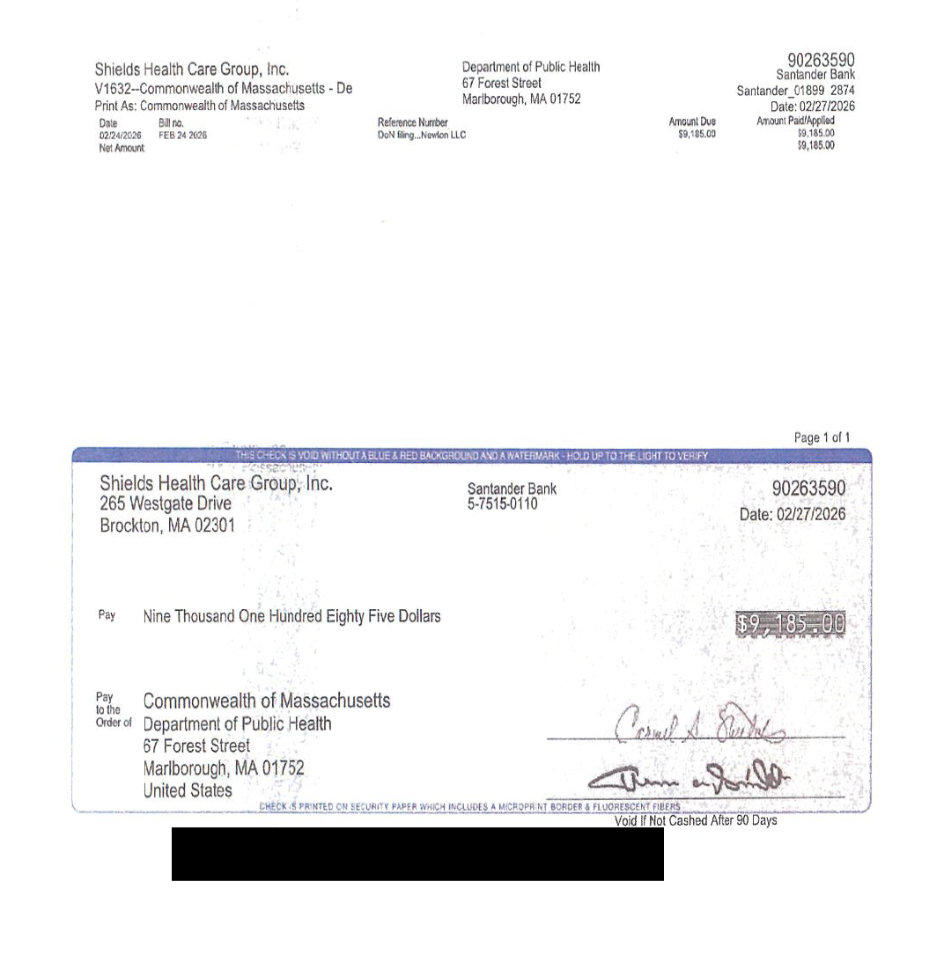

Attachment 3: Community Engagement Presentation - Newton
Shields Health
invites you to a
VIRTUAL
CONVERSATION

Please join us to learn more about high-quality affordable MRI services in Newton, Massachusetts and surrounding community
March 3, 2026
5:00PM
Join Zoom Meeting



High Quality Diagnostic Care Provided Locally
MRI Services Provided by Shields Health in the City of Newton
1

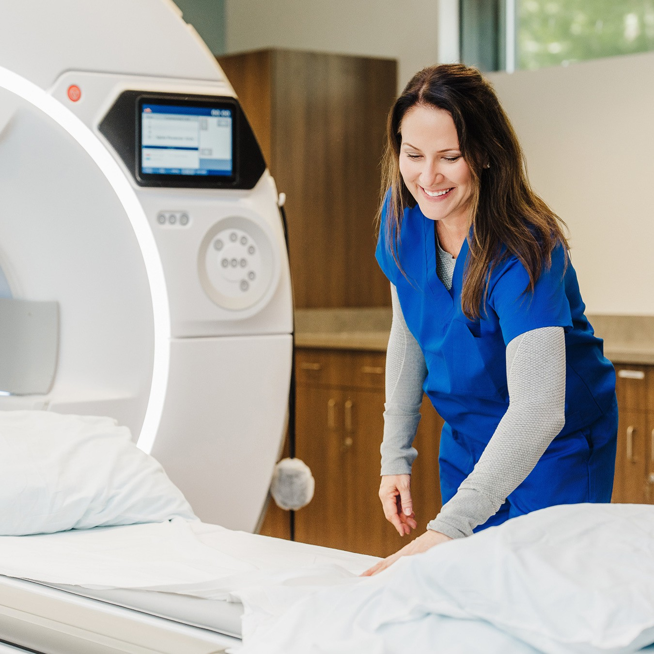

Who we are:
- Shields Health is a Massachusetts-based, family-owned company providing medical imaging, diagnostic testing and outpatient surgery

- Magnetic Resonance Imaging (MRI) is just one of the services Shields Health provides

- Joe Martins, Vice President of MRI Operations at Shields Health

COMPANY CONFIDENTIAL
2

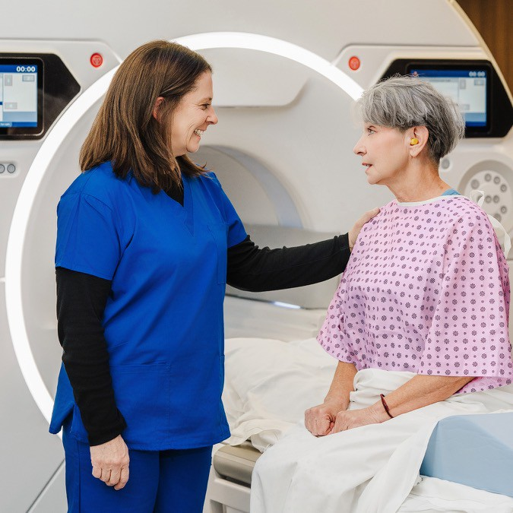

Our vision:
Welcome and thank you for your interest in this project
- We are excited to share our plans to bring high quality low cost MRI services to Newton and the surrounding community
- This project will bring state-of-the-art MRI imaging technology with 3 Tesla magnetic field and AI-enabled technology that reduces scan times and enhances imaging capabilities
- The service will operate on an outpatient fee schedule, which can be half the price of receiving the same service in a hospital outpatient department or other setting
- Today’s presentation is an opportunity to introduce you to some of the individuals involved, solicit your feedback & any answer questions

COMPANY CONFIDENTIAL
3



What is Magnetic Resonance Imaging (MRI)?
- MRI is the cornerstone of modern diagnostic imaging, enabling clinicians to detect pathology with unprecedented precision and plan treatments with confidence

- MRI equipment operations on three fundamental components working together:
  - Magnet systems create the primary magnetic field
  - Radiofrequency coils generate and receive signals for image creation
  - Gradient systems provide spatial encoding for precise anatomical localisation

- The proposed MRI will be a high-resolution 3-Tesla machine with AI-enabled technology
4



Benefits of the MRI service
- 01 High Value
  - Outpatient reimbursement with a high value service creates high patient satisfaction with lower out of pocket responsibility
- 02 Provides greater patient experience
  - Greater scheduling
  - Highly experienced technical staff
  - State of the art equipment
- 03 Keeps care to the community
  - Easy, convenient location
  - Transportation assistance
  - Provides local option for physicians and patients
- 04 Increases accessibility of care
  - Efficient weekly offered care minimizes time to treatment
  - Shifts appropriate care from inpatient to outpatient
COMPANY CONFIDENTIAL
5

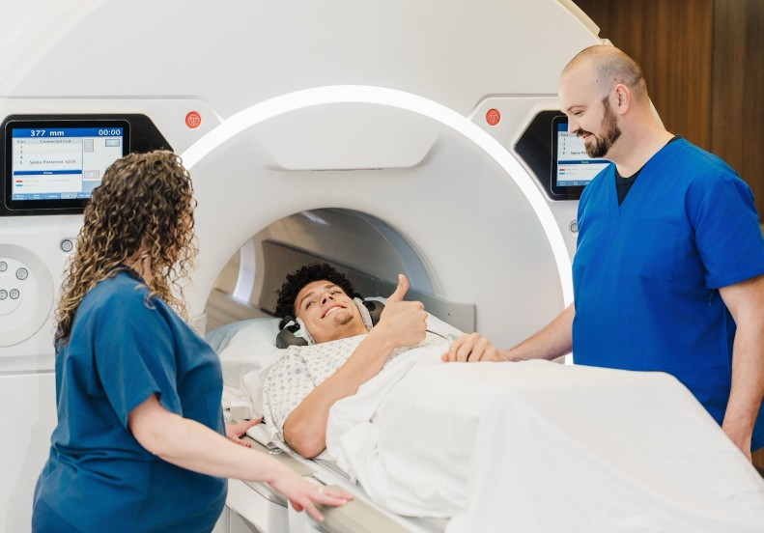

COMPANY CONFIDENTIAL

Summary: MRI Services in the City of Newton
- Full-time MRI service
- The center will offer specialty exams such as prostate and bran scans
- Located in the City of Newton

- Lower cost of care
6



COMPANY CONFIDENTIAL
Next Steps
WE WANT YOUR
INPUT on the proposed
MRI service

WE WILL KEEP YOU
INFORMED as the project progresses
7

Attachment 4. Secretary of State Corporations Filing

Secretary of State Corporations Filing

