Determination of Need by

Sturdy Health – University Orthopedics Center for Orthopedic Surgery
for
Ambulatory Surgery
Application # SH/UO-26031815-AS

Submitted on April 8, 2026

By
Sturdy Health – University Orthopedics
Center for Orthopedic Surgery, LLC
211 Park Street
Attleborough, MA 02703

Sturdy Health – University Orthopedics Center for Orthopedic Surgery, LLC Determination of Need Application #SH/UO-26031815-AS
Table of Contents

Appendix 1 Application Form
Appendix 2 Narrative
Appendix 3 Factor 4 CPA Report
Appendix 4 Factor 6 Materials
4.1 CHI Narrative
4.2 CHNA Self Assessment (submitted separately to the DPH CHI Team)
Appendix 5 Affiliated Parties
Appendix 6 Change in Service Form
Appendix 7 HPC Notice of Material Change Filings
Appendix 8 Notice of Intent
Appendix 9 Certificate of Organization
Appendix 10 ACO Letter
Appendix 11 Affidavit of Truthfulness and Compliance
Appendix 12 Filing Fee

Appendix 4

Factor 6 Supplemental Documents

Appendix 4.1

CHI Narrative

Factor 6: Community Health Initiative Narrative
- Community Health Initiative Monies
This Determination of Need (“DoN”) Application requests approval for the creation of a single specialty orthopedic ambulatory surgery center (ASC). The Applicant is a newly formed joint venture between Sturdy Memorial Hospital, Inc. and University Orthopedics Inc. The proposed ASC will be located at 30 Reservoir Street in Mansfield, The Maximum Capital Expenditure (“MCE”) for the Proposed Project is $10,834,483.
The breakdown of Community Health Initiative (“CHI”) monies for the Proposed Project is as follows, beginning with the MCE.

n/a | Total | Description
MCE | $10,834,483.00 | n/a
CHI Monies | $541,724.15 | (5% of Maximum Capital Expenditure)
Administrative Fee | $16,251.72 | (3% of the CHI Monies, retained by Applicant)
Remaining Monies | $525,472.43 | (CHI Monies minus the Administrative fee)
Statewide Initiative | $131,368.11 | (25% of remaining monies, paid to State-wide fund)
Local Initiative | $394,104.32 | (75% of remaining monies)
Evaluation Monies | $39,410.43 | (10% of Local Initiative Monies, retained by Applicant)
CHI Monies for Local  Disbursement | $354,693.89 | n/a

- Request for Sturdy Memorial Hospital to Carry Out the CHI
The Applicant is requesting the CHI for this DoN to be carried out by Sturdy Memorial Hospital as a JV partner with a Community Health Needs Assessment that includes area where the proposed ASC will be located. In addition, Sturdy Memorial Hospital is currently carrying out a significant CHI resulting from a 2025 DoN for the expansion of the hospital’s emergency department. Therefore, the CHI dollars from this DoN can be pooled with the ED CHI to extend funding for grantees, promoting sustainable funding and efficiency in the administration of all CHI dollars.
- Overview of Sturdy Memorial Hospital and its Community Health Needs Assessment
The CHI will use the hospital’s 2025 CHNA. The CHNA was carried out in 2015 by Sturdy Memorial Hospital and Sturdy Health Medical Group. It evaluated the health needs of individuals living in the hospital service area within Bristol and Norfolk counties in Massachusetts. The assessment examined a variety of health indicators, including chronic health conditions, access to health care, and social determinants of health.
This CHNA enables the Hospital, SHMG, and Sturdy Health broadly to more fully understand its community and the most important issues to them. The 2025 CHNA builds off the work done for the 2022 CHNA.
- Oversight of the Community Health Initiative
In order to facilitate a CHI that is transparent and representative of the community, the Hospital will convene its Community Benefits Advisory Committee (“CBAC”). Its duties will include:
- Selecting the Health Priority(ies) for CHI funding based upon the needs identified in the 2022 CHNA/CHIP and in alignment with the Department of Public Health’s Health Priorities;
- Determining the strategies to address the identified Health Priorities; and, following a conflicts of interest process,
- Deciding on funding amounts for each strategy and advising on how to award and select CHI grantees; and
- Providing general oversight of CHI projects and progress.

- Timeline for CHI Activities
The CHI will follow the timeline of the ED CHI with a request for funds to be distributed over an additional two-three year period.
- Administrative and Evaluation Monies
Applicants submitting a Tier 2 CHI are eligible to retain up to three percent (3%) of the total CHI for administrative costs. Accordingly, the Hospital is requesting $16,251.72 in administrative funding. These monies will support promotion of meetings, interpretation/translation, community engagement, stipends for community resident participation, and additional staff time for these efforts.
Additionally, the Hospital is seeking to use 10% of local CHI funding ($39,410.43) for evaluation efforts. These monies will allow the Hospital to retain the expertise of the internal and/or external resources to develop and implement appropriate evaluation metrics of the CHI-funded projects.

Appendix 4.2

CHNA/CHIP Self-Assessment Form
(Submitted Separately to the CHI Program)

Appendix 7

HPC Notice of Material Change Filings

Notice of Material Change - Sturdy Memorial Hospital, Inc.

Notice of Material Change - University Orthopedics, Inc

Appendix 9

Certificate of Organization

Sturdy Health - University Orthopedics Center for Orthopedic Surgery, LLC – Certificate of Organization

Appendix 10

ACO Letter



December 19, 2025 Mr. Gregory Jones
BMC Health System, Inc.
1 Boston Medical Center Place Boston, MA 02118
RE: ACO LEAP Re-Certification Dear Mr. Jones:
Congratulations! The Health Policy Commission (HPC) is pleased to inform you that BMC Health System, Inc. meets the requirements for ACO Certification under our Learning, Equity, and Patient-Centeredness (LEAP) standards. This certification is effective from January 1, 2026, through December 31, 2027.

The ACO Certification program, in alignment with other state agencies including MassHealth, is designed to accelerate care delivery transformation in Massachusetts and promote a high quality, efficient health system. ACOs participating in the program have met a set of objective criteria focused on core ACO capabilities demonstrating dedication to patient-centered care, use of evidence-based and data-driven strategies to improve care delivery, and commitment to addressing long-standing health inequities. BMC Health System, Inc. meets those criteria.
The HPC will promote BMC Health System, Inc. as a Certified ACO on our website and in our marketing and public materials. Enclosed you will find an ACO Certification logo for your organization to use in accordance with the attached Terms of Use. We hope you will use the logo on promotional materials when you highlight your ACO Certification to your patients, payers, and others.
The HPC looks forward to your continued engagement in the ACO Certification program over the next two years.

Thank you for your dedication to providing accountable, coordinated health care to your patients, and to continued learning and improvement over time. If you have any questions about this letter or the ACO Certification program, please do not hesitate to contact Courtney Anderson, Senior Manager, at HPC-Certification@mass.gov.
Best wishes,

David Seltz Executive Director

Appendix 12

Filing Fee

March 26, 2026

Fabiola Catulle
Application Manager, Determination of Need Program
Department of Public Health
67 Forest Street
Marlborough, MA 01752

Dear Ms. Catulle,

On behalf of Sturdy Health - University Orthopedic Center for Surgery, LLC, enclosed please find the filing fee for DoN Application SH/UO-26031815-AS for an Ambulatory Surgery Determination of Need.

Thank you for your attention to this submission.

Sincerely,
Weber Shill, CEO

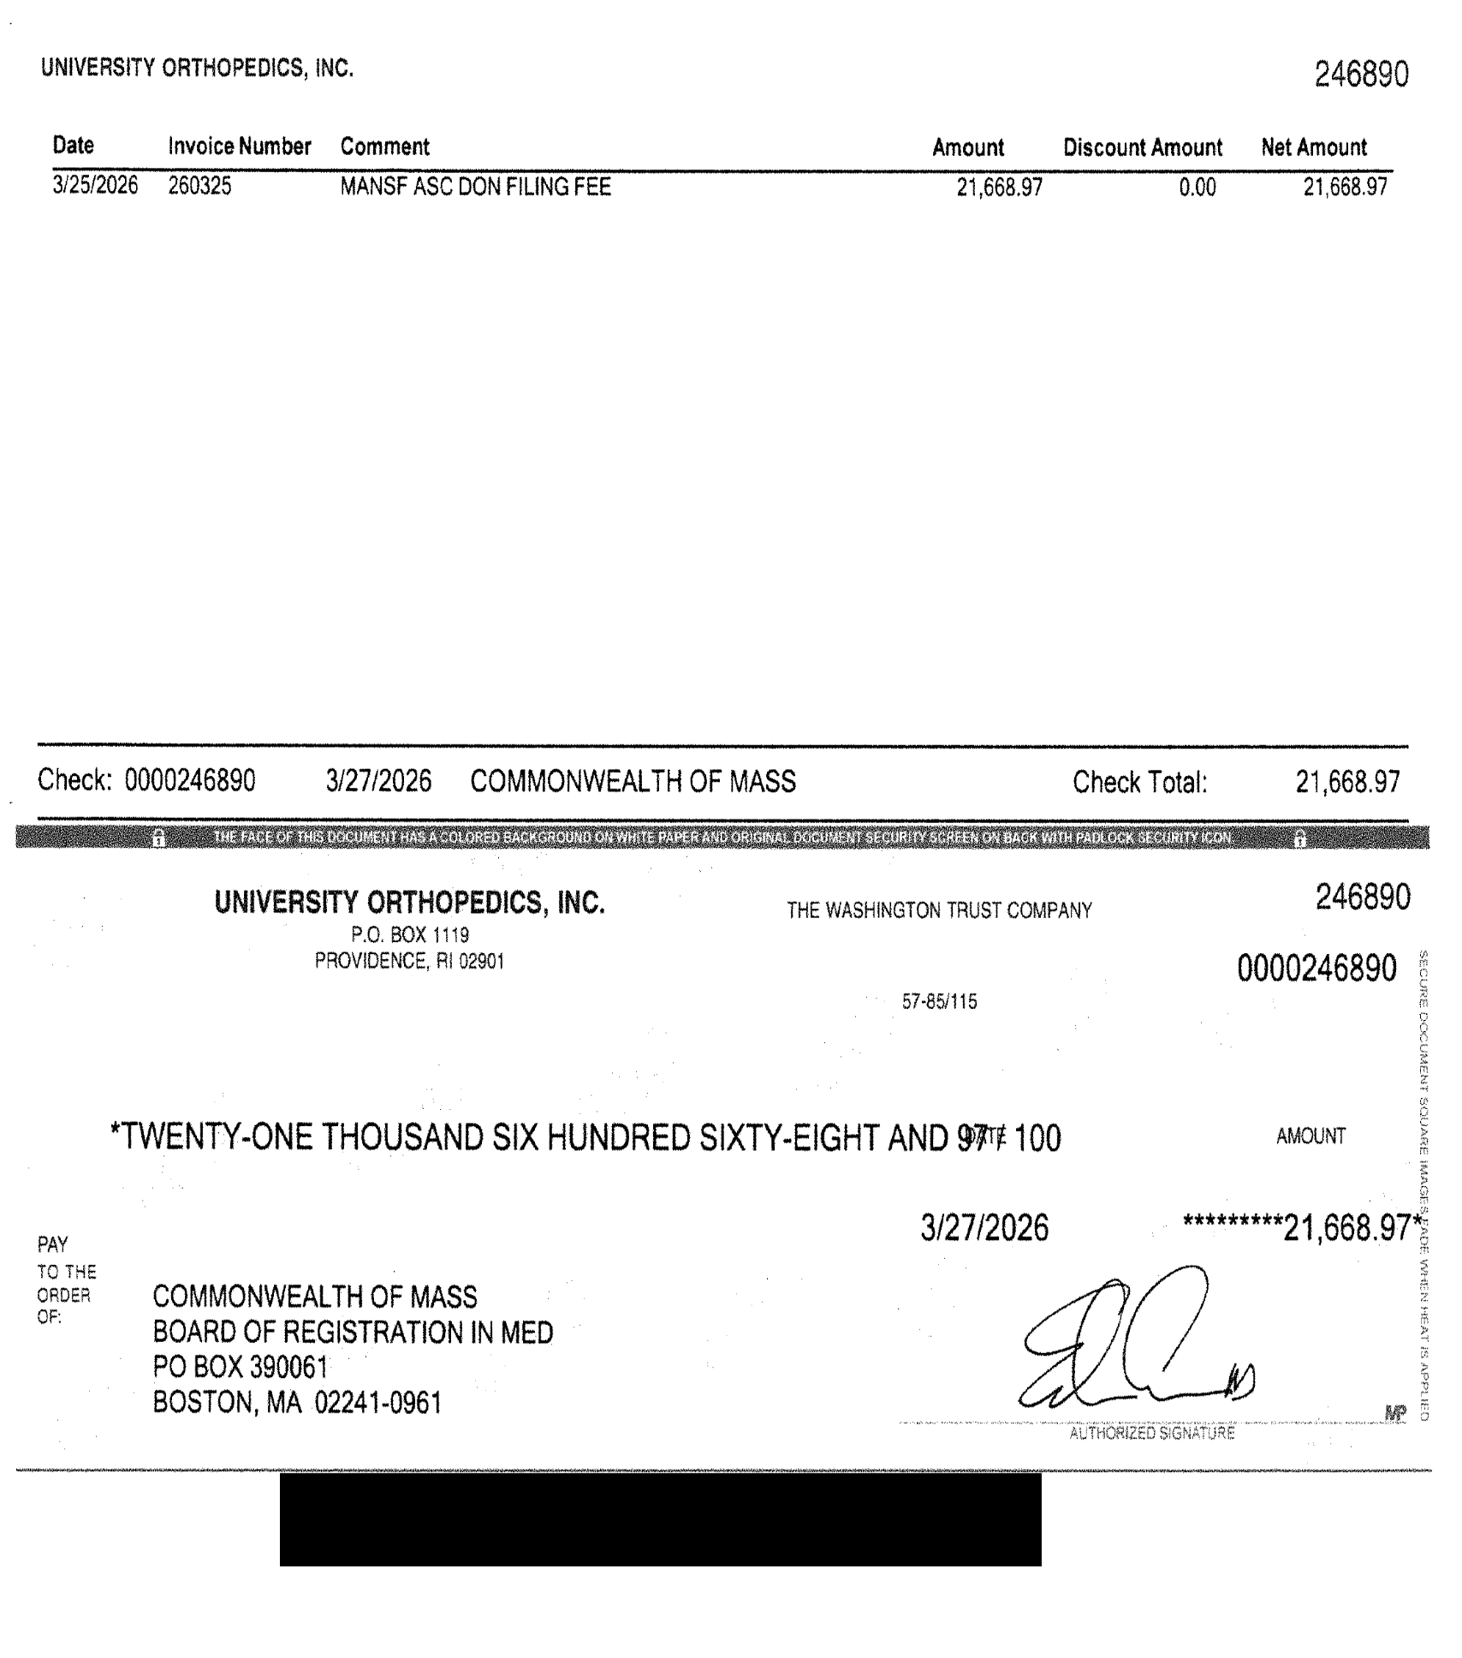

Community Health Needs Assessment 2025

