Supplemental Documents

Reliant Medical Group, Inc.

Restated Articles of Organization

December 19, 2025
Mrs. Melissa Inthirath
Collaborative Care Holdings, LLC
1 Optum Circle
Eden Prairie, Minnesota 55344

RE: ACO LEAP Certification
Dear Mrs. Inthirath:
Congratulations! The Health Policy Commission (HPC) is pleased to inform you that Collaborative Care Holdings, LLC, inclusive of Atrius Health, Inc., and Reliant Medical Group, Inc., meets the requirements for ACO Certification under our Learning, Equity, and Patient-Centeredness (LEAP) standards. This certification is effective from January 1, 2026, through December 31, 2027.
The ACO Certification program, in alignment with other state agencies including MassHealth, is designed to accelerate care delivery transformation in Massachusetts and promote a high quality, efficient health system. ACOs participating in the program have met a set of objective criteria focused on core ACO capabilities demonstrating dedication to patient-centered care, use of evidence-based and data-driven strategies to improve care delivery, and commitment to addressing long-standing health inequities. Collaborative Care Holdings, LLC meets those criteria.
The HPC will promote Collaborative Care Holdings, LLC as a Certified ACO on our website and in our marketing and public materials. Enclosed you will find an ACO Certification logo for your organization to use in accordance with the attached Terms of Use. We hope you will use the logo on promotional materials when you highlight your ACO Certification to your patients, payers, and others.
The HPC looks forward to your continued engagement in the ACO Certification program over the next two years.
Thank you for your dedication to providing accountable, coordinated health care to your patients, and to continued learning and improvement over time. If you have any questions about this letter or the ACO Certification program, please do not hesitate to contact Courtney Anderson, Senior Manager, at HPC-Certification@mass.gov.

Best Wishes,


David Seltz

Filing Fee
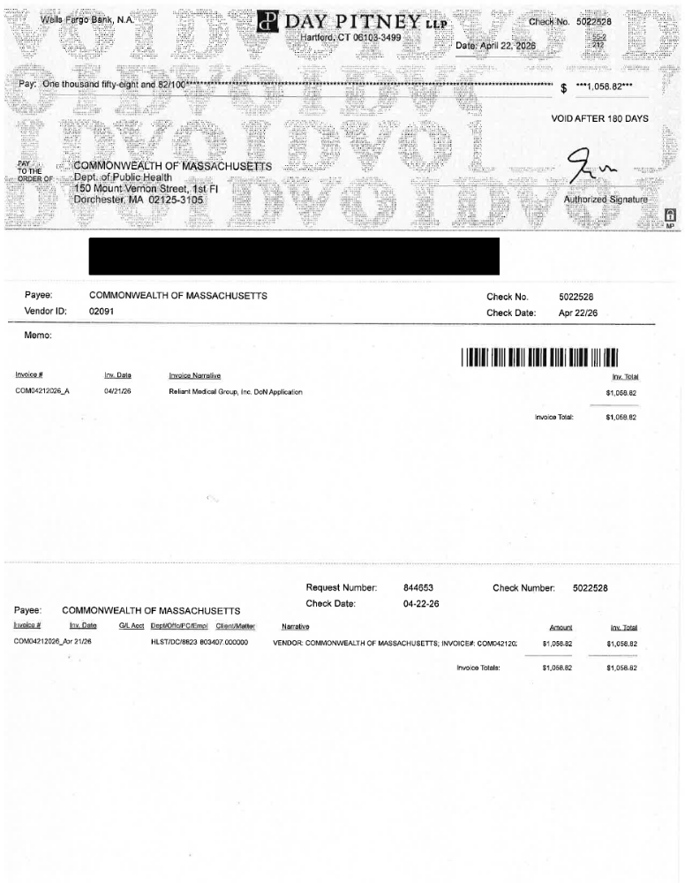

Public Announcement Concerning a Proposed Health Care Project
Reliant Medical Group, Inc. (“Applicant”), with a principal place of business at 5 Neponset Street, Worcester, MA 01606, intends to file a Notice of Determination of Need (“DoN”) with the Massachusetts Department of Public Health for the acquisition of DoN Required Equipment to obtain and utilize a mobile magnetic resonance imaging (“MRI”) unit at its Southborough site located at 24 Newton Street, Southborough, MA 01772 (the “Project”). The total value of the Project based on the maximum capital expenditure is $529,410. The Applicant does not anticipate any adverse price or service impacts on its existing patient panel as a result of this Project. The Applicant intends to file this request under 105 CMR 100.715 on or after June 5, 2026. Any ten Taxpayers of Massachusetts may register in connection with the intended Application by no later than July 5, 2026, or 30 days from the filing date, whichever is later, by contacting the Department of Public Health, Determination of Need Program, at dph.don@state.ma.us or by mail at 67 Forest Street, Marlborough, MA 01752.

