NEXT STEP HEALTHCARE LLC DoN APPLICATION # NSH-22031320-CL
ATTACHMENTS

LONG-TERM CARE CONSERVATION PROJECT 8 COLONIAL DRIVE OPERATOR, LLC D/B/A WESTBOROUGH HEALTHCARE

MARCH 30, 2021

Next Step Healthcare LLC
Don Application # NSH-22031320-CL Long-Term Care Conservation Project 8 Colonial Drive Operator, LLC
d/b/a Westborough Healthcare March 30, 2021

TABLE OF CONTENTS

Determination of Need Narrative

- Factor 4

  - Factor 4.a.i Capital Costs Chart

  - Independent CPA Analysis

- Notice of Intent

- Application for Registration

- Affidavit of Truthfulness and Compliance

- Filing Fee

Attachment 1 – Determination of Need Narrative

  - Project Description
    - Applicant
Next Step Healthcare LLC (“Applicant” or “NSH”) is a locally owned and nursing home operator established in 2008. Its principals each have more than 30 years of experience in the long-term care industry. NSH focuses exclusively on caring for Massachusetts residents and currently operates 21 skilled nursing facilities and one assisted living facility in Massachusetts.
NSH is filing this Determination of Need Application for a conservation project at Westborough Healthcare, 117-bed skilled nursing facility located in Westborough, Massachusetts (the “Facility”). The conservation project (the “Proposed Project”) is necessary for the Facility to come into compliance with applicable regulatory requirements in 105 CMR 150.000 Standards for Long- Term Care Facilities to de-densify three-bedded and four-bedded resident rooms to private and two-bedded rooms (the “De-Densification Requirements”) as described in Section III below.1
    - The Facility
The Facility is 4-story, 117-bed skilled nursing facility located in Central Massachusetts serving Westborough and the surrounding area2. The Facility was built in 1976 and to Applicant’s knowledge has always served as a Department of Public Health (“DPH”) licensed long-term facility. The Facility is a long-standing resource for the community and serves a high mix of government payers including an undeserved, medically vulnerable Medicaid population (84% Medicaid and 11% Medicare).
The Facility is 34,961 square feet building located on 221,059 square feet of land. The ground floor consists of kitchen, laundry room, salon, storage space, and other administrative offices. Resident rooms are located on the first, second and third floors of the Facility as detailed in the chart below:

Current Facility Bedroom Configuration
Floor | Privates | Two-bedded | Three-bedded | Four-bedded | Total Beds
1st | 1 | 3 | 6 | 4 | 41
2nd | 1 | 9 | 0 | 4 | 35
3rd | 1 | 3 | 6 | 4 | 41
Total | 3 | 15 | 12 | 12 | 117

In addition to short-term and long-term skilled nursing care, the Facility provides specialized services to residents requiring geriatric-psychiatric and Alzheimer’s care in a locked environment and the first floor of the Facility is a locked geri-psych unit. This unit consistently has a high

1 On February 7, 2022, Lara Szent-Gyorgyi, the Director of the DoN Program, confirmed that the Proposed Project which adds additional square footage to the Facility will qualify as a conservation project pursuant to the DPH’s April 28, 2021 memorandum “Applications for Determination of Need for Long-Term Care Facilities Seeking to Comply with Updated Licensure Regulations” because the Proposed Project is planned solely to reduce the number of beds per room to come into compliance with the applicable regulatory requirements in 105 CMR 150.000.

2 The top five zip codes of its residence are within a 12-mile radius of the Facility.

1

occupancy rate (95%-100% capacity), and is an essential resource to the community including UMass Memorial Medical Center and MetroWest Medical Center. This unit will continue to operate after the completion of Proposed Project.
    - Reason for Proposed Project
The primary reason for the Proposed Project is to comply with the De-Densification Requirements. The De-Densification Requirements limit nursing facilities rooms to no more than two beds and updates spacing / square footage room requirements to provide for better physical distancing of nursing home residents to protect against the spread of COVID-19. Since the outbreak of COVID- 19, research has found that there is a higher incidence of COVID-19 cases and mortality in small rooms with multiple beds3 and the Centers for Disease Control (CDC) states that older adults living in congregate settings are at high risk of being affected by respiratory and other pathogens, such as SARS-COV-24. The CDC guidance highlights that a strong infection prevention and control program as well as social distancing and the ability to isolate residents is critical. A few recent studies also found that redesigned nursing facilities to allow for social distancing and isolating residents will fare better in light of what is known about COVID-19 and can contribute to increased infection control.
    - Proposed Project
In order to de-densify its 12 four-bedded and 12 three-bedded rooms, the Facility is proposing to construct a 7,000 square feet addition to the south side of the existing building (the “Addition”) and reconfigure the existing room and common area space to meet the current applicable regulatory requirements. In the Addition, the Applicant plans to construct five new two-bedded units on each floor as further explained below. The Addition will also contain a stairwell that will allow staff to navigate quickly between the floors. The Proposed Project will also convert existing resident rooms and common areas space to 1 private room and 18 or 19 two-bedded rooms per floor. Each resident room will have a private toilet. The conversion work will also include reconfiguring dining, activity, common area space and removal of existing bed with associated bedhead equipment and wall lighting.
Upon completion of the Proposed Project, the Facility will have 3 private rooms and 56 two- bedded rooms as detailed in the chart below:

3 Kevin A. Brown et al., Association Between Nursing Home Crowding and COVID-19 Infection and Mortality in Ontario, Canada, 181(2) JAMA INTERN MED., 229–36 (Nov. 9, 2020), available at https://jamanetwork.com/journals/jamainternalmedicine/fullarticle/2772335; Sheryl Zimmerman et al., Nontraditional Small House Nursing Homes Have Fewer COVID-19 Cases and Deaths 22(3) J. AM. MED. DIR. ASS’N 489-93 (Jan. 25, 2021), available at https://www.jamda.com/article/S1525-8610(21)00120-1/fulltext
4 See CTRS. FOR DISEASE CONTROL AND PREVENTION. KEY POINTS,
https://www.cdc.gov/coronavirus/2019- ncov/hcp/long-term-care.html (last updated Sept. 10, 2021).

2

Proposed Project Facility Bedroom Configuration
Floor | Privates | Two-bedded | Three-bedded | Four-bedded | Total Beds
1st | 1 | 18 | 0 | 0 | 37
2nd | 1 | 19 | 0 | 0 | 39
3rd | 1 | 19 | 0 | 0 | 39
Total | 3 | 56 | 0 | 0 | 115

As part of the Proposed Project, the Applicant also proposes to do maintenance and repairs to keep the Facility in good working order. There will be upgrades to the building mechanicals including but not limited to plumbing, HVAC, and the electrical. On the ground floor, the covered drive through will be enclosed and converted to a new lobby and dining room, and the rehabilitation office will be converted to a new activity space.
The construction is expected to begin on or about the Fall of 2023 and be completed in a year. Applicant does not expect significant changes to the Facility’s operating costs from the Proposed Project because the overall bed and potential resident count will stay substantially the same.
The Proposed Project will bring the Facility into compliance with De-densification requirement and maintain 115 of its current 117 beds.
3901\0001\816386.4

3

Attachment 2 – Factor 4 Supplemental Information

Attachment 2a – Factor 4.a.i Capital Costs Chart

Westborough Healthcare
 | F4.a.i Capital Costs Chart
 |  | Present Square Footage |  | Square Footage Involved in Project |  |  |  | Resulting Square Footage |  | Total Cost |  | Cost/Square Footage
 | Functional Area |  |  | New Construction |  | Renovation
 |  | Net | Gross | Net | Gross | Net | Gross | Net | Gross | New Construction | Renovation | New Construction | Renovation
1 | Administration | 2,051 | 2,181 | ‐ | ‐ | ‐ | ‐ | 2,855 | 3,016 | $ ‐ | $ ‐
2 | Bathing and Showers | 562 | 619 | ‐ | ‐ | ‐ | ‐ | 562 | 619 | $ ‐ | $ ‐
3 | Beauty | 155 | 168 | ‐ | ‐ | ‐ | ‐ | 155 | 168 | $ ‐ | $ ‐
4 | Circulation | 9,349 | 9,964 | 1,865 | 2,140 | 2,628 | 2,772 | 12,029 | 12,827 | $ 564,655 | $ 731,413 | $ 263.86 | $ 263.86
5 | Dietary | 130 | 146 | ‐ | ‐ | ‐ | ‐ | 130 | 146 | $ ‐ | $ ‐
6 | Dining/Activity | 4,122 | 4,254 | 783 | 820 | 2,215 | 2,388 | 3,118 | 3,266 | $ 216,363 | $ 630,092 | $ 263.86 | $ 263.86
7 | Janitor | 99 | 118 | ‐ | ‐ | ‐ | ‐ | 99 | 118 | $ ‐ | $ ‐
8 | Kitchen | 870 | 936 | ‐ | ‐ | ‐ | ‐ | 870 | 936 | $ ‐ | $ ‐
9 | Laundry/Linen | 366 | 420 | ‐ | ‐ | ‐ | ‐ | 366 | 420 | $ ‐ | $ ‐
10 | Mechanical | 687 | 728 | 54 | 67 | ‐ | ‐ | 741 | 795 | $ 17,678 | $ ‐ | $ 263.86
11 | Nursing Area | 1,127 | 1,216 | ‐ | ‐ | ‐ | ‐ | 1,127 | 1,216 | $ ‐ | $ ‐
12 | Public Toilets | 274 | 317 | ‐ | ‐ | ‐ | ‐ | 274 | 317 | $ ‐ | $ ‐
13 | Rehab | 318 | 345 | ‐ | ‐ | 318 | 344 | 651 | 681 | $ ‐ | $ 90,767 |  | $ 263.86
14 | Resident Rooms | 13,687 | 14,650 | 4,539 | 5,011 | 9,129 | 9,683 | 18,003 | 19,575 | $ 1,322,189 | $ 2,554,931 | $ 263.86 | $ 263.86
15 | Staff Area | 420 | 456 | ‐ | ‐ | ‐ | ‐ | 420 | 456 | $ ‐ | $ ‐
16 | Storage | 869 | 937 | 96 | 115 | ‐ | ‐ | 964 | 1,052 | $ 30,344 | $ ‐ | $ 263.86
 | TOTAL: | 35,086 | 37,455 | 7,337 | 8,153 | 14,290 | 15,187 | 42,364 | 45,608 | $ 2,151,229.48 | 4,007,202.52 | 263.86 | 263.86

Attachment 2b – Independent CPA Analysis

[To be submitted separately]

Attachment 3 – Notice of Intent

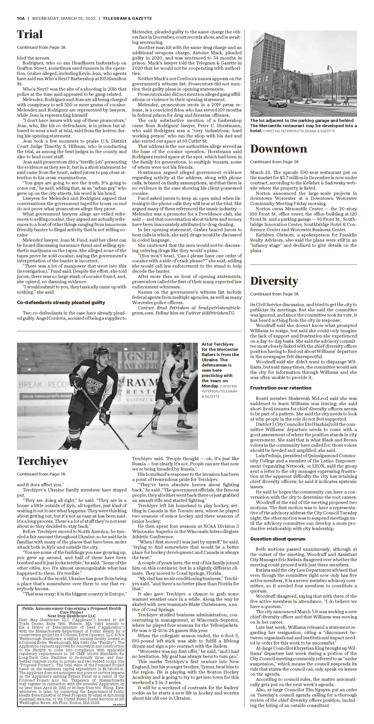
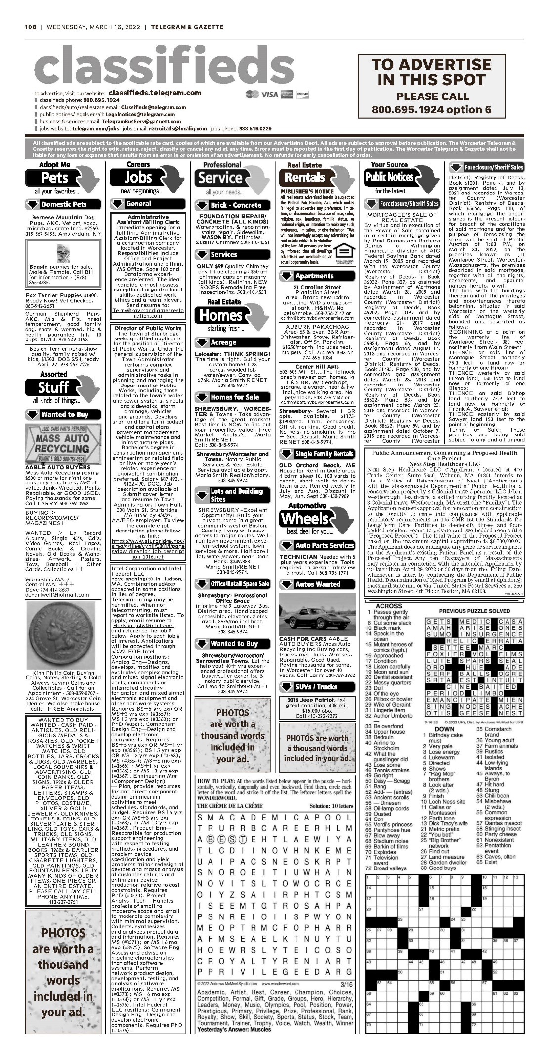
Attachment 4 – Application for Registration

MA SOC Filing Number: 201719967260 Date: 2/23/2017 11:40:00 AM
FAX Stamp 02-23-17 11:34 From Bay State 617-742-8482 T-633 P0002/0005 F-859

The Commonwealth of Massachusetts
William Francis Galvin
Secretary of the Commonwealth
One Ashburton Place, Room 1717, Boston, Massachusetts 02108-1512

Foreign Limited Liability Company
Application for Registration
(General Laws Chapter 156C, Section 48)

Federal Identification No.: _

(la) The exact name of the limited liability company:
Next Step Healthcare LLC

(1b) If different, the name under which it proposes to do business in the Commonwealth of Massachusetts:

- The jurisdiction• where the limited liability company was organized:
Delaware

- The date of organization in that jurisdiction: March 7, 2008
- The general character of the business the limited liability company proposes to do in the Commonwealth:
Management of health care facilities.

- The business address of its principal office:
75 Second Avenue
Suite 605
Needham, MA 02494
- The business address of its principal office in the Commonwealth, if any:
75 Second Avenue
Suite 605
Needham, MA 02494
{7) The name and business address, if different from principal office location, of each manager:

None

FAX Stamp 02-23-17 11:34 From Bay State 617-742-8482 T-633 P0002/0005 F-859

- The name and business address of each person authorized co execute, acknowledge, deliver and record any recordable instrument purporting to affect an interest in real property recorded with a registry of deeds or district office of the land court:

NAME
Damian N. Dell'Anno

William H. Stephan
ADDRESS
75 Second Avenue
Suite 605
Needham, MA 02494

75 Second Avenue Suite605
Needham, MA 02494

- The name and street address of the resident agent in the Commonwealth:

William H. Stephan 18 Constellation Wharf Charlestown, MA 02129

- The latest date of dissolution, if specified: N/A _
- Additional matters

Signed by (by at least one authorized signatory): <Signature of William H. Stephan, member>

I, William H, Stephan
resident agent of the above limited liability company, consent to my appointment as resident agent pursuant to G.L. c156C § 48 (or attach resident agent’s consent hereto).

*Attach certificate of existence or good standing issued by an officer or agency properly authorized in home state.

02-23-'17 11:35 FROM- Bay State 617-742-8482
Delaware
The First State

T-633 P0004/0005 F-859
Page 1

I, JEFFREY W. BULLOCK, SECRETARY OF STATE OF THE STATE OF DELAWARE, DO HEREBY CERTIFY "NEXT STEP HEALTHCARE LLC" IS DULY FORMED UNDER THE LAWS OF THE STATE OF DELAWARE AND IS IN GOOD STANDING AND HAS A LEGAL EXISTENCE SO FAR AS THE RECORDS OF THIS OFFICE SHOW, AS OF THE TWENTY-THIRD DAY OF EEBRUARY, A.D. 2017.
AND I DO HEREBY FURTHER CERTIFY THAT THE SAID "NEXT STEP HEALTHCARE LLC" WAS FORMED ON THE SEVENTH DAY OF MARCH, A.D. 2008.
AND I DO HERE BY FURTHER CERTIFY THAT THE ANNUAL TAXES HAVE BEEN PAID TO DATE.

<Signature on File>
Jeffery W. Burlick, Secretary of State

<Image of Delaware Secretary’s Office>
4512330 8300
SRI/ 20171170802
You may verify this certificate online at corp.delaware.gov/authver.shtml
Authentication: 20208534S
Date: 02-23-17

MA SOC Filing Number: 201719967260 Date: 2/23/2017 11:40:00 AM

THE COMMONWEAL TH OF MASSACHUSETTS

I hereby certify that, upon examination of this document, duly submitted to me, it appears that the provisions of the General Laws relative to corporations have been complied with, and I hereby approve said articles; and the filing fee having been paid, said articles are deemed to have been filed with me on:
February 23, 2017 11:40 AM

<Signature on File for William Francis Galvin>

WILLIAM FRANCIS GALVIN

Secretary of the Commonwealth

Attachment 5 – Affidavit of Truthfulness and Compliance

Massachusetts Department of Public Health

Determination of Need

Affidavit of Truthfulness and Compliance
with Law and Disclosure Form 100.405(8)
Version 7-6-17

Instructions: Complete information below. When complete check the box “This document is ready to print:” This will date stamp and lock the form. Print Form. Each person must sign and date the form. When all signatures have been collected, scan the document and e-mail to: dph.don@state.ma.us Include all attachments as requested.

Application Number: NSH-2203132 Original Application Date: 03/30/ 2022
Applicant Name: Next Step Healthcare LLC

Application Type: Conservation Long Term Care Project

Applicant's Business Type: LLC
Is the Applicant the sole member or sole shareholder of the Health Facility(ies) that are the subject of this Application? Yes
The undersigned certifies under the pains and penalties of perjury:
- The Applicant is the sole corporate member or sole shareholder of the Health Facility[ies] that are the subject of this Application;
- I have read 105 CMR 100.000, the Massachusetts Determination of Need Regulation;
- I understand and agree to the expected and appropriate conduct of the Applicant pursuant to 1OS CMR 100.800;
- I have read this application for Determination of Need including all exhibits and attachments, and certify that all of the information contained herein is accurate and true;
- I have submitted the correct Filing Fee and understand it is nonrefundable pursuant to 105 CMR 100.405(8);
- I have submitted the required copies of this application to the Determination of Need Program, and, as applicable, to all Parties of Record and other parties as required pursuant to 105 CMR 100.405(8);
- I have caused, as required, notices of intent to be published and duplicate copies to be submitted to all Parties of Record, and all carriers or third-party administrators, public and commercial, for the payment of health care services with which the Applicant contracts, and with Medicare and Medicaid, as required by 1OS CMR 100.40S(C), et seq.;
- I have caused proper notification and submissions to the Secretary of Environmental Affairs pursuant to 105 CMR 100.40S(E) and 301 CMR 11.00;
- If subject to M.G.L. c. 6D, § 13 and 958 CMR 7.00, I have submitted such Notice of Material Change to the HPC - in accordance with 105 CMR 100.40S(G);
- Pursuant to 1OS CMR 100.210(A)(3), I certify that both the Applicant and the Proposed Project are in material and substantial compliance and good standing with relevant federal, state, and local laws and regulations, as well as with all previously issued Notices of Determination of Need and the terms and Conditions attached therein;
- I have read and understand the limitations on solicitation of funding from the general public prior to receiving a Notice of Determination of Need as established in 105 CMR 100.41S;
- I understand that, if Approved, the Applicant, as Holder of the DoN, shall become obligated to all Standard Conditions pursuant to 1OS CMR 100.310, as well as any applicable Other Conditions as outlined within 105 CMR 100.000 or that otherwise become a part of the Final Action pursuant to 105 CMR 100.360;
- Pursuant to 1OS CMR 100.70S(A), I certify that the Applicant has Sufficient Interest in the Site or facility ; and
- Pursuant to 1OS CMR 100.705(A), I certify that the Proposed Project is authorized under applicable zoning by-laws or ordinances, whether or not a special permit is required; or,
  - If the Proposed Project is not authorized under applicable zoning by-laws or ordinances, a variance has been received to permit such Proposed Project; or,
  - The Proposed Project is exempt from zoning by-laws or ordinances.
LLC:
All parties must sign. Add additional names as needed.
William H. Stephan <Signature on File> 03/25/22
Name: Signature: Date

This document is ready to print: <Not selected> Date/time Stamp: <Not Provided>

1 been informed of the content of
2 been informed of/that

Attachment 6 – Filing Fee

