EXHIBIT 1.1:

FACTOR 1 COMMUNITY ENGAGEMENT FORUM PRESENTATION

#Atrius Health-2210177-RE Page 40



New Services Coming to Plymouth

Dr. David Grace, Chief, Internal Medicine
Dr. Rebecca Schwartz, Executive Chair, Ancillary Services John Clark, Senior Director, Real Estate
Karen Craft, Senior Director, Radiology Services

Page 41
#Atrius Health-2210177-RE



- Introduction
- Overview of New PMG Building
- Review of Imaging Services
- Overview of Intended Benefits to the Community
- Your Questions Answered

36 Shops at 5 Way—birds eye view

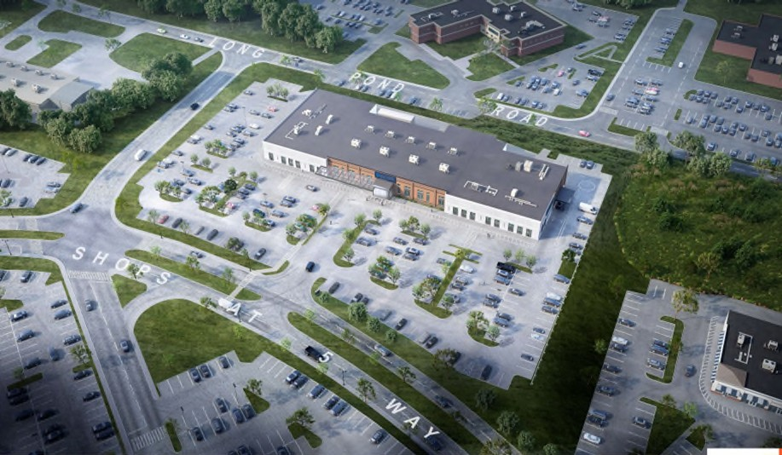

36 Shops at 5 Way—street view

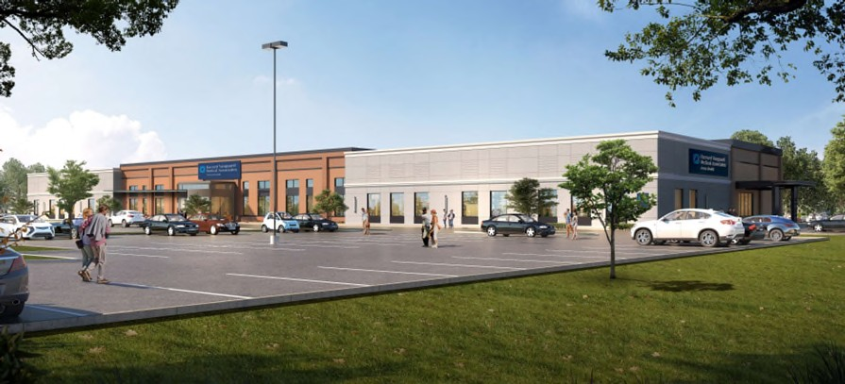

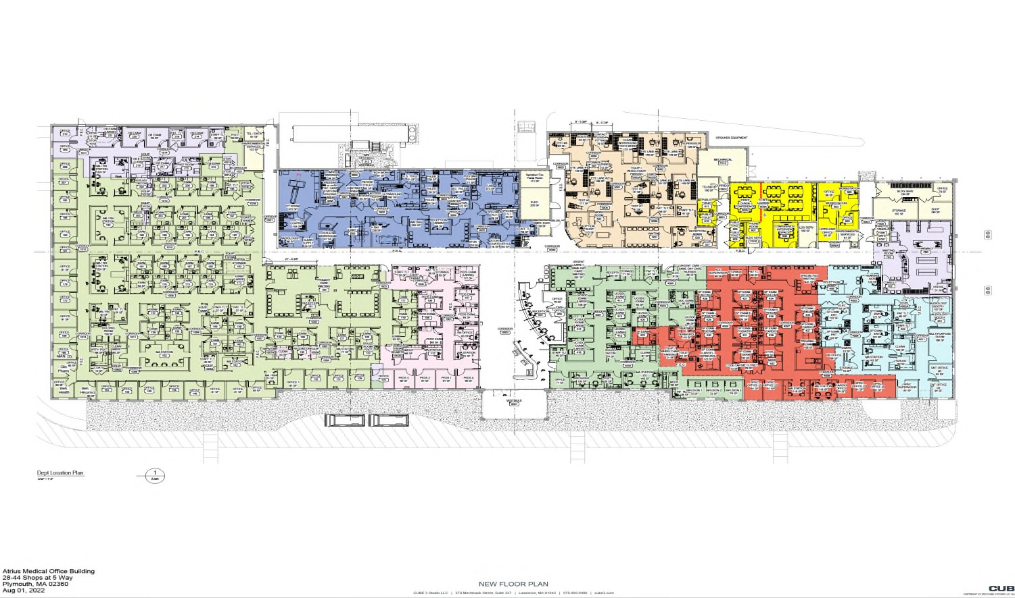

Overall Facility Layout

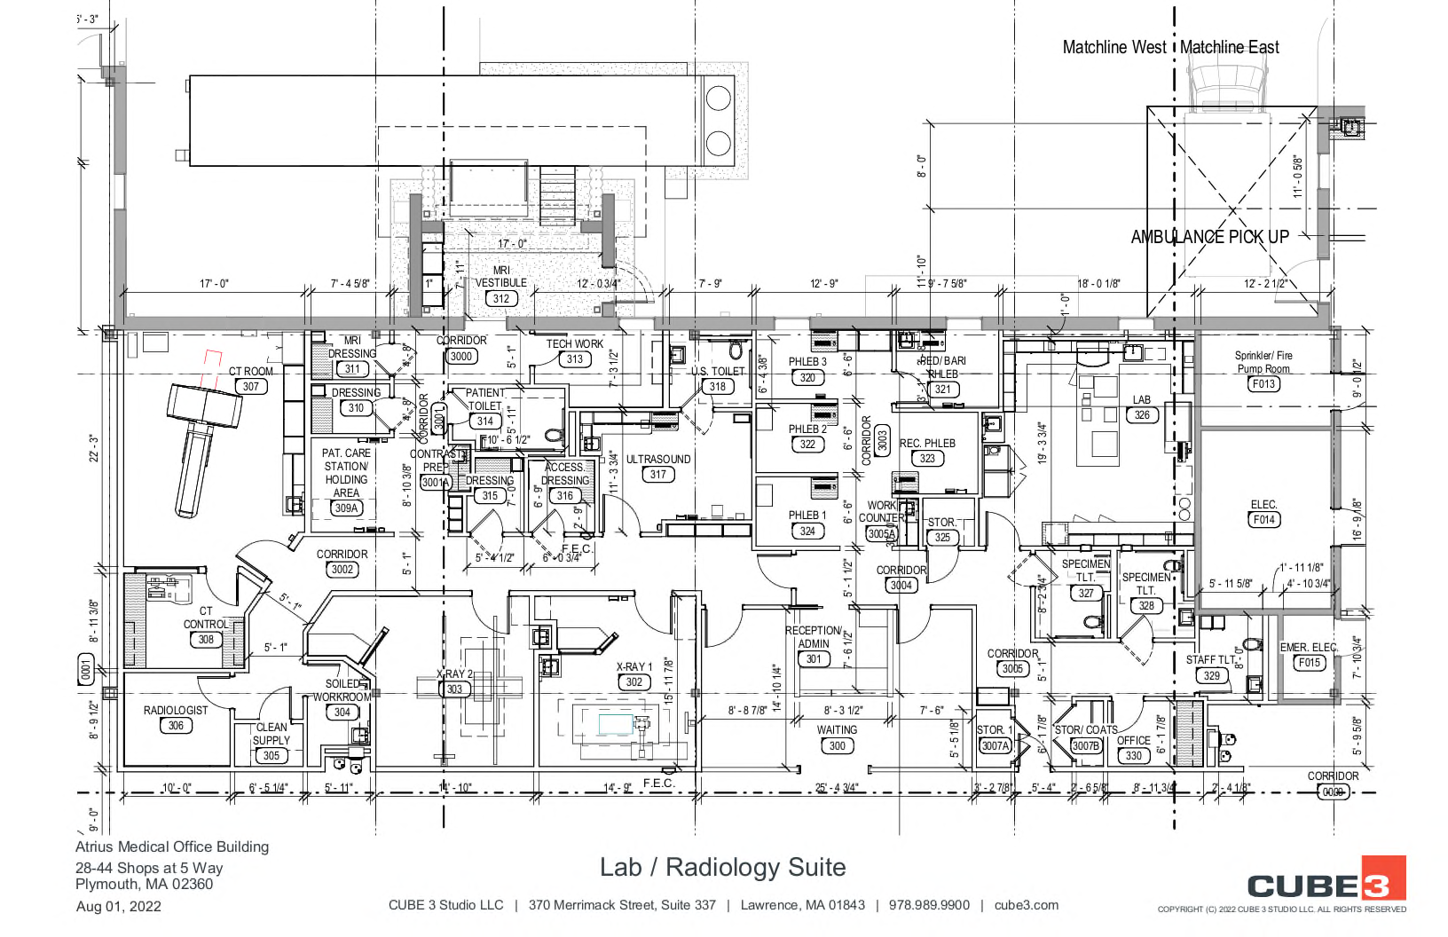

Radiology Suite

Intended Benefits to the Community

- Improved Coordinated Care
- Improved Access
- Cost Containment

Questions??

HPC ACO CERTIFICATION LETTER

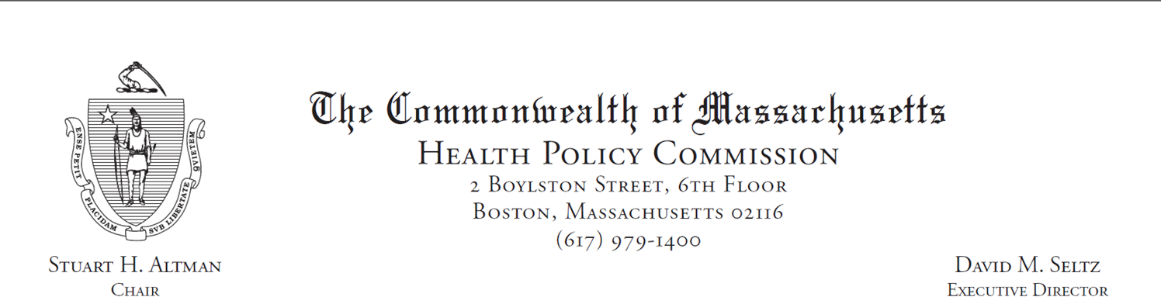
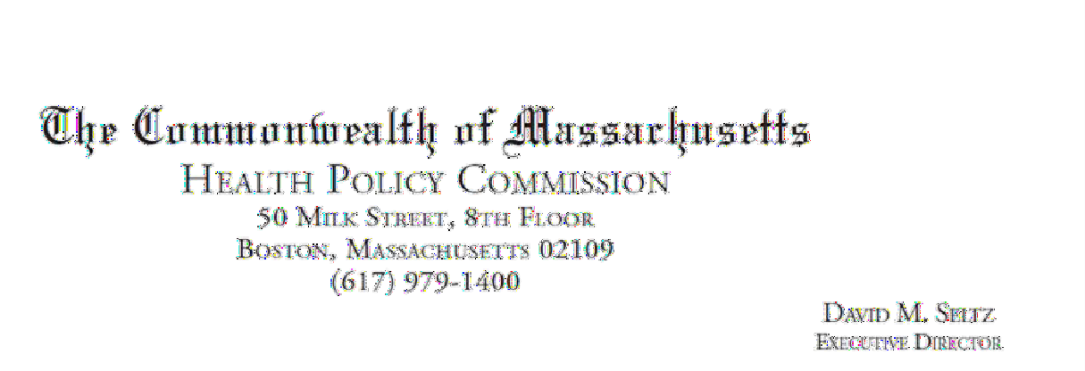
April 12, 2022

Margaret Senese Atrius Health, Inc.
275 Grove Street, Suite 3-300
Newton, MA 02466

RE: ACO LEAP Certification Dear Ms. Senese:
Congratulations! The Health Policy Commission (HPC) is pleased to inform you that Atrius Health, Inc. meets the requirements for ACO Certification under our Leaming, Equity, and Patient­ Centeredness (LEAP) standards. This certification is effective from January l, 2022, through December 31, 2023.

The ACO Certification program, in alignment with other state agencies including MassHealth, is designed to accelerate care delivery transformation in Massachusetts and promote a high quality, efficient health system. ACOs participating in the program have met a set of objective criteriia focused on core ACO capabilities demonstrating dedication to patient-centered care, use of evidence-based and data-driven strategies to improve care delivery,, and commitment to addressing long-standing health inequities. Atrius Health, Inc. meets those criteria.

The HPC will promote Atrius Health, Inc. as a Certified ACO on our website and in our marketing and public materials. Enclosed you will find an ACO Certification logo for your organization to use in accordance with the attached Terms of Use. We hope you will use the logo on promotional materials when you highlight your ACO Certification to your patients, payers, and others.

The HPC looks forward to ongoing engagement with you over the next two years. We intend to follow up shortly to provide an overview and some reflections on what we saw in the Health Equity Responses, a new feature of the ACO Certification application this year, across the cohort of Certified ACOs. We hope your organization will find that information helpful as we all continue to explore ways to improve health equity in the Commonwealth.

Thank you for your dedication to providing accountable, coordinated health care to your patients, and to continued learning and improvement over time. If you have any questions about this letter or the ACO Certification program, please do not hesitate to contact Mike Stanek, Senior Manager, at HPC-Certification@mass.gov or (617) 757-1649.

Best wishes,

[signature on file]

David Seltz Executive Director

NOTICE OF INTENT



Public Notices

Originally published at capecodtimes.com on 09/16/2022

Public Announcement Concerning a Proposed Health Care Project

Atrius Health, Inc. (“Applicant”) with a principal place of business at 275 Grove St., Suite 2-300, Auburndale, MA 02466, intends to file a Notice of Determination of Need (“DoN”) with the Massachusetts Department of Public Health for the acquisition of DoN Required Equipment that will result in the addition of one (1) computed tomography (CT) scanner and two (2) days of mobile magnetic resonance imaging (MRI) services at 36 Shops at 5 Way, Plymouth, Massachusetts 02360 (the “Project”). The total value of the Project based on the maximum capital expenditure is $978,000.00. The Applicant does not anticipate any adverse price or service impacts on the Applicant’s existing patient panel as a result of this Project. The Applicant intends to file this request under 105 CMR 100.715 on or after October 1, 2022. Any ten Taxpayers of Massachusetts may register in connection with the intended Application by no later than October 31, 2022 or 30 days from the Filing Date, whichever is later, by contacting the Department of Public Health Determination of Need Program, at dph.don@state.ma.us or 67 Forest Street, Marlborough, MA 01752.
September 16, 2022 7787225

gannett local market paper logo

Public Notices

Originally published at patriotledger.com on 09/16/2022

NOTICE OF DETERMINATION OF NEED LEGAL NOTICE
Public Announcement Concerning a Proposed Health Care Project

Atrius Health, Inc. (“Applicant”) with a principal place of business at 275 Grove St., Suite 2-300, Auburndale, MA 02466, intends to file a Notice of Determination of Need (“DoN”) with the Massachusetts Department of Public Health for the acquisition of DoN Required Equipment that will result in the addition of one (1) computed tomography (CT) scanner and two (2) days of mobile magnetic resonance imaging (MRI) services at 36 Shops at 5 Way, Plymouth, Massachusetts 02360 (the “Project”). The total value of the Project based on the maximum capital expenditure is $978,000.00. The Applicant does not anticipate any adverse price or service impacts on the Applicant’s existing patient panel as a result of this Project. The Applicant intends to file this request under 105 CMR 100.715 on or after October 1, 2022. Any ten Taxpayers of Massachusetts may register in connection with the intended Application by no later than October 31, 2022 or 30 days from the Filing Date, whichever is later, by contacting the Department of Public Health Determination of Need Program, at dph.don@state.ma.us or 67 Forest Street, Marlborough, MA 01752.

AD# 7790279 PL 09/16/2022

ARTICLES OF ORGANIZATION

https://corp.sec.state.ma.us/CorpWeb/CorpSearch/CorpSearchRedirector.aspx?Action=PDF&Path=CORP_ DRIVE1/2022/0525/002216453/0001/202228020370_1.pdf

#Atrius Health-2210177-RE Page 82

AFFIDAVIT OF TRUTHFULNESS

 Version: 7-6-17

Massachusetts Department of Public Health

Determination of Need

Affidavit of Truthfulness and Compliance

with Law and Disclosure Form 100.405 (B)
Instructions: Complete Information below. When complete check the box "This document is ready to print:". This will date stamp and lock the form. Print Form. Each person must sign and date the form. When all signatures have been collected, scan the document and e-mail to: dph.don@state.ma.us Include all attachments as requested.
Application Number: Atrius Health, Inc. -22101711-RE
Original Application Date: 11/17/2022
Applicant Name: Atrius Health, Inc.
Application Type: DoN-Required Equipment
Applicant's Business Type: Corporation
Is the Applicant the sole member or sole shareholder of the Health Facility(ies) that are the subject of this Application? Yes
The undersigned certifies under the pains and penalties of perjury:
- The Applicant is the sole corporate member or sole shareholder of the Health Facility(ies) that are the subject of this Application;
- I have read [been informed of the contents of] 105 CMR 100.000, the Massachusetts Determination of Need Regulation;
- I understand and agree to the expected and appropriate conduct of the Applicant pursuant to 105 CMR 100.800;
- I have read [been informed of the contents of] this application for Determination of Need including all exhibits and attachments, and certify that all of the information contained herein is accurate and true;
- I have submitted the correct Filing Fee and understand it is nonrefundable pursuant to 105 CMR 100.405(B);
- I have submitted the required copies of this application to the Determination of Need Program, and, as applicable, to all Parties of Record and other parties as required pursuant to 105 CMR 100.405(B);
- I have caused [have been informed that], as required, notices of intent to be published and duplicate copies to be submitted to all Parties of Record, and all carriers or third-party administrators, public and commercial, for the payment of health care services with which the Applicant contracts, and with Medicare and Medicaid, as required by 105 CMR 100.405(C), et seq.;
- I have caused proper notification and submissions to the Secretary of Environmental Affairs pursuant to 105 CMR 100.405(E) and 301 CMR 11.00; will be made, if applicable.
- If subject to M.G.L. c. 6D, § 13 and 958 CMR 7.00, I have submitted such Notice of Material Change to the HPC - in accordance with 105 CMR 100.405(G);
- Pursuant to 105 CMR 100.210(A)(3), I certify that both the Applicant and the Proposed Project are in material and substantial compliance and good standing with relevant federal, state, and local laws and regulations, as well as with all previously issued Notices of Determination of Need and the terms and Conditions attached therein [issued in compliance with 105 CMR 100.00, the Massachusetts Determination of Need Regulation effective January 27, 2017 and amended December 28, 2018];
- I have read [been informed of the contents of] and understand the limitations on solicitation of funding from the general public prior to receiving a Notice of Determination of Need as established in 105 CMR 100.415;
- I understand that, if Approved, the Applicant, as Holder of the DoN, shall become obligated to all Standard Conditions pursuant to 105 CMR 100.310, as well as any applicable Other Conditions as outlined within 105 CMR 100.000 or that otherwise become a part of the Final Action pursuant to 105 CMR 100.360;
- Pursuant to 105 CMR 100.705(A), I certify that the Applicant has Sufficient Interest in the Site or facility; and
- Pursuant to 105 CMR 100.705(A), I certify that the Proposed Project is authorized under applicable zoning by-laws or ordinances, whether or not a special permit is required; or,
  - If the Proposed Project is not authorized under applicable zoning by-laws or ordinances, a variance has been received to permit such Proposed Project; or,
  - The Proposed Project is exempt from zoning by-laws or ordinances.

Corporation
Attach a copy of Articles of Organization/Incorporation, as amended

Steven Strongwater, MD <Signature on File> 11/17/2022
CEO for Corporation: Signature: Date:

Steven Strongwater, MD <Signature on File> 11/17/2022
Board Chair for Corporation Name: Signature: Date:

This document is ready to print: check Date/time Stamp: 11/17/2022 2:22 pm

FILING FEE

#Atrius Health-2210177-RE Page 93

