# Atrius Health, Inc.

**Determination of Need DoN Application # 24061110-AS**

**Application for Determination of Need Ambulatory Surgery Center**

**August 15, 2024**

**Table of Contents**

1. **Application Form\***
2. **Narrative\***
3. **Affiliated Parties Form\***
4. **Change in Service Form\***
5. **Certiﬁcation from Independent Certiﬁed Public Accountant\***
6. **Articles of Organization**
7. **HPC ACO Certiﬁcation**
8. **Community Engagement Presentation**
9. **Notice of Intent**
10. **Affidavit of Truthfulness**
11. **Application Fee**

**\***certain sections listed in the Table of Contents are attached as a sperate ﬁle for the

submission

# Articles of Organization

[https://corp.sec.state.ma.us/CorpWeb/CorpSearch/CorpSearchRedirector.aspx?Action=PDF&Pat](https://corp.sec.state.ma.us/CorpWeb/CorpSearch/CorpSearchRedirector.aspx?Action=PDF&Path=CORP_DRIVE1/2022/0525/002216453/0001/202228020370_1.pdf) [h=CORP_DRIVE1/2022/0525/002216453/0001/202228020370_1.pdf](https://corp.sec.state.ma.us/CorpWeb/CorpSearch/CorpSearchRedirector.aspx?Action=PDF&Path=CORP_DRIVE1/2022/0525/002216453/0001/202228020370_1.pdf)

# HPC ACO Certiﬁcation



###### DEBORAH DEVAUX

**'<rrqr Qlammanfurctlf*q* af az:z:ctcquz:dfz:**

HEALTH POLICY COMMISSION

50 MILK STREET, 8TH FLOOR BOSTON, MASSACHUSETTS 02109

(617) 979-1400

DAVID M. SELTZ

##### CHAIR

E.'u!ClfTIVE DIRECTOR

December 27, 2023

Margaret Senese Atrius Health, Inc.

275 Grove Street, Suite 2-300

Newton, MA 02466

RE: ACO LEAP Re-Certification Dear Ms. Senese:

Congratulations! The Health Policy Commission (HPC) is pleased to inform you that Atrius Health, Inc. meets the requirements for ACO Certification under our Leaming, Equity, and Patient-Centeredness (LEAP) standards. This certification is effective from January 1, 2024, through December 31, 2025.

The ACO Certification program, in alignment with other state agencies including MassHealth, is designed to accelerate care delivery transformation in Massachusetts and promote a high quality, efficient health system. ACOs participating in the program have met a set of objective criteria focused on core ACO capabilities demonstrating dedication to patient-centered care, use of evidence-based and data-driven strategies to improve care delivery, and commitment to addressing long-standing health inequities. Atrius Health, Inc. meets those criteria.

The HPC will promote Atrius Health, Inc. as a Certified ACO on our website and in our marketing and public materials. Enclosed you will find an ACO Certification logo for your organization to use in accordance with the attached Terms of Use. We hope you will use the logo on promotional materials when you highlight your ACO Certification to your patients, payers, and others.

The HPC looks forward to your continued engagement in the ACO Certification program over the next two years.

Thank you for your dedication to providing accountable, coordinated health care to your patients, and to continued learning and improvement over time. If you have any questions about this letter or the ACO Certification program, please do not hesitate to contact Mike Stanek, Associate Director, at [HPC-Certification@mass.gov](mailto:HPC-Certification@mass.gov) or (617) 757-1649.

*y�*)

Best wishes,

David Seltz

**-t:::-**

Executive Director

# Notice of Intent

.,

**CLASSIFIED**

#### [classifiedads@bostonherald.com](mailto:classifiedads@bostonherald.com)

**(617) 423-4545**

#### Monday• Friday "'

##### 8:QQA.t.1.• 5:QQp,t,1,

,

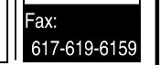

**BUYING**

**I I SELLING**

**A HOME?**

**LOOKING TO**

**CHANGE JOBS OR TRAIN FOR A NEW CAREER?**

To place an ad, call 617.423.4545

m--l. n

1

**111""11""P.': 1**

[www.bostonherald.com](http://www.bostonherald.com/)

PROFESSIONAL

Senior Proch,1c1 M.1naa,,r

(Bol;ton. MA or !00% re·

,,

■

**ca**

VACATION RENTALS

YORK BE...CI-I/CAPE NEO· QjCK,.O.=,or!;': ,e 1 eai1(J07\16M29-II

..

-

**ca**

**Cl>**

**C**

**ca**

()

**a.**

**0**

':..

**Lt)**

**111::1'**

**Lt)**

**.**,**I**.**.I**,,-,g

.."

**111::1'**

O'lil

I

**('I)**

**C\I**

**111::1'**

-

I

.0

,-

....I..

•

**1z:1**

**1:1**

**:Ii**

-d

**0**

-

**(0**

**ca**

()

£**:a**,**,**.

**:z:**

Top$$ Paid

. r. 'tij c ;i-ff,

etc.WetrJvel&Pk:k-11.b-

Ca ontheSPOl

617-594-3255

c.•11T-4lM54Sto

pla(:erc--redlrithtBoston

HeraldClaS$lfkldt,.

Always

BuY.in9 Mihtar1a Top Prices Paid

WWII Items

(617)719-1698

**MARKETPLACE**

MUSICAL INSTRUMENTS WANTEDTO BUY

LEG.llNOTICES UGllNOTICES

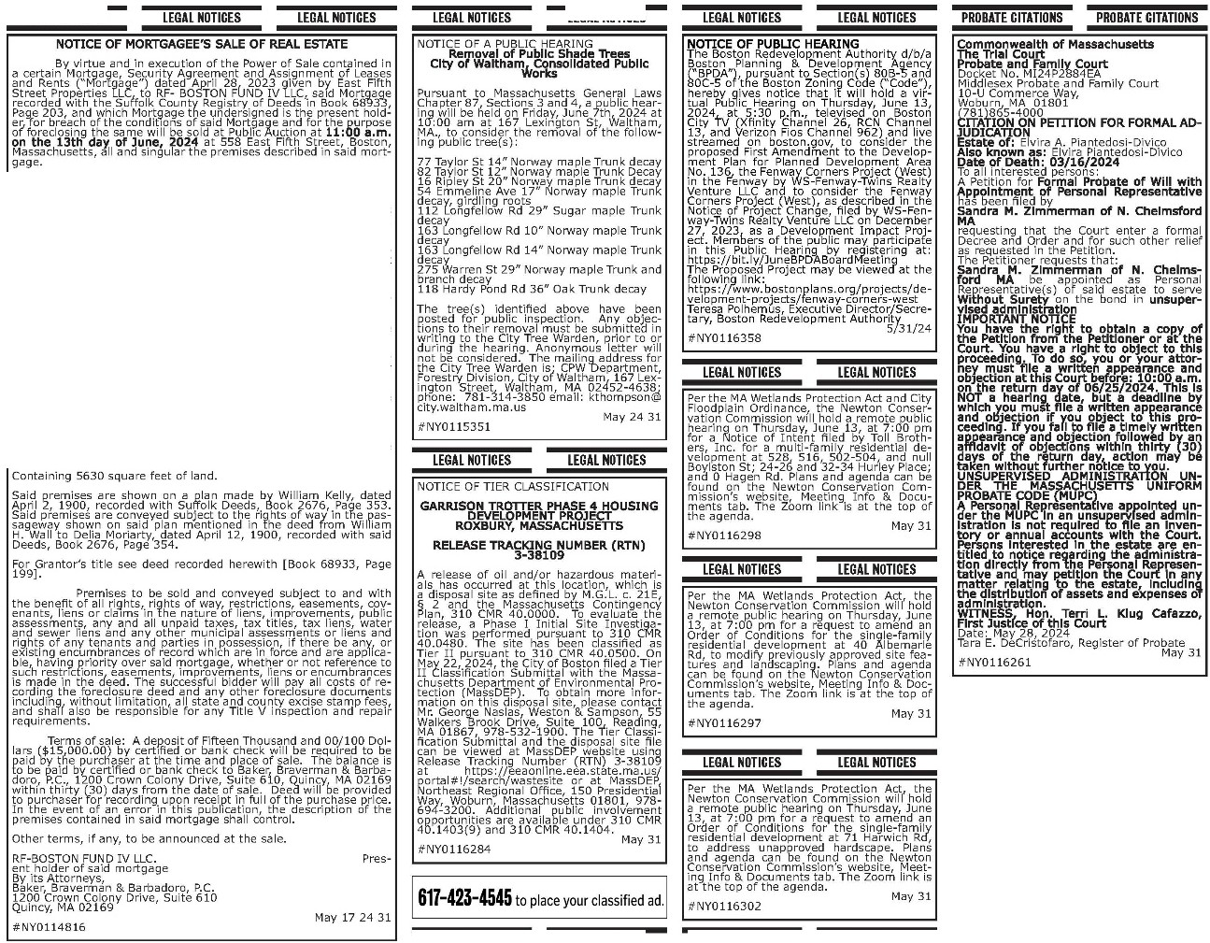

PUBLICIINNOUNCfM£N1CONCIRNING

HIITHOANEHILL 15llRKBRlOEORIVE DANVERS. MA01923

Hatnorn,i SIIF Oper;it)ons lLC 1999 Geda!blldQe """'·

Sule 1A.l.3 .\·oo!I NJ00701 (tll!i·eu,·er''., ha sut,m,t1!d

OT H ltl cm Fm,, Ll::«ISLt and C&rtil!Cation (UIE­ "Der,M1ment") lot a propos&d chinge in o,mtrsliip OI H tharneHil.1510rkllrid! Oriw:.Dan·. rs. LU011l-2:l,:the

·fact1ity") TM E!u,;er. med,ui:ableb-'/ 111!1Departmtrt

lnte-t\CS to PIJ"Cha.Sf th$ Fil!l:ilt Tr\"1111 ttlE-eurMI ("\WM,' Gei"IE'SisHeal!hC3it, Inc. (1h! ·sea,1"). Then 1111 00 chang inlhe bedc:i a-.::tyortll!il.l:lr.'i&espro1'ded b-1the FacO:/. A .-,.itlic Maring may r r.1-!dupon : lion

,anyg1oop01Mnadt.iis.S hpelltion lncl!Ol1hP nm111. m- s lntl $igtia11i"e OI each idu• :ard

one member u 111!1 re resert;in•. OItM groI"'. Wnt1en

cammenl1:conc.emD;JIMB11;ersab1'it,·topro,,ide a•1t1 loo9-t 1m cm 5eni:es 1nd pet 1ans k>Ia ptt,lc 11eirll9 m1y t1::ldl ed IO Ille (leparl1rwmt <:11 Put>lit Heath

Di'.-is,c,nc.,l lth Iel'1tilil)"LictnwreandCtn.f tion 1"1aemad1tHfU1tenseAcrooltst1temiUSilfSert·,-ilmaiI

t<:1 67 fQri,,I Street. Marlto:uoo;ih. MA 01752 fDr a pericld of14dljslolbl><irqthispL.tl!'c1ti:m.Allwrkle11Droral COITm'!rti submlll-!d to lht D!pirtm..,111ma-1 ti.! pooled ontll!IDe artmerhweos-ear.dreleaseaInrtsponselO 1r 1<1lfo1publcrecord!!

an tpplic1h0n to,*t e* CM rlnMnl 0! lie1 h. Division

day,actonmayb-etakeowillloutfurlherooOCeto

Y'}J, UNSUPERVsIm ADMtllSlRATIONUi':OER THEMASSACHUSETTISFORMPROBATE COOE

{MUPC) A PersonaRl ep(esenlahe apporntedund€r lheMUPCin anllflSL41el'VISedad1nlnstrallOnIS!IOI rec,..iredtofiean ffientory orannual accounts wilh lhl Ccurt. Persons interested in theestate *Me* e ed tonotce regarctngtheacmrHStralioncwectytrom thePersooa!Reµresentativeandmaypettlonthe CourlInanyrnatterre\a1rigl01heest.:ie.IAdudnglhe clslrfbutk:molassetsandexpenseso1adntn1Slralk>n. wtTt.l:SS,Hori.TerriL KltJJCafuzzo. hsl Jasbr,eof lhiSCo:irt Date:May 28,2024.Ta.-aE.DeCnsto!'aro.

RegsterofProbate May 31, 2024 #NY0116188

Ccmmoowealltlol

Mass oosensTheTnal Gwl A'obateand Farnuy C-lul Docket t.J.Ml24P2667EA'11id(l'esei,:Rwate andFa:rfy Ccut 10-u comn-.:rce*Wl'f.*wot:un,MA 01601(781)865-4000crrATON 00 PElnlONfOR

FORMAL ADJJDICATl!l"J

Estaleo1:BetlillaBeglllDateofDeath: J:ne 11, 2-013Toal ilterestedpersoos: APetllon for Late

andlh1 ledFormalTc.mcy and,'or Appontmfrthas

been fledbyH.KeithBegun of Shine'(, MArequesting hit lheCou"tentera foonalDecree:.tlldOn:ler:.tnd forSOChot11erret;efasreq.,ested1nthePet1on.The Petlkmerrecµests ll'oc H KeithBeyuno1Shttley, MA beappeintedasPersonal RefteS€1taliW!(S}Of saklestae10serveWITOOISJL! rely onlilebondIn LhsupervisedMmslratioll

IWORTANTOOTICE Yoohavetheright toOOttin a copyo1thePetWontom!hePefrlooer or al the Co.rt Youhavearight to(qecl lo thisproceeliflll Todoso, youoryourancrrey!IHISI!ileawrlMn

al)pearanceMdobjectonat thisCo'Jrtbeb"e: 10:00 a.m.oolhereundayof June25,2024.ThiSis NOT ahea-Jlg date,bUIa dea{lheby'A'hcilyoumus! ll'eawr1trenappear.n::eaOOob}ecllO!lfyouobjeet tolhisp-oceed.ng. ttyoulaNtofi1eatimelywr't:IEn appearar.ce andobjectionfolCM'edbyanaffldat.11

cf obje{;toos w:ttillhrty (30) days ofltlereturn

To wit:

Property Address: 558 East Flfth Street, Boston, MA 02127

A cert-:,in p;nccl of land with the buildings thereon numhercd 558 East F11'1:h Street, 1n that P!'rt of said Boston called South Boston, bounded and described as rollows·

JE ?!i{ig : er :h! J :tt ,J ! l{!i l t t1 1 thence running

Easterly on said El!st Fifth Stn-,et, forty (40) feet to land now or formerly of Richmond; thence runmng

Northerly by s.;,id l;,nd of Rir.:hmond, one hundred twenty-five

(125) feet; thence running

###### ef re rty*of* &'a odrd ;J;!g (Cli, t irinhd::1o:."gr1onr w

or Murphy; thence running

Southerly by said land of Murphy, thirty (30) *feet;* thence running

Easterty Twenty-one (21) feet; thence

r J : 1rco sa18Ye: f *FRR*O5t T: p f i1"'nT07· Ql nrAg ty-five

PROBATE **CITAT NS PROBATE** CITATIONS

**Photos Rock!**

## Run an ad in the Herald's Classified Marketplace and we'll include a

photo for free.

**Call 617-423-4545.**

LEGALNOTICES LEGAL NOTICES LEGALNOTICES LEGAL NOTICES

f'Nbllc Anoouneement concerninga Proposeo Htallhcan Pro1ec1

Atrius Heajtti Inc. (Appbcant'"), M H?C Certified ACO. with aprincipal place of businessat27SGrove St., Stoa 2-3{)0 Auburndale, MA 02466 intends to file aNotice of Deterrmna0on of Need ("Do,f') v.ith the lo!assach'.Jsetts Departrn.mt ol Pub:ic Health for .1 lreest!lnding anbulatory surgery cenier to be lcensed to Alrius Hea!th Ambulatoiy Surglc.31

Center.LLC.atobeformeda!IUIateoltheApplic.i!nt

forthl<lpro!ectand located at 153 Second Avenue Walthocn, M$$SflthuS-e11$ 02451 i 'Proposed Project") TheTotalVal.leor thePr .sedPr ect IS

S20,7n.721. TheApl)licantdoe.snotanticipateoo ad,;ersepriceorserviceimpactson theAppl:canl's rnslin; paljcnl panel as a result 01 this Proposed

Project An/ t.:m Ta:,:payers o1 Massachusetts maJ regislerinc:ooneciionl',ilhtheintandedApplication by no later than Ju / 17. 2024 or 30 da-1s from the Filing Date, v.'h:che.-er ls later, b-y contactJng the Department of Pub:ic Health Detennination of N98d Program, at dph.d0Mtsta1e.ma.us or 67Fores1Street. Marl:lorough. MA01752



CROSSWORDSOLUTION

R E **A** D

SUOOKU SOLUTION

--

SW

L 0 WD 0 V EI WAG

-

NC0 A

S E

H A WK R K E y

----

--

* A R I

EMA N D

---

MA

N■

JUMBLE

SOLUTION

INPUT MONTH GOALIE CANVAS

The meteorite that created the huge crater cast of Flagstaff. Arizona made a LASTING IMPACT

-R -A

-DO-S-

C L 0 N

G L E

E A

E I

DI

T E

U R E

I N

A N I

L H

I

E I

CU

N

I

ROB

D T

RR

p A

S I

I Q

E D

E X

E S

S C

p I

* A

C E

■T

U F

E N

N T

R A

RT I

C K

D U

T I 0

RA

N■

E E

S H

•D

E T

0 p

N E

s-

G E

L 0

Y■

L 0

A L

T U

P■

I

C L

E

L

-E

E S

o-

E T

E A

* T

L

Ml

A L

T E A

EI

I

ANG

**01**

H 0

**WA**

**A** D S

**SI**

SI

**A** L

0 p

**Bow... WOWI**

Run your pet listing in the

Boston Herald for two weeks for as low as $42.

**For information,**

**call 617-423-4545.**

PHANTOM: By Lee Falk

**Don't store your boat or motorcycle**

..**.SELL IT!**

**Very Affordable. Very Effective.**

**lw:wwt.bostEonhernald.colm**

**Call Boston Herald Classifieds at 617.423.4545**

•Rules and restrictions may apply

|  |  |  |  |
| --- | --- | --- | --- |
| 92 | 56 | 37 | 841 |
| 1 8 | 42 | 59 | 637 |
| 36 | 78 | 1 4 | 952 |
| 73 | 21 | 68 | 495 |
| 4 1 | 89 | 75 | 263 |
| 59 | 63 | 42 | 1 7 8 |
| 27 | 94 | 83 | 5 1 6 |
| 64 | 35 | 21 | 789 |
| 85 | 1 7 | 96 | 324 |

In the m;iitter of: Anita Fedora M.tcKay Also knowna$: Anita F. MacKay, Anita

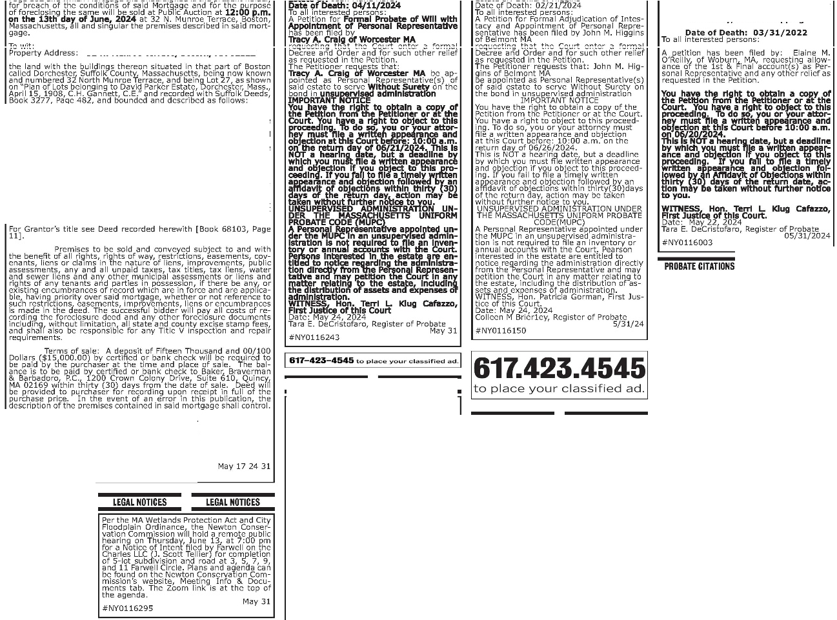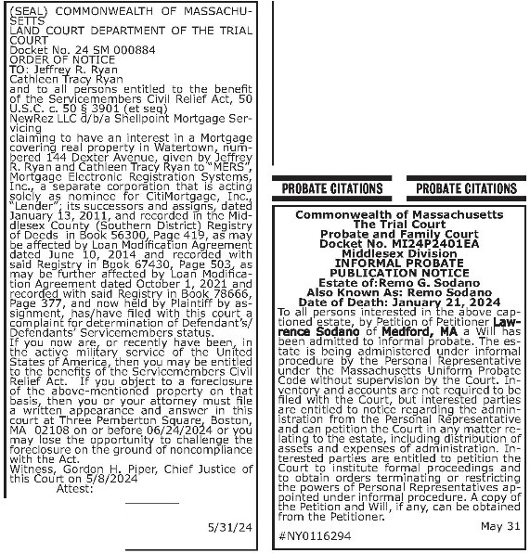

*1a;:Sr:=' =. ::*

Conmorrwcailhof Massar:tusettsTheTtial Coot-Probatear.:jFaml)i court "'1M.esexDivls!ODll ocl«t No.Ml23P6335EA

l ORMAl.ffl.OBATE PUBUCATIOO t.OTIGE

Estateof:MCha-elC.LiddellAlsokOOWn as:Miehael CroninLio:Je'IOate,o1Death: t--ki\'ember 6.2023 To al pc:rsonsUl!CC'C i'l thealXlYc C'4)1ioncd estate, by Petitionof PetitiorierPal.IJ.LKldelof P.ockport MA PiUJ.Lk!OClofRockport, MAhasbecnirifcrrra'ly

appoi"tfdasthef>erso:iaRepresertativeofthe estate toserve v.ithoU:sur<.-tyontic oond. Thecstalcis bei1g fflin.stertid urtderl'ltormi procellletrythe PeraonalRe;resentalr.'elXlderlheMassachusetts UMormPretiateCooe witoot si.wvisOntry1he Cost I11'.'erby and accounts.il'e oolr re-dto

be fi:ed withtheCoot tu: internstedpartes are entilr!dtonoi:. rcgarchglhC ad!m!StrritonfromlhC Persooal Rep(esenlatveaOOcanpetfontheCourtin

partcsarecnUdcd&orx:ttlontt"lcColltlOhstibJL:: formal cilgsa:ldtoObtil.norders terrriniJlirY,; er rcsMcttmpowers *cl*Personal Rcprcscnt:1tvcs aw:iirtedunderinformalprocedure. Acopycth:

PctitlOnal'\dWil, I!any,c:.,beObllloOO fromthe

Petitbler. 05/31i2024 #NY0116323

**We Can Help!**

Looking fortenants?Fillinga job?Sellinga home? TheBostonHerald Classified

**Giveus a call at617-423-4545. [IR**

•-.bost11t1htrald,com

AdvertisingDepartment canhelp!

T. Mackay, Anita F.Tipping

32N.Munroe Terrace, Boston, HA 02122

NORTHERLY by North Munroe Terrace, forty-two (42) fcct;

EASTERLY by Lot 28 as shown on u1id plan, eignty-1\ve

\ :rut;:S:::;

od W&'85•11>' ,;Tut 18 Md Pllrt oflut 19, ,!loS shown unsaid

f26 llsshown on said plan, eighty-five

Containing 3,575 square feet of land.

i=J ,! :ilkdoff2 '.ses is *32* North Munroe Terrace,

! ccc 1 dt n rn'tJ seo / oe1 itnet f

1: fitr i fii

in force and applicab!e.

**PROBATECITATIONS**

other terms, if any, to be announced at the sale.

RFB F4 NB, LLC Present holder of said mortgage

By Its Attorneys,

8r.c¾ n't thnn 8 1°i1ie lo

Quincy, MA 02169

#NY0114814

**PROUT[CITATIONS PROBATE CITATIONS**

C-O<rmo,w;aalh*d*

Massactusetts The Tnal court PrOOateandFamfy

CourtDocket No,MI24P2636EAMidctesexProllatt!

## 30 :i a :t1o r?JA;;;

FORMALMJLOICAIDN

Est,1tr.ot Oscar • Alsoknownas:OscarPaulNell Date olDeath:09/22/2000Toallnerest11d persons AA:tlton*for* Formal Acljudic onof ktrstacy and A.ppcrinerdo1Personalfiep"11serdalivehasDeenfted byUrsulaK{:QcoifLcx·l'l!J,OnMArequesting!hattl'lc ColJtenteraformalDecretnlD"derandftrsuch otherrelief asre ucSl(;d11lheP<:tton.The Ptttlonc-r reQUeStslh UrsijaKegeof 1Le MAbe

a ntcdasPcrso'lalRq>m (s]ofsaidcstatc IOserv11Wit'oolS '.'etyon the 00:td Jl Unsu rvised Acmnst'3tk;m

f.1PORTNIT NOTU YoJhave the ritp:IOotta.n

acw,ofthePe1iOOnfromthePi::tttoocroratthe Court ¼luhavea l'i(tttaobjfcttothiosceedirig Todoso,youor yw attorneymust filea written

;nj objer:!Olatttis Courtbefore: 10.00 a.m.oothercturndayo17/15/24. Ttisis NOTa

heanfl1Jdate,butade.Jd'11ebywtithycurrosti a..n. ncnap;)C:lrnc a.i Objedlon r,youoo ct tathis proceeding. YO!JfaJta1ilealille:ywritten ar.nrearidobjectonfol'owcd try a, attdavU

al objectOllS wilnnthrt','(30) d.ayso1theretlr'n day,llCtlor1*may*be ta cn v.ithoutlt.rthcrnoti t◊ J,'OU. UNSUPER\IISED ADMINISTRATIONUNDER TiiEMASSACHUSETTS UNIFOOMPROBATE COOE

(Ml.Fe) A Pe I Reprr.sent,;1tr.'eapp;i'ntedu!Kier the MUPC Jlan oos1_.:,ervise<:1administraboni not reQ.Jiredtofiieaninventoryoram.1<1I<:ICCOU'llsw'th theGoll"!.Persoos rteresttid Jllheestate.-reentiti,d b nolice regarding ti"'3actri'nistrationci tlyfrom tt,ePersonal Represerrtativea.lidmay petiljonthe Costll any malla" itil'IQ totheestate,iocWrtgthe distnbl.lOOno1assets al1d e:i:penseso1admnlstrctioo.

MTNESS,Hoo.TerriL Kl,JCatmo, FirstJ.Jsticeof hs r.oist.Date:May20, 2024. T.raE.DeCristal.ro, Regisrerof Prooate

5/31/24

#NY0116076

L D COURT **NOT E LAND**COURT **NOTICE**

(3 r). Patterson

#NY0115552

**NOTICE OF MORTGAGEE'S SALE OF REAL ESTATE**

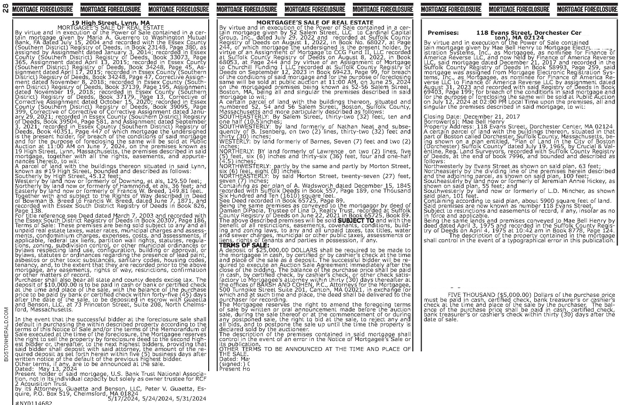

**ter (Bos•**

in" cer·

nit Re •

recorded it°rh:i ?it t o t s i 1!/ ttb e r/ 3Bott7 l7t

Page 124

TERM.S OF SALE: Si,id premises will be sold and convev.ed

f ; j ; s ¼ ?W

said mortgage al>ove described.

g-fct1ir:etre xd i tJ\ eurnl

LLC

### **E L L** Runyou, me,chandise foe salead In!hell<l&OnHe,ald.

**s**

tb

Other terms to be announced at the sale.

Srock & Scotl, PLLC dMfi ger Street

Plainville, MA 02762

Attornev. for Finance of America Reverse LLC

f b1)"lr1 :ot

LheMortgage

8ii1i*�[�0*r;11r-i5 3sio

IJ'NY0116398

- "fr I r:%t r I·o l A

M,iy 31. Jun1a 7 &. 14, 2024

*NY0116192

Miiy 31, June 7, lune 14, 2024

I **617-423-4545** LuµI.ct<..:.,. yuur d.ct,,_,,.;r;.,.u .ctt..J.

**YOUR**

**STUFF!**

### Call the Boston Herald Classifieds at 617.423.4545

*Rules andrestrictions apply. Call for details.

LANDCOURT NOTICE LANO COURT NOTICE

DeOOran J_ Pafters:on

Recorder

05/31/2024

#'NY0115550

##### EDUCATION



**10**

**O/o**

**OFF**

**MCAS opponents onaroll**

**By Grace Zokovitch**

[*gzokovitch@bostonherald.com*](mailto:gzokovitch@bostonherald.com)

appear on the Nov. 5 gen­ Middle School, said in the eral election ballot. MTA release. Greco cited The ballot question, many signatories' "emo­

Advocates have gath­ backed by the MTA along tional" reaction to their ered 25,000 signatures, with other education ad­ memories of the MCAS twice the number needed, vocates, would get rid of and student's stress over to advance a ballot ques­ the requirement for stu­ the test.

tion overturning the dents to pass the MCAS "I knew there were many

MCAS graduation re­ standardized test in or­ parents who, like me, be­ quirement to the Novem­ der to graduate. Student lieved that the MCAS grad­

ber ballot, the Massachu­ would instead be judged uation requirement is not setts Teachers Association on school performance a valid measure of our stu­

announced.

and the completion of dents and presents an un­

The MCAS ballot ques­ coursework. fair hurdle to hardworking

**YOUR FIRST VISIT** I I

tion proponents were The MCAS test would students, like my son, who tasked with collecting still be administered as do not perform well on 12,429 new signatures a "diagnostic tool," advo­ standardized tests," said from registered voters cates have emphasized, Shelley Scruggs, a Lexing­

and submit them to local but would no longer bar ton founding organizer of

, -·-••---.-,•--- • I election officials by June students from graduating initiative.

**Must be presented at the time of purchase. Certain /imitations may apply.** •

18 after the question was high school.

Advocates also far sur­

L **1 MYSTIC AVE, MEDFORD, MA** I **ORDER NOW**  .

_

**62**

__

_

**l!Jt.** I

passed over for legislative approval in early May. If

"People couldn't sign passed the initial num­ the petition fast enough," ber of signatures needed

_ .Jthe signatures are autho­ Susan Greco, an instruc­ to advance the ballot ini­

rized, the question will tional assistant at Doherty tiative last November

**PIEAl:CCIIUIEIERIBI.Y.1\IIPRIDJCTMAYCAUBEMlAIID'TAMIIMYIIIWIITFOIU.TIIIIEMAYIIEHEAIJHRIBKBAIIIIEIATEDWllllcatD111111NIJllll8**

PllllllT.TIISPIIIUlTHASMJIBaNIIW.mDIII-DYTliERIIIIINDIRll!IIMIMSIRAlllll(l!M)TllllEISlflnBlNIIIMATllllllllliESIIEEll!llTSOfUSNl **1\IIPRIDJCT,IIM11\IIIEMAYIIAIIDlmllUlllllllB.MNUMNAIHIJ.aGPRBJWINAMIIIIAST-fEEllrllMAYPIIIEPCJJDffiAI.IWIII.ITl8MVINff11lElAW IDIIIVE[IICIJERAlEMONIY'MlENINIR11lENUEMICFllll8PIDIJDT.IIIPTIIS""8JC'TIIIIINRlllltHUIB.lllBIEMAYIIHEAIJHIIIBA88001ATED WIIHCINUIITIIIIIJTIIIIIDIIIT.IIAIIIJIWM,CMIMlAIICIIIIBflRATIIJl.lXDIIINMIIN,AMI.mlMENT. 11lEIDIIIJll"EflECIBIJEllflfSMMIIEIBAYBIRV**



**PUBLIC ANNOUNCEMENT CONCERNING HATHORNE HILL**

**15 KIRKBRIDE DRIVE DANVERS, MA 01923**

**PUBLIC ANNOUNCEMENT CONCERNING**

A PROPOSE□HEALTH CARE PROJECT

Atrius Health, Inc. ("Applicant"), an HPC Certified AGO, with a principal place of business at 275 Grove St., Suite 2-300, Auburndale, MA 02466, intends to file a Notice of Determination of Need ("DoN") with the Massachusetts Department of Public Health for a freestanding ambulatory surgery center to be licensed to Atrius Health Ambulatory Surgical Center, LLC, a to be formed affiliate of the Applicant for this project and located at 153 Second Avenue, Waltham, Massachusetts 02451 (the "Proposed Project"). The Total Value of the Proposed Project is $20,777,721. The Applicant does not anticipate any adverse price or service impacts on the Applicant's existing patient panel as a result of this Proposed Project. Any ten Taxpayers of Massachusetts may register in connection with the intended Application by no later than July 17, 2024 or 30 days from the Rling Date, whichever is later, by contacting the Department of Public Health Determination of Need Program, at [dph.don@state.ma.us](mailto:dph.don@state.ma.us) or 67 Forest Street, Marlborough, MA01752

**TWIIIDll81RtiDIE.llllAIIIJAIIIIINTAI.NlE8Jffl,lfflWlTIUIIWIDrnll.HIJlllll-D-222-ImlR9-l-l llll8181UlTPiUYIEll.1flW.IIITBIIIJMA.**

with 135,000 signatures,

the highest of any ballot question put forward this election cycle. Proponents have expressed confidence in the "robust support" for the initiative throughout the process.

Opponents have cri­ tiqued the lack of an alter­ native proposal to replace the test as a uniform stan­ dard for schools to assess students' proficiency and argued nixing the gradu­ ation requirement would lower the quality of the state's education system.

"Massachusetts is one of the few states left using a standardized test as a graduation requirement," MTA President Max Page argued in the release. "Keeping our high stan­ dards and eliminating the high stakes attached to one test will be a tre­ mendous benefit to every student as our schools will be able to focus on all of the creative ways our ed­ ucators can use to teach students."

The ballot question is one of ten seeking sig­ natures to advance to the November ballot, in­ cluding measures raising the minimum wage for tipped workers, decrimi­ nalizing some psychedelic substances and allowing Lyft and Uber drivers to unionize.

# Affidavit of Truthfulness

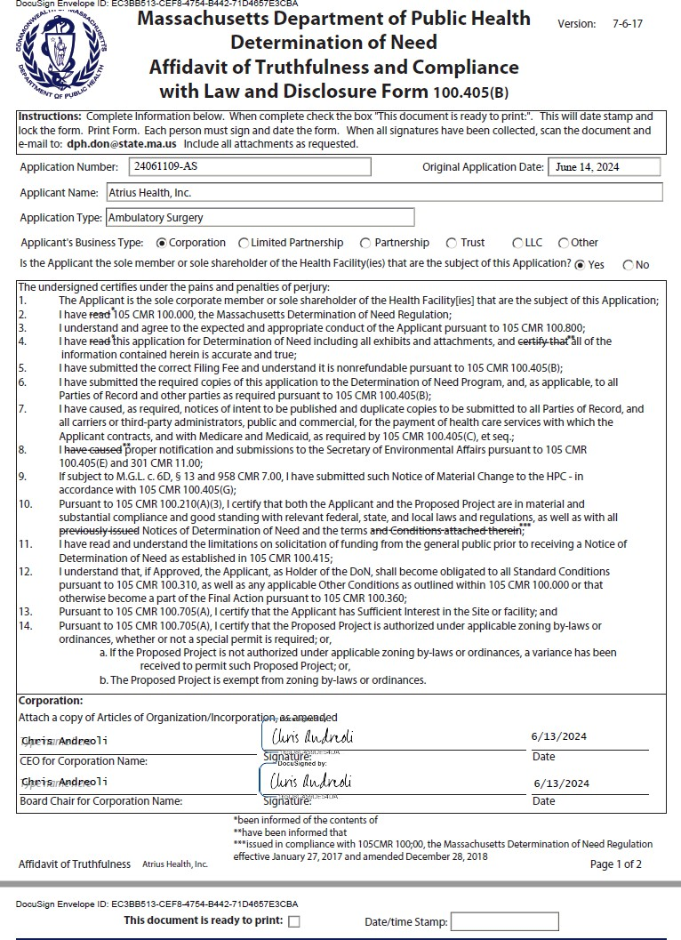

1. **Application Fee**

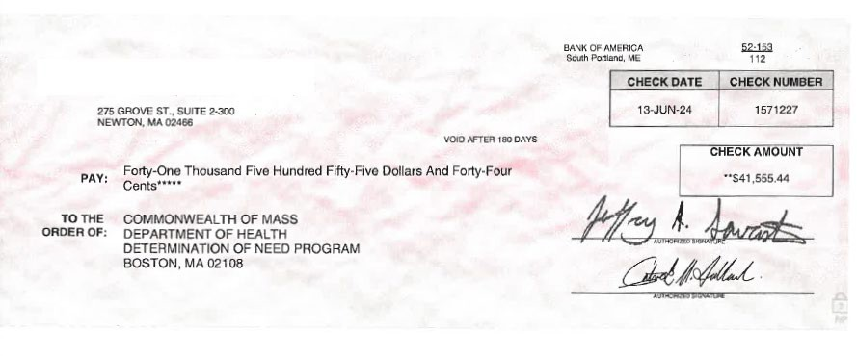

4139\0002\2108699.v1