## APPENDIX 4 NOTICE OF INTENT

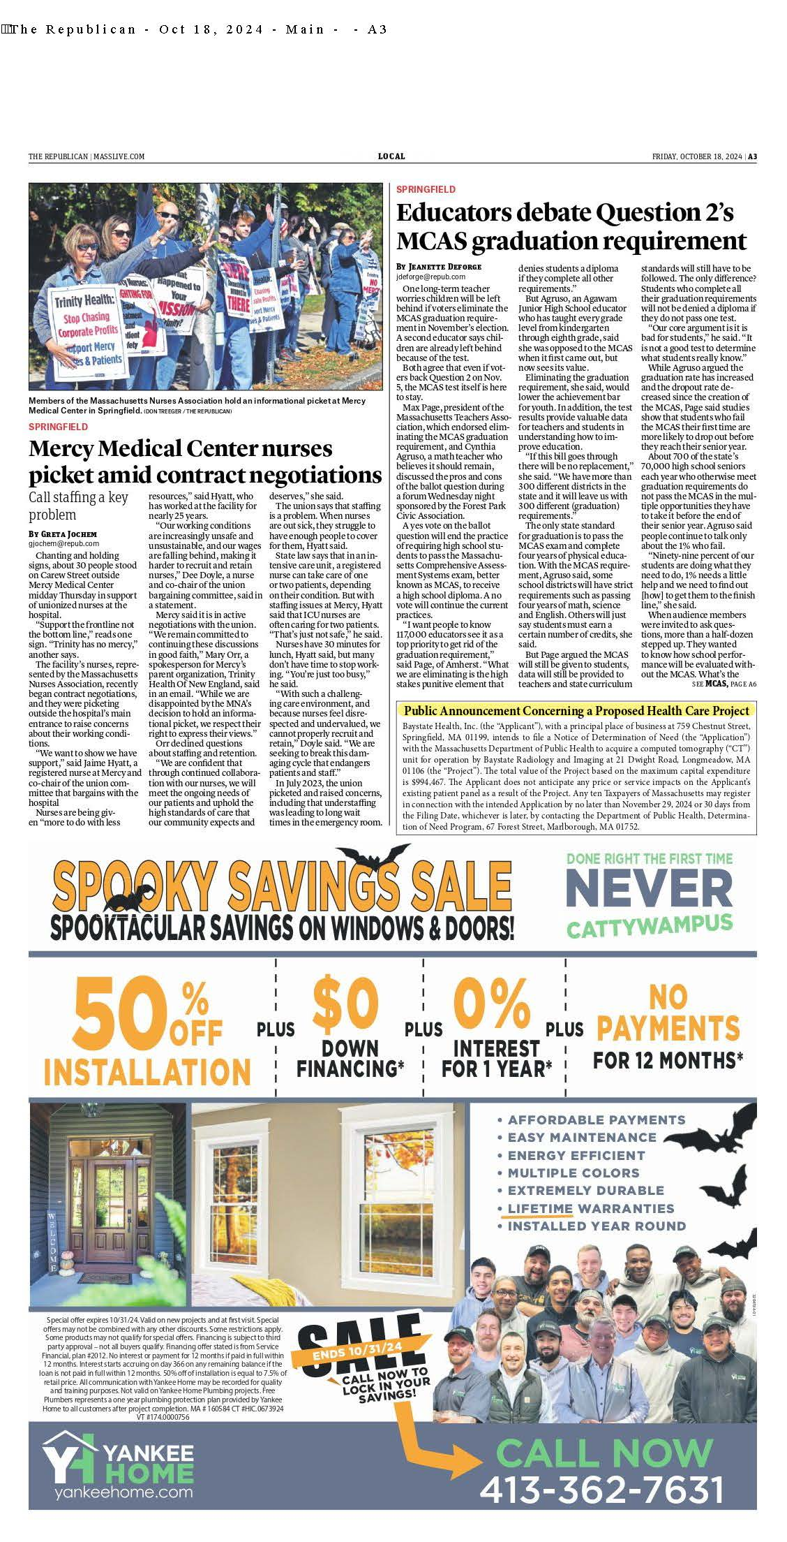



## APPENDIX 7 ARTICLES OF INCORPORATION

[**https://corp.sec.state.ma.us/CorpWeb/CorpSearch/CorpSearchRedirector.aspx?Action**](https://corp.sec.state.ma.us/CorpWeb/CorpSearch/CorpSearchRedirector.aspx?Action=PDF&Path=CORP_DRIVE1/2003/1224/000071371/0001/200358622110_1.pdf)

#### [=PDF&Path=](https://corp.sec.state.ma.us/CorpWeb/CorpSearch/CorpSearchRedirector.aspx?Action=PDF&Path=CORP_DRIVE1/2003/1224/000071371/0001/200358622110_1.pdf) [CORP_DRIVE1/2003/1224/000071371/0001/200358622110_1.pdf](https://corp.sec.state.ma.us/CorpWeb/CorpSearch/CorpSearchRedirector.aspx?Action=PDF&Path=CORP_DRIVE1/2003/1224/000071371/0001/200358622110_1.pdf)

[**https://corp.sec.state.ma.us/CorpWeb/CorpSearch/CorpSearchRedirector.aspx?Action**](https://corp.sec.state.ma.us/CorpWeb/CorpSearch/CorpSearchRedirector.aspx?Action=PDF&Path=CORP_DRIVE1/2005/0725/000143793/0001/200520540770_1.pdf)

[**=PDF&Path=**](https://corp.sec.state.ma.us/CorpWeb/CorpSearch/CorpSearchRedirector.aspx?Action=PDF&Path=CORP_DRIVE1/2005/0725/000143793/0001/200520540770_1.pdf)[**CORP_DRIVE1/2005/0725/000143793/0001/200520540770_1.pdf**](https://corp.sec.state.ma.us/CorpWeb/CorpSearch/CorpSearchRedirector.aspx?Action=PDF&Path=CORP_DRIVE1/2005/0725/000143793/0001/200520540770_1.pdf)

## APPENDIX 8 ACO LETTER

The Commonwealth of Massachusetts
Health Policy Commission
50 Milk Street, 8th Floor
Boston, MA 02109; 617-979-1400
Deborah Devaux: Chair
David M. Seltz: Executive Director

December 27, 2023 Carlos Martins

Baycare Health Partners, Inc. 101 Wason Avenue, Suite 200

Springfield, MA 01107

RE: ACO LEAP Re-Certification Dear Mr. Martins:

Congratulations! The Health Policy Commission (HPC) is pleased to inform you that Baycare Health Partners, Inc. meets the requirements for ACO Certification under our Learning, Equity, and Patient-Centeredness (LEAP) standards. This certification is effective from January 1, 2024, through December 31, 2025.

The ACO Certification program, in alignment with other state agencies including MassHealth, is designed to accelerate care delivery transformation in Massachusetts and promote a high quality, efficient health system. ACOs participating in the program have met a set of objective criteria focused on core ACO capabilities demonstrating dedication to patient-centered care, use of evidence-based and data-driven strategies to improve care delivery, and commitment to addressing long-standing health inequities. Baycare Health Partners, Inc. meets those criteria.

The HPC will promote Baycare Health Partners, Inc. as a Certified ACO on our website and in our marketing and public materials. Enclosed you will find an ACO Certification logo for your organization to use in accordance with the attached Terms of Use. We hope you will use the logo on promotional materials when you highlight your ACO Certification to your patients, payers, and others.

The HPC looks forward to your continued engagement in the ACO Certification program over the next two years.

Thank you for your dedication to providing accountable, coordinated health care to your patients, and to continued learning and improvement over time. If you have any questions about this letter or the ACO Certification program, please do not hesitate to contact Mike Stanek, Associate Director, at [HPC-Certification@mass.gov](mailto:HPC-Certification@mass.gov) or (617) 757-1649.

Best wishes,



David Seltz Executive Director

## APPENDIX 9 AFFIDAVIT

 Version: 7-6-17

**Massachusetts Department of Public Health**

**Determination of Need**

**Affidavit of Truthfulness and Compliance**

**with Law and Disclosure Form 100.405 (B)**

**Instructions**: Complete Information below. When complete check the box "This document is ready to print:". This will date stamp and lock the form. Print Form. Each person must sign and date the form. When all signatures have been collected, scan the document and e-mail to: [dph.don@state.ma.us](mailto:dph.don@state.ma.us) Include all attachments as requested.

Application Number: BH-231102416-RE

Original Application Date: 12/18/2024

Applicant Name: Baystate Health, Inc.

Application Type: DoN-Required Equipment

Applicant's Business Type: Corporation

Is the Applicant the sole member or sole shareholder of the Health Facility(ies) that are the subject of this Application? Yes

The undersigned certifies under the pains and penalties of perjury:

1. The Applicant is the sole corporate member or sole shareholder of the Health Facility(ies) that are the subject of this Application;
2. I have ~~read~~ [been informed of the contents of] 105 CMR 100.000, the Massachusetts Determination of Need Regulation;
3. I understand and agree to the expected and appropriate conduct of the Applicant pursuant to 105 CMR 100.800;
4. I have ~~read~~ [been informed of the contents of] this application for Determination of Need including all exhibits and attachments, and ~~certify that~~ [have been informed that] all of the information contained herein is accurate and true;
5. I have submitted the correct Filing Fee and understand it is nonrefundable pursuant to 105 CMR 100.405(B);
6. I have submitted the required copies of this application to the Determination of Need Program, and, as applicable, to all Parties of Record and other parties as required pursuant to 105 CMR 100.405(B);
7. I have caused, as required, notices of intent to be published and duplicate copies to be submitted to all Parties of Record, and all carriers or third-party administrators, public and commercial, for the payment of health care services with which the Applicant contracts, and with Medicare and Medicaid, as required by 105 CMR 100.40S(C), et seq.;
8. I ~~have caused~~ [have been informed that] proper notification and submissions to the Secretary of Environmental Affairs pursuant to 105 CMR 100.405(E) and 301 CMR 11.00;
9. If subject to M.G.L c. 6D, § 13 and 958 CMR 7 .00, I have submitted such Notice of Material Change to the HPC – in accordance with 105 CMR 100.40S(G);
10. Pursuant to 105 CMR 100.210(A)(3), I certify that both the Applicant and the Proposed Project are in material and substantial compliance and good standing with relevant federal, state, and local laws and regulations, as well as with all ~~previously issued~~ Notices of Determination of Need and the terms ~~and Conditions attached therein;~~ [issued in compliance with 105 CMR 100.00, the Massachusetts Determination of Need Regulation effective January 27, 2017 and amended December 28, 2018]
11. I have read and understand the limitations on solicitation of funding from the general public prior to receiving a Notice of Determination of Need as established in 105 CMR 100.415;
12. I understand that, if Approved, the Applicant, as Holder of the DoN, shall become obligated to all Standard Conditions pursuant to 105 CMR 100310, as well as any applicable Other Conditions as outlined within 105 CMR 100.000 or that otherwise become a part of the final Action pursuant to 105 CMR 100.360;
13. Pursuant to 105 CMR 100.705(A), I certify that the Applicant has Sufficient Interest in the Site or facility; and
14. Pursuant to 105 CMR 100.70S(A), I certify that the Proposed Project is authorized under applicable zoning by-laws or ordinances, whether or not a special permit is required; or,
    1. If the Proposed Project is not authorized under applicable zoning by-laws or ordinances, a variance has been received to permit such Proposed Project; or,
    2. The Proposed Project is exempt from zoning by-laws or ordinances.

|  |
| --- |
| **Corporation**  All parties must sign. Add additional names as needed.  Peter D. Banko <Signature on File> 12/9/2024  CEO for Corporation Name: Signature: Date:  Harriet DeVerry <Signature on File> 12.9.2024  Board Chair for Corporation Name: Signature: Date: |

**This document is ready to print:** [unchecked] **Date/time Stamp:** [blank]

## APPENDIX 10 FILING FEE

**BAYSTATE RADIOLOGY AND IMAGING, L.L.C.**

•

**Department 7991**

**PO Box 4110**

**Woburn, MA 01888-4110**

**(413) 495-1100**

10/17/2024

Dennis Renaud, Director Determination of Need Program Department of Public Health

67 Forest St.

Marlborough, MA 01752

Dear Dennis Renaud,

I am writing to submit a check pursuant to the Determination of Need application filed by Baystate Health, Inc. under Application #BH-23102416-RE. Enclosed, please find the check for $1,988.93 as required for the application process.

We appreciate the opportunity to participate in this important initiative and look forward to the review and consideration of our application. If there are any further requirements or additional information needed, please do not hesitate to reach out.

Thank you for your attention to this matter.

Sincerely,

[signature on file]

Kai Dulaimy, M.D.

BRI Board Member

Baystate Radiology & Imaging LLC

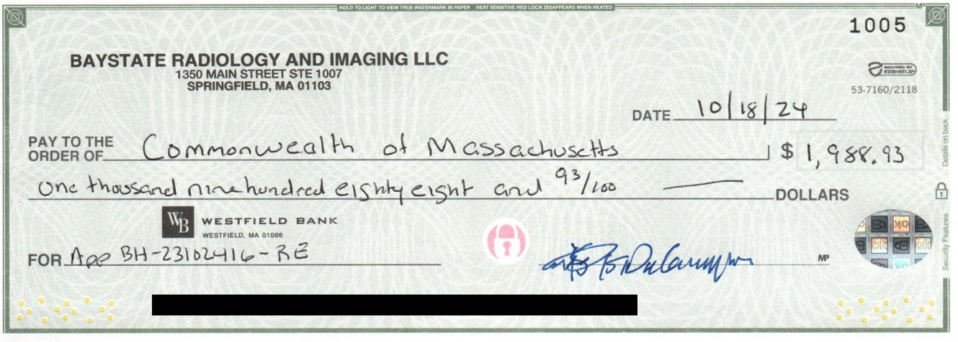

## APPENDIX 11 CHI NARRATIVE

##### Factor 6.1: Community Health Initiative Narrative

A. Community Health Initiative Monies

###### Based on the Proposed Project’s MCE of $994,467, the corresponding Community Health Initiative (“CHI”) is $49,723.35. The following breakdown of CHI monies illustrates the total dollars to be allocated.

|  | **Total** | **Description** |
| --- | --- | --- |
| **MCE** | $994,467.00 |  |
| **CHI Monies** | $49,723.35 | (5% of Maximum Capital Expenditure) |
| **Administrative Fee** | $1,988.93 | (4% of the CHI Monies, retained by Baystate) |
| **Remaining Monies** | $47,734.42 | (CHI Monies minus the Administrative fee) |
| **Statewide Initiative** | $4,773.44 | (10% of remaining monies, paid to State-wide fund) |
| **Local Initiative** | $42,960.98 | (90% of remaining monies) |
| **Evaluation Monies** | $4,296.09 | (10% of Local Initiative Monies, retained by Baystate) |
| **CHI Monies for Local Disbursement** | $38,664.89 |  |

1. Request to Pool Funding with Another Project for the Hospital

###### In 2022, Baystate Health received approval for Baystate Medical Center (“BMC”) to carry out the CHI on behalf of Baystate New England Orthopedic Surgeons Alliance, LLC (“BNEOS”) for DoN # BNEOS- 21122916-AS. Accordingly, BMC kicked off that CHI in 2023. In June 2024, BMC awarded $500,000 in Better Together grant awards targeting youth mental health prevention. Five local non-profit organizations benefitted from $100,000 awards aimed at addressing youth mental health in their respective target populations. Those organizations were: Latino Counseling Center, Martin Luther King Jr. Family Services, Springfield Pride Parade Organization, Community Legal Aid and Follow My Steps Foundation. These projects will continue for 1-2 years. To date, each organization has received an initial installment of $25,000 to begin their work. Investments were decided in partnership with the BMC Community Benefits Advisory Council (CBAC). Given the size of the present CHI, Baystate Health is requesting approval for the CHI to be rolled into BMC’s ongoing CHI to maximize the impact the combined funding.

1. Timeline for CHI Activities

###### BMC will convene its CBAC following approval of this Application to determine the most appropriate distribution of the CHI funding. It expects to have a distribution plan within three months of DoN approval and will meet with DPH staff for review and approval.

1. Administrative and Evaluation Funds

Baystate is requesting $1,988.93 (4% of the CHI) to be used towards administrative costs. These monies will assist with staff salaries and may also be used towards the cost of reporting and

distributing promising practices and lessons learned, facilitation support for the CBAC and Allocation Committee, the development of communication materials and placement of procurement information in community newspapers. Additionally, Baystate is seeking to use 10% of local CHI funding, $4,296.09, for evaluation efforts. These monies may be used to engage a third- party evaluator to carry out technical assistance and ensure appropriate evaluation of the CHI- funded projects.