BAYSTATE HEALTH, INC. APPLICATION FOR DON REQUIRED EQUIPMENT
APPLICATION # -20121611-

TABLE OF CONTENTS

Appendix 1 Application Form Appendix 2 Narrative
Appendix 3 Factor 1 Community Engagement Presentations Appendix 4 Factor 4 CPA Report
Appendix 5 Factor 6 Supplemental Documents

  - CHI Narrative
  - Community Health Needs Assessment
  - Strategic Implementation Plan

Appendix 6 Affiliated Parties Appendix 7 Change in Service Appendix 8 Notice of Intent Appendix 9 ACO Letter
Appendix 10 Articles of Organization Appendix 11 Affidavit of Truthfulness Appendix 12 Filing Fee

APPENDIX 3

FACTOR 1
COMMUNITY ENGAGEMENT PRESENTATIONS

Baystate Noble - CT DON

Community Benefits Advisory Council October 15, 2021

Baystate Noble Hospital is requesting to install a second CT scanner through the MA DPH DON approval process.

- BNH is seeing a higher acuity of patients and a significant increase in our geriatric population.

- A second CT scanner at BNH will improve patient flow immensely, decreasing patient wait times.
o Being able to quickly diagnose, efficiently treat, and provide quality healthcare is vital to our greater Westfield community.
- BNH has an emphasis in stroke care, geriatric care, and believe that an additional CT scanner will bring us tremendous value as well as improve our patient flow/patient times in the ED

- Increased access to care allows the ability to quickly diagnose to efficiently treat.

BNH CT - DON: Proposed Location
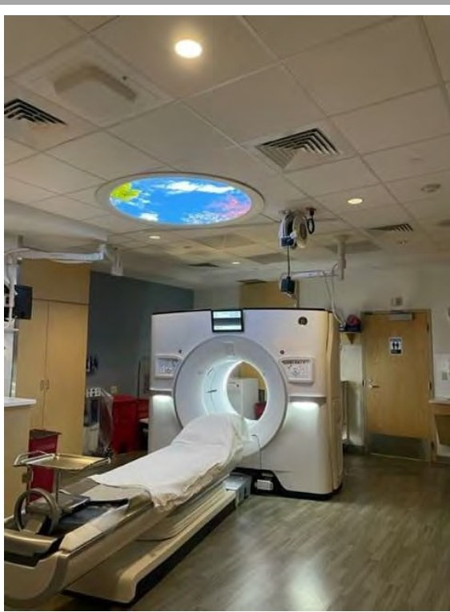The proposed location for the new CT is centralized on the first floor of Baystate Noble Hospital

    - Equidistant from the BNH main entrance and emergency department.

    - Adjacent to the Existing CT, creating a CT Hub.

    - Across the hall from the Radiology Registration Area and Waiting Room.

BNH CT - DON: Proposed Location

BNH CT - DON: Proposed Location

BNH CT - Draft Project Schedule

2021 2022

PROJECT KICKOFF

DoN Documentation &
Approval Design
Engineering Permitting

Construction

CONSTRUCTION START
(DPH Approval)



Go-Live

- DoN Documentation, Review and Approval October 2021- March 2022
- Architectural Design and DPH Permitting January 2022 - May 2022
- Construction July 2022 - October 2022
- CT Fabrication, Installation, and Training July 2022 - November 2022
- Go Live (Target) November 2022

Community Engagement Plan

- -

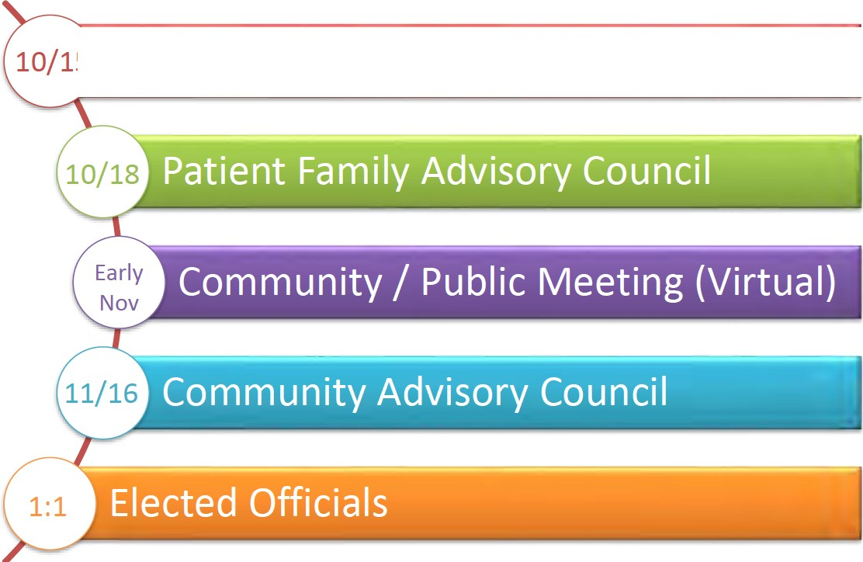
Community Benefits Advisory Council

Determination of Need (DoN)
Community Health Initiatives (CHI) Funding

Project: BNH CT

Approval: MA DPH Public Health Council {Delegated Review) - Month 2022 TBD

Total Cost of Project: $1.2 Million {$850,000 CT+ $350,000 Construction)
- 5% Community Health Initiatives (CHI): $60,000 {Tier 1)
- Administrative: $2,400 {not to exceed 4%)
- 10% to DPH for Statewide CHI Fund: $5,760 {due within 30 days of approval)
- Evaluation: $5,000 for PHWIM {not to exceed 10%) [Optional]
- CHI Community Commitment Total: $46k - $51k

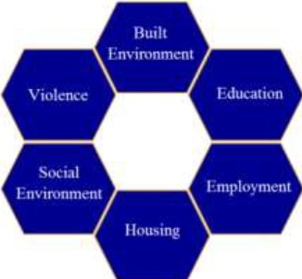
Community Health Initiatives (CHI) Funding

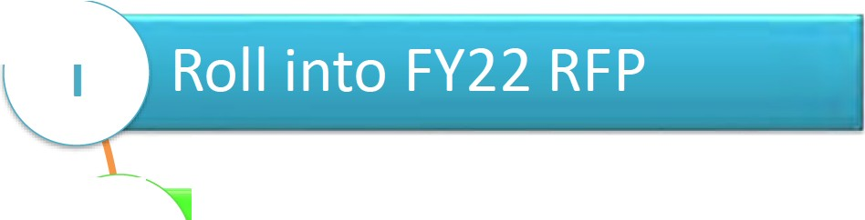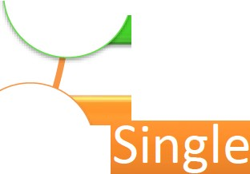l

Investment 2
Pathways

3



Baystate Noble Hospital (BNH)
Community Meeting Tuesday, November 30, 2021

Determination of Need (DoN) Application for a new CT-scan

Virtual Engagement

Add your name/pronouns to your video picture
Mute your microphone
? During Q&A please use the Chat or "Raise Hand" to ask questions
Presentation is being recorded

GOALS
- Overview of Determination of Need (DoN) Program and why the MA Department of Public Health requires a DoN application for this project
- Shared understanding of the need for a new (additional) CT-scan
machine at BNH and how it will improve access to care and patient outcomes
- Overview of DoN application and purchase/installation of CT-scan
timelines
- Overview of DoN Community Health Initiative (CHI) requirement and how BNH plan to invest the required CHI funding related to this project
- BNH fulfillment of community engagement as prescribed by DoN requirements

AGENDA

  - Welcome, Introductions, Overview ANNAMARIE GOLDEN
Director, Community Relations, BH

  - Greetings RON BRYANT
President, BNH
Co-Chair, BNH Community Benefits Advisory Council

  - Need for CT/ Impact on Patient Care SUNDEEP "SUNNY" M. SHUKLA, MD, MBA, FACEP
Chief of Emergency Medicine, BNH

  - DoN Application Timeline/CT-Scan Project KRIS KENNEDY, AIA, LEED AP BD+C
Facilities Manager, BNH

  - Community Health Initiative (CHI) Requirement ANNAMARIE GOLDEN

  - CHI Investment Plan ELIZA LAKE, MSW
Chief Executive Officer, Hilltown Community Health Center Co-Chair, BNH Community Benefits Advisory Council
7. Q&A
Moderated by: ANNAMARIE GOLDEN

THE NEED

BNH is requesting to install a second CT scanner through the MA Department of Public Health Determination of Need (DoN) application/approval process

- BNH is seeing a higher acuity of patients and a significant increase in our geriatric population
- A second CT scanner at BNH will improve patient flow immensely, decreasing patient wait times
- Being able to quickly diagnose, efficiently treat, and provide quality healthcare is vital to our greater Westfield community.
- BNH has an emphasis in stroke care, geriatric care, and believe that an additional CT scanner will bring us tremendous value, as well as improve our patient flow/patient times in the ED
- Increased access to care allows the ability to quickly diagnose to efficiently treat.
l

PROPOSED LOCATION

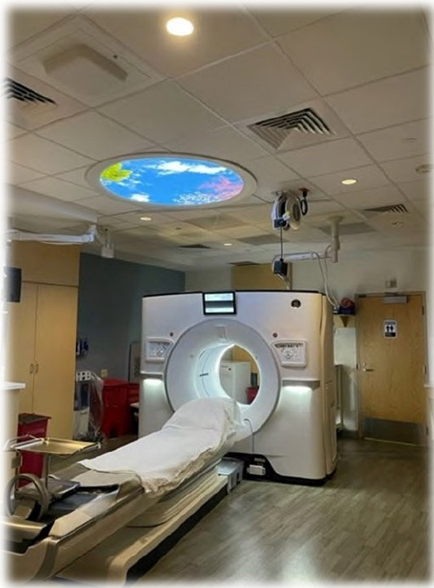
The proposed location for the new CT­ scan is centralized on the first floor of BNH

Equidistant from the BNH main entrance and emergency department
  - Adjacent to the existing CT, creating a
CT hub

Across the hall from the radiology registration area and waiting room

PROPOSED LOCATION continued ...

PROPOSED LOCATION continued ...

PROJECT SCHEDULE (DRAFT)

2021 2022

PROJECT KICKOFF


Construction

DoN Documentation & Approval

Design Engineering Permitting

CONSTRUCTION START
(DPH Approval)

Go-Live

DoN Documentation, Review, and Approval Architectural Design and MDPH Permitting
Construction CT Fabrication, Installation, and Training
Go Live (Target)
October 2021- March 2022

January 2022 - May 2022

July 2022 - October 2022

July 2022 - November 2022

November 2022

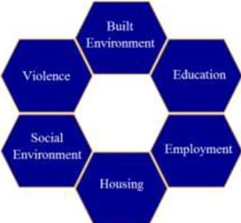
Determination of Need (DoN)
Community Health Initiatives (CHI) Funding
Project: BNH CT-scan

Approval: MA DPH Public Health Council {Delegated Review) - Month 2022 TBD

Total Cost of Project: $1.2 Million {$850,000 CT-scan+ $350,000 Construction)
- 5% Community Health Initiatives (CHI): $60,000 {Tier 1) [funded by BNH]
- Administrative: $2,400 {not to exceed 4%)
- 10% to DPH for Statewide CHI Fund: $5,760 {due within 30 days of approval)
- Evaluation: $5,000 for PHWIM {not to exceed 10%) [Optional]
- CHI Community Commitment Total: $46k-$51k

COMMUNITY ENGAGEMENT PLAN

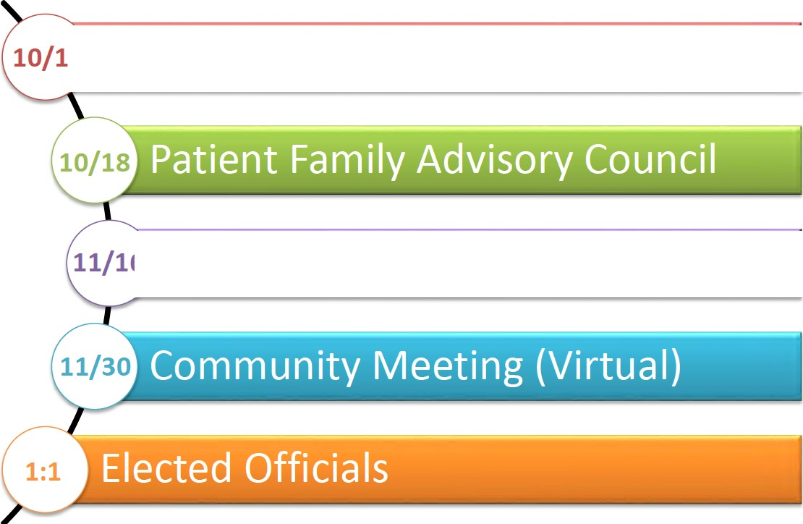
-

Community Benefits Advisory Council

Community Advisory Council

CHI FUNDING

Investment Pathways



APPENDIX 5

FACTOR 6 SUPPLEMENTAL DOCUMENTS

APPENDIX 5.1 CHI NARRATIVE

BAYSTATE NOBLE HOSPITAL
DoN Community Health Initiative Narrative

- Community Health Initiative Monies

The Community Health Initiative ("CHI") processes and community engagement for the proposed Determination of Need ("DoN") Project will be overseen by Baystate Health and its existing Community Benefits program. As part of its planning for previous CHI processes, Baystate Health established a practice for equitable and transparent distribution of CHI funds. There are four hospitals within the system, and the practice is to distribute funds equitably across them, utilizing key criteria. Following approval for DoN Application #BH-20062607-AM, Baystate Health designated $44,020.52 to be allocated within the communities served by Baystate Noble Hospital. As monies remain, Baystate is proposing the funds from this CHI process be pooled with the remaining funds from #BH-20062607-AM and used exclusively for the benefit of the Baystate Noble Hospital's community.

The breakdown of monies for the Proposed Project is as follows. Please note, all totals are presented in the order calculated, beginning with the Maximum Capital Expenditure ("MCE").

 | Total | Description
MCE | $1,218,286
CHI Monies | $60,914.30 | (5% of Maximum Capital Expenditure)
Administrative Fee | $2,436.57 | (4% of the CHI Monies, retained by Baystate)
Remaining Monies | $58,477.73 | (CHI Monies minus the Administrative fee)
Statewide Initiative | $5,847.77 | (10% of remaining monies, paid to State-wide fund)
Local Initiative | $52,692.96 | (90% of remaining monies)
Evaluation Monies | $5,263.00 | (10% of Local Initiative Monies, retained by Baystate)
CHI Monies for Local  Disbursement | $44,020.52
- Basis of the Proposed CHI

Baystate Noble Hospital is a member of the Coalition of Western Massachusetts Hospitals/Insurer (the "Coalition") a partnership between eight non-profit hospitals, clinics, and insurers in the region. The Coalition formed in 2012 to bring hospitals in western Massachusetts together to share resources and work in partnership to conduct their triennial community health needs assessments ("CHNAs") and address regional needs. Baystate worked with the Coalition to conduct its current CHNA (2019) and is currently working with the Coalition to conduct the upcoming, 2022 CHNA. The goals of each CHNA include:

- Improving the Hospital's understanding of the health needs of the communities it serves
- Meeting its fiduciary requirement as a tax-exempt Hospital
- Serve as a resource for community organizations for data that is not readily available in other ways
- Guiding Baystate Noble Hospital's Community Benefits Strategic Implementation Plan ("SIP") development efforts

The CHNA will use a participatory, collaborative approach and examine health in its broadest context. As part of the upcoming assessment, the Coalition is seeking input and will be guided by a Regional Advisory

Council (“RAC”) to inform the methodology, including recommendation of secondary data sources, and identification of key informants and focus group segments. The assessment will utilize the following information inputs: 1) social, economic, and health quantitative data from the MDPH, the U.S Census Bureau, the County Health Ranking Reports, the Massachusetts Healthy Aging Collaborative, Social Explorer, and a variety of other data sources; 2) findings from focus groups, interviews with key informants (including with local and regional public health officials), Community Listening Sessions and Community Chats; and 3) existing assessment reports published since 2019 that were completed by community and regional agencies serving Hampden County. As with past assessments, the 2022 CHNA will focus on county-level data and select community-level data as available.

Based on reflection and feedback from the 2019 CHNA, the following changes are being made to the upcoming CHNA:

- Revised and expanded representation of community members on the RAC.
- Implemented a co-chair structure for the RAC – one community and one hospital coalition representative
- Added two community RAC members to join the monthly Steering Committee meeting, previously limited to hospital representatives and consultants.
- Allocated stipend funding for RAC members who are residents/are not compensated by their employer to participate on the RAC
- Hired two research assistants and engaged three interns from local colleges to assist with note taking, data tasks, and other administrative duties
- Switched the monthly RAC meeting to Zoom which has driven strong attendance due to the ability of members to join virtually and avoid commuting.

- Oversight of the CHI Process

The CHI will be overseen by Baystate Noble Hospital’s Community Benefits Advisory Council (“CBAC”). The scope of work that the Council will carry out includes:

- Ensuring appropriate engagement with residents from targeted communities and community partners around the CHI.
- Determining the Health Priorities for CHI funding based upon the needs identified in the 2022 CHNA/CHIP. The CBAC will ensure that all Health Priorities are aligned with the Department of Public Health’s Health Priorities and the Executive Office of Health and Human Services’ Focus Areas.
- Providing oversight to the evaluator that is carrying out the evaluation of CHI-funded projects.
- Conducting a conflict-of-interest disclosure process to determine which members also will comprise the Allocation Committee.
- Reporting to the Department of Public Health on the DoN – CHI.

- Allocation Committee Duties

The Allocation Committee will be comprised of individuals from the CBAC who do not have a conflict of interest in regard to funding. The scope of work that the Allocation Committee will carry out includes:
- Selecting Strategies for the noted Health Priorities.
- Completing and submitting the Health Priorities and Strategies Selection Form for approval by the Department of Public Health.
- Determining the process by which CHI funds will be awarded.
- Engaging resources that can support and assist applicants with their responses to the RFP.

- Disbursement of CHI funding.
- Providing oversight to a third-party vendor that is selected to carry out the evaluation of CHI- funded projects.

- Timeline for CHI Activities

Upon a Notice of Determination of Need being issued by the Public Health Council, the CBAC will commence meeting and begin the CHI Process. However, as Baystate will be relying on the results of its 2022 CHNA to serve as the basis of this CHI, activities may be pushed back to ensure the CHNA is sufficiently complete in order for the CBAC to review its findings. The timeline for CHI activities is as follows:

- Six weeks post-approval: The CBAC will begin meeting and reviewing the 2022 CHNA/CHIP to commence the process of selecting Health Priorities.
- Three – four months post-approval: The CBAC has determined Health Priorities for funding.
- Four – five months post-approval: The Allocation Committee is selecting strategies for the Health Priorities and will submit the Health Priorities and Strategies Form to the Department.
- Five – six months post-approval: The Allocation Committee is determining how to award and distribute funds (e.g., direct funding or an RFP) and determining how this process will work in tandem with Baystate’s current grant efforts.
- Seven-to-nine months post-approval: The award process is announced and will begin.
- Ten-to-twelve months post-approval: Funding decisions are made, and the disbursement of funds begins.
- Eighteen months to five years post-approval: Evaluator will begin evaluation work.

- Evaluation Overview

Baystate is seeking to use 10% of local CHI funding ($5,263.00) for evaluation efforts. These monies will be used to provide technical assistance to applicants and to ensure appropriate evaluation of the CHI- funded projects.

- Administrative Monies

Applicants submitting a Tier 1 CHI are eligible to retain four percent (4%) of the total CHI for administrative uses. Accordingly, Baystate is requesting $2,436.57 in administrative funding. These monies will aid in developing a sound CHI process that complies with the Department of Public Health’s expectations as administrative funding will be used to hire additional support staff. These monies will also provide compensation to support for the CBAC and Allocation Committee and costs associated with the development of communication materials and placement of procurement information in community newspapers.

APPENDIX 5.2

COMMUNITY HEALTH NEEDS ASSESSMENT

https://cdn1-originals.webdamdb.com/13686 137834897?cache=1664560750&response-content- disposition=inline;filename=BNH-2022-CHNA-FINAL-Lo-
Res 30SEP2022.pdf&response-content- type=application/pdf&Policy=eyJTdGF0ZW1lbnQiOlt7IlJlc291cmNlIjoiaHR0cCo6Ly9jZG4xL W9yaWdpbmFscy53ZWJkYW1kYi5jb20vMTM2ODZfMTM3ODM0ODk3P2NhY2hlPTE2Nj Q1NjA3NTAmcmVzcG9uc2UtY29udGVudC1kaXNwb3NpdGlvbj1pbmxpbmU7ZmlsZW5hb WU9Qk5ILTIwMjItQ0hOQS1GSU5BTC1Mby1SZXNfMzBTRVAyMDIyLnBkZiZyZXNwb25
zZS1jb250ZW50LXR5cGU9YXBwbGljYXRpb24vcGRmIiwiQ29uZGl0aW9uIjp7IkRhdGVM ZXNzVGhhbiI6eyJBV1M6RXBvY2hUaW1lIjoyMTQ3NDE0NDAwfX19XX0 &Signature=QI 51wFckhkrRkCAO8YTC1Xq- dznuyEAFHDelAFJiFmhxMD5YbxeCBY36Gz5eAOy81aV1Hdglbf~qOFO~TtpgfivYGQnP1B 2pS9meTKiMIBps8GHeSJXjX5eN~i3LZe1UdoNUvo0YyzvCf- Zo5W8j13bx7pdec78AZPIAUW4vkt5VpJ1KJ1fjUUqTpGTUqSLiWDMfzAjLTleys0z2AAep4 N8SYB0PnpA-YJeorwlPqkJ-dmjwTsfGC- Wk36SQDRpYcAxT9odd3SveKobZFA4DdEZs1IlWuW2UhM~3o1QvUuXiVW76UBgCOz12l Ojxhk7PyX1eCU7KlX5YdDVOakoARQ &Key-Pair-Id=APKAI2ASI2IOLRFF2RHA

APPENDIX 5.3

STRATEGIC IMPLEMENTATION PLAN

https://baystatehealth.webdamdb.com/directdownload.php?ti=78698615&tok=Te3QTzvMOeuIr e7pSewQwgRR

APPENDIX 8 NOTICE OF INTENT

The Republican – Sep 26 , 2022 -Main - - A3



APPENDIX 9 ACO LETTER

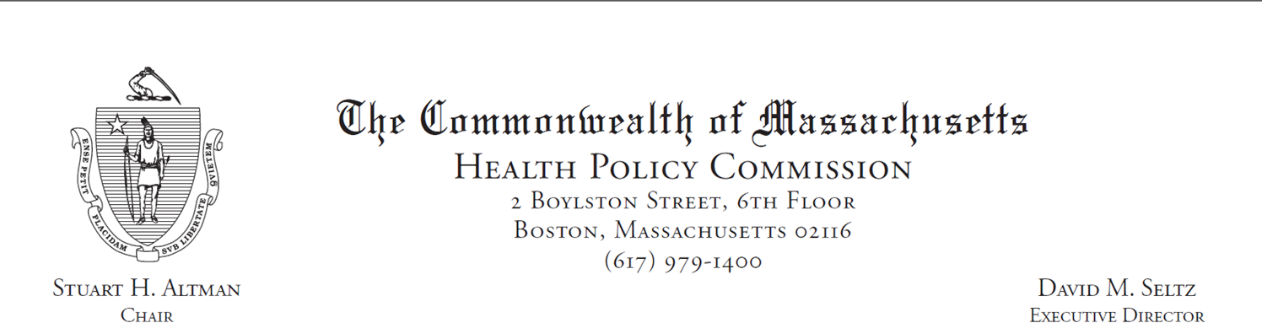
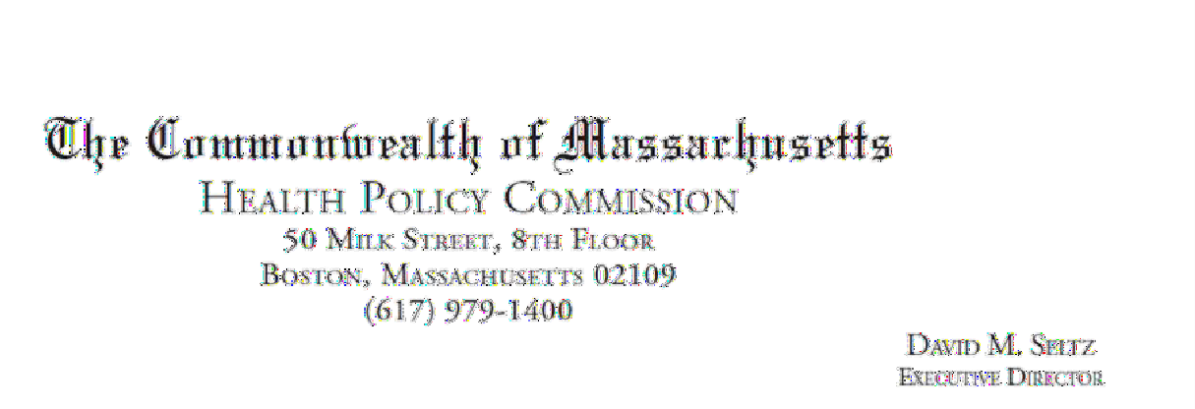

April 12, 2022

Lucesita Scammon
Baycare Health Partners, Inc. 101 Wason Avenue, Suite 200
Springfield, MA 01107

RE: ACO LEAP Ce1tification Dear Mrs. Scammon:
Congratulations! The Health Policy Commission (HPC) is pleased to inform you that Baycare Health Partners, Inc. meets the requirements for ACO Certification under our Learning, Equity, and Patient­ Centeredness (LEAP) standards. This certification is effective from January 1, 2022, through December 31, 2023.

The ACO Certification program, in alignment with other state agencies including MassHealth, is designed to accelerate care delivery transformation in Massachusetts and promote a high quality, efficient health system. ACOs participating in the program have met a set of objective criteria focused on core ACO capabilities demonstrating dedication to patient-centered care, use of evidence-based and data-driven strategies to improve care delivery, and commitment to addressing long-standing health inequities. Baycare Health Partners, Inc. meets those criteria.

The HPC will promote Baycare Health Partners, Inc. as a Certified ACO on our website and in our marketing and public materials. Enclosed you will find an ACO Certification logo for your organization to use in accordance with the attached Terms of Use. We hope you will use the logo on promotional materials when you highlight your ACO Certification to your patients, payers, and others.

The HPC looks forward to ongoing engagement with you over the next two years. We intend to follow up shortly to provide an overview and some reflections on what we saw in the Health Equity Responses, a new feature of the ACO Certification application this year, across the cohort of Certified ACOs. We hope your organization will find that information helpful as we all continue to explore ways to improve health equity in the Commonwealth.

Thank you for your dedication to providing accountable, coordinated health care to your patients, and to continued learning and improvement over time. If you have any questions about this letter or the ACO Certification program, please do not hesitate to contact Mike Stanek, Senior Manager, at HPC­ Certification@mass.gov or (617) 757-1649.

Best wishes,

[signature on file]

David Seltz Executive Director

APPENDIX 10 ARTICLES OF INCORPORATION

https://corp.sec.state.ma.us/CorpWeb/CorpSearch/CorpSearchRedirector.aspx?Action=PDF&Pat h=CORP_DRIVE1/2003/1224/000071371/0001/200358622110_1.pdf

APPENDIX 11 AFFIDAVIT

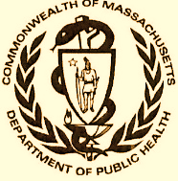 Version: 7-6-17

Massachusetts Department of Public Health

Determination of Need

Affidavit of Truthfulness and Compliance

with Law and Disclosure Form 100.405 (B)
Instructions: Complete Information below. When complete check the box "This document is ready to print:". This will date stamp and lock the form. Print Form. Each person must sign and date the form. When all signatures have been collected, scan the document and e-mail to: dph.don@state.ma.us Include all attachments as requested.
Application Number: -20121611-
Original Application Date: 11/1/2022
Applicant Name: Baystate Health, Inc.
Application Type: DoN-Required Equipment
Applicant's Business Type: Corporation
Is the Applicant the sole member or sole shareholder of the Health Facility(ies) that are the subject of this Application? Yes
The undersigned certifies under the pains and penalties of perjury:
- The Applicant is the sole corporate member or sole shareholder of the Health Facility(ies) that are the subject of this Application;
- I have read [been informed of the contents of] 105 CMR 100.000, the Massachusetts Determination of Need Regulation;
- I understand and agree to the expected and appropriate conduct of the Applicant pursuant to 105 CMR 100.800;
- I have read [been informed of the contents of] this application for Determination of Need including all exhibits and attachments, and certify that [have been informed that] all of the information contained herein is accurate and true;
- I have submitted the correct Filing Fee and understand it is nonrefundable pursuant to 105 CMR 100.405(B);
- I have submitted the required copies of this application to the Determination of Need Program, and, as applicable, to all Parties of Record and other parties as required pursuant to 105 CMR 100.405(B);
- I have caused, as required, notices of intent to be published and duplicate copies to be submitted to all Parties of Record, and all carriers or third-party administrators, public and commercial, for the payment of health care services with which the Applicant contracts, and with Medicare and Medicaid, as required by 105 CMR 100.405(C), et seq.;
- I have caused [have been informed that] proper notification and submissions to the Secretary of Environmental Affairs pursuant to 105 CMR 100.405(E) and 301 CMR 11.00; [will be made, if applicable.]
- If subject to M.G.L. c. 6D, § 13 and 958 CMR 7.00, I have submitted such Notice of Material Change to the HPC - in accordance with 105 CMR 100.405(G);
- Pursuant to 105 CMR 100.210(A)(3), I certify that both the Applicant and the Proposed Project are in material and substantial compliance and good standing with relevant federal, state, and local laws and regulations, as well as with all previously issued Notices of Determination of Need and the terms and Conditions attached therein [issued in compliance with 105 CMR 100.00, the Massachusetts Determination of Need Regulation effective January 27, 2017 and amended December 28, 2018];
- I have read [been informed of the contents of] and understand the limitations on solicitation of funding from the general public prior to receiving a Notice of Determination of Need as established in 105 CMR 100.415;
- I understand that, if Approved, the Applicant, as Holder of the DoN, shall become obligated to all Standard Conditions pursuant to 105 CMR 100.310, as well as any applicable Other Conditions as outlined within 105 CMR 100.000 or that otherwise become a part of the Final Action pursuant to 105 CMR 100.360;
- Pursuant to 105 CMR 100.705(A), I certify that the Applicant has Sufficient Interest in the Site or facility; and
- Pursuant to 105 CMR 100.705(A), I certify that the Proposed Project is authorized under applicable zoning by-laws or ordinances, whether or not a special permit is required; or,
  - If the Proposed Project is not authorized under applicable zoning by-laws or ordinances, a variance has been received to permit such Proposed Project; or,
  - The Proposed Project is exempt from zoning by-laws or ordinances.

Corporation
Attach a copy of Articles of Organization/Incorporation, as amended

Mark A. Keroack, MD <Signature on File> 10/11/2022
CEO for Corporation Name: Signature: Date:

Robert J. Bacon <Signature on File> 10/11/2022
Board Chair for Corporation Name: Signature: Date

APPENDIX 12 FILING FEE

November 1, 2022

Dennis Renaud
Determination of Need Program
Department of Public Health
67 Forest Street
Marlborough, MA 01752

RE: Determination of Need (DoN) Application #20121611

Dear Dennis Renaud:

Enclosed please find a check made payable to the Commonwealth of Massachusetts in the amount of $2,436.57 pursuant to the Determination of Need filing fee for Application #20121611, submitted by Baystate Noble Hospital, Inc.

Kindly direct any questions regarding this fee to my attention, per my contact information, supplied below.

Sincerely,

Bill Kern
Sr. Director, Business Development Baystate Health, Inc.
280 Chestnut Street
Springfield, MA 01199
413-794-5556
William.kernii@baystatehealth.org

This Application requests approval for the acquisition of one (1) computed tomography unit to be located on the main campus of Baystate Noble Hospital.

