**Beth Israel Lahey Health**

**DoN Application #: BILH-24080714-HE Application for Determination of Need Substantial Capital Expenditure Substantial Change in Service**

**Attachments October 1, 2024**

**Submitted By**

**Beth Israel Lahey Health, Inc.**

**20 University Road,**

**Suite 700**

**Cambridge, MA 02138**

**Attachment 1: Articles of Incorporation**

Per instruction from the Department of Public Health, the Applicant is providing links to its corporate documents on the Massachusetts Secretary of State’s website. Please use the following links to access the Applicant’s Articles of Organization, and related amendments, on the Secretary of State’s website:

**Articles of Organization** [https://corp.sec.state.ma.us/CorpWeb/CorpSearch/CorpSearchRedirector.aspx?Action=PDF&Pat](https://corp.sec.state.ma.us/CorpWeb/CorpSearch/CorpSearchRedirector.aspx?Action=PDF&Path=CORP_DRIVE1/2018/1127/001517515/0003/201848640920_1.pdf) [h=CORP_DRIVE1/2018/1127/001517515/0003/201848640920_1.pdf](https://corp.sec.state.ma.us/CorpWeb/CorpSearch/CorpSearchRedirector.aspx?Action=PDF&Path=CORP_DRIVE1/2018/1127/001517515/0003/201848640920_1.pdf)

**Articles of Amendment**

* 2024 Amendment: [https://corp.sec.state.ma.us/CorpWeb/CorpSearch/CorpSearchRedirector.aspx?Action=P](https://corp.sec.state.ma.us/CorpWeb/CorpSearch/CorpSearchRedirector.aspx?Action=PDF&Path=CORP_DRIVE1/2024/0329/000000003/2244/202465383320_1.pdf) [DF&Path=CORP_DRIVE1/2024/0329/000000003/2244/202465383320_1.pdf](https://corp.sec.state.ma.us/CorpWeb/CorpSearch/CorpSearchRedirector.aspx?Action=PDF&Path=CORP_DRIVE1/2024/0329/000000003/2244/202465383320_1.pdf)
* 2022 Amendment: [https://corp.sec.state.ma.us/CorpWeb/CorpSearch/CorpSearchRedirector.aspx?Action=P](https://corp.sec.state.ma.us/CorpWeb/CorpSearch/CorpSearchRedirector.aspx?Action=PDF&Path=CORP_DRIVE1/2022/0119/000000000/1391/202297128210_1.pdf) [DF&Path=CORP_DRIVE1/2022/0119/000000000/1391/202297128210_1.pdf](https://corp.sec.state.ma.us/CorpWeb/CorpSearch/CorpSearchRedirector.aspx?Action=PDF&Path=CORP_DRIVE1/2022/0119/000000000/1391/202297128210_1.pdf)
* 2019 Amendment: [https://corp.sec.state.ma.us/CorpWeb/CorpSearch/CorpSearchRedirector.aspx?Action=P](https://corp.sec.state.ma.us/CorpWeb/CorpSearch/CorpSearchRedirector.aspx?Action=PDF&Path=CORP_DRIVE1/2019/0719/001716104/0001/201915220970_1.pdf) [DF&Path=CORP_DRIVE1/2019/0719/001716104/0001/201915220970_1.pdf](https://corp.sec.state.ma.us/CorpWeb/CorpSearch/CorpSearchRedirector.aspx?Action=PDF&Path=CORP_DRIVE1/2019/0719/001716104/0001/201915220970_1.pdf)

**Attachment 2: Community Health Needs Assessment**

Per the instructions from the Department of Public Health, the Applicant is providing links to the most recent community health needs assessment (“CHNA”) for Beth Israel Deaconess Hospital– Plymouth (“BID Plymouth”) and Beth Israel Deaconess Hospital–Milton (“BID Milton”).

* BID Plymouth - [https://bidplymouth.org/-/media/files/plymouth/bid-plymouth-2022-](https://bidplymouth.org/-/media/files/plymouth/bid-plymouth-2022-chna-093022.pdf) [chna-093022.pdf](https://bidplymouth.org/-/media/files/plymouth/bid-plymouth-2022-chna-093022.pdf)
* BID Milton - <https://bidmilton.org/-/media/files/milton/bid-milton-chna-report-2022.pdf>

**Attachment 3: Notice of Intent**

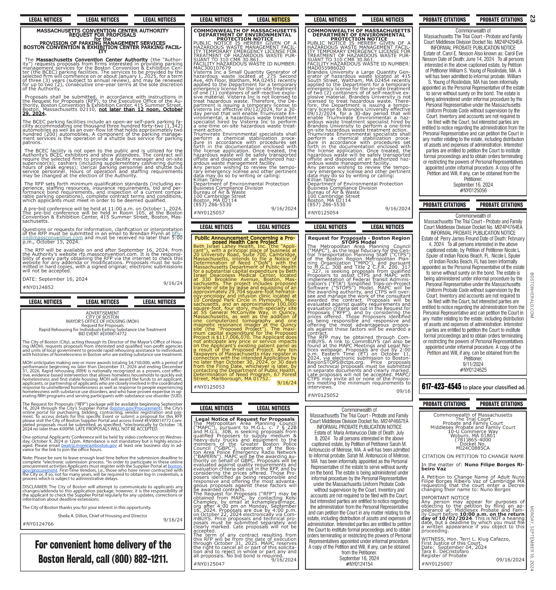

**Attachment 4: Evidence of Filing Fee**

Office of General Counsel

529 Main Street

Charlestown, MA 02129

**Beth Israel Lahey Health**

October 3, 2024

Commonwealth of Massachusetts

Attn: Determination of Need Program

67 Forest St.

Marlborough, MA 01752

Re: **DoN Application #: BILH-24080714-HE**

Dear Sir/Madam:

Please find enclosed a check in the amount of Two Hundred Thirty-Four Thousand Twelve Dollars and Fourteen Cents ($234,012.14) related the above-referenced DoN Application.

Sincerely,

[signature on file]

Stephen Boyd

Divisional Vice President, Deputy General Counsel for Community Division

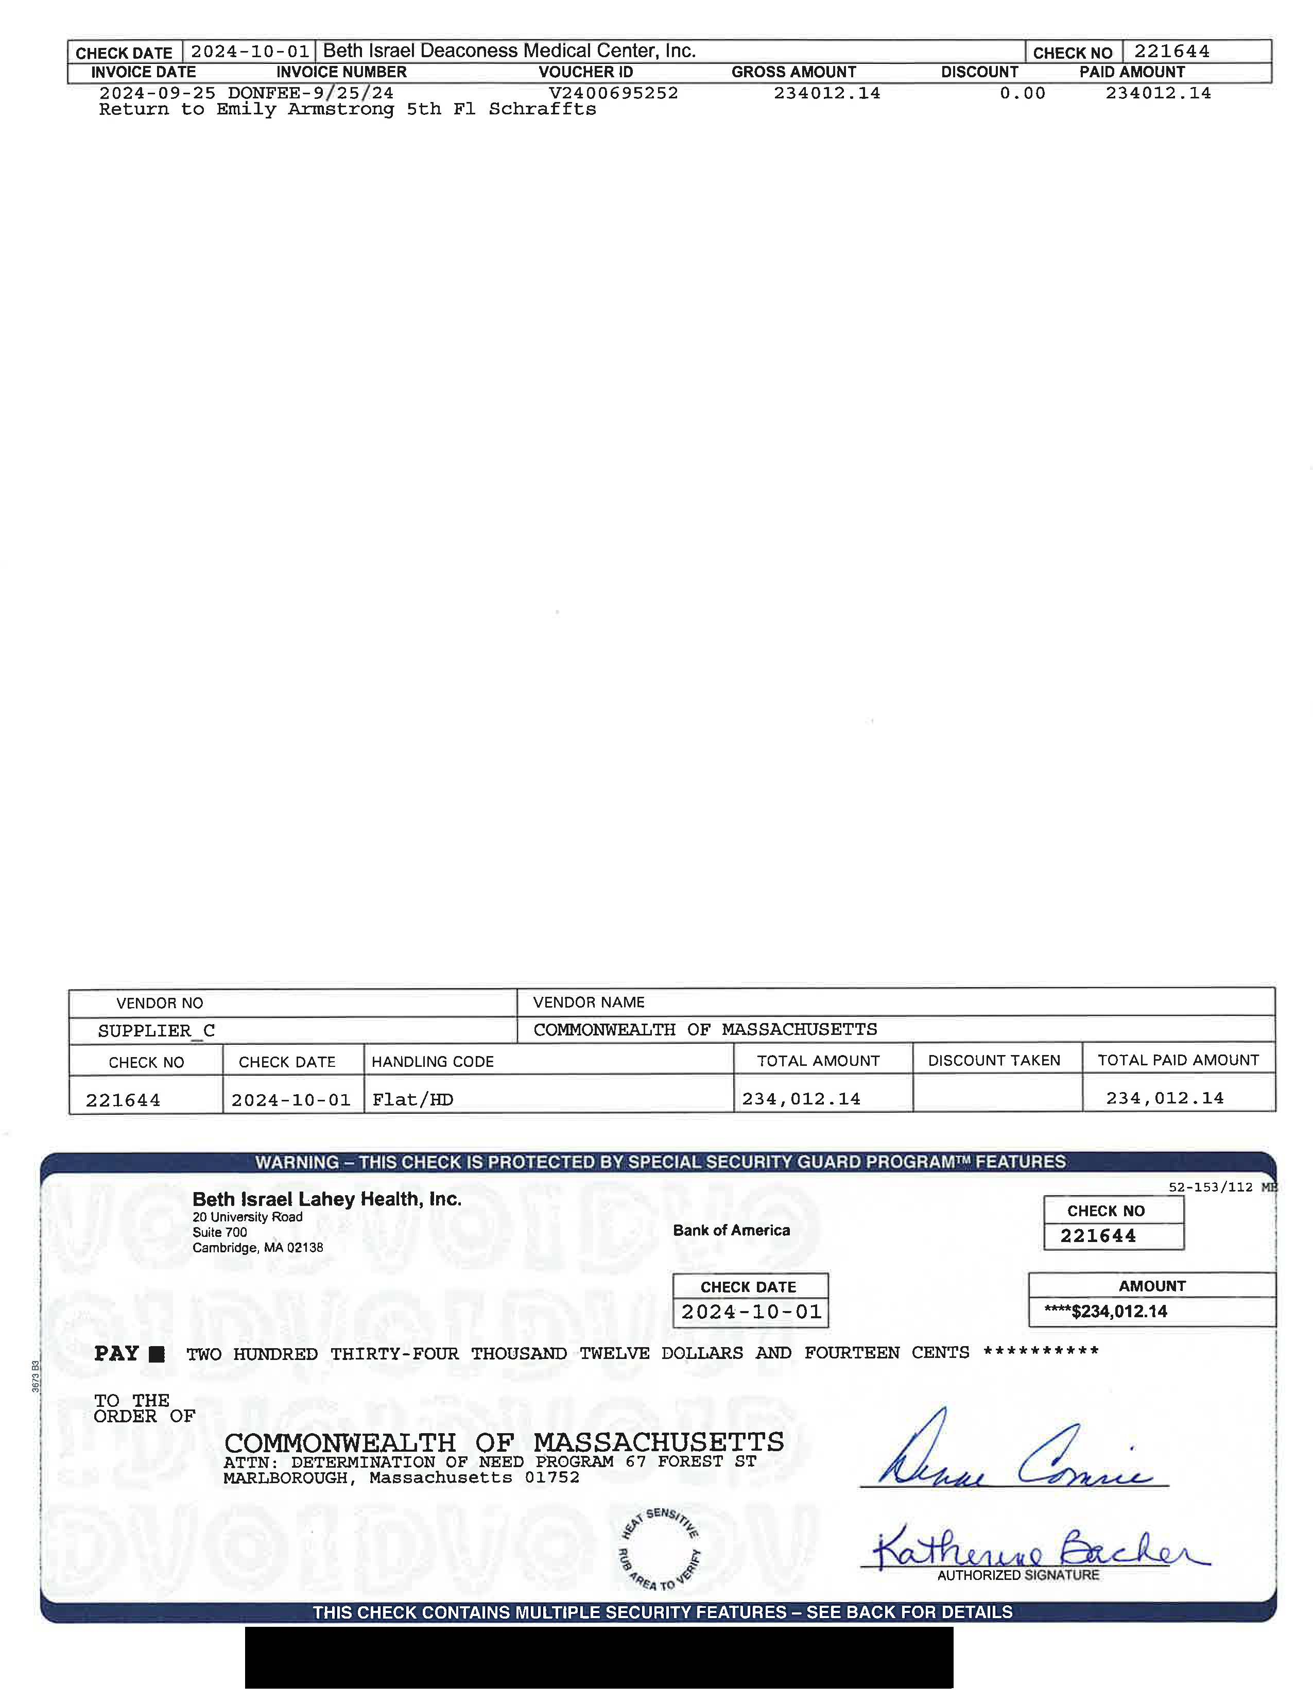

**Attachment 5: Affidavit of Truthfulness Form**

 Version: 7-6-17

**Massachusetts Department of Public Health**

**Determination of Need**

**Affidavit of Truthfulness and Compliance**

**with Law and Disclosure Form 100.405 (B)**

**Instructions**: Complete Information below. When complete check the box "This document is ready to print:". This will date stamp and lock the form. Print Form. Each person must sign and date the form. When all signatures have been collected, scan the document and e-mail to: [dph.don@state.ma.us](mailto:dph.don@state.ma.us) Include all attachments as requested.

Application Number: BILH-24080714-HE

Original Application Date: 10/1/2024

Applicant Name: Beth Israel Lahey Health, Inc.

Application Type: Hospital/Clinic Substantial Capital Expenditure

Applicant's Business Type: Corporation

Is the Applicant the sole member or sole shareholder of the Health Facility(ies) that are the subject of this Application? Yes

The undersigned certifies under the pains and penalties of perjury:

1. The Applicant is the sole corporate member or sole shareholder of the Health Facility(ies) that are the subject of this Application;
2. I have read 105 CMR 100.000, the Massachusetts Determination of Need Regulation;
3. I understand and agree to the expected and appropriate conduct of the Applicant pursuant to 105 CMR 100.800;
4. I have read this application for Determination of Need including all exhibits and attachments, and certify that all of the information contained herein is accurate and true;
5. I have submitted the correct Filing Fee and understand it is nonrefundable pursuant to 105 CMR 100.405(B);
6. I have submitted the required copies of this application to the Determination of Need Program, and, as applicable, to all Parties of Record and other parties as required pursuant to 105 CMR 100.405(B);
7. I have caused, as required, notices of intent to be published and duplicate copies to be submitted to all Parties of Record, and all carriers or third-party administrators, public and commercial, for the payment of health care services with which the Applicant contracts, and with Medicare and Medicaid, as required by 105 CMR 100.40S(C), et seq.;
8. I have caused proper notification and submissions to the Secretary of Environmental Affairs pursuant to 105 CMR 100.405(E) and 301 CMR 11.00;
9. If subject to M.G.L c. 6D, § 13 and 958 CMR 7 .00, I have submitted such Notice of Material Change to the HPC – in accordance with 105 CMR 100.40S(G);
10. Pursuant to 105 CMR 100.210(A)(3), I certify that both the Applicant and the Proposed Project are in material and substantial compliance and good standing with relevant federal, state, and local laws and regulations, as well as with all previously issued Notices of Determination of Need and the terms and Conditions attached therein~~;~~
11. I have read and understand the limitations on solicitation of funding from the general public prior to receiving a Notice of Determination of Need as established in 105 CMR 100.415;
12. I understand that, if Approved, the Applicant, as Holder of the DoN, shall become obligated to all Standard Conditions pursuant to 105 CMR 100310, as well as any applicable Other Conditions as outlined within 105 CMR 100.000 or that otherwise become a part of the final Action pursuant to 105 CMR 100.360;
13. Pursuant to 105 CMR 100.705(A), I certify that the Applicant has Sufficient Interest in the Site or facility; and
14. Pursuant to 105 CMR 100.70S(A), I certify that the Proposed Project is authorized under applicable zoning by-laws or ordinances, whether or not a special permit is required; or,
    1. If the Proposed Project is not authorized under applicable zoning by-laws or ordinances, a variance has been received to permit such Proposed Project; or,
    2. The Proposed Project is exempt from zoning by-laws or ordinances.

|  |
| --- |
| **Corporation**  All parties must sign. Add additional names as needed.  Kevin Tabb, MD <Signature on File> 10/01/2024  CEO for Corporation Name: Kevin Tabb, MD Signature: Date:  Ann-Ellen Hornidge, JD <Signature on File> 10/01/2024  Board Chair for Corporation Name: Ann-Ellen Hornidge, JD Signature: Date: |

**This document is ready to print:** [unchecked] **Date/time Stamp:** [blank]

Beth Israel Lahey Health, Inc. BILH-24080714-HE

**Attachment 8:**

**Certified Public Accountant Certification**

147662651_1

**Beth Israel Lahey Health, Inc.**

**Analysis of the Reasonableness of Assumptions Used For and**

**Feasibility of Projected Financial Information associated with the relocation and expansion of the hematology- oncology and infusion clinics currently located at Beth Israel Deaconess Hospital – Plymouth, Inc. and the development of a new multispecialty ambulatory center**

**For Years Ending September 30, 2027 through September 30, 2031**

**BETH ISRAEL LAHEY HEALTH, INC.**

**TABLE OF CONTENTS**

Page

1. Executive Summary 1
2. Relevant Background Information 1
3. Scope of Report 2
4. Primary Sources of Information Utilized 2 - 3
5. Review of the Projections 4 - 9
6. Feasibility 9 - 10

Meyers Brothers Kalicka
Certified Public Accountants

September 30, 2024 Ms. Karen Wolfson

Assistant Vice President – Taxation Beth Israel Lahey Health, Inc.

529 Main Street, 4th Floor Charlestown, MA 02129

Dear Karen:

We have performed an analysis of the financial projections prepared by Beth Israel Lahey Health, Inc. (the “Applicant” or “BILH”) on behalf of Beth Israel Deaconess Medical Center (“BIDMC”) detailing the projected operations to (i) develop a satellite for the provision of hematology-oncology and infusion services in Plymouth, MA (the “Cordage Park Satellite”), as well as a (ii) multispecialty satellite in Quincy, MA (the “Quincy Satellite”)(collectively, the “Satellites”) which includes the addition of one computerized tomography machine and one magnetic resonance imaging machine at the Quincy Satellite (collectively, the “Project”). The Satellites will be licensed as a BIDMC hospital-based satellite and will be run as a hospital outpatient department of BIDMC. This report details our analysis and findings with regards to the reasonableness of assumptions used in the preparation and feasibility of the projected financial information of the Project as prepared by the management of BILH (“Management”). This report is to be included by the Applicant in its Determination of Need (“DON”) application, (see Factor 4(a) of the DON) and should not be distributed or relied upon for any other purpose.

# Executive Summary

The scope of our analysis was limited to the five-year financial projections for the years ending September 30, 2027 through September 30, 2031 (the “Projections”) prepared by Management, and the related supporting documentation provided by Management. The purpose is to assess the reasonableness of assumptions used in the preparation and feasibility of the projections with regards to the relocation and expansion of the hematology-oncology and infusion clinics currently located at Beth Israel Deaconess Hospital – Plymouth, Inc. and the development of a new multispecialty ambulatory center.

The development of the Satellites is projected to have positive overall cash flows (see section V of this report). We determined that the projections were not likely to result in a scenario where there are insufficient funds available for the ongoing operating costs required to support the Satellites. Except as described in section V of this report, it is not anticipated that the Applicant will require any additional financing associated with this Project. It is our conclusion that the projections are financially feasible and within the financial capability of the Applicant as detailed below.

# Relevant Background Information

Refer to Factor 1 of the DON application for a description of the scope of the Applicant, as well as the overall description and rationale for the relocation and expansion of the hematology-oncology and infusion clinics currently located at Beth Israel Deaconess Hospital – Plymouth, Inc. and the development of a new multispecialty ambulatory center.

-1-

**Meyers Brothers Kalicka, P.C. | Certified Public Accountants | 330 Whitney Avenue, Suite 800 | Holyoke, MA 01040**

**(413) 536-8510 | mbkcpa.com**

# Scope of Report

The scope of this report is limited to an analysis of the five-year financial projections prepared by Management and the supporting documentation in order to assess the reasonableness of assumptions used in the preparation and feasibility of the projections with regards to the Project. Our analysis of the projections and conclusions contained within this report are based upon our detailed review of all relevant information (see section IV of this report). We gained an understanding through our review of the information provided by Management, as well as a review of the DON application.

Reasonableness is defined within the context of this report as supportable and proper, given the underlying information. Feasibility is defined as based on the assumptions used, the plan is not likely to result in insufficient funds available for capital and ongoing operating costs necessary to support the proposed project without negative impacts or consequences to the Applicant’s existing patient panel.

This report is based upon historical and prospective financial information provided to us by Management. If Meyers Brothers Kalicka, P.C. had audited the underlying data, matters may have come to our attention that would have resulted in our using amounts that differ from those provided. Accordingly, we do not express an opinion or any other assurances on the underlying data presented or relied upon in this report. We do not provide assurance on the achievability of the results forecasted by Management because events and circumstances frequently do not occur as expected, and the achievement of the forecasted results is dependent on the actions, plans, and assumptions of Management. We reserve the right to update our analysis, if we are provided with additional information.

# Primary Sources of Information Utilized

In formulating our opinions and conclusions contained in this report, we obtained and reviewed various documents obtained from Management. The documents and information we reviewed and relied on are noted below and/or referenced in this report:

* + Historical infusion services volume at Lahey Hospital & Medical Center (“Burlington”) and Lahey Medical Center, Peabody (“Peabody”) for the years ended September 30, 2022 and 2023 and historical hematology- oncology volume at Beth Israel Deaconess Hospital – Needham (“Needham”) and BID-Plymouth Oncology Cancer Center (“BID-Plymouth”) for the year ended September 30, 2022.
  + Historical volume at Beth Israel Lahey Health Primary Care Quincy Square (“Primary Care”)and Beth Israel Lahey Health Urgent Care Quincy (“Urgent Care”) for the years ended September 30, 2022 and 2023.
  + Historical revenue and expenses for infusion services at Lahey Hospital & Medical Center and Lahey Medical Center, Peabody for the years ended September 30, 2022 and 2023 and historical revenue and expenses for hematology-oncology services at Beth Isreal Deaconess Hospital – Needham and BID- Plymouth Oncology Cancer Center for the year ended September 30, 2022.
  + Historical revenue and expenses at Beth Israel Lahey Health Primary Care Quincy Square and Beth Israel Lahey Health Urgent Care Quincy for the years ended September 30, 2022 and 2023.
  + Beth Israel Lahey Health, Inc. and Affiliates audited consolidated financial statements as of and for the years ended September 30, 2022 and September 30, 2023.
  + Projected volume for the Project for the years ending September 30, 2027, 2028, 2029, 2030, and 2031.
  + Projected revenue and expenses for the Project for the years ending September 30, 2027, 2028, 2029, 2030, and 2031.

1. **Primary Sources of Information Utilized (continued)**
   * Projected statements of cash flows from operations for the Project for the years ending September 30, 2027, 2028, 2029, 2030, and 2031.
   * Lease agreement and valuation for a 29,704 square foot hematology-oncology and infusion clinic located at 10 Cordage Park Circle in Plymouth, Massachusetts.
   * Lease agreement for a build-to-suit, 100,000 square foot multispecialty site located at 55 General McConville Way in Quincy, Massachusetts, of which 78,812 square feet will be occupied by the Quincy Satellite during the years ending September 30, 2027 through September 30, 2031.
   * Lease agreement dated April 1, 2019 for existing BILH primary care services located at 31 Hancock Court in Quincy, Massachusetts.
   * Historical revenues and expenses at Beth Israel Deaconess Healthcare - Chestnut Hill (“Chestnut Hill”) for the year ended September 30, 2023.
   * Total fit out costs for the Quincy Satellite are made up of the following:

|  |  |  |
| --- | --- | --- |
| Total hard and soft costs | $ | 42,438,618 |
| Landlord’s turnkey contribution |  | (9,851,500) |
| Total fit out costs financed | $ | 32,587,118 |

* + Construction contractor budget proposal of project costs for the Cordage Park Satellite provided by Consigli Construction.
  + Beth Israel Deaconess Medical Cetner, Inc. pharmacy services agreement dated October 21, 2021.
  + DON Application Instructions dated July 2023.
  + DON Narrative draft provided September 5, 2024.
  + DON Application Form.
  + Total project costs of the Applicant are made up of the following:

|  | Cordage Park  Satellite | Quincy  Satellite | Total |
| --- | --- | --- | --- |
| Building acquisition costs | $ 18,350,900 | $ 40,065,788 | $ 58,416,688 |
| Construction costs | 28,921,230 | 19,448,663 | 48,369,893 |
| Fixed medical equipment | - | 6,514,590 | 6,514,590 |
| Architectural costs | 1,332,069 | 2,372,830 | 3,704,899 |
| Total project costs | $ 48,604,199 | $ 68,401,871 | $ 117,006,070 |

# Review of the Projections

This section of the report summarizes our review of the reasonableness of the assumptions used and feasibility of the projections. The tables that follow summarize the projected results of the relocation and expansion of the hematology- oncology and infusion clinics currently located at Beth Israel Deaconess Hospital – Plymouth, Inc. and the development of a new multispecialty ambulatory center.

**Revenues**

We have reviewed and analyzed the net operating revenues in the historical and projected financial information. For the purposes of this pro-forma, volume represents the number of patient visits.

Cordage Park Satellite

Based on discussions with Management and review of the information provided, the volume disclosed in the table below represents total infusion and hematology-oncology clinic patient visits for the years ending September 30, 2027 through September 30, 2031. The infusion clinic will have 36 infusion chairs. Historical volume for the Peabody and Burlington infusion clinics averaged two patients per chair per day for the year ended September 30, 2023. For the year ending September 30, 2027, management has estimated volume based on two patients per chair per day. For the years ending September 30, 2028 through September 30, 2030, management has estimated an increase in total patient visits of 13% to 15% annually. For the year ending September 30, 2031, management estimates that the clinic will operate at full efficiency, an increase of approximately 1% over the year ending September 30, 2030. Hematology-oncology volume is based on historical 2022 volume for BID-Plymouth Oncology Cancer Center. Base volume for the projections was 13,826 patients, who were seen by an equivalent of 6.5 physicians and two nurse practitioners. Management has estimated that one full time physician and nurse practitioner will see 1,843 and 1,520 patients annually, respectively. Management anticipates that through the addition of three physicians and one nurse practitioner over the five-year projection, that patients seen will increase between 10% and 13% annually.

The average gross charge per patient visit for the infusion clinic is $14,700 and the average gross charge per patient visits for the hematology-oncology clinic is $506, which is consistent with historical charges per patient for the year ended September 30, 2022 for Burlington, Peabody and Needham. Contractual allowances are estimated at 73% of gross revenue, which is consistent with historical reimbursements rates for the year ended September 30, 2022.

Quincy Satellite

Based on discussions with Management and review of the information provided, the volume disclosed in the table below is based on the number of patient visits for the years ending September 30, 2027 through September 30, 2031. The Quincy Satellite is a multispecialty location that will provide urgent care, block specialties, hotel specialties, primary care, laboratory and other ancillary services. Management has used historical volume levels from existing BILH locations to estimate patient volume capacity across the multispecialty services. Based on discussions with management, the Quincy Satellite location will operate at 48% of projected volume capacity for the year ending September 30, 2027. For the years ending September 30, 2028 through September 30, 2031, volume is anticipated to be approximately 67%, 96%, 99% and 100% of projected volume capacity, respectively. Net revenue is based on the average of Commercial (44%), Medicare (40%), and Medicaid/other (16%) reimbursement rates, which is based on reimbursement rates for existing BILH locations for the year ended September 30, 2022. Net revenue per case for the years ending September 30, 2027 through September 30, 2031 ranges from $28 to $3,969, based on the type of service provided, with average net revenue rate per patient visit fluctuating based on changes in patient volume by service type.

**V. Review of the Projections (continued)**

The tables below provide a summary of some of the key information for the projected incremental volume and revenues by year for both the Cordage Park Satellite and Quincy Satellite (fiscal year September):

Cordage Park Satellite

| Category | Projected/ pro-forma  2027 | Projected/ pro-forma  2028 | Projected/ pro-forma  2029 | Projected/ pro-forma  2030 | Projected/ pro-forma  2031 |
| --- | --- | --- | --- | --- | --- |
| **Volume** |  |  |  |  |  |
| Infusion clinic | 17,784 | 20,451 | 23,119 | 26,676 | 27,000 |
| Hematology-oncology clinic | 15,208 | 17,189 | 19,032 | 19,032 | 20,875 |
| Total volume | 32,992 | 37,640 | 42,151 | 45,708 | 47,875 |
| **Revenues** |  |  |  |  |  |
| Gross revenue | $ 269,120,111 | $ 309,336,070 | $ 349,482,263 | $ 401,767,223 | $ 407,462,497 |
| Contractual allowances | (196,457,681) | (225,815,331) | (255,122,052) | (293,290,073) | (297,447,623) |
| Total revenue, net | $ 72,662,430 | $ 83,520,739 | $ 94,360,211 | $ 108,477,150 | $ 110,014,874 |
| Gross revenue per patient visit | $ 8,157 | $ 8,218 | $ 8,291 | $ 8,790 | $ 8,511 |
| Net revenue per patient visit | $ 2,202 | $ 2,219 | $ 2,239 | $ 2,373 | $ 2,298 |

Quincy Satellite

| Category | Projected/ pro-forma 2027 | Projected/ pro-forma 2028 | Projected/ pro-forma 2029 | Projected/ pro-forma 2030 | Projected/ pro-forma 2031 |
| --- | --- | --- | --- | --- | --- |
| Volume | 163,706 | 229,274 | 312,852 | 329,758 | 344,716 |
| Total revenue, net | $ 42,920,452 | $ 61,892,165 | $ 88,862,273 | $ 93,337,591 | $ 97,614,519 |
| Net revenue per patient visit | $ 262 | $ 270 | $ 284 | $ 283 | $ 283 |

We analyzed the projected/pro-forma incremental net revenue for the Satellites for the years ending September 30, 2027 through September 30, 2031 to assess the reasonableness of the projected/pro-forma statements. Based on our analysis, the revenue projected by Management is a reasonable estimation and conservative based primarily upon the historical patient volume.

**Expenses**

We analyzed each of the categorized expenses for reasonableness and feasibility as it relates to the projected revenue. The tables below provide a summary of some of the key information for the projected expenses by year for both the Cordage Park Satellite and Quincy Satellite (fiscal year September):

Cordage Park Satellite

| Expenses | Projected/ pro-forma  2027 | Projected/ pro-forma  2028 | Projected/ pro-forma  2029 | Projected/ pro-forma  2030 | Projected/ pro-forma  2031 |
| --- | --- | --- | --- | --- | --- |
| Salaries and wages (1) | $ 6,298,718 | $ 7,309,269 | $ 8,170,451 | $ 9,063,156 | $ 9,244,419 |
| Fringe benefits (2) | 1,385,718 | 1,608,039 | 1,797,499 | 1,993,894 | 2,033,772 |
| Supplies (3) | 40,235,026 | 46,112,607 | 52,147,897 | 60,260,669 | 60,916,028 |
| Professional fees (4) | 3,817,709 | 4,225,809 | 5,124,498 | 5,483,213 | 6,557,278 |
| Rent (5) | 900,000 | 936,000 | 973,440 | 1,012,378 | 1,052,873 |
| Depreciation (6) | 3,240,280 | 3,240,280 | 3,240,280 | 3,240,280 | 3,240,280 |
| Other operating expenses (7) | 5,263,717 | 6,019,173 | 6,821,379 | 7,781,331 | 7,980,437 |
| Total Expenses | $ 61,141,168 | $ 69,451,177 | $ 78,275,444 | $ 88,834,921 | $ 91,025,087 |

1. **Review of the Projections (continued)**
   1. Salaries and wages in the year ending September 30, 2027 include 71 full time equivalents (“FTEs”) with an average salary of approximately $89,000. The years ending September 30, 2028 through September 30, 2031 include an Advanced Practice Provider with an average salary of $180,000. Total FTEs are projected to increase by 8 annually through the year ending September 30, 2031 to support an increase in volume. Management assumes a 2% cost of living adjustment every year. Projected salaries and wages are based on historical FTEs and average salaries for BID-Plymouth for the year ended September 30, 2022.
   2. Management has estimated the projected fringe benefits at approximately 22% of salaries and wages for the years ending September 30, 2027 through September 30, 2031. Management’s projection is based on historical fringe benefits for BID-Plymouth for the year ended September 30, 2022 of approximately 22% of total salaries and wages. These expenses include health insurance, dental insurance, disability, pension, workers compensation, FICA, and other fringe benefits received through employment.
   3. Supplies include the cost of drugs and other medical supplies. Drug costs are estimated at approximately 15% of gross revenue for the years ending September 30, 2027 through September 30, 2031. Management’s projection is based on historical drug costs of approximately 15% of gross revenue for the years ended September 30, 2022 and 2023 for Burlington and Peabody.
   4. Professional fees in the year ending September 30, 2027 include 7.5 FTEs for physicians, plus additional administrative costs to operate the hematology-oncology clinic with an average total cost per physician of approximately $527,000. Management projects one incremental physician to be added in the years ending September 30, 2029 and September 30, 2031. Management assumes a 7% cost of living adjustment annually for the years ending September 30, 2028 through September 30, 2031. Management’s projected professional fee expenses are based on historical physicians and administrative costs of approximately $527,000 per physician for the year ended September 30, 2022 for BID-Plymouth.
   5. The hematology-oncology and infusion clinics will operate in an approximately 30,000 square foot leased facility. Based on the provided lease agreement, base rent is $24 per square foot and common area maintenance charges are estimated at $6 per square foot. The base rent is subject to annual increases over the prior year’s rent based on the consumer price index but in no event shall base rent increase more than 5% annually. Management assumes a 4% increase annually for the years ending September 30, 2028 through September 30, 2031.
   6. Total project costs of $48,604,199 will be depreciated over 15 years, beginning in the year ending September 30, 2027.
   7. Other operating expenses include costs for inventory, small equipment, maintenance and other contingency costs. Other operating expenses are estimated at approximately 10% of total expenses, excluding depreciation. Projected operating expenses are based on historical information for the years ended September 30, 2022 and 2023 for Burlington and Peabody.
2. **Review of the Projections (continued)**

Quincy Satellite

| Expenses | Projected/  pro-forma 2027 | Projected/  pro-forma 2028 | Projected/  pro-forma 2029 | Projected/  pro-forma 2030 | Projected/  pro-forma 2031 |
| --- | --- | --- | --- | --- | --- |
| Salaries and wages (1) | $ 12,651,442 | $ 13,030,985 | $ 13,421,915 | $ 13,824,572 | $ 14,239,309 |
| Fringe benefits (2) | 3,162,860 | 3,257,746 | 3,355,479 | 3,456,143 | 3,559,827 |
| Supplies (3) | 21,037,361 | 30,190,771 | 42,698,947 | 45,205,213 | 47,994,437 |
| Other clinic expenses (4) | 4,172,143 | 5,928,245 | 7,432,079 | 7,458,112 | 7,760,885 |
| Rent (5) | 2,127,924 | 2,893,977 | 2,951,856 | 3,010,893 | 3,071,111 |
| Utilities (6) | 315,248 | 324,705 | 334,447 | 344,480 | 354,814 |
| Repairs and maintenance (7) | 2,561,390 | 2,638,232 | 2,717,379 | 2,798,900 | 2,882,867 |
| Quincy square lease (8) | 600,000 | 600,000 | 600,000 | - | - |
| Depreciation (9) | 6,207,580 | 6,207,580 | 6,207,580 | 6,207,580 | 6,207,580 |
| Interest expense (10) | 2,272,545 | 2,424,765 | 2,363,605 | 2,297,539 | 2,226,174 |
| Total Expenses | $ 55,108,493 | $ 67,497,006 | $ 82,083,287 | $ 84,603,432 | $ 88,297,005 |

* 1. Salaries and wages in the year ending September 30, 2027 include 147 full time equivalents (“FTEs”) with an average salary of approximately $86,000. Management assumes a 3% cost of living adjustment every year. Management does not anticipate an increase in FTEs as the Satellite increases patient volume. Projected salaries and wages are based on historical FTEs and average salaries for existing BID locations for the year ended September 30, 2022.
  2. Management has estimated the projected fringe benefits at approximately 25% of salaries and wages. Management’s projection is based on historical average fringe benefits for Primary Care and Urgent Care for the years ended September 30, 2022 and 2023 of approximately 25% of total salaries and wages. These expenses include health insurance, dental insurance, disability, pension, workers compensation, FICA, and other fringe benefits received through employment.
  3. Supplies expense include costs associated with the treatment of patients. Pharmacy costs, which are related to infusion services, make up 95% of total supplies expenses annually. Pharmacy costs for the year ending September 30, 2027 are estimated to be approximately $2,700 per encounter, with approximately 7,300 encounters. The average cost per encounter is expected to increase approximately 3% annually for the years ending September 30, 2028 through September 30, 2031, with pharmacy encounters estimated to increase 40% for the year ending September 30, 2028, 38% for the year ending September 30, 2029, and 3% for the years ending September 30, 2030 and 2031. Projected pharmacy costs are based on average historical cost per encounter for the year ended September 30, 2022 for Lahey Hospital & Medical Center and Lahey Medical Center, Peabody.
  4. Other clinic expenses include pharmacy dispensing fees, which are calculated at 27.5% of net pharmacy revenue based on the pharmacy services agreement (represents 23% of other clinic expenses in the year ending September 30, 2027), other operating expense for urgent care, which are based on historical other operating expenses at Beth Israel Lahey Health Urgent Care Qunicy (represents 45% of other clinic expenses in the year ending September 30, 2027), and contingency costs estimated at approximately 2% of total operating expenses during the years ending September 30, 2027 through September 30, 2029 and approximately 1% of total operating expenses for the years ending September 30, 2030 and 2031 (represents 32% of other clinic expenses in the year ending September 30, 2027). In addition, management estimates approximately $511,000 of service maintenance on medical equipment beginning in the year ending September 30, 2028 and increasing 3% annually for the years ending September 30, 2029 through September 30, 2031.

**V. Review of the Projections (continued)**

* 1. The Quincy Satellite will be operating in a 78,812 square foot leased facility. Based on the provided leased agreement, base rent in the year ending September 30, 2027 is $36 per square foot, with increases of 2% annually for the years ending September 30, 2028 through September 30, 2031. The City of Quincy has granted a 40-year real estate tax exemption for medical use of the building.
  2. Utilities are estimated at $4.00 per square foot of the leased facility. Management’s projection is based on historical rates for Chestnut Hill. Management assumes a 3% increase annually for the years ending September 30, 2028 through September 30, 2031.
  3. Repairs and maintenance are estimated at $32.50 per square foot of the leased facility. Management’s projection is based on historical rates for Chestnut Hill. Management assumes a 3% increase annually for the years ending September 30, 2028 through September 30, 2031.
  4. The existing operations at Beth Israel Lahey Health Primary Care Quincy Square (“Quincy Square”) will relocate to the new Quincy Satellite in the year ending September 30, 2027. The new Quincy Satellite will assume the annual lease payments of $600,000 for Quincy Square until lease termination in the year ending September 30, 2029. There is no early termination option included in the lease.
  5. Toal building acquisition and architectural costs of $42,438,618, excluding the landlord’s turnkey contribution of $9,851,500, will be depreciated over 20 years, beginning in the year ending September 30, 2027. Total construction costs and fixed medical equipment of $25,963,253, including a 5% community health initiative fee and a 2% filing fee to the Commonwealth of Massachusetts based on the total project costs, resulting in a fee of $6,084,316, will be depreciated over 7 years, beginning in the year ending September 30, 2027.
  6. Interest expenses are related to fit out costs of approximately $32,587,000 which will be financed over 20 years with interest payable at the FHLB Boston Five Year Regular Classic Advance Rate plus 350 basis points, which is estimated at 7.74%.

We analyzed the projected/pro-forma expenses for the years ending September 30, 2027 through September 30, 2031 to assess the reasonableness of the pro-forma statements. Based on our analysis, the pro-forma total expenses projected by Management are a reasonable estimation and conservative.

**Net Income**

The table below provides a summary of the net income by year (fiscal year September) for both the Cordage Park Satellite and Quincy Satellite:

| Category | Projected/ pro-forma  2027 | Projected/ pro-forma  2028 | Projected/ pro-forma  2029 | Projected/ pro-forma  2030 | Projected/ pro-forma  2031 |
| --- | --- | --- | --- | --- | --- |
| **Revenues** |  |  |  |  |  |
| Cordage Park Satellite | $ 72,662,430 | $ 83,520,739 | $ 94,360,211 | $ 108,477,150 | $ 110,014,874 |
| Quincy Satellite | 42,920,452 | 61,892,165 | 88,862,273 | 93,337,591 | 97,614,519 |
| Total revenue, net | 115,582,882 | 145,412,904 | 183,222,484 | 201,814,741 | 207,629,393 |
| **Expenses** |  |  |  |  |  |
| Cordage Park Satellite | 61,141,168 | 69,451,177 | 78,275,444 | 88,834,921 | 91,025,087 |
| Quincy Satellite | 55,108,493 | 67,497,006 | 82,083,287 | 84,603,432 | 88,297,005 |
| Total expenses | 116,249,661 | 136,948,183 | 160,358,731 | 173,438,353 | 179,322,092 |
| Net (loss) income | $ (666,779) | $ 8,464,721 | $ 22,863,753 | $ 28,376,388 | $ 28,308,301 |

1. **Review of the Projections (continued)**

**Cash Flows**

The table below provides a summary of cash flow by year (fiscal year September) for the Satellites:

| Category | Projected/ pro-forma  2027 | Projected/ pro-forma  2028 | Projected/ pro-forma  2029 | Projected/ pro-forma  2030 | Projected/ pro-forma  2031 |
| --- | --- | --- | --- | --- | --- |
| Net (loss) income | $ (666,779) | $ 8,464,721 | $ 22,863,753 | $ 28,376,388 | $ 28,308,301 |
| Depreciation | 9,447,860 | 9,447,860 | 9,447,860 | 9,447,860 | 9,447,860 |
| Principal payments (1) | (649,157) | (701,223) | (757,465) | (818,218) | (883,844) |
| CHI payment (2) | (1,462,576) | (1,462,576) | (1,462,576) | - | - |
| Cash, beginning of year (3) | - | 6,669,348 | 22,418,130 | 52,509,702 | 89,515,732 |
| Cash, end of year | $ 6,669,348 | $ 22,418,130 | $ 52,509,702 | $ 89,519,732 | $ 126,388,049 |

* 1. Fit out costs for the Quincy Satellite of approximately $32,587,000 will be financed over 20 years with an interest rate of 7.74%, resulting in annual principal payments ranging from $649,157 in the year ending September 30, 2027 to $883,844 in the year ending September 30, 2031.
  2. The Applicant is required to pay a 5% fee to the Commonwealth of Massachusetts based on the total projected project costs of approximately $117,006,000, which results in a community health initiative (“CHI”) payment of

$5,850,304, which will be paid over a four-year period, with the final three payments occurring during the years ending September 30, 2027, 2028 and 2029.

* 1. Management expects there will be no cash available at the beginning of the year ending September 30, 2027. Of the total capital expenditures for the Project of approximately $117,006,000, approximately $42,439,000 will be funded by the landlord of the Quincy lease as part of the fit out, of which approximately $32,587,000 will be repaid by the Applicant as noted above, and the remaining costs of approximately $74,567,000 will be funded by available capital funds of the Applicant.

Based upon our discussion with Management and our review of the information provided, the capital needs and ongoing operating costs required for the relocation and expansion of the hematology-oncology and infusion clinics currently located at Beth Israel Deaconess Hospital – Plymouth, Inc. and the development of a new multispecialty ambulatory center are not likely to result in a scenario where there is negative cash flow over the five-year projected period. The Applicant has the resources to fund the capital needs and ongoing operating costs of the Satellites.

# Feasibility

We analyzed the projected operations, including volume of treatments, revenue and expenses for the Satellites. In performing our analysis, we considered multiple sources of information including historical and projected financial information. It is important to note that the projections do not account for any anticipated changes in accounting and regulatory standards. These standards, which may have a material impact on individual future years, are not anticipated to have a material impact on the aggregate projections.

# Feasibility (continued)

We determined that the projections were not likely to result in insufficient funds available for ongoing operating costs necessary to support the Project. Based upon our review of the projections and relevant supporting documentation, we determined the relocation and expansion of the hematology-oncology and infusion clinics currently located at Beth Israel Deaconess Hospital – Plymouth, Inc. and the development of a new multispecialty ambulatory center is financially feasible and within the financial capability of the Applicant.



Holyoke, Massachusetts September 30, 2024