BETH ISRAEL DEACONESS HOSPITAL - PLYMOUTH

APPLICATION FOR DETERMINATION OF NEED APPLICATION # BILH-23082513-RE
for
DON-REQUIRED EQUIPMENT

SEPTEMBER 29, 2023

BY

BETH ISRAEL LAHEY HEALTH, INC.
20 UNIVERSITY DRIVE, SUITE 700
CAMBRIDGE, MA 02138

BETH ISRAEL LAHEY HEALTH, INC. DON APPLICATION # BILH-23082513-RE

TABLE OF CONTENTS

Appendix 1 Application Form Appendix 2 Narrative Appendix 3 Notice of Intent
Appendix 4 Factor 4 Financial Feasibility Report
Appendix 5 Change in Service Appendix 6 ACO Letter Appendix 7 Affiliated Parties
Appendix 8 Articles of Incorporation Appendix 9 Affidavit
Appendix 10 Filing Fee

APPENDIX 4

NOTICE OF INTENT
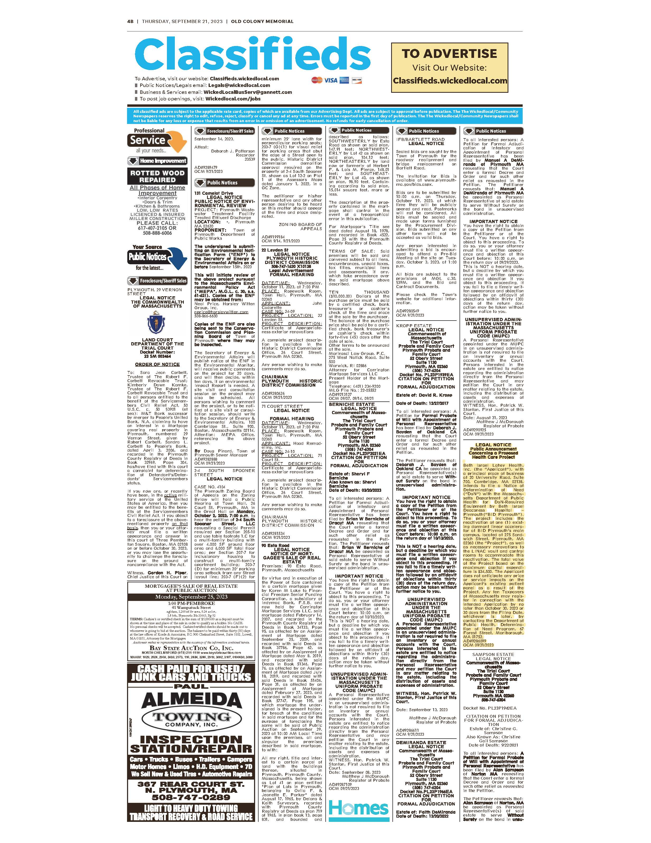

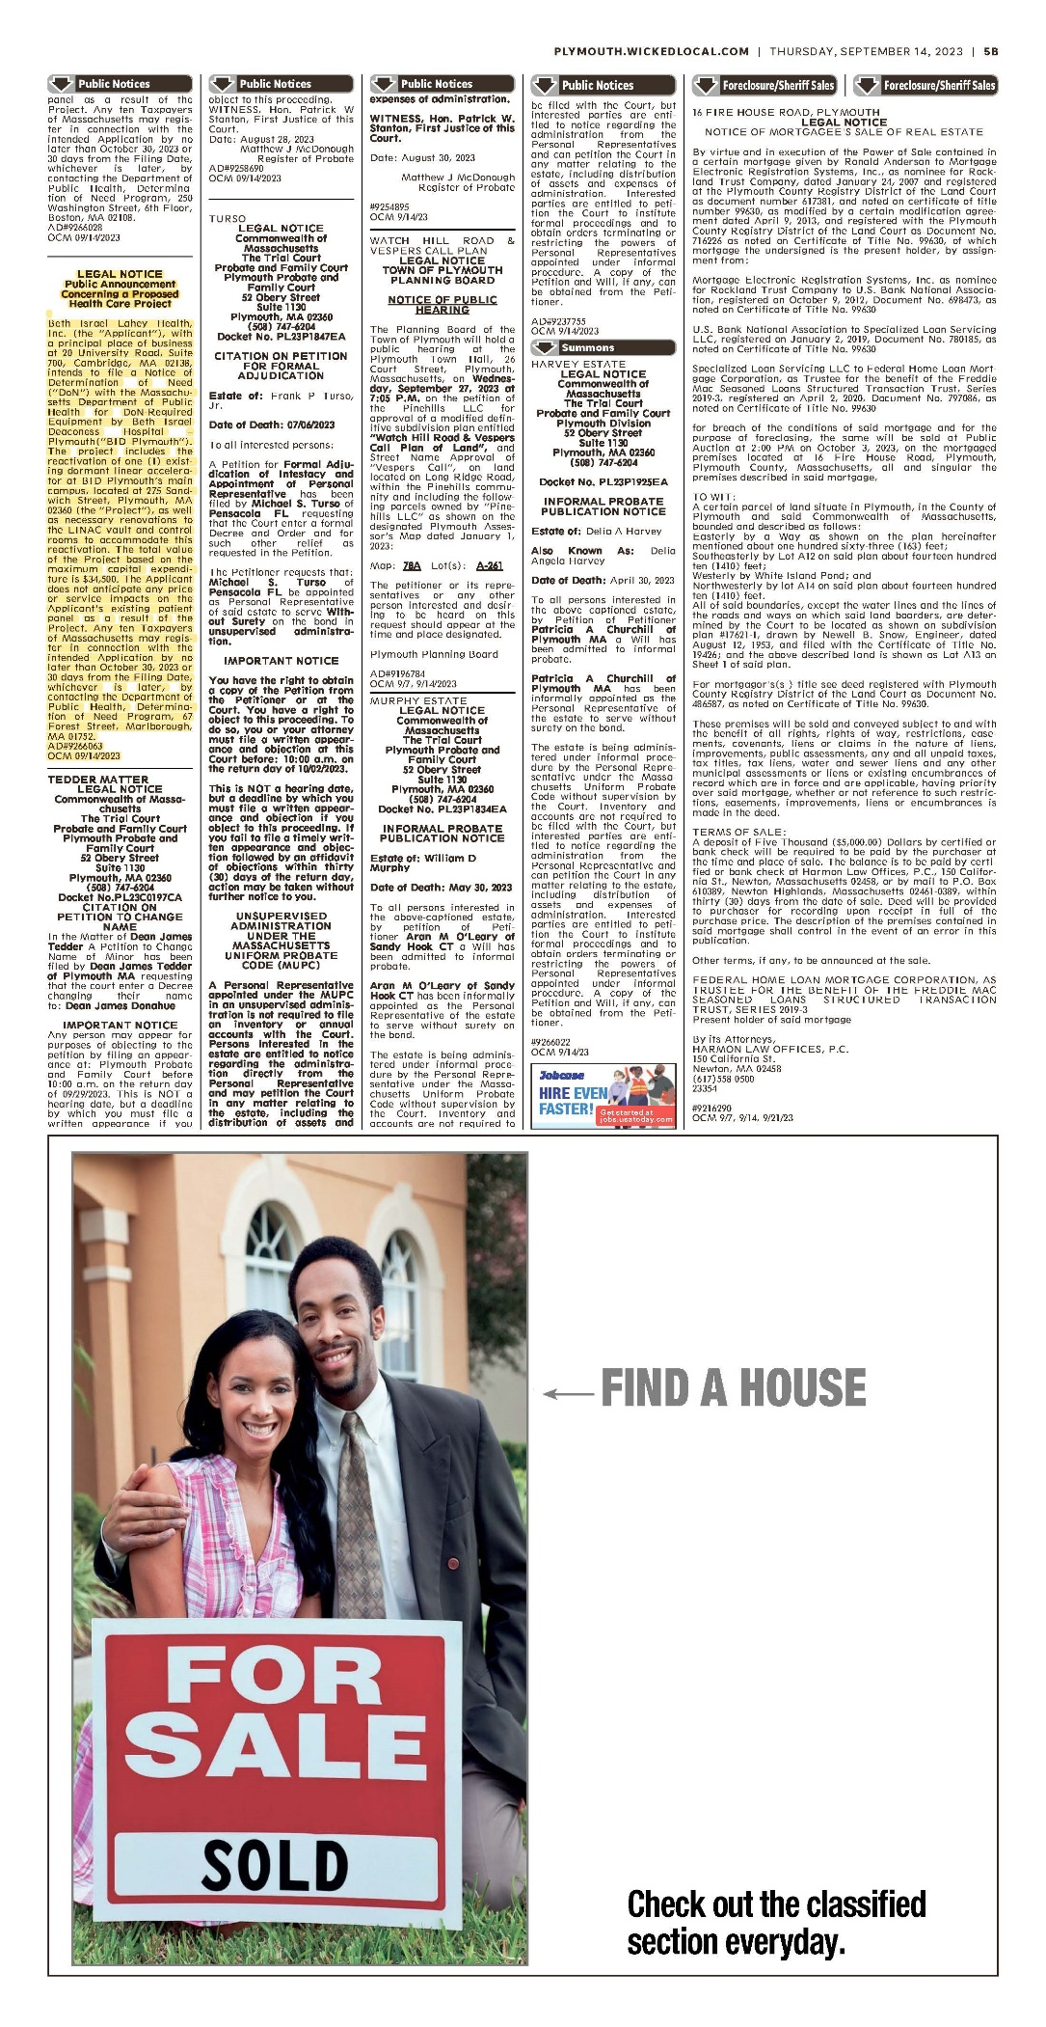

APPENDIX 5

CHANGE IN SERVICE

Version 6-14-17
Massachusetts Department of Public Health
Determination of Need
Change in Service
Application Number: BILH-23082513-RE
Original Application Date: 09/29/2023

Applicant Information:
Applicant Name: Beth Israel Lahey Health, Inc.
Contact Person: Daniel Canaday, MD
Title: Radiation Oncologist
Phone: 5088302575
E-mail: dcanaday@bidplymouth.org

Facility:
Complete the tables below for each facility listed in the Application Form
1 Facility Name: Beth Israel Deaconess Hospital - Plymouth
CMS Number: 220060
Facility Type: Hospital

Change in Service:
2.2 Complete the chart below with existing and planned service changes. Add additional services within each grouping if applicable.
Add/ Del Rows |  | Licensed Beds | Operating Beds | Change in Number of Beds (+/-) |  | Number of Beds After Project Completion (calculated) |  | Patient Days | Patient Days | Occupancy Rate for Operating Beds |  | Average Length of Stay | Number of Discharges | Number of Discharges
 |  | Existing | Existing | Licensed | Operating | Licensed | Operating | (Current/ Actual) | Projected | Current Beds | Projected | (Days) | Actual | Projected
 | Acute
 | Medical/ Surgical |  |  |  |  |  |  |  |  | 0% | 0%
 | Obstetrics (Maternity) |  |  |  |  |  |  |  |  | 0% | 0%
 | Pediatrics |  |  |  |  |  |  |  |  | 0% | 0%
 | Neonatal Intensive Care |  |  |  |  |  |  |  |  | 0% | 0%
 | ICU/CCU/SICU |  |  |  |  |  |  |  |  | 0% | 0%
+/- |  |  |  |  |  |  |  |  |  | 0% | 0%
 | Total Acute |  |  |  |  |  |  |  |  | 0% | 0%
 | Acute Rehabilitation |  |  |  |  |  |  |  |  | 0% | 0%
+/- |  |  |  |  |  |  |  |  |  | 0% | 0%
 | Total Rehabilitation |  |  |  |  |  |  |  |  | 0% | 0%
 | Acute Psychiatric
 | Adult |  |  |  |  |  |  |  |  | 0% | 0%
 | Adolescent |  |  |  |  |  |  |  |  | 0% | 0%
 | Pediatric |  |  |  |  |  |  |  |  | 0% | 0%
 | Geriatric |  |  |  |  |  |  |  |  | 0% | 0%
+/-
 | Total Acute Psychiatric |  |  |  |  |  |  |  |  | 0% | 0%
 | Chronic Disease |  |  |  |  |  |  |  |  | 0% | 0%
+/- |  |  |  |  |  |  |  |  |  | 0% | 0%
 | Total Chronic Disease |  |  |  |  |  |  |  |  | 0% | 0%
 | Substance Abuse
 | Detoxification |  |  |  |  |  |  |  |  | 0% | 0%
 | Short-term intensive |  |  |  |  |  |  |  |  | 0% | 0%
+/- |  |  |  |  |  |  |  |  |  | 0% | 0%
 | Total Substance Abuse |  |  |  |  |  |  |  |  | 0% | 0%
 | Skilled Nursing Facility
 | Level II |  |  |  |  |  |  |  |  | 0% | 0%
 | Level III |  |  |  |  |  |  |  |  | 0% | 0%
 | Level IV |  |  |  |  |  |  |  |  | 0% | 0%
+/- |  |  |  |  |  |  |  |  |  | 0% | 0%
 | Total Skilled Nursing |  |  |  |  |  |  |  |  | 0% | 0%

Complete the chart below If there are changes other than those listed in table above.
Add/Del Rows | List other services if Changing e.g. OR, MRI, etc | Existing Number of Units | Change in Number +/- | Proposed Number of Units | Existing Volume | Proposed Volume
+/- | Mobile Computed Tomography Unit | 1 | 1 | 2 | 7,945 | 9,026

Document Ready for Filing
When document is complete click on "document is ready to file". This will lock in the responses and date and time stamp the form. To make changes to the document un-check the "document is ready to file" box.
Edit document then lock file and submit. Keep a copy for your records. Click on the "Save" button at the bottom of the page.
To submit the application electronically, click on the "E-mail submission to Determination of Need" button.

This document is ready to file? Yes
Date/Time Stamp: 9/29/2023

Email Submission to Determination of Need

APPENDIX 6

ACO LETTER

April 12, 2022 Eryn Eddy
Beth Israel Lahey Health Performance Network
109 Brookline Avenue Suite 300
Boston, MA 02118

RE: ACO LEAP Certification Dear Mrs. Eddy:
Congratulations! The Health Policy Commission (HPC) is pleased to inform you that Beth Israel Lahey Health Performance Network meets the requirements for ACO Certification under our Learning, Equity, and Patient-Centeredness (LEAP) standards. This certification is effective from January 1, 2022, through December 31, 2023.

The ACO Certification program, in alignment with other state agencies including MassHealth, is designed to accelerate care delivery transformation in Massachusetts and promote a high quality, efficient health system. ACOs participating in the program have met a set of objective criteria focused on core ACO capabilities demonstrating dedication to patient-centered care, use of evidence-based and data-driven strategies to improve care delivery, and commitment to addressing long-standing health inequities. Beth Israel Lahey Health Performance Network meets those criteria.

The HPC will promote Beth Israel Lahey Health Performance Network as a Certified ACO on our website and in our marketing and public materials. Enclosed you will find an ACO Certification logo for your organization to use in accordance with the attached Terms of Use. We hope you will use the logo on promotional materials when you highlight your ACO Certification to your patients, payers, and others.

The HPC looks forward to ongoing engagement with you over the next two years. We intend to follow up shortly to provide an overview and some reflections on what we saw in the Health Equity Responses, a new feature of the ACO Certification application this year, across the cohort of Certified ACOs. We hope your organization will find that information helpful as we all continue to explore ways to improve health equity in the Commonwealth.

Thank you for your dedication to providing accountable, coordinated health care to your patients, and to continued learning and improvement over time. If you have any questions about this letter or the ACO Certification program, please do not hesitate to contact Mike Stanek, Senior Manager, at HPC- Certification@mass.gov or (617) 757-1649.

Best wishes,
David Seltz Executive Director

APPENDIX 7

AFFILIATED PARTIES

draft version 3-15-2017
Massachusetts Department of Public Health
Determination of Need
Affiliated Parties

Application Date: 09/29/2023
Application Number: BILH-23082513-RE

Applicant Information

Applicant Name: Beth Israel Lahey Health, Inc.
Contact Person: Daniel Canady, MD
Title: Radiation Oncologist
Phone: [blank]
E-mail: dcanaday@bidplymouth.org

Affiliated Parties
1.9 Affiliated Parties: List all officers, members of the board of directors, trustees, stockholders, partners, and other Persons who have an equity or otherwise controlling interest in the application.

Add/ Del Rows | Name (Last) | Name (First) | Mailing Address | City | State | Affiliation | Position with affiliated entity (or with Applicant) | Stock, shares, or partnership | Percent Equity (numbers only) | Convictions or violations | List other health care facilities affiliated with | Business relationship with Applicant
+/- | Hornidge | Ann-Ellen | 9 Wilsondale Street | Dover | MA | Beth Israel Lahey Health, Inc. | Trustee/Officer |  |  | No |  | No
+/- | Kimball, M.D. | Alexa | 4 Monmouth Street | Brookline | MA | Beth Israel Lahey Health, Inc. | Trustee |  |  | No |  | No
+/- | Canepa | John | 83 Church Street | Watertown | MA | Beth Israel Lahey Health, Inc. | Trustee/Officer |  |  | No |  | No
+/- | Jick | Daniel J. | 15 Lawrence Road | Chestnut Hill | MA | Beth Israel Lahey Health, Inc. | Trustee |  |  | No |  | No
+/- | Walsh | Jane | 89 Turnpike Street | North Andover | MA | Beth Israel Lahey Health, Inc. | Trustee |  |  | No |  | No
+/- | Sullivan, M.D. | Mary Anna | 2529 Mystic Valley Parkway | Somerville | MA | Beth Israel Lahey Health, Inc. | Trustee |  |  | No |  | No
+/- | Liesching, M.D. | Timothy | 21 Fernway | Winchester | MA | Beth Israel Lahey Health, Inc. | Trustee |  |  | No | Care Dimensions | No
+/- | Valetta | Robert | 112 Captains Road | Mashpee | MA | Beth Israel Lahey Health, Inc. | Trustee |  |  | No |  | No
+/- | Tabb, M.D. | Kevin | 64 Beethoven Ave. | Waban | MA | Beth Israel Lahey Health, Inc. | Trustee/Officer |  |  | No |  | Yes
+/- | Norman, M.D. | Nancy | 71 Alban Street | Dorchester | MA | Beth Israel Lahey Health, Inc. | Trustee |  |  | No |  | No
+/- | Linde | Doug | One Baldwin Circle | Weston | MA | Beth Israel Lahey Health, Inc. | Trustee |  |  | No |  | No
+/- | Gupta | Yogesh | 451 Malborough St., Unit 3E | Boston | MA | Beth Israel Lahey Health, Inc. | Trustee |  |  | No |  | No
+/- | Grant | Tom H. | One Reach Street, #5 | Beverly | MA | Beth Israel Lahey Health, Inc. | Trustee |  |  | No |  | No
+/- | Francisco | Betty | 137 Park Street, 37 | Dorchester | MA | Beth Israel Lahey Health, Inc. | Trustee |  |  | No |  | No
+/- | O'Hanley | Ronald | 27 Jackson Street, Apt. 240 | Lowell | MA | Beth Israel Lahey Health, Inc. | Trustee |  |  | No |  | No
+/- | McCullough, M.D. | Daniel | 900 Cummings Center | Beverly | MA | Beth Israel Lahey Health, Inc. | Trustee |  |  | No |  | No
+/- | Hannon | Trish | 15288 Devon Green Lane | Naples | FL | Beth Israel Lahey Health, Inc. | Trustee |  |  | No |  | No
+/- | Mandell, MD | James | 47 Chatham Street | Brookline | MA | Beth Israel Lahey Health, Inc. | Trustee |  |  | No |  | No
+/- | McKenna | Margaret | 100 Belvidere Street | Boston | MA | Beth Israel Lahey Health, Inc. | Trustee |  |  | No |  | No
+/- | Kington, MD, PhD | Raynard S. | 189 Main Street | Andover | MA | Beth Israel Lahey Health, Inc. | Trustee |  |  | No |  | No

Document Ready for Filing
When document is complete click on "document is ready to file". This will lock in the responses and date and time stamp the form. To make changes to the document un-check the "document is ready to file" box.
Edit document then lock file and submit Keep a copy for your records. Click on the "Save" button at the bottom of the page. To submit the application electronically, click on the "E-mail submission to Determination of Need" button.

This document is ready to file? Yes
Date/time Stamp: 06/09/2023 9:40 am
E-mail submission to Determination of Need

APPENDIX 8

ARTICLES OF INCORPORATION

https://corp.sec.state.ma.us/CorpWeb/CorpSearch/CorpSearchRedirector.aspx?Action=PDF&Path= CORP_DRIVE1/2018/1127/001517515/0003/201848640920_1.pdf

https://corp.sec.state.ma.us/CorpWeb/CorpSearch/CorpSearchRedirector.aspx?Action=PDF&Path= CORP_DRIVE1/2022/0119/000000000/1391/202297128210_1.pdf

https://corp.sec.state.ma.us/CorpWeb/CorpSearch/CorpSearchRedirector.aspx?Action=PDF&Path= CORP_DRIVE1/2019/0719/001716104/0001/201915220970_1.pdf

APPENDIX 9

AFFIDAVIT

Version: 7-6-17

Massachusetts Department of Public Health

Determination of Need

Affidavit of Truthfulness and Compliance

with Law and Disclosure Form 100.405 (B)
Instructions: Complete Information below. When complete check the box "This document is ready to print:". This will date stamp and lock the form. Print Form. Each person must sign and date the form. When all signatures have been collected, scan the document and e-mail to: dph.don@state.ma.us Include all attachments as requested.
Application Number: BILH-23082513-RE
Original Application Date: 09/29/2023
Applicant Name: Beth Israel Lahey Health, Inc.
Application Type: DoN-Required Equipment
Applicant's Business Type: Corporation
Is the Applicant the sole member or sole shareholder of the Health Facility(ies) that are the subject of this Application? Yes
The undersigned certifies under the pains and penalties of perjury:
- The Applicant is the sole corporate member or sole shareholder of the Health Facility(ies) that are the subject of this Application;
- I have read [been informed of the contents of] 105 CMR 100.000, the Massachusetts Determination of Need Regulation;
- I understand and agree to the expected and appropriate conduct of the Applicant pursuant to 105 CMR 100.800;
- I have read [been informed of the contents of] this application for Determination of Need including all exhibits and attachments, and certify that [have been informed that] all of the information contained herein is accurate and true;
- I have submitted the correct Filing Fee and understand it is nonrefundable pursuant to 105 CMR 100.405(B);
- I have submitted the required copies of this application to the Determination of Need Program, and, as applicable, to all Parties of Record and other parties as required pursuant to 105 CMR 100.405(B);
- I have caused, as required, notices of intent to be published and duplicate copies to be submitted to all Parties of Record, and all carriers or third-party administrators, public and commercial, for the payment of health care services with which the Applicant contracts, and with Medicare and Medicaid, as required by 105 CMR 100.405(C), et seq.;
- I have caused [have been informed that] proper notification and submissions to the Secretary of Environmental Affairs pursuant to 105 CMR 100.405(E) and 301 CMR 11.00; will be made, if applicable.
- If subject to M.G.L. c. 6D, § 13 and 958 CMR 7.00, I have submitted such Notice of Material Change to the HPC - in accordance with 105 CMR 100.405(G);
- Pursuant to 105 CMR 100.210(A)(3), I certify that both the Applicant and the Proposed Project are in material and substantial compliance and good standing with relevant federal, state, and local laws and regulations, as well as with all previously issued Notices of Determination of Need and the terms and Conditions attached therein [issued in compliance with 105 CMR 100.00, the Massachusetts Determination of Need Regulation effective January 27, 2017 and amended December 28, 2018];
- I have read [been informed of the contents of] and understand the limitations on solicitation of funding from the general public prior to receiving a Notice of Determination of Need as established in 105 CMR 100.415;
- I understand that, if Approved, the Applicant, as Holder of the DoN, shall become obligated to all Standard Conditions pursuant to 105 CMR 100.310, as well as any applicable Other Conditions as outlined within 105 CMR 100.000 or that otherwise become a part of the Final Action pursuant to 105 CMR 100.360;
- Pursuant to 105 CMR 100.705(A), I certify that the Applicant has Sufficient Interest in the Site or facility; and
- Pursuant to 105 CMR 100.705(A), I certify that the Proposed Project is authorized under applicable zoning by-laws or ordinances, whether or not a special permit is required; or,
  - If the Proposed Project is not authorized under applicable zoning by-laws or ordinances, a variance has been received to permit such Proposed Project; or,
  - The Proposed Project is exempt from zoning by-laws or ordinances.
Corporation
Attach a copy of Articles of Organization/Incorporation, as amended

Kevin Tabb, MD <Signature on File> 9/26/23
CEO for Corporation: Signature: Date:

Ann-Ellen Hornidge, JD <Signature on File> 9/26/23
Board Chair for Corporation Name: Signature: Date:

This document is ready to print: unchecked Date/time Stamp: [blank]

APPENDIX 10

FILING FEE

Crystal M. Bloom
Partner

One Beacon Street, Suite 1320 Boston, MA 02108
Direct: 617.598.6783
Fax: 617.720.5092
crystal.bloom@huschblackwell.com

September 29, 2023

Via FedEx

Dennis Renaud
Director, Determination of Need Program Department of Public Health
250 Washington Street
Boston, MA 02108

Re: Beth Israel Lahey Health, Inc.
Determination of Need Application # BILH-23082513-RE

Dear Mr. Renaud:

Please find enclosed the filing fee for the Beth Israel Deaconess Hospital – Plymouth, Determination of Need Application (Application # BILH-23082513-RE).

We thank you for your assistance with this matter. Please do not hesitate to contact Claire Postman, Esq. or me if you have any questions or require additional information.

Sincerely

HUSCH BLACKWELL LLP

[signature on file]

Crystal M. Bloom

Enclosure

Husch Blackwell LLP

I
