CAMBRIDGE HEALTH ALLIANCE DON APPLICATION # CHA-22061514-RE

DON REQUIRED EQUIPMENT
ADDITION OF PET-CT SERVICES AT CHA MALDEN CARE CENTER

AUGUST 31, 2022

CAMBRIDGE HEALTH ALLIANCE DON APPLICATION # CHA-22061514-RE

TABLE OF CONTENTS

- Determination of Need Narrative and Tables

- Evidence of Community Engagement
  - Patient and Family Advisory Council Presentation

- Factor 4 Independent CPA Analysis

- Factor 6 Community Health Initiative Materials
  - Community Health Initiative Narrative
  - Everett-Malden Community Health Needs Assessment (2019/2020)
  - Community Health Implementation Strategy – Everett and Malden (July 2021)
  - CHNA/CHIP Self-Assessment Form

- Notice of Intent

- HPC ACO Certification Approval Letter

- Formation Documents: Chapter 147 of the Acts of 1996, as amended by Chapter 365 of the Acts of 1998

- Affidavit of Truthfulness and Compliance

- Filing Fee

ATTACHMENT 2

EVIDENCE OF COMMUNITY ENGAGEMENT
  - PATIENT AND FAMILY ADVISORY COUNCIL PRESENTATION

CHA Mobile PET/CT Proposal
Patient & Family Advisory Council (PFAC) 6-16-22

What is PET/CT?
- Positron Emission Tomography (PET) is an imaging test that can help reveal the metabolic or biochemical function of your tissues and organs. PET images are then overlaid with the anatomic data of Computed Tomography (CT) or Magnetic Resonance (MR) images to identify the exact location and stage of disease.
- PET/CT allows both the PET images and CT images to be obtained at the same time assuring the positioning is the same for both sets of images.
- PET has been used for cancer detection and follow up care since inception and is becoming the standard of care for various cancers.
- Newer uses for PET include cardiac imaging to determine decreased blood flow and brain imaging for conditions such as tumors, Alzheimer’s and seizures.

Present State
- Cambridge Health Alliance (CHA) currently does not provide this service so patients are referred externally to other healthcare organizations.
- There are no local providers in Malden which is an inconvenience for patients who may need to seek public transportation, disrupt their work schedule, and bear additional cost and hardship.
- CHA receives insurance claims data for the majority of our Primary Care panel patients (Adults and Children). The data indicated 150 unique Adult patients had PET/CT outside of CHA in Calendar Year 2019 and another 129 patients had it in Calendar Year 2020. We project demand for this service of 300-350 patients on 100% of our Primary Care Adult panel.
- The majority of CHA’s patients went to Beth Israel Deaconess Medical Center in downtown Boston.

Proposal
- Pending budget approval from CHA’s Board of Trustees, CHA will offer PET/CT services through a partnership with Alliance HealthCare Radiology. Alliance is a well known, established PET/CT provider in Massachusetts.
- This service will be offered in a state-of-the art mobile van adjacent to the Malden Care Center. Ample parking will be available and no existing green space will be converted to offer this service.
- A parking pad will need to be constructed to support the weight of the van.
- Mobile PET/CT will be initially offered one day per week, but can be ramped-up based on patient demand.
- Prospective patients will be registered at a check-in area within the Malden Care Center.
- The goal is to offer this service within a year subject to regulatory approval.

Thank you!!!
Any questions???
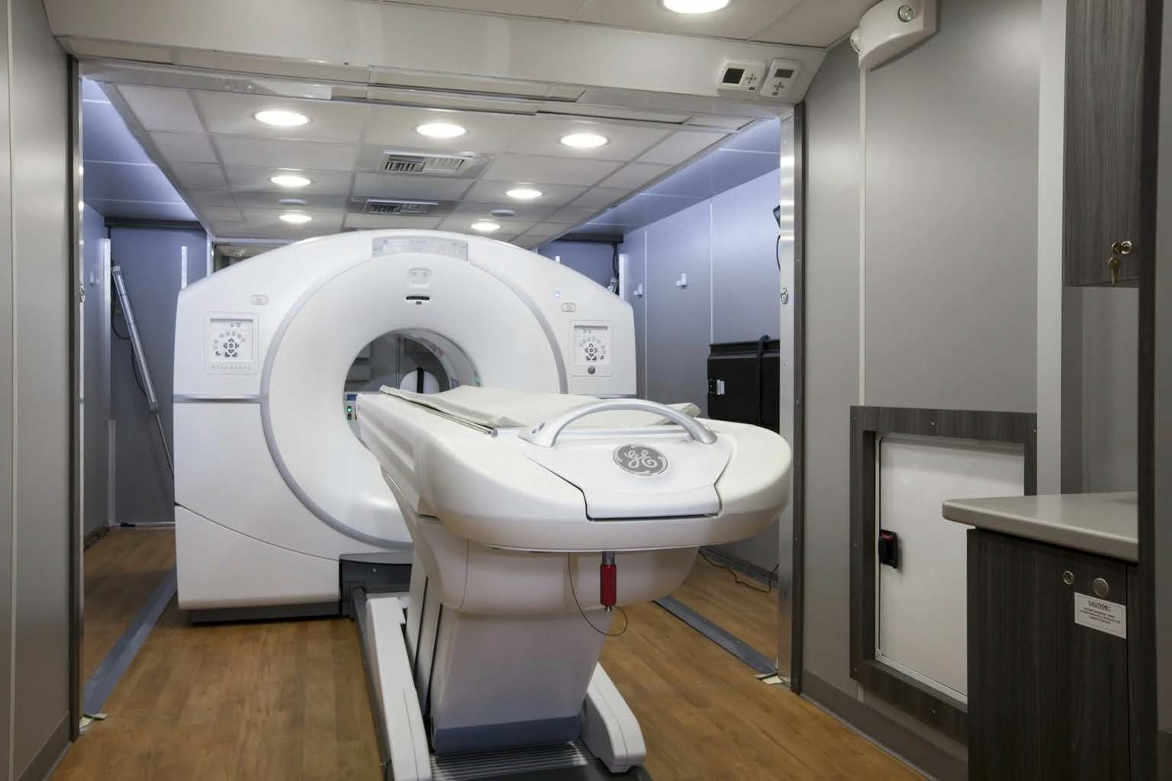

ATTACHMENT 4

FACTOR 6 COMMUNITY HEALTH INITIATIVE MATERIALS

ATTACHMENT 4 (A)

COMMUNITY HEALTH INITIATIVE NARRATIVE

CHA Regional Wellbeing Assessment Process Overview

Cambridge Health Alliance (CHA) through the Community Health Improvement Department conducts Community Health Needs Assessments (CHNA) and Implementation Strategy (IS) within the Patient Service Area are on a 3 year cycle. This has evolved from single municipal assessments to a regional assessment that describes the strengths and challenges of the CHA service area, including the communities of Somerville, Medford, Malden, Everett, Chelsea, Revere and Winthrop. The municipalities are grouped into 3 sub-regions, each with a Community Advisory Board, also referred to as a CAB, to guide the local implementation of the regional process. The CHNA includes primary and secondary data sources used to guide discussions and prioritize implementation strategies. The goal of this process is for people to tell their stories, elevate priorities that matter to them, and collaborate to improve the health of their communities.

Through this process, CHA engages members of communities who are closest to the impact of inequitable health outcomes and are actively involved in what questions are asked, what information is collected, and how that information is examined. CHA developed two Community Advisory Boards (CABs) to guide the work at the local level. One CAB guided the assessment in Medford and Somerville, and one guided the work in Everett and Malden. CHA is integrated with the efforts of the North Suffolk Public Health Collaborative’s Steering Committee, which continues its role in guiding assessment in Chelsea, Revere, and Winthrop. CAB members were recruited from diverse communities – across professional sectors, forms of power, and lived experience of the impacts of structural forms of inequity. Each CAB met regularly, about every 6–8 weeks. This work was connected with CHA’s Community Health Advisory Committee. Cambridge Public Health Department implements a single community CHNA to fulfill their Accreditation requirements.

The CHA CHNA/IS is based on the framework called the Tool for Health + Resilience in Vulnerable Environments (THRIVE), co-developed by the Prevention Institute and the US Office for Minority Health. CHA chose THRIVE because it has an explicit focus on equity and addressing structural determinants of health by elevating the community conditions that contribute to inequitable health outcomes. THRIVE is also a tool for engaging community members in assessing community conditions, prioritizing them, and taking action to change them. THRIVE identifies three ways of describing community conditions, also known as social determinants of health. The first is PEOPLE, which refers to the social and cultural environment. The second is PLACE, or the natural and built environment. The third is EQUITABLE OPPORTUNITY, or the economic and educational environment. Each area includes factors that research and experience have shown are associated with health and wellbeing outcomes. THRIVE is designed to help communities focus their analysis of the factors that contribute to illness, injury, and inequity at the community level, and to determine where and how to take action to make an impact on these interacting factors.

The Health Improvement Team (HIT) leads this work, in coordination with the efforts of health system and municipal partners who are also engaging in assessments – including Beth Israel Lahey Health, Mass General Brigham, the North Suffolk Public Health Collaborative, and the Metropolitan Area Planning Council. The CHA CHNA/IS process and deliverable timeline has been as follows:

During Summer 2021, CAB members and other community members and advisors participated in defining the areas of inquiry, guiding principles, what information was needed, and how it should be collected. HIT staff and partners did the work of creating the tools and documenting the methods.

In Fall 2021, HIT staff, community researchers, interns, and partners began collecting and analyzing the data. This involved focus groups, key informant interviews, administering surveys, analyzing existing data from different sources, and other methods. 2,045 Surveys, 130 participants in Focus Groups and 52 participants in Key Informant (in depth) Interviews were held through CHA’s Primary Service Area in 5 languages. Surveys were available in digital and written format.
In early 2022, we held community meetings to share initial findings and to make sense of the data together. The results of the assessment were interpreted in collaboration with community members, and shared in formats that were accessible to and of value to diverse communities.
In Spring 2022, CAB members continued to collaborate to select priority focus areas. Through Summer 2022, the HIT will work together with partners to develop implementation strategies and goals, including deciding on indicators to monitor progress. We will develop plans to secure and leverage, when appropriate, the resources necessary to realize the collaborative plans that have been developed.
By Fall 2022, plans will be finalized to guide collective efforts to strengthen wellbeing across the CHA region. As we collaborate toward shared goals, we will communicate openly and regularly, and ask what is working well, what needs to change, and how we can continue to improve.
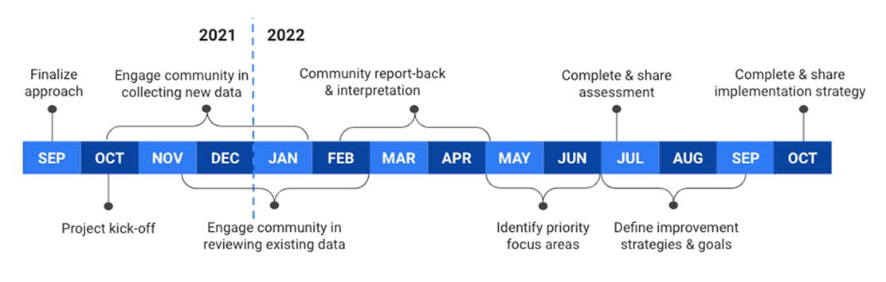
3965\0001\847903.1

ATTACHMENT4 (B)

EVERETT-MALDEN COMMUNITY HEALTH NEEDS ASSESSMENT (2019/2020)

Here is the link for the CHNA: https://www.challiance.org/file%20library/about%20cha/community%20health%20improvement/community%20health%20data%20and%20reports/everett-malden_chna_report_2019.pdf

ATTACHMENT 4(C)

COMMUNITY HEALTH IMPLEMENTATION STRATEGY –EVERETT AND MALDEN (JULY 2021)

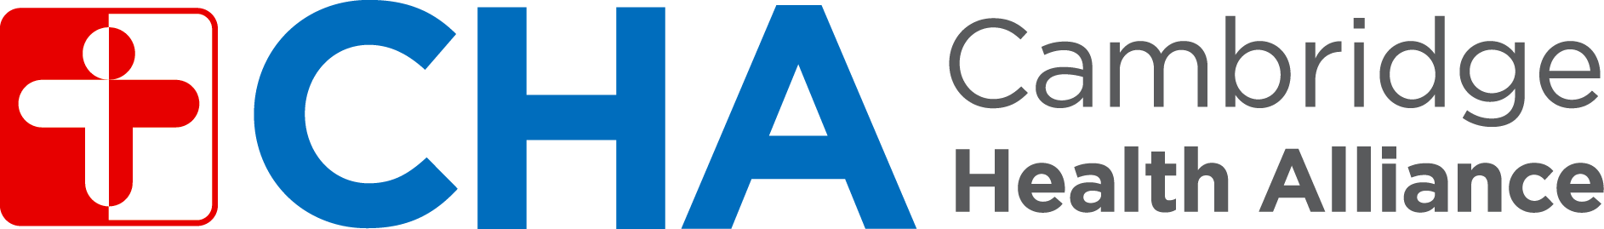

Community Health Implementation Strategy
Everett and Malden

Department of Community Health Improvement July 2021



Introduction 2
Part 1: Everett-Malden CHNA Process & Findings 3
Strengths of our communities 4
Concerns impacting health 4
Equity concerns 4
Part 2: Modified Implementation Strategy Process, and
Looking Ahead to a Regional Wellbeing Assessment 5
Part 3: Key Findings 7
Part 4: Goals, Strategies, and Collaborative Efforts 8
Quick Summary: Priority Areas and Goals 8
Implementation Strategy Details 9
Access to Health Care and Services 9
Mental Health and Substance Use 10
Chronic Diseases and STIs 12
Economic Stability and Mobility 13
Access to Healthy Food 14
Safe and Affordable Housing 15
Conclusion 15
Acknowledgements 16

Every three years, Massachusetts health systems and hospitals carry out a Community Health Needs Assessment (CHNA), which informs an Implementation Strategy. A CHNA is a collaboration between a health system and the community it serves, to understand, prioritize, and take action on strengths and concerns related to community health. An Implementation Strategy documents the health system’s efforts to address priorities identified in the CHNA in collaboration with the community. It serves as a guide for the health system’s work. Figure 1 depicts the CHNA & Implementation Strategy cycle.

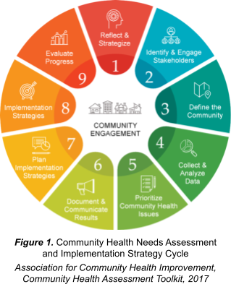
In 2019, Cambridge Health Alliance (CHA) partnered with Mass General Brigham and Melrose Wakefield Healthcare to carry out a CHNA in Everett and Malden. The final report was released in March 2020, but the development of CHA’s Implementation Strategy was interrupted due to COVID-19.

In early 2021, CHA’s Health Improvement Team launched a modified process to reflect and document how CHA’s community health strategies – in and with our communities – address priorities that Everett and Malden residents had identified through the CHNA. This process of reflection frames the work that lies ahead for CHA – a Regional Wellbeing Assessment, which will launch in Fall 2021.

We are pleased to share CHA’s Implementation Strategy report with you. In this document, you will find four main sections:

- In Part 1, we will review the process and findings of the 2019-2020 Everett-Malden CHNA.
- In Part 2, we will share why and how we modified the Implementation Strategy development process, and introduce you to the upcoming Regional Wellbeing Assessment.
- In Part 3, we will share the key findings that shaped the Implementation Strategy.
- In Part 4, we will share the goals, strategies, and collaborative efforts that compose the Department of Community Health Improvement’s commitment to addressing the priorities identified in the 2019-2020 Everett-Malden CHNA.

Part 1: Everett-Malden CHNA Process & Findings
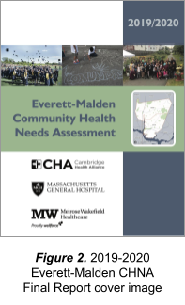
In 2019, CHA partnered with Mass General Brigham and Melrose Wakefield Healthcare to carry out a collaborative CHNA in Everett and Malden. The 2019-2020 Everett-Malden Community Health Needs Assessment final report was released in March 2020. The cover image of the report is shown in Figure 2.

We used a framework called the Tool for Health and Resilience in Vulnerable Environments, or THRIVE, to guide the CHNA. THRIVE is a model for engaging community members in assessing community conditions and taking action on priorities to advance health equity.
THRIVE identifies three main clusters of community conditions that influence the health of the community. These clusters are:
- PEOPLE, which refers to the social and cultural environment – factors like social cohesion and sense of collective efficacy.
- PLACE, or the natural and built environment – factors like housing, transit, air & water, and arts & cultural expression.
- EQUITABLE OPPORTUNITY, or the economic and
educational environment – factors like the job market, local wealth, and schools.

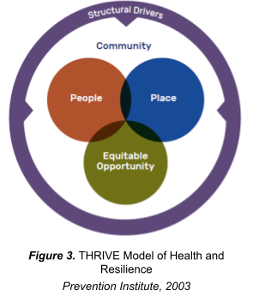
As shown in Figure 3, the framework emphasizes that the nature of community conditions emerges from structural drivers – such as racism and white privilege, class oppression and privilege, and gender inequity. In turn, the community conditions in which people live influence how health outcomes are distributed along lines of place, socioeconomic position, racial or ethnic group, or other elements of identity.
By orienting the assessment process around exploring these domains of People, Place, and Equitable Opportunity, we aimed to lay the groundwork for thinking about what strategies could be developed, and what barriers could be removed, to facilitate opportunity for better, equitable health outcomes.
THRIVE was developed by the Prevention Institute – for more information, visit their website.

Through interviews, focus groups, community surveys, and analysis of existing data sources, the assessment illuminated many strengths and concerns of the Everett and Malden communities.

Strengths of our communities
The main community strengths that were identified included:

- Cultural and language diversity
- Open space and recreation
- Meals for students and seniors
- Produce markets and community gardens
- Social service, civic, and community organizations

Concerns impacting health
The main concerns impacting health that were identified included:

- Housing affordability and stability
- Economic stability and mobility
- Access to healthy food
- Access to health care and services
- Mental health and substance use
- Chronic diseases and sexually transmitted infections

Equity concerns
Equity concerns were highlighted along lines of:

- Race and ethnicity
- Immigration status
- Language
- Age

Part 2: Modified Implementation Strategy Process, and Looking Ahead to a Regional Wellbeing Assessment
Almost as soon as the CHNA was released in March 2020, CHA’s Department of Community Health Improvement team had to shift our focus to responding to COVID-19. Nine months later, in early 2021, we decided to take a step back, review the 2019-2020 CHNA, and determine how we could develop an Implementation Strategy that took into account the new reality that COVID-19 had resulted in. We took this opportunity to establish a baseline of how CHI shows up in the community-identified priority areas, and aimed to respect the time and bandwidth of the people in Everett and Malden who would soon be asked to participate in a Regional Wellbeing Assessment starting in Fall 2021.
While the findings of the CHNA were still valid, we believed the priority needs and equity concerns had been amplified. Community strengths had been stretched and grown in new ways. Many people involved in the CHNA had moved to new jobs, or their roles had shifted. The pandemic had been a shock to our lives and systems – we would need to work together intentionally to recover and heal.
We decided to modify the Implementation Strategy development process to be carried out over the first six months of 2021, by orienting it around a new framing question:

How does the work of CHA’s Department of Community Health Improvement (CHI) align with the priority needs, community strengths, and equity concerns identified in the Everett-Malden CHNA?

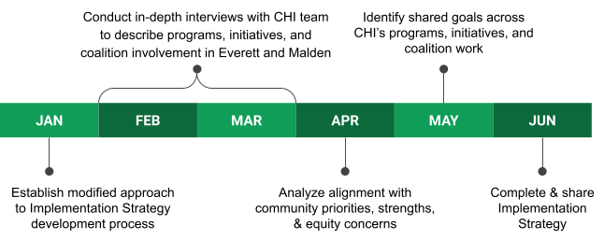
This modified process enabled us to reflect on the current state, and to lay the groundwork for moving forward collaboratively, effectively, and equitably – in coordination with other health systems, community partners, municipal partners, and within CHA, across clinical services, mental health, community health, and beyond.

To that end, we are planning a Regional Wellbeing Assessment, to launch in Fall 2021, that will include community members and partners in Everett and Malden, along with other municipalities in CHA’s primary service area. This upcoming assessment represents an opportunity to collaborate on elevating the priorities that are now most important, particularly to communities most impacted by inequity. It will be aligned with the CHNA cycles that other health systems in our region are carrying out as well. A high-level timeline for the assessment is shown below.

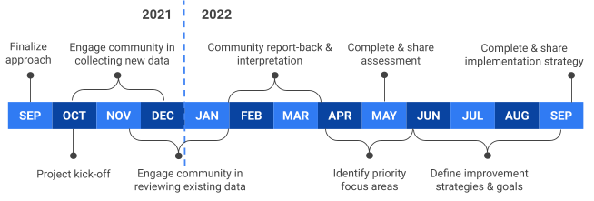

Learn more about the Regional Wellbeing Assessment in this two-page concept overview.

Part 3: Key Findings
When we looked across CHI’s programs, initiatives, and coalition involvement, we found that many of our CHI strategies align with multiple community-identified priorities. And, many focus on equity concerns voiced by and on behalf of multiple populations. Figure 4 shows the number of strategies that are aligned with each priority need, and Figure 5 shows the number of strategies that are aligned with equity concerns related to each population.
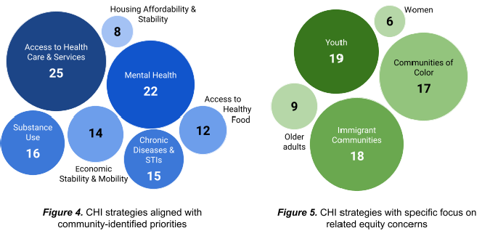

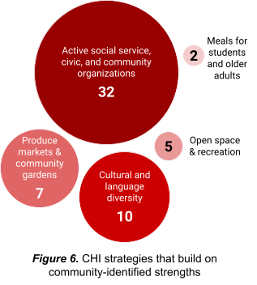
We also found that our CHI strategies build on many community-identified strengths, especially in terms of collaborating with the many social service, civic, and community organizations that are active in Everett and Malden. Figure 6 shows the number of strategies that build on the strengths that were identified through the CHNA process.

Part 4: Goals, Strategies, and Collaborative Efforts
Based on the key findings, we identified common themes, community partners, and aligned objectives. We synthesized these into 8 goals across 6 community-identified priorities, with 2–4 strategies per goal. The tables below describe the Department of Community Health Improvement’s commitment to addressing the priorities identified in the 2019-2020 Everett-Malden CHNA.

Quick Summary: Priority Areas and Goals
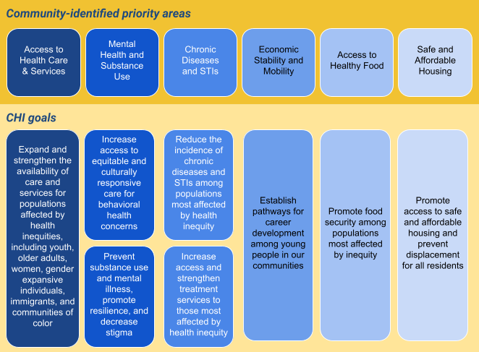

Implementation Strategy Details

Priority: Access to Health Care and Services
Our Goals: CHI works to... Our Strategies: We approach this goal by...
Expand and strengthen the ● Promoting affordability, language inclusivity, location + hours
1 availability of care and accessibility, and culturally responsive care options that services for populations address structural barriers to care.
affected by health ● Developing and maintaining systems of care navigation, inequities, including youth, screening, and referral.
older adults, women and
gender expansive ● Promoting peer learning, workshops, and health individuals, immigrant communication tailored to experiences.
communities, and ● Investing in current and future public health and health care communities of color. professionals, including through internships and training
opportunities that embody and emphasize anti-racism.
Key Programs and Collaborative Initiatives
- Health care, prevention, education, and referral services are offered in alignment with equity and access goals at the Everett Care Center and Malden Care Center, and Everett Teen Health Center and the Starr Center (Malden’s pilot School Based Health Center), including:
  - HIV and STI screening, testing, and referral to treatment
  - Sexual and reproductive health counseling and family planning options
  - Mental health counseling and services
  - Substance use counseling and recovery, including Medication-Assisted Treatment
- Community Connects engages members of communities disproportionately impacted by COVID-19 in conversations about priority topics, such as myths and facts about the virus, preventing exposure and infection, keeping families safe, accessing testing and treatment, and promoting vaccine confidence.
- The Volunteer Health Advisors (VHA) program provides training to diverse community members to serve in a variety of community health worker roles, including connecting individuals to health care and other services, and supports community-based engagement activities tailored to the experiences and priorities of communities affected by health inequities.
- Mental Health Awareness Training (MHAT) and Mental Health First Aid (MHFA) provide training to community members to support mental health among adults and youth, including by responding and connecting individuals to appropriate care during a mental health crisis.
- The Women’s Health Program promotes education and navigation to breast cancer screening, tailored to the experiences of women of diverse ethnic identities and language backgrounds.

- Aging Wisely Everett and Senior to Senior offer health education, information about available services, and engagement opportunities to older adults.
- Healthy ME, Street Smart, and Helping Hands at Work provide health education, leadership development, and information about available health care services to youth.
- The Everett Youth Worker Network and summer internships provide young people with opportunities to gain experience and skills in public health and health care.

Key Community Partners
- Everett Haitian Community Center
- Everett and Malden Mayor’s Offices
- Everett and Malden Public Schools
- Greater Malden Asian American Community Coalition (GMAACC)
- La Comunidad, Inc.
- Malden YWCA and YMCA
- Sharewood Clinic
Approaches to Measurement
- Service utilization
- Community event participation
- Training participation
- Participant surveys

Priority: Mental Health and Substance Use
Our Goals: CHI works to... Our Strategies: We approach this goal by...
- Increase access to ● Investing in developing services and outreach programs that equitable and culturally are affordable, culturally relevant, accessible in diverse
responsive care for languages, and responsive to the needs of communities behavioral health impacted by inequity.
concerns ● Developing policies, systems, and infrastructure to increase access to mental health and substance use care.

- Prevent substance use ● Investing in assessment of risks and opportunities, and in the and mental illness, policies, systems, and infrastructure necessary to address
promote resilience, and those risks and leverage those opportunities.
decrease stigma ● Strengthening capacity for resilience among communities
most affected by inequity, by investing in knowledge, self-eﬃcacy, and connectedness

Key Programs and Collaborative Initiatives
  - Behavioral health care, prevention, education, and referral services are offered in alignment with equity and access goals at the Everett Care Center and Malden Care Center, the

Everett Teen Health Center and Starr Center (Malden pilot School Based Health Center), and the Bridge Recovery Center.
  - The Volunteer Health Advisors (VHA) program provides training to diverse community members to serve in a variety of community health worker roles, including connecting individuals to behavioral health care services, and supports community-based engagement activities on topics including mental health, substance use, and stigma.
  - Participation in coalitions and cross-sector efforts, such as the Mystic Valley Public Health Coalition, Malden Public School Wellness Committee, Healthy Neighborhoods Study, Malden’s Promise Coalition, and the Regional Assessment of Casino Impact, facilitate assessment, planning, advocacy, and collective efforts to address behavioral health priorities.
  - Mental Health Awareness Training (MHAT) and Mental Health First Aid (MHFA) provide training to community members to support mental health among adults and youth, including responding to and de-escalating mental health crises, addressing stigma, and connecting individuals to appropriate prevention and treatment options in the community.
  - Aging Wisely Everett and Senior to Senior offer health education and engagement opportunities that promote mental health among older adults.
  - TEASA (Teens in Everett Against Substance Abuse), Healthy ME, Street Smart, Helping Hands at Work, and Empowering Youth in our Community (EYC) offer education, leadership development, and opportunities for youth to carry out campaigns and other collaborative activities related to promoting mental health, preventing substance use, combating stigma, and promoting resilience and connectedness.

Key Community Partners
    - Eliot Community Human Services, Behavioral Health Clinic + Family Resource Center
    - Everett Council on Aging
    - Everett Haitian Community Center
    - Everett and Malden Mayor’s Offices
    - Everett and Malden Public Schools
    - Housing Families, Inc.
    - Joint Committee for Children’s Health Care in Everett (JCCHCE)
    - La Comunidad, Inc.
    - Latinos Unidos en MA (LUMA)
    - Malden Senior Center
    - Malden Teen Enrichment Center (MTEC)
Approaches to Measurement
- Service utilization
- Community event participation
- Training participation
- Participant surveys
- Public health surveillance data and health outcome data
- Student health surveys

Priority: Chronic Diseases and STIs
Our Goals: CHI works to... Our Strategies: We approach this goal by...
- Reduce the incidence of ● Developing education and prevention resources and programs chronic diseases & STIs to encourage preventive behaviors.
among populations most ● Collaborating to develop and advocate for policies, systems, affected by health inequity and environments that promote healthy behaviors and reduce
exposures that lead to chronic diseases and STIs

- Increase access and ● Promoting affordability, language inclusivity, location + hours strengthen treatment accessibility, and culturally responsive care options for chronic
services to those most disease and STI treatment services.
affected by health inequity ● Developing and maintaining systems of care navigation,
screening, and referral for chronic diseases and STIs

Key Programs and Collaborative Initiatives
  - Care, prevention, education, and referral services are offered in alignment with equity and access goals for chronic diseases and STIs, including HIV, at the Everett Care Center and Malden Care Center, and the Everett Teen Health Center and Starr Center (Malden pilot School Based Health Center).
  - Participation in coalitions and cross-sector efforts, such as Malden Is Moving, Malden Public School Wellness Committee, and the Healthy Neighborhoods Study, facilitate assessment, planning, advocacy, and collective efforts to address and prevent chronic diseases and STIs.
  - Mental Health Awareness Training (MHAT) and Mental Health First Aid (MHFA) provide training to community members to support mental health among adults and youth, including responding to and de-escalating mental health crises, addressing stigma, and connecting individuals to appropriate prevention and treatment options in the community.
  - Aging Wisely Everett, Senior to Senior, and My Life My Health offer health education and engagement opportunities related to living with a chronic illness for older adults.
  - Healthy ME, Street Smart, Helping Hands at Work, and Empowering Youth in our Community (EYC) offer education, leadership development, and opportunities for youth to carry out campaigns and other collaborative activities related to promoting health, preventing chronic disease and STIs, combating stigma, and promoting resilience and connectedness.

Key Community Partners
    - Everett Council on Aging
    - Everett and Malden Public Schools
    - Malden YWCA
Approaches to Measurement
- Service utilization
- Community event participation
- Training participation
- Participant surveys

  - Public health surveillance data and health outcome data
  - Student health surveys

Priority: Economic Stability and Mobility
Our Goals: CHI works to... Our Strategies: We approach this goal by...
6 Establish pathways for ● Creating youth jobs and internship opportunities and offering career development resources for leadership development among young people
among young people in that embody and emphasize anti-racism.
our communities ● Strengthening capacity for resilience among communities
most affected by inequity, by investing in promoting knowledge, self-eﬃcacy, and connectedness.

Key Programs and Collaborative Initiatives
- TEASA (Teens in Everett Against Substance Abuse) and Empowering Youth in our Community (EYC) offer leadership development and opportunities for youth to carry out campaigns and other collaborative activities related to community health and systems change.
- The Everett Youth Worker Network and summer internships provide young people with opportunities to gain experience and skills in public health and health care.
- The Volunteer Health Advisors (VHA) program provides training to diverse community members to serve in a variety of community health worker roles.
- Co-located free VITA Tax Preparation Services at CHA through partnership with ABCD

Key Community Partners
  - Action for Boston Community Development
  - Everett Haitian Community Center
  - Everett Public Schools
  - Malden YMCA
  - Malden YWCA
Approaches to Measurement
- Job/internship placements
- Training participation
- Participant surveys

Priority: Access to Healthy Food
Our Goals: CHI works to... Our Strategies: We approach this goal by...
7 Promote food security ● Investing in local food production and distribution by leveraging among populations most community strengths around gardens, farms, and markets.
affected by inequity ● Collaborating to assess and evaluate the food environment, and
to develop and advocate for policies that promote food security.

Key Programs and Collaborative Initiatives
- Everett Community Growers grows and distributes fresh produce from urban farms, partnering with residents and organizations invested in promoting food security through sustainable agriculture.
- Aging Wisely Everett and Senior to Senior engage older adults in gardening.
- Farmer Dave’s CSA is a partnership with a local farm, offering reduced cost community-supported agriculture (CSA) shares to CHA patients and staff.
- Participation in coalitions and cross-sector efforts, such as the Malden Community Food Assessment; Healthy Neighborhoods Study; Tri-City Hunger Network; Housing, Health, and Hunger Advocates; and CHA’s Food Security Strategic Plan, facilitate assessment, planning, advocacy, and collective efforts to address hunger and promote food security.

Key Community Partners
  - Bread of Life
  - Eliot Family Resource Center
  - Everett Council on Aging
  - Everett and Malden Public Schools
  - La Comunidad, Inc.
  - Malden YWCA
  - Malden YMCA
  - Metropolitan Area Planning Council (MAPC)
Approaches to Measurement
- Produce distributed (pounds)
- Program participation
- Participant surveys
- Public survey data related to food security

Priority: Safe and Affordable Housing
Our Goals: CHI works to... Our Strategies: We approach this goal by...
8 Promote access to safe ● Co-developing and advocating for policies that protect tenants’ and affordable housing rights, preserve and expand affordable housing, and provide
and prevent displacement emergency ﬁnancial support.
for all residents ● Investing in assessment of housing concerns, and in resources
to address those issues.

Key Programs and Collaborative Initiatives
  - Participation in coalitions and cross-sector efforts, such as the Everett Housing Task Force; Tri-City Hunger Network; Housing, Health, and Hunger Advocates; Healthy Neighborhoods Study; and Regional Assessment of Casino Impact, facilitate assessment, planning, advocacy, and collective efforts to address emergency and long-term housing issues.

Key Community Partners
    - Action for Boston Community Development
    - Housing Families, Inc.
    - Joint Committee for Children’s Health Care in Everett (JCCHCE)
    - Malden Warming Center
    - Malden Housing Stability Taskforce
Approaches to Measurement
- Service utilization
- Public data on eviction, housing cost burden, homelessness, and housing affordability

Conclusion
As the COVID-19 pandemic continues to impact communities in Everett and Malden, CHI recognizes the importance of collaboration to advance strategies that address structural challenges and root causes of inequity. CHI’s current initiatives in and with the communities of Everett and Malden reflect our commitment to offering health care and community health resources tailored to the diverse communities CHA serves, and to collaborating with community members and partners to invest in strengths, remove barriers to health and opportunity, and promote equity. It is essential that the voices of people who are closest to the impact of health inequities in our society are centered in defining our next steps and collective goals. The upcoming Regional Wellbeing Assessment will create the space to build on these findings, to continue to improve, and to nurture new strategies in collaboration with communities, focused on the priorities that matter most.

Acknowledgements
Cambridge Health Alliance thanks all of the community members and partner organizations in Everett and Malden, as well as our health system partners at Mass General Brigham and Melrose Wakefield Healthcare, whose participation in the collaborative 2019 Community Health Needs Assessment (CHNA) created the foundation for this Implementation Strategy.

We thank our colleagues in the Department of Community Health Improvement for their collaboration in weaving together and documenting our department’s collective work in and with the communities of Everett and Malden.

We thank our Masters in Public Health graduate student intern, Maryam Abdul-Rahman from Tufts University School of Medicine, who conducted interviews, synthesized findings, and assisted with all aspects of this project.

The Cambridge Health Alliance Community Health Implementation Strategy in Everett and Malden was authored by members of the Health Improvement Team, including Renée Cammarata Hamilton, Jean Granick, Laura McNulty, and Kathleen O’Brien.

For more information about Cambridge Health Alliance and the Department of Community Health Improvement, please visit our website:
https://challiance.org/community-health

ATTACHMENT 4(D) CHNA/CHIP SELF-ASSESSMENT FORM

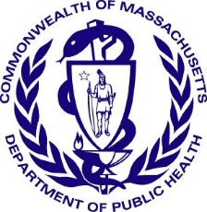 Version: 8-1-17
Massachusetts Department of Public Health
Determination of Need
Community Health Initiative
CHNA/CHIP Self Assessment
This self-assessment form is to understand the Community Engagement process that has led/ will lead to the identification of priorities for community health planning processes. It is being used to demonstrate to DPH that an existing community health planning process adequately meets DPH standards for community engagement specific to Determination of Need, Community Health Initiative purposes.

This form will provide the basic elements that the Department will use to determine if additional community engagement activities will be required. When submitting this form to DPH, please also submit your IRS Form 990 and Schedule H CHNA/CHIP and/or current CHNA/ CHIP that was submitted to the Massachusetts Attorney General's Office. Additionally, the Applicant is responsible for ensuring that the Department receives Stakeholder-Assessments from the stakeholders involved in the CHNA / CHIP process.
All questions in the form, unless otherwise stated, must be completed
Approximate DoN Application Date: 09/01/2022
DoN Application Type: DoN-Required Equipment
What CHI Tier is the project? Tier 1

1. DoN Applicant Information
Applicant Name: Cambridge Public Health Commission d/b/a Cambridge Health Alliance
Mailing Address: 1493 Cambridge Street
City: Cambridge State: Massachusetts Zip Code: 02139

2. Community Engagement Contact Person
Contact Person: Doug Kress
Title: Chief Community Officer
Mailing Address: 1035 Cambridge Street
City: Cambridge State: Massachusetts Zip Code: 02141
Phone: 7813380309 Ext: none
Email: dkress@challiance.org

3. About the Community Engagement Process
Please indicate what community engagement process (e.g. the name of the CHNA/CHIP) the following form relates to. This will be use as a point of reference for the following questions and does not need to be a fully completed CHNA or implemented CHIP.
(please limit the name to the following field length as this will be used throughout this form): 2019-2020 Everett-Malden CH NA/CHIP

4. Associated Community Health Needs Assessments
In addition to the above engagement process, please list Community Health Needs Assessments and/or Community Health Improvement Planning Processes, if any that the Applicant been involved with in the past 5 years (i.e. CHNA/ CHIP processes not led by the Applicant bur where the Applicant was involved?

(Please see page 22 of the Community-Based Health Initiative Guidelines for reference.)
Add/ Del Rows | Lead Organization Name / CHNA/CHIP Name | Years of Collaboration | Name of Lead Organizer | Phone Number | Email Address of Lead Organizer
+/- | North Suffolk CHNA CHIP 2019-22 | 4 | North Suffolk Public Health Collaborative - Barry Keppard |  | bkeppard@mapc.org
+/- | North Suffolk CHNA CHIP 2022-24 | 4 | North Suffolk Public Health Collaborative - Barry Keppard |  | bkeppard@mapc.org
+/- | Mt Auburn BILH CHNA CHIP 2021 and 2022-2024 | 4 | Mary Decourcey |  | mdecourc@mah.harvard.edu

5. CHNA Analysis Coverage
Within the 2019-2020 Everett-Malden CH NA/CHIP, please describe how the following DPH Focus Issues were analyzed DoN Health Priorities and Focus Issues (please provide summary information including types of data used and reference to where in the submitted CHNA/CHIP documents these issues are discussed):
5.1 Built Environment:
The 2019-2020 Everett-Malden CH NA/CHIP explored both the experiences of the built environment of the residents of Everett and Malden as well as the environment itself, through primary (surveys, focus groups, interviews) and secondary (Subsidized Housing Inventory, rates of housing cost burden, eviction rates, food retail access, rates of food insecurity, etc.) data collection and analysis. CHA recognized a need for a strong focus on the impact that a community's environment and distribution of its resources has upon its health. To better understand these, CHA piloted the use of a framework called A Tool for Health & Resilience In Vulnerable Environments (THRIVE) - a tool for assessing community conditions, prioritizing them, and taking action to change them to improve both health outcomes and health equity. We chose to use this framework because we believe that expertise about community wellbeing exists in the community. Using the THRIVE framework as our conceptual guide, the issues of top concern can be found on pages 13 - 17, and all indicators can be found in the Community Data Profiles in Appendix D. The challenges and areas of highest priority that came up most often in primary and secondary data analysis included (1) housing affordability and stability, (2) access to healthy food, (3) economic stability & mobility and (4) access to care & services. Components of the built environment came up as both strengths as well as challenges. The availability of parks, open spaces and bike paths/bike lanes in both Everett and Malden was highlighted as a strength in focus groups and interviews (p. 11 ). Challenges included lack of affordable housing stock (evidenced by low Subsidized Housing Inventory or SHI, which is used to measure a community's stock of low- or moderate-income housing: Everett at 6.4% and Malden at 10%; (p. 15) and poor quality, unsafe, unaffordable housing (focus group and interview themes; p. 15); and lack of access to healthy affordable food (illustrated in maps of the food environment (p. 16), as well as focus group and interview themes (p. 17)). Youth in Everett mentioned that Dunkin and Pizza Hut are right next to their school, and that it would be better to have healthier options closer to school; Malden participants noted that junk food is cheaper and often more available than healthy food; for example, a lot of the convenience stores in Malden do not carry fresh produce, which limits access to healthier foods.
5.2 Education:
Primary source data was captured through surveys, focus groups and key informant interviews. Quantitative secondary data from the most recent Census/ACS was analyzed to understand the education attainment of Malden and Everett residents, and can be found in Appendix D. Data from the most recent Youth Risk Behavior Survey/Student Health Survey in each community was analyzed as well. This survey is used to understand the behaviors and perceptions of the students in the two public school systems in Malden and Everett. DESE data was also analyzed to understand student demographics and statistics related to health, such as churn rates, which can be used as an indicator of unstable housing conditions (reported on page 15). Churn measures the number of students transferring into or out of a public school district during the course of a school year, and is also referred to as "student mobility." The churn rate in 2018 was 19% in Everett and 18.5% in Malden, twice as high as the MA state rate of 8.6%. Research shows that each time students switch schools, they generally lose the equivalent of 3 months of reading and math learning in the classroom, and that school districts with higher concentrations of mobile students had higher percentages of students with disabilities and fewer students in gifted education programs. Additionally, it was noted that Everett and Malden both had lower graduation rates during the previous school year (2018-19) than the state (74.9% in Everett, 79.5% in Malden versus 88% in Massachusetts.)
5.3 Employment:
Quantitative data captured from the most recent Census/ ACS data available to understand the employment status of the Malden and Everett communities is reported on page 17. A top concern was economic stability & mobility, particularly due to the lack of good jobs (jobs that pay a living wage and have benefits that meet the needs of individuals and families). Available data on income and employment (pages 17-18) illustrate that our communities have high rates of poverty (especially among youth and families); long commute times; and high housing cost burden (indicating that wages do not keep up with housing costs and other necessary household expenses). Both Everett and Malden have a higher percentage of residents under 18 living below poverty level than the state. For those 65 and older, almost 18% in Malden are living below poverty level compared to 9% in MA. Additionally, both communities have a higher percentage of families living below poverty level than the state. Although median household income has increased since 2000 in both Everett (by 41 %) and Malden (by 37%), it has been at a lower rate of growth than the state (47%). Conversely, the percentage of families living below poverty level in Everett and Malden has increased at a much higher rate than the state. Thirty percent of Everett and Malden residents have long commute times (over 45 minutes) than the state. This means that at least 1.5 hours of their time is spent getting to and from work, taking time away from family/personal responsibilities. It is important to note that wages are not sufficient to keep up with housing costs in these two cities. 56% of Everett renters and 51% of Malden renters are cost-burdened or severely cost-burdened, while 40% of Everett home owners and 34% of Malden home owners are cost-burdened or severely cost-burdened. Malden and the surrounding communities of Everett and Revere have been designated Gateway City communities; which recognizes that these cities all had a legacy of economic success, but have struggled in recent years.
5.4 Housing:
Housing Affordability, Stability and Safety was by far the biggest challenge identified and an area of high priority voiced from participants throughout the engagement process. Secondary data analysis supported this concern, as it was found that in comparison to the state, the communities of Malden and Everett had high housing cost burden (especially among renters), high eviction rates, and low Subsidized Housing Inventory (SHI). This is reported on pages 14-15. As mentioned previously, 56% of Everett renters and 51% of Malden renters are cost-burdened or severely cost-burdened, while 40% of Everett home owners and 34% of Malden home owners are cost-burdened or severely cost-burdened. Both Everett and Malden have had higher eviction rates than the state. In 2016 (most recent data available), 2.17% of Everett renters and 1.71 % of Malden renters were evicted from their households. The Subsidized Housing Inventory (SHI) is used to measure a community's stock of low- or moderate-income housing. Massachusetts SHI was at 9.7%. Everett was lower than the state with 6.4% subsidized housing. Malden was slightly higher than the state at 10.1 %.
5.5 Social Environment:
Primary data from community engagement sessions was analyzed and the common themes that emerged indicated that social services and civic and community engagement are largely seen as strengths in the communities of Everett and Malden. Many participants voiced appreciation of the various agencies and organizations in the area that offer services and opportunities for civic and community engagement, making special note of those organizations and entities that offered interpretation services. Also, secondary data illustrated that more residents in Everett and Malden are registered to vote compared to the state (52.8% of Everett residents, 48.1 % of Malden residents, 44.5% of MA.) all available on page 11. However, certain populations expressed a need for improvement in their social environments. In particular, during focus groups with the senior populations, they discussed a lack of connection within their neighborhoods. We would like to note that COVID has exacerbated issues related to isolation and this emerged from the most recent CHNA. During COVID-19, each of the communities were also designated as Vaccine Equity Initiative communities.
5.6 Violence and Trauma:
Quantitative secondary data from Federal Bureau of Investigation and Youth Risk Behavior Survey surveys from Malden and Everett were collected and analyzed. This data is reported in Appendix D. In Everett, violent crime rate was higher than the state (368/100,000 vs. 338/100,000 in MA) and property crime was higher than the state (1457 /100,000 vs. 1263/100,000 in MA.) In Malden, violent crime rate was lower than the state (293/100,000 vs. 338/100,000 in MA) and property crime was lower than the state (957 /100,000 vs. 1263/100,000 in MA.) Additionally, focus group data were analyzed and themes that emerged included safety concerns and neighborhood attrition have led to a limited sense of community. Seniors stated that people no longer know their neighbors-one example of this is older people selling their houses and leaving the neighborhood. Furthermore, seniors recalled that neighbors used to watch each other's children but said that is no longer the case. In addition, youth participants stated that Everett is culturally diverse, which is a strength because it helps build community, but it also sometimes pits people against those in their own culture. Participants also brought up safety concerns; one participant's home was broken into by a neighbor, and participants mentioned there were no street lights and often needles on the ground in public spaces. There were also reports of community violence-youth mentioned that violence is normalized, as there have been shootings in the community. Lastly, in one focus group, youth felt that social media helps spread ideas of hate and violence in the community.
5.7 The following specific focus issues
a. Substance Use Disorder:
Both communities see higher age-adjusted rates of opioid-related mortality than the state (33.9/100,000 in Everett, 21 .9/100,000 in Malden compared to 19.3/100,000 in MA) as well as all substance-related mortality rates (49.4/100,000 in Everett, 34.3/100,000 in Malden compared to 30.7 /100,000 in MA). Everett had higher opioid-related ED visits and hospitalizations than the state (148.7 /100,000 compared to 90.5/100,000 in MA), and total drug overdose ED visits than the state 344/100,000 compared to 250.9/100,000 across MA (see page 21 ). For youth substance use, the data appears to contradict the perceptions of high youth rates of substance use, as most data indicators show Everett and Malden at lower rates than the state (pages 20 - 25). Thematic analysis of youth focus group data indicated that alcohol and vaping/ smoking are normalized and widespread. Youth stated that weed, vaping, and alcohol are very accessible; as a result, people are more inclined to use these substances. In addition, youth mentioned that smoking occurs regularly in the bathrooms at school, and there are empty nip bottles in public areas on the way to school. In addition, alcohol is easily accessible because there is a liquor store next to the school in Everett. Youth mentioned that YouTube ads and commercials that attempt to get people to stop smoking do not work because kids do not listen to their parents. Similarly, youth reported that these types of ads aren't effective in changing behavior.
b. Mental Illness and Mental Health:
Areas of mental health (particularly youth depression and elder isolation) and substance use disorder (particularly the use of opioids, alcohol, youth vaping & marijuana) were issues that were voiced from participants through the community and stakeholder engagement process as the biggest health outcome concerns in our communities (pages 20 - 25). Review and analysis of public health data (from MA Department of Public Health and the 2018/2019 Youth Risk Behavior Survey) on these areas indicate that these issues show up differently in each community. CHA reviewed and analyzed various indicators for mental health and substance use in each community, in comparison to the state of Massachusetts. These data are reported in the respective Community Data Profiles in Appendix D. While age-adjusted suicide rates were lower than the state rate in both Everett and Malden, both communities see higher rates of youth depression and lack of a trusted adult to talk to compared to the state. This issue also came up in our focus groups, as some youth stated that the lack of adults who they can identify with (linguistically, culturally, etc.) causes them to feel distrustful. Among youth, rates of both Everett and Malden middle school (MS) students who experienced depression in the past 12 months were higher than the state (41.7% and 44.9% higher, respectively). Similarly, Everett and Malden high school (HS) students' rates of depression were also higher than the state, particularly in Everett, which was almost 40% higher than the state. Everett middle and high school students reported higher rates of attempted suicide in the past 12 months than the state; 44% higher for middle school students and 7% higher for high school students. Additionally, Everett high school students who had seriously considered suicide in the past 12 months was higher than the state; 14% of students compared to 12% of the state.
c. Housing Stability/Homelessness:
Using primary and secondary data, housing stability was identified as a key issue of concern. For housing stability, please see above. For homelessness, secondary data was not illustrative of need in Malden and Everett, since in 2019 - 2020 there was no shelter for homeless individuals and Point in Time counts did not identify homeless individuals. The need for a homeless shelter in the greater Malden and Everett areas was identified as an issue of concern in primary data collection, especially with regard to homeless students and their families. In Everett there were 166 students who identified as homeless and in Malden there were 150 students who identified as homeless in 2019. This was collected from the DESE Office of Family and Student Support, McKinney-Vento Homeless Education Data (2019-2020). After this assessment was completed, two new resources for homeless individuals were opened. The first was a shelter for individuals opened in Malden by Housing Families, Incorporated. The second was a warming center operated by volunteers convened and located at the First Church of the Nazarene in Malden.
d. Chronic Disease with a focus on Cancer, Heart Disease, and Diabetes:
Qualitative data on chronic disease rates were gathered from primary sources such as from DPH and secondary qualitative data sources and were reported on pages 26-29. During community and stakeholder engagement, the chronic diseases of concern that came up most often were cancer, diabetes, and obesity. Review and analysis of public health data for cancer showed that age adjusted rates of lung and colorectal cancer mortality were higher in Everett compared to the state. Lung cancer mortality rate was 48.8 in Everett compared to 40.5 in MA. The colorectal mortality rate in Everett was 14.7 compared to 12.5 in Massachusetts. In Malden, age adjusted all cancer mortality rates were higher than the state (Breast, Ovarian, Prostate, Colorectal and Lung) The all cancer mortality rate was 177 /100,000 in Malden compared to 156/100,000 in Massachusetts. Review of Department of Public Health data showed that age adjusted diabetes mortality, ED visit and hospitalization rates for Everett and Malden residents were higher than the state rates. Age adjusted diabetes mortality rates (Everett 22.1, Malden 22.9 and Massachusetts 14.8 per 100,000 respectively) diabetes ED visit rates (Everett 183.5, Malden 153.5, and Massachusetts 143.1 per 100,000 respectively) and diabetes hospitalization rates (Everett 161.3, Malden 187.8 and Massachusetts 143.1 per 100,000 respectively.) Pediatric obesity rates in both Everett and Malden are higher than the state (with the exception of Malden Grade 10, which is the same as the state). Everett and Malden also had higher age adjusted rates of cardiovascular ED visits compared to the state. (856.6 in Everett, 663.1 in Malden compared to 596 in MA.) Most recent data for age adjusted percentage rate of chronic obstructive pulmonary disease (COPD), emphysema, or chronic bronchitis (lifetime) among adults was higher in Everett (6.5%) and Malden (5.8%) versus the statewide percentage rate (4.4%). Also, most recent data for age adjusted percentage rate of coronary heart disease or angina (lifetime) among adults was higher in Everett (5.9%) and Malden (5.6%) versus the statewide percentage rate (3.2%). Lastly, age adjusted asthma hospitalization rates were higher in Everett (100.1) and Malden (97.9) versus the statewide rate (87.1 ).

6. Community Definition
Specify the community(ies) identified in the Applicant’s 2019-2020 Everett-Malden CH NA/CHIP

Add/ Del Rows | Municipality | If engagement occurs in specific neighborhoods, please list those specific neighborhoods:
+/- | Malden
+/- |  | Everett {doesn't populate in the list)
+/-
+/-
+/-

7. Local Health Departments
Please identify the local health departments that were included in your 2019 Boston CHNA-CHIP Process. Indicate which of these local health departments were engaged in this 2019-2020 Everett-Malden CHNA/CHIP. For example, this could mean participation on an advisory committee, included in key informant interviewing, etc.
(Please see page 24 in the Community-Based Health Initiative Guidelines for further description of this requirement.)

Add/ Del Rows | Municipality | Name of Local Health Dept | Name of Primary Contact | Email address | Describe how the health department was involved
+/- |  | Everett Health Department | Sabrina Firicano | sabrina.firicano@ci.everett.ma.us | Key informant, member of Community Advisory Board
+/- | Malden | Malden Health Department | Peter Finn | pfinn@cityofmalden.org | Key informant, member of Community Advisory Board

8. CHNA/CHIP Advisory Committee
Please list the community partners involved in the CHNA/CHIP Advisory Committee that guided the 2019-2020 Everett-Malden CHNA/CHIP. (please see the required list of sectorial representation in the Community Engagement Standards for Community Health Planning Guidelines) Please note that these individuals are those who should complete the Stakeholder Engagement Assessment form. It’s the responsibility of the Applicant to ensure that DPH receives the completed Stakeholder Engagement Assessment form:

Add/ Del Rows | Sector Type | Organization Name | Name of Primary Contact | Title in Organization | Email Address | Phone Number
 | Municipal Staff | City of Malden | Chris Webb | Director, Health Department | cwebb@cityofmalden.org
 | Education | Malden Public Schools | John Oteri | Superintendent | joteri@maldenps.org
 | Housing | Housing Families, Inc. | Heather Van Orman | Pro Bono legal services | hvanorman@housingfamilies.org
 | Social Services | Joint Committee for Children's Health Care in  Everett | Nicole Graffam | Executive Director | ngraffam@ci.everett.ma.us
 | Planning + Transportation | City of Everett | Tony Sousa | Director of Planning and  Development | tony.sousa@ci.everett.ma.us
 | Private Sector/ Business | Cataldo Ambulance | Dan Hoffenberg | VP of Operations | dhoffenberg@cataldoambulance.com
 | Community Health Center | Melrose Wakefield Healthcare  *CHA Filled role of CHC, and MWHC provided services at the time. | Barbara Kaufman | Manager, Community Benefits | bkaufman@hallmarkhealth.org
 | Community Based Organizations | Mass Senior Action/Friends of Fellsmere Heights | Dee Campbell | member | dcampitup@comcast.net
+/- | Additional municipal staff (such as elected officials, planning, etc.) | City of Everett | Sabrina Firicano | Director of Health and Human Services | sabrina.firicano@ci.everett.ma.us
+/- | Education | City of Everett Public Schools | Julie Ann Whitson | Director of Health Education | jwhitson@everett.kl2.ma.us
+/- | Community-based organizations | ABCD | Aiesha Washington | Operations Director, Mystic Valley Opportunity Center | awashington@bostonabcd.org
+/- | Community-based organizations | YMCA | Gregg Ellenberg | Director of Programs | gellenberg@ymcamalden.org
+/- | Community-based organizations | Mystic Valley Elder Services | Lauren Reid | Director of Community Outreach | lreid@mves.org
+/- | Additional municipal staff (such as elected officials, planning, etc.) | Malden School Committee | Jen Spadafora | School Committee Member | jspadafora@maldenps.org

8a. Community Health Initiative
For Tier 2 and Tier 3 CHI Projects, is the Applicant's CHNA / CHIP Advisory Board the same body that will serve as the CHI advisory committee as outlined in the Table 1 of the Determination of Need Community-Based Health Initiative Guideline? [no option selected]

9. Engaging the Community at Large
Thinking about the extent to which the community has been or currently is involved in the 2019-2020 Everett-Malden CHNA/CHIP, please choose one response for each engagement activity below. Please also check the box to the left to indicate whether that step is complete or not. (For definitions of each step, please see pages 12-14 in the Community Engagement Standards for Community Health Planning Guidelines).
Assess Needs and Resources: checked.
Response: Delegate
Please describe the engagement process employed during the “Assess Need and Resources” phase.: The purpose of this assessment was to develop a full picture not only of health needs in Everett and Malden, but also of community strengths and assets. Over the course of the process, both secondary (publicly reported and existing) and primary (first-hand and new) data were collected and analyzed. The Community Advisory Board (CAB) was instrumental in identifying how primary data could be collected and ensuring that the surveys, focus groups and key informant interviews would be with individuals representative of the community. The CAB was involved in reviewing initial analysis of primary and secondary data and advising on how to ensure stratifications of data should be analyzed to better understand dimensions of equity.
Focus on What’s Important: checked
Response: Community-Driven/ Led
Please describe the engagement process employed during the “Focus on What's Important” phase.: After the review of primary and secondary data, and throughout the CHNA process, CAB members provided continuous feedback to refine data analysis and focus. Members of the CAB used the data and themes that emerged from the assessment process to set priorities. The priorities were set as a result of a collaborative review of all data sources (primary/secondary as well as qualitative and quantitative) that was collected from a diverse cross sector of community members and community leaders.
Choose Effective Policies and Programs: checked
Response: Involve
Please describe the engagement process employed during the “Choose Effective Policies and Programs” phase.: Almost as soon as the CHNA was released in March 2020, CHA's Department of Community Health Improvement team had to shift our focus to responding to COVID-19. We reviewed the 2019-2020 CHNA to develop an Implementation Strategy that took into account the new reality that COVID-19 had resulted in. We recognized the community-identified priority needs and equity concerns had in fact been amplified by the pandemic.
Act on What’s Important: checked
Response: Collaborate
Please describe the engagement process employed during the “Act on What's Important” phase.: Cambridge Health Alliance is committed to collaborating with our community partners to improve the health of our patients and communities. In our drive to Care for All, CHA works closely with community members, community based organizations, municipal departments, places of worship, civic and cultural organizations to elevate the voices of those who are most directly impacted by the society's injustices which lead to health inequities. Consistent and persistent presence in the community by our teams allow for ongoing community engagement on the issues we collaboratively work to address.
Evaluate Actions: checked
Response: Involve
Please describe the engagement process employed during the “Evaluate Actions” phase.: Community partners provide feedback on various programs and initiatives to help evaluate efforts. Cambridge Health Alliance works with Community Advisory Board to communicate outcomes and evaluation measures. This is done through formal means {reports, presentations to Board of Trustees, Community Health Advisory Committee, and others throughout CHA. CHA staff also ensure information and results from the CHNA/CHIP is shared through ongoing partnerships where regular communication exchange occurs.
10. Representativeness
Approximately how many community agencies are currently involved in 2019-2020 Everett-Malden CHNA/CHIP within the engagement of the community at large? 25 Agencies
Approximately how many people were engaged in the process (please include team members from all relevant agencies and independent community members from the community at large)? 60 Individuals

Please describe the diversity of the people who have been engaged in the process both within the CHNA/CHIP Advisory Committee and the community at large. Explicitly describe how the process included diverse representation from different groups/individuals with varied gender, sexual orientation, race/ethnicity, disability status, international status and age. Please see page 10 and Appendix A of the Community Engagement Standards for Community Health Planning Guideline for further explanation of this.:
The Community Advisory Board is comprised of men, women and non-gender conforming individuals representing and/or serving a variety of populations. The membership includes individuals who work with youth, older adults, those with cognitive and physical disabilities, LGBTQ individuals, BIPOC individuals, low income individuals and immigrants. Partnerships with school personnel and youth serving CBOs provide insight into the youth population; Elder Service personnel provide information about the elder population, civic and cultural organization leadership provide insights into community members from diverse religious, linguistic and cultural backgrounds. And participation from CBOs help gain insight into a variety of other populations such as low income, food insecure and housing insecure populations. The CAB membership evolves as positions change within respective organizations. Over time, CHA will add additional organizations to ensure our CABs are representative of the communities served.

Please describe the type of representation that was/is employed in the community engagement process and the rationale for that type of representation. For more information on types of representation and representativeness, please see Appendix A from the Community Engagement Standards for Community Health Planning Guidelines. Please include descriptions of both the Advisory Board and the Community at large.:
CAB members provided input and insights into key health issues in the communities. Community members of the CAB provided input from their own experiences, and what they heard from their constituents and those who they represented. Additionally, the members of the CHA CAB guided the process for deeper engagement in the community through identification of key informants, focus group participants and survey location sites.
To your best estimate, of the people engaged in 2019-2020 Everett-Malden CHNA/CHIP approximately how many: Please indicate the number of individuals

Number of people who reside in rural area: 0
Number of people who reside in urban area: 60
Number of people who reside in suburban area: 0
,
11. Resource and Power Sharing
For more information on Power Sharing, please see Appendix A from the Community Engagement Standards for Community Health Planning Guidelines.
By community partners, we mean agencies, organizations, tribal community, health departments, or other entities representing communities.
By Applicant partners, we mean the hospital / health care system applying for the approval of a DoN project
Which partner hires personnel to support the community engagement activities? Applicant Partners
Who decides the strategic direction of the engagement process? Both [Community Partners and Applicant Partners]
Who decides how the financial resources to facilitate the engagement process are shared? Both [Community Partners and Applicant Partners]
Who decides which health outcomes will be measured to inform the process? Both [Community Partners and Applicant Partners]

12. Transparency
Please describe the efforts being made to ensure that the engagement process is transparent. For more information on transparency, please see Appendix A from the Community Engagement Standards for Community Health Planning Guidelines.:
The reports are posted on https://www.challiance.org/community-health/community-health-data-and-reports/community-health-data-and-reports for public access and utilization. We ensure that community members and leaders interested in exploring and using our analyses, reports, and recommended resources have the ability to do so freely. In addition to the reports, we include community-specific data profiles as well as our approach to the community health needs assessment process. Results of the reports were presented to the Community Advisory Board, CHA Board Committee on Population Health and to various municipal groups and community based organizations. This report was also shared informally at a variety of community and coalition meetings. Our Community Advisory Board members have open access to all materials shared during the CHNA-CHIP process through a collaborative Google platform. This ensures that the CAB members may access and use meeting agendae, minutes, presentations and other important documents at any time, during and after the CHNA-CHIP process.
13. Formal Agreements
Does/Did the 2019-2020 Everett-Malden CHNA/CHIP have written formal agreements such as a Memorandum of Agreement/Understanding (MOU) or Agency Resolution? No, there are no written formal agreements
Did decision making through the engagement process involve a verbal agreement between partners? No, there are no verbal agreements

14. Formal Agreement Specifics
Thinking about your MOU or other formal agreement(s), does it include any provisions or language about:
Distribution of funds? Doesn’t Apply
Written Objectives? Doesn’t Apply
Clear Expectations for Partners’ Roles? Doesn’t Apply
Clear Decision Making Process (e.g. Consensus vs. Voting)? Doesn’t Apply
Conflict Resolution? Doesn’t Apply
Conflict of Interest Paperwork? Doesn’t Apply

15. Document Ready for Filing
When document is complete click on "document is ready to file". This will lock in the responses and date and time stamp the form. To make changes to the document un-check the "document is ready to file" box.
Edit document then lock file and submit Keep a copy for your records. Click on the "Save" button at the bottom of the page. To submit the application electronically, click on the "E-mail submission to DPH" button.

This document is ready to file? unchecked
Date/time Stamp: 08/16/2022 3:18 pm
E-mail submission to DPH
E-mail submission to Stakeholders and CHI Advisory Board

When providing the Stakeholder Assessment Forms to the community advisory board members (individuals identified in Section 8 of this form), please include the following information in your correspondence with them. This will aid in their ability to complete the form:
- Community Engagement Process: 2019-2020 Everett-Malden CHNA/CHIP
- Applicant: Cambridge Public Health Commission d/b/a Cambridg,
- A link to the DoN CHI Stakeholder Assessment

ATTACHMENT 5 NOTICE OF INTENT

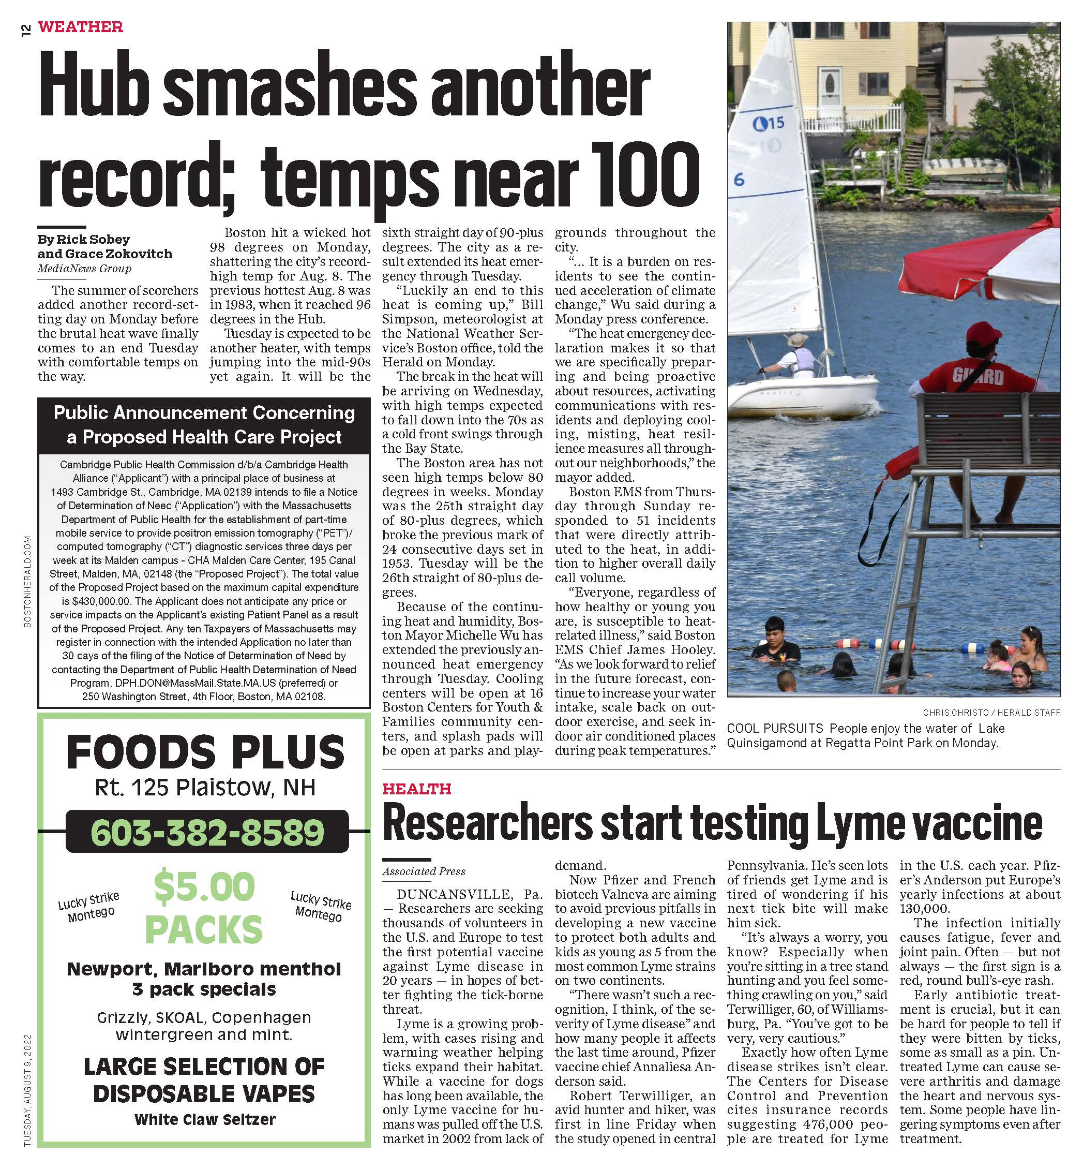
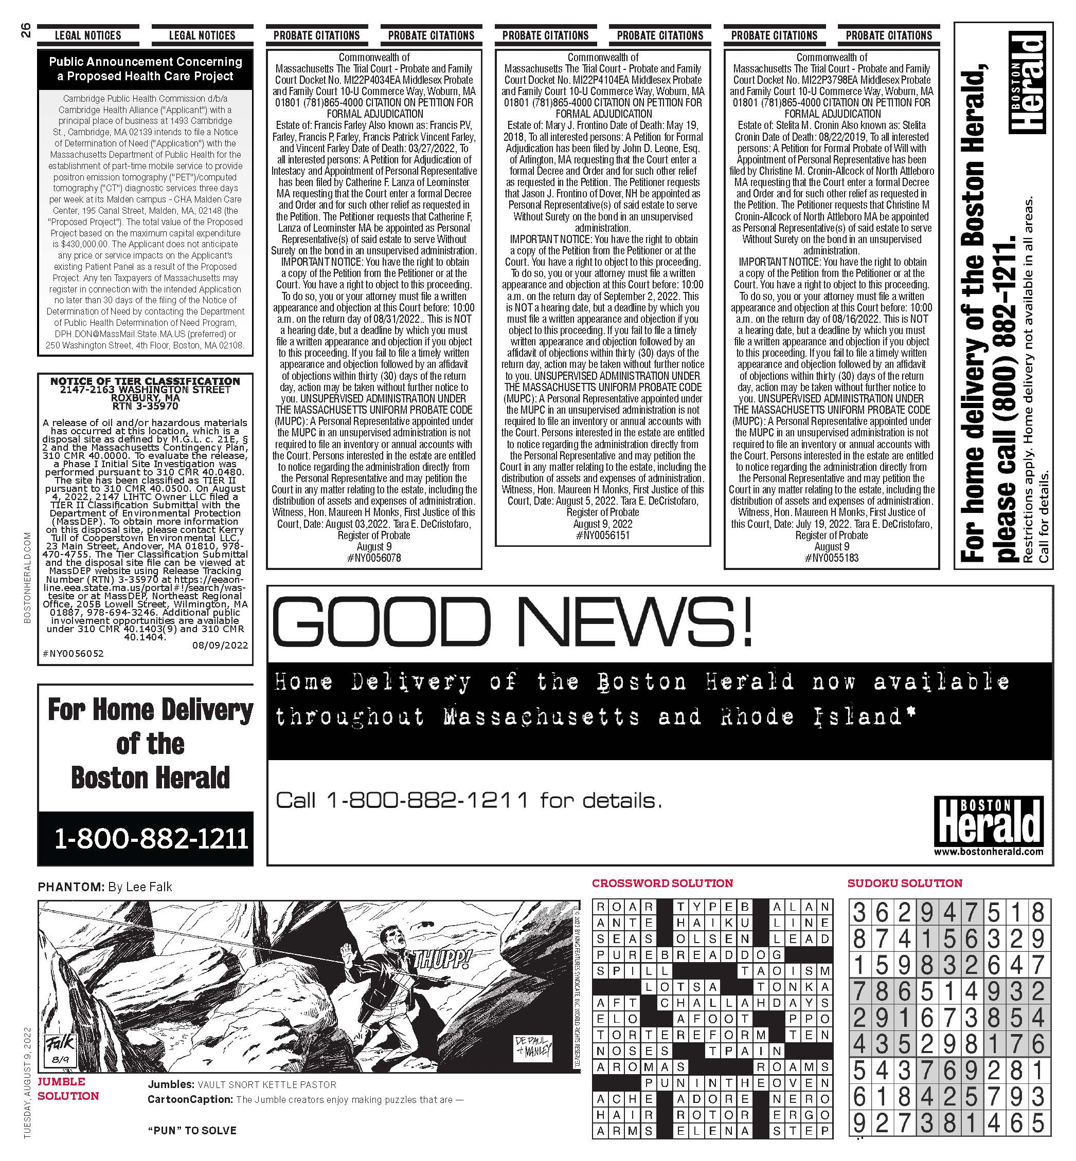
ATTACHMENT 6

HPC ACO CERTIFICATION APPROVAL LETTER

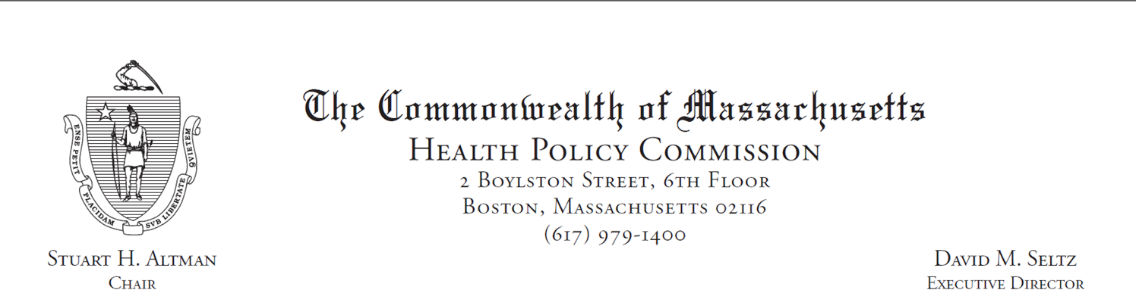
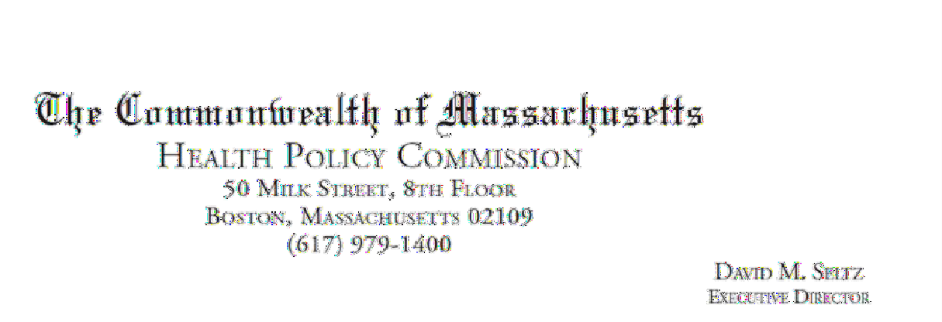

April 12, 2022 Glover Taylor
Cambridge Public Health Commission d/b/a Cambridge Health Alliance
1493 Cambridge Street
Cambridge, MA 02139

RE: ACO LEAP Certification Dear Mr. Taylor:
Congratulations! The Health Policy Commission (HPC) is pleased to inform you that Cambridge Health Alliance meets the requirements for ACO Certification under our Learning, Equity, and Patient-Centeredness (LEAP) standards. This certification is effective from January 1, 2022, through December 31, 2023.

The ACO Certification program, in alignment with other state agencies including MassHealth, is designed to accelerate care delivery transformation in Massachusetts and promote a high quality, efficient health system. ACOs participating in the program have met a set of objective criteria focused on core ACO capabilities demonstrating dedication to patient-centered care, use of evidence-based and data-driven strategies to improve care delivery, and commitment to addressing long-standing health inequities. Cambridge Health Alliance meets those criteria.

The HPC will promote Cambridge Health Alliance as a Certified ACO on our website and in our marketing and public materials. Enclosed you will find an ACO Certification logo for your organization to use in accordance with the attached Terms of Use. We hope you will use the logo on promotional materials when you highlight your ACO Certification to your patients, payers, and others.

The HPC looks forward to ongoing engagement with you over the next two years. We intend to follow up shortly to provide an overview and some reflections on what we saw in the Health Equity Responses, a new feature of the ACO Certification application this year, across the cohort of Certified ACOs. We hope your organization will find that information helpful as we all continue to explore ways to improve health equity in the Commonwealth.

Thank you for your dedication to providing accountable, coordinated health care to your patients, and to continued learning and improvement over time. If you have any questions about this letter or the ACO Certification program, please do not hesitate to contact Mike Stanek, Senior Manager, at HPC- Certification@mass.gov or (617) 757-1649.

Best wishes,

[signature on file]

David Seltz Executive Director

ATTACHMENT 7
FORMATION DOCUMENTS: CHAPTER 147 OF THE ACTS OF 1996, AS AMENDED BY CHAPTER 365 OF THE ACTS OF 1998

Cambridge Health Alliance was established by the legislature, which enabling legislation is included in the submission. Accordingly, there is no filing with the Secretary of State for this hospital. Here are the links to enabling legislation:
https://archives.lib.state.ma.us/handle/2452/120533
https://malegislature.gov/Laws/SessionLaws/Acts/1998/Chapter365

ATTACHMENT 8
AFFIDAVIT OF TRUTHFULNESS AND COMPLIANCE

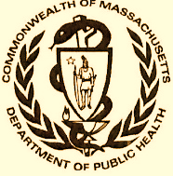 Version: 7-6-17

Massachusetts Department of Public Health

Determination of Need

Affidavit of Truthfulness and Compliance

with Law and Disclosure Form 100.405 (B)
Instructions: Complete Information below. When complete check the box "This document is ready to print:". This will date stamp and lock the form. Print Form. Each person must sign and date the form. When all signatures have been collected, scan the document and e-mail to: dph.don@state.ma.us Include all attachments as requested.
Application Number: CHA-22061514-RE
Original Application Date: August 31, 2022
Applicant Name: Cambridge Public Health Commission d/b/a Cambridge Health Alliance
Application Type: DoN-Required Equipment
Applicant's Business Type: Other
Is the Applicant the sole member or sole shareholder of the Health Facility(ies) that are the subject of this Application? No
Describe the role /relationship: N/A

The undersigned certifies under the pains and penalties of perjury:
- The Applicant is N/A;
- I have read [been informed of the contents of] 105 CMR 100.000, the Massachusetts Determination of Need Regulation;
- I understand and agree to the expected and appropriate conduct of the Applicant pursuant to 105 CMR 100.800;
- I have read [been informed of the contents of] this application for Determination of Need including all exhibits and attachments, and certify that [have been informed that] all of the information contained herein is accurate and true;
- I have submitted the correct Filing Fee and understand it is nonrefundable pursuant to 105 CMR 100.405(B);
- I have submitted the required copies of this application to the Determination of Need Program, and, as applicable, to all Parties of Record and other parties as required pursuant to 105 CMR 100.405(B);
- I have caused, as required, notices of intent to be published and duplicate copies to be submitted to all Parties of Record, and all carriers or third-party administrators, public and commercial, for the payment of health care services with which the Applicant contracts, and with Medicare and Medicaid, as required by 105 CMR 100.405(C), et seq.;
- I have caused [have been informed that] proper notification and submissions to the Secretary of Environmental Affairs pursuant to 105 CMR 100.405(E) and 301 CMR 11.00; [will be made, if applicable.]
- If subject to M.G.L. c. 6D, § 13 and 958 CMR 7.00, I have submitted such Notice of Material Change to the HPC - in accordance with 105 CMR 100.405(G);
- Pursuant to 105 CMR 100.210(A)(3), I certify that both the Applicant and the Proposed Project are in material and substantial compliance and good standing with relevant federal, state, and local laws and regulations, as well as with all previously issued Notices of Determination of Need and the terms and Conditions attached therein [issued in compliance with 105 CMR 100.00, the Massachusetts Determination of Need Regulation effective January 27, 2017 and amended December 28, 2018];
- I have read [been informed of the contents of] and understand the limitations on solicitation of funding from the general public prior to receiving a Notice of Determination of Need as established in 105 CMR 100.415;
- I understand that, if Approved, the Applicant, as Holder of the DoN, shall become obligated to all Standard Conditions pursuant to 105 CMR 100.310, as well as any applicable Other Conditions as outlined within 105 CMR 100.000 or that otherwise become a part of the Final Action pursuant to 105 CMR 100.360;
- Pursuant to 105 CMR 100.705(A), I certify that the Applicant has Sufficient Interest in the Site or facility; and
- Pursuant to 105 CMR 100.705(A), I certify that the Proposed Project is authorized under applicable zoning by-laws or ordinances, whether or not a special permit is required; or,
  - If the Proposed Project is not authorized under applicable zoning by-laws or ordinances, a variance has been received to permit such Proposed Project; or,
  - The Proposed Project is exempt from zoning by-laws or ordinances.

Other Business Type

Define Business Type: Public Instrumentality per Chapter 147 of the Acts of 1996

All parties must sign. Add additional names as needed.

Assaad Sayah, MD, CEO [signature on file] 8/31/2022
Name: Signature: Date

This document is ready to print? unchecked Date/time Stamp: [blank]

ATTACHMENT 9 FILING FEE

