## APPENDIX 4

### FACTOR 6 MATERIALS

## APPENDIX 4.1

### CHI NARRATIVE

**Factor 6.1: Community Health Initiative Narrative**

1. Community Health Initiative Monies

As with the original Determination of Need (DoN), the Community Health Initiative (“CHI”) for this DoN will be carried out by Emerson Hospital, a co-owner of the Applicant and an acute care hospital with a Community Health Needs Assessment (CHNA) covering the service area of the Applicant’s ASC.

The breakdown of CHI monies for the proposed DoN Project is as follows. Please note, all totals are presented in the order calculated, beginning with the Maximum Capital Expenditure (“MCE”). The following table illustrates how Emerson Hospital would like to allocate CHI monies.

|  | **Total** | **Description** |
| --- | --- | --- |
| **MCE** | $484,856.00 |  |
| **CHI Monies** | $24,242.80 | (5% of Maximum Capital Expenditure) |
| **Administrative Fee** | $484.86 | (2% of the CHI Monies, retained by Emerson) |
| **Remaining Monies** | $23,757.94 | (CHI Monies minus the Administrative fee) |
| **Statewide Initiative** | $2,375.79 | (10% of remaining monies, paid to State-wide fund) |
| **Local Initiative** | $21,382.15 | (90% of remaining monies) |
| **Evaluation Monies** | $1,382.15 | (<10% of Local Initiative Monies, retained by Emerson) |
| **CHI Monies for Local**  **Disbursement** | $20,000.00 |  |

1. Direct Funding Model

Emerson Hospital, through its Community Benefits Advisory Committee (CBAC), would like to direct the CHI monies to past or future recipients of the Christine Gallery Community Benefit Grant Program (CGCBG). Through the CGCBG, Emerson Hospital collaborates with its community partners to directly improve the health of the area’s residents, address the root causes of health disparities, and improve education within the community about healthcare prevention and self-care strategies. With this CHI contribution, Emerson Hospital will be able to provide additional resources to CGCBG recipients focused on addressing the mental health priorities outlined in the Hospital’s most recent CHNA. Therefore, Emerson Hospital is requesting approval to use the CHI monies to increase funding to the CGCBG to further initiatives that will improve overall community health.

1. Timeline for CHI Activities

Upon a Notice of Determination of Need being issued by the Public Health Council, Emerson Hospital will open the next CGCBG application cycle to include the CHI monies for distribution. The timeline for the CHI activities is as follows:

* One month post-approval: The CBAC will decide whether to award the CHI monies to a past recipient or recipients or whether it will add it to the next round of funding.
* Two to three months post-approval: The CBAC will meet to determine the recipient(s).
* Five months post-approval: The CBAC will distribute the CHI monies to recipient(s).
* Six months to eighteen months post-approval: Ongoing evaluation efforts and reporting to DPH.

1

HB: 4906-0663-4021.5

1. Administrative and Evaluation Funds

Emerson Hospital is requesting permission to allocate a portion of the CHI monies to administer and evaluate the awards under this CHI. Emerson Hospital anticipates using approximately $485 to create the award agreements and forms, and $1,383 to develop evaluations tools for the recipient(s) to complete. By allocating a smaller percentage of the CHI monies to administrative and evaluation costs than usually allowed under the CHI Guidelines, Emerson Hospital is able to increase funding to recipients.

1. Emerson Hospital Community Health Needs Assessment

*Participation and Input from Local Agencies*

Emerson Hospital collaborated with the various local health departments to identify and understand the diverse needs of the residents within the towns surrounding the Hospital including Hudson Health Department, Westford Health Department and Community Wellness Coordinator, Concord Health Department, and Bedford Health Department.

*Influence of Emerson Hospital’s CBAC*

Additionally, Emerson Hospital seeks guidance from its CBAC as part of the CHNA process. The members of the CBAC help Emerson Hospital facilitate the CHNA process by offering varying prospectives on the health issues affecting the community, which assists the Hospital with setting goals to address the social, economic, and health factors effecting community residents. The CBAC participated in the CHNA process by recommending secondary data sources, identifying stakeholders and focus group segments, conducting interviews to explore the perceptions of the community, and receiving recommendations for how to address those concerns. The names, titles, and affiliations of all CBAC members are in the table below.

| **Name** | **Title** | **Representation** |
| --- | --- | --- |
| Kelsey Magnuson | Community Benefits Manager | Emerson Hospital |
| Pat Worsley | Community Health Worker | Emerson Hospital |
| Christine Kielar | Development | Emerson Hospital |
| Jackie Clancy | VP Strategic Marketing | Emerson Hospital |
| Bill Ryan | Board Member | Emerson Health Board member |
| James Street, MD | Board Member | Emerson Health Board member |
| Roseann Giordano | Board Member | Emerson Health Board member |
| Anna Rassmusen | Board Member | Emerson Health Board member |
| Jack McKeen | Resident | Maynard |
| Susan Rask | Resident | Hudson |
| Sandra Hinds | Resident | Acton |
| Jill Block | Resident | Concord |
| Sara Wilson | Resident | Carlisle |
| Heidi Porter | Director of Health and Human Services | Bedford Health Department |
| Melanie Dineen | Public Health Director | Concord Health Department |
| Rick Lefferts | Chair | Maynard Affordable Housing Trust |
| Liz Rust | Director | Regional Housing Services Office |
| Lori Krinsky | President | NAMI Central Middlesex |
| Nicole Saia | Social Worker | Concord Council on Aging |

2

HB: 4906-0663-4021.5

*Role of Community Empowerment and Collaboration in Emerson’s CHNA Process*

Emerson Hospital prioritizes community-based feedback and involvement in the CHNA process. While conducting the CHNA, Emerson Hospital sought feedback and input from community members and groups ranging from collaboration to allowing the residents to directly coordinate responding to the community’s demonstrated health needs. During the most recent CHNA process, the level of involvement from the community throughout the various steps of Emerson Hospital’s CHNA are as follows:

* + **Asses Needs and Resources**: Empower
  + **Focus on What’s Important**: Empower
  + **Choose Effective Policies and Programs**: Collaborate
  + **Act of What’s Important:** Collaborate
  + **Evaluate Actions**: Consult

*Total Number of Individuals and Entities Involved in Emerson Hospital’s CHNA*

Additionally, Emerson Hospital consulted with various individuals and agencies to understand the social, behavioral, and physical health issues and outcomes affecting its community as part of its CHNA process. In total, Emerson Hospital received over 800 responses from the Massachusetts Department of Public Health’s Community Health Equity Survey, which it considered while developing the CHNA. Also, Emerson Hospital interviewed another 27 individuals in focus groups and 35 other individuals were included in the CHNA information gathering process. Emerson Hospital also received useful input from local agencies and departments. Altogether, 9 local agencies participated in interviews and focus groups with Emerson Hospital and over 15 agencies contributed to the information gathering process. Emerson Hospital intends to continue to rely upon individual and agency feedback in future CHNA processes.

*Efforts to Diversify Individuals Involved in CHNA/CHIP Efforts*

Emerson Hospital prioritizes including individuals and entities from diverse racial, ethnic, socioeconomic, and linguistic backgrounds in its CHNA process. As part of continuing efforts to include diverse perspectives in the CHNA process, Emerson Hospital has increased the number of towns, health departments, and subject matter experts represented on the CBAC. Moreover, to respond to the varying health needs of community members, Emerson Hospital also engages affiliates of Public Health Shared Resource coalitions as members of the CBAC. Also, in order to identify how social factors may impact health issues and outcomes of residents, local human services agencies as well as volunteer community members are members of Emerson Hospital’s CBAC. Emerson Hospital is committed to ensuring the diverse perspectives of the communities it service are included in the CHNA process, and it continues to increase engagement and representation from individuals with distinct racial, linguistic, and disability statuses.

In addition to the CBAC, Emerson Hospital has increased community engagement by inviting organizations and community members to participate in monthly work groups. The work groups are focused on carrying out the Strategic Implementation Plan by sharing their own efforts and recommendations for Emerson Hospital’s initiatives or partnerships. Members of Emerson Hospital’s monthly working groups include individual from various age, socioeconomic, and ethnic background as well as social determinants of health subject experts. The monthly working groups are an additional method Emerson Hospital uses to ensure diversity in its CHNA efforts.

3

HB: 4906-0663-4021.5

## APPENDIX 4.2

### 2024 COMMUNITY HEALTH NEEDS ASSESSMENT

[https://emersonhealth.org/wp-content/uploads/2025/02/2024-Community-Health-Needs-](https://emersonhealth.org/wp-content/uploads/2025/02/2024-Community-Health-Needs-Assessment.pdf) [Assessment.pdf](https://emersonhealth.org/wp-content/uploads/2025/02/2024-Community-Health-Needs-Assessment.pdf)

## **APPENDIX 7**

### NOTICE OF INTENT



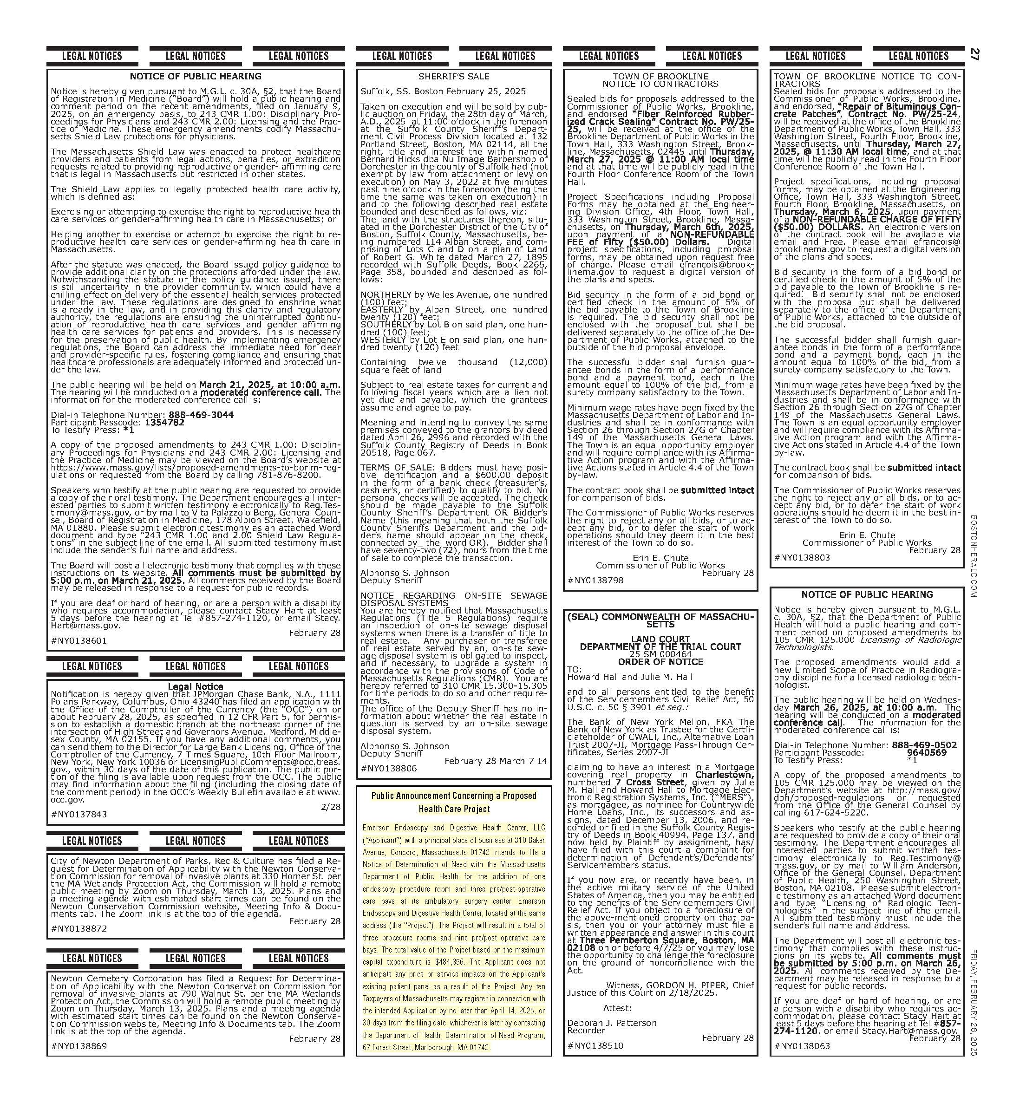

## APPENDIX 8

### CERTIFICATE OF ORGANIZATION

[https://corp.sec.state.ma.us/CorpWeb/CorpSearch/CorpSearchRedirector.aspx?Action=PDF&Pat](https://corp.sec.state.ma.us/CorpWeb/CorpSearch/CorpSearchRedirector.aspx?Action=PDF&Path=CORP_DRIVE1/2019/1018/001743641/0001/201933311700_1.pdf) [h=CORP_DRIVE1/2019/1018/001743641/0001/201933311700_1.pdf](https://corp.sec.state.ma.us/CorpWeb/CorpSearch/CorpSearchRedirector.aspx?Action=PDF&Path=CORP_DRIVE1/2019/1018/001743641/0001/201933311700_1.pdf)

## APPENDIX 9

### ACO LETTER

The Commonwealth of Massachusetts
Health Policy Commission
50 Milk Street, 8th Floor, Boston, Massachusetts 02109
617-979-1400
Deborah Devaux: Chair
David M. Seltz: Executive DirectorDecember 27, 2023 Bethany Stewart

Mass General Brigham Incorporated 800 Boylston Street, 11TH Floor Boston, MA 02199

RE: ACO LEAP Re-Certification Dear Ms. Stewart:

Congratulations! The Health Policy Commission (HPC) is pleased to inform you that Mass General Brigham Incorporated meets the requirements for ACO Certification under our Learning, Equity, and Patient-Centeredness (LEAP) standards. This certification is effective from January 1, 2024, through December 31, 2025.

The ACO Certification program, in alignment with other state agencies including MassHealth, is designed to accelerate care delivery transformation in Massachusetts and promote a high quality, efficient health system. ACOs participating in the program have met a set of objective criteria focused on core ACO capabilities demonstrating dedication to patient-centered care, use of evidence-based and data-driven strategies to improve care delivery, and commitment to addressing long-standing health inequities. Mass General Brigham Incorporated meets those criteria.

The HPC will promote Mass General Brigham Incorporated as a Certified ACO on our website and in our marketing and public materials. Enclosed you will find an ACO Certification logo for your organization to use in accordance with the attached Terms of Use. We hope you will use the logo on promotional materials when you highlight your ACO Certification to your patients, payers, and others.

The HPC looks forward to your continued engagement in the ACO Certification program over the next two years.

Thank you for your dedication to providing accountable, coordinated health care to your patients, and to continued learning and improvement over time. If you have any questions about this letter or the ACO Certification program, please do not hesitate to contact Mike Stanek, Associate Director, at [HPC-Certification@mass.gov](mailto:HPC-Certification@mass.gov) or (617) 757-1649.

Best wishes,



David Seltz Executive Director

## APPENDIX 10

### AFFIDAVIT

 Version: 7-6-17

**Massachusetts Department of Public Health**

**Determination of Need**

**Affidavit of Truthfulness and Compliance**

**with Law and Disclosure Form 100.405 (B)**

**Instructions:** Complete Information below. When complete check the box "This document is ready to print:". This will date stamp and lock the form. Print Form. Each person must sign and date the form. When all signatures have been collected, scan the document and e-mail to: [**dph.don@state.ma.us**](mailto:dph.don@state.ma.us)Include all attachments as requested.

Application Number: EDHC-25021711-AS

Original Application Date: 05/01/2025

Applicant Name: Emerson Endoscopy and Digestive Health Center, LLC

Application Type: Ambulatory Surgery

Applicant's Business Type: LLC

Is the Applicant the sole member or sole shareholder of the Health Facility(ies) that are the subject of this Application? Yes

Describe the role/relationship: [blank]

The undersigned certifies under the pains and penalties of perjury:

1. The Applicant is;
2. I have ~~read~~ [been informed of the contents of] 105 CMR 100.000, the Massachusetts Determination of Need Regulation;
3. I understand and agree to the expected and appropriate conduct of the Applicant pursuant to 105 CMR 100.800;
4. I have ~~read~~ [been informed of the contents of] this application for Determination of Need including all exhibits and attachments, and ~~certify that~~ [have been informed that] all of the information contained herein is accurate and true;
5. I have submitted the correct Filing Fee and understand it is nonrefundable pursuant to 105 CMR 100.405(B);
6. I have submitted the required copies of this application to the Determination of Need Program, and, as applicable, to all Parties of Record and other parties as required pursuant to 105 CMR 100.405(B);
7. I have caused, as required, notices of intent to be published and duplicate copies to be submitted to all Parties of Record, and all carriers or third-party administrators, public and commercial, for the payment of health care services with which the Applicant contracts, and with Medicare and Medicaid, as required by 105 CMR 100.405(C), et seq.;
8. I ~~have caused~~ [have been informed that] proper notification and submissions to the Secretary of Environmental Affairs pursuant to 105 CMR 100.405(E) and 301 CMR 11.00; will be made, if applicable.
9. If subject to M.G.L. c. 6D, § 13 and 958 CMR 7.00, I have submitted such Notice of Material Change to the HPC - in accordance with 105 CMR 100.405(G);
10. Pursuant to 105 CMR 100.210(A)(3), I certify that both the Applicant and the Proposed Project are in material and substantial compliance and good standing with relevant federal, state, and local laws and regulations, as well as with all ~~previously issued~~ Notices of Determination of Need ~~and the terms and Conditions attached therein~~ [issued in compliance with 105 CMR 100.00, the Massachusetts Determination of Need Regulation effective January 27, 2017 and amended December 28, 2018];
11. I have ~~read~~ [been informed of the contents of] and understand the limitations on solicitation of funding from the general public prior to receiving a Notice of Determination of Need as established in 105 CMR 100.415;
12. I understand that, if Approved, the Applicant, as Holder of the DoN, shall become obligated to all Standard Conditions pursuant to 105 CMR 100.310, as well as any applicable Other Conditions as outlined within 105 CMR 100.000 or that otherwise become a part of the Final Action pursuant to 105 CMR 100.360;
13. Pursuant to 105 CMR 100.705(A), I certify that the Applicant has Sufficient Interest in the Site or facility; and
14. Pursuant to 105 CMR 100.705(A), I certify that the Proposed Project is authorized under applicable zoning by-laws or ordinances, whether or not a special permit is required; or,
    1. If the Proposed Project is not authorized under applicable zoning by-laws or ordinances, a variance has been received to permit such Proposed Project; or,
    2. The Proposed Project is exempt from zoning by-laws or ordinances.

|  |
| --- |
| **LLC**  All parties must sign. Add additional names as needed  Christine Schuster <Signature on File> 3/19/2025  Name: Signature: Date:  Craig Best <Signature on File> 3/18/2025  Name: Signature: Date: |

**This document is ready to print:** check **Date/time Stamp:** [blank]

Affidavit of Truthfulness Page 2 of 2

## APPENDIX 11

### FILING FEE

Emerson Endoscopy & Digestive Health Center, LLC 310 Baker Avenue Ext.

Suite 175A

Concord, MA01742

March 20, 2025

Dennis Renaud, Director Determination of Need Program Department of Public Health

67 Forest Street

Marlborough, MA 01752

Dear Mr. Renaud,

Please find enclosed a check for $969.71 made payable to "The Commonwealth of Massachusetts," pursuant to the Determination of Need application filed by Emerson Endoscopy & Digestive Health Center, LLC under EDHC- 25021711-AS.

Sincerely,

[signature on file]

Christine Schultz, RN CEO

