APPENDIX 4 LEGAL NOTICE

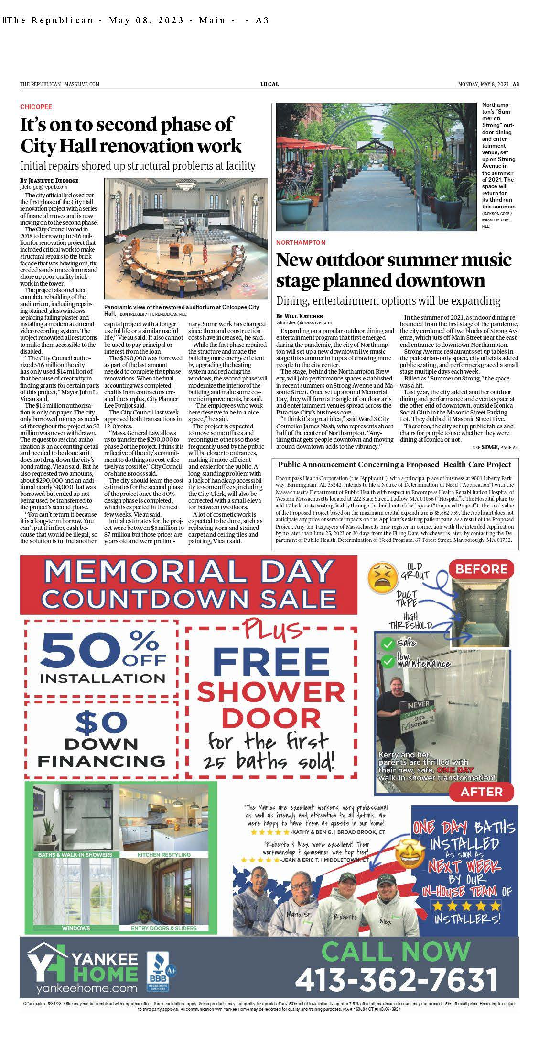

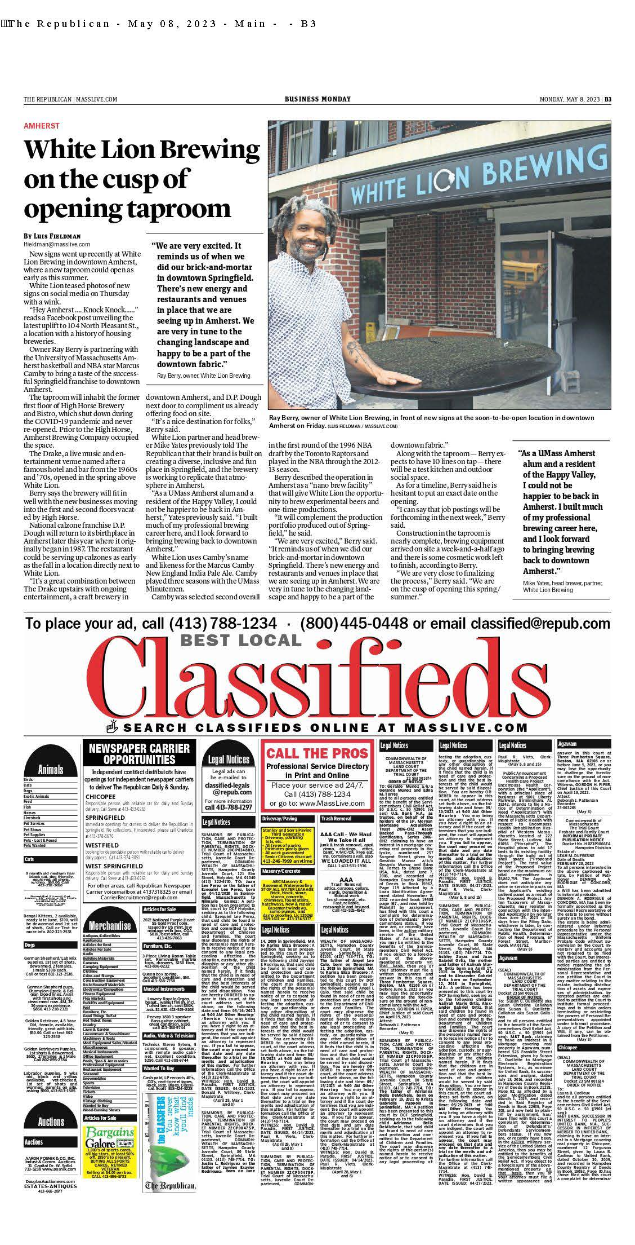

APPENDIX 7 ARTICLES OF INCORPORATION

https://corp.sec.state.ma.us/CorpWeb/CorpSearch/CorpSearchRedirector.aspx?Action=PDF&Pat h=CORP_DRIVE1/2015/0605/000671361/0697/020502087723_1.pdf

https://corp.sec.state.ma.us/CorpWeb/CorpSearch/CorpSearchRedirector.aspx?Action=PDF&Pat h=CORP_DRIVE1/2018/0112/001368836/0001/201874269270_1.pdf

APPENDIX 8 AFFIDAVIT

 Version: 7-6-17

Massachusetts Department of Public Health

Determination of Need

Affidavit of Truthfulness and Compliance

with Law and Disclosure Form 100.405 (B)
Instructions: Complete Information below. When complete check the box "This document is ready to print:". This will date stamp and lock the form. Print Form. Each person must sign and date the form. When all signatures have been collected, scan the document and e-mail to: dph.don@state.ma.us Include all attachments as requested.
Application Number: 23050511-HE
Original Application Date: 08/25/2023
Applicant Name: Encompass Health Corporation
Application Type: [blank]
Applicant's Business Type: Corporation
Is the Applicant the sole member or sole shareholder of the Health Facility(ies) that are the subject of this Application? [blank]

The undersigned certifies under the pains and penalties of perjury:
- The Applicant is the sole corporate member or sole shareholder of the Health Facility(ies) that are the subject of this Application;
- I have read [been informed of the contents of] 105 CMR 100.000, the Massachusetts Determination of Need Regulation;
- I understand and agree to the expected and appropriate conduct of the Applicant pursuant to 105 CMR 100.800;
- I have read [been informed of the contents of] this application for Determination of Need including all exhibits and attachments, and certify that [have been informed that] all of the information contained herein is accurate and true;
- I have submitted the correct Filing Fee and understand it is nonrefundable pursuant to 105 CMR 100.405(B);
- I have submitted the required copies of this application to the Determination of Need Program, and, as applicable, to all Parties of Record and other parties as required pursuant to 105 CMR 100.405(B);
- I have caused, as required, notices of intent to be published and duplicate copies to be submitted to all Parties of Record, and all carriers or third-party administrators, public and commercial, for the payment of health care services with which the Applicant contracts, and with Medicare and Medicaid, as required by 105 CMR 100.405(C), et seq.;
- I have caused [have been informed that] proper notification and submissions to the Secretary of Environmental Affairs pursuant to 105 CMR 100.405(E) and 301 CMR 11.00; will be made, if applicable.
- If subject to M.G.L. c. 6D, § 13 and 958 CMR 7.00, I have submitted such Notice of Material Change to the HPC - in accordance with 105 CMR 100.405(G);
- Pursuant to 105 CMR 100.210(A)(3), I certify that both the Applicant and the Proposed Project are in material and substantial compliance and good standing with relevant federal, state, and local laws and regulations, as well as with all previously issued Notices of Determination of Need and the terms and Conditions attached therein [issued in compliance with 105 CMR 100.00, the Massachusetts Determination of Need Regulation effective January 27, 2017 and amended December 28, 2018];
- I have read [been informed of the contents of] and understand the limitations on solicitation of funding from the general public prior to receiving a Notice of Determination of Need as established in 105 CMR 100.415;
- I understand that, if Approved, the Applicant, as Holder of the DoN, shall become obligated to all Standard Conditions pursuant to 105 CMR 100.310, as well as any applicable Other Conditions as outlined within 105 CMR 100.000 or that otherwise become a part of the Final Action pursuant to 105 CMR 100.360;
- Pursuant to 105 CMR 100.705(A), I certify that the Applicant has Sufficient Interest in the Site or facility; and
- Pursuant to 105 CMR 100.705(A), I certify that the Proposed Project is authorized under applicable zoning by-laws or ordinances, whether or not a special permit is required; or,
  - If the Proposed Project is not authorized under applicable zoning by-laws or ordinances, a variance has been received to permit such Proposed Project; or,
  - The Proposed Project is exempt from zoning by-laws or ordinances.

Corporation
Attach a copy of Articles of Organization/Incorporation, as amended

Mark Tarr <Signature on File> 7/26/2023
CEO for Corporation Name Signature: Date:

Patrick Darby <Signature on File> 7/26/2023
General Counsel, EVP & Secretary Name Signature: Date:

This document is ready to print: yes Date/time Stamp: [blank]

Affidavit of Truthfulness Page 2 of 2

APPENDIX 9 FILING FEE

Crystal M. Bloom
Partner

One Beacon Street, Suite 1320 Boston, MA 02108
Direct: 617.598.6783
Fax: 617.720.5092
crystal.bloom@huschblackwell.com

August 25, 2023

Via Email and FedEx

Dennis Renaud
Director, Determination of Need Program Department of Public Health
250 Washington Street
Boston, MA 02108

Re: Encompass Health Rehabilitation Hospital of Western Massachusetts Determination of Need Application # -23050511-HE

Dear Mr. Renaud:

We write to provide additional documentation for the above-captioned Determination of Need ("DoN") Application submitted to your office electronically on August 25, 2023. Please find enclosed the filing fee for the Encompass Health Rehabilitation Hospital for Western Massachusetts. Determination of Need Application (Application # -23050511-HE).

We thank you for your assistance with this matter. Please do not hesitate to contact Kasey Ciolfi, Esq. or me if you have any questions or require additional information.

Sincerely

HUSCH BLACKWELL LLP

[signature on file]

Crystal M. Bloom

Enclosure

cc: dph.don@mass.gov

HB: 4885-4528-5749.1 Husch Blackwell LLP

