The Children’s Medical Center Corporation
DoN Application No. BCH-23082514-HE
Attachments

Substantial Capital Expenditure

Ambulatory Surgery Center

Franciscan Hospital for Children, Inc.

September 6, 2023

Submitted By
The Children’s Medical Center Corporation
300 Longwood Avenue
Boston, MA 02115

Table of Contents

- Introduction
- Project Description
- Narrative Responses:
  - Factor 1 - Patient Panel, Need, Public Health Values and Operational Objectives
  - Factor 2 – Health Priorities
  - Factor 5 – Relative Merit
- Factor 4 – Capital Costs and Independent CPA Analysis
- Factor 6 – Community Health Initiative Supplemental Information
  - 2021 Community Health Needs Assessments (990 Schedule H CHNA/CHIP)
  - CHNA/CHIP Self – Assessment Form Cover Page
  - Community Health Initiative Narrative
  - Community Engagement Plan
- Notice of Intent
- Articles of Organization
- Affidavit of Truthfulness and Compliance
- Filing Fee
- HPC ACO Certification Approval Letter
- Affiliated Parties
- Change in Service

Attachment 4

Factor 4
Capital Costs and Report from Independent CPA Analysis

Attachment 5

Factor 6

Community Health Initiative Supplemental Information

  - 2021 FC Community Health Needs Assessment
franciscanchildrens.org/wp-content/uploads/2021/07/Franciscan-Childrens-CHNA-Full-Report.pdf
  - 990
  - CHNA/CHIP – Self- Assessment Form Cover -Submitted Separately
  - Community Health Initiative Narrative
  - Community Engagement Plan - Submitted Separately

Attachment 5d
Factor 6: Community Health Initiative Narrative
Franciscan Hospital for Children, Inc., (“FC”) is the only pediatric chronic disease and rehabilitation hospital in Massachusetts and has specialized capacity to care for the most medically complex children, including (i) newborn babies on ventilators, (ii) children with mental health conditions requiring inpatient, short-term residential, school-based, ambulatory and/or community-based services, (iii) children who need specialized dental services, including dental surgeries under general anesthesia, and (iv) children with specialized educational needs due to their physical and/or cognitive condition. FC is located at 30 Warren Street in the Allston-Brighton neighborhood of Boston, and also operates school-based programs across Boston in the neighborhoods of Dorchester, Hyde Park, Mattapan, Roxbury and the South End. The Children’s Medical Center Corporation is the sole corporate member of FC.
Community Health Initiative Community Engagement Processes
Community Health Needs Assessment: FC most recently completed a triennial Community Health Needs Assessment (CHNA) and adopted an implementation strategy in 2021 (FC 2021 CHNA). The FC 2021 CHNA was conducted by Health Resources in Action which solicited input community stakeholders in Allston/Brighton with further input from representatives of the Boston Public Health Commission, Massachusetts Society for the Prevention of Cruelty to Children, and Children’s Services of Roxbury. The FC 2021 CHNA built off the work from previous assessments conducted in 2015 and 2018. Priority areas identified in the 2018 FC CHNA included mental health for children and adolescents, primary care for children and adolescents, child wellness (e.g., nutrition, child development, physical activity), and community engagement with Allston/Brighton organizations.
The FC 2021 CHNA was conducted using an overarching framework to guide the assessment process with a Social Determinants of Health Framework and Health Equity Lens/Approach. Key community needs identified by the FC 2021 CHNA include: (1) housing access and affordability, (2) mental health, (3) oral health, and (4) family support services.

Community Health Initiative Community Engagement Processes: The Community Health Initiative (“CHI”) processes and community engagement for the proposed Determination of Need (“DoN”) Project will be facilitated by FC working in collaboration with the Boston Children’s Hospital Office of Community Health (“BCH OCH”). FC is not an acute hospital subject to the Massachusetts Attorney General’s Community Benefits Guidelines. The Community Health Initiative Advisory Board (“CHIAB”) to be formed will consult with the following organizations or organizational types: Boston Public Schools, Boston Public Health Commission, stakeholders in the sectors of Education, Housing, Social Services, and Community Health, and Community-based Organizations with expertise in children’s mental/behavioral health, oral health, and child development. In addition, the CHIAB will include community representation from the local Allston Brighton neighborhood and from across other Boston neighborhoods.
Working together FC and the BCH OCH will ensure (1) appropriate community engagement throughout the planning, implementation, and evaluation of the CHI process, (2) transparency in CHI decision-making, (3) accountability for planned CHI activities, and (4) strategies and initiatives that influence the social determinants of health and intentionally reduce health inequities. The FC/BCH OCH leadership team will also employ DPH priority elements to community engagement: power sharing amongst constituencies, culturally competent accommodations to address potential barriers, experienced facilitation, and representation that incorporates a mixture of grassroots and grass tops approaches.
Based on the FC 2021 CHNA and FC’s work with the community, the overarching goal for the proposed CHI Engagement Program would focus on evidence-informed and impactful CHI initiatives to address social determinants of health and reduction of health inequities for children who live in Boston, particularly for children and families of color from low and moderate income households, LGTBQ children and adolescents, and other systematically underserved groups of children and adolescents. Anticipated areas of focus include: 1) expanding prevention-based approaches to mental health, 2) improving pediatric oral health, 3) furthering early childhood health and development, and 4) increasing caregiver support and education, especially for children with special health care needs.

Request for Eight (8) Years for CHI Funding: FC is proposing to distribute local initiative CHI funds over 8 years with the goal of engaging and evaluating CHI initiatives over this time period. Community Health Initiative Funding
The breakdown of Community Health Initiative (“CHI”) monies for the Proposed Project is as follows. All totals are presented in the order calculated, beginning with the Maximum Capital Expenditure (“MCE”).

 | Amounts | Description
Maximum Capital Expenditure (“MCE”) | $481,371,000.00
Community Health Initiative | $24,068,550.00 | 5% of MCE
Administrative Fee | $481,371.00 | 2% of CHI Monies retained by Applicant
CHI Less Administrative Fee | $23,587,179.00 | CHI Monies less Administrative Fee
Statewide Initiative | $5,896,794.75 | 25% of CHI Less Administrative Fee
Local Initiative | $17,690,380.25 | 75% of CHI Less Administrative Fee

Please note that following the DoN Community Based Health Initiative Planning Guideline (issued in 2017), FC is also including a two percent (2%) allowable administrative fee to assist with the development of the community engagement process. These funds will be used to develop and implement a CHI process in accordance with DPH guidelines and to support ongoing community engagement throughout the CHI funding period.

Attachment 6

Notice of Intent

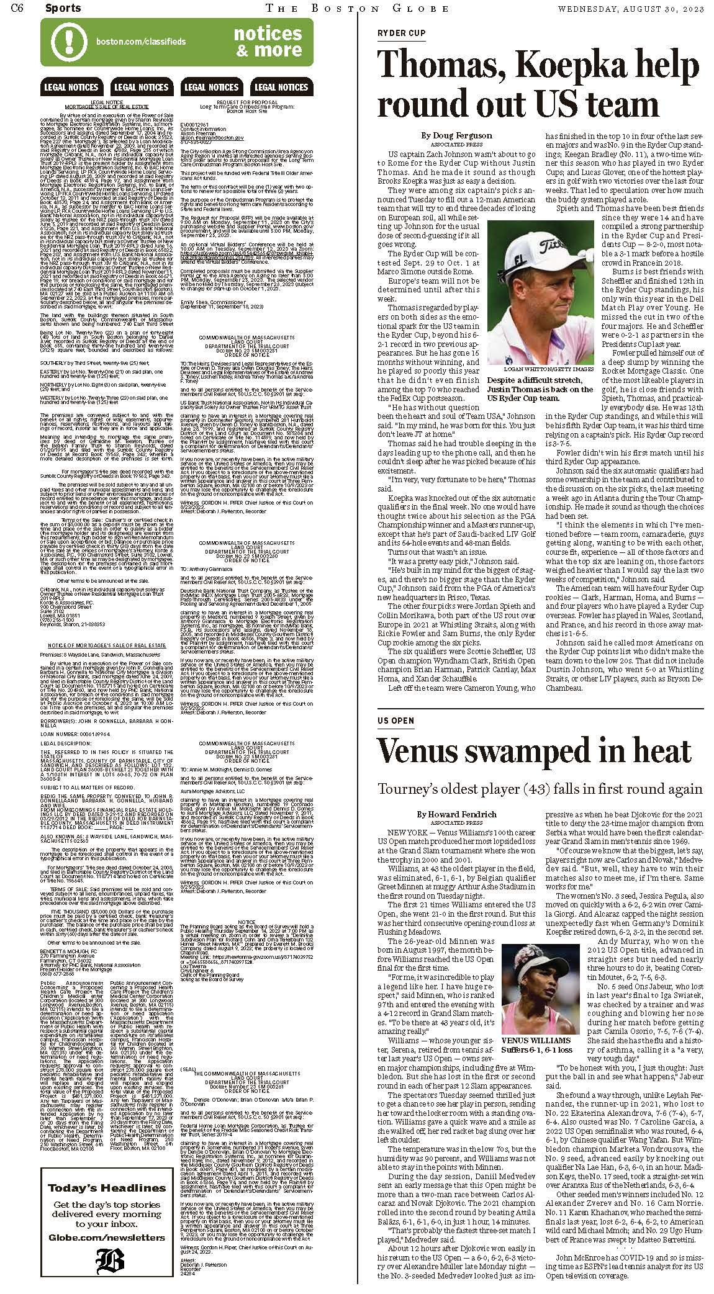

Attachment 7

Articles of Organization
https://corp.sec.state.ma.us/CorpWeb/CorpSearch/CorpSearchRedirector.aspx?Action=PDF&Path=CORP_DRIVE1/2018/0717/001460517/0001/020503189219_1.pdf

Attachment 8

Affidavit of Truthfulness and Compliance

 Version: 7-6-17
Massachusetts Department of Public Health

Determination of Need

Affidavit of Truthfulness and Compliance

with Law and Disclosure Form 100.405 (B)
Instructions: Complete Information below. When complete check the box "This document is ready to print:". This will date stamp and lock the form. Print Form. Each person must sign and date the form. When all signatures have been collected, scan the document and e-mail to: dph.don@state.ma.us Include all attachments as requested.
Application Number: BCH-23082514-HE
Original Application Date: 09/06/2023
Applicant Name: The Children’s Medical Center Corporation
Application Type: Hospital/Clinic Substantial Capital Expenditure
Applicant's Business Type: Corporation
Is the Applicant the sole member or sole shareholder of the Health Facility(ies) that are the subject of this Application? Yes
The undersigned certifies under the pains and penalties of perjury:
- The Applicant is the sole corporate member or sole shareholder of the Health Facility(ies) that are the subject of this Application;
- I have been informed of the contents of 105 CMR 100.000, the Massachusetts Determination of Need Regulation;
- I understand and agree to the expected and appropriate conduct of the Applicant pursuant to 105 CMR 100.800;
- I have been informed of the contents of this application for Determination of Need including all exhibits and attachments, and been informed that all of the information contained herein is accurate and true;
- I have submitted the correct Filing Fee and understand it is nonrefundable pursuant to 105 CMR 100.405(B);
- I have submitted the required copies of this application to the Determination of Need Program, and, as applicable, to all Parties of Record and other parties as required pursuant to 105 CMR 100.405(B);
- I have caused, as required, notices of intent to be published and duplicate copies to be submitted to all Parties of Record, and all carriers or third-party administrators, public and commercial, for the payment of health care services with which the Applicant contracts, and with Medicare and Medicaid, as required by 105 CMR 100.405(C), et seq.;
- I have been informed of proper notification and submissions to the Secretary of Environmental Affairs pursuant to 105 CMR 100.405(E) and 301 CMR 11.00; will be made, if applicable.
- If subject to M.G.L. c. 6D, § 13 and 958 CMR 7.00, I have submitted such Notice of Material Change to the HPC - in accordance with 105 CMR 100.405(G);
- Pursuant to 105 CMR 100.210(A)(3), I certify that both the Applicant and the Proposed Project are in material and substantial compliance and good standing with relevant federal, state, and local laws and regulations, as well as with all previously issued Notices of Determination of Need and the terms and Conditions attached therein;
- I have been informed of the contents of and understand the limitations on solicitation of funding from the general public prior to receiving a Notice of Determination of Need as established in 105 CMR 100.415;
- I understand that, if Approved, the Applicant, as Holder of the DoN, shall become obligated to all Standard Conditions pursuant to 105 CMR 100.310, as well as any applicable Other Conditions as outlined within 105 CMR 100.000 or that otherwise become a part of the Final Action pursuant to 105 CMR 100.360;
- Pursuant to 105 CMR 100.705(A), I certify that the Applicant has Sufficient Interest in the Site or facility; and
- Pursuant to 105 CMR 100.705(A), I certify that the Proposed Project is authorized under applicable zoning by-laws or ordinances, whether or not a special permit is required; or,
  - If the Proposed Project is not authorized under applicable zoning by-laws or ordinances, a variance has been received to permit such Proposed Project; or,
  - The Proposed Project is exempt from zoning by-laws or ordinances.

Corporation
Attach a copy of Articles of Organization/Incorporation, as amended

Kevin B. Churchwell <Signature on File> 8/18/2023
CEO for Corporation Name Signature: Date:

Douglas A. Berthlaume <Signature on File> 8/18/2023
Board Chair for Corporation Name Signature: Date:

This document is ready to print: yes Date/time Stamp: [blank]

Attachment 9

Filing Fee



September 6, 2023

By E-mail and First Class mail

Robert Goldstein, M.D.
Commissioner
Department of Public Health
250 Washington St.
Boston, MA 02108

Determination of Need
Boston Children’s Hospital
Project Number: BCH-23082514-HE

Dear Commissioner Goldstein:

On behalf of Children’s Medical Center Corporation, I am submitting a Determination of Need application for a project related to a Substantial Capital Expenditure and Ambulatory Surgery Center. The application was submitted online and the attachments were emailed according to the instructions. Attached to this letter, please find the check for the application fees.

Please feel free to contact me at 617-355-2683 with any questions regarding the application.

Sincerely,

Donna M. Casey
Senior Vice President, Strategic Business Planning
Boston Children’s Hospital
Donna.Casey@Childrens.Harvard.Edu

Attachment 10

HPC ACO Certification Approval Letter
5/27/2021 The HPC Accountable Care Organization (ACO) Certification Program | Mass.gov
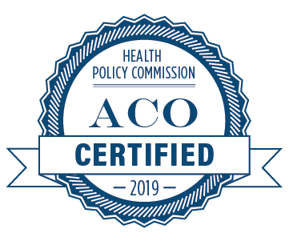
Atrius Health, Inc.

Baycare Health Partners, Inc., inclusive of Pioneer Valley Accountable Care, LLC; and Baystate Health Care Alliance, LLC

Beth Israel Lahey Performance Network, inclusive of Beth Israel Deaconess Physician Organization, LLC (Beth Israel Deaconess Care Organization); Lahey Clinical Performance Network, LLC; and Lahey Clinical Performance Accountable Care Organization, LLC

BMC Health System, Inc., inclusive of Boston Accountable Care Organization, Inc.; and BMC Integrated Care Services, Inc.

Cambridge Public Health Commission D/B/A Cambridge Health Alliance

Children’s Medical Center Corporation, inclusive of Children’s Hospital Corporation; and Boston Children’s Health Accountable Care Organization (Boston Children’s Accountable Care Organization)

Community Care Cooperative, Inc.

https://www.mass.gov/service-details/the-hpc-accountable-care-organization-aco-certification-program 4/6

Attachment 11

Affiliated Parties

Attachment 12

Change in Service

