APPENDIX 3 ORIGINAL DoN STAFF SUMMARY

STAFF REPORT TO THE PUBLIC HEALTH COUNCIL FOR A DETERMINATION OF NEED
Applicant Name | Partners HealthCare System, Inc.
Applicant Address | 800 Boylston Street, Suite 1150  Boston, MA 02199
Date Received | February 22, 2018
Type of DoN Application | Substantial Capital Expenditure
Total Value | $30,504,587
Ten Taxpayer Group (TTG) | None
Community Health Initiative (CHI) | Total CHI: $1,525,229  Statewide Contribution: $369,868 Administrative/Community Engagement Allowance: $45,756 CHI Local Health Priority Strategy Funding: $1,109,604
Staff Recommendation | Approval
Public Health Council (PHC) Meeting Date | June 13, 2018
Project Summary and Regulatory Review

Partners HealthCare System, Inc. (Partners or the Applicant) submitted a Determination of Need (DoN) application for a substantial capital expenditure to expand ambulatory surgical services at Mass General Waltham (MG Waltham), which is located at 40 Second Avenue in Waltham. MG Waltham is a licensed satellite of Mass. General Hospital. Partners intends to buildout, within the existing building, six additional ambulatory surgery operating rooms, 21 perioperative bays with support space, and 9,881 gross square feet (GSF) of additional shell space for future build-out as demand warrants. The capital expenditure for the Proposed Project is $30,504,587.
Applications for substantial capital expenditures are reviewed under the DoN regulation 105 CMR 100.000. Under the regulation, the Department must determine that need exists for a Proposed Project, on the basis of material in the record, where the Applicant makes a clear and convincing demonstration that the Proposed Project meets each Determination of Need factor set forth within 105 CMR 100.210. This staff report addresses each of the six factors set forth in the regulation.
The Department received no public comment on the application.

Background
MG Waltham is a licensed satellite of Massachusetts General Hospital (MGH) which is, in turn, an affiliate of Partners HealthCare System, Inc. (Partners). Partners is the Applicant for this DoN. The MG Waltham site currently houses physician services that include: advanced imaging, primary care, and specialty physician services as well as hospital satellite-based services: including oncology/infusion, blood laboratory, pharmacy, rheumatology, vascular, physical and occupational therapies, and ambulatory surgery services for orthopedics, plastic surgery and pain management. There are four operating rooms on the second floor where these surgeries are performed. If approved, the Applicant proposes to build-out six additional ambulatory surgery operating rooms, and 21 perioperative bays with support space along with 9,881 gross square feet (GSF) of additional shell space for future build-out as demand warrants (together, the “Proposed Project”).
The Proposed Project will add capacity to enable MG Waltham to offer 750 additional types of lower-acuity outpatient-appropriate procedures across gynecology, urology, general surgery, orthopedics, surgical oncology, and interventional radiology. These are all procedures that are currently performed at MGH’s main campus but not currently offered at MG Waltham’s Ambulatory Surgery Center (ASC) location and which Partners proposes to shift to MG Waltham. The Applicant asserts that approval of the Proposed Project will allow it to meet the increased demand from its patient panel for a broad range of approved outpatient surgical procedures in a setting that is more efficient, convenient and lower cost than at the hospital outpatient department (HOPD) at the MGH main campus.

Analysis
This analysis and recommendation reflect the purpose and objective of DoN which is “to encourage competition and the development of innovative health delivery methods and population health strategies within the health care delivery system to ensure that resources will be made reasonably and equitably available to every person within the Commonwealth at the lowest reasonable aggregate cost advancing the Commonwealth's goals for cost containment, improved public health outcomes, and delivery system transformation” 105 CMR 100.001.
All DoN factors are applicable in reviewing a capital expenditure Proposed Project. This Staff Report addresses each of these factors in turn.

Factors 1 and 2
Factor 1 of the DoN regulation asks that the Applicant address patient panel need, public health value, and operational objectives of the Proposed Project, while Factor 2 focuses on health priorities. Under factor 1, the Applicant must provide evidence of consultation with government agencies who have licensure, certification or other regulatory oversight which, in this case, has been done and so will not be addressed further in this staff report. This analysis will approach the remaining requirements of factors 1 and 2 by describing each element of the Proposed Project and how each element complies with those parts of the regulation.
Patient Panel, Need, and Projected Growth
In 2016, Partners’ patient panel consisted of approximately 1.3 million patients, which represented 19% of all discharges in Massachusetts that year. Most of Partners patients (77%) reside in the eastern part of the

state. Partners’ patient mix is approximately 41% male and 58% female; based upon self-reporting, the racial mix is largely Caucasian, with 4% identifying as African American-Black and 17% not reporting at all. Sixty-one percent of the patient panel is between ages 18 and 64, and 26% is 65 years or older.
Partners maintains that the growing demand for outpatient procedures is driven, in part, by improvements in the administration of anesthesia and analgesics and the development and expansion of many minimally invasive or non-invasive procedures across many specialties. Partners argues that providing access to a broader range of high-quality surgical services in an ASC, rather than at the MGH main campus, will be more efficient, cost-effective and convenient and will result in higher patient and provider satisfaction.
Partners looked at types of surgeries performed at MGH and determined which of those would have been clinically appropriate for an ASC. This analysis indicated that annually, over 11,000 patients who received outpatient surgery in oncology, gynecology, orthopedics, urology, and general surgery could have been treated in an ASC.
Partners also argues that its patient panel need for outpatient surgery will increase as a result of population forecasts; that by 2035, approximately a quarter of the population will be age 65 and older; and that approximately half of the population over the age of 65 will require surgery at least once in their lifetime. Approximately 53% of all surgical procedures are performed on patients age 65 or older. Partners asserts that this cohort of older patients is likely to experience a higher incidence of a broad range of lower acuity conditions for which treatment in an ambulatory surgery setting is beneficial to patients, and generally at a lower cost.
Partners states that the projected increased need by its patient panel has driven its efforts to expand access for outpatient-appropriate services at an ASC, and for that ASC to serve as a community-based alternative to the existing HOPDs located at MGH and system-wide. Since the existing ambulatory surgical capacity at MG Waltham was not sufficient to accommodate the projected increase in demand and types of procedures, Partners determined that shell space at the MG Waltham site could be effectively and efficiently built-out to accommodate that projected increase and that doing so met other quality and cost goals.
Public Health Value

The DoN regulation requires the Applicant to demonstrate that the Proposed Project will add measurable public health value in terms of improved health outcomes and quality of life for the existing patient panel, while providing reasonable assurances of health equity.
Partners maintains that by having sufficient capacity to meet the outpatient surgery needs of their patient panel in a lower cost ASC rather than a hospital-based setting, it will increase access, maintain high quality,

offer continued care coordination, including connection with primary care, and improve efficiency for patients and providers.

The ASC model is centered on uniformity of procedures performed within a scheduled block of time. Generally, one surgeon works with the same clinical team for the entire block of time performing multiple, very similar types of procedures. The team develops a specialized skill-set and works in a facility designed and equipped to meet the specific needs of ambulatory surgical patients, which, Partners says, generates efficiencies and cost-savings due to reduced procedure times as compared to a similar procedure performed in a HOPD.
Partners asserts that mixing the lower acuity surgeries with higher acuity procedures at the MGH campus can result in delays when acute cases take precedence over elective procedures for operating room time. These delays can lead to unnecessary expenses; anxiety and inconvenience for patients and their families; compromise plans for the care of patients upon discharge; and result in inefficiencies in the use of resources. Partners argues that having the majority of the lower acuity, outpatient appropriate procedures located at MG Waltham will remove barriers to access related to scheduling and transportation, save money, improve efficiencies and result in improved outcomes and greater patient and family satisfaction.
Competitiveness and Cost Containment
Partners asserts that the expansion of surgical services at MG Waltham and shifting lower acuity patients from the HOPD at MGH will reduce health care spending. Patients at an ASC spend most of the time preparing for and recovering from surgery (rather than having surgery) and thus, the organization, staffing and specialization at an ASC can result in cost differences between ASCs and HOPDs.

Partners asserts that reducing the time per procedure will generate cost savings as well as more effectively manage utilization of system-wide resources. Partners states that on average, procedures performed in ASCs take 25% less time relative to the mean procedure time at a HOPD. Citing a 2014 study published in Health Affairs that suggests that ASCs are a lower-cost alternative to hospitals for outpatient surgical procedures, Partners asserts that shifting outpatient appropriate surgery from the HOPD to an ASC will reduce delays, reduce costs, and increase capacity.
Community Engagement

Prior to submitting a DoN application, the DoN Regulation requires applicants to have engaged and consulted with the community. The Community Engagement Guide describes community engagement processes on a continuum from “Inform” and “Consult” through “Community driven-led.” For the purposes of factor 1, engagement defines “community” as the Patient Panel, and requires that the minimum level of engagement for this step is “Consult.” During the planning phase of the Proposed Project, MGH engaged patients, local residents, and resident groups affected by the Proposed Project by hosting a community forum and through presenting the Proposed Project at the Patient Perspective on

Perioperative Care Committee at MGH. Partners reports that feedback was positive and supportive of the plan, and the group expressed no concerns. DoN staff reviewed the slides and minutes of these meetings and found that in the context of factor 1 the Applicant met the community engagement standards in the planning phase of the Proposed Project.

Factor 3

Partners has certified that it is in compliance and in good standing with federal, state, and local laws and regulations, including, but not limited to M.G.L. c. 30, §§ 61 through 62H and the applicable regulations thereunder, and in compliance with all previously issued notices of Determination of Need and the terms and conditions attached therein.

Factor 4

Under factor 4, the Applicant must demonstrate that it has sufficient funds available for capital and operating costs necessary to support the Proposed Project without negative effects or consequences to the existing patient panel. Documentation sufficient to make such finding must be supported by an analysis by an independent CPA. The Applicant submitted such an analysis performed by Bernard L. Donohue, III, CPA, (Donohue) dated January 4, 2018 (CPA Report).
In order to assess the reasonableness of assumptions used, and the feasibility of the projections for the construction and build-out, the CPA Report reflects a review and analysis of the Applicant’s draft audited financial statements, current financial position, and other public information about the organization. Five- year pro forma financial projections were reviewed in relation to the most current two-year financial performance of Partners and MG Waltham and were determined by Donohue to be based on reasonable assumptions. In review of the net patient service revenue (NPSR), Donohue reports that the Proposed Project would represent approximately 0.073% and 0.166% in 2020 and 2022 respectively, of Partners’ NPSR. Donohue also analyzed each category of operating expenses for reasonableness and feasibility and concluded that the operating expenses from the Proposed Project represent approximately 0.109% and 0.171% respectively in 2020 and 2022.

Donohue found both the revenue and operating expense projections to be reasonable. The impact of adding six additional operating rooms and 21 perioperative bays are projected to increase total operating margins for Partners’ overall by 0.1% in 2022. Donohue also analyzed the capital expenditures and cash flows to determine whether Partners would have sufficient funds and cash flow for the Proposed Project, in light of its other financial obligations. Based on that review, Donohue stated that the capital obligations, expenditures, and resulting impact on cash flows are reasonable.

The CPA Report found that because the impact of the proposed capital project represents a relatively insignificant portion of the operations and financial position of Partners, it determined that the projections are not likely to result in insufficient funds available for any capital and ongoing operating costs necessary

to support the Proposed Project. Therefore, it determined that the Proposed Project is financially feasible, within the financial capability of Partners and based upon feasible financial assumptions.

Factor 5

Factor 5 requires the Applicant to “describe the process of analysis and the conclusion that the Proposed Project, on balance, is superior to alternative and substitute methods for meeting the existing Patient Panel needs and addressing, at a minimum, the quality, efficiency, and capital and operating costs of the Proposed Project relative to potential alternatives or substitutes.”
The Proposed Project is a build-out within an existing multi-use clinical structure at MG Waltham. The Applicant looked at the relative merit of building the additional ORs and perioperative space at each of MGH main campus and Charles River plaza as well as expanding the hours of operation at the main campus site. Expansion at the main campus or at the Charles River plaza site were dismissed as capital and operating costs would have been significantly higher at either site; accessibility to the sites would be difficult; and the reduced costs, and added convenience and efficiencies of a free-standing site would not be achieved. The Applicant asserts that the Proposed Project is the superior option because it meets anticipated increased demand, and it will continue to provide efficient, high quality services in a site specifically designed and equipped for the surgeries to be provided with a specialized team. With more capacity, Partners argues, more patients will gain greater access to the multi-specialty services that the site offers such as onsite free parking, pharmacy and cost effective care with efficient patient flow.

Factor 6
The Community Health Initiative (CHI) component of the DoN regulation requires approval of the Applicant's plans for fulfilling its responsibilities set out in the Department's Community-based Health Initiatives Guideline (Guideline). This is a Tier 2 project in which the Applicant is required to and did submit documentation showing that the existing community health needs assessment (CHNA) and community health improvement planning (CHIP) processes both evidence a sound community engagement process and demonstrate an understanding of the DoN Health Priorities.
After approval by the Department of the DoN, the Applicant (then Holder of a DoN) will work with its Community Health Initiatives Advisory Board to select Health Priority strategies and funding. These processes, selection of the Health Priorities and funding decisions are conditions of the DoN and enforceable as such. Partners HealthCare, after consultation with DPH, is using the CHNA/CHIP processes from Newton-Wellesley Hospital (NWH) as the basis for planning and decision-making.
In compliance with the requirements of the Guideline, and based on their own analysis, Partners Health Care submitted the following: a completed Community Engagement (CE) Self-Assessment form; four completed Stakeholder Assessment forms; a completed Community Engagement Plan (CEP); and NWH’s 2015 CHNA/CHIP. At the time of this Application, NWH had recently begun a new CHNA/CHIP (to be published in 2018), and it is that 2018 CHNA/CHIP that will serve as the basis for Health Priority Strategy Selection and implementation. Upon review of the CEP submitted at the time of Application, DPH

determined that the Applicant needed to and did complete a new CEP which would focus on the first two stages of the CHNA/CHIP process: “Assess Needs and Resources”; and “Focus on What’s Important”. By doing this, the Applicant is describing the CE process they will undergo for the completion of the 2018 CHNA. The Applicant will then (as a Holder of a DoN) submit revised CEP detailing community engagement activities for the latter stages of the CHNA/CHIP process.
DPH staff found that the revised CEP (Attachment 1) meets minimum standards and will be used as the basis for actions and reporting post-PHC approval of the DoN project. Compliance with the CEP is a condition to this DoN.

CHI Conditions to the DoN
- Of the total CHI contribution of $1,525,229 an Administrative Allowance of $45,756 (for community engagement activities and management of RFP related processes) will be taken by the Applicant. An additional $369,868 will be directed to the CHI Statewide Initiative and $1,109,604 will be dedicated to local approaches to the DoN Health Priorities. To comply with the Holder’s obligation to contribute to the Statewide CHI Initiative, the Holder must submit a check for $369,868 to Health Resources in Action (the fiscal agent for the CHI Statewide Initiative). The Holder must submit the funds within one month from the date of this Notice of Approval. The Holder must promptly notify DPH (CHI contact staff) when the payment has been made.
- For this DoN CHI, the Applicant and the Department have agreed to certain post PHC approval steps and a timeline (Attachment 2). The timeline is based upon certain assumptions:
  - The timeline assumes NWH completes its’ CHNA in mid-2018 and,
  - Reflects discussions with the Applicant of plans for another and forthcoming DoN Application that will be based at Mass General Waltham and for which the Applicant/Holder will engage in a combined CHI planning process for both projects.

If that Application is not received or it is not approved, the timeline will be revised to be in line with the timelines described in the CHI Planning Guideline. Compliance with the timeline agreed to with DPH staff is a condition of this DoN.
- The Applicant will implement the Community Engagement Plan attached hereto as Attachment 1.

Findings and Recommendations

The Applicant has provided evidence that the Proposed Project is likely to improve patient access to care in a lower cost setting by accommodating both the current demand for a broad range of lower acuity procedures that are now performed at MGH’s main campus, and anticipated demands of the aging patient panel for the surgical procedures offered. The Applicant complies with factor 3; based upon the CPA analysis, the Proposed Project is financially feasible in the context of factor 4; expansion within an existing facility is, on balance, the superior alternative for meeting the existing Patient Panel needs from the perspective of quality, efficiency, and capital and operating costs as required by factor 5; and the Applicant is in compliance with the requirements of the CHI planning process for the purposes of factor 6 subject to the CHI Conditions and Timeline and the Community Engagement Plan pursuant to 105 CMR 100.310(J).
Based upon a review of the materials submitted, Staff finds that the Applicant has met each DoN factor and recommends that the Department approve this Determination of Need application for an operating room expansion including pre and post-operative care rooms and shell space subject to all standard conditions (105 CMR 100.310). In compliance with the provisions of 105 CMR 100.310(L) and (Q), which require a

report to the Department, at a minimum on an annual basis, including the measures related to achievement of the DoN factors for a period of five years from completion of the Proposed Project, the Holder shall address its assertions with respect to the cost and quality and access benefits of outpatient surgery, as well as the shift of lower acuity procedures from MGH main campus to MG Waltham, with specificity and with associated metrics.

ATTACHMENT 1

Community Engagement Plan

ATTACHMENT 2

CHI Timeline

- Four weeks post-approval or sooner (July): NWH will submit an updated Community Engagement Plan Form to the Department of Public Health outlining CHI engagement activities for the “Choose Effective Policies and Procedures”, “Act on What’s Important” and “Evaluate Actions” phases. At that time, Newton-Wellesley Hospital will report on the community engagement activities described in the Community Engagement Plan.
- Six weeks post-approval (late July): The NWH 2018 community health needs assessment (“CHNA”) will be finalized with Health Resources in Action (“HRiA”) reporting to the Community Benefits Committee (“CBC”) on the key findings from the assessment and overall recommendations for focus areas. Additionally, NWH will direct HRiA to conduct a Dissemination of Results meeting with the Advisory Committee and the community at large to receive feedback on the findings.
- Two months post-approval (mid-August): The CHI Advisory Committee (as constituted and described in the Applicant’s Self-Assessment Form (Attachment 2) will begin meeting and reviewing the 2018 CHNA to commence the process of selecting Health Priorities.
- Three to four months post-approval (mid-September to mid-October): NWH will seek to work with an evaluator that will serve as a technical resource to applicants and grantees during the solicitation process, as well as evaluate planning processes.
- Three to four months post-approval (mid-September to mid-October): The Advisory Committee will meet at least three times to discuss health priorities. After these meetings, the Advisory Committee will select the final health priorities for funding.
- Four to five months post approval (mid-October to mid-November): The Advisory Committee completes a conflict of interest process to determine which members are eligible to participate in the Allocation Committee. The Allocation Committee reviews the health priorities and selects strategies for CHI funding. The Health Priorities and Strategies Form is returned to the Department of Public Health for review and approval.
- Six to seven months post-approval (mid-December to mid-January): Upon approval of the Health Priorities and Strategies Form from the Department of Public Health, the Allocation Committee begins developing the request for proposal (“RFP”) process and determining how this process will work in tandem with NWH’s current grant efforts.
- Eight to ten months post-approval (mid-February to mid-April): The RFP for funding is released.
- Eleven months post-approval (mid-May): Bidders conferences are held on the RFP with technical assistance resources present.
- Twelve months post-approval (mid-June): Responses are due for the RFP.
- Thirteen months post-approval (with allowance for an additional two months if Committee Members are not available in summer months post-approval (mid-July): Funding decisions are made, and the disbursement of funds begins.
- Ongoing: Evaluation of CHI and Reporting to the Department on an annual basis.

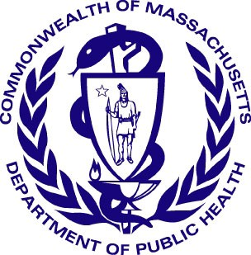 Version: 8-1-17
Massachusetts Department of Public Health
Determination of Need
Community Health Initiative
Community Engagement Plan

The Community Engagement Plan is intended for those Applicants with CHIs that require further engagement above and beyond the regular and routine CHNA/CHIP processes. For further guidance, please see the Community Engagement Standards for Community Health Planning Guidelines and its appendices for clarification around any of the following terms and questions.

All questions in the form, unless otherwise stated, must be completed

Approximate DoN Application Date: 02/22/2018
DoN Application Type: Hospital/Clinic Substantial Capital Expenditure
Applicant Name: Partners HealthCare System, Inc.
What CHI Tier is the project? Tier 2

1. Community Engagement Contact Person
Contact Person: Lauren Lele, MPA, CAVS
Title: Director of Community Benefit and Volunteer Services
Mailing Address: 2014 Washington Street
City: Newton State: Massachusetts Zip Code: 02462
Phone: 6172436330 Ext: none
Email: LLELE@Partners.org

2. Name of CHI Engagement Process
Please indicate what community engagement process (e.g. the name DoN CHI Initiative associated with the CHI amount) the following form relates to. This will be use as a point of reference for the following questions.
(please limit the name to the following field length as this will be used throughout this form): 2018 Community Health Needs Assessment

3. CHI Engagement Process Overview and Synergies with Broader CHNA /CHIP
Please briefly describe your overall plans for the CHI engagement process and specific how this effort that will build off of the CHNA / CHIP community engagement process as is stated in the DoN Community-Based Health Initiative Planning Guideline.: Please see attached narrative.

4. CHI Advisory Committee
In the CHNA/CHIP Self Assessment, you listed (or will list) the community partners that will be involved in the CHI Advisory Committee to guide the 2018 Community Health Needs Assessment. As a reminder:

For Tier 2 DON CHI Applicants: The CHI Advisory Committee is tasked with helping select DoN Health Priorities based on the CHNA / CHIP unless the Applicant is directed by DPH to conduct additional community engagement. If so, the advisory committee's role is to guide that additional work.

For Tier 3 DON CHI Applicants: The CHI Advisory Committee is to select DoN Health Priorities based on, but not exclusive to, the CHNA / CHIP. This includes the additional community engagement that must occur to develop the issue priorities.

5. Focus Communities for CHI Engagement
Within the 2018 Community Health Needs Assessment, please specify the target community(ies), please consider the community(ies) represented in the CHNA / CHIP processes where the Applicant is involved.
Add/Del Rows | Municipality | If engagement occurs in specific neighborhoods, please list those specific neighborhoods:
+ / - | Waltham
+ / - | Natick
+ / - | Needham
+ / - | Newton
+ / - | Wellesley
+ / - | Weston

6. Reducing Barriers
Identify the resources needed to reduce participation barriers (e.g. translation, interpreters, child care, transportation, stipend). For more information on participation barriers that could exist, please see Appendix A from the Community Engagement Standards for Community Health Planning Guidelines:
NWH and HRiA will work with community partners to facilitate focus groups and key informant interviews as part of the 2018 CHNA process. These partners are aware of the barriers their constituencies face in participating in engagement processes. Accordingly, NWH, in tandem with HRiA and our community partners, will address translation barriers by conducting focus groups in English and Hatian Creole. Additionally, transportation vouchers will be provided to residents in need and a family-friendly environment will be established at all community meetings. These efforts will combat barriers that residents may face when participating in engagement activities, such as focus groups and/or the potential Dissemination of Results meeting with the community upon completion of the CHNA.
7. Communication
Identify the communication channels that will be used to increase awareness of this project or activity:
NWH is committed to a transparent process and ongoing communication to ensure stakeholders are informed, engaged and have opportunities to provide feedback and participate as partners to shape the hospital's CHI strategy. Accordingly, for the Assess the Needs and Resources and the Focus on What's Important Phases of engagement, focus groups will be publicized via community partners, including through fliers, word of mouth, etc. Additionally, the 2018 CHNA and CHIP will be placed on NWH's web site. Residents can provide additional feedback via feedback forms distributed at the focus group meetings and/or at the potential Dissemination of Results meeting that NWH will hold with the community to discuss overall findings from the CHNA. Additional communication channels are described in more fully in question 11 below.
8. Build Leadership Capacity
Are there opportunities with this project or activity to build community leadership capacity? Yes
If yes, please describe how.:
Throughout each aspect of the CHI process, NWH staff, the CBC and the Advisory Committee, in tandem with HRiA staff, will determine what leadership opportunities exist and how NWH may seek to work with community partners to bolster their leadership capacity. Given the assessment of resources and overall needs, as well of the determination of health priorities for the CHI, there are potential opportunities for building community leadership capacity.

9. Evaluation
Identify the mechanisms that will be used to evaluate the planning process, engagement outcome, and partner perception and experience:
Post-Public Health Council approval, NWH will hire an evaluator to facilitate the evaluation of CHI planning processes and partner experience. The evaluation plan will be developed in a revised version of this form that will be submitted upon completion of the CHNA. However, to obtain meaningful demographic data from focus group participants, during the first two phases of engagement, NWH will ask all participants to complete formal surveys that will be aggregated to determine demographic representation.
10. Reporting
Identify the mechanisms that will be used for reporting the outcomes of this project or activity to different groups within the community:
Residents of Color: NWH staff will ensure CHNA materials are sent to the following organizations with a request to distribute among their networks: Charles River Community Health, Myrtle Baptist Church, Watch CDC and Riverside Community Care. Additionally, representatives and individuals from these groups will be asked to attend the potential Dissemination of Results meeting upon completion of the CHNA.
Residents who speak a primary language other than English: NWH staff will ensure CHNA materials are sent to the following organizations with a request to distribute among their networks: Latinas 'Know Your Rights' and Waltham High School. Additionally, representatives and individuals from these groups will be asked to attend the potential Dissemination of Results meeting upon completion of the CHNA.
Aging population: NWH staff will ensure CHNA materials are sent to the following organizations with a request to distribute among their networks: local councils on aging and Springwell, Inc. Additionally, representatives from these groups will be asked to attend the potential Dissemination of Results meeting upon completion of the CHNA for community members.
Youth: NWH staff will ensure CHNA materials are sent to the following organizations with a request to distribute among their networks: Waltham Schools and the Waltham Partnership for Youth. Additionally, representatives from these groups will be asked to attend the potential Dissemination of Results meeting upon completion of the CHNA for community members.
Residents Living with Disabilities: NWH staff will ensure CHNA materials are sent to the following organization with a request to distribute among its network: Healthy Waltham. Additionally, representatives from this group will be asked to attend the potential Dissemination of Results meeting upon completion of the CHNA for community members.
GLBTQ Community: NWH staff will ensure CHNA materials are sent to the following organization with a request to distribute among its network: Out MetroWest. Additionally, representatives from this group will be asked to attend the potential Dissemination of Results meeting upon completion of the CHNA.
Residents with Low Incomes: As stated, NWH staff will ensure CHNA materials are sent to the following organizations with a request to distribute among their networks: local health centers, such as Charles River Community Health and Riverside Community Care. Additionally, representatives from these groups will be asked to attend the potential Dissemination of Results meeting upon completion of the CHNA.
Other Residents: NWH staff will ensure CHNA materials are sent to the following organizations with a request to distribute among their networks: NWH Substance Use Services and Metro-Boston Project Outreach, so residents and families dealing with substance use disorders have access to the information. Additionally, representatives from these groups will be asked to attend the potential Dissemination of Results meeting upon completion of the CHNA for community members.

11. Engaging the Community At Large
Which of the stages of a CHNA/CHIP process will the 2018 Community Health Needs Assessment focus on? Please describe specific activities within each stage and what level the community will be engaged during the 2018 Community Health Needs Assessment. While the step(s) you focus on are dependent upon your specific community engagement needs as a result of your previous CHNA/CHIP work, for tier 3 applicants the CHI community engagement process must at a minimum include the “Focus on What's Important,” “Choose Effective Policies and Programs” and “Act on What's Important” stages. (For definitions of each step, please see pages 12-14 in the
Community Engagement Standards for Community Health Planning Guidelines
Assess Needs and Resources? Yes, Involve
Please describe the engagement process employed during the “Assess Needs and Resources” phase.: As discussed in Section 3, to commence the CHNA process, Lauren Lele worked with the CBC at length. CBC members were asked to provide feedback on the following: 1) Identification of potential key informant interviewees and focus groups; 2) Recruitment and/or partners to host focus groups; and 3) Review and comment on the following draft documents: a) List of secondary data indicators; b) Interview guide; c) Focus group guide; d) An outline of the CHNA Report; e) How feedback should be received on the CHNA Report and the CHNA Key Findings. Based on feedback from the CBC, HRiA has developed six focus group meetings/
listening sessions with community partners to assess the needs of the community and potential solutions for ongoing social determinant of health issues, as well as chronic disease needs, etc. Additionally, a list of eight key informant interviewees has been generated. These individuals represent organizations working with people of color, people of different ethnicities, underserved populations, the LGBTQ community, seniors and youth, individuals with chronic disease, such as substance use disorders, behavioral health issues, etc. These focus groups/community meetings allow NWH to reach the "Consult" level of community engagement for this phase as local Waltham residents will be able to provide feedback and discuss potential solutions regarding the prevalent health and social determinant of health factors in the community. However, the key informant interviews, as well as the CBC serving as an Advisory Body overseeing the CHNA and representing various community perspectives, allow NWH to reach a higher level of engagement, “Involve,” for the Assess Needs and Resources Phase of engagement.
Focus on What's Important? Yes, Collaborate
Please describe the engagement process employed during the “Focus on What’s Important” phase.: As discussed in Section 3, to ensure that a community voice is leveraged in the selection of the DoN Health Priorities, NWH will first present the key findings and themes from the 2018 CHNA to the CBC for feedback. If administrative monies allow, after the CBC's review, a community meeting will be held for dissemination of the results of the 2018 CHNA to the Advisory Committee, as well as the community at large. At this meeting, HRiA may provide an overview of key findings from the assessment and allow continued engagement with local residents through community feedback. Next, the Advisory Committee will utilize these key findings and the completed CHNA to determine health priorities for the CHI process. Again, the cross-representation of individuals that are on both the CBC and the Advisory Committee will allow the Advisory Committee to understand the CBC’s priorities ensuring cohesive action between the two committees. Moreover, the Allocation Committee will utilize the key findings from the CHNA to develop health strategies and potential procedures for developing the CHI RFP process. Overall, these activities will allow NWH to reach the "Collaborate" level of engagement for these phases through the work of the Advisory and Allocation Committees, including their consensus building efforts and participatory decision-making in determining health priorities and strategies for the CHI.
Choose Effective Policies and Programs? unchecked
Act on What's Important? unchecked
Evaluate Actions? unchecked

12. Document Ready for Filing
When document is complete click on "document is ready to file". This will lock in the responses and date/time stamp the form. To make changes to the document un-check the "document is ready to file" box.
Edit document then lock file and submit. Keep a copy for your records. Click on the "Save" button at the bottom of the page. To submit the application electronically, click on the "E-mail submission to DPH" button.

This document is ready to file? Yes
Date/time Stamp: 04/25/2018 3:07 pm
E-mail submission to DPH

Community Engagement Plan Form Section 3 Supplement

Currently, Newton-Wellesley Hospital ("NWH") is in the midst of conducting its 2018 Community Health Needs Assessment ("CHNA"). This CHNA will cover the hospital's catchment area of Natick, Needham, Newton, Waltham, Wellesley and Weston. However, additional engagement is being facilitated in Waltham (two specific focus groups with occur in the City of Waltham – one at Charles River Community Health, as well as one with Watch CDC) given the location of the proposed Determination of Need ("DoN") project at MG Waltham. To facilitate the CHNA process, NWH hired Health Resources in Action ("HRiA"), a public health consulting firm with expertise in conducting needs assessments and engagement processes. The 2018 CHNA is being overseen by NWH's Community Benefits Committee ("CBC") with Lauren Lele, NWH's Director of Community Benefit ensuring that the CBC has a strong voice in the process. To ensure a robust community health initiative (“CHI”) engagement process, NWH will carry out the following activities:

  - Development of a DoN Advisory Committee: NWH has developed a Waltham-centric Advisory Committee comprised of representatives from the noted constituencies listed in the Community Engagement Standards for Community Health Planning Guideline (please see the CHNA/CHIP Self-Assessment Form for a list of members). These individuals work with Waltham residents on various social determinant of health issues. Consequently, these representatives have a deep understanding of the barriers to care that many Waltham residents face, as well as the necessary social supports that are needed to ensure each resident has equal access to healthcare and other support services. To ensure continuity between the DoN Advisory Committee and NWH's CBC that is overseeing the CHNA, there are five individuals that will serve on both committees, ensuring cross-representation in facilitating the goals and priorities of each group. This cross-representation will also allow for on-going engagement of local stakeholders throughout the CHI process. The Advisory Committee will be tasked with selecting the health priorities for the CHI based on key themes from the 2018 CHNA process, as well as feedback from engaged Waltham residents and key informants. It is anticipated that the Advisory Committee will meet at least three times to select DoN health priorities (using the 2018 CHNA as the basis for all decisions). Once health priority decisions have been made, the Advisory Committee will engage in a conflict of interest process to determine which members of the group are eligible for participation in the Allocation Committee. The Allocation Committee is then tasked with determining the health strategies for the CHI and submitting the necessary Health Priorities Form to the Department of Public Health. Post-approval of the Health Priorities Form, the Allocation Committee develops the request for proposal (“RFP”) for CHI funding and the allocation of all CHI monies.

  - Development of a DoN Allocation Committee: As discussed, this Committee is charged with determining the strategies that will be employed based on the health priorities selected by the Advisory Committee and feedback from local residents and key informants. This Committee is also charged with facilitating a transparent RFP process and allocating funds to selected organizations.

  - Assessing Needs and Resources: To start the CHNA process, in her role as the Director of Community Benefit, Lauren Lele met with the CBC to receive feedback on the following topics around engagement: 1) Identification of potential key informant interviewees and focus groups;
2) Recruitment and/or partners to host focus groups; and 3) Review and comment on the following draft documents: a) List of secondary data indicators; b) Interview guide; c) Focus group guide; d) An outline of the CHNA Report; e) How feedback should be received on the CHNA Report and the CHNA Key Findings. Based on feedback from the CBC, HRiA has

developed six focus group meetings/listening sessions with community partners to assess the needs of the community and potential solutions for ongoing social determinant of health issues, as well as chronic disease needs, etc. Additionally, a list of eight key informant interviewees has been generated. These individuals represent organizations working with people of color, people of different ethnicities, underserved populations, the LGBTQ community, seniors and youth, individuals with chronic disease, such as substance use disorders, behavioral health issues, etc. These focus groups/community meetings allow NWH to reach the "Consult" level of community engagement for this phase as local Waltham residents will be able to provide feedback and discuss potential solutions regarding the prevalent health and social determinant of health factors in the community. However, the key informant interviews, as well as the CBC serving as an Advisory Body overseeing the CHNA and representing various community perspectives, allow NWH to reach a higher level of engagement, “Involve,” for the Assess Needs and Resources Phase.

  - Focusing on What's Important and the Choosing Effective Policies and Procedures: To ensure that a community voice is leveraged in the selection of the DoN Health Priorities, NWH will first present the key findings and themes from the 2018 CHNA to the CBC for feedback. If administrative monies allow, after the CBC's review, a community meeting will be held for dissemination of the results of the 2018 CHNA to the Advisory Committee, as well as the community at large. At this meeting, HRiA may provide an overview of key findings from the assessment and allow continued engagement with local residents through community feedback. Next, the Advisory Committee will utilize these key findings and the completed CHNA to determine health priorities for the CHI process. Again, the cross-representation of individuals that are on both the CBC and the Advisory Committee will allow the Advisory Committee to understand the CBC’s priorities ensuring cohesive priorities between the two committees. Moreover, the Allocation Committee will utilize the key findings from the CHNA to develop health strategies and potential procedures for developing the CHI RFP process. Overall, these activities will allow NWH to reach the "Collaborate" level of engagement for these phases through the work of the Advisory and Allocation Committees, including their consensus building efforts and participatory decision-making in determining health priorities and strategies for the CHI.

  - Act on What's Important: The Allocation Committee will develop a transparent funding and allocation process. This Committee is tasked with developing a sound solicitation process including a Bidders Conference that allows potential grantees to inquire about questions on the request for proposal ("RFP"). Additionally, the Allocation Committee will ensure that technical assistance resources are available during the RFP process, so as many applicants as possible may submit viable proposals. The Allocation Committee also will ensure there are no conflicts of interest with the distribution of funds. For the procurement process aspect of this phase, NWH will reach the “Involve” level of engagement. Additionally, for the CHI implementation aspect of this phase, where CHI funds are distributed to organizations and CHI projects are implemented, NWH will reach the “Consult” level of engagement.

  - Evaluate Actions: Post-Public Health Council approval, NWH will be selecting an evaluator to work with on the CHI process. The evaluator will be tasked with monitoring and evaluating the community partners on an ongoing basis and reporting progress to NWH on CHI activities on an annual basis. Post-review, these reports will be submitted to the Department of Public Health. For this phase, NWH will reach the “Consult” level of engagement.

Regarding the CHI administrative fee, as outlined in Table 1: CHI Funding Tiers and Community Engagement Requirements for Hospitals in the Department of Public Health’s Determination of

Need Community-Based Health Initiative Planning Guideline, Applicants submitting a Tier 2 CHI are eligible for a three percent (3%) administrative fee. However, for this CHI, 3% would only provide NWH with $45,756.88. If this funding is distributed over a three-to-five-year period, NWH will only have $9,151 to $15,252 per year available for administrative support. As discussed at our previous meeting with Ben Wood and Halley Reeves, this funding is inadequate for NWH to hire the required staff necessary to carry out each aspect of engagement that is necessary for this project. Consequently, NWH, as a community hospital is seeking 10% of the CHI monies for administrative fees ($152,522.94). Over three years this is an investment of $50,841 per year and over five years, and investment of $30,505 per year.
These monies are critical in developing a sound CHI process that complies with the Department of Public Health’s expectations as administrative funding will be used to hire additional support staff, as currently Lauren Lele facilitates all engagement and community benefit activities with the CBC. These monies will also pay for HRiA’s time to provide continued engagement with the community around the CHNA’s key findings, as well as CHI implementation, reporting and dissemination of promising practices and lessons learned, facilitation support for the Advisory Committee and Allocation Committee, costs associated with the development of communication materials and placement of procurement information in community newspapers (this will be further described in the revised Community Engagement Plan Form submitted upon completion of the CHNA). Finally, these monies will help to offset the costs of the development and implementation of the RFP process. NWH has received one estimate for conducting the solicitation process that is between $200,000 and $300,000.

Finally, the rest of this form addresses the Assess Needs and Resources and Focus on What’s Important aspects of engagement. A revised Community Engagement Plan Form will be submitted to the Department of Public Health in July, once the CHNA has been finalized.

APPENDIX 4

ORIGINAL DoN NOTICE OF APPROVAL

 The Commonwealth of Massachusetts
Executive Office of Health and Human Services
Department of Public Health
250 Washington Street, Boston, MA 02108-4619

CHARLES D. BAKER
Governor

KARYN E. POLITO
Lieutenant Governor

MARYLOU SUDDERS
Secretary

MONICA BHAREL, MD, MPH
Commissioner

June 14, 2018

VIA EMAIL - alevine@barrettsingal.com

Andrew Levine, Esq.

Barrett & Singal

One Beacon Street

Suite 1320

Boston, MA 02108-3106

RE: Notice of Final Action DoN # PHS-18022210-HE

Partners HealthCare System, Inc. – MG Waltham

Dear Mr. Levine:

At their meeting of June 13, 2018, the Commissioner and the Public Health Council, acting together as the Department, voted pursuant to M.G.L. c.111, §25C and the regulations adopted thereunder, to approve the Determination of Need application filed by Partners HealthCare System, Inc. (Partners or the Applicant) for a substantial capital expenditure to expand ambulatory surgical services at Mass General Waltham (MG Waltham), which is located at 40 Second Avenue in Waltham. This Notice of Final Action incorporates by reference the Staff Report and the Public Health Council proceedings concerning this application.

This application was reviewed pursuant to M.G.L. c. 111, § 25C and the regulatory provisions of 105 CMR 100.000 et seq. Based upon a review of the materials submitted, the Department found that the Applicant has met each DoN factor and approves this Determination of Need application for an operating room expansion including pre and post-operative care rooms and shell space subject to all standard conditions (105 CMR 100.310) including the CHI Conditions and Timeline and the Community Engagement Plan pursuant to 105 CMR 100.310(J).

In compliance with the provisions of 105 CMR 100.310(L) and (Q), which require a report to the Department, at a minimum on an annual basis, including the measures related to achievement of the DoN factors for a period of five years from completion of the Proposed Project, the Holder shall address its assertions with respect to the cost and quality and access benefits of outpatient surgery, as well as the shift of lower acuity procedures from Mass General Hospital main campus to MG Waltham, with specificity and with associated metrics.

Sincerely,

~S~

Nora J. Mann, Esq. Director

Determination of Need Program

cc: Sherman Lohnes, Director, Division of Health Care Facility Licensure and Certification

Rebecca Rodman, Deputy General Counsel

Samuel Louis, Office of Health Equity

Mary Byrnes, Center for Health Information Analysis

Steven Sauter, MassHealth

Katherine Mills, Health Policy Commission

Ben Wood, Office of Community Health Planning

Elizabeth Maffei, Office of Community Health Planning

Eric Gold, Attorney General’s Office

APPENDIX 5 NOTICE OF INTENT

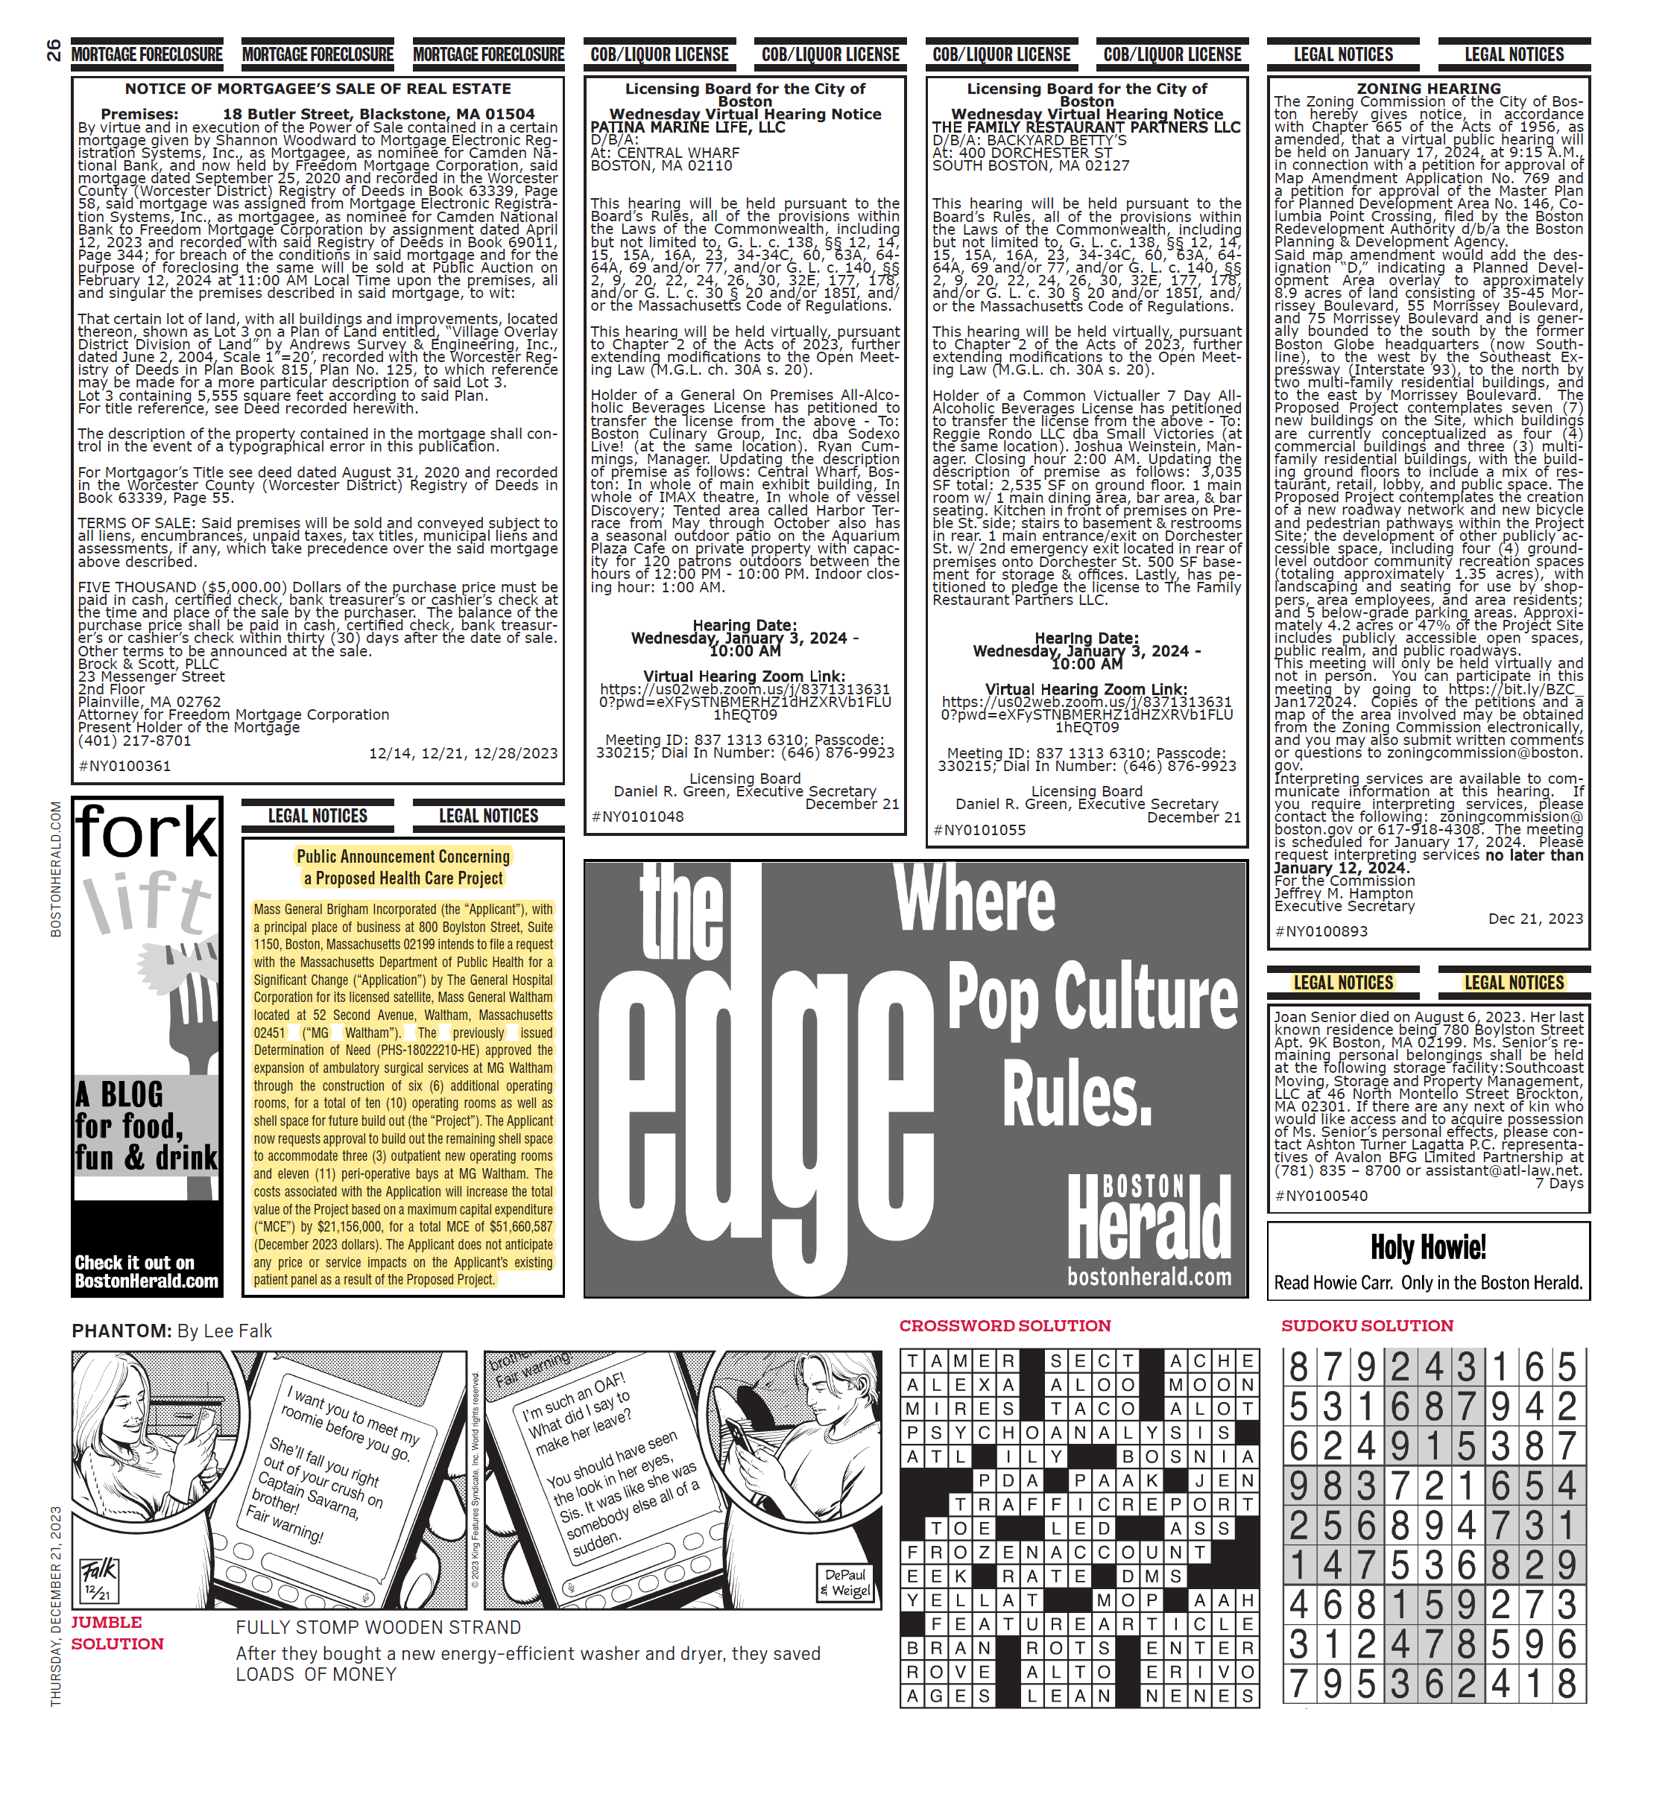

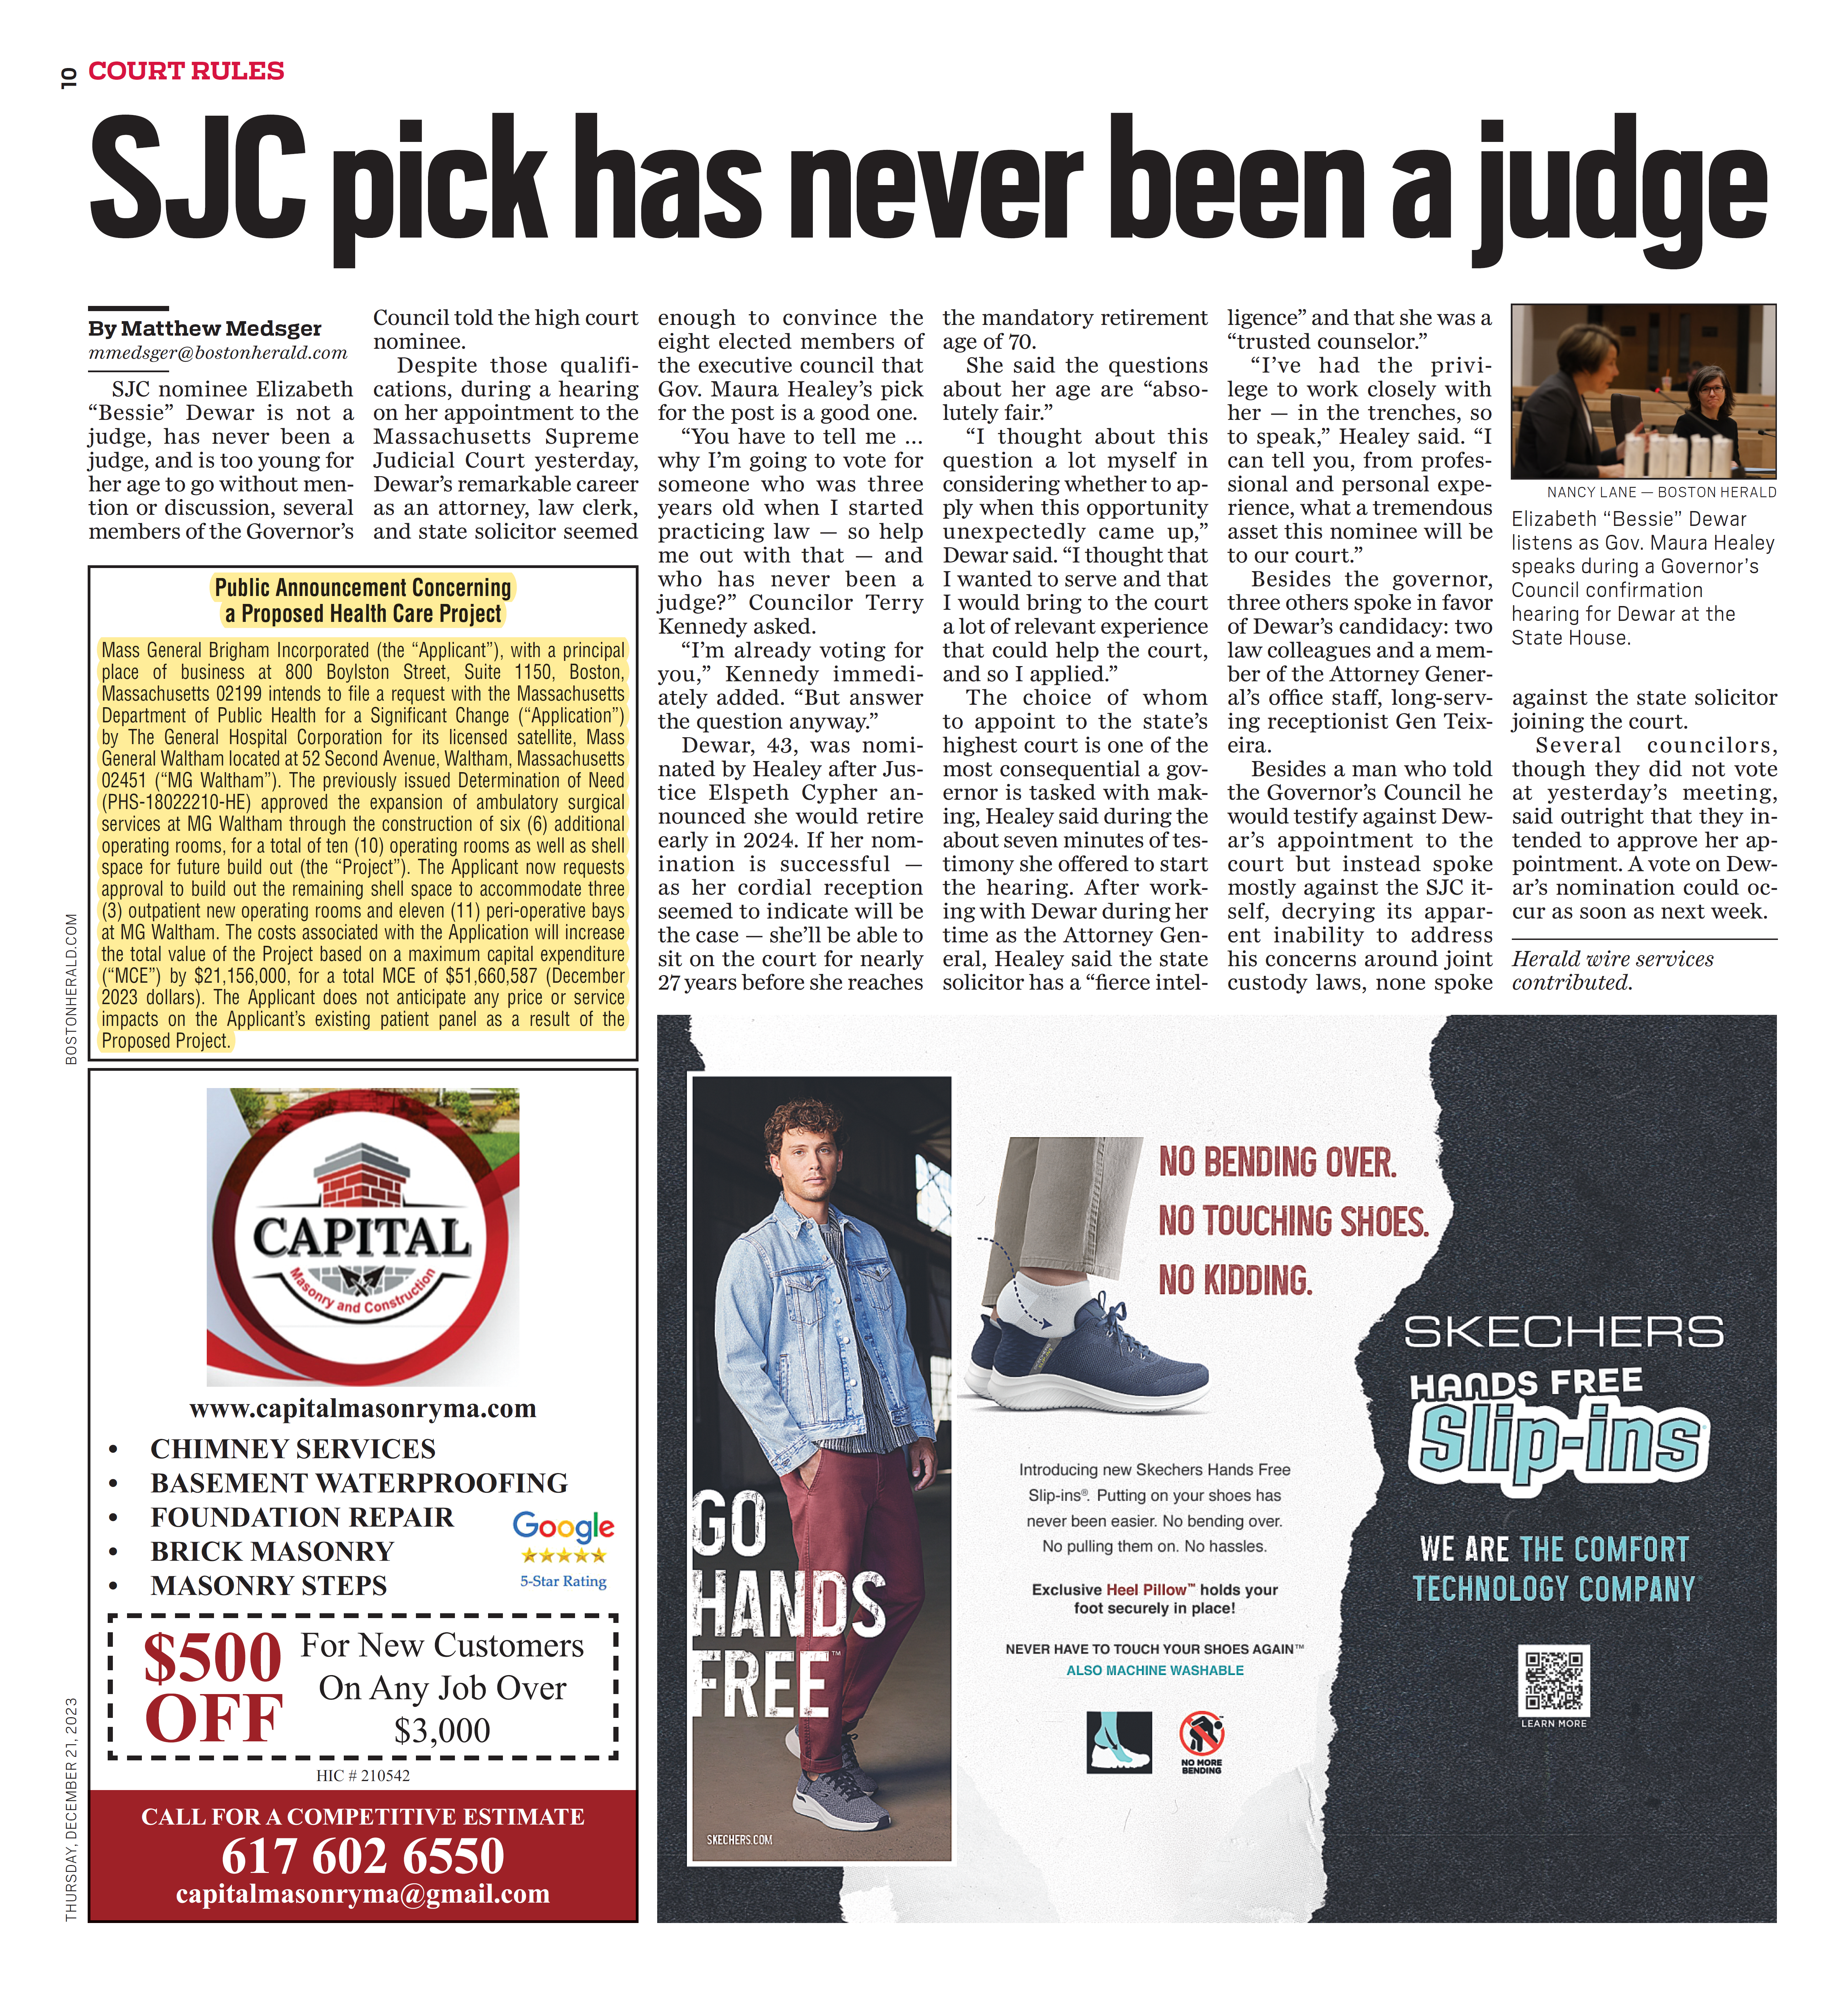

APPENDIX 7

NEWTON WELLESLEY HOSPITAL 2022 COMMUNITY HEALTH NEEDS ASSESSMENT

https://www.nwh.org/media/file/NWH%20CHNA%20Report%202022.pdf

HB: 4856-6734-4794.1

APPENDIX 9

ARTICLES OF INCORPORATION

https://corp.sec.state.ma.us/CorpWeb/CorpSearch/CorpSearchRedirector.aspx?Action= PDF&Pat h=CORP_DRIVE1/2009/0507/000279511/0012/020502088196_1.pdf
https://corp.sec.state.ma.us/CorpWeb/CorpSearch/CorpSearchRedirector.aspx?Action= PDF&Pat h=CORP_DRIVE1/2013/1023/000486352/0018/020502150409_1.pdf

https://corp.sec.state.ma.us/CorpWeb/CorpSearch/CorpSearchRedirector.aspx?Action= PDF&Pat h=CORP_DRIVE1/2009/0507/000279511/0011/020503153684_1.pdf

https://corp.sec.state.ma.us/CorpWeb/CorpSearch/CorpSearchRedirector.aspx?Action= PDF&Pat h=CORP_DRIVE1/2009/0507/000279511/0010/020503418276_1.pdf
https://corp.sec.state.ma.us/CorpWeb/CorpSearch/CorpSearchRedirector.aspx?Action= PDF&Pat h=CORP_DRIVE1/2016/0420/000000000/1086/201680695540_1.pdf
https://corp.sec.state.ma.us/CorpWeb/CorpSearch/CorpSearchRedirector.aspx?Action= PDF&Pat h=CORP_DRIVE1/2020/0423/001830448/0001/202085415470_1.pdf

APPENDIX 10 AFFIDAVIT

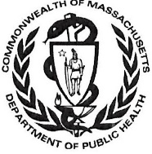 Version: 7-6-17

Massachusetts Department of Public Health

Determination of Need

Affidavit of Truthfulness and Compliance

with Law and Disclosure Form 100.405 (B)

Instructions: Complete Information below. When complete check the box "This document is ready to print:". This will date stamp and lock the form. Print Form. Each person must sign and date the form. When all signatures have been collected, scan the document and e-mail to: dph.don@state.ma.us Include all attachments as requested.
Application Number: MGB-23120412-AM
Original Application Date: [blank]
Applicant Name: Mass General Brigham Incorporated
Application Type: Amendment Significant
Applicant's Business Type: Corporation
Is the Applicant the sole member or sole shareholder of the Health Facility(ies) that are the subject of this Application? Yes
Describe the role /relationship: Owner
The undersigned certifies under the pains and penalties of perjury:
- The Applicant is the sole corporate member or sole shareholder of the Health Facility[ies] that are the subject of this Application;
- I have read [been informed of the contents of] 105 CMR 100.000, the Massachusetts Determination of Need Regulation;
- I understand and agree to the expected and appropriate conduct of the Applicant pursuant to 105 CMR 100.800;
- I have read [been informed of the contents of] this application for Determination of Need including all exhibits and attachments, and certify that [have been informed that] all of the information contained herein is accurate and true;
- I have submitted the correct Filing Fee and understand it is nonrefundable pursuant to 105 CMR 100.405(B);
- I have submitted the required copies of this application to the Determination of Need Program, and, as applicable, to all Parties of Record and other parties as required pursuant to 105 CMR 100.405(B);
- I have caused, as required, notices of intent to be published and duplicate copies to be submitted to all Parties of Record, and all carriers or third-party administrators, public and commercial, for the payment of health care services with which the Applicant contracts, and with Medicare and Medicaid, as required by 105 CMR 100.405(C), et seq.;
- I have caused [have been informed that] proper notification and submissions to the Secretary of Environmental Affairs pursuant to 105 CMR 100.405(E) and 301 CMR 11.00; will be made, if applicable.
- If subject to M.G.L. c. 6D, § 13 and 958 CMR 7.00, I have submitted such Notice of Material Change to the HPC - in accordance with 105 CMR 100.405(G);
- Pursuant to 105 CMR 100.210(A)(3), I certify that both the Applicant and the Proposed Project are in material and substantial compliance and good standing with relevant federal, state, and local laws and regulations, as well as with all previously issued Notices of Determination of Need and the terms and Conditions attached therein [issued in compliance with 105 CMR 100.00, the Massachusetts Determination of Need Regulation effective January 27, 2017 and amended December 28, 2018];
- I have read [been informed of the contents of] and understand the limitations on solicitation of funding from the general public prior to receiving a Notice of Determination of Need as established in 105 CMR 100.415;
- I understand that, if Approved, the Applicant, as Holder of the DoN, shall become obligated to all Standard Conditions pursuant to 105 CMR 100.310, as well as any applicable Other Conditions as outlined within 105 CMR 100.000 or that otherwise become a part of the Final Action pursuant to 105 CMR 100.360;
- Pursuant to 105 CMR 100.705(A), I certify that the Applicant has Sufficient Interest in the Site or facility; and
- Pursuant to 105 CMR 100.705(A), I certify that the Proposed Project is authorized under applicable zoning by-laws or ordinances, whether or not a special permit is required; or,
  - If the Proposed Project is not authorized under applicable zoning by-laws or ordinances, a variance has been received to permit such Proposed Project; or,
  - The Proposed Project is exempt from zoning by-laws or ordinances.

Corporation
Attach a copy of Articles of Organization/Incorporation, as amended

Anne Klibanski, MD <Signature on File> 01/02/24
CEO for Corporation Name: Signature: Date:

Scott Sperling
Board Chair for Corporation Name: Signature: Date

This document is ready to print: unchecked Date/Time stamp: [blank]

Version: 7-6-17

Massachusetts Department of Public Health

Determination of Need

Affidavit of Truthfulness and Compliance

with Law and Disclosure Form 100.405 (B)
Instructions: Complete Information below. When complete check the box "This document is ready to print:". This will date stamp and lock the form. Print Form. Each person must sign and date the form. When all signatures have been collected, scan the document and e-mail to: dph.don@state.ma.us Include all attachments as requested.
Application Number: MGB-23120412-AM
Original Application Date: [blank]
Applicant Name: Mass General Brigham Incorporated
Application Type: Amendment Significant
Applicant's Business Type: Corporation
Is the Applicant the sole member or sole shareholder of the Health Facility(ies) that are the subject of this Application? Yes
Describe the role /relationship: Owner
The undersigned certifies under the pains and penalties of perjury:
- The Applicant is the sole corporate member or sole shareholder of the Health Facility[ies] that are the subject of this Application;
- I have read [been informed of the contents of] 105 CMR 100.000, the Massachusetts Determination of Need Regulation;
- I understand and agree to the expected and appropriate conduct of the Applicant pursuant to 105 CMR 100.800;
- I have read [been informed of the contents of] this application for Determination of Need including all exhibits and attachments, and certify that [have been informed that] all of the information contained herein is accurate and true;
- I have submitted the correct Filing Fee and understand it is nonrefundable pursuant to 105 CMR 100.405(B);
- I have submitted the required copies of this application to the Determination of Need Program, and, as applicable, to all Parties of Record and other parties as required pursuant to 105 CMR 100.405(B);
- I have caused, as required, notices of intent to be published and duplicate copies to be submitted to all Parties of Record, and all carriers or third-party administrators, public and commercial, for the payment of health care services with which the Applicant contracts, and with Medicare and Medicaid, as required by 105 CMR 100.405(C), et seq.;
- I have caused [have been informed that] proper notification and submissions to the Secretary of Environmental Affairs pursuant to 105 CMR 100.405(E) and 301 CMR 11.00; will be made, if applicable.
- If subject to M.G.L. c. 6D, § 13 and 958 CMR 7.00, I have submitted such Notice of Material Change to the HPC - in accordance with 105 CMR 100.405(G);
- Pursuant to 105 CMR 100.210(A)(3), I certify that both the Applicant and the Proposed Project are in material and substantial compliance and good standing with relevant federal, state, and local laws and regulations, as well as with all previously issued Notices of Determination of Need and the terms and Conditions attached therein [issued in compliance with 105 CMR 100.00, the Massachusetts Determination of Need Regulation effective January 27, 2017 and amended December 28, 2018];
- I have read [been informed of the contents of] and understand the limitations on solicitation of funding from the general public prior to receiving a Notice of Determination of Need as established in 105 CMR 100.415;
- I understand that, if Approved, the Applicant, as Holder of the DoN, shall become obligated to all Standard Conditions pursuant to 105 CMR 100.310, as well as any applicable Other Conditions as outlined within 105 CMR 100.000 or that otherwise become a part of the Final Action pursuant to 105 CMR 100.360;
- Pursuant to 105 CMR 100.705(A), I certify that the Applicant has Sufficient Interest in the Site or facility; and
- Pursuant to 105 CMR 100.705(A), I certify that the Proposed Project is authorized under applicable zoning by-laws or ordinances, whether or not a special permit is required; or,
  - If the Proposed Project is not authorized under applicable zoning by-laws or ordinances, a variance has been received to permit such Proposed Project; or,
  - The Proposed Project is exempt from zoning by-laws or ordinances.

Corporation
Attach a copy of Articles of Organization/Incorporation, as amended

Anne Klibanski, MD
CEO for Corporation Name: Signature: Date:

Scott Sperling <Signature on File> 12/21/2023
Board Chair for Corporation Name: Signature: Date

This document is ready to print: unchecked Date/Time stamp: [blank]

Partners operates another outpatient satellite nearby. That facility, a licensed satellite of the Newton-Wellesley Hospital, is located in a leased building. Partners states that it does not have the ability to expand at that site because of lease terms as well as parking capacity.
At the same time, the Centers for Medicare and Medicaid Services (CMS) approved Medicare reimbursement for ambulatory surgery performed both at Hospital Outpatient Departments (HOPDs) and ambulatory surgery centers (ASCs).
Margaret J. Hall et al., Ambulatory Surgery Data From Hospitals and Ambulatory Surgery Centers: United States, 2010, 102 NATL HEALTH STATISTICS REPORTS 1 (2017), at https://www.cdc.gov/nchs/data/nhsr/nhsr102.pdf
Of the identified surgeries performed that could have been shifted to an outpatient setting nearly 30% of were for the 65+ age cohort. Partners expects this percentage to increase as the range of lower acuity procedures offered in the ASC setting expands.
University of Massachusetts Donahue Institute http://www.donahue.umassp.edu/business-groups/economic-public-policy-research/massachusetts-population-estimates-program/population-projections
Relin Yang et al., Unique Aspects of the Elderly Surgical Population: An Anesthesiologist's Perspective, 2 GERIATRIC ORTHOPAEDIC SURGERY & REHABILITATION 56 (2011), at https://www.ncbi.nlm.nih.gov/pmc/articles/PMC3597305/
Judith S. L. Partridge et al., Frailty in the older surgical patient: a review, 41 AGE AND AGEING 142 (2012), available at https://academic.oup.com/ageing/article/41/2/142/47699
AMBULATORY SURGERY CENTERS: A POSITIVE TREND IN HEALTH CARE (Ambulatory Surgery Center Ass'n), available at http://www.ascassociation.org/advancingsurgicalcare/aboutascs/industryoverview/apositivetrendinhealthcare
While the goal is to shift most of the patients to Waltham, some will continue to be served at the main campus.
Elizabeth L. Munnich & Stephen T. Parente, Procedures Take Less Time At Ambulatory Surgery Centers, Keeping Costs Down And Ability To Meet Demand Up, 33 HEALTH AFFAIRS 764 (2014), available at https://doi.org/10.1377/hlthaff.2013.1281 .
Id.
https://www.mass.gov/files/documents/2017/01/vr/guidelines-community-engagement.pdf
Id at Page 13
The Perspective on Perioperative Care Committee is comprised of patients and members from MGH's General Patient Family Advisory Council ("G-PFAC"), and is dedicated to fostering a partnership among patients, families, and staff to support the strategic goals and initiatives of MGH. The MGH G-PFAC was formed in 2011 to advance patient experience and promote patient and family involvement in all aspects of hospital operations. It has an enterprise-wide focus, including in and outpatient operations, across the continuum of care, and is comprised of a dedicated group of patient and family members who have experienced many different aspects of care and services at MGH and who volunteer their time, expertise and input, to make care even better. Meeting monthly throughout the year, the Council is co-chaired by a patient member and staff, and as part of its oversight, G-PFAC members participate in committees and task forces at MGH.
See, FN¹, supra for an explanation of why expansion at this site was the superior alternative to expanding the existing ambulatory surgery capacity at the nearby Newton-Wellesley Hospital satellite.
MG Waltham is a satellite of an acute care hospital and therefore is not required to comply with community benefits related CHNA/CHIP processes as determined by the IRS or the Massachusetts Attorney General’s Office. Newton-Wellesley Hospital (NWH) has overlapping service areas with MG Waltham and is the most relevant hospital within the Partners system for any community health planning activity. DPH has agreed that this and future Community Health Initiatives arising from MG Waltham will use the CHNA/CHIP processes of NWH.

