**APPENDIX 4**

**FACTOR 6 SUPPLEMENTAL DOCUMENTS**

**APPENDIX 4.1 CHI NARRATIVE**

**SALEM HOSPITAL DETERMINATION OF NEED AMENDMENT**

## Community Health Initiative Narrative

1. Community Health Initiative Monies

The breakdown of Community Health Initiative (“CHI”) monies for the Proposed Project is as follows. Please note, all totals are presented in the order calculated, beginning with the Maximum Capital Expenditure (“MCE”).

|  | **Total** | **Description** |
| --- | --- | --- |
| **MCE** | $4,341,755.00 | Original MCE, adjusted with subsequent amendments |
| **Total CHI Monies** | $217,087.75 | (5% of Maximum Capital Expenditure) |
| **Administrative Fee** | $8,683.51 | (4% of the CHI Monies, retained by Applicant) |
| **Remaining Monies** | $208,404.24 | (CHI Monies minus the Administrative fee) |
| **Statewide Initiative** | $20,840.42 | (10% of remaining monies, paid to State-wide fund) |
| **Local Initiative** | $187,563.82 | (90% of remaining monies) |
| **Evaluation Monies** | $18,756.38 | (10% of Local Initiative Monies, retained by Applicant) |
| **CHI Monies for Local Disbursement** | $168,807.44 |  |

1. Overview and Discussion of CHNA/DoN Processes

The CHI processes and community engagement for the proposed Determination of Need (“DoN”) Project will be conducted by Salem Hospital. Salem Hospital, a member of Mass General Brigham, is the North Shore’s largest healthcare provider and one of its largest employers. The Hospital offers a wide range of comprehensive care at its main hospital campus, ambulatory care sites, and physician offices throughout the service area.

In 2022, Salem Hospital led a highly participatory community health needs assessment (“CHNA”) in collaboration with neighboring communities to advance a shared vision of safe, thriving, and healthy neighborhoods. Salem Hospital respectfully requests that its 2025 CHNA may serve as the basis for this CHI. Salem Hospital is starting the 2025 CHNA process, which will build upon work done for the 2022 CHNA and is expected to be completed in Fall 2025.

Salem Hospital’s CHNA process serves to:

* Identify and provide an update on the health needs and assets of Salem Hospital’s service area - Danvers, Lynn, Lynnfield, Marblehead, Nahant, Peabody, Salem, and Swampscott - including information on social determinants of health;
* Design targeted health programs and allocate resources based on the priority health needs and;
* Understand how outreach activities may be more effectively coordinated and delivered by Salem Hospital and in collaboration with community partners.

As with the 2022 CHNA, the 2025 CHNA will focus on eight communities: Danvers, Lynn, Lynnfield, Marblehead, Nahant, Peabody, Salem, and Swampscott. The CHNA employed a Social Determinants of Health (“SDoH”) framework to examine how factors like income, education, employment, food security, housing, access to affordable and quality health services impact the health of community members, particularly those most likely to experience inequities in SDoH.

The 2022 CHNA utilized updated data from the U.S. Census, Centers for Disease Control and Prevention, Massachusetts Departments of Public Health and Elementary and Secondary Education, the Federal Bureau of Investigation, and Mass General Brigham. Based on lessons learned from the 2021 CHNA, participation in the online 2022 CHNA focus groups was expanded from 50 to over 100 invitees to broaden the scope of organizations included in the process. An additional focus group for immigration issues was established. The nine 2022 focus groups represented the following sectors: Community Health Centers, behavioral health (mental health and substance use disorder) services, youth services, elder services, housing, food security, the faith community, health care advocacy, and immigration. The focus group data were analyzed for common and divergent themes about health concerns and SDoH.

The 2022 CHNA also included a multi-lingual community survey available on-line and in print. The survey was available in 9 different languages to reflect the linguistic diversity of the communities served by Salem Hospital. The purpose of the survey was to get input from community residents on the priority health needs and suggestions for Salem Hospital to address the needs. The Community Affairs and Health Access Committee played a critical role ensuring the survey was distributed to vulnerable, underserved members of the community.

The 2025 CHNA will replicate the above-described structure of the 2022 CHNA. Because Salem Hospital is seeking permission to rely on its 2025 CHNA, Salem Hospital is similarly requesting an extension to the Self-Assessment Form to be provided to the Department upon approval by the Salem Hospital Board Trustees.

1. Oversight of the CHI Process

For this CHI, Salem Hospital will utilize its existing Community Affairs and Health Access Committee (“CAHAC”) to determine the use and oversight of the CHI funds.

The CAHAC of the Salem Hospital Board was established in 2004 to strengthen long-standing community relationships and advance our community health objectives. The Committee is comprised of 20 members including Board Trustees, clinical leaders, members of the Lynn Health Task Force, representatives from the local community health centers, and other community organizations (including local food pantries, YMCAs, children’s legal services, educational organizations, and elder services). Together they serve as our Community Benefit Advisory Committee with the responsibilities, functions and procedures outlined in the current Massachusetts Attorney General’s Community Benefit Guidelines.

The Committee meets quarterly and is responsible for:

* The review of the community needs assessment and other information related to access and the availability of healthcare
* The oversight, review and evaluation of the community affairs and community benefit programs and activities of Salem Hospital.

1. Advisory Committee Duties

Given that this is a Tier 1 CHI, the scope of work that the CAHAC will carry out includes:

* Ensuring appropriate engagement with residents from targeted communities and community partners around the CHI.
* Determining the Health Priorities for CHI funding based upon the needs identified in the 2025 CHNA/CHIP. The CAHAC will ensure that all Health Priorities are aligned with the Department of Public Health’s Health Priorities and the Executive Office of Health and Human Services’ Focus Areas.
* Providing oversight to the evaluator that is carrying out the evaluation of CHI-funded projects.
* Conducting a conflict-of-interest disclosure process to determine which members also will comprise the Allocation Committee (description).
* Reporting to the Department of Public Health on the DoN – CHI.

1. Allocation Committee Duties

The Allocation Committee is comprised of individuals from the CAHAC who do not have a conflict of interest in regard to funding. The scope of work that the Allocation Committee will carry out includes:

* Selecting Strategies for the noted Health Priorities.
* Completing and submitting the Health Priorities and Strategies Selection Form for approval by the Department of Public Health.
* Carrying out a formal request for proposal (“RFP”) process (or an equivalent, transparent process) for the disbursement of CHI funds.
* Engaging resources that can support and assist applicants with their responses to the RFP.
* Disbursement of CHI funding.
* Providing oversight to a third-party vendor that is selected to carry out the evaluation of CHI- funded projects.

1. Timeline for CHI Activities

Upon a Notice of Determination of Need being issued by the Public Health Council, the CAHAC will commence meeting and begin the CHI Process. The timeline for CHI activities is as follows:

* June 2025 – Expected project approval.
* September 2025 – Finalization of 2025 CHNA. The CAHAC will begin meeting and reviewing the 2025 CHNA/CHIP to commence the process of selecting Health Priorities.
* December 2025: The CAHAC has determined Health Priorities for funding.
* January 2026: The Allocation Committee is selecting strategies for the Health Priorities.
* March 2026: The Allocation Committee is determining the process to award funding, either through a direct funding model, inviting specific organizations to apply, or a public request for proposals (“RFP”).
* April 2026: The funding process opens.
* May 2026: Applications are due (depending on award process).
* June 2026: Funding decisions are made, and the disbursement of funds begins.
* Spring – Fall 2027: Evaluator will begin evaluation work.

Informal updates will be provided to the Department of Public Health once the 2025 CHNA process begins. Salem Hospital is committed to working with DPH on any differences in priorities that may arise during the 2025 CHNA.

1. Evaluation Overview

Salem Hospital is seeking to use 10% of local CHI funding ($18,756.38) for evaluation efforts. These monies will allow Applicant to utilize an experienced party to carry out technical assistance and ensure appropriate evaluation of the CHI-funded projects.

1. Administrative Monies

Applicants submitting a Tier 1 CHI are eligible for a four percent (4%) administrative fee. Accordingly, Salem Hospital is requesting $8,683.51 in administrative funding. These monies will help pay for reporting and dissemination of promising practices and lessons learned, facilitation support for the CAHAC and Allocation Committee, costs associated with the development of communication materials and placement of procurement information in community newspapers.

**APPENDIX 4.2**

**COMMUNITY HEALTH NEEDS ASSESSMENT**

[https://salem.massgeneralbrigham.org/cmslibrary/nsmc/pdf/2022%20Salem%20Hospital%20CH](https://salem.massgeneralbrigham.org/cmslibrary/nsmc/pdf/2022%20Salem%20Hospital%20CHNA%20Report.pdf) [NA%20Report.pdf](https://salem.massgeneralbrigham.org/cmslibrary/nsmc/pdf/2022%20Salem%20Hospital%20CHNA%20Report.pdf)

**APPENDIX 4.3 CHNA SELF-ASSESSMENT**

*(Submitted separately to the CHI Program)*

**APPENDIX 7 NOTICE OF INTENT**

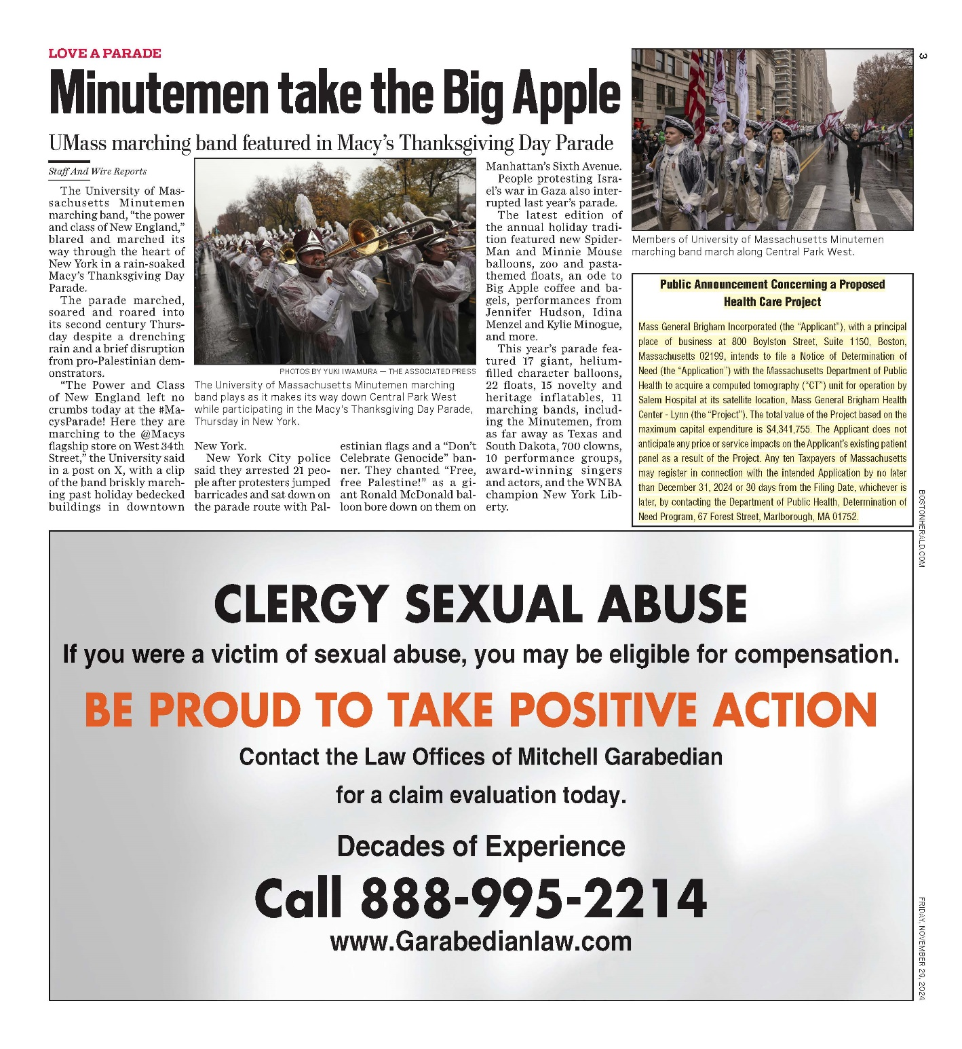

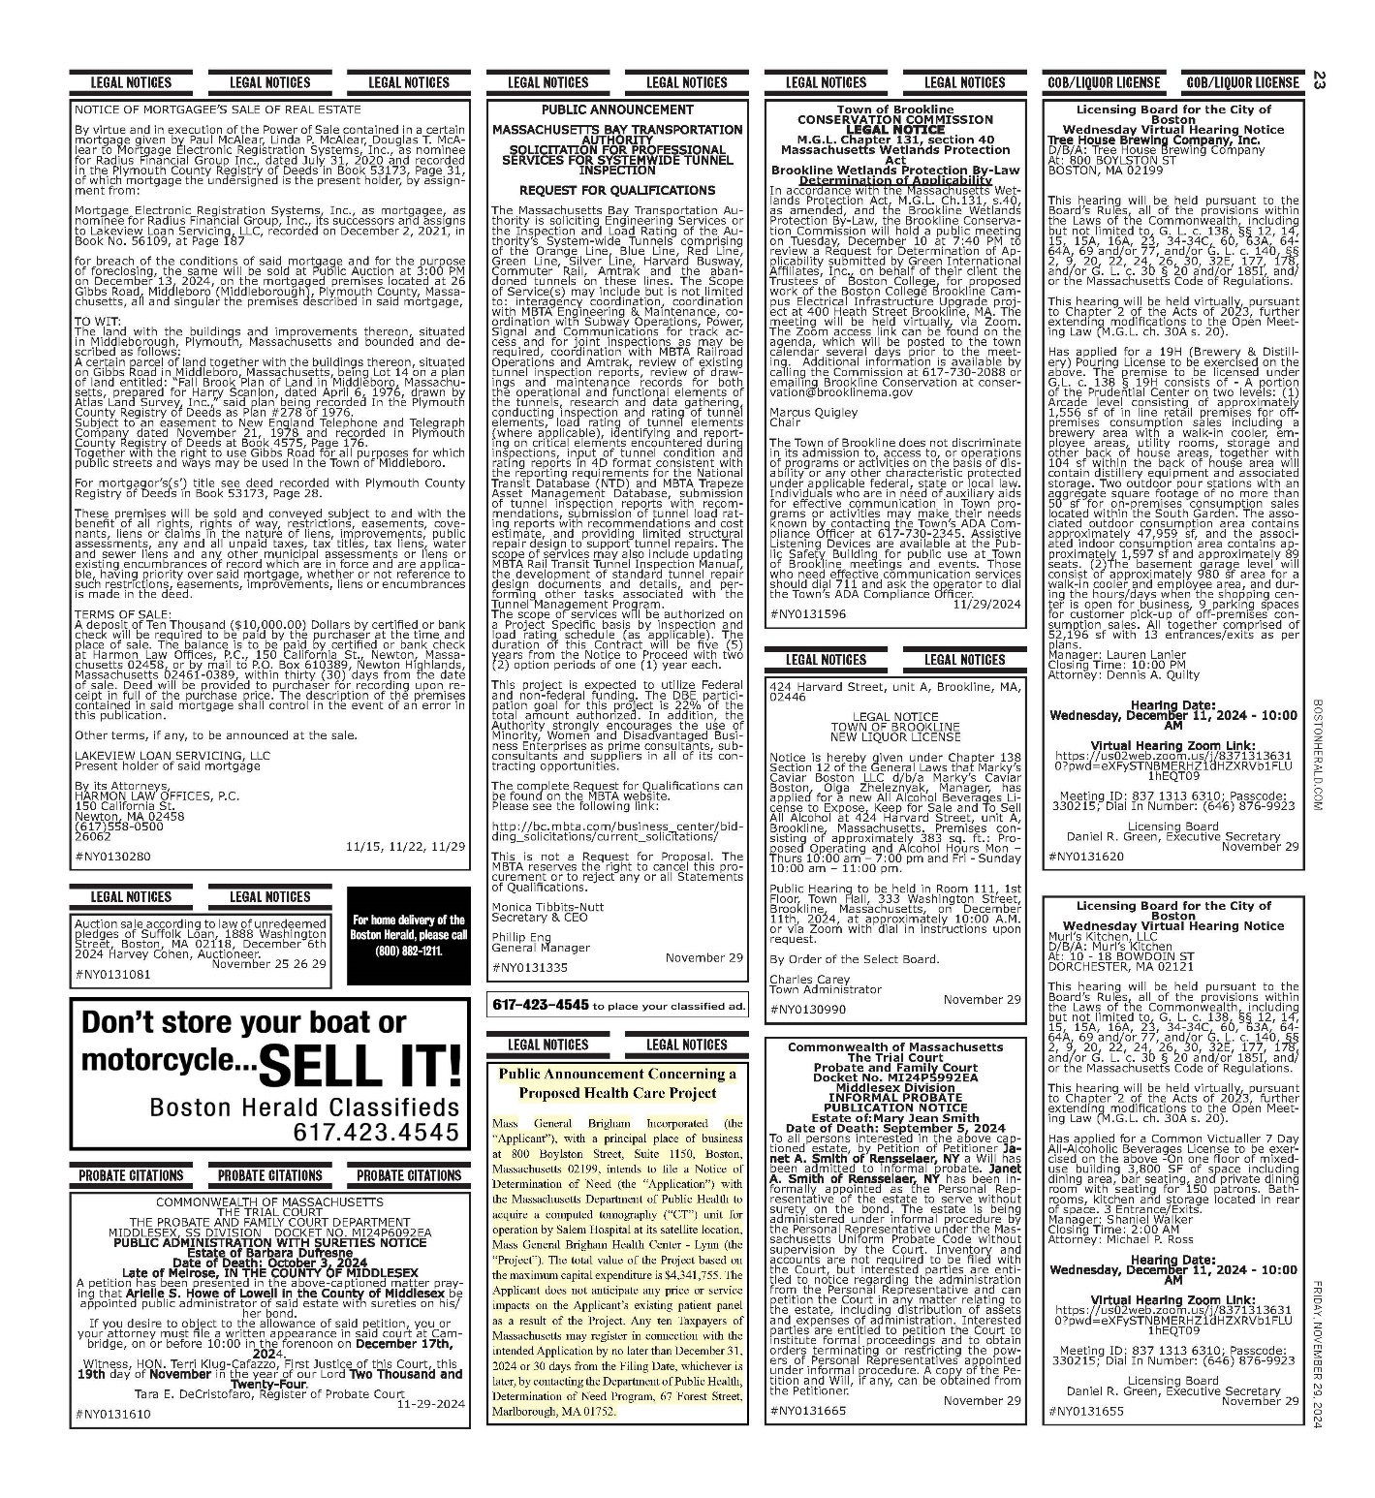

**APPENDIX 8** **ARTICLES OF INCORPORATION**

[**https://corp.sec.state.ma.us/CorpWeb/CorpSearch/CorpSearchRedirector.aspx?Action=**](https://corp.sec.state.ma.us/CorpWeb/CorpSearch/CorpSearchRedirector.aspx?Action=PDF&Path=CORP_DRIVE1/2009/0507/000279511/0012/020502088196_1.pdf)[**PDF&Pat**](https://corp.sec.state.ma.us/CorpWeb/CorpSearch/CorpSearchRedirector.aspx?Action=PDF&Path=CORP_DRIVE1/2009/0507/000279511/0012/020502088196_1.pdf)[**h=CORP_DRIVE1/2009/0507/000279511/0012/020502088196_1.pdf**](https://corp.sec.state.ma.us/CorpWeb/CorpSearch/CorpSearchRedirector.aspx?Action=PDF&Path=CORP_DRIVE1/2009/0507/000279511/0012/020502088196_1.pdf)

[**https://corp.sec.state.ma.us/CorpWeb/CorpSearch/CorpSearchRedirector.aspx?Action=**](https://corp.sec.state.ma.us/CorpWeb/CorpSearch/CorpSearchRedirector.aspx?Action=PDF&Path=CORP_DRIVE1/2013/1023/000486352/0018/020502150409_1.pdf)[**PDF&Pat**](https://corp.sec.state.ma.us/CorpWeb/CorpSearch/CorpSearchRedirector.aspx?Action=PDF&Path=CORP_DRIVE1/2013/1023/000486352/0018/020502150409_1.pdf)[**h=CORP_DRIVE1/2013/1023/000486352/0018/020502150409_1.pdf**](https://corp.sec.state.ma.us/CorpWeb/CorpSearch/CorpSearchRedirector.aspx?Action=PDF&Path=CORP_DRIVE1/2013/1023/000486352/0018/020502150409_1.pdf)

[**https://corp.sec.state.ma.us/CorpWeb/CorpSearch/CorpSearchRedirector.aspx?Action=**](https://corp.sec.state.ma.us/CorpWeb/CorpSearch/CorpSearchRedirector.aspx?Action=PDF&Path=CORP_DRIVE1/2009/0507/000279511/0011/020503153684_1.pdf)[**PDF&Pat**](https://corp.sec.state.ma.us/CorpWeb/CorpSearch/CorpSearchRedirector.aspx?Action=PDF&Path=CORP_DRIVE1/2009/0507/000279511/0011/020503153684_1.pdf)[**h=CORP_DRIVE1/2009/0507/000279511/0011/020503153684_1.pdf**](https://corp.sec.state.ma.us/CorpWeb/CorpSearch/CorpSearchRedirector.aspx?Action=PDF&Path=CORP_DRIVE1/2009/0507/000279511/0011/020503153684_1.pdf)

[**https://corp.sec.state.ma.us/CorpWeb/CorpSearch/CorpSearchRedirector.aspx?Action=**](https://corp.sec.state.ma.us/CorpWeb/CorpSearch/CorpSearchRedirector.aspx?Action=PDF&Path=CORP_DRIVE1/2009/0507/000279511/0010/020503418276_1.pdf)[**PDF&Pat**](https://corp.sec.state.ma.us/CorpWeb/CorpSearch/CorpSearchRedirector.aspx?Action=PDF&Path=CORP_DRIVE1/2009/0507/000279511/0010/020503418276_1.pdf)[**h=CORP_DRIVE1/2009/0507/000279511/0010/020503418276_1.pdf**](https://corp.sec.state.ma.us/CorpWeb/CorpSearch/CorpSearchRedirector.aspx?Action=PDF&Path=CORP_DRIVE1/2009/0507/000279511/0010/020503418276_1.pdf)

[**https://corp.sec.state.ma.us/CorpWeb/CorpSearch/CorpSearchRedirector.aspx?Action=**](https://corp.sec.state.ma.us/CorpWeb/CorpSearch/CorpSearchRedirector.aspx?Action=PDF&Path=CORP_DRIVE1/2016/0420/000000000/1086/201680695540_1.pdf)[**PDF&Pat**](https://corp.sec.state.ma.us/CorpWeb/CorpSearch/CorpSearchRedirector.aspx?Action=PDF&Path=CORP_DRIVE1/2016/0420/000000000/1086/201680695540_1.pdf)[**h=CORP_DRIVE1/2016/0420/000000000/1086/201680695540_1.pdf**](https://corp.sec.state.ma.us/CorpWeb/CorpSearch/CorpSearchRedirector.aspx?Action=PDF&Path=CORP_DRIVE1/2016/0420/000000000/1086/201680695540_1.pdf)

[**https://corp.sec.state.ma.us/CorpWeb/CorpSearch/CorpSearchRedirector.aspx?Action=**](https://corp.sec.state.ma.us/CorpWeb/CorpSearch/CorpSearchRedirector.aspx?Action=PDF&Path=CORP_DRIVE1/2020/0423/001830448/0001/202085415470_1.pdf)[**PDF&Pat**](https://corp.sec.state.ma.us/CorpWeb/CorpSearch/CorpSearchRedirector.aspx?Action=PDF&Path=CORP_DRIVE1/2020/0423/001830448/0001/202085415470_1.pdf)[**h=CORP_DRIVE1/2020/0423/001830448/0001/202085415470_1.pdf**](https://corp.sec.state.ma.us/CorpWeb/CorpSearch/CorpSearchRedirector.aspx?Action=PDF&Path=CORP_DRIVE1/2020/0423/001830448/0001/202085415470_1.pdf)

[**https://corp.sec.state.ma.us/CorpWeb/CorpSearch/CorpSearchRedirector.aspx?Action=**](https://corp.sec.state.ma.us/CorpWeb/CorpSearch/CorpSearchRedirector.aspx?Action=PDF&Path=CORP_DRIVE1/2023/0221/002451478/0001/202377475580_1.pdf)[**PDF&Path=CORP_DRIVE1/2023/0221/002451478/0001/202377475580_1.pdf**](https://corp.sec.state.ma.us/CorpWeb/CorpSearch/CorpSearchRedirector.aspx?Action=PDF&Path=CORP_DRIVE1/2023/0221/002451478/0001/202377475580_1.pdf)

**APPENDIX 9 ACO LETTER**

The Commonwealth of Massachusetts
Health Policy Commission
50 Milk Street, 8th Floor
Boston, MA 02109; 617-979-1400
Deborah Devaux: Chair
David M. Seltz: Executive Director

December 27, 2023 Bethany Stewart

Mass General Brigham Incorporated 800 Boylston Street, 11TH Floor Boston, MA 02199

RE: ACO LEAP Re-Certification Dear Ms. Stewart:

Congratulations! The Health Policy Commission (HPC) is pleased to inform you that Mass General Brigham Incorporated meets the requirements for ACO Certification under our Learning, Equity, and Patient-Centeredness (LEAP) standards. This certification is effective from January 1, 2024, through December 31, 2025.

The ACO Certification program, in alignment with other state agencies including MassHealth, is designed to accelerate care delivery transformation in Massachusetts and promote a high quality, efficient health system. ACOs participating in the program have met a set of objective criteria focused on core ACO capabilities demonstrating dedication to patient-centered care, use of evidence-based and data-driven strategies to improve care delivery, and commitment to addressing long-standing health inequities. Mass General Brigham Incorporated meets those criteria.

The HPC will promote Mass General Brigham Incorporated as a Certified ACO on our website and in our marketing and public materials. Enclosed you will find an ACO Certification logo for your organization to use in accordance with the attached Terms of Use. We hope you will use the logo on promotional materials when you highlight your ACO Certification to your patients, payers, and others.

The HPC looks forward to your continued engagement in the ACO Certification program over the next two years.

Thank you for your dedication to providing accountable, coordinated health care to your patients, and to continued learning and improvement over time. If you have any questions about this letter or the ACO Certification program, please do not hesitate to contact Mike Stanek, Associate Director, at [HPC-Certification@mass.gov](mailto:HPC-Certification@mass.gov) or (617) 757-1649.

Best wishes,

Signature for David Seltz

David Seltz Executive Director

**APPENDIX 10 AFFIDAVIT**

 Version: 7-6-17

**Massachusetts Department of Public Health**

**Determination of Need**

**Affidavit of Truthfulness and Compliance**

**with Law and Disclosure Form 100.405 (B)**

**Instructions**: Complete Information below. When complete check the box "This document is ready to print:". This will date stamp and lock the form. Print Form. Each person must sign and date the form. When all signatures have been collected, scan the document and e-mail to: [dph.don@state.ma.us](mailto:dph.don@state.ma.us) Include all attachments as requested.

Application Number: MGB-24120209-RE

Original Application Date: 12/26/2024

Applicant Name: Mass General Brigham Incorporated

Application Type: DoN-Required Equipment

Applicant's Business Type: Corporation

Is the Applicant the sole member or sole shareholder of the Health Facility(ies) that are the subject of this Application? Yes

The undersigned certifies under the pains and penalties of perjury:

1. The Applicant is the sole corporate member or sole shareholder of the Health Facility(ies) that are the subject of this Application;
2. I have ~~read~~ [been informed of the contents of] 105 CMR 100.000, the Massachusetts Determination of Need Regulation;
3. I understand and agree to the expected and appropriate conduct of the Applicant pursuant to 105 CMR 100.800;
4. I have ~~read~~ [been informed of the contents of] this application for Determination of Need including all exhibits and attachments, and ~~certify that~~ [have been informed that] all of the information contained herein is accurate and true;
5. I have submitted the correct Filing Fee and understand it is nonrefundable pursuant to 105 CMR 100.405(B);
6. I have submitted the required copies of this application to the Determination of Need Program, and, as applicable, to all Parties of Record and other parties as required pursuant to 105 CMR 100.405(B);
7. I have caused, as required, notices of intent to be published and duplicate copies to be submitted to all Parties of Record, and all carriers or third-party administrators, public and commercial, for the payment of health care services with which the Applicant contracts, and with Medicare and Medicaid, as required by 105 CMR 100.40S(C), et seq.;
8. I ~~have caused~~ [have been informed that] proper notification and submissions to the Secretary of Environmental Affairs pursuant to 105 CMR 100.405(E) and 301 CMR 11.00;
9. If subject to M.G.L c. 6D, § 13 and 958 CMR 7 .00, I have submitted such Notice of Material Change to the HPC – in accordance with 105 CMR 100.40S(G);
10. Pursuant to 105 CMR 100.210(A)(3), I certify that both the Applicant and the Proposed Project are in material and substantial compliance and good standing with relevant federal, state, and local laws and regulations, as well as with all ~~previously issued~~ Notices of Determination of Need and the terms ~~and Conditions attached therein;~~ [issued in compliance with 105 CMR 100.00, the Massachusetts Determination of Need Regulation effective January 27, 2017 and amended December 28, 2018]
11. I have read and understand the limitations on solicitation of funding from the general public prior to receiving a Notice of Determination of Need as established in 105 CMR 100.415;
12. I understand that, if Approved, the Applicant, as Holder of the DoN, shall become obligated to all Standard Conditions pursuant to 105 CMR 100310, as well as any applicable Other Conditions as outlined within 105 CMR 100.000 or that otherwise become a part of the final Action pursuant to 105 CMR 100.360;
13. Pursuant to 105 CMR 100.705(A), I certify that the Applicant has Sufficient Interest in the Site or facility; and
14. Pursuant to 105 CMR 100.70S(A), I certify that the Proposed Project is authorized under applicable zoning by-laws or ordinances, whether or not a special permit is required; or,
    1. If the Proposed Project is not authorized under applicable zoning by-laws or ordinances, a variance has been received to permit such Proposed Project; or,
    2. The Proposed Project is exempt from zoning by-laws or ordinances.

|  |
| --- |
| **Corporation**  All parties must sign. Add additional names as needed.  Anne Klibanski, MD <Signature on File> 12/17/2024  CEO for Corporation Name: Signature: Date:  Scott Sperling <Signature on File> 12/17/2024  Board Chair for Corporation Name: Signature: Date: |

**This document is ready to print:** [unchecked] **Date/time Stamp:** [blank]

**APPENDIX 11 FILING FEE**

**Mass General Brigham**

=

**Salem Hospital**

81 Highland Avenue, Salem, **MA** 01970

T 978 7411200

T 978 825 6200

Salem.massgeneralbrigham.org

December 20, 2024

Dennis Renaud, Director Determination of Need Program Department of Public Health

67 Forest St.

Marlborough, MA 01752

Re: Mass General Brigham Incorporated DON MGB-24120209-RE Dear Director Renaud:

Please find attached a check for $8,683.51. This check represents the filing fee for the Mass General Brigham Incorporated Determination of Need application MGB-24120209-RE.

Please don't hesitate to contact me with any questions regarding the check or application. Sincerely,

[signature on file]

Charles Adams

Executive Director, Finance Salem Hospital

Mass General Brigham 81 Highland Avenue Salem, MA O1970

Cc: Roxanne Ruppel, Salem Hospital Joan Casper, Salem Hospital Shelly Bisegna, Salem Hospital

Kim Booker Schmid, MGB Accounting Crystal Bloom, Husch Blackwell

Kasey Ciolfi, Husch Blackwell

