APPENDIX 3

FACTOR 1 e.ii
EVIDENCE OF SOUND COMMUNITY ENGAGEMENT

Navigator Elder Homes of Martha’s Vineyard

“Thriving Elders, Empowered Helpmates: A Home for Life” Unitarian Universalist Society of Martha’s Vineyard
February 21, 2021 1
Confidential

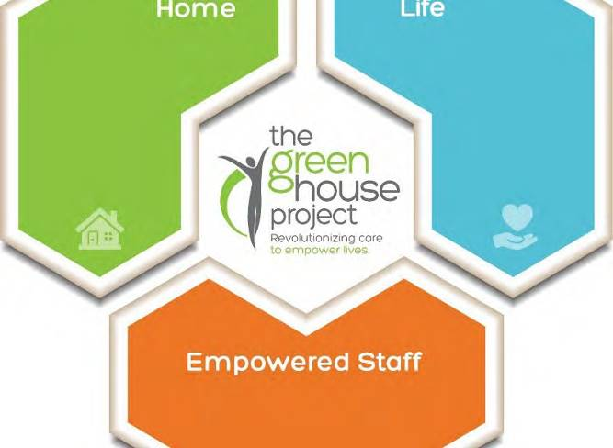What is the Green House Project?

The Green House Project :
  - Non-Profit Organization
  - Everyone has right to age with Dignity
  - GHP aims to destigmatize aging and humanize care
  - Promote radical non-institutional eldercare environments
  - Empowering lives of people who live and work with them

Navigator Elder Homes
of Martha’s Vineyard Confidential

Green House Project

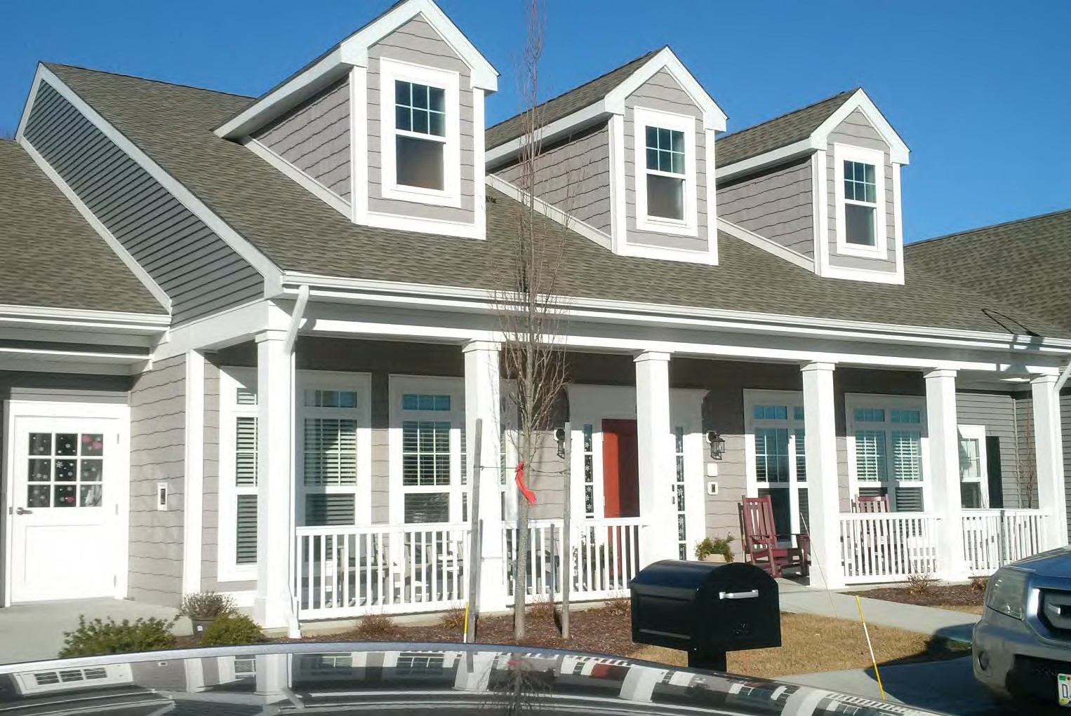
- Green House Homes:
  - 300 homes in 32 states
  - Elders are at the Center
  - Small-scale, self-contained and self sufficient
  - Assisted Living and Skilled Nursing
  - Private Rooms and Bathrooms for each elder
  - Easy-to-access Living Room, Fireplace, kitchen and outdoor space

Navigator Elder Homes
of Martha’s Vineyard Confidential

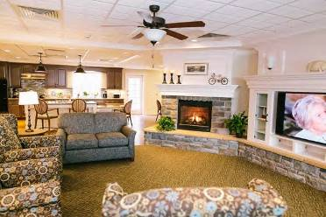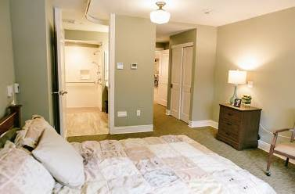
Navigator Elder Homes
of Martha’s Vineyard
Confidential
4
GREEN HOME Images
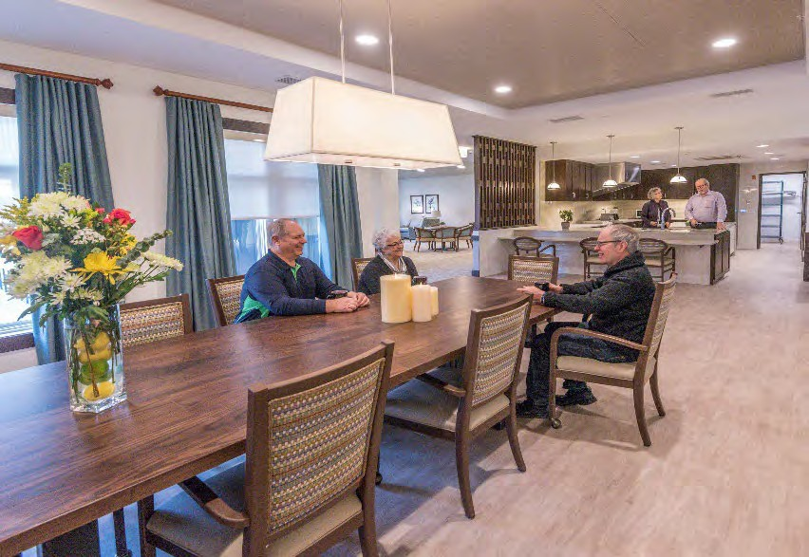
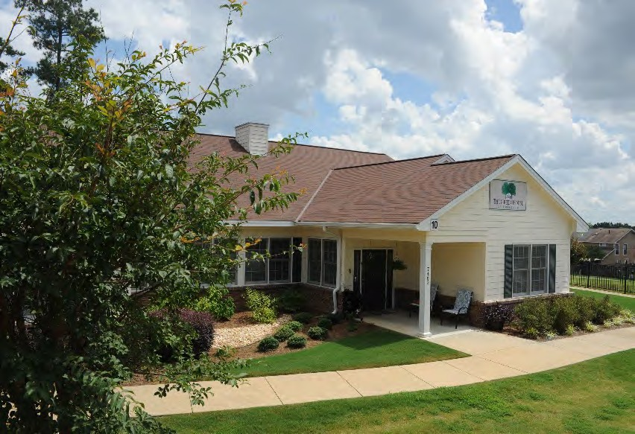
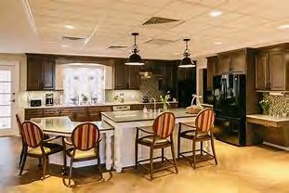
Fostering Meaningful Lives in Real Homes

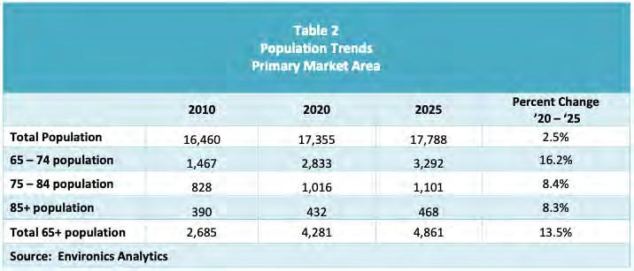
Highlights of the 2020 Martha’s Vineyard Market Study
Navigator Elder Homes
of Martha’s Vineyard
Confidential

- Age 75 plus population projected to increase by 84% on MV between 2020- 2035
- Windemere is the only nursing facility located on the Island.
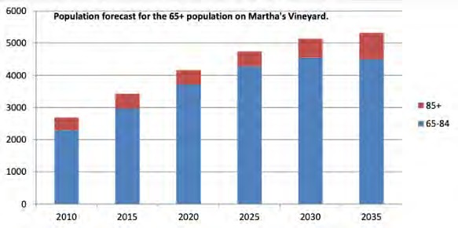
- Greenhouse will capture demand of patients currently seeking off –island care due to physical obsolescence of the current Windemere facility

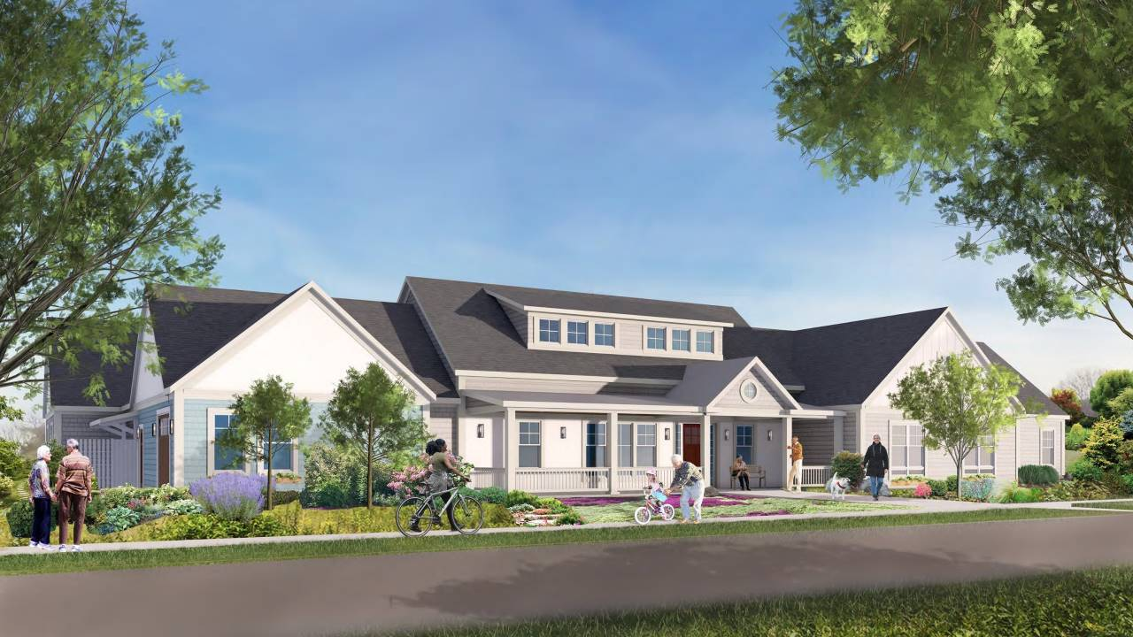Draft Depiction of one Navigator Green House Home, Edgartown, MA

Navigator Elder Homes of Martha’s Vineyard
Navigator Elder Homes
of Martha’s Vineyard Confidential

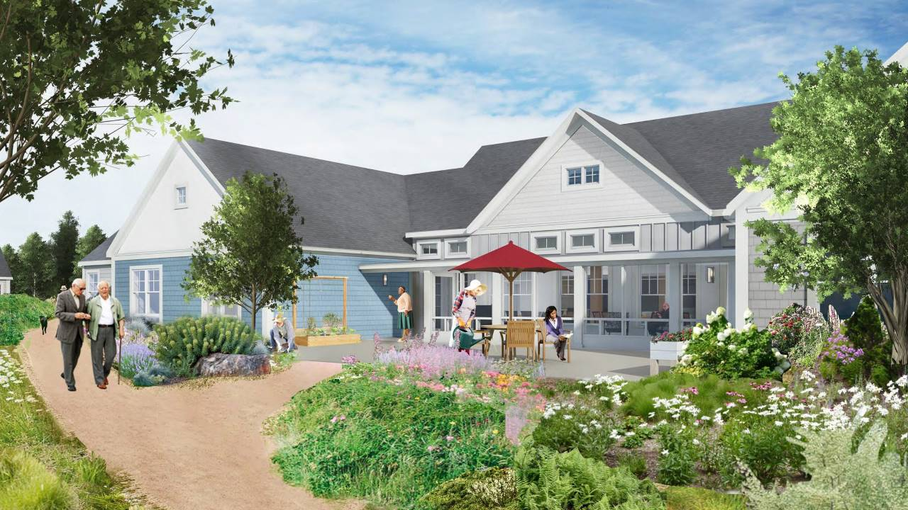Draft Depiction of the Garden View
Edgartown, MV

Navigator Elder Homes of Martha’s Vineyard
Navigator Elder Homes
of Martha’s Vineyard Confidential

Connection to Nature is Key to Health and Wellbeing

- Walking paths, outdoor spaces, and connection to nature

PHYSICAL
Navigator Elder Homes
of Martha’s Vineyard
Confidential

Health

SOCIAL
MENTAL

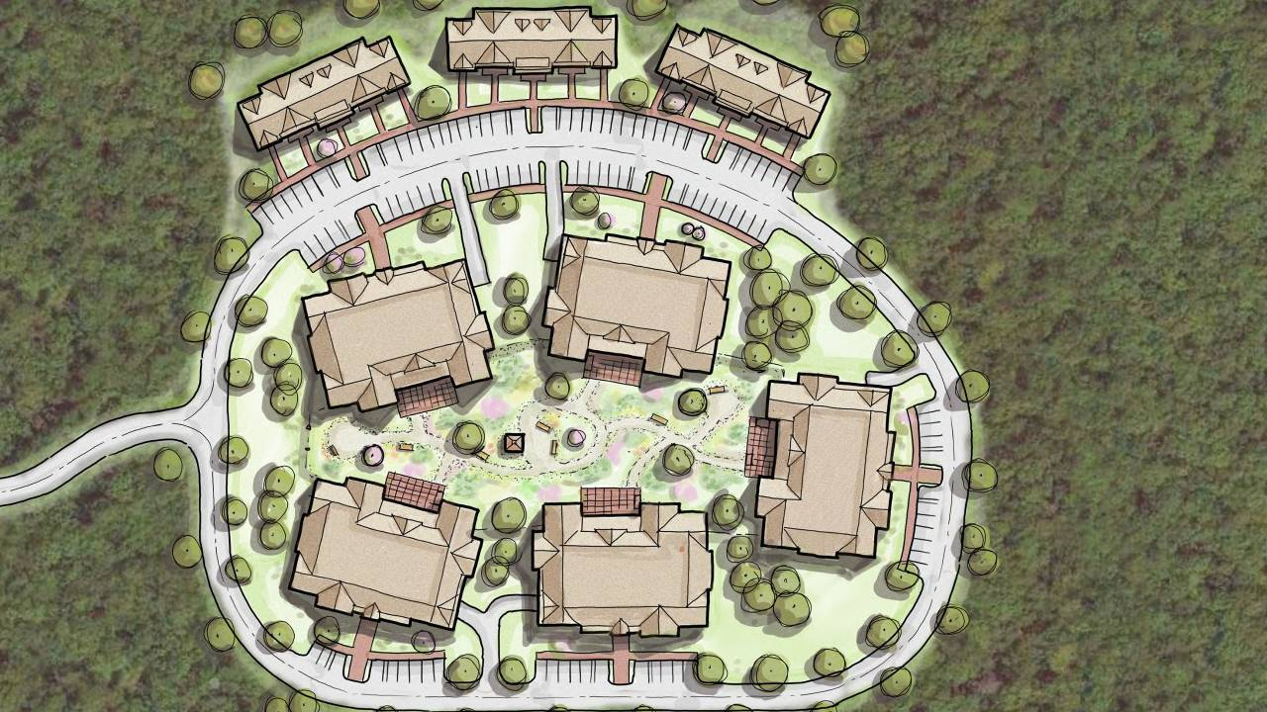

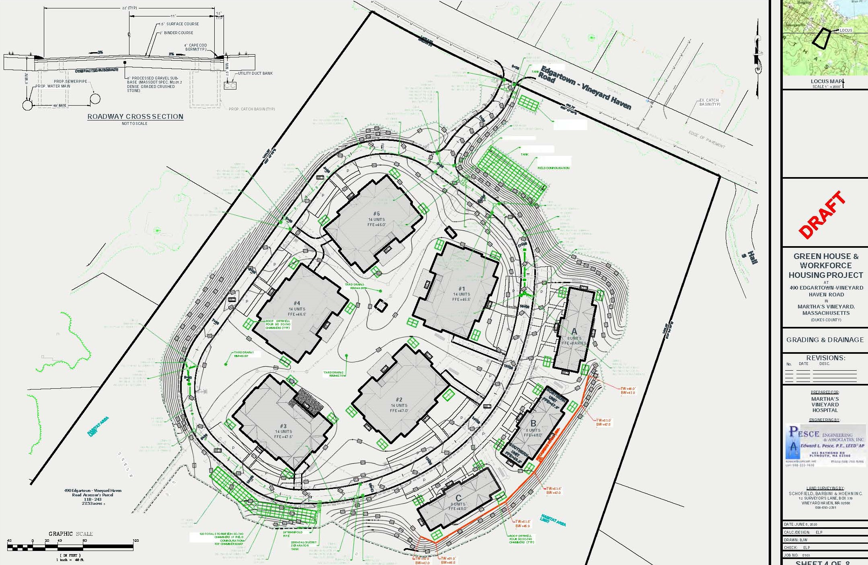

Design Principals For Dementia Friendly Environments
Navigator Elder Homes
of Martha’s Vineyard
Confidential
11

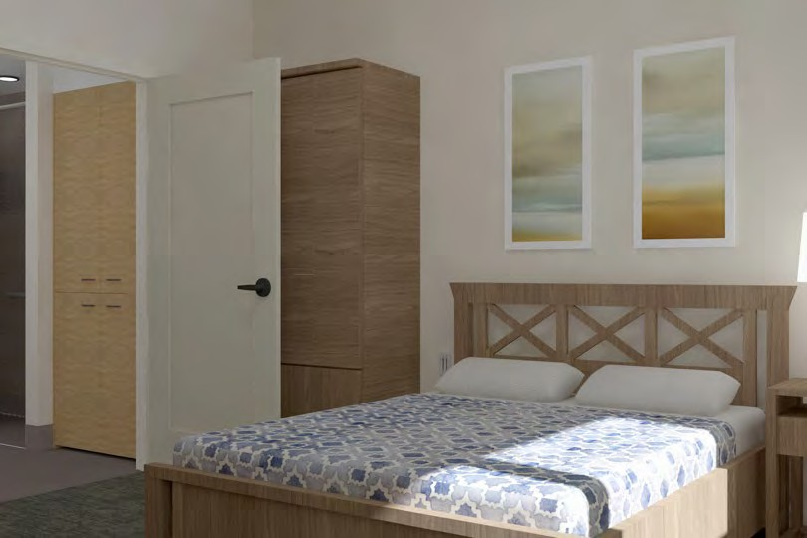
- Seamless continuity between interior and exterior living spaces
- The environment, as an integral component in cognitive and behavioral therapeutic approach (Biological lighting)
- Landmarks that provide as many “Hardwired” cues that assist in navigation and orientation

Transition from Windemere To The Green Houses
Navigator Elder Homes
of Martha’s Vineyard
Confidential

Existing | Green House Model | Notes
Census under 50 | Census of 70 in Five Green House Homes | Initial estimates upon transition: Medicare Beds 14  Private Pay 29 beds Medicaid 27 beds
Reduced staffing | Universal worker runs each home + Registered Nurses per MA DPH regulations | Reduce need for “laundry , housekeeping and food service staff”
Significant Temporary Workers | 70% Employed Staff | Thanks to the MV Hospital, Workforce Homes to be available to house Green House staff
Windemere experiencing Losses | New Model shows over $2M in Net Operating Income | Market Study supports greater number of Private Pay in this model. Supported by national Green House data

Project Schedule –High Level | KEY DATES: 2021 | Notes
Waste-Water | `Preliminary Approval on 2/18/21 | If local Edgartown capacity is insufficient, Solution for on- site waste-water
Zoning | Town Meeting in May 2021 | Original Town Meeting was 4/13. Town Administrator seeking change for meeting in May.
MV Commission | July- August-Sept | 30 days after Town Meeting for estimated 90 days
Fundraising | May-September
SNF License Transfer and Determination of Need | July 2021 | Underway now and through next 4-5 months
Construction Financing USDA Community Facilities | October 1, 2021 | Closing on or about 9/30
Construction Start | `October 15, 2021

PR and Outreach in the time of Coronavirus and into 2021
Navigator Elder Homes
of Martha’s Vineyard
Confidential
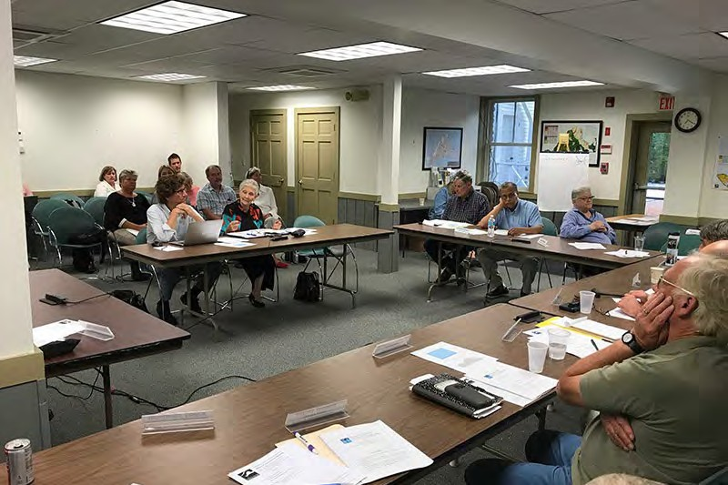
- Over 20 Community Virtual Events, featuring education, and presentations.
  - Libraries
  - Town Selectmen
  - Faith Communities
  - Duke’s County Commission
- Navigator quickly pivoted and has enjoyed interviews with MVY, MVTV, Skilled Nursing News and others.
- Renee Lohman penned an Op-Ed for Cape Cod Times in 2020

Thank You!
Navigator Elder Homes
of Martha’s Vineyard
Confidential
QUESTIONS
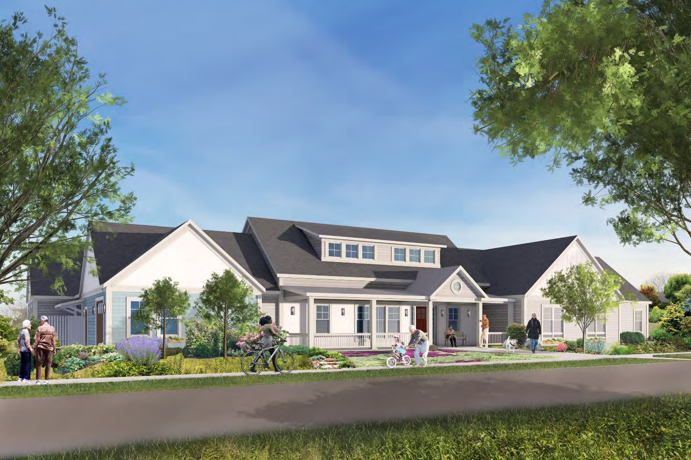
Renee Lohman President & CEO
Navigator Elder Homes of New England LLC
508-276-0757 Office
703-598-5131 Mobile
rlohman@navigatorelderhomes.com
www.navigatorelderhomes.com

Navigator Elder Homes
of Martha’s Vineyard

Healthy Aging , Martha’s Vineyard
May 21, 2020
1
Confidential

Navigator Elder Homes
of Martha’s Vineyard
Confidential
2
“Out of 300 Green House Project Homes in 31, states, leaders from
266 of these homes responded to a recent survey going back 60 days. “Of these 266 Green House Homes, only 4 residents in total had been diagnosed with Covid-19 and there have been 0 (zero) deaths”
Susan Ryan, Managing Director, The Green House Project, Inc. 4/30/2020

Today’s Presentation
- Discussion
Navigator Elder Homes
of Martha’s Vineyard
Confidential

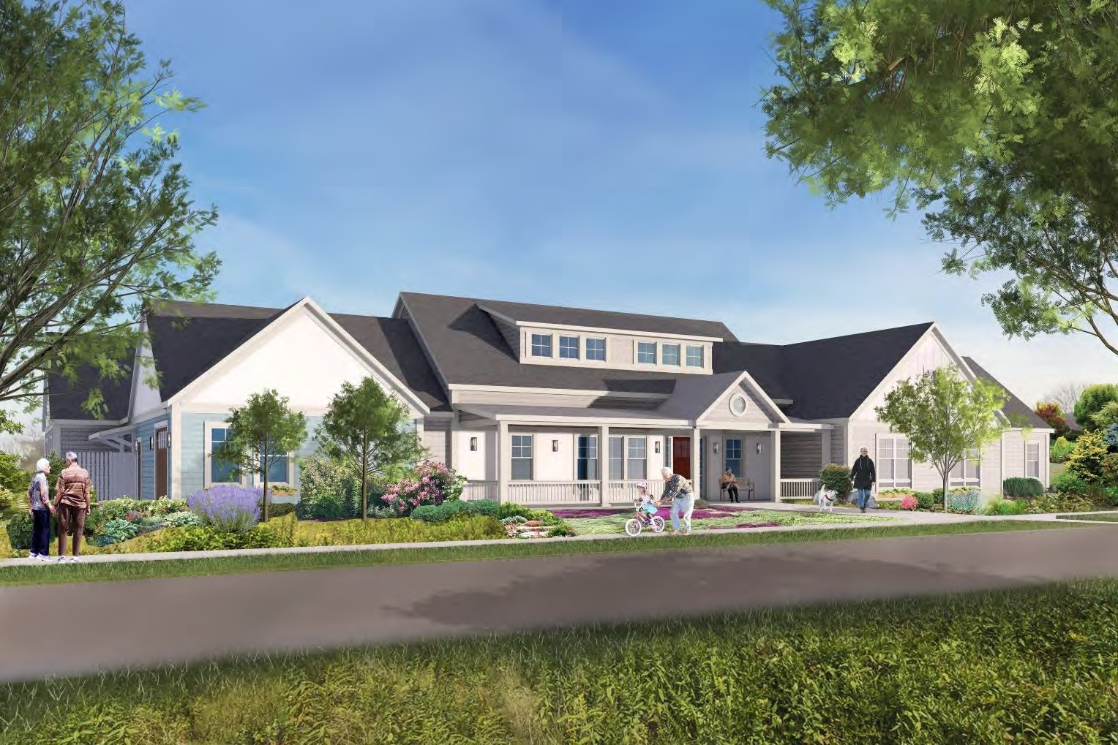
- Green House Model
- Mission /Vision
- Background, History and Connection to
Healthy Aging, Martha’s Vineyard
- Accomplishments and Progress: February 2020-Present
- Goals and Objectives for Third and Fourth Quarters, 2020
- Financial Plan
- Impact of Corona Virus

Navigator Elder Homes
of Martha’s Vineyard
Confidential
4

Mission and Vision
We partner with organizations, advocates, and communities to lead the transformation of institutional long-term and post-acute care by creating viable homes that spread THE GREEN HOUSE® Project vision – demonstrating more powerful, meaningful, and satisfying lives, work, and relationships.

Our mission is to enable elders to live the most meaningful life possible in our Navigator homes. We are passionate about fostering control, dignity, and a sense of well-being for elders, their families, caregivers and direct care staff.

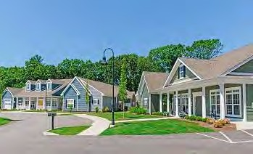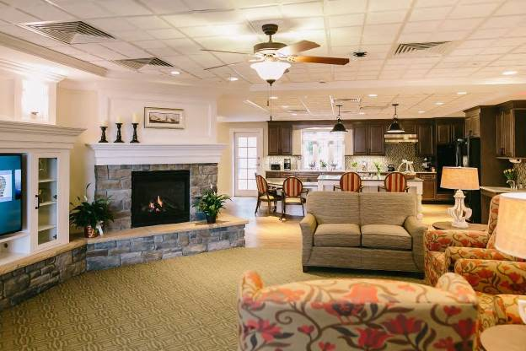St. Elizabeth’s Community:
Green House Homes, East Greenwich, RI

Real Home

Navigator Elder Homes
of Martha’s Vineyard Confidential

- January , 2020- Navigator signs Letter of Intent with MV Hospital to build Green
NavigHatoor EuldesreHomHesomes
of Martha’s Vineyard
Confidential

Brief History :
- 2016 - Healthy Aging, Martha’s Vineyard launches process to review The Green
House Project Model
- Healthy Aging funds Market Study which validates need for 70+ Skilled Nursing
Beds on the Island
- 2018- The Green House Project organization introduces Navigator Elder Homes of New England, Developer on Cape Cod to Paddy Moore and Peter Temple
- 2018- Navigator begins discussions with MV Hospital and leadership of Windemere Skilled Nursing Home
- 2019 - Navigator responds to RFP and is awarded RFP by MV Hospital.
- 2019- Navigator and Healthy Aging MV provide Island-wide Education

Highlights of the 2020 Martha’s Vineyard Market Study
Navigator Elder Homes
of Martha’s Vineyard
Confidential

- Age 75 plus population projected to increase by 84% on MV between 2020- 2035
- Demand for 42 Private Pay Beds established
- Demand for 42 Medicaid Beds established
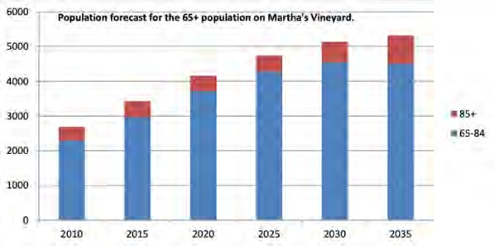
- Demand for 17 Medicare Beds (short-stay) Beds established

- Greenhouse will capture demand of patients currently seeking off –island care due to physical obsolescence of the current Windemere facility

Proposed Green House Floor Plan
Navigator Elder Homes
of Martha’s Vineyard
Confidential

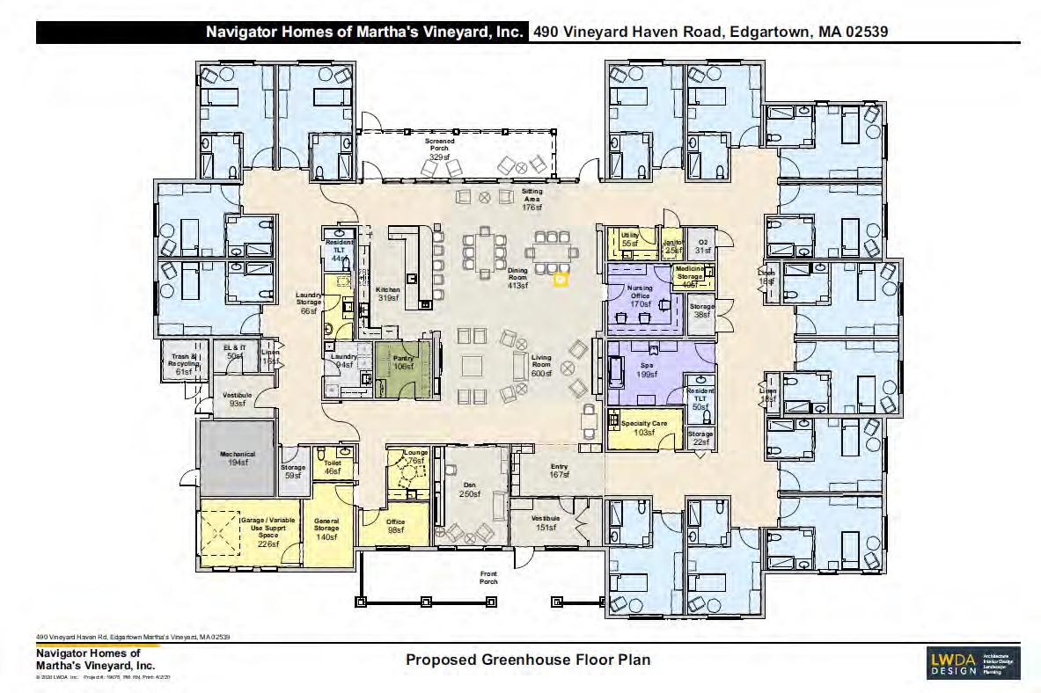
- 14-Private Resident Rooms
- All with Private Baths and Showers
- Hearth with open floor plan
- Open kitchen and dining area
- Easy access to the outside spaces
- Non-institutional design and layout
- Significant natural light
- All DPH Requirements met for SNF

Development Team of Navigator Homes of MV, Inc.
Navigator Elder Homes
of Martha’s Vineyard
Confidential
- Martha’s Vineyard Hospital
- Paddy Moore, Board Member, Navigator Homes of Martha’s Vineyard
- The Green House Project, Inc.
- Navigator Elder Homes of New England, LLC , Renee Lohman, CEO
- LWDA Architects - Principal, Ruth Neeman AIA , Director for Senior Environments Studio
- The Congress Companies, Peabody, MA: Construction and Development
- Arent Fox Attorneys – Richard Newman, /Gerald Billows, Healthcare Regulatory and Non-profit
expertise
- Denise DeLorey, Public Relations , Community Outreach, Marketing
- Edward Pesce/Chris Alley , Civil Engineering
- Pleasant Bay Homes- General Contractor
- John Carberry, Charles River Mortgage, Financial/Fundraising

Development Achievements: February - May 10, 2020
Navigator Elder Homes
of Martha’s Vineyard
Confidential
- Establishment of Non-profit entity
- Demand Market Study for Duke’s County
- Financial and Development Budget
- initial Department of Public Health programmatic design was approved
- Site Planning to present for Zoning approvals
- Contract with Green House Project
- Completion of Architectural, Mechanical, Structural & Interior Schematic Design
- Plans ready for Determination of Need Application
- Lender Term Sheet for Construction Loan
- Initiated a series of public interviews & media presentations

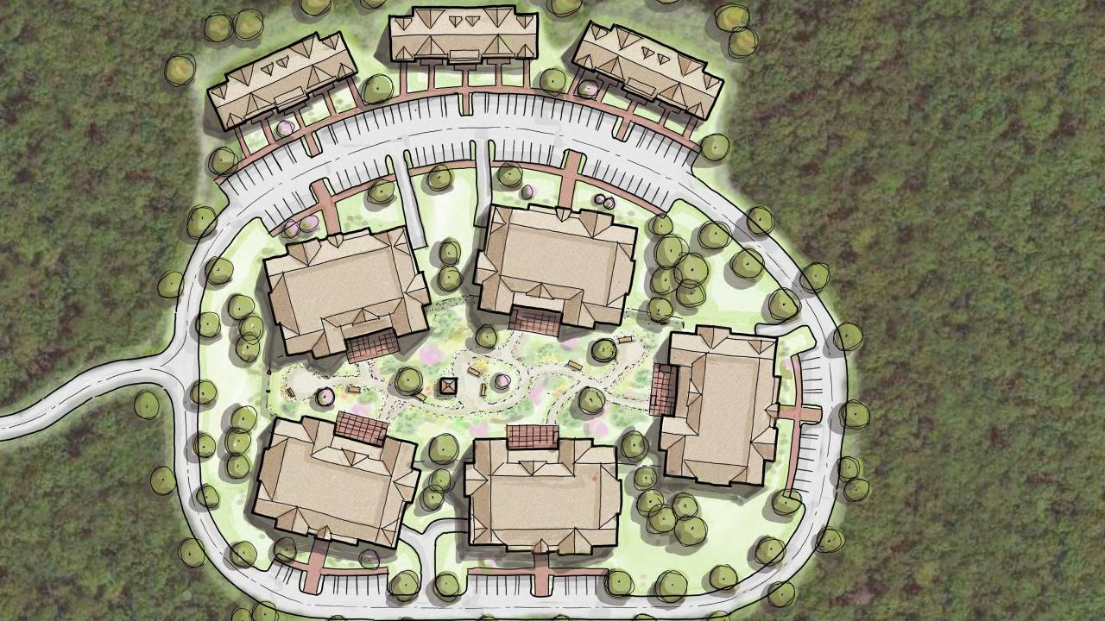Site Plan

Navigator Elder Homes
of Martha’s Vineyard

Main Civil Engineering Work to Date (last 60 days)
Navigator Elder Homes
of Martha’s Vineyard
Confidential

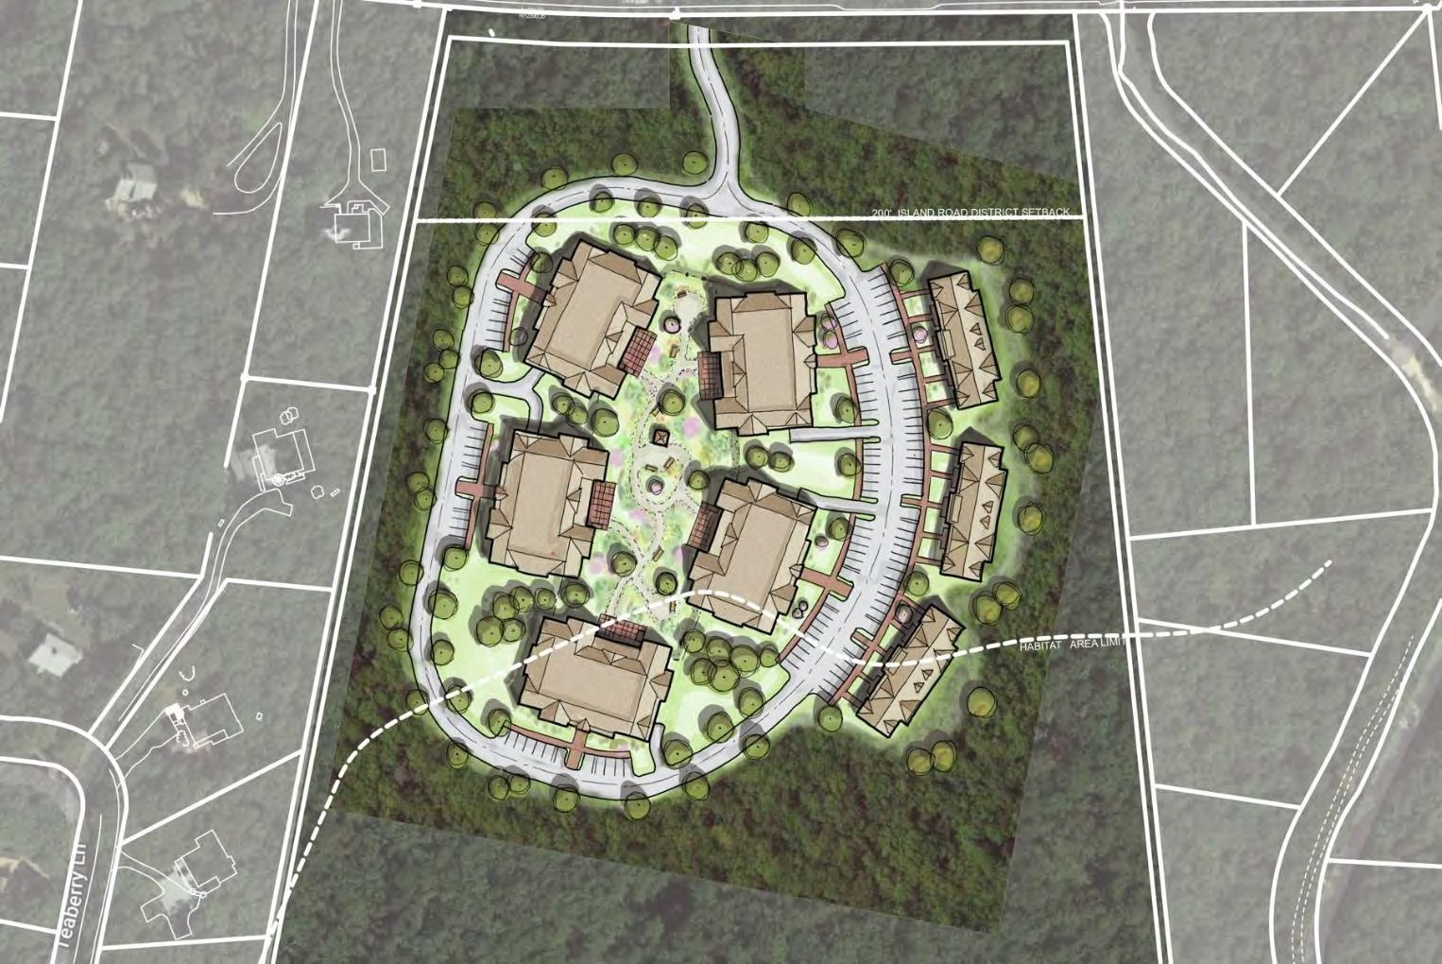
- Preliminary site grading & utilities layout design
- Several iterations of site grading & earthwork analysis performed in order to balance the cut & fill on site (no import of fill required)
- Review & Approval of the Traffic Study Scope of Work by the MV Commission Transportation Planner
- Project Notification Form Filed with the Mass. Historical Commission

Upcoming Civil Engineering Efforts (next 60 days)
Navigator Elder Homes
of Martha’s Vineyard
Confidential

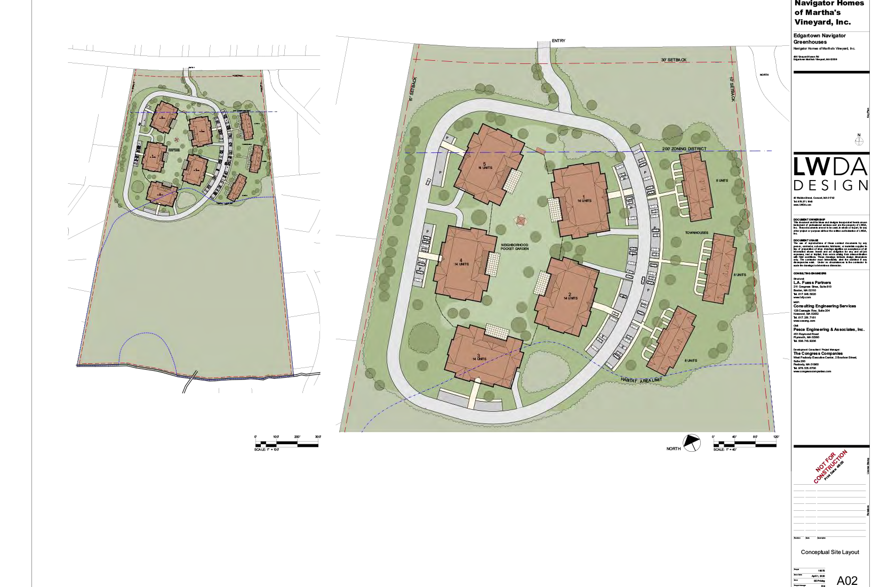
- Geotechnical soil borings and Soil Test Pits – week of June 8th
- Traffic Study – field measurements and traffic counts (after normal traffic has resumed) – June-July
- Advance the Civil Engineering Design
Plans and Construction Details
- Initial Meeting with the Mass. Natural Heritage & Endangered Species Program staff

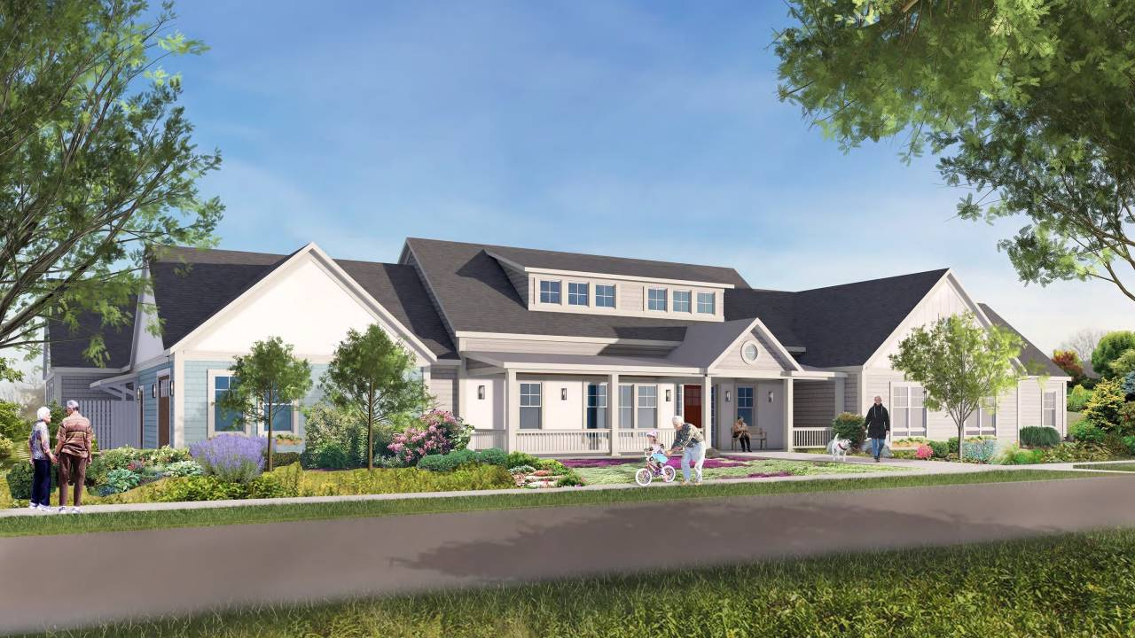Front of one Navigator Green House Home, Edgartown, MA

Navigator Elder Homes
Nav igat o r El d er H o mes
of Mar t h a’ s Vin eyar d Confidential
of Martha’s Vineyard

Garden View

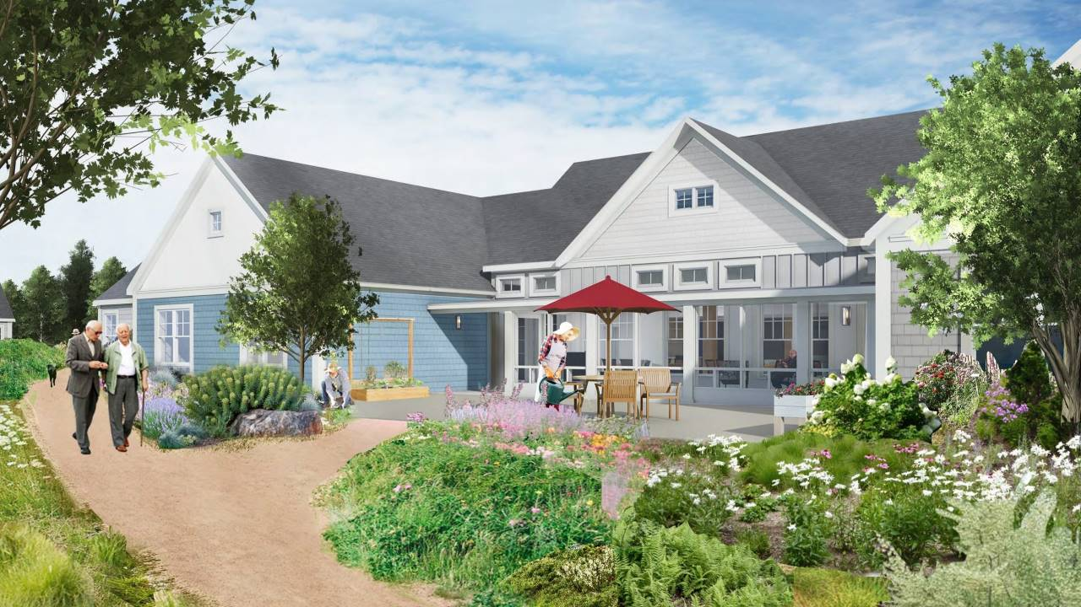Navigator Elder Homes
of Martha’s Vineyard

Confidential

Connection to Nature is Key to Health and Wellbeing

- Walking paths, outdoor spaces, and connection to nature

PHYSICAL
Navigator Elder Homes
of Martha’s Vineyard
Confidential

Health

SOCIAL
MENTAL

Design Principles For Dementia Friendly Environments
Navigator Elder Homes
of Martha’s Vineyard
Confidential
17

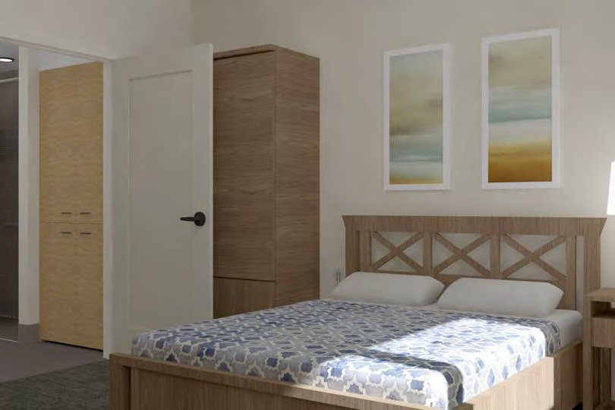
- Seamless continuity between interior and exterior living spaces
- The environment, as an integral component in cognitive and behavioral therapeutic approach (Biological lighting)
- Landmarks that provide as many “Hardwired” cues that assist in navigation and orientation

Navigator Elder Homes
of Martha’s Vineyard
Confidential

Operational: Financial Highlights
. Operational Financial for 70 Green House Residents (after 1 full year of ops)

  - Total Revenues of $11M
  - Net Operating Income of $2.47M
  - 14 Medicare short-stay beds
  - 24 (Initial) Private Pay
  - 32 Current Medicaid residents assumed coming from Windemere
  - Staff Housing options reduce reliance on Traveling /Short-term Nurses
  - Debt service for Construction loan of $20M

Green House : Comparison
Navigator Elder Homes
of Martha’s Vineyard
Confidential

Existing | Green House Model | Notes
Census under 50 | Census of 70 in Five Green House Homes | Medicare Beds 14 Private Pay 33 beds Medicaid 23 beds
Reduced staffing | Universal worker runs each home + Registered Nurses per MA DPH regulations | Reduce need for “laundry , housekeeping and food service staff”
Significant Traveler/Agency Workers | 70% Employed Staff | Thanks to the MV Hospital, Workforce Homes to be available to house Green House staff
Windemere experiencing Losses | New Model shows over $2M in Net Operating Income | Market Study supports greater number of Private Pay in this model. Supported by national Green House data

Development Budget
Navigator Elder Homes
of Martha’s Vineyard
Confidential
Construction and Soft Costs

  - $27.5M to build Green House Homes
  - Additional $6M in soft costs
  - Equity raise will range between $8M-$14M
  - Subordinated Mezz Debt
  - USDA – proposal to pay 90% of Loan (loan to cost) results in $6-$8M less in equity to raise
  - Events, Grants, State funding, Federal funding
  - Full Time Fund raising & Grant Resources

Fund Raising
Navigator Elder Homes
of Martha’s Vineyard
Confidential
The Coronavirus has certainly presented challenges- However:
  - Term Sheet in hand with established FHA insured lender
  - Submission of three Grants (awaiting responses) for a total of $2M
  - Community Preservation Funding
  - Significant exploration of USDA Funding mechanism for up to perhaps 90% of the Loan
  - Significant Donor pledge in hand (check pending zoning approval)
  - Events scheduled and re-scheduled

Public Relations and Outreach
Navigator Elder Homes
of Martha’s Vineyard
Confidential

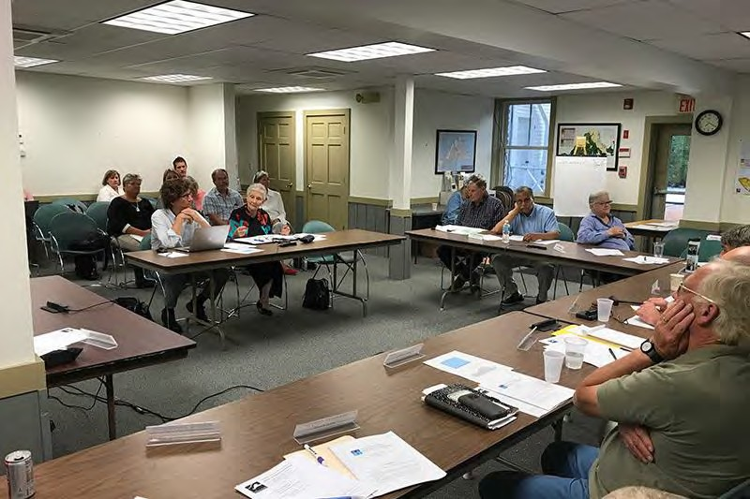
- Over 12 Community Events, largely re- scheduled
- Healthy Aging Transformation Team :
May 21
- Presenting June 2nd: Dukes County Commissioners
- Presentation with Edgartown Selectmen June 29.
- Navigator has enjoyed interviews with MVY, MVTV, Skilled Nursing News and others.
- Renee Lohman penned an Op-Ed -CCT

Public Relations and Outreach in the time of Coronavirus
Navigator Elder Homes
of Martha’s Vineyard
Confidential

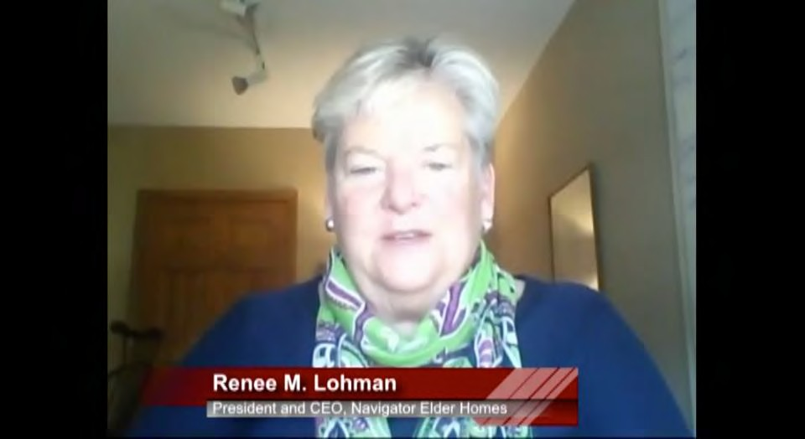
Other interviews soon to take place:
- WCAI
- McKnight's
- Boston Globe
- Cape Cod Times
- MV Times
- MV Gazette
- Second interview with MVTV
Tank Talk Interview

Key Deliverables : May 15 –August 30, 2020
Navigator Elder Homes
of Martha’s Vineyard
Confidential
Navigator will continue to:

  - Support MV Hospital ‘s efforts to secure zoning approvals
  - Team with MV Hospital to secure sewer line approvals to the property
  - Finalize Tax- Exempt Bond financing sources
  - USDA debt funding sources
  - Finalize proposal to Federal Government /Office of Undersecretary for Emergency Preparedness
to fund Green House Model replacement SNF
  - MA Executive Office of Elder Affairs
  - Secure donations
  - Events, Individual Donor Meetings , Grant Awards
  - Additional Debt Term Sheet for construction loans
  - Support efforts with Windemere to submit the Determination of Need

Key Deliverables: September- December, 2020
Navigator Elder Homes
of Martha’s Vineyard
Confidential
- Submit Community Preservation Grants for Edgartown and Oak Bluffs
- Fundraising to raise a total of approximately
- Support Hospital on Transition Plan and Secure all approvals (MV Commission)
- Reporting/Monitoring of Plans
- Public Relations/Community Outreach
- Significant Presence on the Island from July 1 forward
- Events

Thank You!
Navigator Elder Homes
of Martha’s Vineyard
Confidential

Renee Lohman President
Navigator Homes of MV 508-276-0757 Office
703-598-5131 Mobile

www.navigatorelderhomes.com

APPENDIX 7 NOTICE OF INTENT

https://www.capecodtimes.com/public-notices

https://www.capecodtimes.com/public-notices/notice/10/10/2022/public- announcement-concerning-a-2022-10-10-cape-cod-times-massachusetts-336d5e

APPENDIX 8 ARTICLES OF ORGANIZATION

https://corp.sec.state.ma.us/CorpWeb/CorpSearch/CorpSearchRedirector.a spx?Action=PDF&Path=CORP_DRIVE1/2020/0319/001795121/0001/2020 77793920_1.pdf

APPENDIX 9 AFFIDAVIT OF TRUTHFULNESS

Version: 7-6-17

Massachusetts Department of Public Health

Determination of Need

Affidavit of Truthfulness and Compliance

with Law and Disclosure Form 100.405 (B)
Instructions: Complete Information below. When complete check the box "This document is ready to print:". This will date stamp and lock the form. Print Form. Each person must sign and date the form. When all signatures have been collected, scan the document and e-mail to: dph.don@state.ma.us Include all attachments as requested.
Application Number: MHMV-22090717-LE
Original Application Date: 10/27/2022
Applicant Name: Navigator Homes of Martha's Vineyard, Inc.
Application Type: Long Term Care Substantial Capital Expenditure
Applicant's Business Type: Corporation
Is the Applicant the sole member or sole shareholder of the Health Facility(ies) that are the subject of this Application? Yes
The undersigned certifies under the pains and penalties of perjury:
- The Applicant is the sole corporate member or sole shareholder of the Health Facility(ies) that are the subject of this Application;
- I have read [been informed of the contents of] 105 CMR 100.000, the Massachusetts Determination of Need Regulation;
- I understand and agree to the expected and appropriate conduct of the Applicant pursuant to 105 CMR 100.800;
- I have read [been informed of the contents of] this application for Determination of Need including all exhibits and attachments, and certify that all of the information contained herein is accurate and true;
- I have submitted the correct Filing Fee and understand it is nonrefundable pursuant to 105 CMR 100.405(B);
- I have submitted the required copies of this application to the Determination of Need Program, and, as applicable, to all Parties of Record and other parties as required pursuant to 105 CMR 100.405(B);
- I have caused [have been informed that], as required, notices of intent to be published and duplicate copies to be submitted to all Parties of Record, and all carriers or third-party administrators, public and commercial, for the payment of health care services with which the Applicant contracts, and with Medicare and Medicaid, as required by 105 CMR 100.405(C), et seq.;
- I have caused proper notification and submissions to the Secretary of Environmental Affairs pursuant to 105 CMR 100.405(E) and 301 CMR 11.00; will be made, if applicable.
- If subject to M.G.L. c. 6D, § 13 and 958 CMR 7.00, I have submitted such Notice of Material Change to the HPC - in accordance with 105 CMR 100.405(G);
- Pursuant to 105 CMR 100.210(A)(3), I certify that both the Applicant and the Proposed Project are in material and substantial compliance and good standing with relevant federal, state, and local laws and regulations, as well as with all previously issued Notices of Determination of Need and the terms and Conditions attached therein [issued in compliance with 105 CMR 100.00, the Massachusetts Determination of Need Regulation effective January 27, 2017 and amended December 28, 2018];
- I have read [been informed of the contents of] and understand the limitations on solicitation of funding from the general public prior to receiving a Notice of Determination of Need as established in 105 CMR 100.415;
- I understand that, if Approved, the Applicant, as Holder of the DoN, shall become obligated to all Standard Conditions pursuant to 105 CMR 100.310, as well as any applicable Other Conditions as outlined within 105 CMR 100.000 or that otherwise become a part of the Final Action pursuant to 105 CMR 100.360;
- Pursuant to 105 CMR 100.705(A), I certify that the Applicant has Sufficient Interest in the Site or facility; and
- Pursuant to 105 CMR 100.705(A), I certify that the Proposed Project is authorized under applicable zoning by-laws or ordinances, whether or not a special permit is required; or,
  - If the Proposed Project is not authorized under applicable zoning by-laws or ordinances, a variance has been received to permit such Proposed Project; or,
  - The Proposed Project is exempt from zoning by-laws or ordinances.

Corporation
Attach a copy of Articles of Organization/Incorporation, as amended

David McDonough <Signature on File> 10/21/2022
CEO for Corporation: Signature: Date:

David McDonough <Signature on File> 10/21/2022
Board Chair for Corporation Name: Signature: Date:

This document is ready to print: unchecked Date/time Stamp: [blank]

APPENDIX 10 FILING FEE

