Sherrill House, Inc.
Determination of Need
DoN Application # -25091910-CL

Application for Determination of Need
Conservation Long Term Care
September 19, 2025

Table of Contents

- Application Form*
- Narrative
- Affiliated Parties Form*
- Change in Service Form*
- Certification from Independent Certified Public Accountant*
- Articles of Organization
- Notice of Intent
- Affidavit of Truthfulness
- Application Fee
*certain sections listed in the Table of Contents are attached as a sperate file for the submission

- Application Form*

- Narrative
Sherrill House, Inc. (the “Applicant” or “Sherrill House”) operates a 182 bed non-for-profit skilled nursing facility that serves a historically urban under bedded area in Boston (the “SNF”). The SNF is a CMS 5 Star rated facility that provides multiple levels of care of skilled nursing care - long-term care, short-term rehabilitation services, and memory care. Sherrill House’s mission is to achieve, sustain, and exceed standards of excellence in skilled nursing and rehabilitation, to aging adults and their families in the Greater Boston community that it has been serving since 1907. To meet this mission, Sherrill House is committed to meeting the evolving needs of its community and offers specialized clinical skilled nursing programs including palliative and end of life services, onsite dialysis, care for patient with a left ventricular assistive device (VAD), and complex wound care. Sherrill House envisions a diverse Greater Boston community where all aging adults and their families will experience being known, comforted, and cared for with skill, dignity, and respect.
The SNF:
The SNF is a seven story, 117,770 gross square foot facility that has been operating at its current location on Huntington Avenue since 1970. The SNF went through a major renovation in 2003 that added a new wing, numerous amenities and technological enhancements to improve residents’ quality of life and to make the working environment more pleasant and efficient for staff. The SNF includes three 45-bed skilled nursing units and one 47-bed skilled nursing unit, several dining and activity spaces, a family room, an exterior courtyard, and large outdoor garden for residents, family members, and other visitors.
The Proposed Project:
The Proposed Project includes renovation and relocation of the SNF’s rehabilitation gym and maintaining the building envelop by replacing the roof and rooftop HVAC units, upgrading the elevator flooring and installing new fire panel motherboard and new windows. The Applicant’s overall goal for the Proposed Project is to sustain the facility while also creating efficiencies and improving treatment spaces to improve patient health outcomes and patient satisfaction.
Rehabilitation Gym
The rehabilitation gym is currently 2,339 gross square fee located at the back of the ground level (i.e. basement) of the SNF. The Proposed Project would relocate the rehabilitation gym to the top floor of the facility where the entire floor, 2,490 gross square feet, would be designated for rehabilitation services. The new location is geographically more efficient than the current one because it will significantly reduce the distance of travel between resident care units and the rehabilitation gym (currently approximately 10 minutes). The relocated rehabilitation gym will be immediately accessible from the elevator creating these efficiencies and the patients will step into a room filled with natural light. The relocation will increase productivity and time spent directly on treatment, provide for a better patient experience and improve patient outcomes. The current rehabilitation gym will be converted to an employee café.
The revamped rehabilitation gym will include south, west, and east-facing greenhouse windows that allow for natural light to flood the area during all hours of operation. The space will also include a large outdoor patio with views of the surrounding Boston neighborhood which will be used for physical and occupational therapy that mimics activities at home such as ambulating on outdoor surfaces and fine and gross motor gardening. These features were purposefully incorporated into the Proposed Project to lessen the traditionally institutional design of healthcare settings and encourage the support of proven remedies that nature has to offer. Sherrill House strives to reduce the functional, clinical, and procedural limitations to sunlight and fresh air as a part of providing quality care in the least restrictive way possible.
Building Envelop Upgrades

Based on useful life of the building systems and to sustain the facility in good working order and ensure that the facility continues to operate in the normal course, the Applicant will be replacing the roof, the rooftop HVAC systems, elevator flooring, and fire panel motherboards. This work will involve electrical and plumbing and include accessibility and safety features. It will not only increase the well-being and quality of the physical plant for the residents but it will crease material operational savings. In addition, based on the useful life of the windows and resident feedback, the windows in the SNF are in need of replacement. Once done, this will attribute to energy conservation of the facility.

- Affiliated Parties Form*

- Change in Service Form*

- Certification from Independent Certified Public Accountant*

- Articles of Organization
https://corp.sec.state.ma.us/CorpWeb/CorpSearch/CorpSearchRedirector.aspx?Action=PDF&Path=CORP_DRIVE1/2013/0424/000479098/0036/020502555122_1.pdf
https://corp.sec.state.ma.us/CorpWeb/CorpSearch/CorpSearchRedirector.aspx?Action=PDF&Path=CORP_DRIVE1/2013/0424/000479098/0035/020502555123_1.pdf
https://corp.sec.state.ma.us/CorpWeb/CorpSearch/CorpSearchRedirector.aspx?Action=PDF&Path=CORP_DRIVE1/2014/0402/000559090/0004/020502555124_1.pdf

- Notice of Intent




- Affidavit of Truthfulness
 Version: 7-6-17

Massachusetts Department of Public Health

Determination of Need

Affidavit of Truthfulness and Compliance

with Law and Disclosure Form 100.405 (B)
Instructions: Complete Information below. When complete check the box "This document is ready to print:". This will date stamp and lock the form. Print Form. Each person must sign and date the form. When all signatures have been collected, scan the document and e-mail to: dph.don@state.ma.us Include all attachments as requested.
Application Number: -25091910-CL
Original Application Date: 09/19/2025
Applicant Name: Sherrill House, Inc.
Application Type: Conservation Long Term Care Project
Applicant's Business Type: Corporation
Is the Applicant the sole member or sole shareholder of the Health Facility(ies) that are the subject of this Application? Yes
The undersigned certifies under the pains and penalties of perjury:
- The Applicant is the sole corporate member or sole shareholder of the Health Facility(ies) that are the subject of this Application;
- I have read [been informed of the contents of] 105 CMR 100.000, the Massachusetts Determination of Need Regulation;
- I understand and agree to the expected and appropriate conduct of the Applicant pursuant to 105 CMR 100.800;
- I have read [been informed of the contents of] this application for Determination of Need including all exhibits and attachments, and certify that [have been informed that] all of the information contained herein is accurate and true;
- I have submitted the correct Filing Fee and understand it is nonrefundable pursuant to 105 CMR 100.405(B);
- I have submitted the required copies of this application to the Determination of Need Program, and, as applicable, to all Parties of Record and other parties as required pursuant to 105 CMR 100.405(B);
- I have caused, as required, notices of intent to be published and duplicate copies to be submitted to all Parties of Record, and all carriers or third-party administrators, public and commercial, for the payment of health care services with which the Applicant contracts, and with Medicare and Medicaid, as required by 105 CMR 100.405(C), et seq.;
- I have caused [have been informed that] proper notification and submissions to the Secretary of Environmental Affairs pursuant to 105 CMR 100.405(E) and 301 CMR 11.00;
- If subject to M.G.L. c. 6D, § 13 and 958 CMR 7.00, I have submitted such Notice of Material Change to the HPC - in accordance with 105 CMR 100.405(G);
- Pursuant to 105 CMR 100.210(A)(3), I certify that both the Applicant and the Proposed Project are in material and substantial compliance and good standing with relevant federal, state, and local laws and regulations, as well as with all previously issued Notices of Determination of Need and the terms and Conditions attached therein [issued in compliance with 105 CMR 100.00, the Massachusetts Determination of Need Regulation effective January 27, 2017 and amended December 28, 2018];
- I have read [been informed of the contents of] and understand the limitations on solicitation of funding from the general public prior to receiving a Notice of Determination of Need as established in 105 CMR 100.415;
- I understand that, if Approved, the Applicant, as Holder of the DoN, shall become obligated to all Standard Conditions pursuant to 105 CMR 100.310, as well as any applicable Other Conditions as outlined within 105 CMR 100.000 or that otherwise become a part of the Final Action pursuant to 105 CMR 100.360;
- Pursuant to 105 CMR 100.705(A), I certify that the Applicant has Sufficient Interest in the Site or facility; and
- Pursuant to 105 CMR 100.705(A), I certify that the Proposed Project is authorized under applicable zoning by-laws or ordinances, whether or not a special permit is required; or,
  - If the Proposed Project is not authorized under applicable zoning by-laws or ordinances, a variance has been received to permit such Proposed Project; or,
  - The Proposed Project is exempt from zoning by-laws or ordinances.
Corporation
Attach a copy of Articles of Organization/Incorporation, as amended.

Patrick J. Stapleton <Signature on File> 9/16/2025
CEO for Corporation Name: Signature: Date:
Rev. Thomas B. Kennedy <Signature on File> 9/16/2025
Board Chair for Corporation Name: Signature: Date:

This document is ready to print: check Date/time Stamp: 02/24/2025 10:12am

- Application Fee

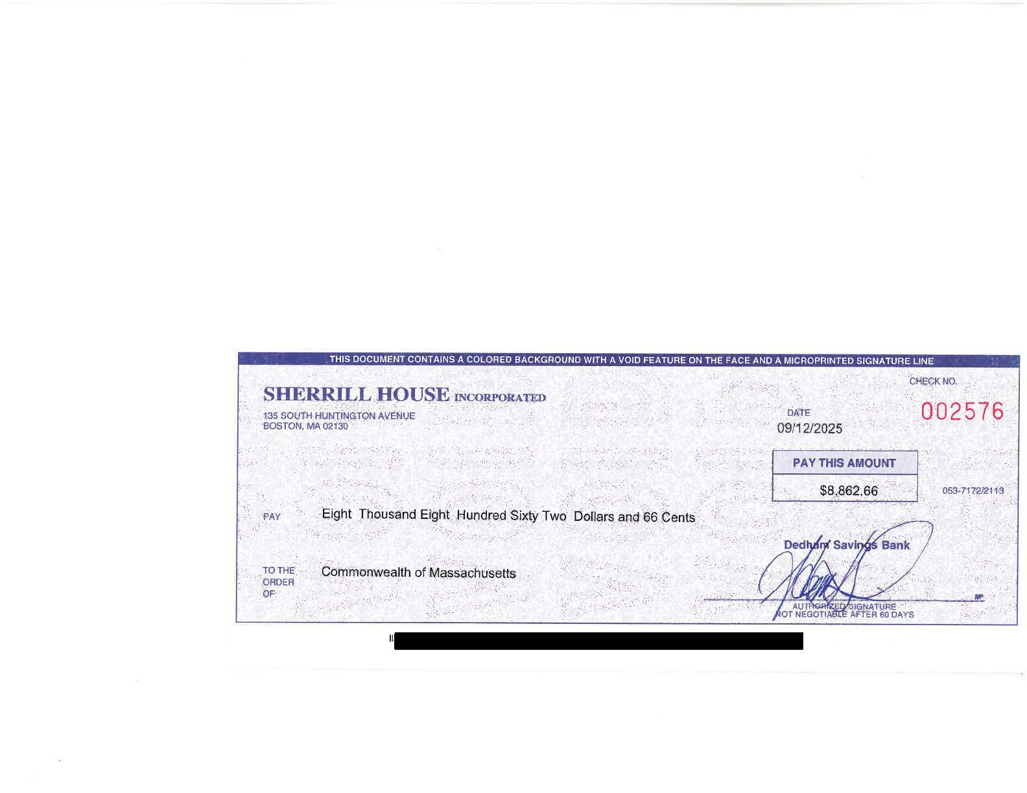

3947\0011\2230230.v1

