Exhibit A.a
Atrius Health, Inc.
ACO Certification Documentation

December 27. 2023

Margaret Senese Atrius Health. Inc.
275 Grove Street. Suite 2-300
Newton, MA 02466

RE: ACO LEAP Re-Certification Dear Ms. Senese:
Congratulations! The Health Policy Commission (HPC) is pleased to inform you that Atrius Health, Inc. meets the requirements for ACO Certification under our Learning. Equity. and Patient-Centeredness (LEAP) standards. This certification is effective from January 1, 2024, through December 31. 2025.

The ACO Certification program, in alignment with other state agencies including MassHealth, is designed to accelerate care delivery transformation in Massachusetts and promote a high quality. efficient health system. ACOs participating in the program have met a set of objective criteria focused on core ACO capabilities demonstrating dedication to patient-centered care, use of evidence-based and data-driven strategies to improve care delivery, and commitment to addressing long-standing health inequities. Atrius Health, Inc. meets those criteria.

The HPC will promote Atrius Health, Inc. as a Certified ACO on our website and in our marketing and public materials. Enclosed you will find an ACO Certification logo for your organization to use in accordance with the attached Terms of Use. We hope you will use the logo on promotional materials when you highlight your ACO Certification to your patients. payers. and others.

The HPC looks forward to your continued engagement in the ACO Certification program over the next two years.

Thank you for your dedication to providing accountable, coordinated health care to your patients, and to continued learning and improvement over time. If you have any questions about this letter or the ACO Certification program, please do not hesitate to contact Mike Stanek, Associate Director. at HPC-Certification@mass.gov or (617) 757-1649.

Best wishes.
David Seltz Executive Director

Exhibit A.b
Material Change Notice Approval Email

Courtney Pasay Vaughan

From:

Sent:
To:

Subject: Attachments:
Kerry Whelan
Friday, March 1, 2024 4:03 PM
Paul Anderson; Patrick Holland; Thomas Montminy; Peter Ferrari; Courtney Pasay Vaughan; Steven Netishen; Tom Shields
Dedham PETCT - HPC Update
image007.png; image003.png; image004.png; image00S.png; image006.png

Good Afternoon,

Please find HPC approval below.

A big thank you to the entire team. Kerry

Begin forwarded message:

From: "Elstermeyer, Coleen (HPC}" <coleen.elstermeyer@mass.gov> Date: March 1, 2024 at 3:58:49 PM EST
To: Kerry Whelan
Cc: "Seltz, David (HPC)" <david.seltz@mass.gov>, "Mills, Katherine (HPC}" <katherine.mills@mass.gov>, "Johnson, Lois (HPC)" <lois.johnson@mass.gov>, "Hayes-Rusnov, Sasha (HPC)" <sasha.hayes-rusnov@mass.gov>
Subject: HPC Update

EXTERNAL EMAIL - This message originated from outside of Shields Health.

Good afternoon,

The Health Policy Commission (HPC} has recently received completed notices of material change regarding the proposed joint venture between Atrius MSO, LLC, and Shields Imaging Services, LLC to own and operate a PET/CT service licensed as a clinic in the Dedham area.

The HPC has conducted a preliminary review of the notice based on available information and has elected not to proceed with a cost and market impact review.

Thank you,

Coleen Elstermeyer

cc:

David Seltz. Executive Director, Health Policy Commission

Katherine Mills, Director of Market Performance, Health Policy Commission Lois Johnson, General Counsel, Health Policy Commission
Sasha Hayes-Rusnov, Associate Director, Market Oversight and Monitoring, Health Policy Commission

[image007.png]<http://www.mass.gov/hpc> Coleen Elstermeyer, MPP
Deputy Executive Director Pronouns: She/Her/Hers
Coleen.Elstermeyer@mass.gov<mailto:Coleen.Elstermeyer@mass.gov>
Mobile: (617) 653-4118

[image003.png] <http://www.mass.gov/hpc> [image004.png] <https://twitter.com/Mass_HPC> [imageO0S.png] <https://www.linkedin.com/company/health-policy-commission> [image006.png]
<https://www.youtube.com/channel/UCGZknspl63TdBuHLf3IrrKQ>

THIS MESSAGE IS INTENDED FOR THE USE OF THE PERSON TO WHOM IT IS ADDRESSED. IT MAY CONTAIN INFORMATION THAT IS PRIVILEGED, CONFIDENTIAL AND EXEMPT FROM DISCLOSURE UNDER APPLICABLE LAW. If you are not the
intended recipient, your use of this message for any purpose is strictly prohibited. If you have received this communication in error, please delete the message and notify the sender so that we may correct our records.

2

Exhibit B Determination of Need Attachments

Exhibit B.b
Copy of Notice of Intent (Affidavit of Publication)

AFFIDAVIT OF PUBLICATION

STATE OF MASSACHUSETTS,

Suffolk County ss:
City of Boston

Michele Sisco-Martin residing in Kingston, NY, being duly sworn, deposes and says that she is the Regional Legal Clerk of Media News Group, a Corporation duly organized under the laws of the State of Massachusetts; that said Corportation is the publisher of The Boston Herald', a daily newspaper published in the City of Boston, County of Suffolk and State of Massachusetts, and that the notice of which the annexed is a printed copy, has been regularly published in The Boston Herald'.

Once Daily for One Day

To wit: 03/05/24

Public Announcement Concerning a Proposed Health Care Proiect
Shields and Atrius Health PET/Ci"at Dedham,< LLC (" plicant") lo-
5 \e g t ggsCt n f,;5,; N5 fi :t•or5g [e atfi n fNe:asr, U7fc
i
tion") with the Massachusetts Department of Public Healtli cP8PH") for the addition of a Positron Emission Tomography - Computed To- mogral)hy (PET/CT) imaging service one day a week at 40 Allied Drive,. Dedham, Massachusel:ts 02026. The total value of the Project is $213,687.00. The Applicant does not anticipate any price or ser- vice impacts to the Applicant's existing patient panel as a result of the Project. Any ten Taxpayers of Massachusetts may register in connection with the Intended Application by no later than April 18, 2024 or 30 days from the Filing Date, whichever is later bY. contacting the Department of Publicriealth Determination of Need Program"" 250 Washington Street, 6th floor, Boston, MA 02108 or dph.don state.ma.us
#NY010GS44 March 5, 2024

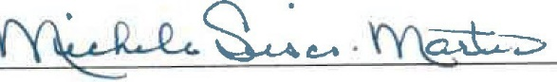

Sworn to before me this

03/05/24
�d�

Notary Public
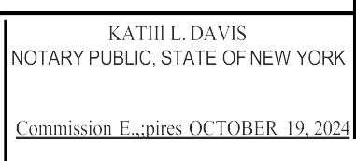

Ree:istration No. 01DA6410130 Qualified in Ulster County

9 2576921 ­ cpvaughan@publicpolicylaw.com

Exhibit B.c
Affidavit of Truthfulness Form

 Version: 7-6-17

Massachusetts Department of Public Health

Determination of Need

Affidavit of Truthfulness and Compliance

with Law and Disclosure Form 100.405 (B)
Instructions: Complete Information below. When complete check the box "This document is ready to print:". This will date stamp and lock the form. Print Form. Each person must sign and date the form. When all signatures have been collected, scan the document and e-mail to: dph.don@state.ma.us Include all attachments as requested.
Application Number: N/A-24031814-RE
Original Application Date: 03/19/2024
Applicant Name: Shields and Atrius Health PET/CT at Dedham, LLC
Application Type: DoN-Required Equipment
Applicant's Business Type: LLC
Is the Applicant the sole member or sole shareholder of the Health Facility(ies) that are the subject of this Application? Yes

The undersigned certifies under the pains and penalties of perjury:
- The Applicant is the sole corporate member or sole shareholder of the Health Facility(ies) that are the subject of this Application;
- I have read 105 CMR 100.000, the Massachusetts Determination of Need Regulation;
- I understand and agree to the expected and appropriate conduct of the Applicant pursuant to 105 CMR 100.800;
- I have read this application for Determination of Need including all exhibits and attachments, and certify that all of the information contained herein is accurate and true;
- I have submitted the correct Filing Fee and understand it is nonrefundable pursuant to 105 CMR 100.405(B);
- I have submitted the required copies of this application to the Determination of Need Program, and, as applicable, to all Parties of Record and other parties as required pursuant to 105 CMR 100.405(B);
- I have caused, as required, notices of intent to be published and duplicate copies to be submitted to all Parties of Record, and all carriers or third-party administrators, public and commercial, for the payment of health care services with which the Applicant contracts, and with Medicare and Medicaid, as required by 105 CMR 100.40S(C), et seq.;
- I have caused proper notification and submissions to the Secretary of Environmental Affairs pursuant to 105 CMR 100.405(E) and 301 CMR 11.00;
- If subject to M.G.L c. 6D, § 13 and 958 CMR 7 .00, I have submitted such Notice of Material Change to the HPC – in accordance with 105 CMR 100.40S(G);
- Pursuant to 105 CMR 100.210(A)(3), I certify that both the Applicant and the Proposed Project are in material and substantial compliance and good standing with relevant federal, state, and local laws and regulations, as well as with all previously issued Notices of Determination of Need and the terms and Conditions attached therein;
- I have read and understand the limitations on solicitation of funding from the general public prior to receiving a Notice of Determination of Need as established in 105 CMR 100.415;
- I understand that, if Approved, the Applicant, as Holder of the DoN, shall become obligated to all Standard Conditions pursuant to 105 CMR 100310, as well as any applicable Other Conditions as outlined within 105 CMR 100.000 or that otherwise become a part of the final Action pursuant to 105 CMR 100.360;
- Pursuant to 105 CMR 100.705(A), I certify that the Applicant has Sufficient Interest in the Site or facility; and
- Pursuant to 105 CMR 100.70S(A), I certify that the Proposed Project is authorized under applicable zoning by-laws or ordinances, whether or not a special permit is required; or,
  - If the Proposed Project is not authorized under applicable zoning by-laws or ordinances, a variance has been received to permit such Proposed Project; or,
  - The Proposed Project is exempt from zoning by-laws or ordinances.

LLC
All parties must sign. Add additional names as needed.

Thomas A. Shields <Signature on File> 2/6/2024
Name: Signature: Date:

This document is ready to print: yes Date/time Stamp: 03/18/2024 1:06pm

Exhibit B.d
Scanned Copy of Application Filing Fee Check

Exhibit B.h
Evidence of Community Engagement for Factor 1



0

High Quality Diagnostic Care Provided Locally
Mobile PET/CT Services Provided by Shields and Atrius Health in the Town of Dedham



Who we are:
  - Lou Masella, Vice President PET/CT and Radiation Oncology Shields Health

  - Rebecca K. Schwartz, Executive Chair, Ancillary Services and Chief, Radiology Optum Massachusetts

Our vision:

    - Welcome and thank you for your interest in this project

    - We are excited to share our plans to provide mobile PET/CT services in the Town of Dedham

    - This project will use a combination of inside space and a mobile PET/CT unit aligned within the existing building one day per week

    - PET/CT services will provide greater local access to cancer treatment and memory services

    - The service will operate on an outpatient fee schedule which will lower the cost of services

    - Today's presentation is an opportunity to introduce you to some of the individuals involved, solicit your feedback & any answer questions

What is a mobile PET/CT?

•PET/CT is a radiology based imaging tool which is valuable in staging cancer, evaluating Alzheimer s disease, and also has cardiac applications.

- With a growing demand for cancer care, timeliness to treatment is critical and is commonly referenced as a quality measure.

•Providing PET/CT in a mobile environment provides care locally.

•Patients would enter the center and then would enter the mobile environment that is temporarily attached to the building, enclosed from the outside elements.

Benefits of a mobile PET/CT service

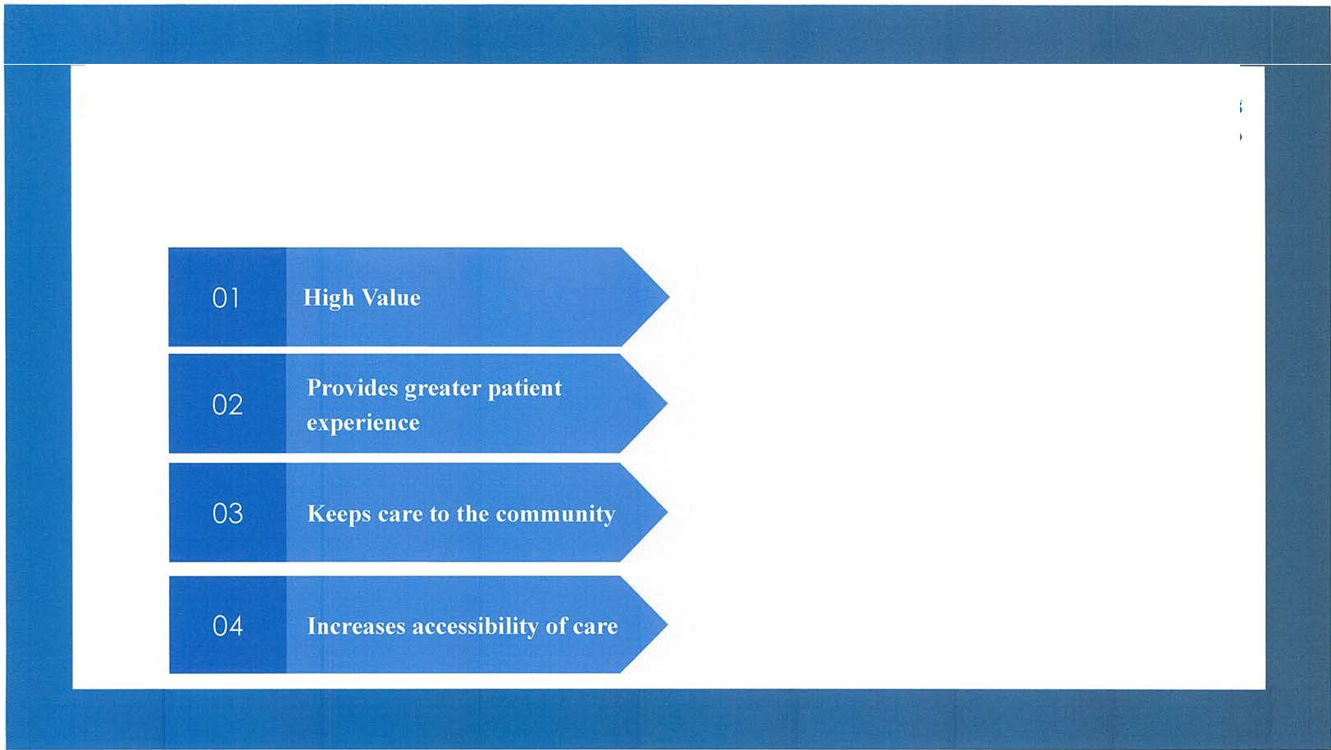
  - Outpatient reimbursement with a high value service creates high patient satisfaction with lower out of pocket responsibility

    - Greater scheduling
    - Highly experienced technical staff
    - State of the art equipment

    - Easy, convenient location
    - Transportation assistance
    - Provides local option for physicians and patients

    - Efficient weekly offered care minimizes time to treatment
    - Shifts appropriate care from inpatient to outpatient

Summary: Mobile PET/CT Services in the Town of Dedham
- PET/CT Service one midweek day per week
- Cancer staging, Alzheimer's disease evaluation, cardiac applications
- Located in the Town of Dedham
- Mobile PET/CT with weather tight connector
- Lower cost of care




Next Steps

WE WANT YOUR INPUT
on the concept of mobile PET/CT
WE WILL KEEP YOU INFORMED
as the project progresses

Exhibit B.i
Corporate Document Accessibility Statement

Shields and Atrius Health PET/CT at Dedham, LLC Application# N/A-24031814-RE

Corporate Document Accessibility Statement

Per instruction from the Department of Public Health, Shields and Atrius Health PET/CT at Dedham ("Applicant") is providing a link to its corporate documents on the Massachusetts Secretary of State's website for accessibility purposes. Please use the following link to access the Applicant's Limited Liability Company ("LLC") Certificate on the Secretary of State's website:

https://corp.sec.state.ma.us/CorpWeb/CorpSearch/CorpSummary.aspx?sysvalue=.N8VYr1QcEw6BvVU1sEvpwZS5hlvNvU8NLXZmi.DihE-

