## ATTACHMENT 1 NARRATIVE

#### Project Description

The proposed request is filed with respect to DoN Project # 5-4887 which provided for a third MRI unit at St. Luke’s Hospital located at 361 Allen Street, New Bedford, Massachusetts. Shields Healthcare of Dartmouth, Inc. d/b/a Fall River New Bedford Regional MRI Center is the Holder of the DoN issued on October 30, 2003, for the third MRI unit (“Holder”). This MRI unit provides the inpatient and outpatient MRI scans for St. Luke’s Hospital’s patients.

#### 10. Amendment

* + 1. **Describe the proposed change.**

Fall River/New Bedford MRI Limited Partnership (“JV”) is a joint venture among Southcoast Ventures, Inc. (a wholly owned subsidiary of Southcoast Health System, Inc. (“SHS”) and a sister corporation to Southcoast Hospitals Group, Inc. (“SHG”)), Shields Healthcare of Dartmouth, Inc., and Shields Family Equity, LLC. The proposed significant change will remove Shields Healthcare of Dartmouth, Inc. d/b/a Fall River New Bedford MRI Center as the Holder of the DoN, release Shields Healthcare of Dartmouth, Inc., and Shields Family Equity, LLC (collectively, “Shields”) from the ownership of the satellite clinic at St. Luke’s Hospital and acknowledge SHG on behalf of SHV as the holder of the DoN for the third MRI unit (“Proposed Project”).

#### Describe the associated cost implications to the Holder.

The Proposed Project will have modest cost implications for SHS. The Proposed Project will require SHG to purchase the Shields’ ownership interest in the MRI equipment. The MRI service is an existing service operated by the JV. The Proposed Project will not result in significant capital costs to continue the MRI service at St. Luke’s Hospital. The additional capital costs are estimated to be $2,600,000. The Proposed Project will not result in significant additional operating costs to SHG because SHG will only assume the additional operating expenses attributable to Shields to operate the MRI services at St. Luke’s Hospital. The additional operating costs are estimated to be

$1,200,000 per year.

#### Describe the associated cost implications to the Holder’s existing Patient Panel.

The Proposed Project will not have significant cost implications to SHG’s patient panel.

#### Provide a detailed narrative, comparing the approved project to the proposed Significant Change, and the rationale for such change.

The Applicant is Shields Healthcare of Dartmouth, Inc. d/b/a Fall River New Bedford Regional MRI Center on behalf of the JV. The JV was formed to provide inpatient and outpatient MRI services in Fall River/New Bedford. The JV agreement indicated that Shields would transfer the DoN to the JV. The JV currently operates a clinic satellite at St. Luke’s Hospital and provides the inpatient and outpatient MRI scans for St. Luke’s Hospital’s patients.

2

The rationale for the significant change is that the JV partners wish to discontinue the JV’s provision of MRI services at St. Luke’s Hospital and Shields wish to release their interest in the DoN to SHG. SHG wishes to purchase the MRI unit currently being used and continue using it for the St. Luke’s Hospital MRI services. SHG also wishes to become the provider of the MRI service at St. Luke’s Hospital. SHG anticipates that the Proposed Project will result in enhanced care coordination and prevent delays in care because SHG will become the provider of the MRI services at St. Luke’s in addition to continuing its current role as the provider of clinical care at St. Luke’s. SHG also expects that the Proposed Project will improve the quality of inpatient care for St. Luke’s patients by: (i) reducing length of stay at St. Luke’s as a result of its ability to prioritize inpatient MRIs for St. Luke’s patients; (ii) enhancing oversight for clinical care by integrating the peer review processes for MRI services with all hospital locations of SHG; (iii) supporting breast oncology services by adding inpatient MRI services for breast and biopsy imaging, which are not currently available at St. Luke’s; and (iv) enabling comparisons of patients’ inpatient MRI imaging with other imaging studies and modalities by integrating patients’ MRIs into St. Luke’s electronic medical record.

3

## ATTACHMENT 2

**EXISTING DON APPROVAL & STAFF SUMMARY**



MITT ROMNEY

GOVERNOR

KERRY HEALEY

UELJTENANT GOVERNOR

RONALD PRESTON

SECRETARY

CHRISTINE C. FERGUSON

COMMISSIONER

**The Commonwealth of Massachusetts Executive Office of Health and Human Services Department of Public Health**

**Determination of Need Program**

**250 Washington Street, Boston, MA 02108-4619**

**Telephone (617) 624-5002**

**Fax (617} 624-5183**

October 30, 2003

##### CERTIFIED MAIL

RETURNED RECEIPT REQUESTED

Carmel Shields Vice President

Shields Health Care Group 700 Congress Street, Suite 204

Quincy, MA 02169

* Dear Ms. Shields:

##### NOTICE OF DETERMINATION OF NEED

Project Number 5-4887

Fall River-New Bedford Regional MRI Center (Expansion of MRI Service through Acquisition of a Third MRI Unit)

This is to notify you that pursuant to M.G.L. c.111, s.25C and the Regulations adopted thereunder, including the provisions of 105 CMR 100.504, I hereby approve with conditions the Determination of Need application filed by Shields Healthcare of Dartmouth, Inc. d/b/a Fall River-New Bedford Regional MRI Center (FRNB). The application, as approved, provides for expansion of its existing magnetic resonance imaging (MRI) by acquiring a third unit, a 1.5 Tesla field strength fixed-base unit, to be located in renovated space in the radiology department of St. Luke's Hospital at 361 Allen Street, New Bedford, Massachusetts. The proposed MRI unit is intended to address the problems of increasing demand for services, excessive waiting times and the need for more modem MRI technology. This Notice of Determination of Need incorporates by reference the attached Staff Summary.

The total approved gross square footage (GSF) associated with the project is 4,531 GSF of renovated space. The approved maximum capital expenditure of $3,303,895 (April 2001 dollars) is itemized below:

|  |  |
| --- | --- |
| Building Acquisition Cost | $ 203,895 |
| Construction Contract | 950,000 |
| Major Movable Equipment (MRI unit) | 2,150,000 |
| Total Construction Costs | 3,303,895 |
| Total Maximum Capital Expenditure | $ 3,303,895 |

The approved operating costs of $3,629,613 (April 2001 dollars), based on a projected incremental volume of 8,994 scans for the project's first full year of operation (FY 2004), are as follows:

|  |  |
| --- | --- |
| Salaries, Wages and Fringe | $870,400 |
| Purchased Services | 1,119,492 |
| Supplies and Other | 900,687 |
| Depreciation | 596,022 |
| Interest | 143,012 |
| Total Operating Costs | $3,629,613 |

Salaries, wages and fringe benefits and purchased services include costs for 36.0 FTEs:

19.0 technologists and 17.0 clerical and administrative staff.

The reasons for this approval with conditions are as follows:

1. Shields Healthcare of Dartmouth, Inc. d/b/a The Fall River-New Bedford Regional MRI Center (FRNB) is proposing to expand its magnetic resonance imaging (MRI) service by

acquiring a third unit, a 1.5 Tesla field strength fixed-base unit to be located in renovated space in the radiology department of St. Luke's Hospital at 361 Allen Street, New Bedford, Massachusetts. The proposed MRI unit is intended to address the problems of increasing demand for services, excessive waiting times and the need for more modem MRI technology at FRNB's St. Lukes site.

1. The Department found that the health planning process for this project was satisfactory.
2. The Department found need for the proposed third MRI unit at FRNB based on existing and projected utilization, consistent with the revised August 19, 1997 Determination of Need Guidelines for Magnetic Resonance hnaging (Guidelines).
3. The Department found that the project, with adherence to certain conditions, met the operational objectives factor of the Guidelines.
4. The Department found that the project met the compliance standards of the Guidelines.
5. The Department found the recommended maximum capital expenditure of

$3,303,895 (April 2001 dollars) reasonable compared to similar, previously approved projects.

1. The Department found the recommended incremental operating costs of

$3,629, 613 (April 2001 dollars) reasonable compared to similar, previously approved projects.

1. The Department found the project financially feasible and within the financial capability of the applicant.
2. The Department found the project met the relative merit requirements of the Guidelines.
3. The Department found the applicant's proposed community health initiatives, with adherence to a certain condition, consistent with the Guidelines.

This Determination is effective upon receipt of this Notice. The Determination is subject to the conditions set forth in Determination of Need Regulation 105 CMR 100.551, including sections 100.551 (C) and (D) which read in part:

(C) ...such determination shall be valid authorization only for the project for which made and only for the total capital expenditure approved.

###### (D)

The determination...shall be valid authorization for three years. If substantial and continuing progress toward completion is not made during the three year authorization period, the authorization shall expire if not extended by the Department for good cause shown (see 105 CMR 100.756)... Within the period of authorization, the holder shall make substantial and continuing progress toward completion; however, no construction may begin until the holder has received final plan approval in writing from the Division of Health Care Quality.

This Determination is subject to the following conditions, in addition to the terms and conditions set forth in 105 CMR 100.551. Failure of the applicant to comply with the conditions may result in Department sanctions, including possible fines and/or revocation of the DoN.

1. The applicant shall accept the maximum capital expenditure of $3,303,895

(April 2001 dollars) as the final cost figure except for those increases allowed pursuant to 105 CMR 100.751 and 752.

1. The applicant shall contribute 35.8% in equity ($1,182,500 in April 2001 dollars) to the final approved maximum capital expenditure.
2. For Massachusetts residents, the applicant shall not consider ability to pay or insurance status in selecting or scheduling patients for MRI services.
3. The applicant shall agree to operate MRI equipment that has pre-market approval by the Food and Drug Administration.
4. The total approved gross square feet (GSF) shall be 4,531 GSF for renovation

Regional MRI Center

in the radiology department of St. Luke's Hospital.

1. The applicant shall provide a total of $165,000 (April 2001 dollars) over a five year period for a mini-grant(s) program for prevention services or programs to address priority areas identified by the local Community Health Network Agency (CHNA #26). The funds shall be awarded to providers through a Request for Proposal (RFP) process to be developed,

administered and evaluated by the CHNA.

#### Christine C. Ferguson

*?j LG/4*

Commissioner

CCF:hw

**cc:**

Sherman Lohnes, Division of Health Care Quality Donna Allen, Division of Health Care Quality Cathy O'Connor, Office of Healthy Communities

Steve McCabe, Division of Health Care Finance and Policy Elizabeth Pressman, Division of Medical Assistance Decision Letter File

Public File

##### MIS

Holly Wright, Program Analyst

###### STAFF SUMMARY FOR DETERMINATION OF NEED BY THE COMMISSIONER OF PUBLIC HEALTH

•

(DELEGATED REVIEW PROCESS) OCTOBER 2003

APPLICANT: Shields Healthcare of Dartmouth, Inc. PROGRAM ANALYST: Holly Wright d/b/a Fall River-New Bedford

Regional MRI Center

LOCATION: 313 Faunce Comer Road

North Dartmouth, MA 02747

###### REGION: RSA V

DATE OF APPLICATION: April 20, 2001 PROJECT NUMBER: 5-4887

PROJECT DESCRIPTION: Expansion of magnetic resonance imaging (MRI) service by acquiring a third MRI unit, a 1.5 Tesla field strength fixed-base unit, to be located in renovated space in the radiology department of St. Luke's Hospital at 361 Allen Street, New Bedford, Massachusetts.

###### ESTIMATED MAXIMUM CAPITAL EXPENDITURE:

Originally Requested: Revised Requested:

* Recommended:

$3,100,000 (April 2001 dollars)

$3,303,895 (April 2001 dollars)

$3,303,895 (April 2001 dollars)

###### ESTIMATED FIRST YEAR OPERATING COSTS:

Requested: Recommended:

$3,629,613 (April 2001 dollars)

$3,629,613 (April 2001 dollars)

LEGAL STATUS: A unique application for a Determination of Need for substantial change in services pursuant to M.G.L. c.111, s. 25C and the Regulations adopted thereunder.

ENVIRONMENTAL STATUS: No environmental notification form or environmental impact report is required to be submitted for this project since it is exempt under 301 Code of Massachusetts Regulations 11.00, promulgated by the Executive Office of Environmental Affairs pursuant to Massachusetts General Laws, Chapter 30, Sections 61-62H. This exemption has the effect of a determination that the project will cause no significant damage to the environment.

OTHER PENDING APPLICATIONS: None

COMPARABLE FRNBS: None

COMMENTS BY THE DIVISION OF MEDICAL ASSISTANCE: None submitted

COMMENTS BY THE DIVISION OF HEALTH CARE FINANCE AND POLICY: None submitted

TEN TAXPAYER GROUPS: None formed

* RECOMMENDATION: Approval with conditions
  1. BACKGROUND AND PROJECT DESCRIPTION

Shields Healthcare of Dartmouth, Inc. d/b/a The Fall River-New Bedford Regional MRI Center (FRNB) filed a Determination of Need application to expand its existing magnetic resonance imaging (MRI) service by acquiring a third MRI unit, a 1.5 Tesla field strength fixed-base unit, to be located in renovated space in the radiology department of St. Luke's Hospital at 361 Allen Street, New Bedford, Massachusetts. The application proposes the purchase of a General Electric Signa Horizon EchoSpeed LX full body MRI unit. The FRNB currently operates a .2 Tesla and a 1.5 Tesla MRI unit at its location at 313 Faunce Comer Road, North Dartmouth. The proposed MRI unit is intended to address the problems of increasing demand for services, excessive waiting times and the need for more modem MRI technology. On April 27, 2000, the applicant received a 308 exemption to acquire the third unit. The exemption provided that in order for the FRNB to continue operating the unit, a Determination of Need (DoN) application must be filed within one year. On April 20, 2001, the FRNB filed this application.

FRNB is owned by the Fall River/New Bedford MRI Limited Partnership consisting of Shields Healthcare of Dartmouth, Inc., the general partner, and three limited partners: SLH Ventures, Inc., the corporate limited partner owned and controlled by Southcoast Health Systems; and two noncorporate limited partners, Thomas F. and Mary J. Shields. The licensee of the center is Thomas

F. and Mary **J.** Shields d/b/a Fall River-New Bedford Regional **MRI** Center. Shields Healthcare of

Dartmouth, Inc. is a member of the Shields Health Care Group, a group of affiliated corporations that owns and operates six MRI centers in Massachusetts.

* 1. STAFF ANALYSIS

The application was reviewed against the revised August 19, 1997 Determination ofNeed­ Guidelines for Magnetic Resonance Imaging (Guidelines).

* + 1. Health Planning Process

Prior to filing this applications, FRNB consulted with Staff of the Determination of Need Program and the Division of Medical Assistance. Further, FRNB contacted other MRI providers in its service area to determine their waiting times.

Staff finds the applicant has engaged in a satisfactory health planning process.

* + 1. Health Care Requirements

The revised MRI Guidelines, adopted by the Public Health Council on August 19, 1997, allocate MRI units on a statewide basis. The Guidelines recommend that applicants with existing licensed MRI services provided in either a hospital or freestanding facility with fixed or mobile MRI equipment, be allowed to expand their existing services provided sufficient demand is present as demonstrated by the following:

* + - * The applicant's existing fixed or mobile MRI unit has been operating at 90% of capacity for the past year as evidenced by the number of scans performed annually and the hours of operation.

In FY 2002, the two existing MRI units performed 11,243 scans, with average time per scan of one hour. The units were in operation from 6 a.m. to 12 midnight on weekdays and from 6 a.m. to

6 p.m. on Saturdays and Sundays, 52 weeks per year. Taking into account an estimated two hours per week downtime for repair, maintenance, and education, a total of 11,648 available hours was used in calculating the operating capacity of the two existing units. Given a reported 11,243 scans during FY 2002, Staff calculated that FRNB 's two existing MRI units operated at 96.5 % capacity, as shown below in Table 1.

Table 1

Percent Operating Capacity of Two Existing Units in FY 2002

Number of Scans Average Hours per Scan Annual Scan Hours

Average Available Hours per Year* Operating Capacity (l l ,243/11,648)

11,243

1.0

11,243

11,648

96.5%

*Calculated at 114 hours per week, 52 weeks per year, minus 2 hours per week for repair, maintenance and education.

Based on FY 2002 actual utilization of the third unit which was acquired under a section 105 CMR 100.308 exemption approval in April 2000 as previously discussed, FRNB estimates that in FY 2004, the first full year of operation, a total of 8,994 scans will be performed on the third MRI unit, with an average of 50 minutes or .83 hours per scan. FRNB 's proposed hours of operation for this MRI unit will be from 6 a.m. to 12 midnight on weekdays and from 6 a.m. to 6 p.m. on Saturdays and Sundays, with the estimated two hours per week downtime for repair, maintenance, and education. Combining the actual utilization of the two existing MRI units and the projected utilization of the third unit results in a total of 20,237 scans annually with an operating capacity of 96.1 %, as shown in Table 2.

Table 2

Projected Scans and Percent Operating Capacity of Three Units, FY 2004

Projected Number of Scans in FY 2004 Average Hours per Scan

Annual Scan Hours

Average Available Hours per Year* Operating Capacity (16,797/17,472)

20,237

.83

16,797

17,472

96.1%

*Calculated at 114 hours per week, 52 weeks per year, minus 2 hours per week for repair, maintenance and education.

* Documented findings from the Clinical Oversight Committee of the appropriateness and quality of MRI scans and evaluation activities provided in the last three years.

FRNB states that its Clinical Oversight Committee is composed of internal and external physicians including two in specialties outside ofradiology. At Staff's request, FRNB provided a report documenting evaluations of the quality of MRI scans and interpretations. FRNB reports that from five to seven scan interpretations are reviewed for quality each week and of these, 1% are found to require

discussion of the interpretation with the radiologist. With regard to documentation of the appropriateness of referrals, FRNB states that there were no findings of inappropriate referrals since appropriateness of MRI is reviewed for all referrals. That is, 100% ofreferrals for scans are reviewed by a board certified radiologist for appropriateness prior to procedures. If an inappropriate referral is made, the referring physician is contacted and the scan is not performed.

Staff finds need for the proposed project based on the applicant's existing and projected utilization and appropriateness and quality ofMRl scans, consistent with the Guidelines.

* + 1. Operational Objectives

The operational objectives of the Guidelines require the applicant to provide a qualified clinical

. director and appropriately trained and adequate physician, technician and nurses staffing of the unit; use of an **MRI** unit that has received pre-market approval from the Food and Drug Administration (FDA); training and educational opportunities for area physicians; availability of CT and other imaging procedures on site or through referral agreements; establishment of a clinical oversight committee; and scheduling of scans based on clinical protocols without regard to the patient's ability to pay.

FRNB states that the Clinical Director of the **MRI** service is a board certified radiologist with over twelve (12) years experience in clinical MRI, which exceeds the requirements of the Guidelines. The proposed service will provide for interpretation of scans by the Clinical Director and four board certified radiologists who are on-site 75% of the MRI service's hours of operation, which exceeds that required by the Guidelines. FRNB proposes to use a 1.5 Tesla MRI unit that has received pre-market approval from the FDA, and which has been included as a condition of approval for the project. FRNB submitted a copy of its referral agreement with St. Luke's Hospital, which provides for availability of CT scanning, nuclear medicine, ultrasound and angiography services, as required by the Guidelines.

The staff will receive orientation on techniques and as well as underlying conditions and diagnostic consideration related to MRI testing. All technologists are experienced nuclear medicine technologists and certified as American Registry of Radiologic Technologist in Radiology and MRI. FRNB proposes an additional 19.0 technologist FTEs and 17.0 clerical and administrative FTEs dedicated to the MRI service. In order to assure that area radiologists and other physicians are familiar with current and new applications of MRI services, FRNB sponsors meetings on developments in MRI technology and new applications. FRNB has agreed, as a condition of approval, to schedule scans based on clinical protocols without regard to the patient's ability to pay.

Staff finds that, with adherence to certain conditions, the project meets the operational objectives requirements of the Guidelines.

* + 1. Compliance Standards

FRNB has agreed to meet all standards necessary to operate the proposed fixed-base MRI unit, including all relevant licensure standards of the Division of Health Care Quality. The proposed gross square footage (GSF) for this project is 4,531 of renovated space in the radiology department at St.

Luke's Hospital. FRNB states that the 4,531 GSF of space is being leased from St. Luke's Hospital. This gross square footage is within the range proposed by the Guidelines.

Staff finds that the project meets the compliance standards of the Guidelines.

* + 1. Reasonableness of Expenditures and Cost

1. Maximum Capital Expenditure

The revised requested and recommended maximum capital expenditure (MCE) for the proposed project is $3,303,895 (April 2001 dollars), itemized as follows:

|  |  |
| --- | --- |
| Building Acquisition Cost | $ 203,895 |
| Construction Contract | 950,000 |
| Major Movable Equipment | 2,150,000 |
| Total Construction Costs | 3,303,895 |
| Total Maximum Capital Expenditure | $ 3,303,895 |

The MCE initially requested by FRNB was $3,100,000 (April 2001 dollars). At Staffs request, FRNB submitted a revised MCE to include the fair market value of the leased space which is represented above as the building acquisition cost. The major movable equipment cost is for the MRI unit. The estimated cost per GSF of the renovation is $195/GSF, which is within the range of similar, previously approved projects.

Staff finds the recommended MCE reasonable based on similar, previously approved projects.

•

2. Incremental Operating Costs

The requested and recommended incremental operating costs of $3,629,613 (April 2001 dollars) for the project's first full year of operation (FY 2004) are based on a projected volume of 8,994 scans for the third unit. The requested and recommended incremental operating costs are itemized as follows:

|  |  |
| --- | --- |
| Salaries, Wages and Fringe | $870,400 |
| Purchased Services | 1,119,492 |
| Supplies and Other | 900,687 |
| Depreciation | 596,022 |
| Interest | 143,012 |
| Total Operating Costs | $3,629,613 |

Supplies and other expenses includes the rental payments for the leased space at St. Luke's Hospital. Salaries, wages and fringe benefits and purchased services include costs for 36.0 FTEs:

19.0 technologists and 17.0 clerical and administrative staff. Staff notes that the FRNB already has a number of radiologists active with the existing service to staff the unit, and a physicist who is available when needed.

Staff finds the recommended operating costs reasonable compared to similar, previously approved projects.

1. Financial Feasibility and Capability

* FRNB has proposed to finance the recommended MCE of $3,303,895 (April 2001 dollars) with a 35.8% equity contribution of$1,182,500 (April 2001 dollars): $232,500 in loans from affiliates and

$950,000 in leasehold improvements contributed by the landlord, St. Luke's Hospital. The remaining

recommended MCE of $2,121,395 (Aprill 2001 dollars) will be financed through a capital lease at an 8.3% interest rate for 5 years. Staffs review ofFRNB's FY 2002 audited financial statements show a current ratio of 1.6 which is above the DoN minimum requirement of 1.5. The debt service coverage ratio projected for FY 2004, the first full year of operation, will be 7.00, which exceeds the DoN minimum standard of 1.4. Updated financial schedules, submitted at Staffs request, show actual gains from operations in FY 2002 of$3,188,143 with projected gains from operations of $4,174,202 in FY 2004. The updated financial schedules also show actual excess revenues over expenses of $3,221,367 in FY 2002 and projected excess revenues over expenses of $4,217,235 in FY 2004.

Staff finds the project financially feasible and within the financial capability of the applicant.

1. Relative Merit

FRNB considered the alternative of maintaining the status quo. This alternative was rejected because it did not address the problem of waiting times and insufficient MRI hours to meet the demands for MRI scans in the service area.

Staff finds that the project meets the relative merit requirements of the Guidelines.

1. Community Health Initiatives

FRNB will provide $165,000 (April 2001 dollars) over a five year period ($33,000 annually) in mini-grant(s) for prevention services or programs to address priority areas identified by the local Community Health Network Agency (CHNA#26). The funds will be awarded to providers through an RFP process to be developed, administered and evaluated by the CHNA.

ill. STAFF RECOMMENDATION

Based on the above analysis and findings, Staff recommends approval with conditions of Project Number 5-4887 filed by Shields Healthcare of Dartmouth, Inc. d/b/a The Fall River-New Bedford Regional MRI Center for expansion of its existing magnetic resonance imaging (MRI) by acquiring a third unit, a 1.5 Tesla field strength fixed-base unit, to be located in renovated space in the radiology department of St. Luke's Hospital at 361 Allen Street, New Bedford, Massachusetts. The proposed **MRI** unit is intended to address the problems of increasing demand for services, excessive waiting times and the need for more modem **MRI** technology. The recommended conditions are listed below.

Failure of the applicant to comply with the conditions may result in Department sanctions, including possible fines and/or revocation of the DoN.

1. The applicant shall accept the maximum capital expenditure of $3,303,895

(April 2001dollars) as the final cost figure except for those increases allowed pursuant to 105 CMR 100.751 and 752.

1. The applicant shall contribute 35.8% in equity ($1,182,500 in April 2001 dollars) to the final approved maximum capital expenditure.
2. For Massachusetts residents, the applicant shall not consider ability to pay or insurance status in selecting or scheduling patients for MRI services.
3. The applicant shall agree to operate MRI equipment that has pre-market approval by the

Food and Drug Administration.

1. The total approved gross square feet (GSF) shall be 4,531 of renovation in the radiology department at St. Luke's Hospital.
2. The applicant shall provide a total of $165,000 (April 2001 dollars) over a five year period for a mini-grant(s) program for prevention services or programs to address priority areas identified by the local Community Health Network Agency (CHNA). The funds shall be awarded to providers through an RFP process to be developed, administered and evaluated by the CHNA.

DON APPLICATION #: FRNB-25011310-AM

## ATTACHMENT 3 NOTICE OF INTENT

[Home](https://www.southcoast.org/) / [Southcoast News](https://www.southcoast.org/news/) / [Community](https://www.southcoast.org/category/community/) /

**COMMUNITY**

**Public Announcement Concerning a Proposed Health Care Project**

**DEC 13.** 2024 | BY SOUTHCOAST HEALTH

Shields Healthcare of Dartmouth, Inc. d/b/a Fall River-New Bedford Regional MRI Center (“Applicant”), with

an address of 700 Congress Street, Suite 204, Quincy, Massachusetts 02169, intends to file an application for an amendment to the Notice of Determination of Need issued by the Department of Public Health (Project #5- 4887) (the “DoN”). The DoN provided the Applicant with a third magnetic resonance imaging (MRI) unit at St. Luke’s Hospital located at 361 Allen Street, New Bedford, Massachusetts. Applicant is a member of the Fall

River/New Bedford MRI Limited Partnership, a joint venture that also includes Shields Family Equity, LLC, and Southcoast Ventures, Inc. (a wholly owned subsidiary of Southcoast Health System, Inc. (“SHS”)), and provides MRI services at St. Luke’s Hospital. The proposed amendment will release the Applicant and Shields Family Equity, LLC from the DoN (“Proposed Project”). The Total Value of the Proposed Project is

$2,600,000. The Applicant anticipates that the Proposed Project will not have a significant increase on prices and will improve access to inpatient MRI services for the Applicant’s existing patient panel.

# Public Notices

Originally published at southcoasttoday.com on 12/13/2024

Public Announcement Concerning a Proposed Health Care Project

Shields Healthcare of Dartmouth, Inc. d/b/a Fall River-New Bedford Regional MRI Center (“Applicant”), with an address of 700 Congress Street, Suite 204, Quincy, Massachusetts 02169, intends to file an application for an amendment to the Notice of Determination of Need issued by the Department of Public Health (Project #5-4887) (the “DoN”). The DoN provided the Applicant with a third magnetic resonance imaging (MRI) unit at St. Luke’s Hospital located at 361 Allen Street, New Bedford, Massachusetts. Applicant is a member of the Fall River/New Bedford MRI Limited Partnership, a joint venture that also includes Shields Family Equity, LLC, and Southcoast Ventures, Inc. (a wholly owned subsidiary of Southcoast Health System, Inc. (“SHS”)), and provides MRI services at St. Luke’s Hospital. The proposed amendment will release the Applicant and Shields Family Equity, LLC from the DoN (“Proposed Project”). The Total Value of the Proposed Project is

$2,600,000. The Applicant anticipates that the Proposed Project will not have a significant increase on prices and will improve access to inpatient MRI services for the Applicant’s existing patient panel.

12/13/24 10850592

Originally published at southcoasttoday.com on 12/15/2024

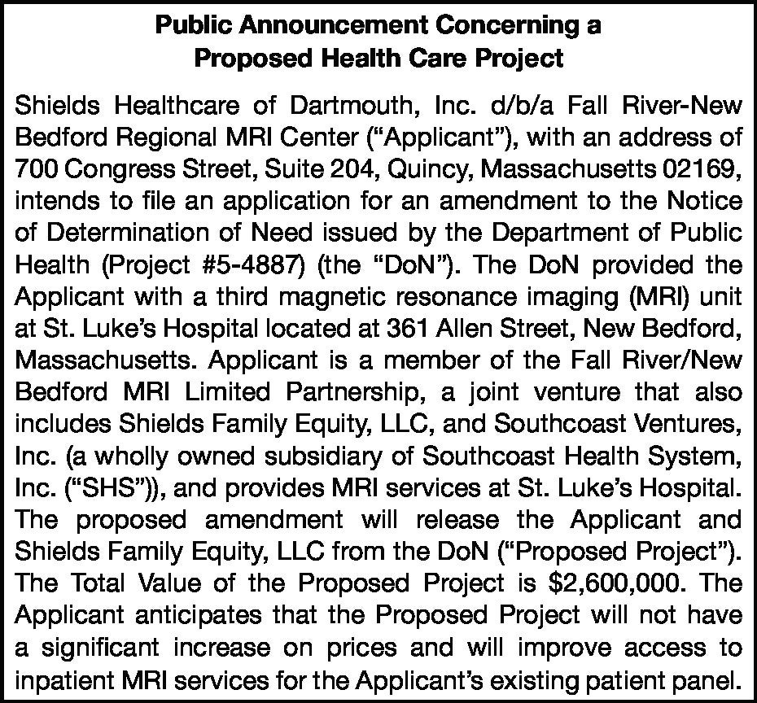

# Public Notices

Originally published at heraldnews.com on 12/13/2024

##### LEGAL NOTICE

Public Announcement Concerning a Proposed Health Care Project

Shields Healthcare of Dartmouth, Inc. d/b/a Fall River-New Bedford Regional MRI Center (“Applicant”), with an address of 700 Congress Street, Suite 204, Quincy, Massachusetts 02169, intends to file an application for an amendment to the Notice of Determination of Need issued by the Department of Public Health (Project #5-4887) (the “DoN”). The DoN provided the Applicant with a third magnetic resonance imaging (MRI) unit at St. Luke’s Hospital located at 361 Allen Street, New Bedford, Massachusetts. Applicant is a member of the Fall River/New Bedford MRI Limited Partnership, a joint venture that also includes Shields Family Equity, LLC, and Southcoast Ventures, Inc. (a wholly owned subsidiary of Southcoast Health System, Inc. (“SHS”)), and provides MRI services at St. Luke’s Hospital. The proposed amendment will release the Applicant and Shields Family Equity, LLC from the DoN (“Proposed Project”). The Total Value of the Proposed Project is

$2,600,000. The Applicant anticipates that the Proposed Project will not have a significant increase on prices and will improve access to inpatient MRI services for the Applicant’s existing patient panel.

#10850666

##### FRHN 12/13/24

Originally published at heraldnews.com on 12/15/2024

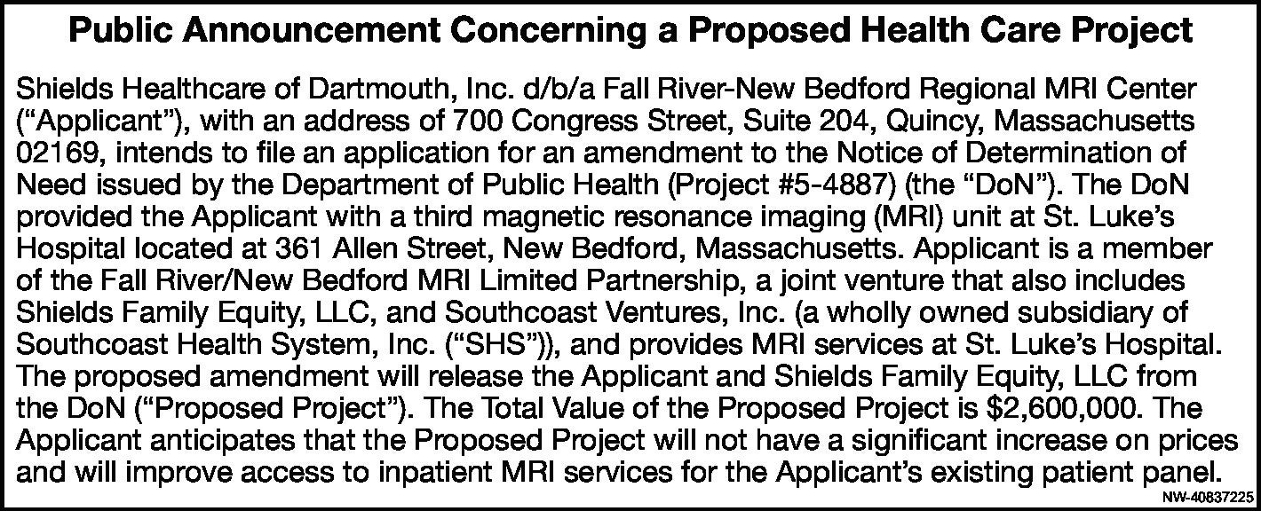

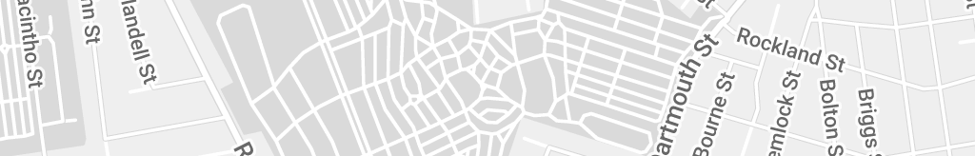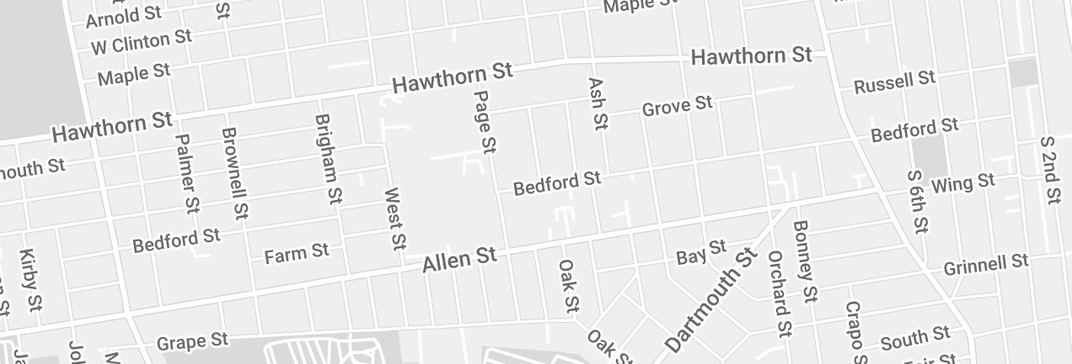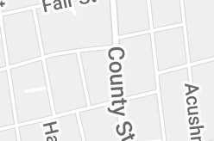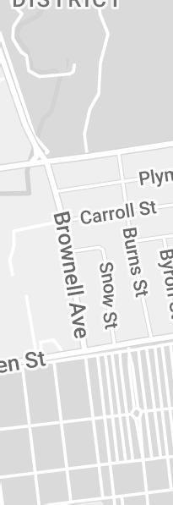

[(https://maps.google.com/maps?ll=41.625807,-70.938238&z=15&t=m&hl=en-US&gl=US&mapclient=apiv3)](https://maps.google.com/maps?ll=41.625807%2C-70.938238&z=15&t=m&hl=en-US&gl=US&mapclient=apiv3) Map data ©2024 200 m

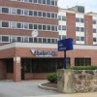

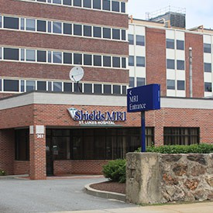**Hours of Operation**

Mon – Fri: 6:00am – 11:00pm Sat – Sun: 6:30am – 6:00pm

1-800-258-4674

**Services:** 1.5T Open MRI, Breast MRI, Arthrograms

*MRI Tax ID: 04-3043884*

Amendment to the Notice of Determination of Need (https://acrobat.adobe.com/id/urn:aaid:sc:va6c2:862c4b76-778f-4bbc-9d11- ace491174770)

Address:

Shields MRI at St. Luke’s Hospital 361 Allen St.,

New Bedford, MA 02740

Get directions from

[(/#twitter)](https://shields.com/#twitter) [(/#linkedin)](https://shields.com/#linkedin) [(/#facebook)](https://shields.com/#facebook)

GO

[](https://shields.com/find-location/) [**Back to Map (/find-location/)**](https://shields.com/find-location/)

[Find a Location: 1-800-258-4674 (https://shields.com/find-location/)](https://shields.com/find-location/)

© 2024 Shields MRI. All Rights Reserved.

[Company](https://shields.com/news/company/) [(/news/company/)](https://shields.com/news/company/) [Contact Us](https://shields.com/contact-us/) [(/contact-us/)](https://shields.com/contact-us/) [Privacy](https://shields.com/privacy/) [(/privacy/)](https://shields.com/privacy/) [Site Map](https://shields.com/site-map) [(/site-map)](https://shields.com/site-map) [SHC Webmail](https://webmail.shields.com/) [(https://webmail.shields.com)](https://webmail.shields.com/)

[](https://shields.com/certifications/) [(/certiications/)](https://shields.com/certifications/) [](https://www.facebook.com/shieldshealth)

[(https://www.facebook.com/shieldshealth)](https://www.facebook.com/shieldshealth)

[ (https://twitter.com/shields_health)](https://twitter.com/shields_health) [](https://www.linkedin.com/company/shields-health/) [(https://www.linkedin.com/company/shield](https://www.linkedin.com/company/shields-health/) [health/)](https://www.linkedin.com/company/shields-health/) [ (https://info.shields.com)](https://info.shields.com/)

#### Amendment to the Notice of Determination of Need

Shields Healthcare of Dartmouth, Inc. d/b/a Fall River-New Bedford Regional MRI Center (“Applicant”), with an address of 700 Congress Street, Suite 204, Quincy, Massachusetts 02169, intends to file an application for an amendment to the Notice of Determination of Need issued by the Department of Public Health (Project #5-4887) (the “DoN”). The DoN provided the Applicant with a third magnetic resonance imaging (MRI) unit at St. Luke’s Hospital located at 361 Allen Street, New Bedford, Massachusetts. Applicant is a member of the Fall River/New Bedford MRI Limited Partnership, a joint venture that also includes Shields Family Equity, LLC, and Southcoast Ventures, Inc. (a wholly owned subsidiary of Southcoast Health System, Inc. (“SHS”)), and provides MRI services at St. Luke’s Hospital. The proposed amendment will release the Applicant and Shields Family Equity, LLC from the DoN (“Proposed Project”). The Total Value of the Proposed Project is $2,600,000. The Applicant anticipates that the Proposed Project will not have a significant increase on prices and will improve access to inpatient MRI services for the Applicant’s existing patient panel.

## ATTACHMENT 6 ARTICLES OF ORGANIZATION

#### Shields Healthcare of Dartmouth, Inc. d/b/a Fall River-New Bedford Regional MRI Center

Articles of Organization (1988): <https://corp.sec.state.ma.us/CorpWeb/CorpSearch/CorpSearchViewPDF.aspx>

## ATTACHMENT 7 AFFIDAVIT OF TRUTHFULNESS FORM

 Version: 7-6-17

**Massachusetts Department of Public Health**

**Determination of Need**

**Affidavit of Truthfulness and Compliance**

**with Law and Disclosure Form 100.405 (B)**

**Instructions**: Complete Information below. When complete check the box "This document is ready to print:". This will date stamp and lock the form. Print Form. Each person must sign and date the form. When all signatures have been collected, scan the document and e-mail to: [dph.don@state.ma.us](mailto:dph.don@state.ma.us) Include all attachments as requested.

Application Number: FRNB-25011310-AM

Original Application Date: 04/20/2001

Applicant Name: Shields Healthcare of Dartmouth, Inc. d/b/a Fall River-New Bedford Regional MRI Center

Application Type: Amendment Significant

Applicant's Business Type: Corporation

Is the Applicant the sole member or sole shareholder of the Health Facility(ies) that are the subject of this Application? No

Describe the role/relationship: a member of a joint venture that owns the Health Facility providing MRI services at St. Luke’s Hospital

The undersigned certifies under the pains and penalties of perjury:

1. The Applicant is a member of a joint venture that owns the Health Facility providing MRI services at St. Luke's Hospital;
2. I have read 105 CMR 100.000, the Massachusetts Determination of Need Regulation;
3. I understand and agree to the expected and appropriate conduct ofthe Applicant pursuant to 105 CMR 100.800;
4. I have read this application for Determination of Need including all exhibits and attachments, and certify that all of the information contained herein is accurate and true;
5. I have caused, as required, notices of intent to be published and duplicate copies to be submitted to all Parties of Record, and all carriers or third-party administrators, public and commercial, for the payment of health care services with which the Applicant contracts, and with Medicare and Medicaid, as required by 105 CMR 100.405((), et seq.;
6. If subject to M.G.L.c. 6D, § 13 and 958 CMR 7.00, I have submitted such Notice of Material Change to the HPC - in accordance with 105 CMR 100.405(G);
7. Pursuant to 105 CMR 100.210(A)(3), I certify that both the Applicant and the Proposed Project are in material and substantial compliance and good standing with relevant federal, state, and local laws and regulations, as well as with all previously issued Notices of Determination of Need and the terms and Conditions attached therein;
8. I have read and understand the limitations on solicitation of funding from the general public prior to receiving a Notice of Determination of Need as established in 1OS CMR 100.415;
9. I understand that, if Approved, the Applicant, as Holder of the DoN, shall become obligated to all Standard Conditions pursuant to 105 CMR 100.310, as well as any applicable Other Conditions as outlined within 105 CMR 100.000 or that otherwise become a part of the Final Action pursuant to 105 CMR 100.360;
10. 1O. Pursuant to 105 CMR 100.70S(A), I certify that the Applicant has Sufficient Interest in the Site or facility; and
11. Pursuant to 1OS CMR 100.705(A), I certify that the Proposed Project is authorized under applicable zoning by-laws or ordinances, whether or not a special permit is required; or,
12. If the Proposed Project is not authorized under applicable zoning by-laws or ordinances, a variance has been received to permit such Proposed Project; or,
13. The Proposed Project ls exempt from zoning by-laws or ordinances.

|  |
| --- |
| **Corporation**  Attach a copy of Articles of Organization/Incorporation as amended  Thomas A. Shields <Signature on File> 12/30/2024  CEO for Corporation Name: Signature: Date:  Thomas A. Shields <Signature on File> 12/30/2024  Board Chair for Corporation Name: Signature: Date: |

**This document is ready to print:** [unchecked] **Date/time Stamp:** [blank]