**Appendix E**

## PFAC Agenda, Presentation, and Meeting Minutes

**Meeting Date Meeting Time Meeting Locations Next Meeting**

April 8, 2024 5:00PM -6:00 PM White Home Living Room and Join Microsoft Teams Meeting 1 (774) 243-0190

Conference ID: 574 536 212#

Date: April 22, 2024

**Chair/Leader Recorder**

Yinka Oluwole Tracey Benson

| **Staff** |  |  |  | **Community Members** |  |  |
| --- | --- | --- | --- | --- | --- | --- |
| Stephen Canessa | Joanne Gregory | Trish Wollner |  | Kathy Campanirio | Sarah Long | Donnie Anderson |
| Yinka Oluwole | Kimberley Coon | Tonya Johnson |  | Pam Ellis | Mary L Francis | Jeffrey Schmalz |
| Alicia Pimentel | Lauren Melby | Traci McNeil |  | Dennis DeMarinis | Susan Melrose |  |
| Bill Burns | Melissa Svay | Tracey Benson |  | Joan Menard | Shawn Morley | **Guests** |
| Christine Snow | Michelle Wakeman | Jennifer Schachter |  | Brian O’Hare | Renee Ledbetter | Renee Clark |
| Dilip Sthapit, **MD** | Nitya Bitthairi, **MD** |  |  | Bonnie Pearson | Danyelle LeBlanc | Dani Hackner, **MD** |
| Jacqueline Somerville | Rachael Hart |  |  | Melanie Cordeiro | Geovanny Sequeira |  |
| Jadene Elden | Robert Mcgowen, **MD** |  |  | Cathie Markow |  |  |

**Members**

**P**resent **/ A**bsent **/ E**xcused

| **Topics** |  |
| --- | --- |
| **Attendance & Introductions**– 10 mins  *Yinka Oluwole* |  |
| **Southcoast Health Surgical Holdings LLC Update–** 30 mins  *Renee Clark Chief Operations Officer*  *Dani Hackner, MD Chief Clinical Officer* | 1. History of relationship with SDS- Dani Hackner, MD Chief Clinical Officer 2. Overview of the transaction- Dani Hackner, MD Chief Clinical Officer 3. The benefits of the Project to SHS’s and SDS’ patient panel and the community-Dani Hackner, MD Chief Clinical Officer 4. The improved health outcomes and quality of life afforded to patients by the project-EVP Chief Operations Officer 5. SHS health equity initiatives that will be available to SDS- 6. Q&A -all |
| **PFAC Updates – 20 mins** |  |
| **Next PFAC Call:** May 13, 2024 @ 5pm 1 (774) 243-0190  Conference ID: 574 536 212#  **Next PFAC Meeting:** April 22, 2024 @ 5pm 1 (774) 243-0190  Conference ID: 237 920 600# |  |

**Resources:**

Add your ideas on the PFAC Idea Board



Patient Handbook

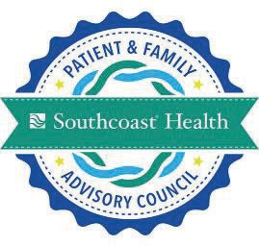

PFAC Members

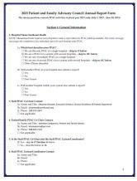

PFAC Annual Reports

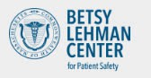

Getting Involved as a Patient



# Determination of Need:



+

Same Day Surgicare of New England

April 8, 2024

 Agenda

* + - * History of Relationship with Same Day Surgicare (SDS)
      * Overview of Transaction
      * The Benefits of the Project to Southcoast Health, SDS, Patients and the Community
      * Improved Health Outcomes and Quality of Life for Patients
      * SHS Health Equity Initiatives that will Extend to SDS
      * Q&A

 History of SDS and Relationship with Southcoast Health

* + - Same Day Surgery Center opened in 1984 as 1st multispecialty freestanding Ambulatory Surgery Center (ASC) in Massachusetts
    - High quality ASC located in Fall River directly behind Truesdale Clinic
      * + 3 Endoscopy Rooms
        + 4 OR Rooms
        + 1 Procedural Room
    - Trusted partner of Southcoast Health (SHS) for many years with outpatient cases and procedures performed by various specialties/providers of SPG
    - Joint Commission accredited and owned by community providers
    - (including some who are SPG providers)

+ SDS owners looking ahead towards retirement

### Large sign outside building, text on sign reading SAME DAY SURGICLINICPurchase/Acquisition in two phases:

* 2022 SHS purchased as a minority interest (49%) with 2 years to full ownership
* Determination of Need to be submitted by end of April 2024 with full purchase upon receipt of regulatory approvals (estimated to be by October 2024}

SHS aims to maintain the current leadership and staff to maintain operations and continuity of care



### Medical professional seated with a chart in an examining room, talking to a patientSDS offers cost effective care in high quality

**setting**

* + - More efficient for outpatient cases with improved throughput
    - Reduce wait times for elective procedures
    - Increased points of care to provide for low acuity

services with high demand

* + - Accommodate growth of aging population

##### SDS is Tier 1 on Southcoast Health Plan and is

**credentialed with all same Payers**

* + - Ease of access for lower cost services
    - Enhanced clinical and operational efficiencies not readily achievable in hospital setting
    - Clinical outcomes in the ASC setting are comparable to those in hospital

setting

* + - Volumes of outpatient surgeries continue to increase each year due partly

to medical and technologic advancements

* + - Advances in medical devices and pharmaceuticals now allow for a procedures to safely shift from inpatient to outpatient care
    - Additional outpatient Points of Care (outside of hospital) allow reduced wait times for inpatient surgical/procedural services inpatients to discharge earlier

##### SHS will replace manual records with EPIC

##### EHR becomes available to all surgeons, clinicians and support staff

##### SHS ancillary results (lab, x-ray, pharmacy) electronically available

##### Improved coordination of care for patients

##### Improved communication among all care team members

##### Improved accuracy of patient demographics

##### Improved registration and scheduling

##### SHS will provide

##### Group purchasing and access to capital

##### Professional education services for staff

##### Infection Prevention, Quality Data Reporting, Revenue Cycle and other supportive essential functions



* Southcoast will become *full* owners of Same Day Surgicare Center upon receipt of regulatory approvals which is estimated to occur before the end of this calendar year
* Integration of SDS into Southcoast Health provides improvements in access, throughput and coordination of care for the communities we serve
* Southcoast will retain all of the SDS staff and leaders to maintain the high quality care of services currently provided
* SDS services will remain open available to *private* surgeons and providers in our community, in addition to Southcoast providers





Questions & Answers

#### + Open discussion



**Meeting Date Meeting Time Meeting Location Next Meeting**

April 8, 2024 5:00PM -6:00PM Join Microsoft Teams Meeting 1 (774) 243-0190

Conference ID: 254 806 531#

Date: April 22, 2024

**Chair/Leader Recorder**

Yinka Oluwole Tracey Benson

| **Staff** | | | | |  | **Community Members** | | |  |  |  | **Guests** |  |
| --- | --- | --- | --- | --- | --- | --- | --- | --- | --- | --- | --- | --- | --- |
| Yinka Oluwole | P | Joanne Gregory | P | Stephen Canessa | E | Kathy Campanirio | P | Sarah Long | A | Renee Ledbetter | P | Renee Clark | P |
| Alicia Pimentel | A | Kimberley Coon | A | Trish Wollner | P | Pam Ellis | P | Mary L Francis | P | Danyelle LeBlanc | A | Wade Broughman | P |
| Christine Snow | A | Lauren Melby | E | Tonya Johnson | P | Dennis DeMarinis | P | Danielle LeBlanc | A |  |  | Robin Hodkinson | P |
| Dilip Sthapit, **MD** | A | Melissa Svay-Yang | P | Traci McNeil | P | Joan Menard | P | Susan Melrose | A |  |  |  |  |
| Dani Hackner, **MD** | P | Michelle Wakeman | A | Tracey Benson | P | Brian O’Hare | E | Shawn Morley | P |  |  |  |  |
| Jacqueline Somerville | P | Nitya Bitthairi, **MD** | A | Jennifer Schachter | P | Bonnie Pearson | E | Jeffrey Schmalz | P |  |  |  |  |
| Jadene Elden | A | Rachael Hart | P |  |  | Melanie Cordeiro | P | Donnie Anderson | P |  |  |  |  |
| Jennifer Schachter | P | Robert Mcgowen,  **MD** | E |  |  | Cathie Markow | P | Geovanny Sequeira | P |  |  |  |  |

**Members**

**P**resent **/ A**bsent **/ E**xcused

###### Call to Order

The Patient Family Advisory Council of the Southcoast Health System, Inc. was called to order on Monday, April 8, 2024, at 5:00pm via Microsoft Teams by Ms. Oluwole.

###### Determination of Need: Same Day Surgicare (SDS) of New England

Speakers: Renee Clarke; EVP & COO and Dani Hackner, MD; Chief Clinical Officer

* History: Location opened in 1984 in Fall River, location was the first multi-specialty freestanding Ambulatory Surgery Center in MA. It includes *3 Endoscopy Rooms*, *4 OR Rooms* and *1 Procedural Room*. It is made up of private providers but has partnered with Southcoast for many years. As the current owners look toward retirement, acquisition talks began.
* Transaction: In 2022, Southcoast purchased as a minority interest (49%) with 2 years to full ownership. Determination of Need to be submitted April 2024 with full purchase (upon approvals) estimated to be October 2024. Current leadership and staff to maintain operations and continuity of care. Service will remain open to private surgeons and community providers, as well as Southcoast providers.
* Benefits: Cost effective and efficient care for outpatient procedures, reduced wait times for elective procedures, increased points of care for services with high demand, and allows for growth of aging population. This SDS is Tier 1 on Southcoast Health Plan (a low cost option).
* Enhancements: Southcoast will replace manual records with EPIC system which will bring improved coordination of care as well as other improvements. Southcoast will also bring access to capital and group buying power, professional education opportunities, as well as essential supportive functions such as Infection Prevention, Quality Reporting and Revenue Cycle.
* Southcoast quality and health equity initiatives for SDS:
  + Population growth
  + SDS sites critical to future; SDS will be important site for our various programs such as - Advanced Total Hip and Knee Program
  + SDS will benefit from the excellence in diabetes care
  + Lower Risk procedures at lower cost, driven by Risk HSS
* Question and Answer:
  + The location is 272 Stanley Street, Fall River
  + We will be extending our interpreter language services to enhance their current services
  + Diabetes program comes into play because they are at a higher surgical risk. The plan is to identify them for pre and post-surgical care.
  + Billing is “ambulatory” not “hospital” – HOPD; SHS category is Tier One. This should reduce patient cost since there is no facility fee.
  + Culture of cost- stability, "equalizing"
  + Choice of site (hospital based or SDS) will be clinically driven taking into account resources and risk.
  + Same day hip replacement may be offered if clinically appropriate.



**Exhibit 3. Notice of Intent**

#### P b A m C g P p d H h C P j

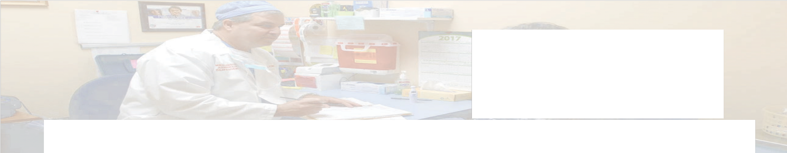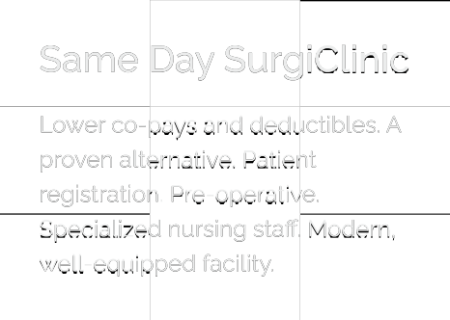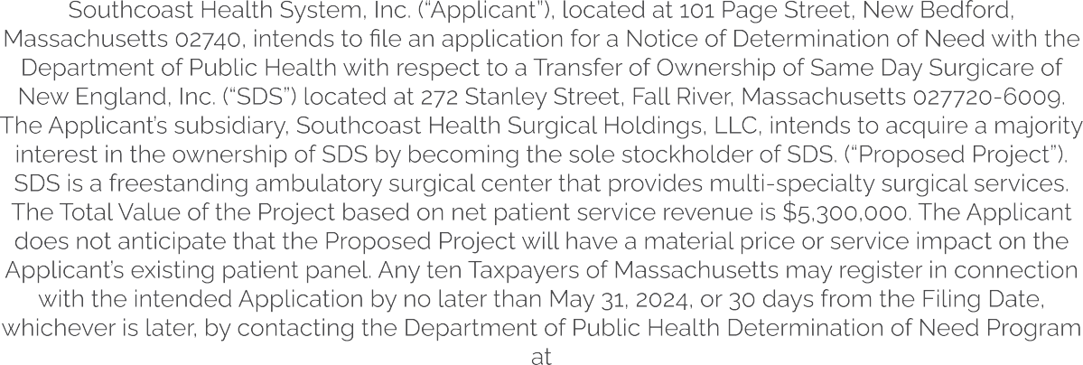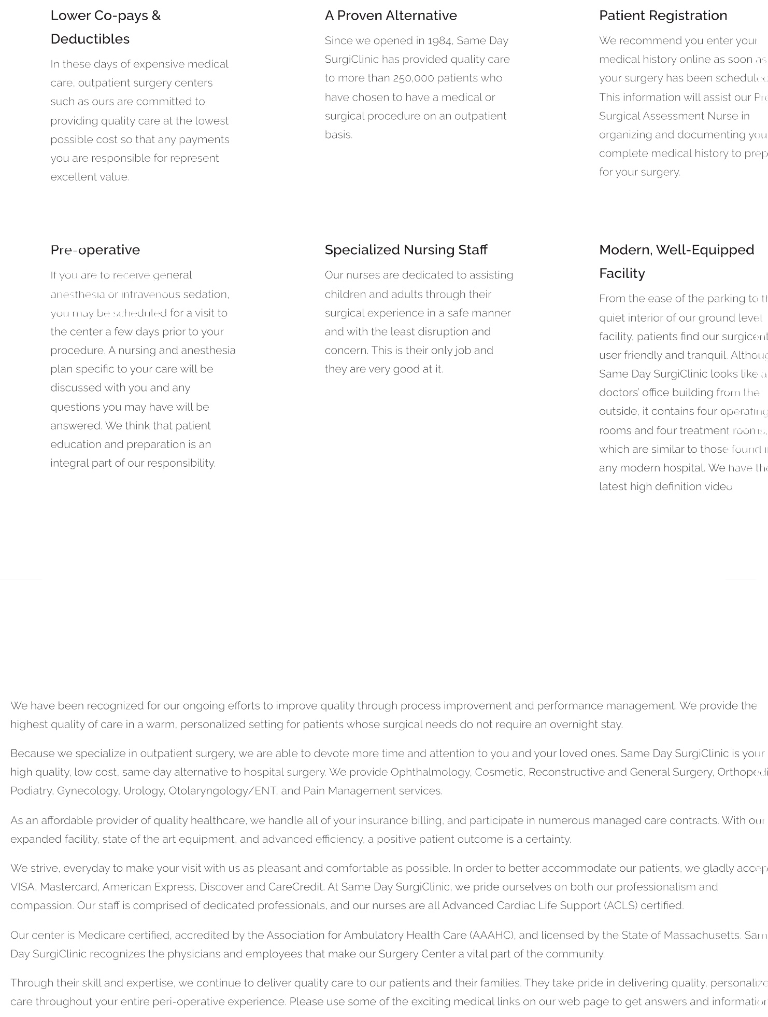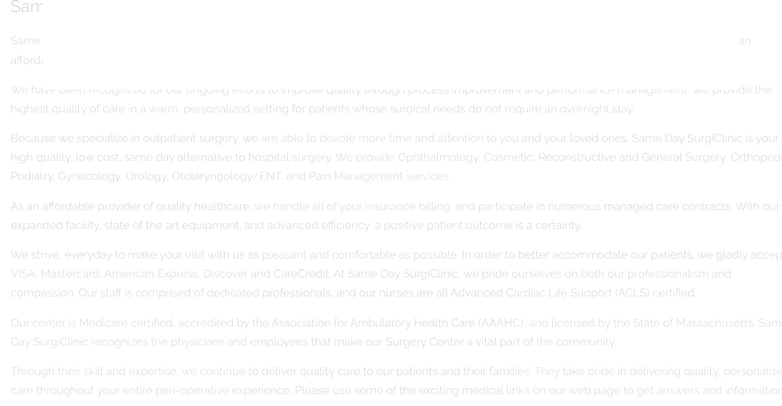

P b

A

m

C

g

P p

d

H h C P j









P b

A

m

C

g

P p

d

H h C P j



Home / Southcoast News / News Releases /

**NEWS RELEASES**

**Public Announcement**

**APR 16.** 2024 | BY SOUTHCOAST HEALTH

Public Announcement Concerning a Proposed Health Care Project

Southcoast Health System, Inc. (“Applicant”), located at 101 Page Street, New Bedford, Massachusetts 02740, intends to file an application for a Notice of Determination of Need with the Department of Public Health with respect to a Transfer of Ownership of Same Day Surgicare of New England, Inc. (“SDS”) located at 272 Stanley Street, Fall River, Massachusetts 027720-6009. The Applicant’s subsidiary, Southcoast Health Surgical Holdings, LLC, intends to acquire a majority interest in the ownership of SDS by becoming the sole stockholder of SDS. (“Proposed Project”). SDS is a freestanding ambulatory surgical center that provides multi-specialty surgical services. The Total Value of the Project based on net patient service revenue is

$5,300,000. The Applicant does not anticipate that the Proposed Project will have a material price or service impact on the Applicant’s existing patient panel. Any ten Taxpayers of Massachusetts may register in connection with the intended Application by no later than May 31, 2024, or 30 days from the Filing Date, whichever is later, by contacting the Department of Public Health Determination of Need Program at **Department of Public Health, Attention: Program Director, Determination of Need Program, 67 Forest St., Marlborough, Massachusetts 01752 or** [**DPH.DON@State.MA.US.**](mailto:DPH.DON@State.MA.US)

The Herald News

**Public Notices**

Originally published at [heraldnews.com](http://heraldnews.com) on 04/16/2024

272 Stanley Street, Fall River

LEGAL NOTICE

Public Announcement Concerning a Proposed Health Care Project

Southcoast Health System, Inc. (“Applicant”), located at 101 Page Street, New Bedford, Massachusetts 02740, intends to file an application for a Notice of Determination of Need with the Department of Public Health with respect to a Transfer of Ownership of Same Day Surgicare of New England, Inc. (“SDS”) located at 272 Stanley Street, Fall River, Massachusetts 027720-6009. The Applicant’s subsidiary, Southcoast Health Surgical Holdings, LLC, intends to acquire a majority interest in the ownership of SDS by becoming the sole stockholder of SDS. (“Proposed Project”). SDS is a freestanding ambulatory surgical center that provides multi-specialty surgical services. The Total Value of the Project based on net patient service revenue is $5,300,000. The Applicant does not anticipate that the Proposed Project will have a material price or service impact on the Applicant’s existing patient panel. Any ten Taxpayers of Massachusetts may register in connection with the intended Application by no later than May 31, 2024, or 30 days from the Filing Date, whichever is later, by contacting the Department of Public Health Determination of Need Program at Department of Public Health, Attention: Program Director, Determination of Need Program, 67 Forest St., Marlborough, Massachusetts 01752 or [DPH.DON@State.MA.US](mailto:DPH.DON@State.MA.US).

#10062512   
FRHN 4/16/24

Southcoast Today: The Standard-Times

**Public Notices**

Originally published at [southcoasttoday.com](http://southcoasttoday.com) on 04/16/2024

Public Announcement Concerning a

Proposed Health Care Project

Southcoast Health System, Inc. (“Applicant”), located at 101 Page Street, New Bedford, Massachusetts 02740, intends to file an application for a Notice of Determination of Need with the Department of Public Health with respect to a Transfer of Ownership of Same Day Surgicare of New England, Inc. (“SDS”) located at 272 Stanley Street, Fall River, Massachusetts 027720-6009. The Applicant’s subsidiary, Southcoast Health Surgical Holdings, LLC, intends to acquire a majority interest in the ownership of SDS by becoming the sole stockholder of SDS. (“Proposed Project”). SDS is a freestanding ambulatory surgical center that provides multi-specialty surgical services. The Total Value of the Project based on net patient service revenue is $5,300,000. The Applicant does not anticipate that the Proposed Project will have a material price or service impact on the Applicant’s existing patient panel. Any ten Taxpayers of Massachusetts may register in connection with the intended Application by no later than May 31, 2024, or 30 days from the Filing Date, whichever is later, by contacting the Department of Public Health Determination of Need Program at Department of Public Health, Attention: Program Director, Determination of Need Program, 67 Forest St., Marlborough, Massachusetts 01752 or [DPH.DON@State.MA.US](mailto:DPH.DON@State.MA.US).

4/16/24 10062258

**Exhibit 4. Affidavit of Truthfulness Form**

 Version: 7-6-17

Massachusetts Department of Public Health

Determination of Need

Affidavit of Truthfulness and Compliance

with Law and Disclosure Form 100.405 (B)

**Instructions**: Complete Information below. When complete check the box "This document is ready to print:". This will date stamp and lock the form. Print Form. Each person must sign and date the form. When all signatures have been collected, scan the document and e-mail to: [dph.don@state.ma.us](mailto:dph.don@state.ma.us) Include all attachments as requested.

Application Number: SHS-24050109-TO

Original Application Date: 05/01/2024

Applicant Name: Southcoast Health System, Inc.

Application Type: Transfer of Ownership

Applicant's Business Type: Corporation

Is the Applicant the sole member or sole shareholder of the Health Facility(ies) that are the subject of this Application? Yes

The undersigned certifies under the pains and penalties of perjury:

1. The Applicant is the sole corporate member or sole shareholder of the Health Facility[ies] that are the subject of this Application;
2. I have ~~read~~ [been informed of the contents of] 105 CMR 100.000, the Massachusetts Determination of Need Regulation;
3. I understand and agree to the expected and appropriate conduct of the Applicant pursuant to 105 CMR 100.800;
4. I have read this application for Determination of Need including all exhibits and attachments, and certify that all of the information contained herein is accurate and true;
5. I have submitted the correct Filing Fee and understand it is nonrefundable pursuant to 105 CMR 100.405(B);
6. I have submitted the required copies of this application to the Determination of Need Program, and, as applicable, to all Parties of Record and other parties as required pursuant to 105 CMR 100.405(B);
7. I have caused, as required, notices of intent to be published and duplicate copies to be submitted to all Parties of Record, and all carriers or third-party administrators, public and commercial, for the payment of health care services with which the Applicant contracts, and with Medicare and Medicaid, as required by 105 CMR 100.40S(C), et seq.;
8. I have caused proper notification and submissions to the Secretary of Environmental Affairs pursuant to 105 CMR 100.405(E) and 301 CMR 11.00;
9. If subject to M.G.L.c. 6D, § 13 and 958 CMR 7.00, I have submitted such Notice of Material Change to the HPC - in accordance with 105 CMR 100.405(G);
10. Pursuant to 105 CMR 100.210(A)(3), I certify that both the Applicant and the Proposed Project are in material and substantial compliance and good standing with relevant federal, state, and local laws and regulations, as well as with all ~~previously issued~~ Notices of Determination of Need ~~and the terms and Conditions attached therein~~ [issued in compliance with 105 CMR 100.00, the Massachusetts Determination of Need Regulation effective January 27, 2017];
11. I have read and understand the limitations on solicitation of funding from the general public prior to receiving a Notice of Determination of Need as established in 105 CMR 100.415;
12. I understand that, if Approved, the Applicant, as Holder of the DoN, shall become obligated to all Standard Conditions pursuant to 105 CMR 100.310, as well as any applicable Other Conditions as outlined within 105 CMR 100.000 or that otherwise become a part of the Final Action pursuant to 105 CMR 100.360;
13. Pursuant to 105 CMR 100.705(A),I certify that the Applicant has Sufficient Interest in the Site or facility; and
14. Pursuant to 105 CMR 100.705(A), I certify that the Proposed Project is authorized under applicable zoning by-laws or ordinances, whether or not a special permit is required; or,
    1. If the Proposed Project is not authorized under applicable zoning by-laws or ordinances, a variance has been received to permit such Proposed Project; or,
    2. The Proposed Project is exempt from zoning by-laws or ordinances.

|  |
| --- |
| **Corporation**  Attach a copy of Articles of Organization/Incorporation, as amended  David O. McCready <Signature on File> 4/24/24  CEO for Corporation Name: Signature: Date:  Donald G. Giumetti <Signature on File> 4/24/24  Board Chair for Corporation Name: Signature: Date: |

###### Exhibit 9. Articles of Organization

**Articles of Organization**

Same Day Surgery of New England, Inc.

Restated Articles of Organization (1999): https://corp.sec.state.ma.us/CorpWeb/CorpSearch/CorpSearchRedirector.aspx?Action=PDF&P ath=CORP_DRIVE1/2014/0718/000558736/0029/020503419284_1.pdf

Articles of Amendment (2004): https://corp.sec.state.ma.us/CorpWeb/CorpSearch/CorpSearchRedirector.aspx?Action=PDF&P ath=CORP_DRIVE1/2004/0506/000086984/0015/200471205980_1.pdf

Southcoast Health System, Inc.

Articles of Merger (1996): https://corp.sec.state.ma.us/CorpWeb/CorpSearch/CorpSearchRedirector.aspx?Action=PDF&P ath=CORP_DRIVE1/2013/1011/000486337/0006/020502701588_1.pdf

###### Exhibit 10. Filing Fee

