Appendix 3:

PATIENT PANEL INFORMATION

Appendix 3: Patient Panel Information

The table below provides certain demographic data on the patient panel for the Proposed Project Site. This table includes information on Boston Medical Center’s patients who reside in the Primary Service Area (“PSA”) and sought diagnostic imaging services at the hospital from fiscal year (“FY”) 2022 through year-to-date FY2025.

 | Combined Scans (MRI and CT) FY22 | Combined Scans (MRI and CT) FY23 | Combined Scans (MRI and CT) FY24 | Combined Scans (MRI and CT) FY25 YTD | Visits/Discharges FY 22 | Visits/Discharges FY 23 |  | Visits/Discharges FY 24 | Visits/Discharges FY 25 YTD |  | Unique Patients FY22 | Unique Patients FY23 | Unique Patients FY24 | Unique Patients FY25 YTD
Gender | FY22 | FY23 | FY24 | FY25 YTD | FY22 | FY23 | FY24 |  |  | FY25 YTD | FY22 | FY23 | FY24 | FY25 YTD
Female | 1,208 | 1,388 | 1,504 | 861 | 878 | 1,086 | 1,103 |  |  | 647 | 619 | 674 | 782 | 498
Male | 1,134 | 1,139 | 1,310 | 729 | 736 | 806 | 913 |  |  | 497 | 483 | 554 | 557 | 343
Unknown/ Unspecified | 0 | 1 | 0 | 1 | 0 | 1 | 0 |  |  | 1 | 0 | 1 | 0 | 1
Total | 2,342 | 2,528 | 2,814 | 1591 | 1614 | 1,893 | 2,016 |  |  | 1145 | 1102 | 1,229 | 1339 | 842
Race/Ethnicity
White/Caucasian | 994 | 858 | 1,006 | 521 | 558 | 615 | 694 |  |  | 357 | 408 | 421 | 454 | 267
Other | 364 | 676 | 872 | 618 | 289 | 542 | 676 |  |  | 449 | 249 | 369 | 475 | 320
Black/African American | 601 | 717 | 614 | 329 | 467 | 516 | 423 |  |  | 233 | 257 | 298 | 303 | 181
Asian | 194 | 193 | 322 | 118 | 151 | 144 | 223 |  |  | 102 | 88 | 82 | 107 | 70
American Indian/Alaska Native | 8 | 4 | 0 | 2 | 7 | 3 | 0 |  |  | 1 | 5 | 3 | 0 | 1
Native Hawaiian/Pacific  Islander | 4 | 2 | 0 | 3 | 3 | 2 | 0 |  |  | 3 | 3 | 2 | 0 | 3
Hispanic/Latino | 177 | 78 | 0 | 0 | 139 | 71 | 0 |  |  | 0 | 92 | 54 | 0 | 0
Total | 2,342 | 2,528 | 2,814 | 1591 | 1614 | 1,893 | 2,016 |  |  | 1145 | 1102 | 1,229 | 1339 | 842

 | Combined Scans (MRI and CT) FY22 | Combined Scans (MRI and CT) FY23 | Combined Scans (MRI and CT) FY24 | Combined Scans (MRI and CT) FY25 YTD | Visits/Discharges FY 22 | Visits/Discharges FY 23 |  | Visits/Discharges FY 24 | Visits/Discharges FY 25 YTD |  | Unique Patients FY22 | Unique Patients FY23 | Unique Patients FY24 | Unique Patients FY25 YTD
Age | FY22 | FY23 | FY24 | FY25 YTD | FY22 | FY23 | FY24 |  |  | FY25 YTD | FY22 | FY23 | FY24 | FY25 YTD
0-17 | 27 | 36 | 63 | 33 | 20 | 31 | 57 |  |  | 29 | 18 | 24 | 52 | 29
18-64 | 1,614 | 1,858 | 1,965 | 1,087 | 1,150 | 1,427 | 1,396 |  |  | 806 | 839 | 939 | 973 | 621
65 and Over | 701 | 634 | 786 | 471 | 444 | 435 | 563 |  |  | 310 | 245 | 266 | 314 | 192
Total | 2,342 | 2,528 | 2,814 | 1,591 | 1,614 | 1,893 | 2,016 |  |  | 1,145 | 1,102 | 1,229 | 1,339 | 842
Payer Mix Percentages | FY22 | FY23 | FY24 | FY25 YTD | FY22 | FY23 | FY24 |  |  | FY25 YTD | FY22 | FY23 | FY24 | FY25 YTD
Mass Health | 24.7% | 34.5% | 29.9% | 27.8% | 28.3% | 37.6% | 31.1% |  |  | 30.1% | 29.5% | 31.2% | 29.8% | 29.7%
Managed Medicaid | 17.8% | 19.5% | 16.2% | 17.4% | 15.4% | 18.1% | 13.7% |  |  | 16.5% | 16.3% | 18.2% | 15.2% | 17.0%
Commercial - Other | 12.5% | 10.0% | 15.7% | 16.2% | 14.4% | 9.8% | 17.1% |  |  | 16.2% | 12.9% | 11.4% | 13.6% | 14.3%
Medicare FFS | 19.9% | 12.1% | 9.6% | 11.4% | 13.2% | 10.2% | 9.6% |  |  | 10.7% | 11.3% | 9.8% | 9.2% | 9.0%
Commercial Medicare | 8.5% | 7.9% | 8.7% | 10.9% | 9.7% | 7.2% | 7.4% |  |  | 8.1% | 7.2% | 7.9% | 7.1% | 8.2%
Commercial - HMO/POS | 6.3% | 5.5% | 8.3% | 6.3% | 7.5% | 6.2% | 9.1% |  |  | 6.5% | 8.7% | 8.1% | 9.7% | 7.3%
Commercial - PPO | 6.1% | 5.8% | 5.2% | 5.9% | 7.2% | 6.9% | 5.6% |  |  | 7.2% | 8.8% | 8.9% | 7.6% | 8.8%
Free Care / HSN | 2.5% | 2.8% | 3.6% | 2.0% | 2.4% | 2.5% | 3.6% |  |  | 2.5% | 2.9% | 2.8% | 4.7% | 3.4%

Appendix 4:
FACTOR 1 MATERIALS COMMUNITY ENGAGEMENT MATERIALS

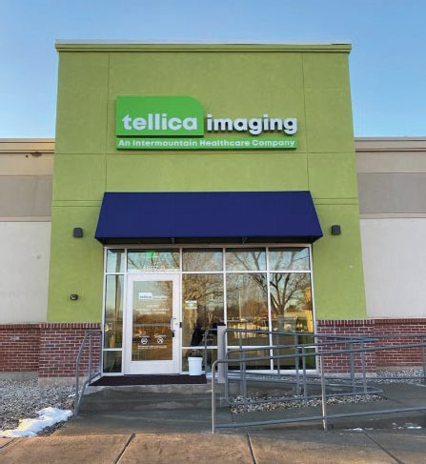



Partnership with Tellica Imaging

May 2024

Executive Summary

- As part of BMC Health System’s (BMCHS) overall strategy, staff are seeking ways to ensure all patients have access to quality imaging services.
- Tellica Imaging (Tellica), a high quality, low cost provider of CT and MRI imaging borne out of Intermountain Health System, approached BMCHS about the possibility of partnering in Massachusetts
  - Tellica is targeting a Northeast expansion due to an expanding population and the need for more imagining services.
- There are opportunities to place sites on the periphery of Boston (including Bedford) based on:
  - Demand among Boston Medical Center patients
  - Market opportunities including:
0 Growing demand – driven by shifts in population on the periphery of Boston.

0 The need for high quality, lower cost imaging services.

2

Site Locations for the Proposed Sites

3

- Properties were selected based on a number of criteria including population growth, the need for imaging services, etc.
- As well as access related factors such as:
ࡳ Parking
ࡳ Access from the highway
ࡳ Configurability

North: 168 Great Road, Bedford, MA “Bedford Marketplace”
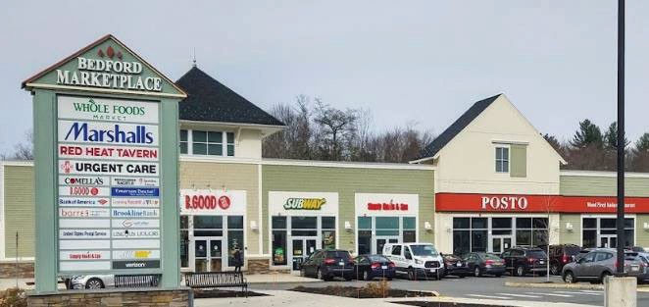

Appendix 8:
HPC ACO Certification Approval Letter


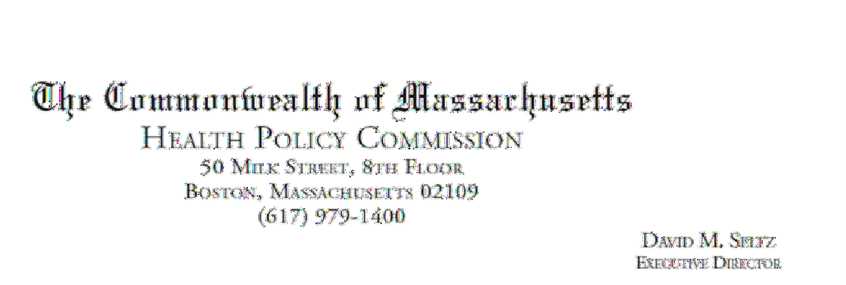

April 12, 2022 Jessica Pagani
BMC Health System, Inc.
1 Boston Medical Center Place Boston, MA 02118

RE: ACO LEAP Certification Dear Mrs. Pagani:
Congratulations! The Health Policy Commission (HPC) is pleased to inform you that BMC Health System, Inc. meets the requirements for ACO Certification under our Learning, Equity, and Patient- Centeredness (LEAP) standards. This certification is effective from January 1, 2022, through December 31, 2023.

The ACO Certification program, in alignment with other state agencies including MassHealth, is designed to accelerate care delivery transformation in Massachusetts and promote a high quality, efficient health system. ACOs participating in the program have met a set of objective criteria focused on core ACO capabilities demonstrating dedication to patient-centered care, use of evidence-based and data-driven strategies to improve care delivery, and commitment to addressing long-standing health inequities. BMC Health System, Inc. meets those criteria.

The HPC will promote BMC Health System, Inc. as a Certified ACO on our website and in our marketing and public materials. Enclosed you will find an ACO Certification logo for your organization to use in accordance with the attached Terms of Use. We hope you will use the logo on promotional materials when you highlight your ACO Certification to your patients, payers, and others.

The HPC looks forward to ongoing engagement with you over the next two years. We intend to follow up shortly to provide an overview and some reflections on what we saw in the Health Equity Responses, a new feature of the ACO Certification application this year, across the cohort of Certified ACOs. We hope your organization will find that information helpful as we all continue to explore ways to improve health equity in the Commonwealth.

Thank you for your dedication to providing accountable, coordinated health care to your patients, and to continued learning and improvement over time. If you have any questions about this letter or the ACO Certification program, please do not hesitate to contact Mike Stanek, Senior Manager, at HPC- Certification@mass.gov or (617) 757-1649.

Best wishes,

[signature on file]

David Seltz Executive Director

Appendix 9: Notice of Intent

Appendix 10:
CERTIFICATE OF FORMATION AND LINK TO MASSACHUSETTS REGISTRATION

CERTIFICATE OF FORMATION OF
Tellica Imaging - Massachusetts, LLC

The undersigned, an authorized natural person, for the purpose of forming a limited liability company under the provisions and subject to the requirements of the Delaware Limited Liability Company Act, hereby certifies that:
FIRST: The name of the limited liability company is Tellica Imaging - Massachusetts, LLC.

SECOND: The address of its registered agent in the State of Delaware is 251 Little Falls Drive, in the City of Wilmington, County of New Castle, Delaware 19808. The name of its registered agent at such address is Corporation Service Company.

~ Signature Page Follows ~

4891-9829-1605v1

~ Signature Page for Certificate of Formation of Tellica Imaging - Massachusetts, LLC ~

Executed on November 29, 2023.

[signature on file]
Authorized Person

Brad Isaacson, President Printed Name

Per instruction from the Department of Public Health, Tellica Imaging - Massachusetts LLC (“Applicant”), is providing a link to the Massachusetts Secretary of State’s website to review its corporate documents for accessibility purposes.

Please use the following link to access the Applicant’s Foreign Limited Liability Company Application for Registration on the Secretary of State’s website: https://corp.sec.state.ma.us/CorpWeb/CorpSearch/CorpSummary.aspx?sysvalue=1y6POgBigWXl_bW1e_6cADG8CXi6dAS7Zv3b57Jiw2M-

Type in the link to a web browser, enter the name: Tellica Imaging - Massachusetts LLC and then click the Search Corporations button.

Appendix 11:
Affidavit of Truthfulness and Compliance

 Version: 7-6-17

Massachusetts Department of Public Health

Determination of Need

Affidavit of Truthfulness and Compliance

with Law and Disclosure Form 100.405 (B)
Instructions: Complete Information below. When complete check the box "This document is ready to print:". This will date stamp and lock the form. Print Form. Each person must sign and date the form. When all signatures have been collected, scan the document and e-mail to: dph.don@state.ma.us Include all attachments as requested.
Application Number: TIM-25041809-RE
Original Application Date: 04/21/2025
Applicant Name: Tellica Imaging – Massachusetts, LLC
Application Type: DoN-Required Equipment
Applicant's Business Type: LLC
Is the Applicant the sole member or sole shareholder of the Health Facility(ies) that are the subject of this Application? No
Describe the role /relationship: Members: Tellica Imaging, LLC with a 51% interest and BMC Health System, Inc. with a 49% interest.
The undersigned certifies under the pains and penalties of perjury:
- The Applicant is the sole corporate member or sole shareholder of the Health Facility(ies) that are the subject of this Application;
- I have read [been informed of the contents of] 105 CMR 100.000, the Massachusetts Determination of Need Regulation;
- I understand and agree to the expected and appropriate conduct of the Applicant pursuant to 105 CMR 100.800;
- I have read [been informed of the contents of] this application for Determination of Need including all exhibits and attachments, and certify that [have been informed that] all of the information contained herein is accurate and true;
- I have submitted the correct Filing Fee and understand it is nonrefundable pursuant to 105 CMR 100.405(B);
- I have submitted the required copies of this application to the Determination of Need Program, and, as applicable, to all Parties of Record and other parties as required pursuant to 105 CMR 100.405(B);
- I have caused, as required, notices of intent to be published and duplicate copies to be submitted to all Parties of Record, and all carriers or third-party administrators, public and commercial, for the payment of health care services with which the Applicant contracts, and with Medicare and Medicaid, as required by 105 CMR 100.405(C), et seq.;
- I have caused [have been informed that] proper notification and submissions to the Secretary of Environmental Affairs pursuant to 105 CMR 100.405(E) and 301 CMR 11.00; will be made, if applicable.
- If subject to M.G.L. c. 6D, § 13 and 958 CMR 7.00, I have submitted such Notice of Material Change to the HPC - in accordance with 105 CMR 100.405(G);
- Pursuant to 105 CMR 100.210(A)(3), I certify that both the Applicant and the Proposed Project are in material and substantial compliance and good standing with relevant federal, state, and local laws and regulations, as well as with all previously issued Notices of Determination of Need and the terms and Conditions attached therein [issued in compliance with 105 CMR 100.00, the Massachusetts Determination of Need Regulation effective January 27, 2017 and amended December 28, 2018];
- I have read [been informed of the contents of] and understand the limitations on solicitation of funding from the general public prior to receiving a Notice of Determination of Need as established in 105 CMR 100.415;
- I understand that, if Approved, the Applicant, as Holder of the DoN, shall become obligated to all Standard Conditions pursuant to 105 CMR 100.310, as well as any applicable Other Conditions as outlined within 105 CMR 100.000 or that otherwise become a part of the Final Action pursuant to 105 CMR 100.360;
- Pursuant to 105 CMR 100.705(A), I certify that the Applicant has Sufficient Interest in the Site or facility; and
- Pursuant to 105 CMR 100.705(A), I certify that the Proposed Project is authorized under applicable zoning by-laws or ordinances, whether or not a special permit is required; or,
  - If the Proposed Project is not authorized under applicable zoning by-laws or ordinances, a variance has been received to permit such Proposed Project; or,
  - The Proposed Project is exempt from zoning by-laws or ordinances.
LLC
All parties must sign. Add additional names as needed.

Brad Isaacson <Signature on File> 27 Feb 2025
Name: Signature: Date:

This document is ready to print: check Date/time Stamp: 02/24/2025 10:12am

Version: 7-6-17

Massachusetts Department of Public Health

Determination of Need

Affidavit of Truthfulness and Compliance

with Law and Disclosure Form 100.405 (B)
Instructions: Complete Information below. When complete check the box "This document is ready to print:". This will date stamp and lock the form. Print Form. Each person must sign and date the form. When all signatures have been collected, scan the document and e-mail to: dph.don@state.ma.us Include all attachments as requested.
Application Number: TIM-25041809-RE
Original Application Date: 04/21/2025
Applicant Name: Tellica Imaging – Massachusetts, LLC
Application Type: DoN-Required Equipment
Applicant's Business Type: LLC
Is the Applicant the sole member or sole shareholder of the Health Facility(ies) that are the subject of this Application? No
Describe the role /relationship: Members: Tellica Imaging, LLC with a 51% interest and BMC Health System, Inc. with a 49% interest.
The undersigned certifies under the pains and penalties of perjury:
- The Applicant is the sole corporate member or sole shareholder of the Health Facility(ies) that are the subject of this Application;
- I have read [been informed of the contents of] 105 CMR 100.000, the Massachusetts Determination of Need Regulation;
- I understand and agree to the expected and appropriate conduct of the Applicant pursuant to 105 CMR 100.800;
- I have read [been informed of the contents of] this application for Determination of Need including all exhibits and attachments, and certify that [have been informed that] all of the information contained herein is accurate and true;
- I have submitted the correct Filing Fee and understand it is nonrefundable pursuant to 105 CMR 100.405(B);
- I have submitted the required copies of this application to the Determination of Need Program, and, as applicable, to all Parties of Record and other parties as required pursuant to 105 CMR 100.405(B);
- I have caused, as required, notices of intent to be published and duplicate copies to be submitted to all Parties of Record, and all carriers or third-party administrators, public and commercial, for the payment of health care services with which the Applicant contracts, and with Medicare and Medicaid, as required by 105 CMR 100.405(C), et seq.;
- I have caused [have been informed that] proper notification and submissions to the Secretary of Environmental Affairs pursuant to 105 CMR 100.405(E) and 301 CMR 11.00; will be made, if applicable.
- If subject to M.G.L. c. 6D, § 13 and 958 CMR 7.00, I have submitted such Notice of Material Change to the HPC - in accordance with 105 CMR 100.405(G);
- Pursuant to 105 CMR 100.210(A)(3), I certify that both the Applicant and the Proposed Project are in material and substantial compliance and good standing with relevant federal, state, and local laws and regulations, as well as with all previously issued Notices of Determination of Need and the terms and Conditions attached therein [issued in compliance with 105 CMR 100.00, the Massachusetts Determination of Need Regulation effective January 27, 2017 and amended December 28, 2018];
- I have read [been informed of the contents of] and understand the limitations on solicitation of funding from the general public prior to receiving a Notice of Determination of Need as established in 105 CMR 100.415;
- I understand that, if Approved, the Applicant, as Holder of the DoN, shall become obligated to all Standard Conditions pursuant to 105 CMR 100.310, as well as any applicable Other Conditions as outlined within 105 CMR 100.000 or that otherwise become a part of the Final Action pursuant to 105 CMR 100.360;
- Pursuant to 105 CMR 100.705(A), I certify that the Applicant has Sufficient Interest in the Site or facility; and
- Pursuant to 105 CMR 100.705(A), I certify that the Proposed Project is authorized under applicable zoning by-laws or ordinances, whether or not a special permit is required; or,
  - If the Proposed Project is not authorized under applicable zoning by-laws or ordinances, a variance has been received to permit such Proposed Project; or,
  - The Proposed Project is exempt from zoning by-laws or ordinances.
LLC
All parties must sign. Add additional names as needed.

Eric Liston <Signature on File> 2/27/2025
Name: Signature: Date:

This document is ready to print: check Date/time Stamp: 02/24/2025 10:12am

Version: 7-6-17

Massachusetts Department of Public Health

Determination of Need

Affidavit of Truthfulness and Compliance

with Law and Disclosure Form 100.405 (B)
Instructions: Complete Information below. When complete check the box "This document is ready to print:". This will date stamp and lock the form. Print Form. Each person must sign and date the form. When all signatures have been collected, scan the document and e-mail to: dph.don@state.ma.us Include all attachments as requested.
Application Number: TIM-25041809-RE
Original Application Date: 04/21/2025
Applicant Name: Tellica Imaging – Massachusetts, LLC
Application Type: DoN-Required Equipment
Applicant's Business Type: LLC
Is the Applicant the sole member or sole shareholder of the Health Facility(ies) that are the subject of this Application? No
Describe the role /relationship: Members: Tellica Imaging, LLC with a 51% interest and BMC Health System, Inc. with a 49% interest.
The undersigned certifies under the pains and penalties of perjury:
- The Applicant is the sole corporate member or sole shareholder of the Health Facility(ies) that are the subject of this Application;
- I have read [been informed of the contents of] 105 CMR 100.000, the Massachusetts Determination of Need Regulation;
- I understand and agree to the expected and appropriate conduct of the Applicant pursuant to 105 CMR 100.800;
- I have read [been informed of the contents of] this application for Determination of Need including all exhibits and attachments, and certify that [have been informed that] all of the information contained herein is accurate and true;
- I have submitted the correct Filing Fee and understand it is nonrefundable pursuant to 105 CMR 100.405(B);
- I have submitted the required copies of this application to the Determination of Need Program, and, as applicable, to all Parties of Record and other parties as required pursuant to 105 CMR 100.405(B);
- I have caused, as required, notices of intent to be published and duplicate copies to be submitted to all Parties of Record, and all carriers or third-party administrators, public and commercial, for the payment of health care services with which the Applicant contracts, and with Medicare and Medicaid, as required by 105 CMR 100.405(C), et seq.;
- I have caused [have been informed that] proper notification and submissions to the Secretary of Environmental Affairs pursuant to 105 CMR 100.405(E) and 301 CMR 11.00; will be made, if applicable.
- If subject to M.G.L. c. 6D, § 13 and 958 CMR 7.00, I have submitted such Notice of Material Change to the HPC - in accordance with 105 CMR 100.405(G);
- Pursuant to 105 CMR 100.210(A)(3), I certify that both the Applicant and the Proposed Project are in material and substantial compliance and good standing with relevant federal, state, and local laws and regulations, as well as with all previously issued Notices of Determination of Need and the terms and Conditions attached therein [issued in compliance with 105 CMR 100.00, the Massachusetts Determination of Need Regulation effective January 27, 2017 and amended December 28, 2018];
- I have read [been informed of the contents of] and understand the limitations on solicitation of funding from the general public prior to receiving a Notice of Determination of Need as established in 105 CMR 100.415;
- I understand that, if Approved, the Applicant, as Holder of the DoN, shall become obligated to all Standard Conditions pursuant to 105 CMR 100.310, as well as any applicable Other Conditions as outlined within 105 CMR 100.000 or that otherwise become a part of the Final Action pursuant to 105 CMR 100.360;
- Pursuant to 105 CMR 100.705(A), I certify that the Applicant has Sufficient Interest in the Site or facility; and
- Pursuant to 105 CMR 100.705(A), I certify that the Proposed Project is authorized under applicable zoning by-laws or ordinances, whether or not a special permit is required; or,
  - If the Proposed Project is not authorized under applicable zoning by-laws or ordinances, a variance has been received to permit such Proposed Project; or,
  - The Proposed Project is exempt from zoning by-laws or ordinances.
LLC
All parties must sign. Add additional names as needed.

Doug Greally <Signature on File> 2/27/25
Name: Signature: Date:

This document is ready to print: check Date/time Stamp: 02/24/2025 10:12am

Version: 7-6-17

Massachusetts Department of Public Health

Determination of Need

Affidavit of Truthfulness and Compliance

with Law and Disclosure Form 100.405 (B)
Instructions: Complete Information below. When complete check the box "This document is ready to print:". This will date stamp and lock the form. Print Form. Each person must sign and date the form. When all signatures have been collected, scan the document and e-mail to: dph.don@state.ma.us Include all attachments as requested.
Application Number: TIM-25041809-RE
Original Application Date: 04/21/2025
Applicant Name: Tellica Imaging – Massachusetts, LLC
Application Type: DoN-Required Equipment
Applicant's Business Type: LLC
Is the Applicant the sole member or sole shareholder of the Health Facility(ies) that are the subject of this Application? No
Describe the role /relationship: Members: Tellica Imaging, LLC with a 51% interest and BMC Health System, Inc. with a 49% interest.
The undersigned certifies under the pains and penalties of perjury:
- The Applicant is the sole corporate member or sole shareholder of the Health Facility(ies) that are the subject of this Application;
- I have read [been informed of the contents of] 105 CMR 100.000, the Massachusetts Determination of Need Regulation;
- I understand and agree to the expected and appropriate conduct of the Applicant pursuant to 105 CMR 100.800;
- I have read [been informed of the contents of] this application for Determination of Need including all exhibits and attachments, and certify that [have been informed that] all of the information contained herein is accurate and true;
- I have submitted the correct Filing Fee and understand it is nonrefundable pursuant to 105 CMR 100.405(B);
- I have submitted the required copies of this application to the Determination of Need Program, and, as applicable, to all Parties of Record and other parties as required pursuant to 105 CMR 100.405(B);
- I have caused, as required, notices of intent to be published and duplicate copies to be submitted to all Parties of Record, and all carriers or third-party administrators, public and commercial, for the payment of health care services with which the Applicant contracts, and with Medicare and Medicaid, as required by 105 CMR 100.405(C), et seq.;
- I have caused [have been informed that] proper notification and submissions to the Secretary of Environmental Affairs pursuant to 105 CMR 100.405(E) and 301 CMR 11.00; will be made, if applicable.
- If subject to M.G.L. c. 6D, § 13 and 958 CMR 7.00, I have submitted such Notice of Material Change to the HPC - in accordance with 105 CMR 100.405(G);
- Pursuant to 105 CMR 100.210(A)(3), I certify that both the Applicant and the Proposed Project are in material and substantial compliance and good standing with relevant federal, state, and local laws and regulations, as well as with all previously issued Notices of Determination of Need and the terms and Conditions attached therein [issued in compliance with 105 CMR 100.00, the Massachusetts Determination of Need Regulation effective January 27, 2017 and amended December 28, 2018];
- I have read [been informed of the contents of] and understand the limitations on solicitation of funding from the general public prior to receiving a Notice of Determination of Need as established in 105 CMR 100.415;
- I understand that, if Approved, the Applicant, as Holder of the DoN, shall become obligated to all Standard Conditions pursuant to 105 CMR 100.310, as well as any applicable Other Conditions as outlined within 105 CMR 100.000 or that otherwise become a part of the Final Action pursuant to 105 CMR 100.360;
- Pursuant to 105 CMR 100.705(A), I certify that the Applicant has Sufficient Interest in the Site or facility; and
- Pursuant to 105 CMR 100.705(A), I certify that the Proposed Project is authorized under applicable zoning by-laws or ordinances, whether or not a special permit is required; or,
  - If the Proposed Project is not authorized under applicable zoning by-laws or ordinances, a variance has been received to permit such Proposed Project; or,
  - The Proposed Project is exempt from zoning by-laws or ordinances.
LLC
All parties must sign. Add additional names as needed.

Ankur Agrawal <Signature on File> 02/27/25
Name: Signature: Date:

This document is ready to print: check Date/time Stamp: 02/24/2025 10:12am

Version: 7-6-17

Massachusetts Department of Public Health

Determination of Need

Affidavit of Truthfulness and Compliance

with Law and Disclosure Form 100.405 (B)
Instructions: Complete Information below. When complete check the box "This document is ready to print:". This will date stamp and lock the form. Print Form. Each person must sign and date the form. When all signatures have been collected, scan the document and e-mail to: dph.don@state.ma.us Include all attachments as requested.
Application Number: TIM-25041809-RE
Original Application Date: 04/21/2025
Applicant Name: Tellica Imaging – Massachusetts, LLC
Application Type: DoN-Required Equipment
Applicant's Business Type: LLC
Is the Applicant the sole member or sole shareholder of the Health Facility(ies) that are the subject of this Application? No
Describe the role /relationship: Members: Tellica Imaging, LLC with a 51% interest and BMC Health System, Inc. with a 49% interest.
The undersigned certifies under the pains and penalties of perjury:
- The Applicant is the sole corporate member or sole shareholder of the Health Facility(ies) that are the subject of this Application;
- I have read [been informed of the contents of] 105 CMR 100.000, the Massachusetts Determination of Need Regulation;
- I understand and agree to the expected and appropriate conduct of the Applicant pursuant to 105 CMR 100.800;
- I have read [been informed of the contents of] this application for Determination of Need including all exhibits and attachments, and certify that [have been informed that] all of the information contained herein is accurate and true;
- I have submitted the correct Filing Fee and understand it is nonrefundable pursuant to 105 CMR 100.405(B);
- I have submitted the required copies of this application to the Determination of Need Program, and, as applicable, to all Parties of Record and other parties as required pursuant to 105 CMR 100.405(B);
- I have caused, as required, notices of intent to be published and duplicate copies to be submitted to all Parties of Record, and all carriers or third-party administrators, public and commercial, for the payment of health care services with which the Applicant contracts, and with Medicare and Medicaid, as required by 105 CMR 100.405(C), et seq.;
- I have caused [have been informed that] proper notification and submissions to the Secretary of Environmental Affairs pursuant to 105 CMR 100.405(E) and 301 CMR 11.00; will be made, if applicable.
- If subject to M.G.L. c. 6D, § 13 and 958 CMR 7.00, I have submitted such Notice of Material Change to the HPC - in accordance with 105 CMR 100.405(G);
- Pursuant to 105 CMR 100.210(A)(3), I certify that both the Applicant and the Proposed Project are in material and substantial compliance and good standing with relevant federal, state, and local laws and regulations, as well as with all previously issued Notices of Determination of Need and the terms and Conditions attached therein [issued in compliance with 105 CMR 100.00, the Massachusetts Determination of Need Regulation effective January 27, 2017 and amended December 28, 2018];
- I have read [been informed of the contents of] and understand the limitations on solicitation of funding from the general public prior to receiving a Notice of Determination of Need as established in 105 CMR 100.415;
- I understand that, if Approved, the Applicant, as Holder of the DoN, shall become obligated to all Standard Conditions pursuant to 105 CMR 100.310, as well as any applicable Other Conditions as outlined within 105 CMR 100.000 or that otherwise become a part of the Final Action pursuant to 105 CMR 100.360;
- Pursuant to 105 CMR 100.705(A), I certify that the Applicant has Sufficient Interest in the Site or facility; and
- Pursuant to 105 CMR 100.705(A), I certify that the Proposed Project is authorized under applicable zoning by-laws or ordinances, whether or not a special permit is required; or,
  - If the Proposed Project is not authorized under applicable zoning by-laws or ordinances, a variance has been received to permit such Proposed Project; or,
  - The Proposed Project is exempt from zoning by-laws or ordinances.
LLC
All parties must sign. Add additional names as needed.

Josh Latson <Signature on File> 2/28/25
Name: Signature: Date:

Appendix 12: Scanned Copy of Filing Fee

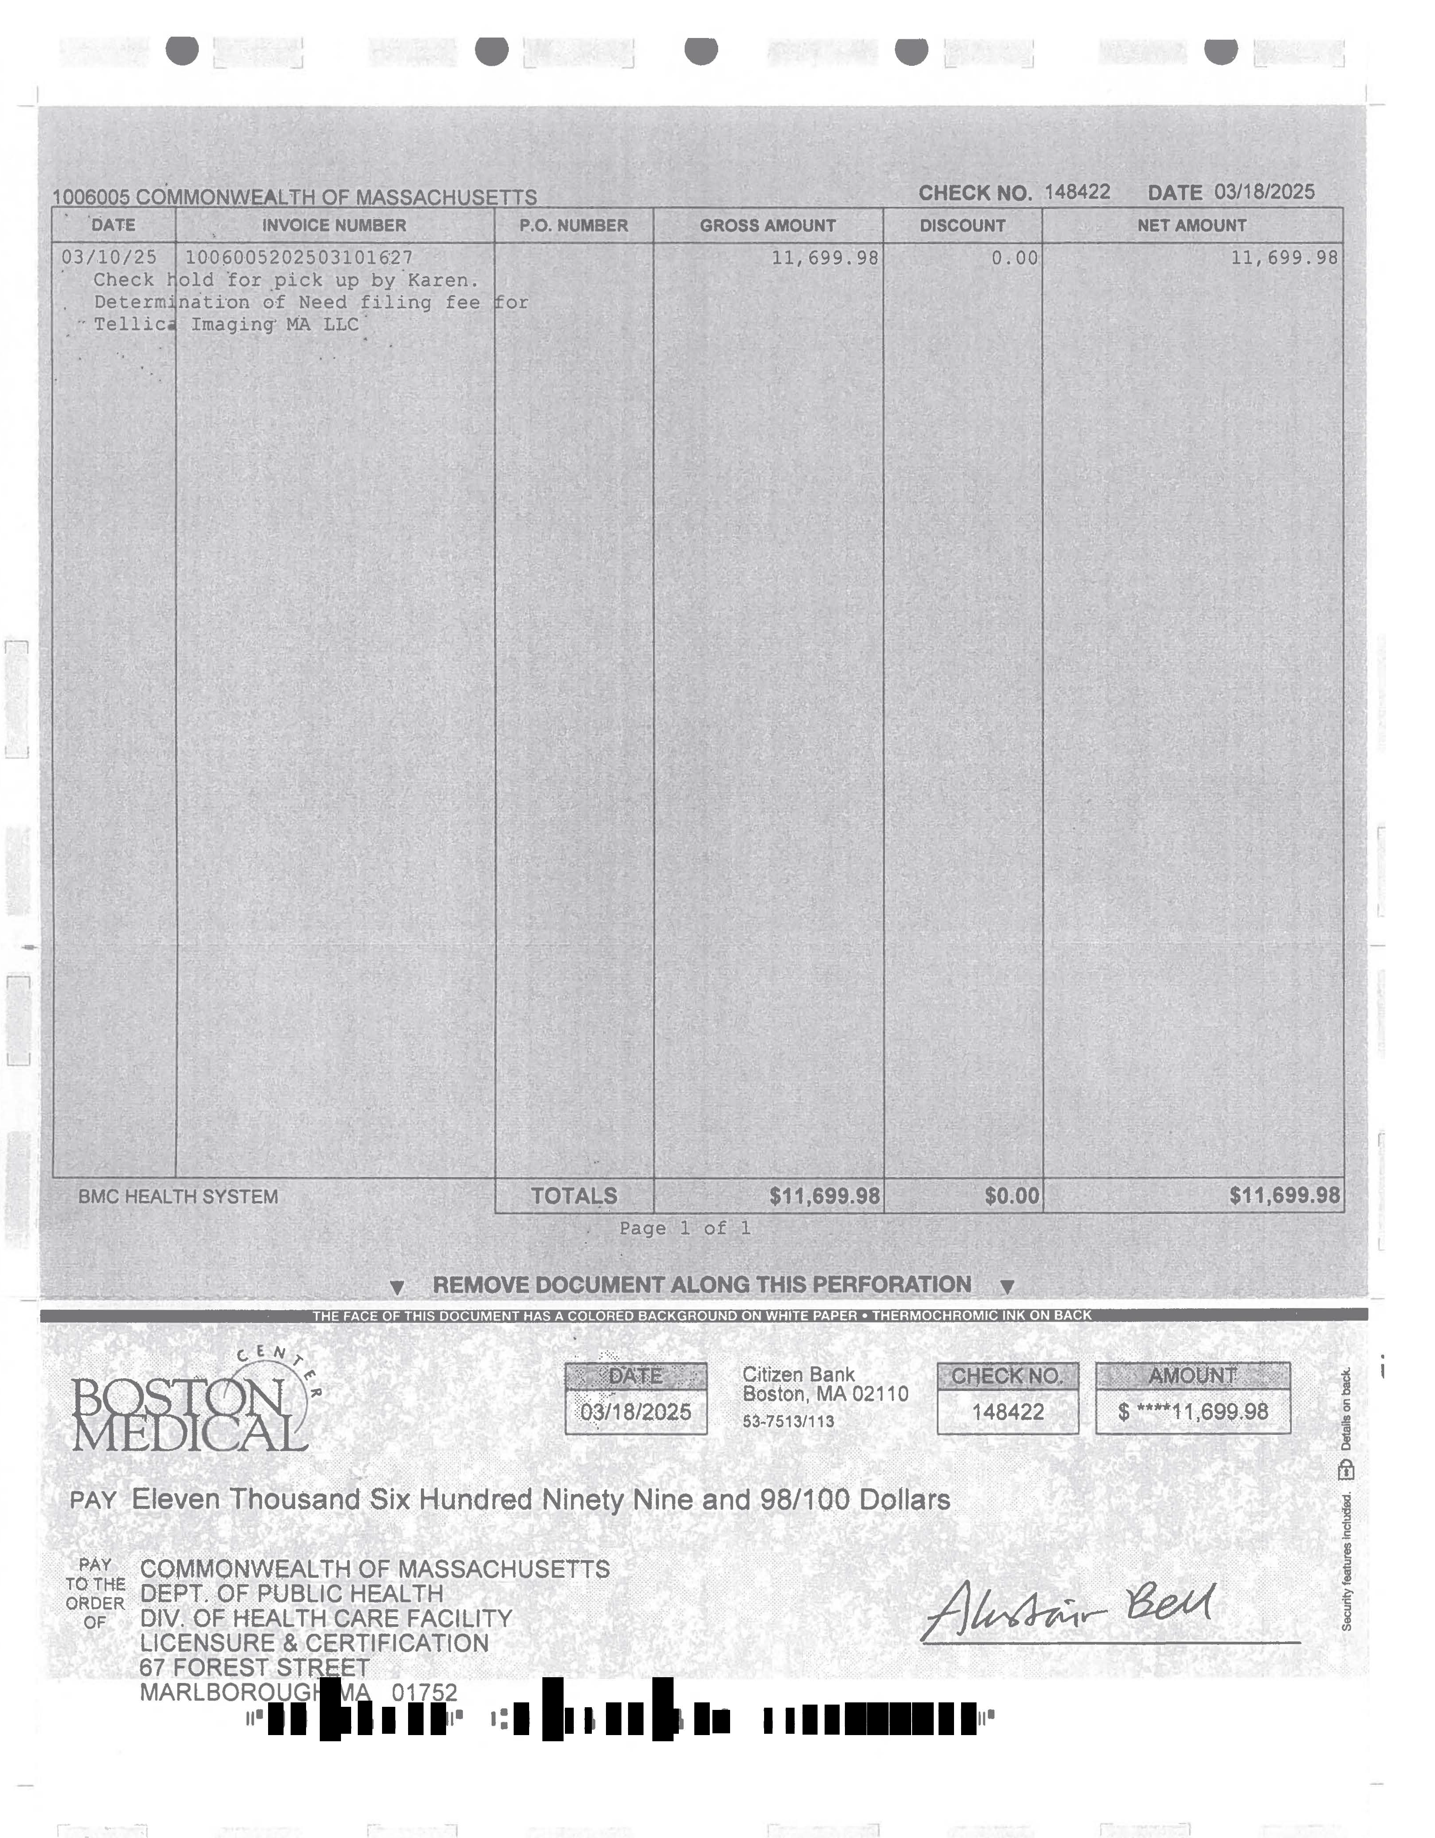

Year-to-date 2025 data encompass through March 2025.
For the Payer Mix, percentages of the population are outlined by payer.

