Children’s Hospital Corporation
Don Application # BCH-23082615-CH
Exhibits

Health Care Conservation Project
Boston Children’s Hospital
September 14, 2023

Submitted By

Children’s Hospital Corporation
300 Longwood Avenue
Boston, MA 02115

Children’s Hospital Corporation
DoN Application: Health Care Conservation Project
September 14, 2023

Table of Contents:
Exhibit 1: Cover Letter
Exhibit 2: Project Description
Exhibit 3: Notice of Intent
Exhibit 4: Affidavit of Truthfulness Form
Exhibit 5: Scanned Copy of Application Fee Check
Exhibit 6: Affiliated Parties table Question 1.9
Exhibit 7: Change in Service Tables Questions 2.2 and 2.3
Exhibit 8: Certification from an Independent Certified Public Accountant
Exhibit 9: Articles of Organization/Trust Agreement
Exhibit 10: Current IRS Form, 990 Schedule H CHNA/CHIP

Exhibit 1: Cover Letter

September 14, 2023

By E-mail and First Class mail

Richard Goldstein, M.D.
Commissioner
Department of Public Health
250 Washington St.
Boston, MA 02108

Health Care Conservation Project
Determination of Need
Boston Children’s Hospital
Project Number BCH-23082615-CH

Dear Dr. Goldstein:

On behalf of Children’s Hospital Corporation, I am submitting a Determination of Need application for a proposed Health Care Conservation Project. The application was submitted online and the attachments were emailed according to the instructions. Attached to this letter, please find the check for the application fees.

Please note, there are no forms or information attached regarding the Community Engagement “Self-Assessment Form” or the “Stakeholder Assessment Form”. Both documents are listed in the documentation checklist as required documents to include with the conservation application. However, pursuant to the DoN Community Engagement Guidelines, those forms are only required when an applicant is required to complete the Health Priorities (Factor 2) requirements. Pursuant to the DoN regulations, a conservation application is not required to complete Factor 2. As a result, it is not possible for these forms to be completed and are not included with this application.

Please feel free to contact me at 617-355-2683 with any questions regarding the application.

Sincerely,

Donna M. Casey
Senior Vice President, Strategic Business Planning
Boston Children’s Hospital
Donna.Casey@childrens.harvard.edu
Exhibit 2: Project Description
Project Description

The Children’s Medical Center Corporation (“Applicant”), located at 300 Longwood Avenue, Boston, MA 02115 is filing a Notice of Determination of Need (“Application”) with the Massachusetts Department of Public Health for its facility The Children’s Hospital Corporation (d/b/a/ Boston Children’s Hospital or “hospital”), a Massachusetts charitable corporation, for projects that meet the definition of a Conservation Project. The Hospital engages in the delivery of pediatric care, research, training and community service. The Hospital’s clinicians deliver care throughout an owned network of licensed facilities, as well as staffing partnerships with affiliated providers in the community. This Application includes projects that will impact those areas under the Hospital licensure located at the main campus (“Longwood Campus”) as well as our Lexington, Peabody, North Dartmouth and Waltham satellite locations. The Longwood campus includes inpatient, outpatient, research and administrative space and serves approximately 21,669 discharges and 387,000 outpatient visits, annually. The Waltham campus includes surgical inpatient beds supported by six operating rooms and additional outpatient specialty services. The Waltham campus serves approximately 843 discharges and 129,000 outpatient visits, annually. The Lexington and Peabody campuses includes outpatient specialty services and annually serves approximately 23,200 and 35,600 outpatient visits, respectively.

The projects included in this Application are designed to keep the licensed hospital space in good working order. The maximum capital expenditure for this conservation application is $26,498,000. Specifically, the projects are intended to sustain and restore facility components that include the following areas:

- Sterile Processing ($9,956,000)
- Building Restoration ($9,560,000)
- Radiology ($6,235,000)
- Various Outpatient Areas ($747,000)

Sterile Processing

The Sterile Processing Department (SPD) is the area in the hospital where cleaning and sterilization of devices used in medical procedures takes place. Instruments are decontaminated, cleaned, disinfected, and sterilized. Once sterilized, the instrument is placed in storage until needed again for a procedure.

The proposed project will include a 2,440 SF+ renovation of existing Level 2 Sterile Processing Department in Waltham. The renovation will include the removal of existing SPD equipment including washers, sterilizers and decontamination sinks. Removal and replacement of existing Clean and Soiled) Dumb-Waiters, within existing shafts will also be included in scope. In addition, the Decontamination and Sub Sterile rooms will be reconfigured to optimize work flow. The Trash room will be repurposed for new MEP risers. The reconfiguration will include all required demolition followed by new walls, architectural finishes, electrical, lighting, mechanical, and plumbing and fire protection systems required for reconfigured Decontamination, Sub-Sterile spaces, and new SPD equipment. The Project will be completed in two phases; an enabling phase in which infrastructure will be provided to a temporary SPD trailer, and to relocated scope washers on Level 3. The second phase will be the primary scope of work on Level 2 as described above.
These renovations will enable the replacement of the equipment that is at or past the intended life expectancy and is frequently out of service for repairs. Specifically,
- The life expectancy of the sterilizers is roughly 15,000 cycles, and a recent recording of the cycle count for the two sterilizers onsite are 17,290 and 20,082 cycles.
- Most washers are designed to perform for 8-10 years. Older washers use a larger amount of water (up to 98.8 gallons per cycle), while new washers use approximately 35.5 gallons. Over the course of a year, based on 10 cycles per day, new washers could save approximately 165,000 gallons of water. New washers also allow for the use of newer, more efficient chemistries for cleaning that are not available with these old washers.
- Older low temperature sterilizers have to run on advanced cycles, with only 1 or 2 items per loads. These cycles are more prone to having cycles fail, requiring rework and wasted supplies. With new machines, we are able to run up to 16 items in a load, with higher reliability and using less consumables.

The intended upgrade will allow for reduced turnaround times, greater safety, and faster, more efficient and reliable services to all departments who require sterile processing to foster the administration of patient care. This will enhance the ability to provide optimal service to patients.

Building Restoration

A small number of children’s hospitals provide highly specialized pediatric care; these regional quaternary care centers comprise the peer group for the Hospital. The following chart provides benchmarking information about the size and physical plant of the Hospital and its peers. The information in the chart demonstrates that the Hospital is older than that of comparable institutions and therefore, requires capital annually to maintain the usefulness of the building and ensure compliance with modern day regulations.

Institution | Beds | Average age of  physical plant (in years)
Boston Children’s Hospital | 485 | 14.7
Children’s Healthcare of Atlanta | 649 | 10.9
Children’s Hospital of Philadelphia | 655 | 11.0
Cincinnati Children’s Hospital Medical Center | 735 | 10.2
Seattle Children’s Hospital | 348 | 7.5
Texas Children’s Hospital | 878 | 12.4
Source: Children’s Hospital Association 2022

Therefore, bi-annually, the Hospital engages in an in-depth evaluation of all major components of its buildings (substructure, superstructure, exterior enclosures, roofing, etc.) considered in the Infrastructure Condition Index (ICI) as defined by the U.S. Department of Commerce. The evaluation produces a series of priority recommendations to guide management of projects that need immediate action to future needs over the next five to ten years. Management uses this information to ensure that funds from the annual capital routine budget are directed to renovation projects with the highest priority in the context of its annual preventive maintenance and renewal of its facilities. Generally, the facilities are showing wear and tear in a variety of areas including walls, floors, ceilings and millwork. These items will be replaced, repaired or modified as required. Heating and AC systems will be replaced with more energy efficient units.
The evaluation of the Longwood campus has demonstrated that $8,060,000 of capital is required for replacement and upgrades to utilities, transformers, air handlers, and facility automation systems.

The evaluation of the Waltham facilities has demonstrated that $500,000 of capital is required for upgrades to roofs, stairwells, hot water systems, sprinklers, flooring, and renewal of the utility substation, replacement of a transformer, and other small projects to maintain the facility.

Finally, the Applicant has a submitted a $1m contingency request to address unforeseen issues that arise during the normal course of business. The Applicant will supply a detailed accounting of any such use of that $1m contingency during the reporting period upon request from the Department of Public Health.

In general, the proposed projects are necessary for the Applicant to comply with either Federal or State regulations or standard upkeep of its facilities.

Radiology Department

The Hospital has a multi-year operational, facility and financial plan to renovate its current radiology suite on both the Longwood, Lexington, Peabody, and North Dartmouth campuses. The plan allows the Hospital to effectively renew its current imaging services as they pass end of life capabilities while allowing for the delivery of care to continue. Any renovation associated with DoN Required Equipment will be submitted separately. The Hospital is including $6,235,000 in architectural and design fees as it continues to develop plans for the future renewal of the imaging suites across the four locations. The architectural and design fees by location are summarized below:

Location | Dollars
Main Campus Radiology | $5,149,000
Lexington Radiology | $118,000
Peabody Radiology | $768,000
North Dartmouth Radiology | $200,000
Total | $6,235,000

Various Outpatient Areas

Boston Children’s continues to expand access to multi-disciplinary integrated outpatient care. The Hospital is evaluating the opportunity to redesign certain spaces in order to create more patient and family centric space within its existing footprint. Renovation projects that exceed the maximum capital allowable threshold will be submitted separately. The Hospital is including $747,000 in architectural and design fees in order to evaluate opportunities for future renewal. The architectural and design fees by location are summarized below:

Location | Dollars
Main Campus | $590,000
Peabody | $157,000
Total | $747,000

Exhibit 3: Notice of Intent

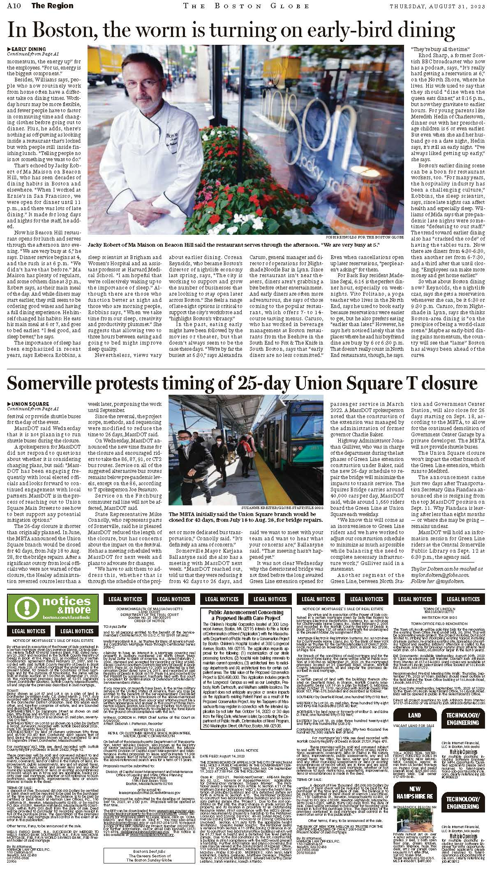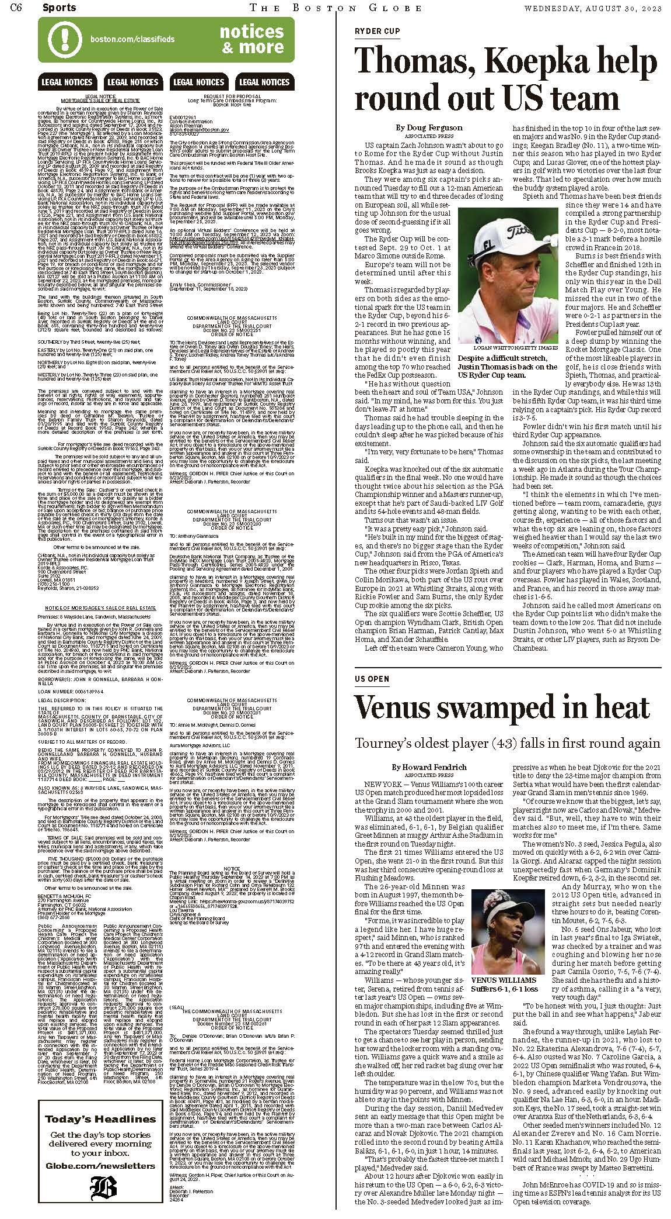
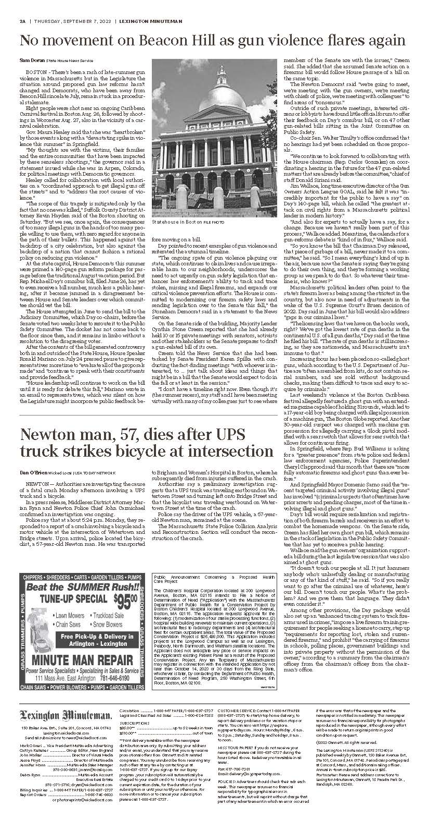
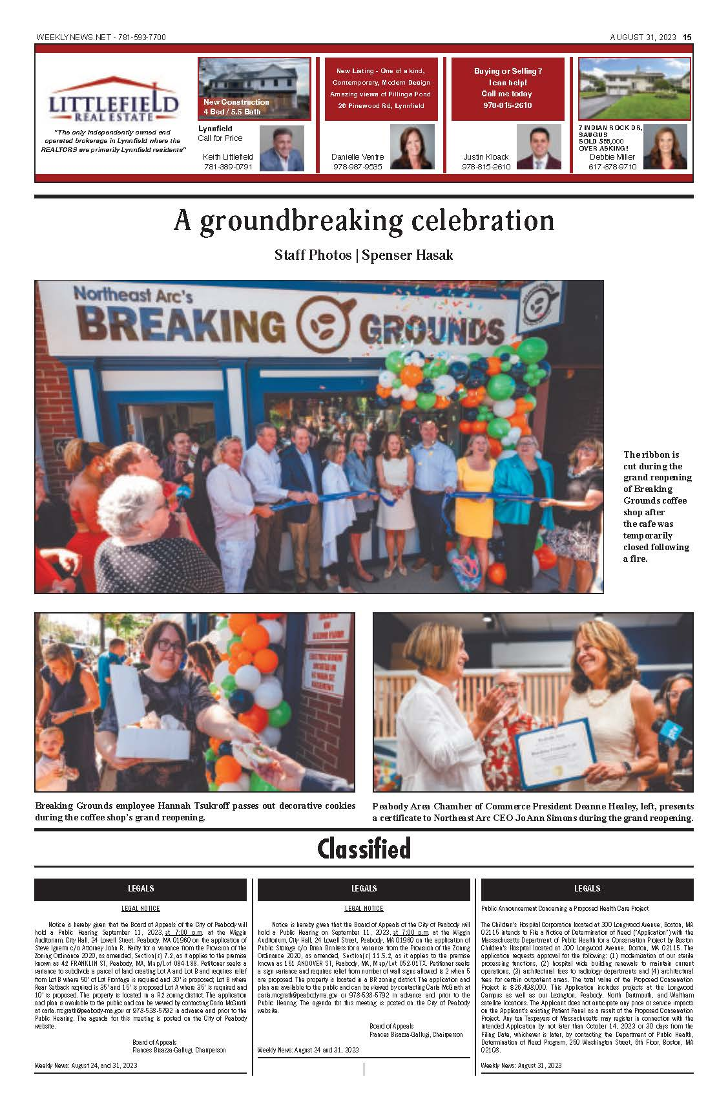
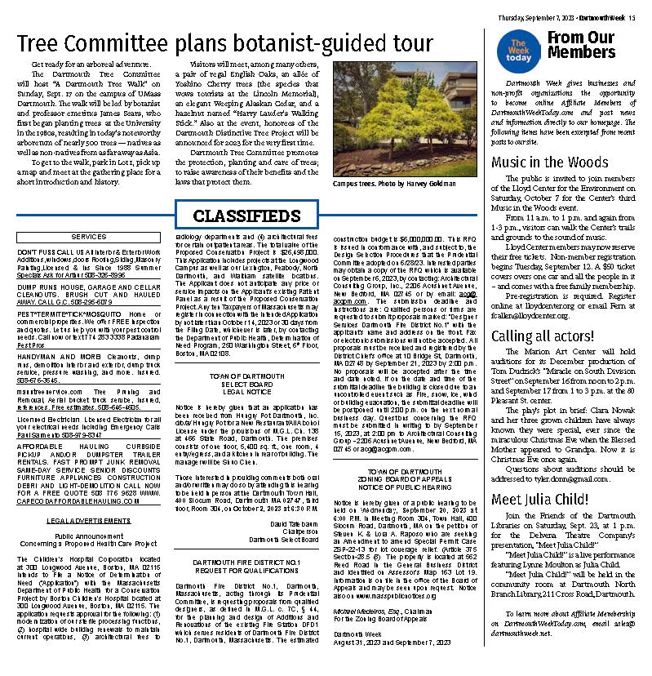

Exhibit 4: Affidavit of Truthfulness Form

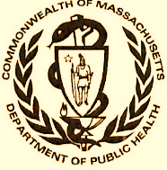 Version: 7-6-17
Massachusetts Department of Public Health

Determination of Need

Affidavit of Truthfulness and Compliance

with Law and Disclosure Form 100.405 (B)
Instructions: Complete Information below. When complete check the box "This document is ready to print:". This will date stamp and lock the form. Print Form. Each person must sign and date the form. When all signatures have been collected, scan the document and e-mail to: dph.don@state.ma.us Include all attachments as requested.
Application Number: BCH-23082615-CH
Original Application Date: 09/14/2023
Applicant Name: The Children’s Medical Center Corporation
Application Type: Conservation Hospital/Clinic Project
Applicant's Business Type: Corporation
Is the Applicant the sole member or sole shareholder of the Health Facility(ies) that are the subject of this Application? Yes
The undersigned certifies under the pains and penalties of perjury:
- The Applicant is the sole corporate member or sole shareholder of the Health Facility(ies) that are the subject of this Application;
- I have been informed of the contents of 105 CMR 100.000, the Massachusetts Determination of Need Regulation;
- I understand and agree to the expected and appropriate conduct of the Applicant pursuant to 105 CMR 100.800;
- I have been informed of the contents of this application for Determination of Need including all exhibits and attachments, and been informed that all of the information contained herein is accurate and true;
- I have submitted the correct Filing Fee and understand it is nonrefundable pursuant to 105 CMR 100.405(B);
- I have submitted the required copies of this application to the Determination of Need Program, and, as applicable, to all Parties of Record and other parties as required pursuant to 105 CMR 100.405(B);
- I have caused, as required, notices of intent to be published and duplicate copies to be submitted to all Parties of Record, and all carriers or third-party administrators, public and commercial, for the payment of health care services with which the Applicant contracts, and with Medicare and Medicaid, as required by 105 CMR 100.405(C), et seq.;
- I have been informed of proper notification and submissions to the Secretary of Environmental Affairs pursuant to 105 CMR 100.405(E) and 301 CMR 11.00; will be made, if applicable.
- If subject to M.G.L. c. 6D, § 13 and 958 CMR 7.00, I have submitted such Notice of Material Change to the HPC - in accordance with 105 CMR 100.405(G);
- Pursuant to 105 CMR 100.210(A)(3), I certify that both the Applicant and the Proposed Project are in material and substantial compliance and good standing with relevant federal, state, and local laws and regulations, as well as with all previously issued Notices of Determination of Need and the terms and Conditions attached therein;
- I have been informed of the contents of and understand the limitations on solicitation of funding from the general public prior to receiving a Notice of Determination of Need as established in 105 CMR 100.415;
- I understand that, if Approved, the Applicant, as Holder of the DoN, shall become obligated to all Standard Conditions pursuant to 105 CMR 100.310, as well as any applicable Other Conditions as outlined within 105 CMR 100.000 or that otherwise become a part of the Final Action pursuant to 105 CMR 100.360;
- Pursuant to 105 CMR 100.705(A), I certify that the Applicant has Sufficient Interest in the Site or facility; and
- Pursuant to 105 CMR 100.705(A), I certify that the Proposed Project is authorized under applicable zoning by-laws or ordinances, whether or not a special permit is required; or,
  - If the Proposed Project is not authorized under applicable zoning by-laws or ordinances, a variance has been received to permit such Proposed Project; or,
  - The Proposed Project is exempt from zoning by-laws or ordinances.

Corporation
Attach a copy of Articles of Organization/Incorporation, as amended

Kevin B. Churchwell <Signature on File> 9/13/2023
CEO for Corporation Name Signature: Date:

Douglas A. Berthlaume <Signature on File> 9/13/2023
Board Chair for Corporation Name Signature: Date:

Exhibit 5: Scanned Copy of Application Fee Check

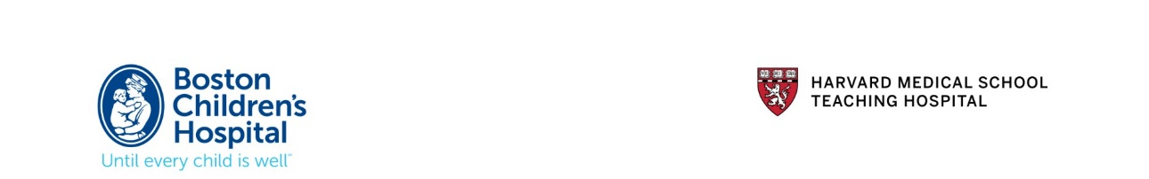

September 14, 2023

By E-mail and First Class mail

Richard Goldstein, M.D.
Commissioner
Department of Public Health
250 Washington St.
Boston, MA 02108

Determination of Need
Boston Children’s Hospital
Project Number: BCH-23082615-CH

Dear Dr. Goldstein:

On behalf of Children’s Hospital Corporation, I am submitting a Determination of Need application for a proposed Health Care Conservation Project. The application was submitted online and the attachments were emailed according to the instructions. Attached to this letter, please find the check for the application fees.

Please note, there are no forms or information attached regarding the Community Engagement “Self-Assessment Form” or the “Stakeholder Assessment Form”. Both documents are listed in the documentation checklist as required documents to include with the conservation application. However, pursuant to the DoN Community Engagement Guidelines, those forms are only required when an applicant is required to complete the Health Priorities (Factor 2) requirements. Pursuant to the DoN regulations, a conservation application is not required to complete Factor 2. As a result, it is not possible for these forms to be completed and are not included with this application.

Please feel free to contact me at 617-355-2683 with any questions regarding the application.
Sincerely,
Donna M. Casey
Senior Vice President, Strategic Business Planning
Boston Children’s Hospital
Donna.Casey@Childrens.Harvard.Edu

Exhibit 6: Affiliated Parties table Question 1.9

Exhibit 7: Change in Service Tables Questions 2.2 and 2.3

Exhibit 8: Certification from an Independent Certified Public Accountant

Exhibit 9: Articles of Organization/Trust Agreement

https://corp.sec.state.ma.us/CorpWeb/CorpSearch/CorpSearchRedirector.aspx?Action=PDF&Path=CORP_DRIVE1/2004/0423/000076506/0001/020500035140_1.pdf

Exhibit 10: Current IRS Form, 990 Schedule H CHNA/CHIP

5/27/2021 The HPC Accountable Care Organization (ACO) Certification Program | Mass.gov
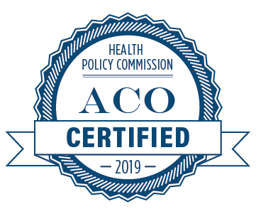
Atrius Health, Inc.

Baycare Health Partners, Inc., inclusive of Pioneer Valley Accountable Care, LLC; and Baystate Health Care Alliance, LLC

Beth Israel Lahey Performance Network, inclusive of Beth Israel Deaconess Physician Organization, LLC (Beth Israel Deaconess Care Organization); Lahey Clinical Performance Network, LLC; and Lahey Clinical Performance Accountable Care Organization, LLC

BMC Health System, Inc., inclusive of Boston Accountable Care Organization, Inc.; and BMC Integrated Care Services, Inc.

Cambridge Public Health Commission D/B/A Cambridge Health Alliance

Children’s Medical Center Corporation, inclusive of Children’s Hospital Corporation; and Boston Children’s Health Accountable Care Organization (Boston Children’s Accountable Care Organization)

Community Care Cooperative, Inc.

https://www.mass.gov/service-details/the-hpc-accountable-care-organization-aco-certification-program

